Supplement C:
  - Acta Geophysica
  - Seismic Hazard Assessment in the Podhale Region, Poland - Zone and Zone-Free Approach
  - Beata Plesiewicz¹, Andrzej Kijko², Jan Wiszniowski¹(jwisz@igf.edu.pl), Kamila Karkowska³
  - ¹Institute of Geophysics Polish Academy of Sciences, Warsaw, Poland
  - ²University of Pretoria Natural Hazard Centre, Pretoria, South Africa
  - ³Polish Geological Institute - National Research Institute, Warsaw, Poland

The PGA computed with Schenk’s GMPE maps for Podhale
For comparison of the individual treatment of the seismicity in the Podhale, the maps of the PGA that will not be exceeded with a probability of 90% in 50, 105, and 527 years were calculated with the ground motion prediction equation by Schenk et al. (2001)
$$lnPGA=a_{1}+a_{2}m+a_{3}ln\left(R_{hypo}+d\right),$$
where PGA is in cm/s², a₁ = 6.15 ± 0.32, a₂ = 0.65 ± 0.02, a₃ = -1.3 ± 0.16, and d = 17.
The equation does not take into account ground effects. This equation does not depend on site parameters, while other GMPEs used in the article for Podhale in the logical tree consider the substrate, which in the case of Podhale should be classified as rock. As a result, the ground motions will be less than with softer ground. The PGA values not exceeded with a probability of 90% in selected periods are illustrated in Fig. S3, which shows the PGA values would be much greater if only the Schenk et al. (2001) equation were applied to this work-developed seismicity model of Podhale. The PGA values that will not be exceeded with a probability of 90% in 50, 105, and 527 years are significantly more extensive than in Schenk hazards maps, both in the zonal and zone-free approach.

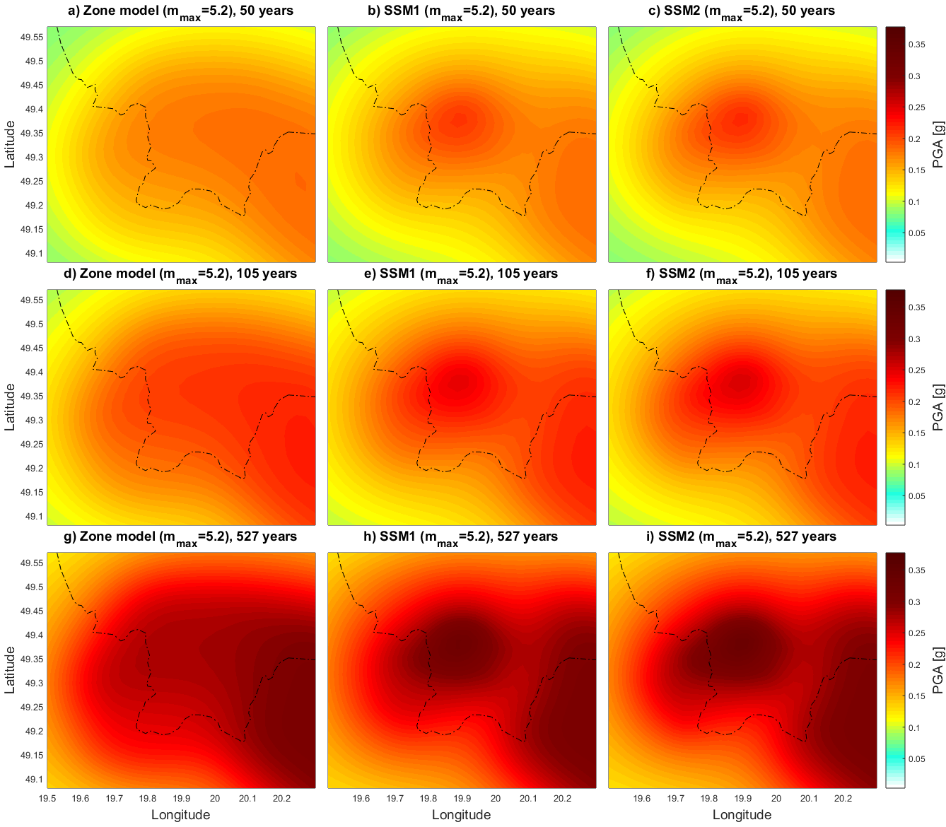
Fig. S3 PGA in Podhale with a 90% probability of non-exceedance calculatedby by Schenk’s et al. (2001) GMM for estimated mmax=5.2 with the zone approach (a, d, and g), the smoothed seismicity approach with magnitude-dependent kernel (SSM1) ( b, e, and h), and the smoothed seismicity approach with magnitude-independent Gaussian kernel (SSM2) ( c, f, and i) describing PGA with the 90% probability of non-exceedance within 50 years (a, b, and c) 105 years (d, e, and f), and 527 years (g, h, and i).
Tab. S1 Max PGA with a 90% probability of non-exceedance within 50, 105, and 527 years for Schenk’s GMM and m_{max} = 5.2. Values ​​for the GMM tree (Tab. 6) are in brackets
Spatial distribution map | Max PGA with a 90% probability of non-exceedance [g]
Spatial distribution map | Years
Spatial distribution map | 50 | 105 | 527
Zone model | 0.18 (0.15) | 0.22 (0.17) | 0.30 (0.25)
SSM, magnitude-dependent kernels | 0.21 (0.19) | 0.25 (0.22) | 0.33 (0.30)
SSM, magnitude-independent Gaussian kernels | 0.22 (0.20) | 0.25 (0.23) | 0.33 (0.31)

Reference
Schenk V, Schenková Z, Kottnauer P, Guterch B, Labák P (2001) Earthquake hazard maps for the Czech Republic, Poland and Slovakia. Acta Geophysica Polonica 49 (3): 287-302.

