Supplementary Table 1: Participants’ nationalities (n = 2529)
Nationality | Frequency
Pakistani | 436
Indonesian | 264
Indian | 262
Chinese | 235
Taiwanese | 192
Malaysian | 181
Sri-Lankan | 111
Australian | 106
New Zealander | 101
Israelian | 97
South African | 95
South Korean | 85
Chilian | 83
Irish | 57
Japanese | 57
Hongkongers | 41
British | 25
American | 22
Canadian | 21
Arabs | 8
Singaporean | 6
Afghan | 5
Colombian | 4
Ecuadorian | 3
Bhutanese | 2
Bolivians | 2
Dutch (nationaliteit: Nederlands) | 2
Persian | 2
Bruneian | 1
Cuba | 1
Ecuadorian | 1
Egyptian | 1
Filipino | 1
German | 1
Grecian | 1
Kuwaiti | 1
Lithuanian | 1
New Zealand European | 1
Nigeria | 1
Polish | 1
Portuguese | 1
Qatari | 1
Saudi Arabia | 1
Solomon Islander | 1
Sudanese | 1
Swazi | 1
Taiwanese Malaysian dual citizen | 1
Thai | 1
Trinidad and Tobago | 1
Ugandan | 1
Yemeni | 1
Zimbabwean | 1

Supplementary Table 2: Participated institutions
University/institution | Frequency
Australia - Flinders University | 18
Australia - Griffith University | 56
Australia - Monash University | 47
Australia - University of Tasmania | 24
Canada - McGill University | 5
Chile - Pontificia Universidad Católica de Chile | 86
Chile - Universidad de Concepción | 6
China - Beijing Hospital | 2
China - Institute on Aging | 2
China - Nanjing University | 2
China - Peking Union Medical College | 4
China - Peking University | 195
China - Shenzhen District Hospital | 1
China - Soochow University | 1
China - Southern Medical University | 1
China - Sun Yat-sen University | 2
China - Tsinghua University | 1
China - Union hospital | 1
Croatia - Zagreb university | 1
Hong Kong - The University of Hong Kong | 58
Hungary - Szeged university | 1
Hungary - University of Debrecen | 1
India - All India Institute of Medical Science | 116
India - Christian Medical College | 55
India - Mahatma Gandhi Institute of Medical Sciences | 83
India - NIMS Jaipur | 1
Indonesia - Universitas Bengkulu | 76
Indonesia - Universitas Indonesia | 114
Indonesia - Universitas Tarumanagara | 43
Indonesia - Universitas Udayana | 32
Ireland - NUI Galway | 45
Ireland - Royal College of Surgeons in Ireland (RCSI) | 31
Ireland - University of Limerick (UL) | 17
Israel - Bar Ilan | 13
Israel - Ben Gurion University | 8
Israel - Hebrew University | 22
Israel - Technion | 10
Israel - Tel Aviv University Sackler School of Medicine | 43
Italy - University of bologna | 1
Italy - University of Florence | 1
Japan - Jichi Medical University | 23
Japan - Kyushu University | 11
Japan - Shinshu University | 9
Japan - University of Tokyo | 3
Japan- Kyoto University | 10
Malaysia - Monash University | 59
Malaysia - Universiti Putra Malaysia | 51
Malaysia - Universiti Sains Malaysia | 77
Netherlands - Vrije Universiteit Amsterdam | 1
New Zealand - The University of Auckland | 63
New Zealand - University of Otago | 59
Pakistan - Khyber Medial University | 159
Pakistan - Rehman medical college | 2
Pakistan - Riphah International University | 59
Pakistan - University of Lahore | 227
Romania - Carol Davila University of Medicine and pharmacy | 2
South Africa - Stellenbosch University | 80
South Africa-University of South Africa | 1
South Korea - Ajoo University | 28
South Korea - Gacheon University | 22
South Korea - Korea University College of Medicine | 33
Sri-Lanka - Faculty of Medicine, University of Kelaniya | 36
Sri-Lanka - University of Jayawardenapura | 19
Sri-Lanka - University of Peradeniya | 53
Taiwan - Chang Gung Memorial Hospital | 92
Taiwan - Chang Gung University of Science and Technology | 38
Taiwan - China Medical University | 1
Taiwan - Chung Shan Medical University | 2
Taiwan - Fu Jen Catholic University | 3
Taiwan - Local clinic | 1
Taiwan - Mackay Medical College | 8
Taiwan - National Cheng Kung University | 8
Taiwan - National Defense Medical Center | 2
Taiwan - National Taiwan University Hospital | 1
Taiwan - National Yang-Ming University | 22
Taiwan - Taipei Medical University | 8
Taiwan - Taiwan number 1 | 1
Taiwan - Tzu Chi University | 16
UK - Newcastle University | 10
UK - SGUL University of Nicosia Medical School | 2
UK - University College London | 1

Supplementary Table 3: Original ranking of country data for our study
 | POWER | INDIVIDUALISM | MASCULINITY | UNCERTAINTY | ORIENTATION | INDULGENCE
Australia | 9 | 3 | 14 | 15 | 10 | 5
Chile | 7 | 5 | 15 | 12 | 4 | 1
China | 3 | 15 | 3 | 3 | 14 | 16
Hong Kong | 8 | 13 | 4 | 11 | 1 | 11
India | 5 | 14 | 5 | 7 | 9 | 13
Indonesia | 6 | 12 | 11 | 2 | 3 | 6
Ireland | 10 | 4 | 10 | 14 | 16 | 2
Israel | 15 | 2 | 1 | 16 | 13 | 3
Japan | 2 | 6 | 16 | 9 | 2 | 8
Malaysia | 1 | 10 | 8 | 4 | 6 | 12
New Zealand | 12 | 1 | 9 | 13 | 15 | 4
Pakistan | 4 | 16 | 2 | 6 | 12 | 15
South Africa | 13 | 7 | 6 | 10 | 8 | 7
South Korea | 11 | 8 | 12 | 8 | 5 | 9
Taiwan | 16 | 9 | 13 | 5 | 7 | 10
Australia | 14 | 11 | 7 | 1 | 11 | 14

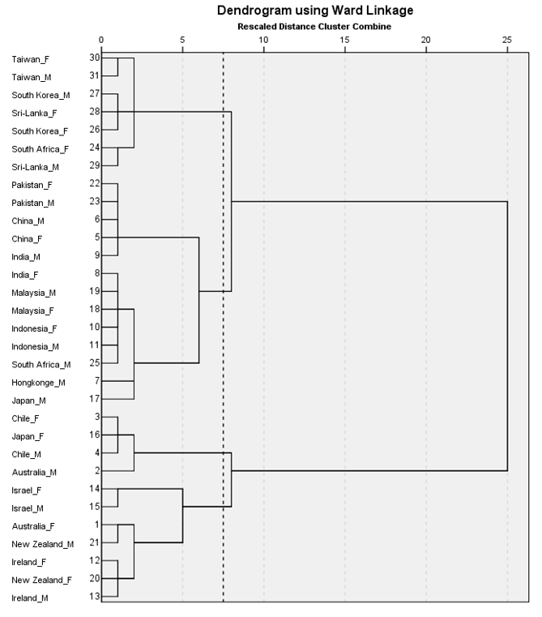

Supplementary Figure 1: Hierarchical tree of the ward algorithm method by country and gender. The dotted line indicates the optimal stopping location, and four distinct clusters are identified: M = male and F = female. Note: In the two-cluster model, cluster 1 and cluster 2 were grouped together as one cluster, and clusters 3 and 4 were grouped together as another cluster. The four-cluster model showed statistically significant results for all six dimensions, while the two-cluster model did not: the values of POWER t(29) = .55, p > .05 and MASCULINITY t(29) = .35, p > .05 showed no significant differences between two different clusters.

