Additional file 3 - Forest plots of stratified meta-analyses
Preterm birth stratified by study design
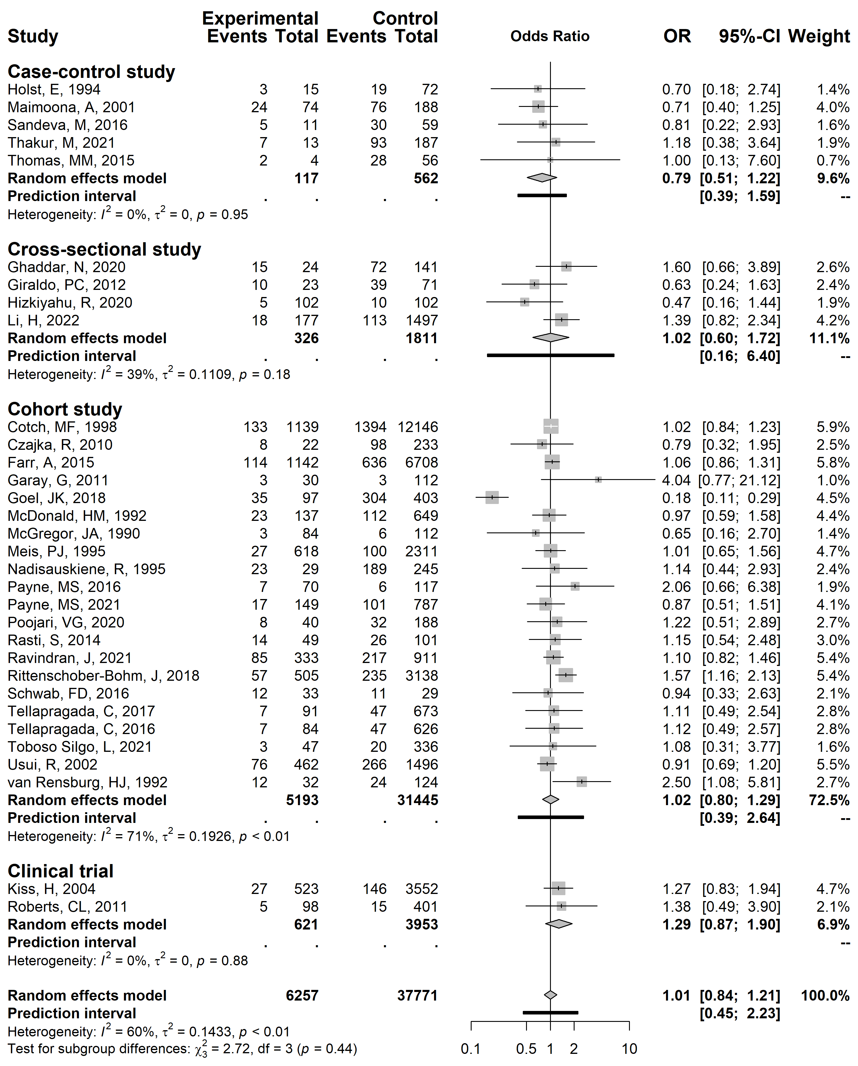
Legend: vertical line, line of no association (odds ratio 1.0); horizontal line, 95% confidence interval; vertical line inside the box, point estimate of odds ratio; grey box, study size; diamond, summary estimate with 95% confidence interval; black bar, 95% prediction interval. To the left of the line of no association, preterm birth was less likely in women with vulvovaginal yeast infection; to the right of the line of no association, preterm birth was more likely.

Preterm birth stratified by diagnostic method used
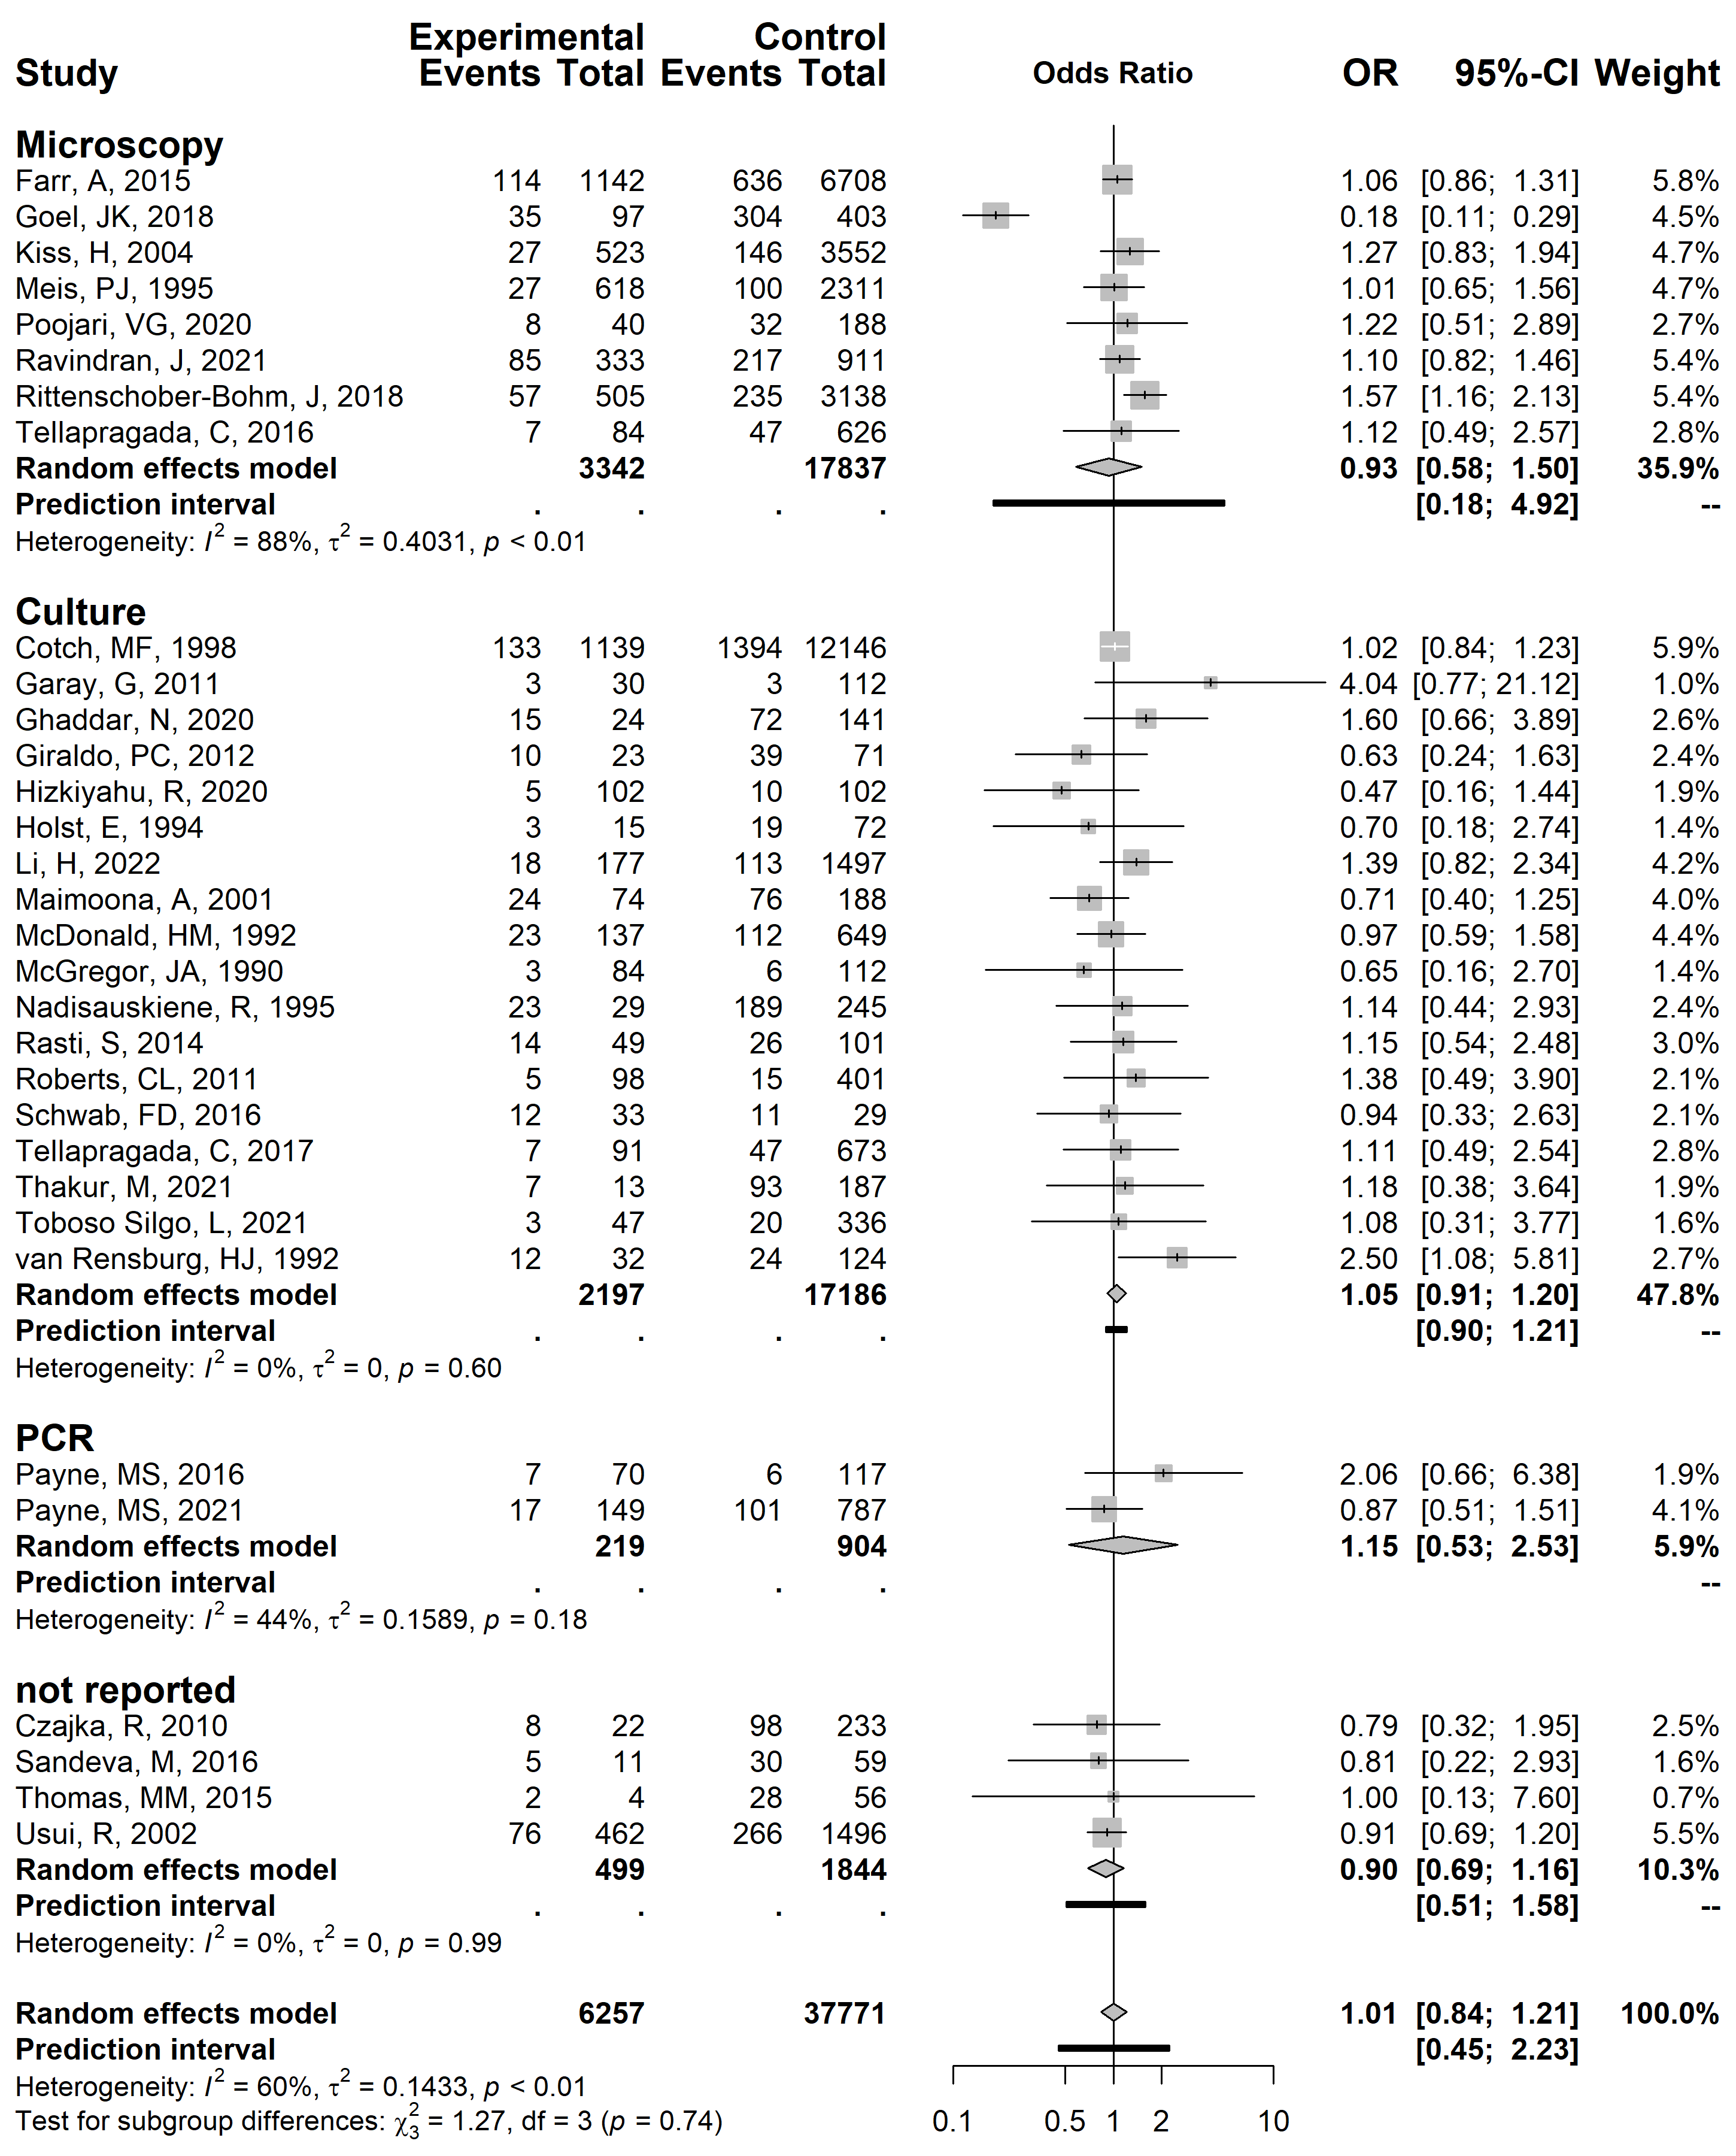
Legend: vertical line, line of no association (odds ratio 1.0); horizontal line, 95% confidence interval; vertical line inside the box, point estimate of odds ratio; grey box, study size; diamond, summary estimate with 95% confidence interval; black bar, 95% prediction interval. To the left of the line of no association, preterm birth was less likely in women with vulvovaginal yeast infection; to the right of the line of no association, preterm birth was more likely.

Preterm birth stratified by income setting
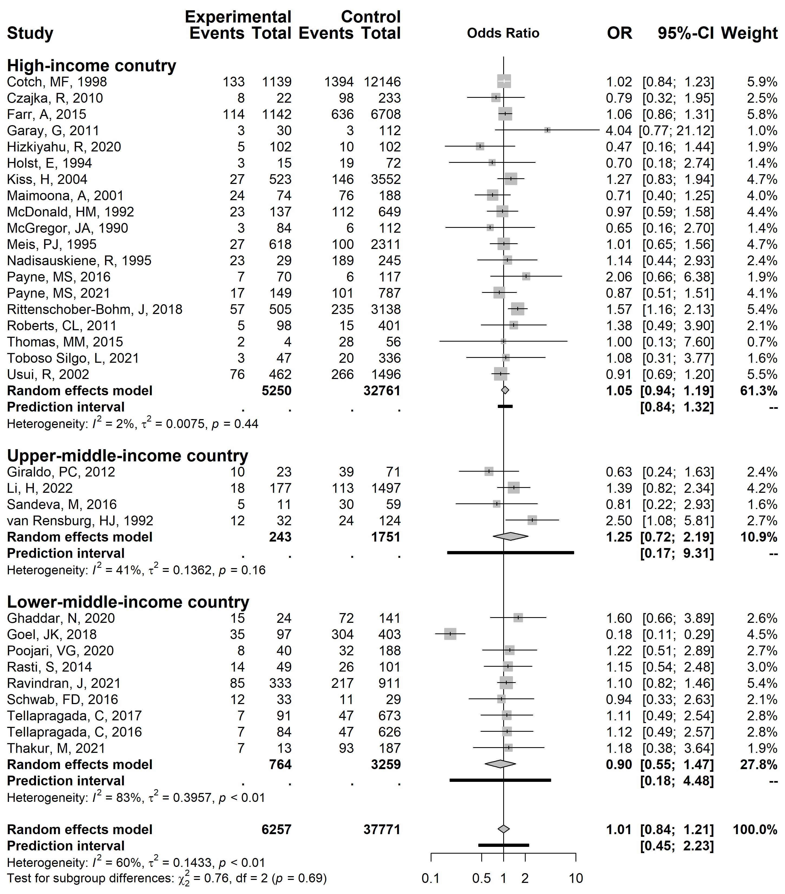
Legend: vertical line, line of no association (odds ratio 1.0); horizontal line, 95% confidence interval; vertical line inside the box, point estimate of odds ratio; grey box, study size; diamond, summary estimate with 95% confidence interval; black bar, 95% prediction interval. To the left of the line of no association, preterm birth was less likely in women with vulvovaginal yeast infection; to the right of the line of no association, preterm birth was more likely.

Preterm birth stratified by time of testing
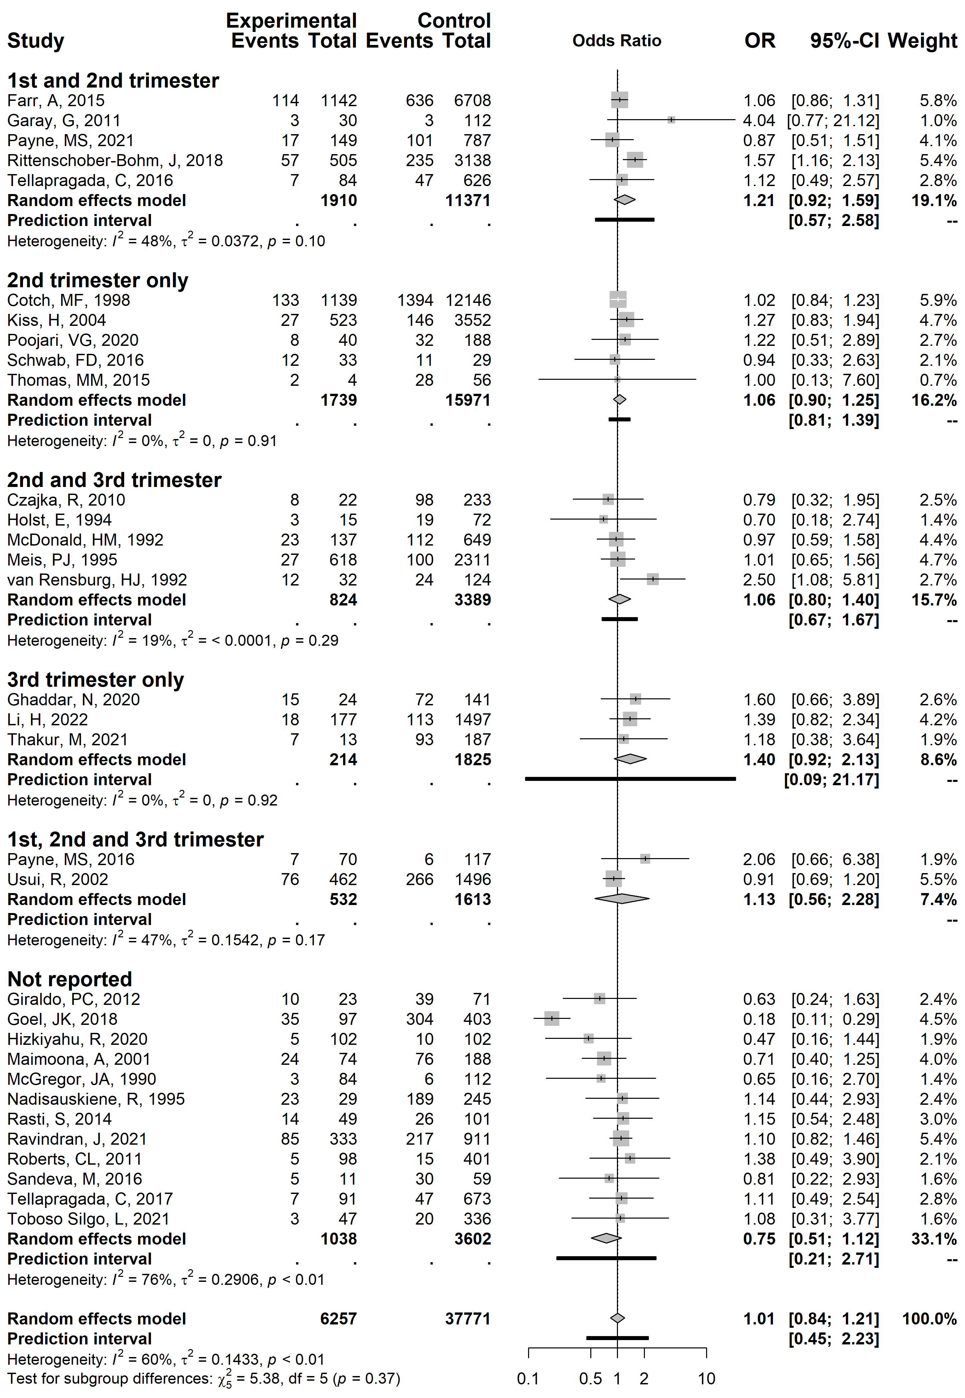
Legend: vertical line, line of no association (odds ratio 1.0); horizontal line, 95% confidence interval; vertical line inside the box, point estimate of odds ratio; grey box, study size; diamond, summary estimate with 95% confidence interval; black bar, 95% prediction interval. To the left of the line of no association, preterm birth was less likely in women with vulvovaginal yeast infection; to the right of the line of no association, preterm birth was more likely.

