Photocatalytic Degradation of Efavirenz and Nevirapine using Visible Light-Activated Ag-AgBr-LDH Nanocomposite Catalyst

Lehlogonolo Tabana*, Davy-Rayn Booysens, Shepherd Tichapondwa
Department of Chemical Engineering, Sustainable Environmental and Water Utilisation Processes Division, University of Pretoria, Pretoria, 0028, South Africa.
tabana.ls@tuks.co.za

Supplementary data
Table S1
Positions of the basal planes and crystallite parameters
Parameter | Sample ID
Parameter | LDH | Ag-AgBr-LDH
2θ (003) (°) | 13.39 | 12.96
2θ (006) (°) | 26.64 | 26.31
2θ (009) (°) | 40.36 | 40.37
2θ (110) (°) | 71.28 | 71.11
d₍₀₀₃₎ (Å) | 7.67 | 7.92
c (Å) | 23.21 | 23.56
a (Å) | 3.07 | 3.07
L (nm) | 18.26 | 14.09

Fig. S1. XRD spectra for Ag-AgBr-LDH photocatalyst.

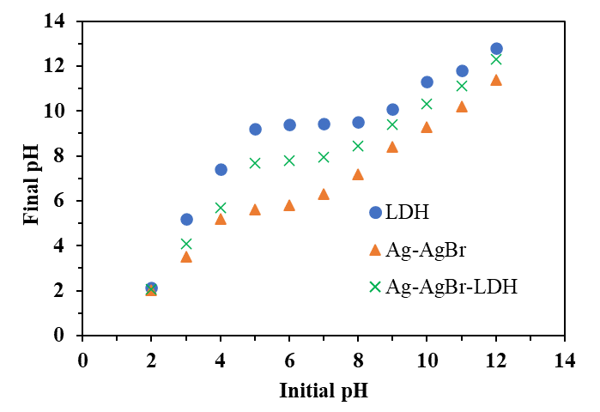
Fig. S2. Point of zero charge for various photocatalyst.

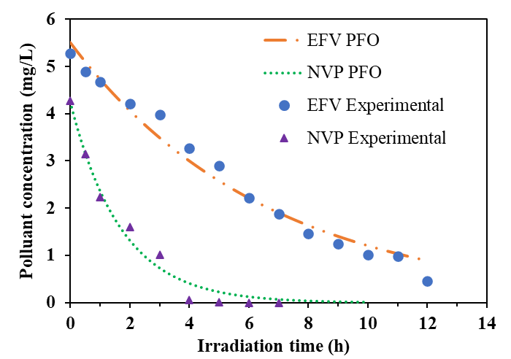
Fig. S3. PFO kinetics model fittings for efavirenz and nevirapine (5 mg/L).

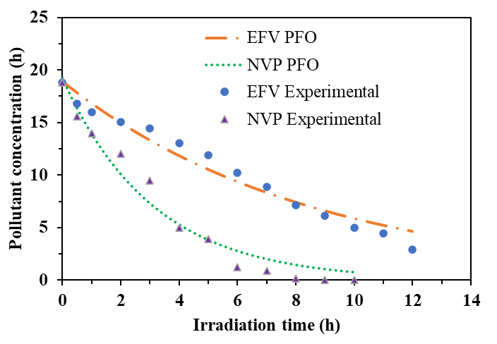
Fig. S4. PFO kinetics model fittings for efavirenz and nevirapine (20 mg/L).

