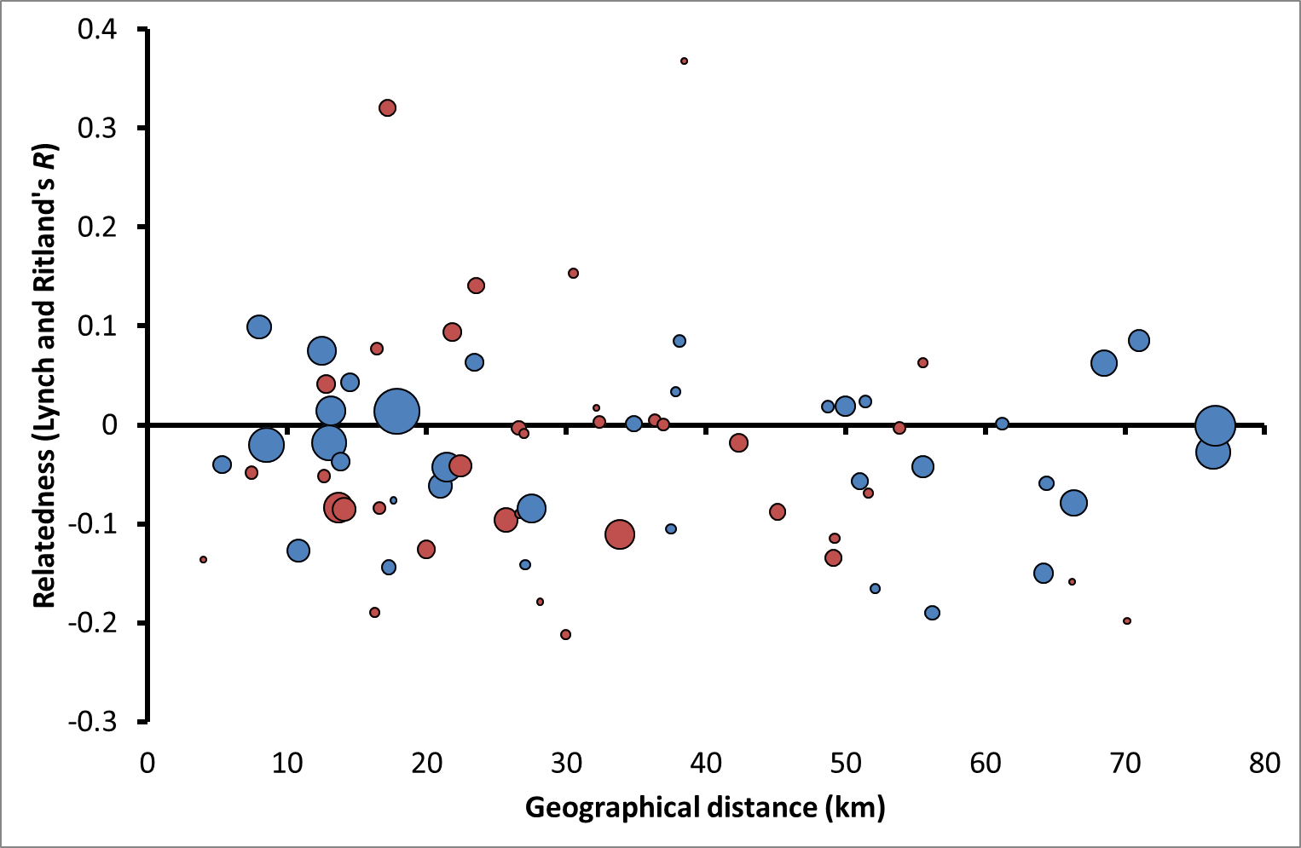
Absence of isolation-by-distance among males ≥ 3 year old.
Red circles: northern Kruger, blue circles: southern Kruger. Circles represent mean relatedness per pair of localities and circle size total number of comparisons per pair of localities (minimum = 1, maximum = 35).
Northern Kruger: Pearson r = -0.08, P = 0.30, n_{individuals} = 19, n_{localities} = 9; southern Kruger: Pearson r = -0.03, P = 0.32, n_{individuals} = 28, n_{localities} = 9.

