Table S1. Sampling locations. ID numbers as reported in Figure 1, geographic coordinates, countries and geographic areas and collection date of the thirteen sampling locations considered in this study.

ID | Latitude | Longitude | Country/State/Province | Geographic areas | Collection date
1 | -25,577983 | 28,640176 | South Africa (Gauteng) | South Africa East | January 2017
2 | -29,537569 | 30,353143 | South Africa (Kwa-Zulu Natal) | South Africa East | January 2017
3 | -33,830554 | 25,085496 | South Africa (Eastern Cape) | South Africa East | September 2016
4 | -34,029675 | 24,223082 | South Africa (Eastern Cape) | South Africa East | September 2016
5 | -33,979278 | 22,713619 | South Africa (Western Cape) | South Africa West | September 2016
6 | -34,155060 | 19,786844 | South Africa (Western Cape) | South Africa West | October 2016
7 | -34,283295 | 19,142453 | South Africa (Western Cape) | South Africa West | June 2016
8 | -32,947125 | 19,043438 | South Africa (Western Cape) | South Africa West | November 2016
9 | -30,892751 | 115,615354 | Western Australia | Australia | May 2017
10 | -33,716476 | 115,127105 | Western Australia | Australia | May 2017
11 | -33,671124 | 115,124943 | Western Australia | Australia | May 2017
12 | 37,4138236 | -8,795577 | Portugal | Europe | April 2017
13 | 43,2811775 | 10,536159 | Italy | Europe | April 2017

Table S2. List of Phytophthora species obtained in this study and relative ITS gene GenBank sequence name. Additional information reported in columns consists of the isolate ID code, the source, and the country where the isolate was obtained.

Phytophthora species | Isolate ID | Substrate | Location | Province | Genbank accession number
P. cinnamomi | 16.1D40 | Fynbos | South Africa | Eastern Cape | OK618416
 | 17.2D35 | Fynbos | South Africa | Eastern Cape | OK618422
 | 17.1D1 | Fynbos | South Africa | Eastern Cape | OK618428
 | 18.5D5 | Fynbos | South Africa | Eastern Cape | OK618385
 | 19.1D13 | Fynbos | South Africa | Eastern Cape | OK618429
 | 20.2D25 | Fynbos | South Africa | Eastern Cape | OK618417
 | 21.3D29 | Fynbos | South Africa | Eastern Cape | OK618415
 | 22.1D10 | Fynbos | South Africa | Eastern Cape | OK618391
 | 22.3D2 | Fynbos | South Africa | Eastern Cape | OK618402
 | 24.2D42 | Fynbos | South Africa | Eastern Cape | OK618434
 | 25.1D12 | Fynbos | South Africa | Eastern Cape | OK618390
 | 41.2D17 | Fynbos | South Africa | Eastern Cape | OK618423
 | 42.2D46 | Fynbos | South Africa | Eastern Cape | OK618432
 | 42.1D41 | Fynbos | South Africa | Eastern Cape | OK618436
 | 44.2D51 | Fynbos | South Africa | Eastern Cape | OK618403
 | 45.1D18 | Fynbos | South Africa | Eastern Cape | OK618395
 | 45.2D30 | Fynbos | South Africa | Eastern Cape | OK618421
 | 46.3D38 | Fynbos | South Africa | Eastern Cape | OK618393
 | 47.5D34 | Fynbos | South Africa | Eastern Cape | OK618435
 | 49.1D54 | Fynbos | South Africa | Eastern Cape | OK618408
 | 78AaD22 | Fynbos | South Africa | Western Cape | OK618418
 | 78PCyD23 | Fynbos | South Africa | Western Cape | OK618433
 | 79R1D11 | Fynbos | South Africa | Western Cape | OK618392
 | 79PcyD28 | Fynbos | South Africa | Western Cape | OK618396
 | 79TxD9 | Fynbos | South Africa | Western Cape | OK618399
 | 79RP2D49 | Fynbos | South Africa | Western Cape | OK618407
 | 79amD27 | Fynbos | South Africa | Western Cape | OK618420
 | 79TH3D24 | Fynbos | South Africa | Western Cape | OK618438
 | 79TH4D26 | Fynbos | South Africa | Western Cape | OK618440
 | 80PcD14 | Fynbos | South Africa | Western Cape | OK618400
 | 80RP4D52 | Fynbos | South Africa | Western Cape | OK618406
 | 80MiD47 | Fynbos | South Africa | Western Cape | OK618409
 | 80Rp2D43 | Fynbos | South Africa | Western Cape | OK618424
 | 80P1D32 | Fynbos | South Africa | Western Cape | OK618437
 | 82AaD8 | Fynbos | South Africa | Western Cape | OK618389
 | 82PCy5D19 | Fynbos | South Africa | Western Cape | OK618394
 | 82ivyD16 | Fynbos | South Africa | Western Cape | OK618398
 | 82RT3D6 | Fynbos | South Africa | Western Cape | OK618426
 | 82Pcy3D7 | Fynbos | South Africa | Western Cape | OK618430
 | 82Pcy4D15 | Fynbos | South Africa | Western Cape | OK618431
 | 82M2D20 | Fynbos | South Africa | Western Cape | OK618439
P. niederhauserii | 140.1D56 | Fynbos | South Africa | Western Cape | OK618383
P. cinnamomi | 175.1D58 | Fynbos | South Africa | Gauteng | OK618384
 | 8RP6D4 | Pink ice | South Africa | Eastern Cape | OK618425
 | 8.1D3 | Pink ice | South Africa | Eastern Cape | OK618427
 | 60.3D21 | Pink ice | South Africa | Western Cape | OK618397
 | 60.2D37 | Pink ice | South Africa | Western Cape | OK618419
 | 168.1D65 | Pink ice | South Africa | Gauteng | OK618388
 | 171.1D64 | Pink ice | South Africa | Gauteng | OK618414
 | 172.2D63 | Pink ice | South Africa | Gauteng | OK618386
 | 172.1D62 | Pink ice | South Africa | Gauteng | OK618410
P. pseudocryptogea | 201D72 | Native bush | Portugal |  | OK618451
P. ornamentata | 202D73 | Native bush | Portugal |  | OK618453
P. cinnamomi | 195.1D66 | Pink ice | Portugal |  | OK618441
 | 195.3D68R | Pink ice | Portugal |  | OK618443
 | 196D69 | Pink ice | Portugal |  | OK618442
 | 197D65 | Pink ice | Portugal |  | OK618444
 | 198D70 | Pink ice | Portugal |  | OK618449
P. pseudocryptogea | 222 | Pink ice | Italy |  | OK618452
P. cinnamomi | 10.3D50 | Safari sunset | South Africa | Eastern Cape | OK618405
 | 13.2D45 | Safari sunset | South Africa | Eastern Cape | OK618404
P. pseudocryptogea | 38.1D36 | Safari sunset | South Africa | Eastern Cape | OK618382
P. cinnamomi | 166.1D67 | Safari sunset | South Africa | Kwa-Zulu Natal | OK618413
 | 180.1D70 | Safari sunset | South Africa | Gauteng | OK618412
 | 181.1D74 | Safari sunset | South Africa | Gauteng | OK618387
 | 182.2D73 | Safari sunset | South Africa | Gauteng | OK618411
 | 206.2D752R | Safari sunset | Portugal |  | OK618446
P. ornamentata | 206D74 | Safari sunset | Portugal |  | OK618454
P. cinnamomi | 224cD85 | Safari sunset | Italy |  | OK618447
 | 224bD84 | Safari sunset | Italy |  | OK618450
P. ornamentata | 227.1D86 | Safari sunset | Italy |  | OK618455
P. multivora | 247.6 | Pink ice | Australia | Western Australia | OK618456
P. cinnamomi | 283.2 | Safari sunset | Australia | Western Australia | OK618457
 | 284 | Safari sunset | Australia | Western Australia | OK618458

Table S3. Phytophthora species were obtained in this study with metabarcoding and isolation methods. Singular detections (metabarcoding) and isolates (baiting) are unique per sampling unit.

Oomycete Phylotype | Metabarcoding Detections |  | Number of isolates detected with baiting
 | RPS10 | ITS | Number of isolates detected with baiting
Phytophthora 12A | 4 | - | -
Phytophthora cactorum | 1 | 1 | -
Phytophthora cryptogea complex | 1 | 1 | 3
Phytophthora sojae | 3 | - | -
Phytopthora cinnamomi | 11 | 12 | 40
Phytopythium sp.1 | 2 | - | -
Phytophthora multivora | - | 1 | 1
Phytophthora nicotianae | - | 4 | -
Phytophthora niederhauserii | - | - | 1
Phytophthora ornamentata | - | - | 3
Phytophthora pachypleura | - | 1 | -
Phytophthora pseudocryptogea | - | 3 | -

Table S4. Distribution of the Phytophthora species isolates obtained with isolation methods across the sampling units analyzed in the study. P.c is P.cinnamomi, P. cry. is P. cryptogea complex, P. m. is P. multivora, P. n. is P. niederhauserii and P. o. is P. ornamentata.

Country | Vegetation type | Number of  sampling units | Taxa |  |  |  |  | Total
 |  |  | P. c. | P. cry. | P. m. | P. n. | P. o.
South Africa | Native vegetation | 80 | 20 | - | - | 1 | - | 21
South Africa | Orchard | 80 | 11 | 1 | - | - | - | 12
Portugal | Native vegetation | 30 | 1 | 1 | - | - | 1 | 3
Portugal | Orchard | 30 | 4 | - | - | - | 1 | 5
Australia | Native vegetation | 10 | - | - | - | - | - | 0
Australia | Orchard | 10 | 2 | - | 1 | - | - | 3
Italy | Orchard | 10 | 2 | 1 | - | - | 1 | 4
Total |  | 250 | 40 | 3 | 1 | 1 | 3

Figure S1. Phylogenetic tree of representative ASVs and the most closely related species based on ITS1 gene region. Representative sequences for backbone Phytophthora species are from the type isolates as found on IDPhy (Abad et al. 2023). For other oomycetes backbone sequences were downloaded from GenBank. Species from the same phylogenetic clade are grouped together.
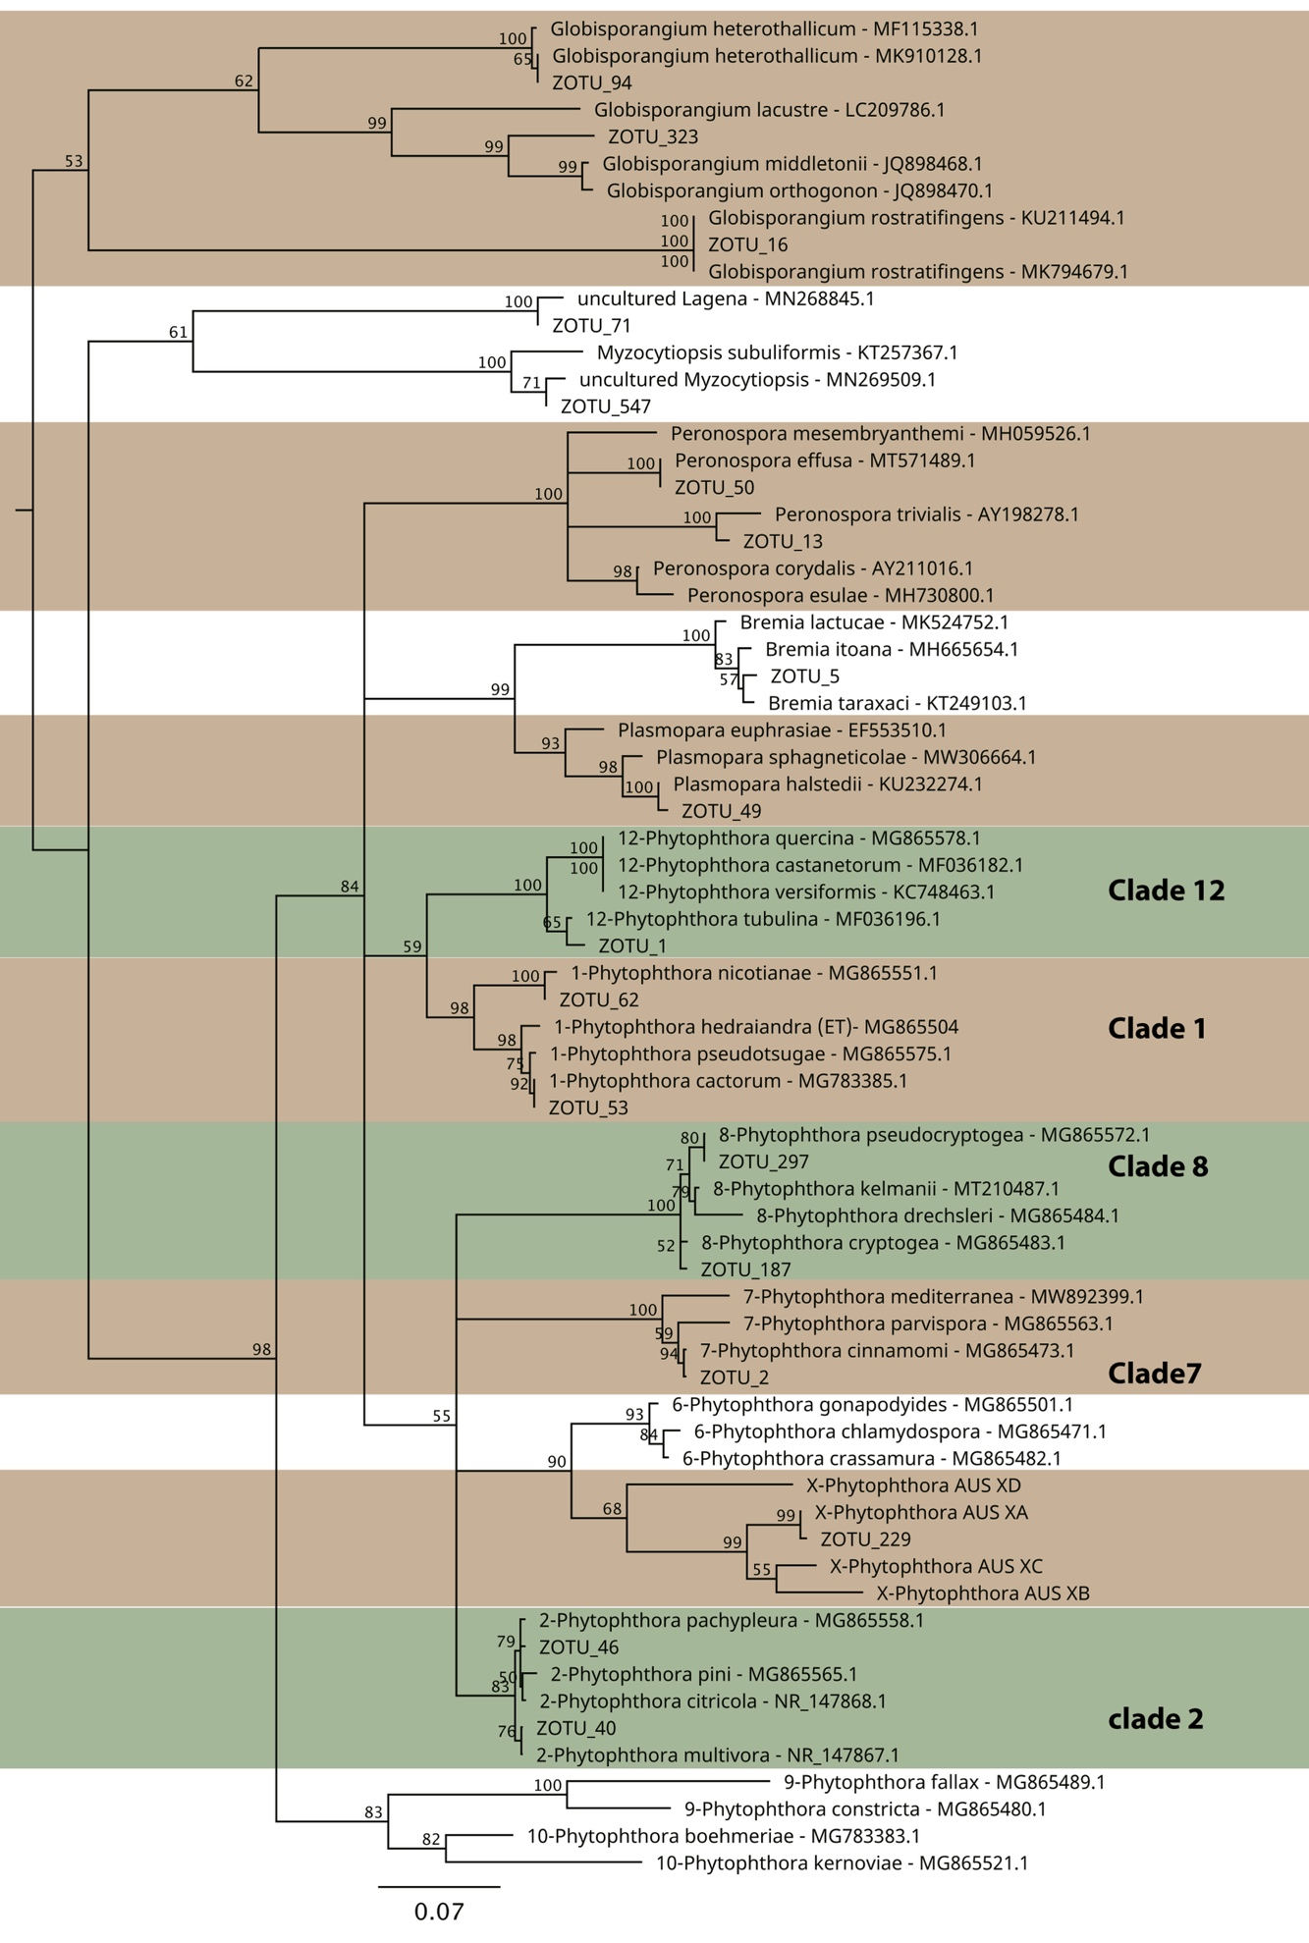

Figure S2. Phylogenetic tree of representative ASVs and the most closely related species based on RPS10 gene region. Representative sequences for backbone Phytophthora species are from the RPS10 curated database (Foster et al. 2022). Species from the same phylogenetic clade are grouped together.
