Supporting information for:
The phylogeography and diversification of an endemic trapdoor spider genus, Stasimopus Simon 1892 (Araneae, Mygalomorphae, Stasimopidae) in the Karoo, South Africa

Table S2. Summary of primers used in this study and their corresponding gene regions.
Gene Region | Primer name | Sequence | Primer references
CO1 | HCO2198 | 5' - TAA ACT TCA GGG TGA CCA AAA - 3' | (Folmer et al., 1994)
CO1 | LCO1490 | 5' - GGT CAA CAA ATC ATA AAG ATA - 3' | (Folmer et al., 1994)
CO1 | C1-J-1751 | 5' - GGA TCA CCT GAT ATA GCA TTC CC - 3' | (Folmer et al., 1994)
16S | LRN-13398 | 5' - CGC CTG TTT AAC AAA AAC AT - 3' | (Simon et al., 1994)
16S | LR-J-12961 | 5' - TTT AAT CCA ACA TCG AGG - 3' | (Cognato and Vogler, 2001)
EF-1ɣ | EF1gF78 | 5’ - ATT GCB GCN CAG TAY AGY GG - 3’ | (Ayoub et al., 2007)
EF-1ɣ | EF1gR1258 | 5’ - CCT TGR TTG AAY TTC TTT CC - 3’ | (Ayoub et al., 2007)
EF-1ɣ | CyrtEF1L | 5’ - CAG TTA CGC GGT ACC ACT CT - 3’ | (Kornilios et al., 2016)
EF-1ɣ | CyrtEF1R | 5’ - CGC ATC TTG TCT AGC CTC TG - 3’ | (Kornilios et al., 2016)

Table S3. The PCR protocol used for CO1 and 16S gene regions. The annealing temperature was adjusted if a sample did not amplify.
Phase | Temperature (°C) | Time (s) | 40 cycles
Denaturation | 94 | 300 | 40 cycles
Denaturation | 94 | 15 | 40 cycles
Annealing | 48-52 | 5 | 40 cycles
Amplification | 72 | 15 | 40 cycles
Amplification | 72 | 420 | 40 cycles

Table S4. The PCR protocol used for EF-1ɣ gene region for both the initial and nested PCR. The initial PCR used the primers EF1g78 and EF1g1258 whereas the nested PCR used CyrtEF1L and CyrtEF1R. The annealing temperature was adjusted if a sample did not amplify.
Phase | Temperature (°C) | Time (s) | 35 cycles
Denaturation | 94 | 180 | 35 cycles
Denaturation | 94 | 60 | 35 cycles
Annealing | 50 / 52 | 60 | 35 cycles
Amplification | 72 | 60 | 35 cycles
Amplification | 72 | 60 | 35 cycles
Table S6. Model of nucleotide substitution selected for each gene region. The contribution of base pairs and samples by each gene region to the combined phylogeny is given. The Akaike Information Criterion (AIC) and the Bayesian Information Criterion (BIC) were both produced by jModelTest.
Dataset | Gene region | Base pairs | Number of samples | Percentage individuals included in phylogeny (%) | AIC model | BIC model | Model selected
Stasimopus | CO1 | 401 | 111 | 86 | TIM1+ I+ G (I=0.379; G=0.638) | TIM1+ I+ G (I=0.379; G=0.638) | GTR+ I+ G (I=0.379; G=0.638)
Stasimopus | 16S | 317 | 115 | 89.15 | TIM3+ G (G=0.348) | TIM3+ G (G=0.348) | GTR+ G  (G=0.348)
Stasimopus | CO1_16S | 720 | 101 | - | TPM1uf+ I+ G (I= 0.001; G=0.299) | TPM1uf+ I+ G (I= 0.001; G=0.296) | GTR+ G  (G=0.299)
Stasimopus | EFɣ-1 | 539 | 103 | 79.84 | TPM2uf+ I+ G (I=0.519; G=0.872) | HKY+ G (G=0.231) | HKY+ G (G=0.231)
Stasimopus | Combined | 1257 | 129 | - | TIM1+ I+ G (I=0.531; G=0.640) | TIM1+ I+ G (I=0.531, G=0.640) | GTR+ I+ G  (I=0.531, G=0.640)

Table S7. The locality coordinates and samples used to conduct the mantle test. The “By locality” section indicates the test that was run on 48 samples each with a unique locality to test for isolation by distance between the CO1 dataset and the geographic distances. The “By species” section indicates the subset of samples and localities tested to determine if there is a correlation between geographic distance and genetic differences across the various species.

By locality
Site number | Specimen code | Species
02 | NCA 2017/1834 | Unidentified
03 | NCA 2017/1835 | S. unispinosus
04 | NCA 2017/1839 | S. maraisi
05B | NCA 2017/1843 | Unidentified
06 | NCA 2017/1849 | S. hamartia
07 | NCA 2017/1852 | S. hamartia
08 | NCA 2017/1855 | S. maraisi
09 | NCA 2017/1861 | S. maraisi
11 | NCA 2017/1866 | S. maraisi
13 | NCA 2017/1870 | S. leipoldti
16A | NCA 2017/1874 | S. maraisi
16B | NCA 2017/1875 | S. maraisi
18B | NCA 2017/1882 | S. maraisi
19 | NCA 2017/1885 | S. maraisi
20B | NCA 2017/1887 | S. maraisi
21 | NCA 2017/1888 | S. hamartia
22 | NCA 2017/1897 | Unidentified
23 | NCA 2017/1899 | Unidentified
24 | NCA 2017/1903 | S. astutus
25B | NCA 2017/1906 | S. astutus
30A | NCA 2017/1913 | S. erythrognathus
30B | NCA 2017/1914 | S. erythrognathus
31 | NCA 2019/610 | S. venterstadensis
32 | NCA 2019/603 | Unidentified
33 | NCA 2019/625 | S. erythrognathus
35 | NCA 2019/620 | Unidentified
36 | NCA 2019/605 | S. finni
37A | NCA 2019/638 | S. astutus
37B | NCA 2019/635 | S. astutus
38B | NCA 2019/676 | S. dylani
39 | NCA 2019/660 | S. hamartia
41 | NCA 2019/636 | S. maraisi
42 | NCA 2019/691 | Unidentified
44A | NCA 2019/662 | Unidentified
47 | NCA 2019/630 | S. maraisi
50 | NCA 2019/689 | S. maraisi
51 | NCA 2019/640 | S. maraisi
52 | NCA 2019/688 | S. maraisi
53 | NCA 2019/647 | S. astutus
55B | NCA 2019/680 | S. maraisi
56 | NCA 2019/643 | S. teras
58 | NCA 2019/671 | S. schrieneri
59B | NCA 2019/655 | S. unispinosus
60 | NCA 2019/665 | S. erythrognathus
ELK | NCA 2019/613 | S. erythrognathus
FRE | NCA 2019/663 | S. dylani
NCRA | NCA 2017/1915 | Unidentified
STH | NCA 2019/642 | S. ignis
By Species
Site number | Specimen code | Species
21 | NCA 2017/1888 | S. hamartia
24 | NCA 2017/1903 | S. astutus
60 | NCA 2019/665 | S. erythrognathus
13 | NCA 2017/1870 | S. leipoldti
08 | NCA 2017/1855 | S. maraisi
19 | NCA 2017/1885 | S. maraisi
52 | NCA 2019/688 | S. maraisi
58 | NCA 2019/671 | S. schrieneri
03 | NCA 2017/1835 | S. unispinosus
06 | NCA 2017/1849 | S. hamartia
FRE | NCA 2019/663 | S. dylani
31 | NCA 2019/610 | S. venterstadensis
36 | NCA 2019/605 | S. finni
STH | NCA 2019/642 | S. ignis
56 | NCA 2019/643 | S. teras

Table S8. Demographic parameters for the 16S gene region for the Stasimopus of the Karoo region. The number of sequences (n), nucleotide diversity (π), haplotypes (H), gene diversity (H_{d}), mean number of pairwise differences (k) and segregating sites (S) (out of 317) are given. The results of Tajima’s D and Fu & Li’s D* are also given. Significant results (p<0.05) are indicated by an asterisk. The species complex referred to is that between S. erythrognathus and S. karooensis. Species with less than four representatives were omitted.
Clade / Lineage | n | π | H | H_{d} | k | S | Tajima’s D | Fu & Li's D*
S. astutus | 11 | 0.080 | 7 | 0.818 | 23.182 | 79 | -1.402 | -1.286
S. dylani | 6 | 0.042 | 5 | 0.933 | 12.867 | 25 | 0.556 | 0.627
S. maraisi | 35 | 0.068 | 23 | 0.973 | 20.225 | 70 | 0.310 | -0.108
S. erythrognathus | 12 | 0.065 | 8 | 0.897 | 19.256 | 56 | -0.092 | 0.444
Species complex* | 13 | 0.078 | 8 | 0.894 | 23.242 | 67 | -0.569 | -0.926
S. hamartia | 11 | 0.095 | 6 | 0.800 | 28.000 | 56 | 1.850 | 1.418**
S. unispinosus | 5 | 0.006 | 2 | 0.600 | 1.800 | 3 | 1.573 | 1.572

Table S9. Demographic parameters for the EF-1ɣ gene region for the Stasimopus of the Karoo region. The number of sequences (n), nucleotide diversity (π), haplotypes (H), gene diversity (H_{d}), mean number of pairwise differences (k) and segregating sites (S) (out of 539) are given. The results of Tajima’s D and Fu & Li’s D* are also given. Significant results (p<0.05) are indicated by an asterisk. The species complex referred to is that between S. erythrognathus and S. karooensis. Species with less than four representatives were omitted.
Clade / Lineage | n | π | H | H_{d} | k | S | Tajima’s D | Fu & Li's D*
S. astutus | 7 | 0.014 | 7 | 1.000 | 7.330 | 21 | -0.813 | -0.651
S. maraisi | 37 | 0.005 | 11 | 0.698 | 2.928 | 26 | -1.825** | -3.140**
S. erythrognathus | 11 | 0.006 | 7 | 0.873 | 3.309 | 10 | -0.131 | -0.478
Species complex* | 12 | 0.083 | 7 | 0.833 | 3.167 | 10 | -0.180 | -0.550
S. hamartia | 11 | 0.005 | 6 | 0.836 | 2.509 | 7 | 0.202 | -0.193
S. unispinosus | 6 | 0.003 | 2 | 0.600 | 1.800 | 3 | 1.910 | 1.400

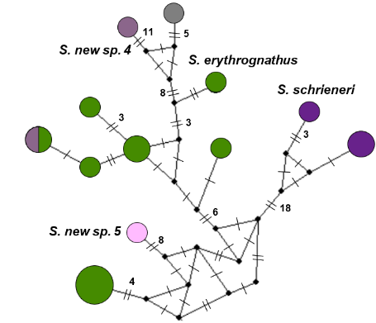
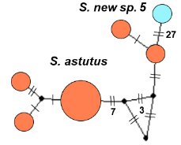
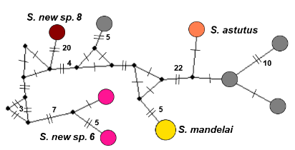
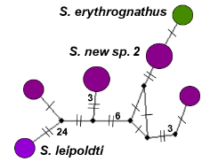
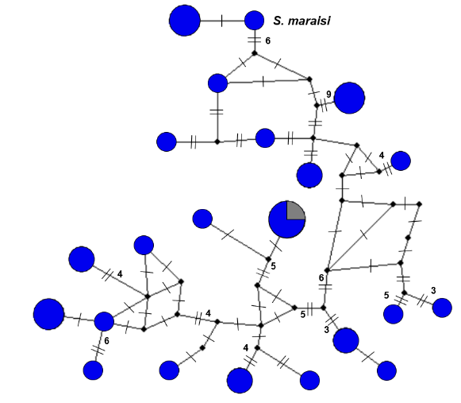
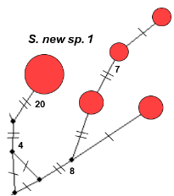
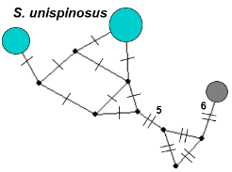
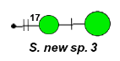
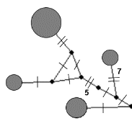
S. venterstadensis
S. ignis
S. teras
S. dylani
S. hamartia
S. finni
S. theaei
S. karooensis
Clade C
Clade I
Clade J
Clade H
Clade G
Clade A
Clade B
Clade F
Clade D & K

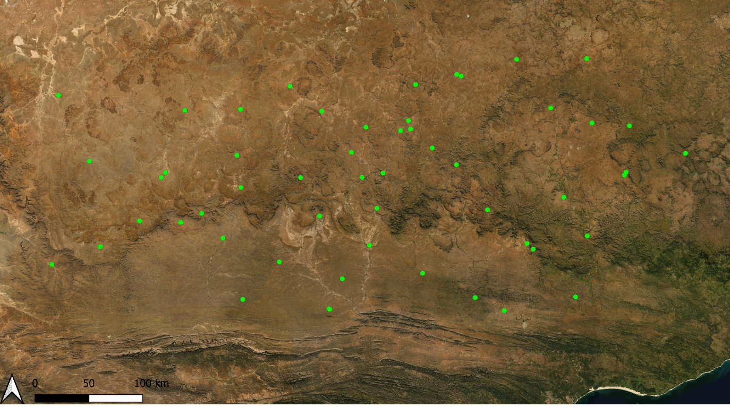
Cape fold belt
The great escarpment
Central plateau
n=1

n=2

n=3

n=4

n=5

n=6

Figure S1. Map of the Karoo area sampled with haplotype networks for the 16S gene region. Each circle in the networks represents a unique haplotype. The black dots on each network represents a hypothetical intermediate haplotype. Mutational steps are indicated by lines, and more than two steps by the corresponding number. The haplotype networks and map circles are proportional to the given sample size.

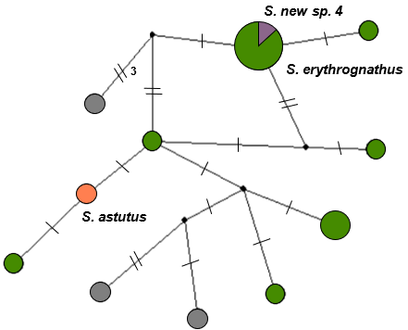
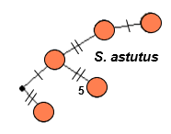
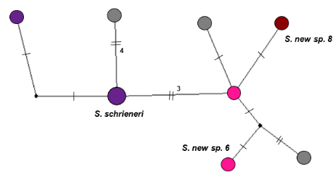
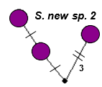
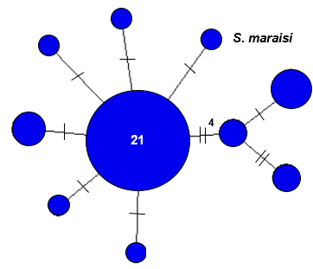
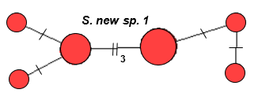
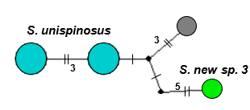
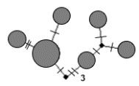
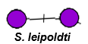
S. venterstadensis
S. hamartia
S. dylani
S. ignis
S. teras
S. karooensis
Clade C
Clade A
Clade F
Clade B
Clade K
Clade J
Clade H & I
Clade G
Clade D

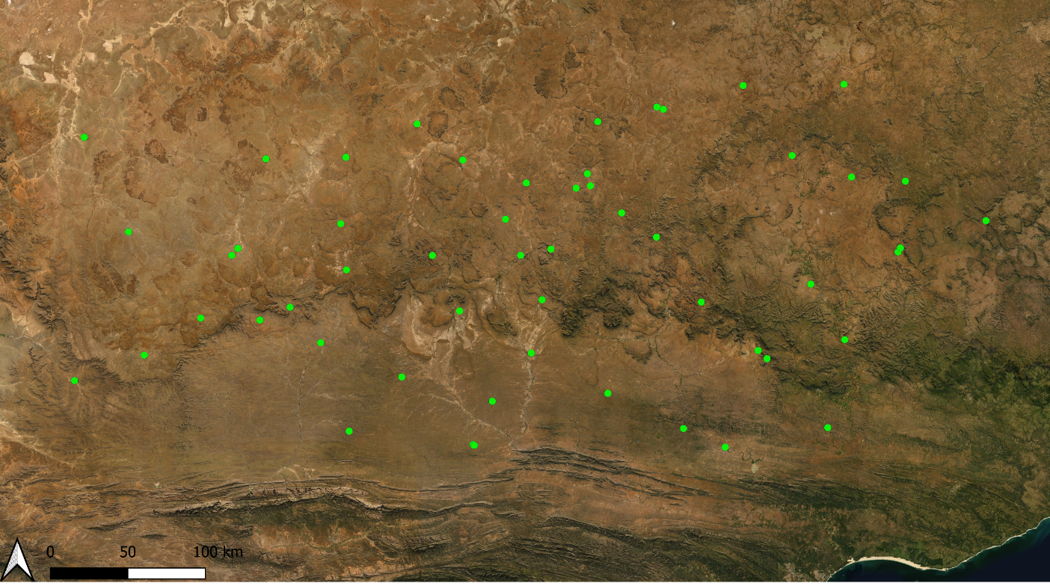
Cape fold belt
Central plateau
n=1

n=2

n=3

n=4

n=5

The great escarpment

Figure S2. Map of the Karoo area sampled with haplotype networks for the EF-1ɣ gene region. Each circle in the networks represents a unique haplotype. The black dots on each network represents a hypothetical intermediate haplotype. Mutational steps are indicated by lines, and more than two steps by the corresponding number. The haplotype networks and map circles are proportional to the given sample size.

