Synthesis and characterization of electrospun composite nanofibers from Moringa oleifera biomass and metal oxide nanoparticles as potential adsorbents for the removal of lead ions

Ronald Ngulube¹, Letitia Pillay², Nolwazi Nombona^{*1}

¹Department of Chemistry, University of Pretoria, Pretoria, 0002, South Africa
²Molecular Sciences Institute, University of the Witwatersrand, Johannesburg, 2000, South Africa

*Corresponding author, e-mail: nolwazi.nombona@up.ac.za

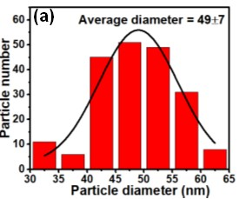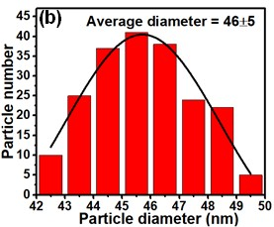
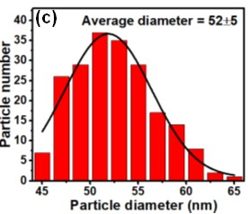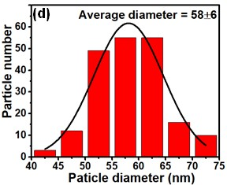
Fig. S1 Diameter distributions of a Fe₃O₄ b Fe₃O₄:Co c Fe₃O₄:Mn and d Fe₃O₄:Co-Mn NPs

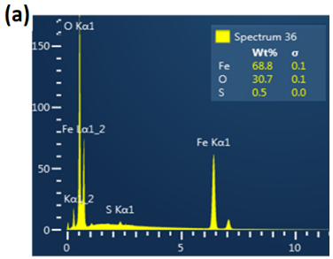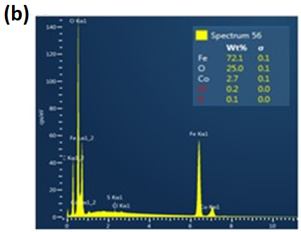
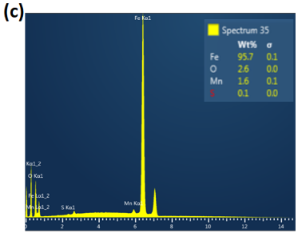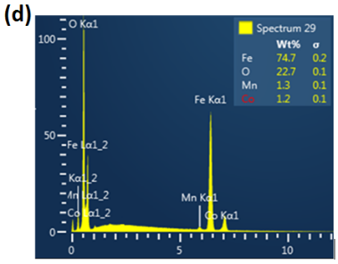
Fig. S2 SEM-EDS spectra of a Fe₃O₄ b Fe₃O₄:Co c Fe₃O₄:Mn and d Fe₃O₄:Co-Mn NPs
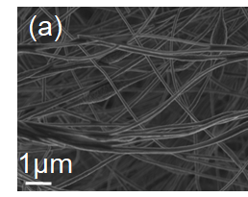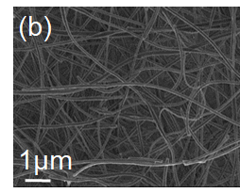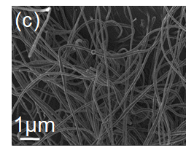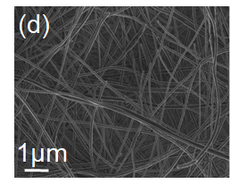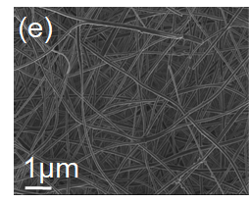
Fig. S3 SEM images of a PAN/M. oleifera b PAN/M. oleifera/Fe₃O₄ c PAN/M. oleifera/Fe₃O₄:Co d PAN/M. oleifera/Fe₃O₄:Mn and e PAN/M. oleifera/Fe₃O₄:Co-Mn nanofibers

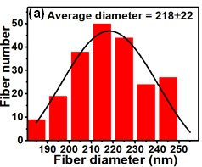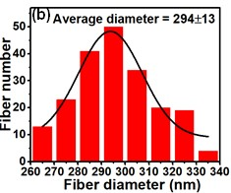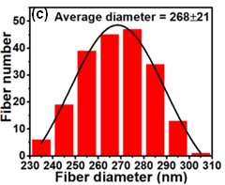
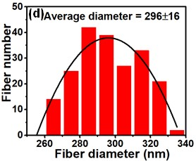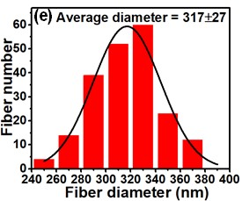
Fig. S4 Diameter distribution of a PAN/M. oleifera b PAN/M. oleifera/Fe₃O₄ c PAN/M. oleifera/Fe₃O₄:Co d PAN/M. oleifera/Fe₃O₄:Mn and e PAN/M. oleifera/Fe₃O₄:Co-Mn nanofibers

