Preferred, small-scale foraging areas of two Southern Ocean fur seal species are not determined by habitat characteristics
Additional Table S1: Spatio-temporal deployment of satellite telemetry devices deployed. HD_SAFS = High=density Subantarctic fur seal colony (Arctocephalus tropicalis), LD_SAFS = the low-density Subantarctic fur seal colony, and HD_AFS = the high-density Antarctic fur seal colony (A. gazella).

 | HD_AFS |  | HD_SAFS |  | LD_SAFS
 | Summer | Winter | Summer | Winter | Summer | Winter
2009 | 0 | 0 | 0 | 4 | 0 | 5
2010 | 4 | 5 | 0 | 5 | 0 | 6
2011 | 5 | 5 | 5 | 5 | 5 | 3
2012 | 5 | 4 | 7 | 4 | 4 | 3
2013 | 4 | 3 | 5 | 3 | 4 | 2
2014 | 3 | 3 | 2 | 0 | 1 | 3
2015 | 3 | 0 | 0 | 0 | 3 | 0
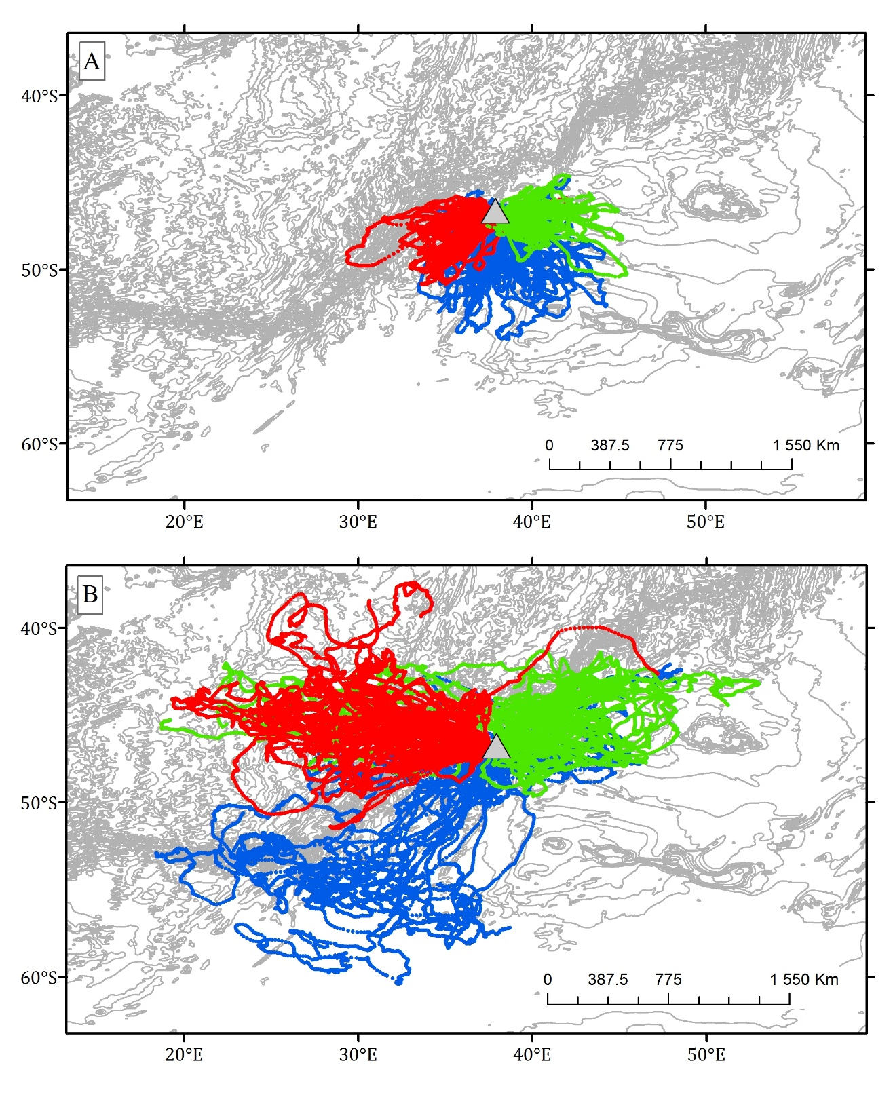
Additional Figure S1: Mean estimated at-sea locations of 121 female Subantarctic and Antarctic fur seals from Marion Island, 2009-2015 during a) summer and b) winter. Green dots represent the low-density Subantarctic fur seal colony, red dots the high-density Subantarctic fur seal colony, and blue dots the high-density Antarctic fur seal colony. Marion Island is shown in figures A and B as a grey triangle. At-sea data are presented with a 1 arc-min bathymetry overlay.

Additional Table S2: Product type (data source), temporal and spatial resolution of the various environmental variables used in Boosted Regression Tree models.
Environmental variable | Product type | Temporal Resolution | Spatial Resolution
chlA - chlorophyll a concentration (mgm⁻³) | MODISª | 3 month average | 0.5° x 0.5°
SST - sea-surface temperature (°C) | NOAA Optimum Interpolation daily Sea Surface Temperature^{b} | weekly average | 0.25° x 0.25°
Bathymetry (m) | gebco_08 | NA | 0.083° x 0.083°
Ocean floor slope | Calculated from GEBCO-08 database | NA | 0.083° x 0.083°
sshA - sea-surface height anomaly | AVISO^{c} | Daily | 0.25° x 0.25°
Oceanic fronts | Sokolov & Rintoul (2009a,b)^{d} | Seasonal 6-month average, 1992-2009 | 0.5° x 0.5°
Wind (magnitude & direction) | NOAA National Centre for Environmental Prediction Reanalysis Information (NCEP2)^{e} | Daily | 0.25° x 0.25°
Current (magnitude & direction) | AVISO^{f} | Daily | 0.25° x 0.25°
ª MODIS: http://oceancolor.gsfc.nasa.gov/
^{b} OI-daily: http://www.ncdc.noaa.gov/oa/climate/research/sst/oi-daily.php
^{c} AVISO: http://www.aviso.altimetry.fr/en/data/products/sea-surface-height-products.html
^{d} Sokolov, S. & Rintoul, S.R. (2009a) Circumpolar structure and distribution of the Antarctic Circumpolar Current fronts: 1. Mean circumpolar paths. Journal of Geophysical Research, 114, C11018.
Sokolov, S. & Rintoul, S.R. (2009b) Circumpolar structure and distribution of the Antarctic Circumpolar Current fronts: 2. Variability and relationship to sea surface height. Journal of Geophysical Research, 114, C11019.
^{e} NOAA http://www.esrl.noaa.gov/psd/data/gridded/data.ncep.reanalysis.html
^{f}AVISO: http://www.aviso.altimetry.fr/en/data/products/windwave-products.html
^{g} All data were reprojected into 0.25 X 0.25° pixels

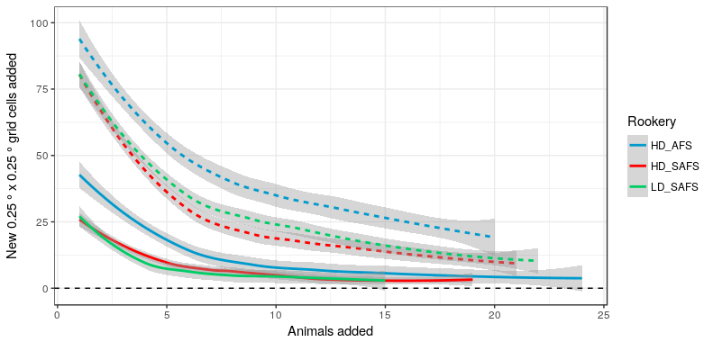
Additional Figure S2: The average (± SE) number of additional 0.25°x0.25 ° grid cells visited with each new animal tracked during summer (solid lines) and winter (dashed lines) for the high-density Subantarctic fur seal colony (HD_SAFS), low-density Subantarctic fur seal colony (LD_SAFS), and high-density Antarctic fur seal colony (HD_AFS).

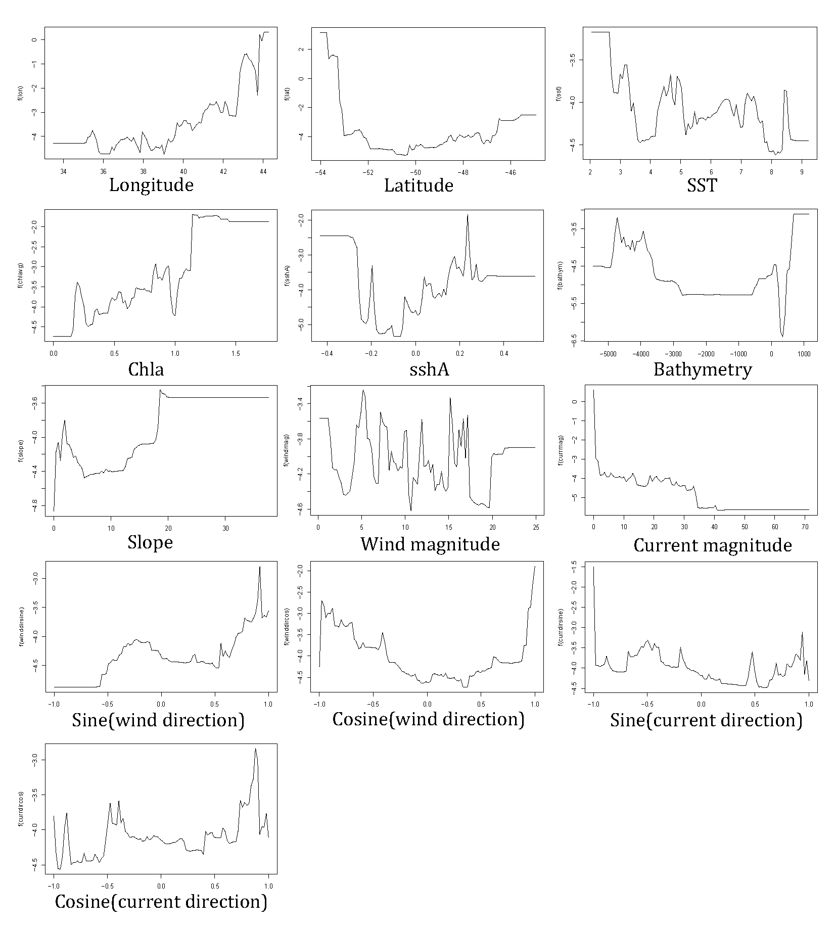
Additional Figure S3: Summer high-density Antarctic fur seal (Arctocephalus gazella; HD_AFS) females’ response curves of each of the environmental predictor variables for the final Boosted Regression Tree model.

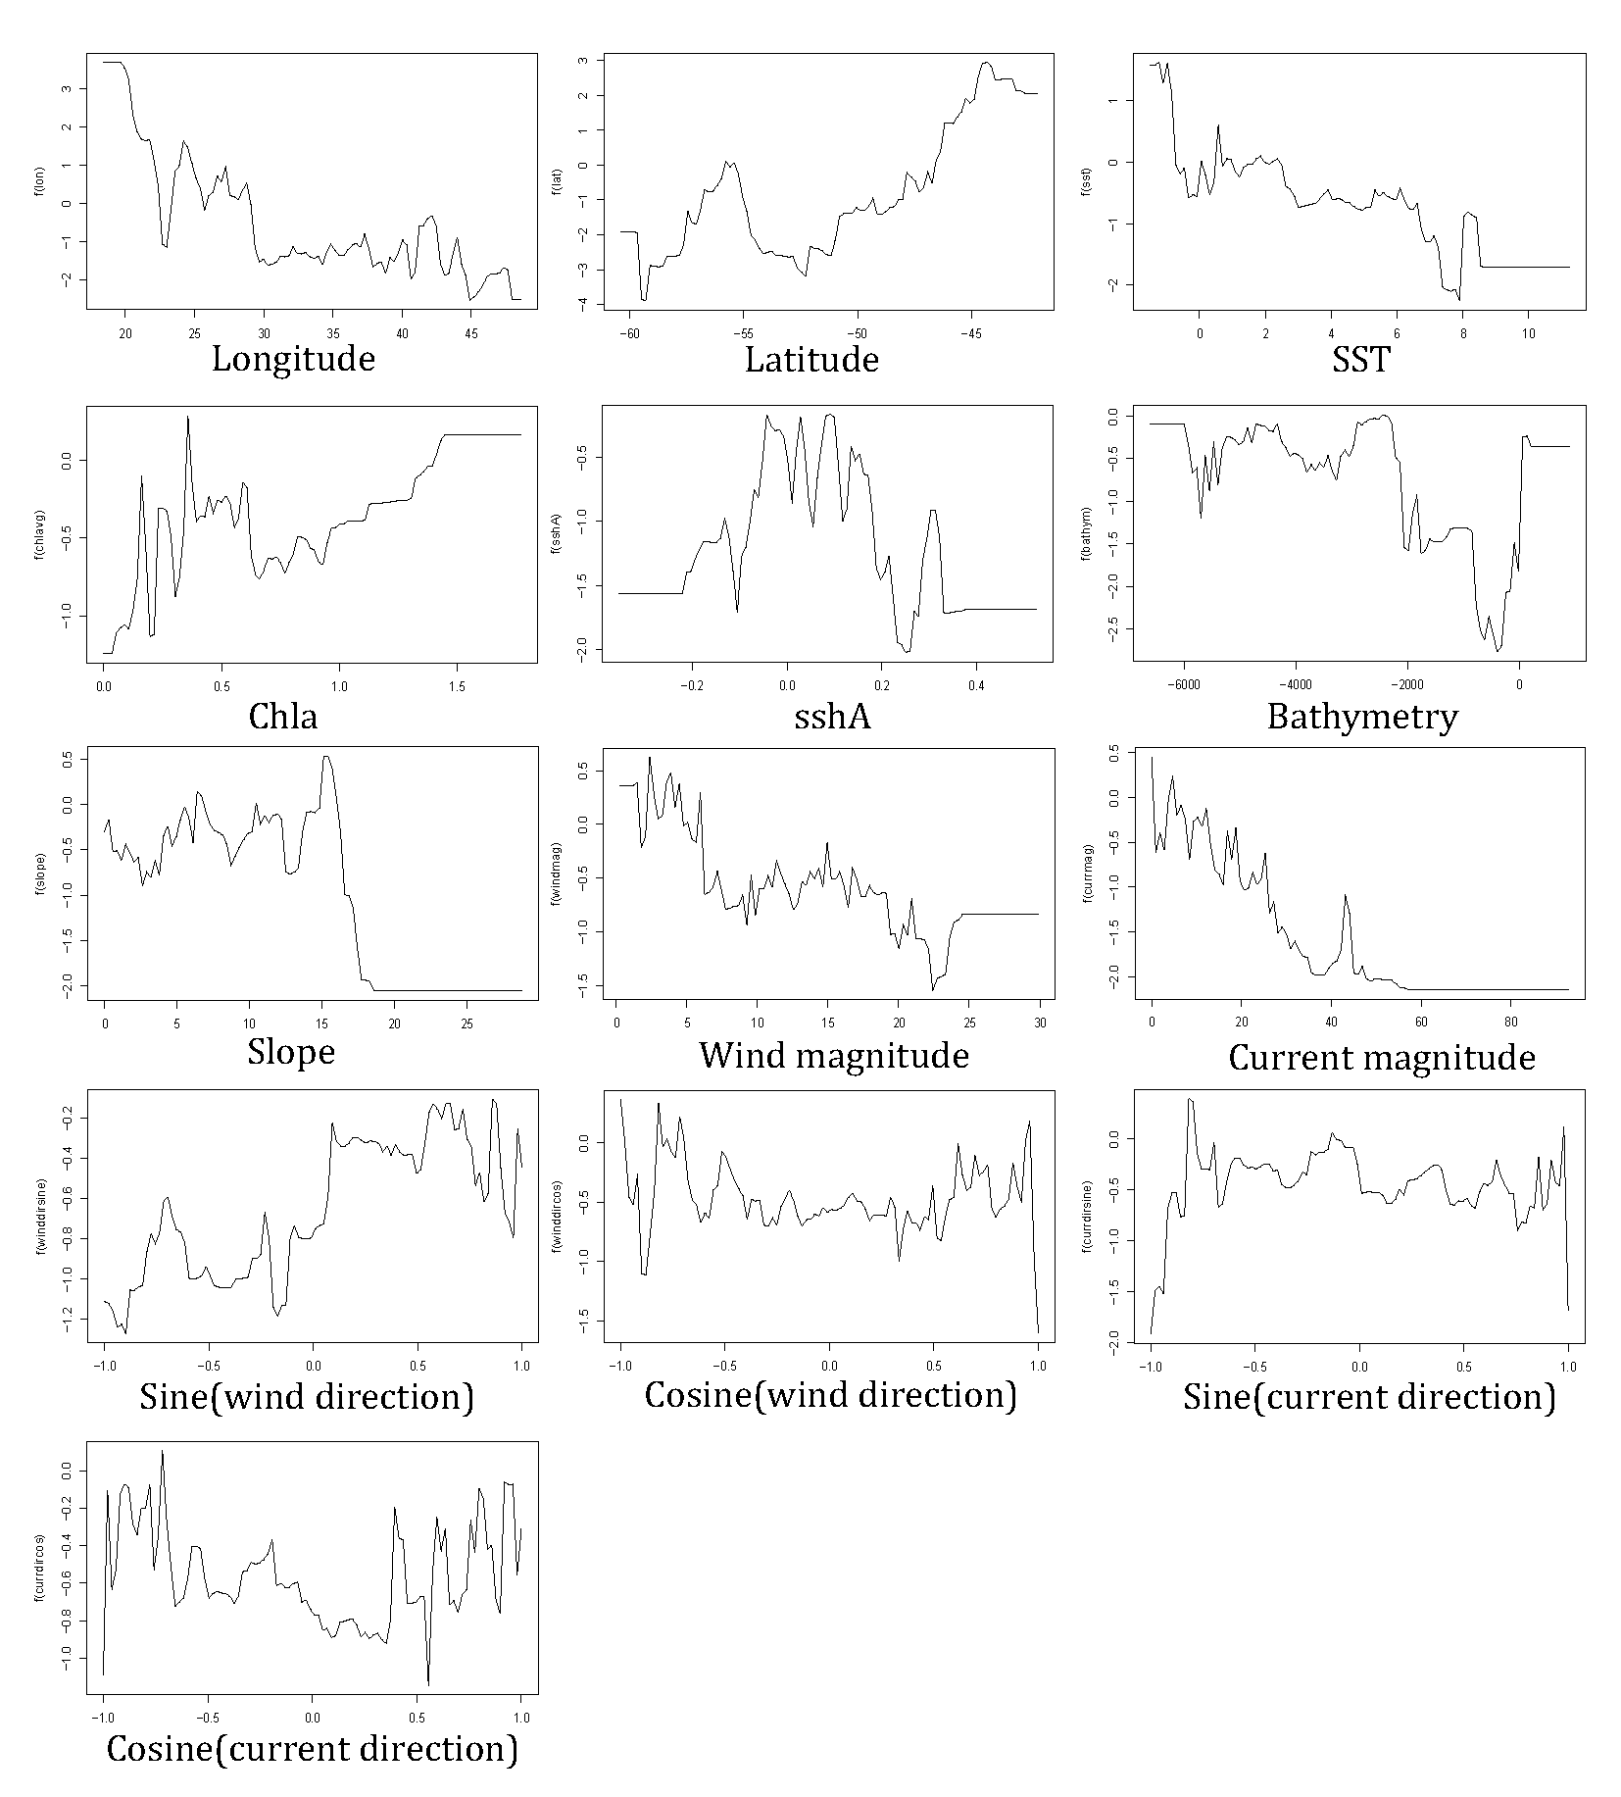
Additional Figure S4: Winter high-density Antarctic fur seal (Arctocephalus gazella; HD_AFS) females’ response curves of each of the environmental predictor variables for the final Boosted Regression Tree model.

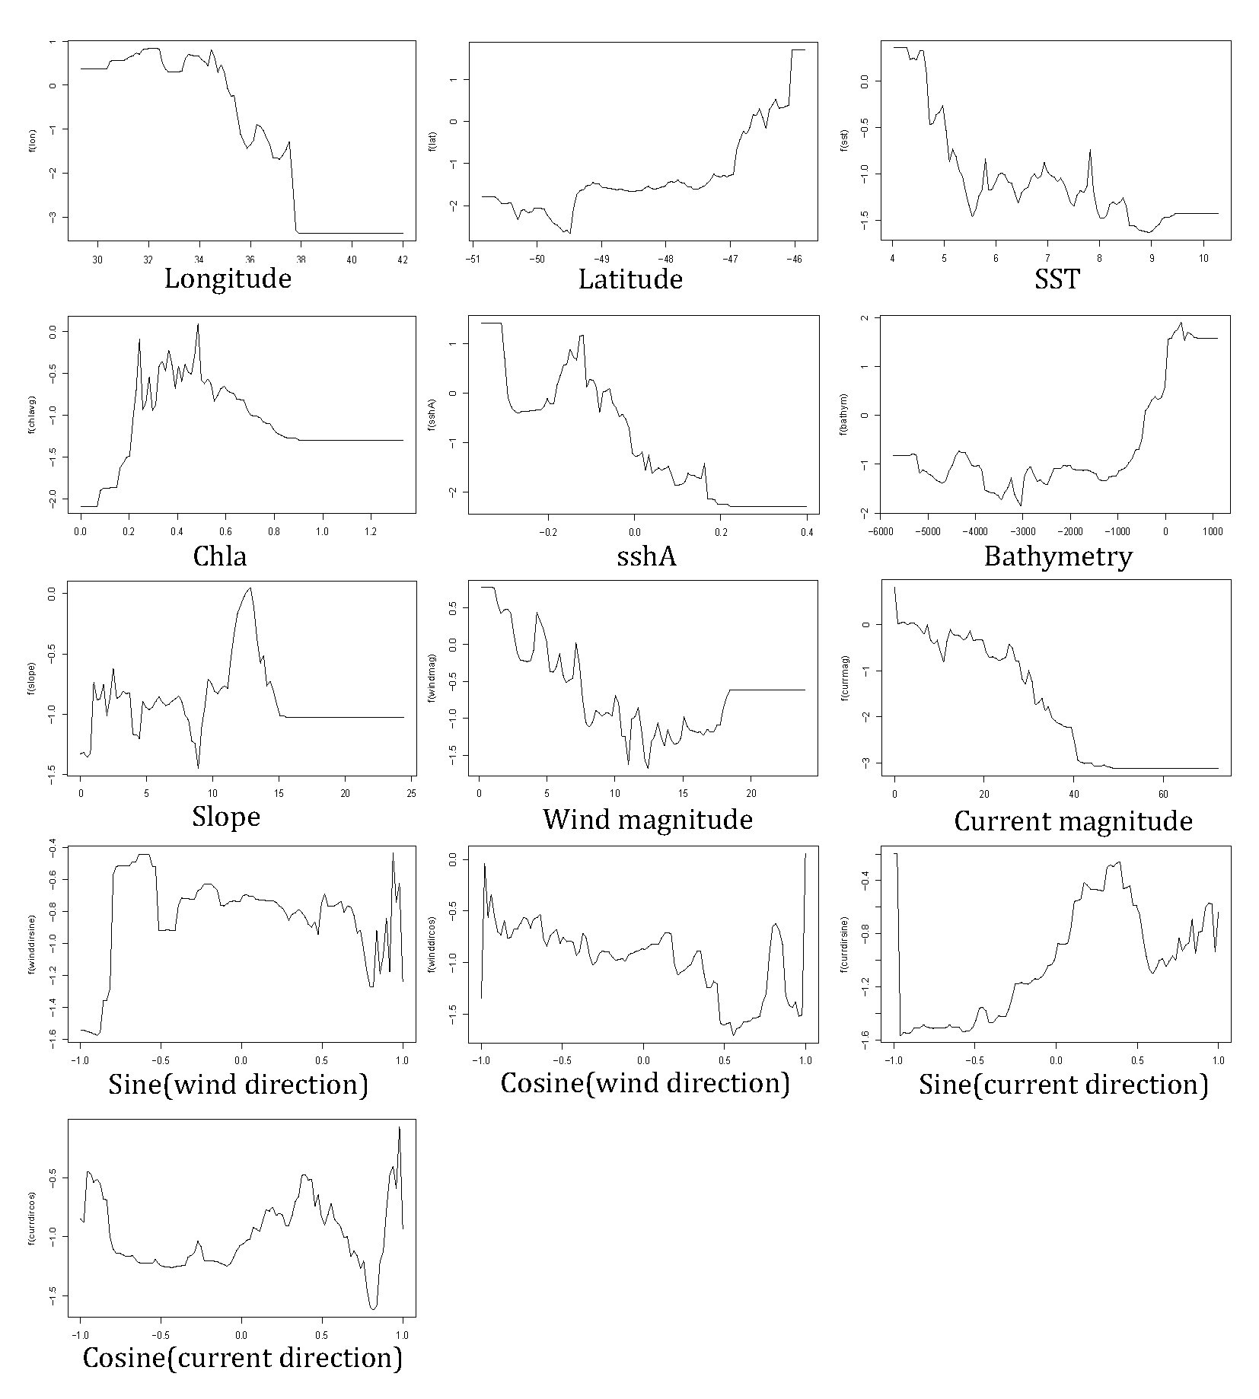

Additional Figure S5: Summer high-density Subantarctic fur seal (Arctocephalus tropicalis; HD_SAFS) females’ response curves of each of the environmental predictor variables for the final Boosted Regression Tree model.

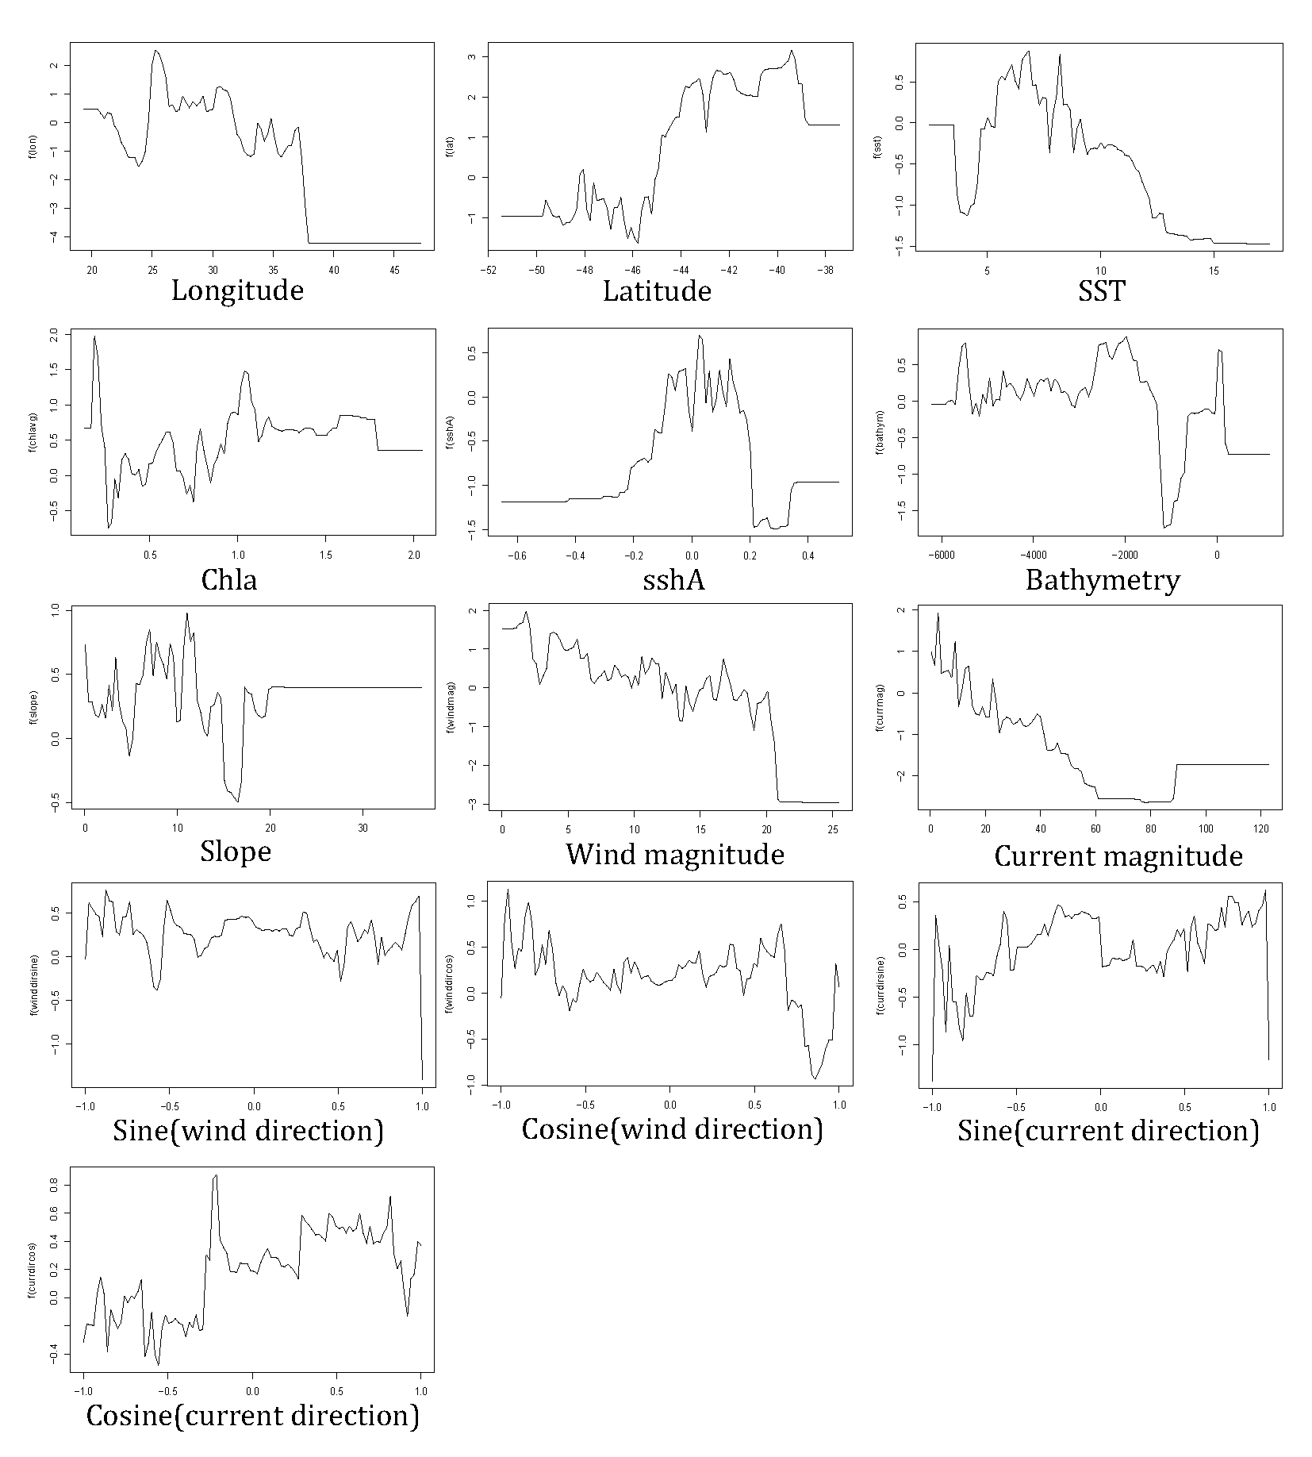
Additional Figure S6: Winter high-density Subantarctic fur seal (Arctocephalus tropicalis; HD_SAFS) females’ response curves of each of the environmental predictor variables for the final Boosted Regression Tree model.

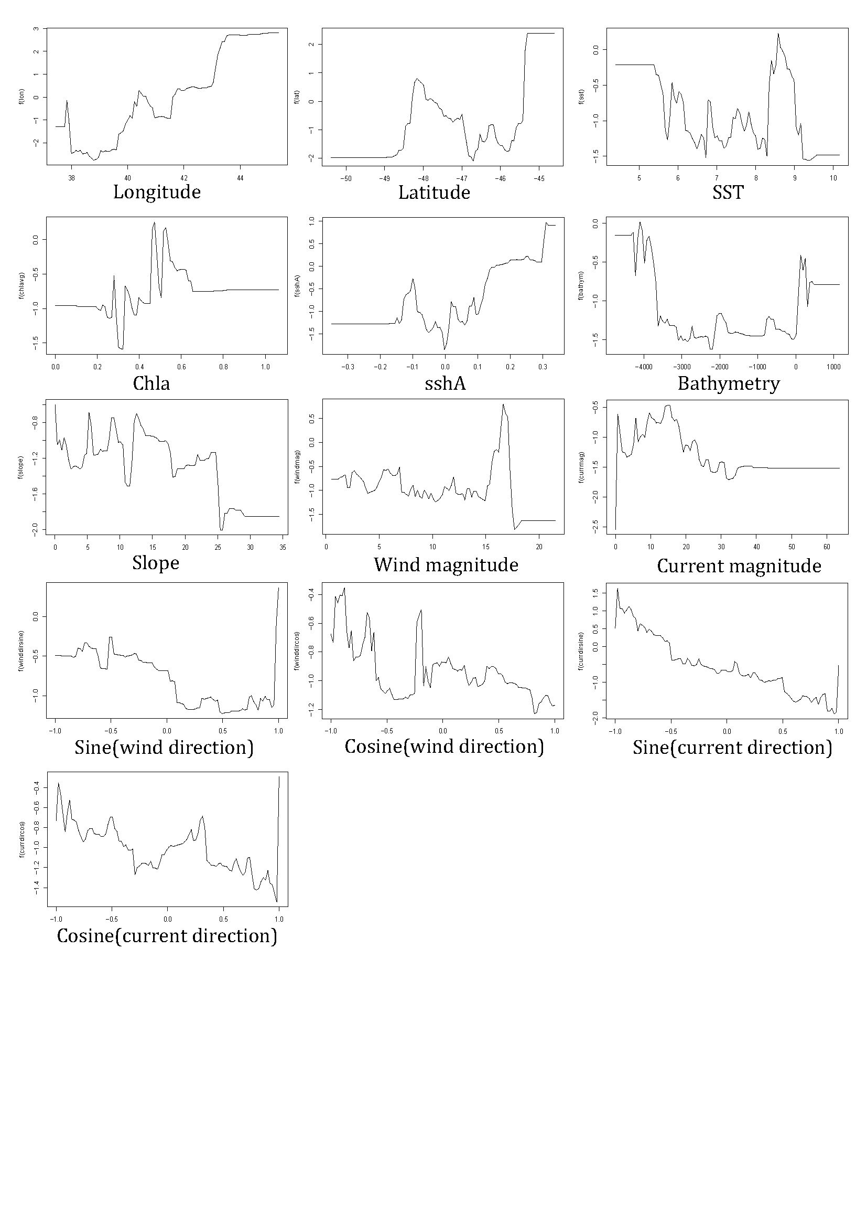
Additional Figure S7: Summer low-density Subantarctic fur seal (Arctocephalus tropicalis; LD_SAFS) females’ response curves of each of the environmental predictor variables for the final Boosted Regression Tree model.
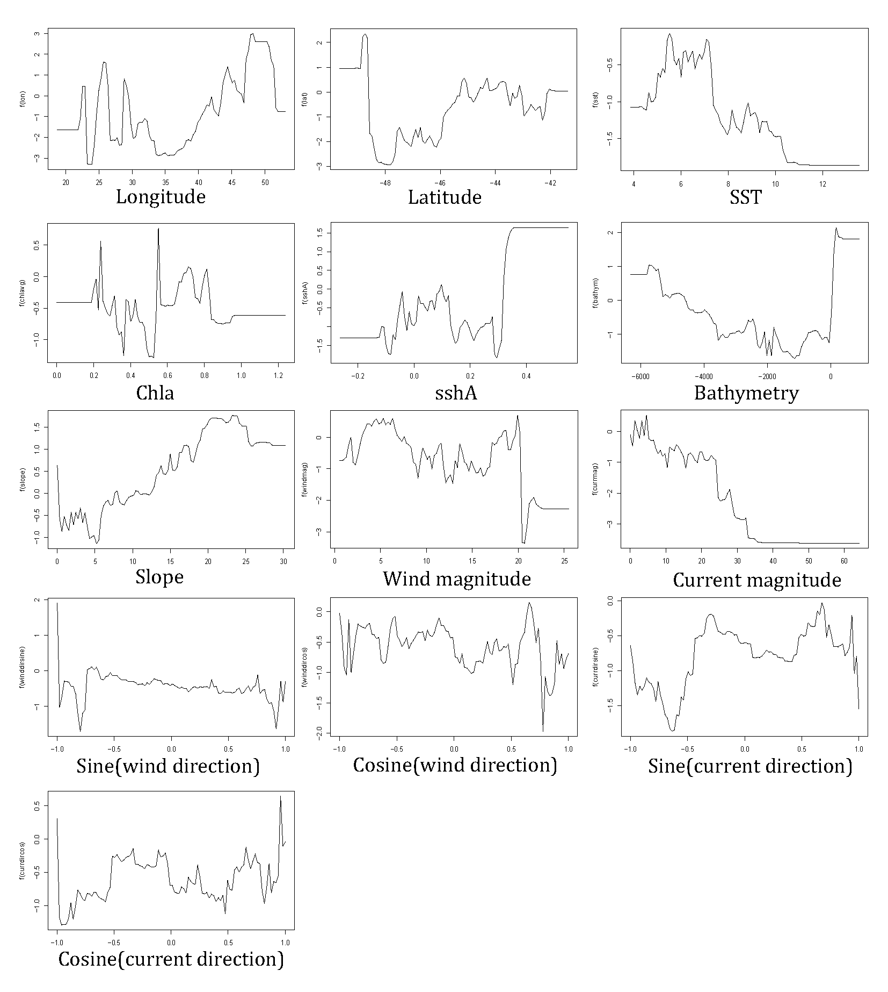
Additional Figure S8: Winter low-density Subantarctic fur seal (Arctocephalus tropicalis; LD_SAFS) females’ response curves of each of the environmental predictor variables for the final Boosted Regression Tree model.

