Table S1 Sampled sites of Ficus tikoua and their genetic composition in Southwest China. Nnu_{SSR} and N_{cpDNA} indicate the numbers of individuals used in microsatellite genotype scanning (nuSSR), and chloroplast genes sequencing, respectively. The chloroplast genes’ haplotypes present in each site are listed as H01-H19. The numbers in parentheses indicate the number of individuals of each haplotype.
Code No. | Code | Population | Latitude (°N) | Longitude (°E) | Altitude (m) |  | Sample sizes |  |  | cpDNA Haplotypes (Copies)
 |  |  |  |  |  |  | Nnu_{SSR} | N_{cpDNA} |  | cpDNA Haplotypes (Copies)
1 | YMZ | Mengzi | 23.37 | 103.53 | 1782.85 |  | 21 | 5 |  | H09(5)
2 | YMJ | Mingjiu | 23.42 | 103.75 | 1836.69 |  | 20 | 5 |  | H09(5)
3 | YJS | Jianshui | 23.61 | 103.06 | 1268.57 |  | 14 | 4 |  | H18(4)
4 | YYS | Yanshan | 23.65 | 104.29 | 1589.73 |  | 28 | 5 |  | H04(4), H09(1)
5 | YSH | Shiping-Tonghai | 23.93 | 102.63 | 1665.5 |  | 32 | 5 |  | H09(5)
6 | GTY | Tianyang | 23.95 | 107.10 | 477.24 |  | 19 | 4 |  | H09(2), H13(2)
7 | YPZ | Puzhehei | 24.09 | 104.05 | 1550.00 |  | 7 | 5 |  | H18(5)
8 | YJY | Jingyan | 24.22 | 102.57 | 1747.75 |  | 18 | 4 |  | H09(3), H18(1)
9 | GYZ | Yizhou | 24.37 | 108.74 | 256.41 |  | 19 | 5 |  | H01(2), H05(2), H14(1)
10 | GLZ | Luzhai | 24.53 | 109.88 | 123.67 |  | 8 | 5 |  | H01(5)
11 | GDL | Donglan | 24.56 | 107.74 | 330.60 |  | -- | 4 |  | H03(4)
12 | GHC | Hechi | 24.57 | 108.46 | 183.08 |  | 13 | 5 |  | H01(4), H05(1)
13 | YLX | Luxi | 24.70 | 103.51 | 1956.36 |  | 27 | 5 |  | H18(5)
14 | YSZ | Shizong | 24.82 | 104.28 | 1755.00 |  | 8 | 5 |  | H09(1), H18(4)
15 | GLL | Longlin | 24.98 | 105.48 | 433.06 |  | 16 | 4 |  | H09(4)
16 | YLP | Luoping | 25.05 | 104.55 | 1231.39 |  | 28 | 5 |  | H18(5)
17 | YKM | Kuming | 25.07 | 102.61 | 2234.00 |  | 31 | 3 |  | H08(3)
18 | GND | Nandan | 25.29 | 107.37 | 823.44 |  | 21 | 5 |  | H10(2), H11(1), H12(2)
19 | YWD | Wuding | 25.54 | 102.39 | 1841.75 |  | 29 | 3 |  | H08(3)
20 | YLQ | Luquan | 25.59 | 102.52 | 1849.85 |  | 13 | 5 |  | H07(1), H08(4)
21 | CSJ | Cong-Shanjiang | 25.77 | 108.95 | 202.44 |  | 29 | 5 |  | H01(2), H02(3)
22 | GGL | Guanling | 25.93 | 105.63 | 847.11 |  | 31 | 5 |  | H02(2), H04(3)
23 | GSD | Sandu | 26.06 | 107.87 | 488.86 |  | 28 | 5 |  | H02(5)
24 | YYR | Yongren | 26.25 | 101.69 | 1893.00 |  | -- | 3 |  | H08(1), H15(1), H19(1)
25 | YXW | Xuanwei | 26.22 | 104.06 | 2082.62 |  | 33 | 5 |  | H04(2), H08(2), H09(1)
26 | GTL | Tianlong | 26.42 | 106.10 | 1350.73 |  | 28 | 5 |  | H08(5)
27 | GKY | Kaiyang | 27.07 | 107.06 | 970.12 |  | 24 | 5 |  | H06(2), H07(2), H08(1)
28 | GWA | Wengan | 27.15 | 107.41 | 1049.55 |  | 12 | 5 |  | H08(5)
29 | SGL | Guling | 28.05 | 105.79 | 585.74 |  | 32 | 5 |  | H08(5)
30 | SPZ | Panzhihua | 26.39 | 101.77 | 1276.04 |  | 31 | 5 |  | H17(5)
31 | YHZ | Huize | 26.49 | 103.17 | 2051.07 |  | 33 | 5 |  | H08(5)
32 | YQJ | Qiaojia | 26.89 | 102.97 | 1633.59 |  | 22 | 5 |  | H08(5)
33 | YLD | Ludian | 27.01 | 103.32 | 1366.89 |  | 12 | 5 |  | H08(5)
34 | SNN | Ningnan | 27.03 | 102.76 | 964.25 |  | 21 | 5 |  | H08(5)
35 | YZX | Zhenxiong | 27.52 | 104.85 | 1538.11 |  | 23 | 5 |  | H08(5)
36 | YDG | Daguan | 27.72 | 103.39 | 1098.44 |  | 15 | 5 |  | H08(5)
37 | SLB | Leibo | 28.32 | 103.64 | 1322.93 |  | 31 | 5 |  | H08(5)
38 | SMH | Mahu | 28.45 | 103.80 | 983.41 |  | 17 | 5 |  | H08(2), H15(3)
39 | SYY | Yanyuan | 27.24 | 101.86 | 1569.35 |  | 29 | 5 |  | H17(5)
40 | SXC | Xichang | 27.87 | 102.28 | 1716.16 |  | 28 | 5 |  | H15(2), H17(3)
41 | SJA | Jiangan | 28.63 | 105.08 | 342.34 |  | 36 | 4 |  | H08(4)
42 | SNX | Naxi | 28.75 | 105.56 | 534.41 |  | 32 | 5 |  | H08(3), H15(1), H16(1)
43 | SHS | Shimian | 29.19 | 102.40 | 1134.43 |  | 28 | 5 |  | H08(1), H15(4)
44 | SCQ | Chongqing | 29.39 | 106.40 | 317.69 |  | 33 | 5 |  | H08(5)
45 | SLS | Leshan | 29.46 | 103.73 | 358.60 |  | 17 | 5 |  | H08(5)
46 | SYJ | Yingjing | 29.68 | 102.85 | 949.74 |  | 31 | 5 |  | H08(5)
47 | SFY | Fengya | 30.14 | 106.90 | 297.62 |  | 28 | 5 |  | H08(5)
48 | SJY | Jianyang | 30.33 | 104.76 | 389.54 |  | 29 | 5 |  | H08(5)
49 | SSP | Shipan | 30.41 | 106.23 | 286.00 |  | 22 | 5 |  | H08(5)
50 | SSN | Suining | 30.52 | 105.48 | 324.00 |  | 27 | 5 |  | H08(5)
51 | SNC | Nanchong | 30.78 | 106.08 | 275.00 |  | 30 | 5 |  | H08(5)
52 | SGJ | Guangji | 31.27 | 104.05 | 683.00 |  | 25 | 5 |  | H08(5)
53 | SMY | Mianyang | 31.34 | 104.53 | 516.00 |  | 29 | 5 |  | H08(5)
54 | SXH | Xuanhan | 31.55 | 107.65 | 780.00 |  | 30 | 5 |  | H08(5)
55 | SBZ | Bazhong | 31.82 | 107.01 | 450.71 |  | 27 | 3 |  | H08(3)
56 | SGY | Guangyuan | 32.42 | 105.83 | 555.96 |  | 29 | 5 |  | H08(5)

Table S2 The sequential combination of aligned sequences psbM-trnD, atpB-rbcL and rps12-rpl20 for 19 haplotypes of F. tikoua, along with their corresponding GenBank accessions.
 | Sequence fragments
Haplotype code | psbM-trnD | atpB-rbcL | rps12-rpl20
H01 | OR888963 | OR888970 | OR888978
H02 | OR888964 | OR888971 | OR888979
H03 | OR888965 | OR888972 | OR888980
H04 | OR888965 | OR888972 | OR888979
H05 | OR888963 | OR888970 | OR888981
H06 | OR888964 | OR888973 | OR888982
H07 | OR888964 | OR888973 | OR888978
H08 | OR888964 | OR888973 | OR888979
H09 | OR888965 | OR888974 | OR888979
H10 | OR888966 | OR888975 | OR888979
H11 | OR888965 | OR888975 | OR888982
H12 | OR888967 | OR888970 | OR888978
H13 | OR888968 | OR888972 | OR888983
H14 | OR888963 | OR888975 | OR888978
H15 | OR888964 | OR888973 | OR888984
H16 | OR888969 | OR888971 | OR888979
H17 | OR888964 | OR888976 | OR888984
H18 | OR888965 | OR888977 | OR888985
H19 | OR888964 | OR888973 | OR888986

Figure S1 The distributions of the three genetic groups (based on COI) of the Ceratosolen sp. pollinator fig wasp associated with Ficus tikoua in Southwest China (red, yellow and blue circles) together with their relationship to phenotypic characters of their host plants (fig male flower distribution). Background shading indicates the male flower distributions in their host figs (ostiolar = purple, scattered = green, intermediate = light yellow oval). The red line defines the boundary between the Yangtze and Pearl river basins. Note that intermediate male flower distributions are more frequently present in populations where pollinators from pairs of COI genetic groups are present. (Modified from Deng et al., 2020)

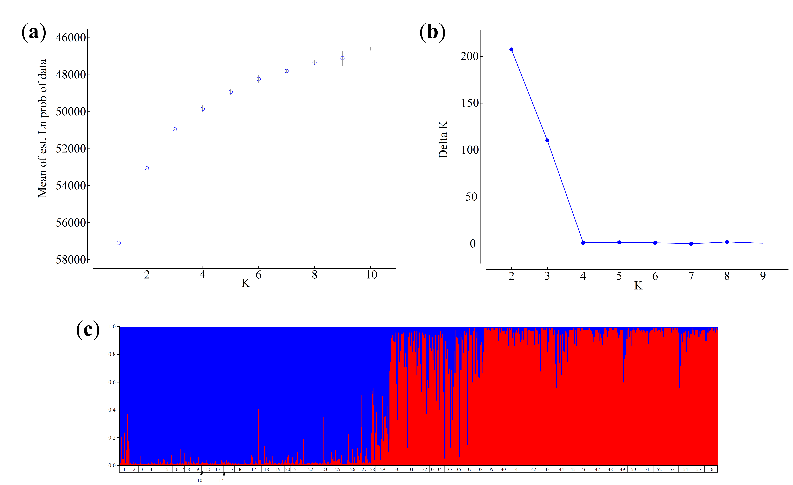

Figure S2 The nuSSR assignment simulated by STRUCTURE. (a) The mean posterior probability of the data for K; (b) The magnitude of delta K (ΔK); (c) The microsatellite memberships of Ficus tikoua individuals. Each vertical line represents one individual. The colors indicate two microsatellite groups respectively. The populations were represented by numbers, which correspond to with the population codes in Table S1.

Figure S3 The relationships of pollinator and F. tikoua’s genetic distances between population pairs based on nuSSR genotypes. The colors red, blue, and black represent comparisons betweensites in the Yangtze basin, sites in the Pearl basin and all between-basin comparisons, respectively.

Figure S4 Kinship coefficients in relation to geographic distances for Yangtze (a) and Pearl (b) sites. The dashed lines are the 95% confidence intervals. The results of permutation tests are shown: ***P < 0.001.

