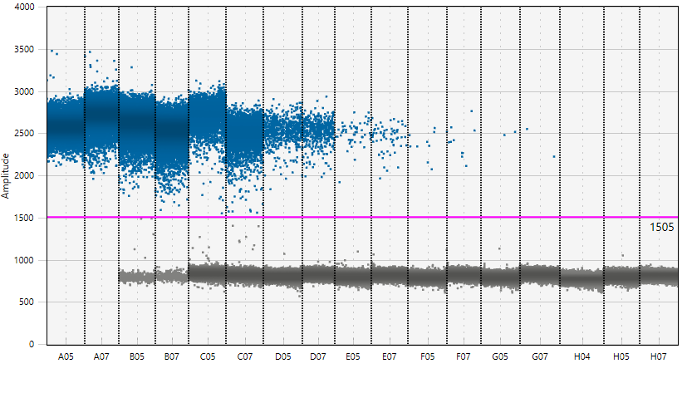
SUPPLEMENTARY DATA
Figure S1. Figure of droplet separation shown and serial dilution of positive reference DNA.

