
Faculty of Natural and Agricultural Sciences
Chemistry Department
CMY 143
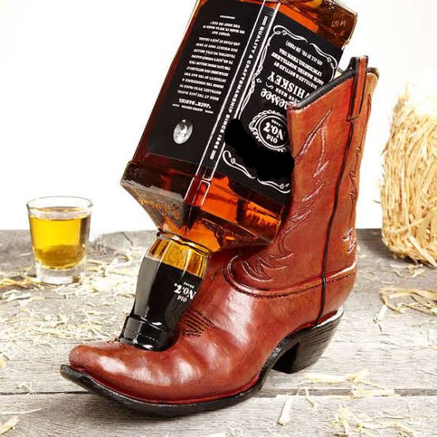
Practical 2: Matter and Separation – Bootlegging Alcohol
In March 2020, the magnitude and severity of the COVID-19 Global pandemic outbreak lead to the president declaring a national state disaster in terms of the Disaster Management Act of 2002 and announced a nationwide lockdown. As a result, a list of regulations to address, prevent and combat the spread of the coronavirus were enforced. Amongst many, the restriction of the sale, dispensing or transportation of liquor left thousands desperate as alcohol was declared a non-essential good. This ultimately led to the interesting and dangerous times of bootlegging and homemade production of alcohol or “moon shine”.
Experiment 1: Blue-Train myth (watch Exp 1: Blue-Train)
Aim: To determine whether filtering methylated spirits results in drinkable alcohol.
This separation technique is used to separate solid matter and liquids from a mixture using a filter medium that allows fluid to pass through.
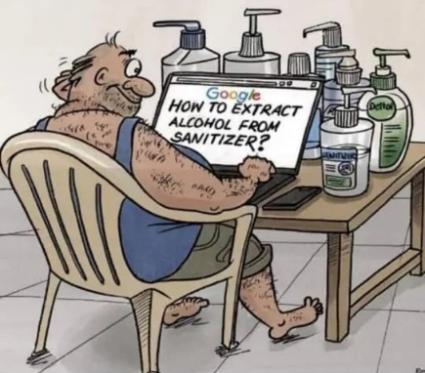
A common household item, methylated spirits, also known as denatured alcohol, became one of the sought after ingredients for quick-fix solutions to make alcohol. This mixture is made by filtering methylated spirits through bread in attempts to remove methanol.
Apparatus: | Chemicals:
- 3 × glass beakers | - Methanol
- Bunsen burner | - Ethanol
- Wire loop | - Methylated spirits
- Loaf of bread

Method:
- Compress 5 slices of bread.
- Place the bread slices into a funnel on top of a labelled beaker.
- Pour 50ml of methylated spirits into the funnel.
- Wait approximately 10 minutes for filtration to occur. Observe the collected filtrate and the bread.
- Repeat 1 to 4 for methanol and ethanol (using fresh slices of bread).
- Dispense a droplet of the filtered methylated spirits onto a watch glass. In a second watch glass, dispense a droplet of the unfiltered methylated spirits.
- Using a candle, set the droplet alight at the same time. Take note of the differences (if any) of the flame of the filtered solution compared to the unfiltered solution.
- Repeat 6 to 7 for filtered and unfiltered methanol and ethanol.
- Discard the solutions, bread and clean the apparatus.
Experiment 2: Pineapple Beer Brewing
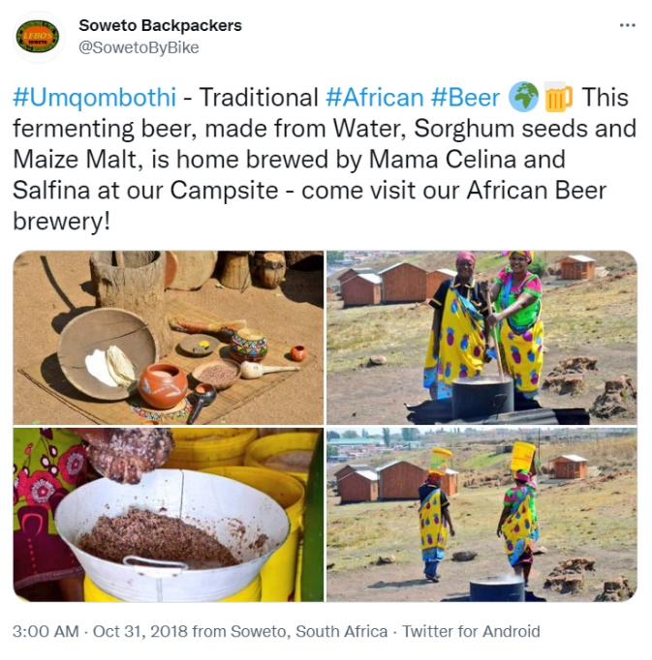
Aim: To determine whether home brewing successfully produces alcohol.
Umqombothi is a popular Xhosa traditional beer usually made from the fermentation of maize, maize malt, sorghum malt, water and yeast. Traditional brews are known by different names by different ethnic groups. For example, Batswana call bojalwa ba Setswana, the Zulu utshwala and the Shona hwahwa. The recipe is passed down to generations and brewed for consumption at occasions and ceremonies like funerals, weddings, initiation ceremonies, ritual performances and other social gatherings. Yvonne Chaka Chaka, South African singer-songwriter writes in her hit song Umqpmbothi - “I work hard to make them happy every weekend. (Umqombothi) makes them party to the rhythm makes them dance, this magic beer (Umqobothi). Due to the resurgence of interest in home brews, a variety of traditional African beer are now available commercially.
During the 2020 National Lockdown, home brewing became an increasing interest with pineapple beer being the most popular. This technique involved the fermentation of pineapple. Fermentation is a metabolic process that involves yeast cells feeding on sugars and converting them into alcohol, carbon dioxide and complex esters. Yeast cells are either purposefully added or naturally enter the mixture from the atmosphere. However, interest in the production of homebrews or “moon shine” did come at a cost for some South Africans.
Apparatus:
3x beakers
1x pipette
1x mass balance
Method:
- Pipette 20ml of the non-fermented mixture into a small conical flask and weigh. Do this at least 3 times to increase the accuracy and reproducibility of the results.
- Repeat for the fermented mixture.
- Discard the samples and clean the vials.

Experiment 3: Distillation of wine (watch Distilling wine)
Aim: Using a micro-distillation set-up to produce brandy or “burnt” wine
Distillation is a technique employed whenever the mixture components to be separated are miscible liquids, with boiling points that differ by at least 8°C. The liquids are heated in a special distillation apparatus (See Brown et.al., 2009, Figure 1.13 page 12). As the temperature of the mixture reaches the boiling point of a particular component, it boils off selectively, and the vapour passes to the condenser where it is condensed to a liquid, and collected in a designated container.
Wine is a beverage produced from the fermentation of the juice from fresh grapes. The distillation and processing of wine in pot stills produces the strong alcoholic spirit, brandy. Pot stills are round copper kettles that allow wine to be heated until the alcohol vaporizes, cooled and converted back into liquid. The spirit is matured in oak barrels where transformation and moulding of the concentrated alcohol into a deep coloured and rich brandy occurs. The brandy is then blended and bottled to be sold. The South African brandy regulations require a minimum of 3 years maturation for a spirit to be classified as brandy.
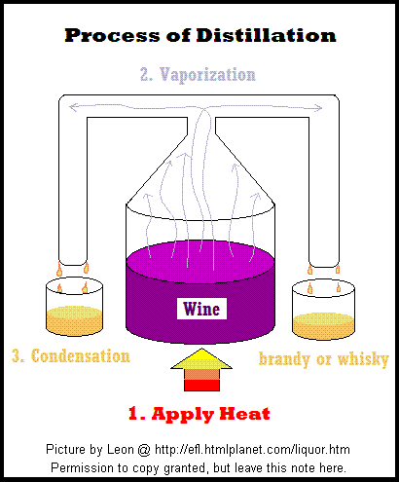
Apparatus:

2x Glass Pipettes (Shared)
1x Rubber Stopper
1x Silicon Tubing (not the one with a metal piece inside
2x Glass Vials
1x Micro-burner (Assembly from Semester 1)
1x Comboplate
1x Retort Stand
1x Cross Bar

Method:
- Organize all the parts as listed in the Materials list apart from the wine.
- Assemble the retort stand by placing the cross bar over the main stand, and placing the assembled retort stand in combo plate well.
- Next, assemble the burner as you did in Semester 1
- Carefully attach the two pipettes to either side of a silicon rubber tube. Do not use the rubber tube with metal inside. SAFETY RISK: Be careful not to break your pipette!
- Attach the rubber stopper to one of the pipettes by pushing the pipette trough the thicker part of the stopper until a small part of the pipette shows on the other side. SAFETY RISK: Again, be careful not to snap the pipette as it can give you a nasty cut!
- Collect a 1 cm sample of wine from the counter in one of your small vials and add a few (2-3) boiling stones. Attach your distillation assembly to the vial by carefully pushing the rubber stopper into the vial. SAFETY RISK: Do this gently! If you push too hard, the vial will shatter.
- Connect your distillation setup to the retort stand and place a collection vial under the open pipette. This is where your distillate will accumulate.
- Light your burner and place it underneath your distillation setup.
- Distill the wine until the wine flask is mostly empty.
- Make sure the wine does not boil too hard. Remove the heat it you observe wine in the distillation tube. SAFETY RISK: if the boiling is too vigorous the rubber stopper may blow off.
- Make sure you can see condensation happening close to the collection vial. If you don't see condensation happening, remove the burner and let the setup cool down a bit.
- Discard of the distillate and clean the vial with the wine residue. This may be too hard, in which case simply leave it or discard the vial into the broken glass container for recycling.

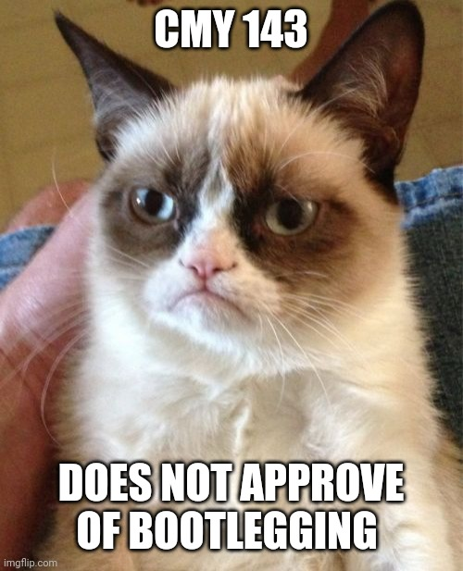

Illegal manufacture/distribution
Umqombothi Beer, Slow Food Foundation for Biodiversity, Slow food [Online] Available from: https://www.fondazioneslowfood.com/en/ark-of-taste-slow-food/umqombothi-beer/
M Chrispen, Understanding how the incorporation of indigenous knowledge (IK) enables or constrains the teaching and learning of alcoholic fermentation in Life Sciences in Grade 11, 2016, Rhodes University
https://www.news24.com/news24/southafrica/news/three-more-die-in-eastern-cape-after-drinking-lethal-moonshine-alcohol-concoction-20210714
Mixable
Brandy and Ginger, Making Brandy 2015 [Online] Available from: https://www.brandyandginger.co.za/brandy-insight/making-brandy/

