Additional File 2. Methods and results for visualizing and counting the metaphase chromosomes of hexaploid Avena fatua; diploid Lolium rigidum; tetraploid Phalaris minor; and tetraploid Salsola tragus.

Preparation of metaphase chromosomes:
Young actively growing root tips were collected early in the morning (before 8 am) and treated with N₂O gas at 10 bar for 3 h, followed by a pre-treatment with α-bromonapthalene for 8 h at 4 °C, and finally, overnight fixation in 3:1 (ethanol: acetic acid) solution at room temperature. The root tips were incubated in a humid chamber with an enzyme mixture containing 0.3% pectolyase, 0.2% cellulase, and 0.2% cytohelicase for 45 min at 37 °C. To acquire well-spread metaphase chromosomes, the macerated root tips were split and squashed with 65% acetic acid (20 μl/slide). The slides were subsequently stored at -80 °C until further use. Vectashield solution diluted with 2% 4, 6-diamidino-2-phenylindole (DAPI) was used to observe metaphase chromosomes under the microscope. All the images were captured at 60× emulsion oil magnification using an Olympus BX61 fluorescent microscope equipped with a Hamamatsu C10600 camera and further processed with the MetaMorph software.
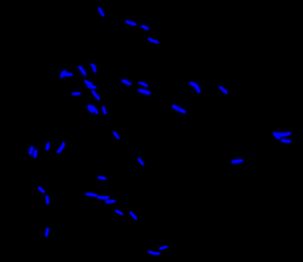
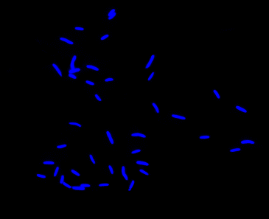
Fig S1. Metaphase chromosomes of hexaploid Avena fatua.
2n = 6x = 42
Wild Oat (Avena fatua)
Fig S2. Metaphase chromosomes of diploid Lolium rigidum.

Annual ryegrass (Lolium rigidum)

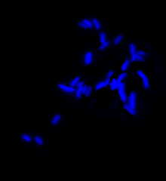

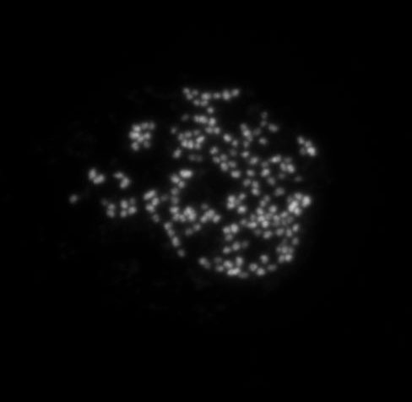
Fig S3. Metaphase chromosomes of tetraploid Phalaris minor.
2n = 2x = 14
Little seed canary grass (Phalaris minor)
2n =4x = 28
Fig S4. Metaphase chromosomes of tetraploid Salsola tragus.
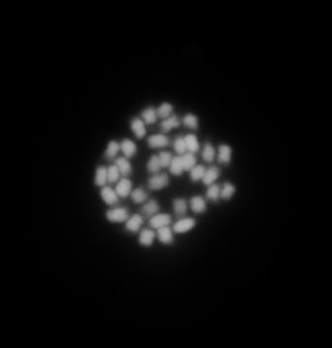
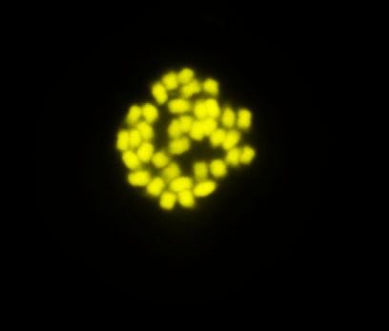
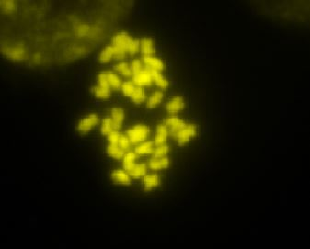
Russian thistle (Salsola tragus)
2n = 4x = 36

