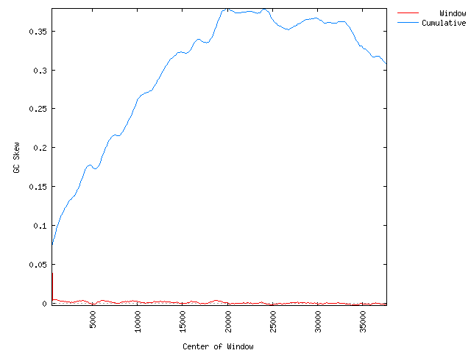
Figure S4. GC skew analysis of the Shpa genome showing putative replication origin (ori) and termination sites (ter) calculated using a window size of 1000 bp and a step size of 100bp

