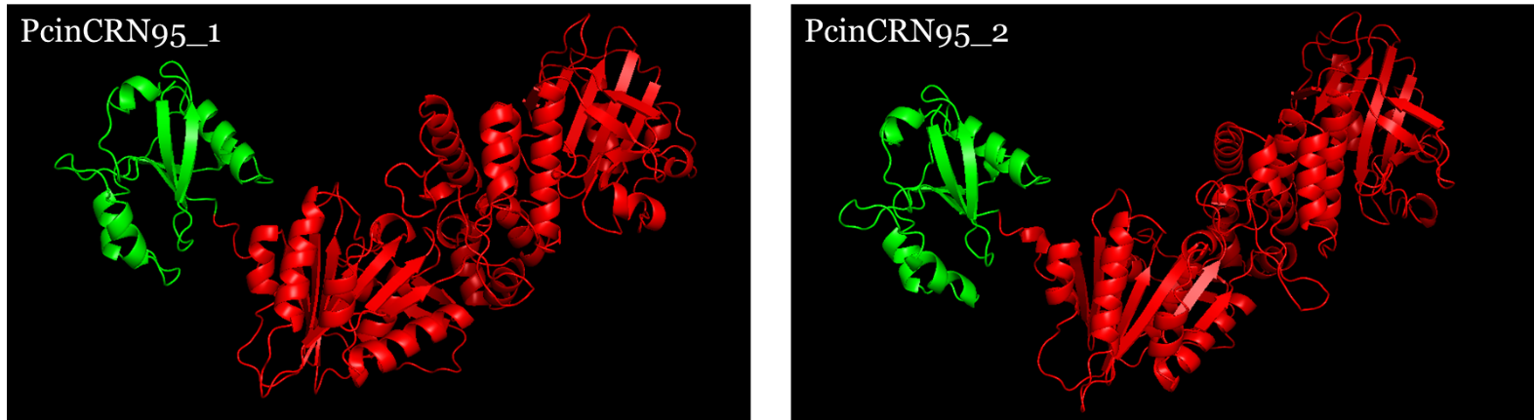
Supplementary Figure 4. Predicted protein structures of the amino acid sequences encoded by the PcinCRN95 alleles using AlphaFold. AlphaFold (28, 29) was used to predict the tertiary structure of Phytophthora cinnamomi crinkling and necrosis effector protein 95 (PcinCRN95). On a scale from 0 to 100, AlphaFold generated a per-residue confidence metric titled predicted local distance difference test (pLDDT). Protein structure of PcinCRN95_1 (pLDDT = 84.27) and PcinCRN95_2 (pLDDT = 84.89) showed no obvious change in tertiary protein folding between them. A high pLDDT score (> 80) indicates high confidence in the structure of the residue, whereas a low pLDDT score (< 50) may indicate that the residues are in intrinsically disordered protein regions. The predicted tertiary structures were visualised in PyMOL v2.5.5 (Schrödinger, LLC). Green labelled structures represent the N-terminal up until the HVLVXXP motif. Red labelled structures represent the C-terminal.

