Supplementary Information

Title
Geomorphological processes shape plant community traits in the Arctic

This PDF file includes:
Supplementary Text
Figures S1 to S3
Tables S1 to S3
Supplementary Information References
Supplementary Text
Systematic literature review
We performed a systematic literature review of articles published between 1.1.1945-4.5.2021. We used the query TOPIC: ("plant functional trait*" OR "structural trait*" OR "leaf economic trait*" OR "leaf trait*" OR "plant trait*") AND TOPIC: ("geomorph*" OR "cryoturbation" OR "deflation" OR "fluvial process*" OR "solifluction" OR "land surface process*" OR "earth surface process*" OR "geodiversity") in the ISI Web of Science. This query resulted in 29 results, of which we considered nine research articles to be relevant, as only those investigated the response of plant functional traits to geomorphological processes. We extracted the following information from the articles: biome, plant functional trait, geomorphological process, the results on the trait-geomorphology relationship, and sample size. Chiefly, we followed the PRISMA 2020 method, including the checklist, reporting recommendations, and flow diagram that are designed for describing systematic literature reviews in high degree of methodological detail to increase transparency in reviews (Page et al., 2021).
We found nine research articles that have reported influences of geomorphological processes on plant functional traits. These articles addressed slope processes (3 articles), patterned ground (1), fluvial processes (3), and dune processes (2). These investigations were carried out using greenhouse experiments (2) and field observations from the following biomes: alpine tundra (2), temperate seasonal forest (2), woodland (2), and tropical seasonal forest (1). We report the results of the review and provide the detailed methodology as a workflow chart in Supplementary Table 1 and Supplementary Figure 1.

Full citation list of the trait data
Aakala T, Shimatani I, Abe T, Kubota Y, Kuuluvainen T (2015) Crown asymmetry in high latitude forests: disentangling the directional effects of tree competition and solar radiation. Oikos 125(7): 1035-1043. http://dx.doi.org/10.1111/oik.02858
Abakumova M, Zobel K, Lepik A, Semchenko M (2016) Plasticity in plant functional traits is shaped by variability in neighbourhood species composition. New Phytologist 211(2): 455Ã‚ –463. http://dx.doi.org/10.1111/nph.13935
Adler PB, R Salguero-Gómez, A Compagnoni, JS Hsu, J Ray-Mukherjee, C Mbeau-Ache, M Franco (2014) Functional traits explain variation in plant life history strategies. PNAS 111 (2) 740-745. doi: 10.1073/pnas.1315179111
Atkin OK, KJ Bloomfield, PB Reich et al. (2015) Global variability in leaf respiration among plant functional types in relation to climate and leaf traits. New Phytologist DOI: 10.1111/nph.13253
Atkinson RRL, Mockford EJ, Bennett C, Christin P, Spriggs EL, Freckleton RP, Thompson K, Rees M, Osborne CP (2016) C4 photosynthesis boosts growth by altering physiology, allocation and size. Nature Plants: 16038. http://dx.doi.org/10.1038/nplants.2016.38
Belluau M, Shipley B (2018) Linking hard and soft traits: Physiology, morphology and anatomy interact to determine habitat affinities to soil water availability in herbaceous dicots. PLoS ONE 13(3): e0193130. https://doi.org/10.1371/journal.pone.0193130
Berner, L. T., H. D. Alexander, M. M. Loranty, P. Ganzlin, M. C. Mack, S. P. Davydov, and S. J. Goetz (2015), Biomass allometry for alder, dwarf birch, and willow in boreal forest and tundra ecosystems of far northeastern Siberia and north-central Alaska, Forest Ecology and Management, 337, 110-118
Blonder, B., Buzzard, B., Sloat, L., Simova, I., Lipson, R., Boyle, B., Enquist, B. (2012) The shrinkage effect biases estimates of paleoclimate. American Journal of Botany. 99.11 1756-1763
Blonder, Benjamin, Vanssa Buzzard, Irena Simova, Lindsey Sloat, Brad Boyle, Rebecca Lipson, Brianna Aguilar-Beaucage, et al. (2012). The leaf-area shrinkage effect can bias paleoclimate and ecology research. American Journal of Botany 99(11): 1756-1763.
Bond-Lamberty, B., C. Wang, and S. T. Gower (2002), Leaf area dynamics of a boreal black spruce fire chronosequence, Tree Physiol., 22(14), 993-1001.
Boucher, F.C., Thuiller, W., Arnoldi, C., Albert, C.H. & Lavergne, S., (2013) Unravelling the architecture of functional variability in wild populations of Polygonum viviparum L. Functional Ecology. 27, 382–391
Bragazza L (2009) Conservation priority of Italian alpine habitats: a floristic approach based on potential distribution of vascular plant species. Biodiversity and Conservation 18: 2823–2835.
Brendan Choat, Steven Jansen, Tim J. Brodribb et al. (2012) Global convergence in the vulnerability of forests to drought. Nature 491:752-755 doi:10.1038/nature11688
Burrascano S, Copiz R, Del Vico E, Fagiani S, Giarrizzo E, Mei M, Mortelliti A, Sabatini FM, Blasi C (2015) Wild boar rooting intensity determines shifts in understorey composition and functional traits. COMMUNITY ECOLOGY 16(2) 244-253 DOI: 10.1556/168.2015.16.2.12
Campbell, C., L. Atkinson, J. Zaragoza-Castells, M. Lundmark, O. Atkin, and V. Hurry. 2007. Acclimation of photosynthesis and respiration is asynchronous in response to changes in temperature regardless of plant functional group. New Phytologist 176:375-389.
Campetella, G; Botta-Dukát, Z; Wellstein, C; Canullo, R; Gatto, S; Chelli, S; Mucina, L; Bartha, S (2011): Patterns of plant trait-environment relationships along a forest succession chronosequence. Agriculture, Ecosystems & Environment, 145(1), 38-48. doi:10.1016/j.agee.2011.06.025
Ciocarlan V. (2009). The illustrated Flora of Romania. Pteridophyta et Spermatopyta. Editura Ceres, 1141 p (in Romanian).
Cornelissen, J. H. C. 1996. An experimental comparison of leaf decomposition rates in a wide range of temperate plant species and types. Journal of Ecology 84:573-582.
Cornelissen, J. H. C., B. Cerabolini, P. Castro-Diez, P. Villar-Salvador, G. Montserrat-Marti, J. P. Puyravaud, M. Maestro, M. J. A. Werger, and R. Aerts. 2003. Functional traits of woody plants: correspondence of species rankings between field adults and laboratory-grown seedlings? Journal of Vegetation Science 14:311-322.
Cornelissen, J. H. C., H. M. Quested, D. Gwynn-Jones, R. S. P. Van Logtestijn, M. A. H. De Beus, A. Kondratchuk, T. V. Callaghan, and R. Aerts. 2004. Leaf digestibility and litter decomposability are related in a wide range of subarctic plant species and types. Functional Ecology 18:779-786.
Cornelissen, J. H. C., P. C. Diez, and R. Hunt. 1996. Seedling growth, allocation and leaf attributes in a wide range of woody plant species and types. Journal of Ecology 84:755-765.
Craine, J. M., A. J. Elmore, M. P. M. Aidar et al. 2009. Global patterns of foliar nitrogen isotopes and their relationships with climate, mycorrhizal fungi, foliar nutrient concentrations, and nitrogen availability. New Phytologist 183:980-992.
Craine, J. M., W. G. Lee, W. J. Bond, R. J. Williams, and L. C. Johnson. 2005. Environmental constraints on a global relationship among leaf and root traits of grasses. Ecology 86:12-19.
Dalke, I.V., Novakovskiy, A.B., Maslova, S.P. et al. Plant Ecol (2018) 219: 1295. https://doi.org/10.1007/s11258-018-0879-2
Dalponte M, Coomes DA (2016) Tree-centric mapping of forest carbon density from airborne laser scanning and hyperspectral data. Methods in Ecology and Evolution, online in advance of print. http://dx.doi.org/10.1111/2041-210X.12575
Deraison H, Badenhausser I, Berger L, Gross N (2014) Herbivore effect traits and their impact on plant community biomass: an experimental test using grasshoppers. Functional Ecology 29(5): 650–661. http://dx.doi.org/10.1111/1365-2435.12362
Díaz, S., J. G. Hodgson, K. Thompson et al. 2004. The plant traits that drive ecosystems: Evidence from three continents. Journal of Vegetation Science 15:295-304.
Dostal P, Fischer M, Chytry M, Prati D (2016) No evidence for larger leaf trait plasticity in ecological generalists compared to specialists. Journal of Biogeography, online in advance of print. http://dx.doi.org/10.1111/jbi.12881
Everwand G, Fry, EL, Eggers T, Manning P (2014) Seasonal variation in the relationship between plant traits and grassland carbon and water fluxes. Ecosystems 17, 1095-1108
Falster DS, Remko A. Duursma et al. 2015. BAAD: a biomass and allometry database for woody plants. Ecology 96: 1445. http://dx.doi.org/10.1890/14-1889.1
Feng Y, van Kleunen M (2016) Phylogenetic and functional mechanisms of direct and indirect interactions among alien and native plants. Journal of Ecology 104(4): 1136–1148. http://dx.doi.org/10.1111/1365-2745.12577
Fitter, A. H. and H. J. Peat 1994. The Ecological Flora Database. Journal of Ecology 82:415-425.
Freschet, G. T., J. H. C. Cornelissen, R. S. P. van Logtestijn, and R. Aerts. 2010. Evidence of the ‘plant economics spectrum’ in a subarctic flora. Journal of Ecology 98:362-373.
Fry, E.L., Power, S.A. Manning, P. (2014) Trait based classification and manipulation of functional groups in biodiversity-ecosystem function experiments. Journal of Vegetation Science, 25, 248-261.
Giarrizzo E., Burrascano S., Chiti T., de Bello F., Leps J., Zavattero L., Blasi C. (2017) Re-visiting historical semi-natural grasslands in the Apennines to assess patterns of changes in plant species composition and functional traits. Applied Vegetation Science 20(2):247-258, doi: 10.1111/avsc.12288
Gos P., Loucougaray G., Colace MP., Arnoldi C., Gaucherand S., Dumazel D., Girard L., Delorme S., Lavorel S. (2016) Oecologia 180:1001 doi:10.1007/s00442-016-3551-3
Green, W. 2009. USDA PLANTS Compilation, version 1, 09-02-02. (http://bricol.net/downloads/data/PLANTSdatabase/) NRCS: The PLANTS Database (http://plants.usda.gov, 1 Feb 2009). National Plant Data Center: Baton Rouge, LA 70874-74490 USA.
Grime, J. P., J. G. Hodgson, and R. Hunt. 2014. Comparative Plant Ecology: A Functional Approach to Common British Species. Springer.
Guy, A. L., J. M. Mischkolz, and E. G. Lamb. 2013. Limited effects of simulated acidic deposition on seedling survivorship and root morphology of endemic plant taxa of the Athabasca Sand Dunes in well watered greenhouse trials. Botany 91:176-181. http://dx.doi.org/10.1139/cjb-2012-0162
Hamann E, Kesselring H, Armbruster GFJ, Scheepens JF, Stocklin J (2016) Evidence of local adaptation to fine- and coarse-grained environmental variability in Poa alpina in the Swiss Alps. Journal of Ecology 104(6): 1627-1637. http://dx.doi.org/10.1111/1365-2745.12628
He, J.-S., Wang, Z., Wang, X., Schmid, B., Zuo, W., Zhou, M., Zheng, C., Wang, M., Fang, J. 2006. A test of the generality of leaf trait relationships on the Tibetan Plateau. New Phytologist, 170: 835-848.
Herz, K., Dietz, S., Haider, S. et al. (2017): Predicting individual plant performance in grasslands. – Ecology and Evolution 7: 8958–8965. DOI: 10.1002/ece3.3393
HILL, M.O., PRESTON, C.D. & ROY, D.B. (2004) PLANTATT - attributes of British and Irish Plants: status, size, life history, geography and habitats. Huntingdon: Centre for Ecology and Hydrology.
Huan, W., Fang, J., Guo, D., Zhang, Y. 2005. Leaf nitrogen and phosphorus stoichiometry across 753 terrestrial plant species in China. New Phytologist, 168:377-385.
Jepson Flora Project, 2006. Ecological Flora of California, 23 July 2006.
Kerkhoff, A. J., W. F. Fagan, J. J. Elser, and B. J. Enquist. 2006. Phylogenetic and growth form variation in the scaling of nitrogen and phosphorus in the seed plants. American Naturalist 168:E103-E122.
Kichenin et al. 2013. Contrasting effects of plant inter- and intraspecific variation on community-level trait measures along an environmental gradient. Functional Ecology, in press.
Kleyer M, Bekker RM, Knevel IC, et al. 2008. The LEDA Traitbase: a database of life-history traits of the Northwest European flora . Journal of Ecology 96: 1266-1274.
Kühn, I., W. Durka, and S. Klotz. 2004. BiolFlor - a new plant-trait database as a tool for plant invasion ecology. Diversity and Distribution 10 363-365.
Laughlin, D. C., J. J. Leppert, M. M. Moore, and C. H. Sieg. 2010. A multi-trait test of the leaf-height-seed plant strategy scheme with 133 species from a pine forest flora. Functional Ecology 24:493-501.
Lhotsky B., Anikó Csecserits, Bence Kovács, Zoltán Botta-Dukát: New plant trait records of the Hungarian flora
Li, Y. and Shipley, B. (2018) Community divergence and convergence along experimental gradients of stress and disturbance. Ecology, 99: 775-781. doi:10.1002/ecy.2162
Liebergesell M, Reu B, Stahl U, Freiberg M, Welk E, Kattge J, Cornelissen JHC, Penuelas J, Wirth C (2016) Functional Resilience against Climate-Driven Extinctions - Comparing the Functional Diversity of European and North American Tree Floras. PLoS ONE 11(2): e0148607. doi:10.1371/journal.pone.0148607
Liu Y, van Kleunen M (2017) Responses of common and rare aliens and natives to nutrient availability and fluctuations. Journal of Ecology, online in advance of print. http://dx.doi.org/10.1111/1365-2745.12733
Liu, K., Eastwood, R.J., Flynn, S., Turner, R.M., and Stuppy, W.H. 2008. Seed Information Database (release 7.1, May 2008) http://www.kew.org/data/sid
Louault, F., V. D. Pillar, J. Aufrere, E. Garnier, and J. F. Soussana. 2005. Plant traits and functional types in response to reduced disturbance in a semi-natural grassland. Journal of Vegetation Science 16:151-160.
Louda, S. M., P. M. Dixon and N. J. Huntly 1987 Herbivory in sun versus shade at a natural meadow-woodland ecotone in the rocky mountains USA. Vegetatio 72 3 141-150
Louw, A. Plant functional types on Marion Island. (Stellenbosch University, Stellenbosch, 2016).
Loveys, B. R., L. J. Atkinson, D. J. Sherlock, R. L. Roberts, A. H. Fitter, and O. K. Atkin. 2003. Thermal acclimation of leaf and root respiration: an investigation comparing inherently fast- and slow-growing plant species. Global Change Biology 9:895-910.
Maire V, Ian J. Wright, I. Colin Prentice, Niels H. Batjes, Radika Bhaskar, Peter M. van Bodegom, Will K. Cornwell, David Ellsworth, Ülo Niinemets, Alejandro Ordoñez, Peter B. Reich, Louis S. Santiago (2015). Global soil and climate effects on leaf photosynthetic traits and rates. Global Ecology and Biogeography 24(6): 706-717.
Marco Moretti and Colin Legg (2009) Combining plant and animal traits to assess community functional responses to disturbance. Ecography 32: 299 309. doi: 10.1111/j.1600-0587.2008.05524.x
Marx HE, Giblin DE, Dunwiddie PW, Tank DC (2016) Deconstructing Darwin’s naturalization conundrum in the San Juan Islands using community phylogenetics and functional traits. Diversity and Distributions 22(3): 318–331. http://dx.doi.org/10.1111/ddi.12401
Mazer S. (1989) Ecological, Taxonomic, and Life History Correlates of Seed Mass Among Indiana Dune Angiosperms. Ecological Monographs 59:153-175
Mazibuko, N. Does wind dispersal potential constrain plant species range expansion on sub-Antarctic Marion Island? (University of Pretoria, Pretoria, 2019).

McPartland M. Alaska Peatland Experiment (APEX) 2016 PFT values
Medeiros, J. S., Burns, J. H., Nicholson, J., Rogers, L. and Valverde & Barrantes, O. (2017), Decoupled leaf and root carbon economics is a key component in the ecological diversity and evolutionary divergence of deciduous and evergreen lineages of genus Rhododendron. American Journal of Botany, 104: 803-816. doi:10.3732/ajb.1700051
Milla & Reich 2011 Annals of Botany 107: 455–465, 2011.
Niu K, He J, Lechowicz MJ (2016) Grazing-induced shifts in community functional composition and soil nutrient availability in Tibetan alpine meadows. Journal of Applied Ecology 53(5): 1554-1564. http://dx.doi.org/10.1111/1365-2664.12727
Onoda Y, Wright IJ, Evans JR, Hikosaka K, Kitajima K, Niinemets Ü, Poorter H, Tosesns T, Westoby M. (2017) Physiological and structural tradeoffs underlying the leaf economics spectrum. New Phytologist
Ordonez, J. C., P. M. van Bodegom, J. P. M. Witte, R. P. Bartholomeus, J. R. van Hal, and R. Aerts. 2010. Plant Strategies in Relation to Resource Supply in Mesic to Wet Environments: Does Theory Mirror Nature? American Naturalist 175:225-239.
Paula, S., M. Arianoutsou, D. Kazanis, Ç. Tavsanoglu, F. Lloret, C. Buhk, F. Ojeda, B. Luna, J. M. Moreno, A. Rodrigo, J. M. Espelta, S. Palacio, B. Fernández-Santos, P. M. Fernandes, and J. G. Pausas. 2009. Fire-related traits for plant species of the Mediterranean Basin. Ecology 90:1420.
Peco B., de Pablos I., Traba J., & Levassor C. (2005) The effect of grazing abandonment on species composition and functional traits: the case of dehesa Basic and Applied Ecology, 6(2): 175-183
Peppe DJ, Lemons CR, Royer DL, Wing SL, Wright IJ, Lusk CH, Rhoden CH (2014) Biomechanical and leaf-climate relationships: a comparison of ferns and seed plants. American Journal of Botany 101(2): 338-347. http://dx.doi.org/10.3732/ajb.1300220
Prentice, I.C., Meng, T., Wang, H., Harrison, S.P., Ni, J., Wang, G., 2011. Evidence for a universal scaling relationship of leaf CO2 drawdown along a moisture gradient. New Phytologist 190: 169–180
Price, C. A., Wright, I. J., Ackerly, D. D., Niinemets, U., Reich, P. B., Veneklaas, E. J. (2014), Are leaf functional traits 'invariant' with plant size and what is 'invariance' anyway? Functional Ecology. doi: 10.1111/1365-2435.12298
Pyankov, V. I., A. V. Kondratchuk, and B. Shipley. 1999. Leaf structure and specific leaf mass: the alpine desert plants of the Eastern Pamirs, Tadjikistan. New Phytologist 143:131-142.
Quested, H. M., J. H. C. Cornelissen, M. C. Press, T. V. Callaghan, R. Aerts, F. Trosien, P. Riemann, D. Gwynn-Jones, A. Kondratchuk, and S. E. Jonasson. 2003. Decomposition of sub-arctic plants with differing nitrogen economies: A functional role for hemiparasites. Ecology 84:3209-3221.
Rogers A, Serbin SP, Ely KS, Sloan VL, Wullschleger SD (2017) Terrestrial biosphere models underestimate photosynthetic capacity and CO2 assimilation in the Arctic. New Phytologist. doi: 10.1111/nph.14740
Royal Botanical Gardens KEW. 2008. Seed Information Database (SID). Version 7.1. Available from: http://data.kew.org/sid/ (May 2011).
Rossouw, M. Spatial variation in plant nutrient composition on Marion Island. (Stellenbosch University, Stellenbosch, 2014).
Sandel, B., J. D. Corbin, and M. Krupa. 2011. Using plant functional traits to guide restoration: a case study in California coastal grassland. Ecosphere 2(2):art23. doi:10.1890/ES10-00175.1
Schmitt M, Mehltreter K., Sundue M., Testo W., Watanabe T., Jansen S. (2017) The evolution of aluminium accumulation in ferns and lycophytes. American Journal of Botany 104: 573-583 DOI: 10.3732/ajb.1600381
Schroeder-Georgi, T., Wirth, C., Nadrowski, K., Meyer, S. T., Mommer, L. and Weigelt, A. (2016), From pots to plots: hierarchical trait-based prediction of plant performance in a mesic grassland. J Ecol, 104: 206–218. doi:10.1111/1365-2745.12489
Schweingruber, F.H., Landolt, W.: The Xylem Database. Swiss Federal Research Institute WSL Updated (2005)
Shipley B., 2002. Trade-offs between net assimilation rate and specific leaf area in determining relative growth rate: relationship with daily irradiance, Functional Ecology(16) 682-689
Shipley, B. and M. Parent. 1991. Germination Responses of 64 Wetland Species in Relation to Seed Size, Minimum Time to Reproduction and Seedling Relative Growth-Rate. Functional Ecology 5:111-118.
Shipley, B. and T. T. Vu. 2002. Dry matter content as a measure of dry matter concentration in plants and their parts. New Phytologist 153:359-364.
Siefert, A., Fridley, J.D., and Ritchie, M.E. 2014. Community functional responses to soil and climate at multiple spatial scales: when does intraspecific variation matter? PLOS ONE 9: e111189
Smith, S. W., Woodin, S. J., Pakeman, R. J., Johnson, D. and van der Wal, R. (2014), Root traits predict decomposition across a landscape-scale grazing experiment. New Phytologist. Doi: 10.1111/nph.12845
Sophie Gachet, Errol Véla, Thierry Tatoni, 2005, BASECO: a floristic and ecological database of Mediterranean French flora. Biodiversity and Conservation 14(4):1023-1034
Spasojevic, M. J. and K. N. Suding. 2012. Inferring community assembly mechanisms from functional diversity patterns: the importance of multiple assembly processes. Journal of Ecology 100:652-661.
Stevens JT, Safford HD, Harrison S, Latimer AM (2015) Forest disturbance accelerates thermophilization of understory plant communities. Journal of Ecology 103(5): 1253-1263. http://dx.doi.org/10.1111/1365-2745.12426
Takkis, K. 2014. Changes in plant species richness and population performance in response to habitat loss and fragmentation. DISSERTATIONES BIOLOGICAE UNIVERSITATIS TARTUENSIS 255, 2014-04-07. Available from: http://hdl.handle.net/10062/39546
Thuiller W - Traits of European Alpine Flora - Wilfried Thuiller - OriginAlps Project - Centre National de la Recherche Scientifique
Walker, A.P. 2014. A Global Data Set of Leaf Photosynthetic Rates, Leaf N and P, and Specific Leaf Area. Data set. Available on-line [http://daac.ornl.gov] from Oak Ridge National Laboratory Distributed Active Archive Center, Oak Ridge, Tennessee, USA. http://dx.doi.org/10.3334/ORNLDAAC/1224
Wang, Han; Harrison, Sandy P; Prentice, Iain Colin; Yang, Yanzheng; Bai, Fan; Furstenau Togashi, Henrique; Wang, Meng; Zhou, Shuangxi; Ni, Jian (2017): The China Plant Trait Database. PANGAEA, https://doi.org/10.1594/PANGAEA.871819
Wenxuan Han, Yahan Chen, Fang-Jie Zhao, Luying Tang, Rongfeng Jiang and Fusuo Zhang, 2012, Floral, climatic and soil pH controls on leaf ash content in China’s terrestrial plants. Global Ecology and Biogeography, DOI: 10.1111/j.1466-8238.2011.00677.x
Vergutz, L., S. Manzoni, A. Porporato, R.F. Novais, and R.B. Jackson. 2012. A Global Database of Carbon and Nutrient Concentrations of Green and Senesced Leaves. Data set. Available on-line [http://daac.ornl.gov] from Oak Ridge National Laboratory Distributed Active Archive Center, Oak Ridge, Tennessee, U.S.A. http://dx.doi.org/10.3334/ORNLDAAC/1106
Wirth, C. and J. W. Lichstein. 2009. The Imprint of Species Turnover on Old-Growth Forest Carbon Balances - Insights From a Trait-Based Model of Forest Dynamics. Pages 81-113 in C. Wirth, G. Gleixner, and M. Heimann, editors. Old-Growth Forests: Function, Fate and Value. Springer, New York, Berlin, Heidelberg.
Wright et al "GLOPNET" leaf economics dataset
Wright, I. J., N. Dong, V. Maire, I. C. Prentice, M. Westoby, S. Díaz, R. V. Gallagher, B. F. Jacobs, R. Kooyman, E. A. Law, M. R. Leishman, Ü. Niinemets, P. B. Reich, L. Sack, R. Villar, H. Wang and P. Wilf (2017). Global climatic drivers of leaf size. Science 357(6354): 917-921. DOI:10.1126/science.aal4760
Yahan Chen , Wenxuan Han , Luying Tang , Zhiyao Tang and Jingyun Fang 2011 Leaf nitrogen and phosphorus concentrations of woody plants differ in responses to climate, soil and plant growth form. Ecography 34, doi: 10.1111/j.1600-0587.2011.06833.x
Zheng, S.X., Ren, H.Y., Lan, Z.C., Li, W.H., Bai, Y.F. 2009. Effects of grazing on leaf traits and ecosystem functioning in Inner Mongolia grasslands: scaling from species to community. Biogeosciences Discussions 6:9945-9975.
Zheng, W. 1983. Silva Sinica: Volume 1-4. China Forestry Publishing House, Beijing.
Zuppinger-Dingley D, Schmid B, Petermann JS, Yadav V, De Deyn GB, Flynn DFB (2014) Selection for niche differentiation in mixed plant communities increases biodiversity effects. Nature 515(7525): 108-111. http://dx.doi.org/10.1038/nature13869

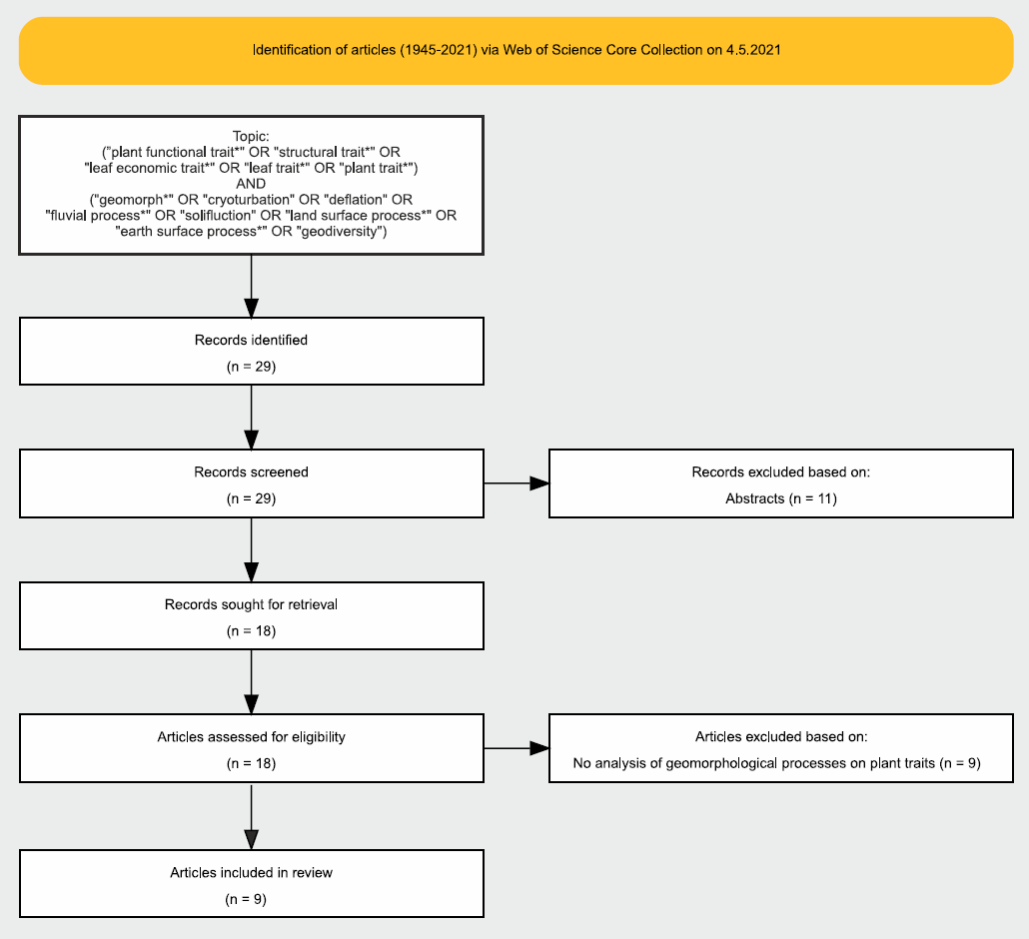

Fig. S1. Work flow diagram of the methodological details behind the systematic literature review. We carried out the review following the PRISMA 2020 method (see Supplementary Text 1 for details).

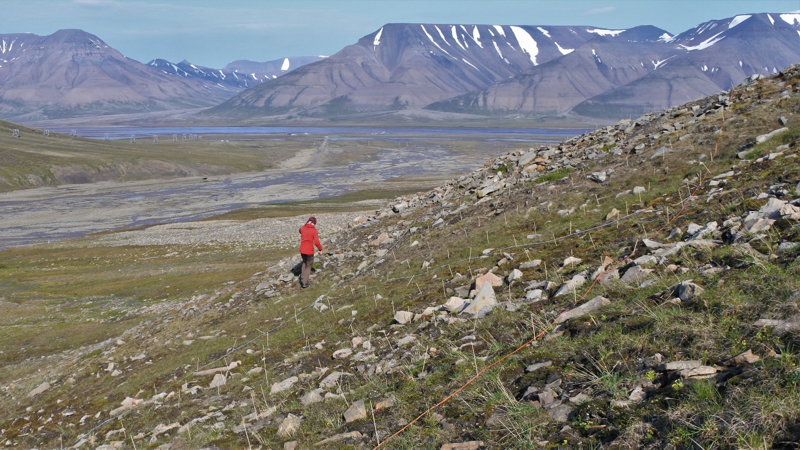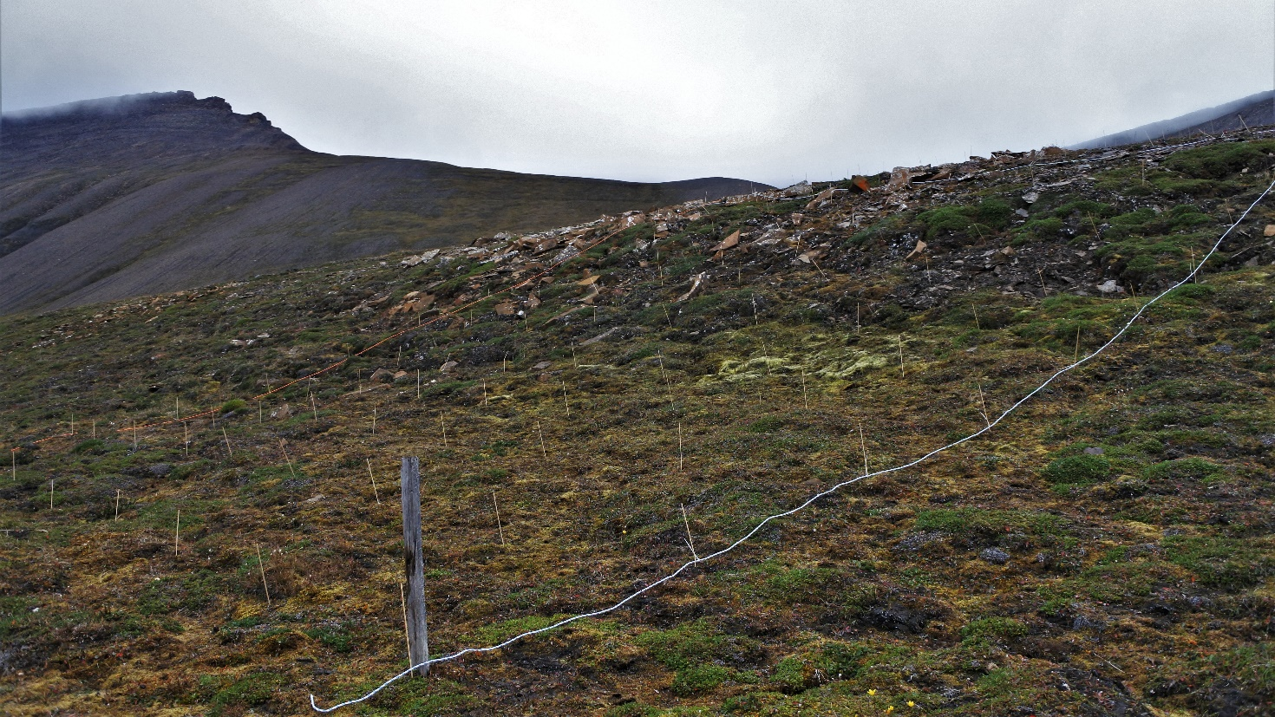
Fig. S2a. Study site photographs. The photographs represent two example study grids from each three study sites. The first two are from the high-Arctic site (Fig. S2a), the next two from the low-Arctic site (Fig. S2b), and the last two from the sub-Arctic site (Fig. S2c). All photographs are taken by JK at the time of the sampling.

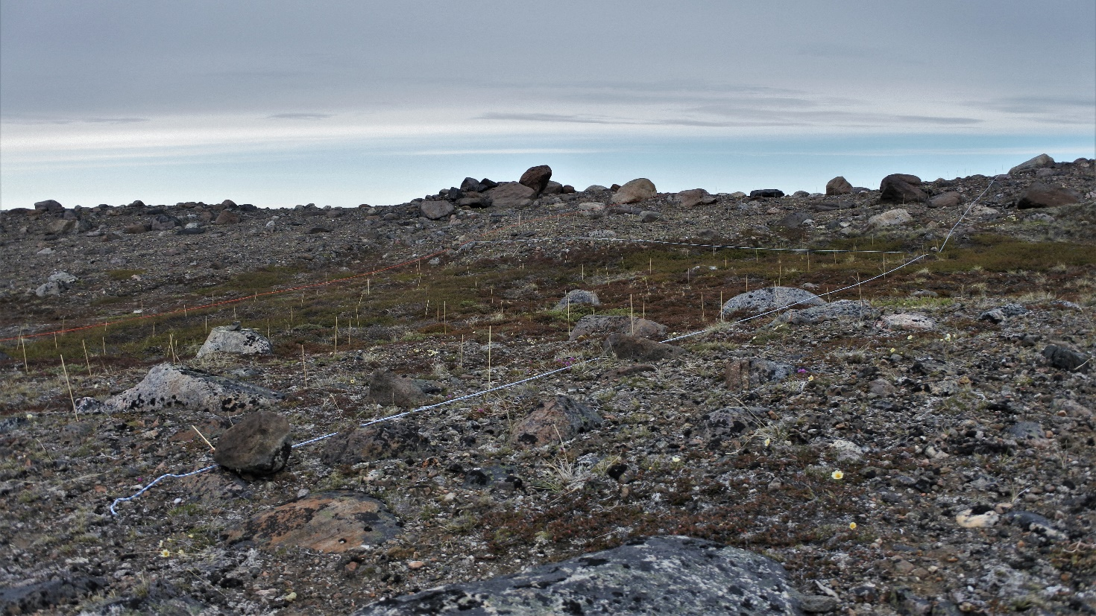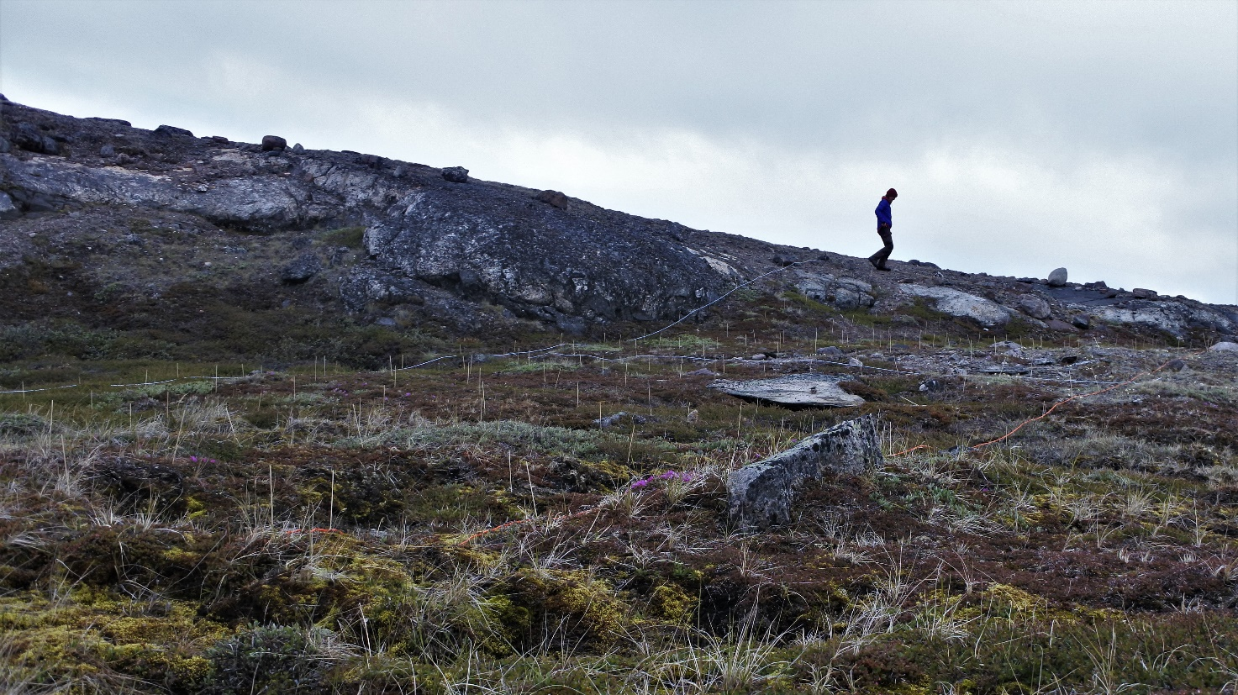
Fig. S2b. Study site photographs. The photographs represent two example study grids from each three study sites. The first two are from the high-Arctic site (Fig. S2a), the next two from the low-Arctic site (Fig. S2b), and the last two from the sub-Arctic site (Fig. S2c). All photographs are taken by JK at the time of the sampling.

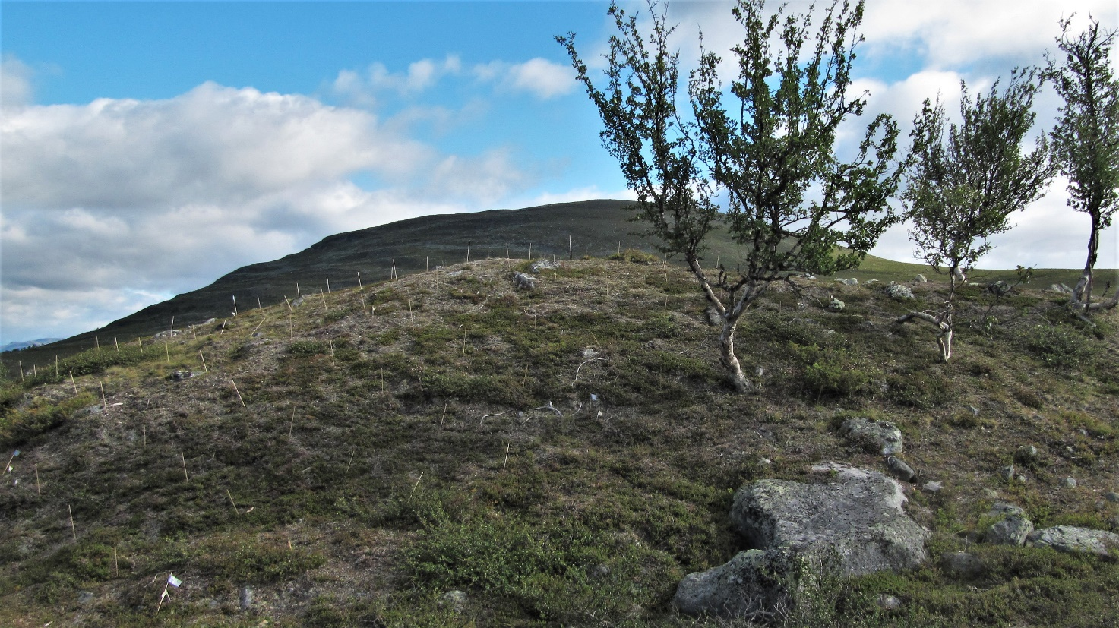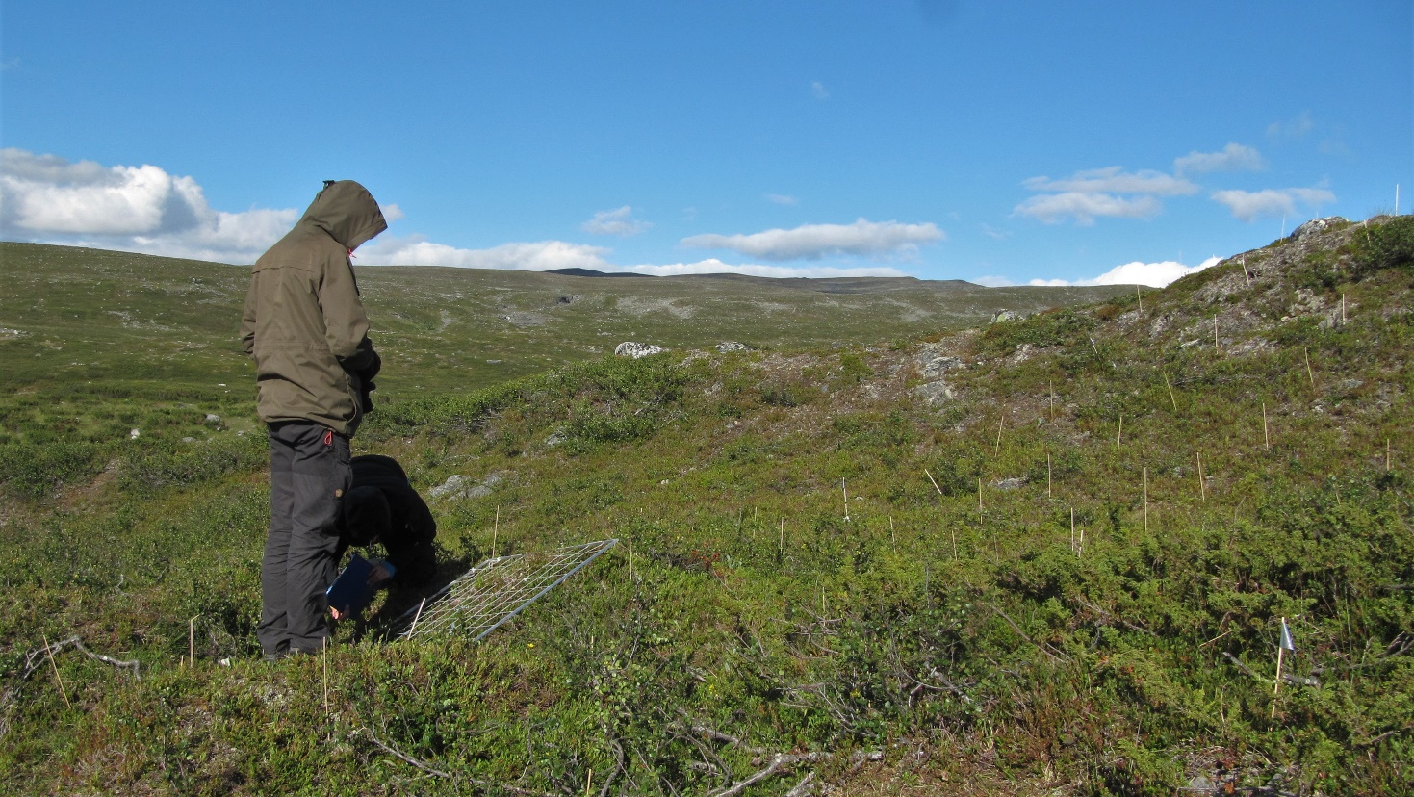
Fig. S2c. Study site photographs. The photographs represent two example study grids from each three study sites. The first two are from the high-Arctic site (Fig. S2a), the next two from the low-Arctic site (Fig. S2b), and the last two from the sub-Arctic site (Fig. S2c). All photographs are taken by JK at the time of the sampling.

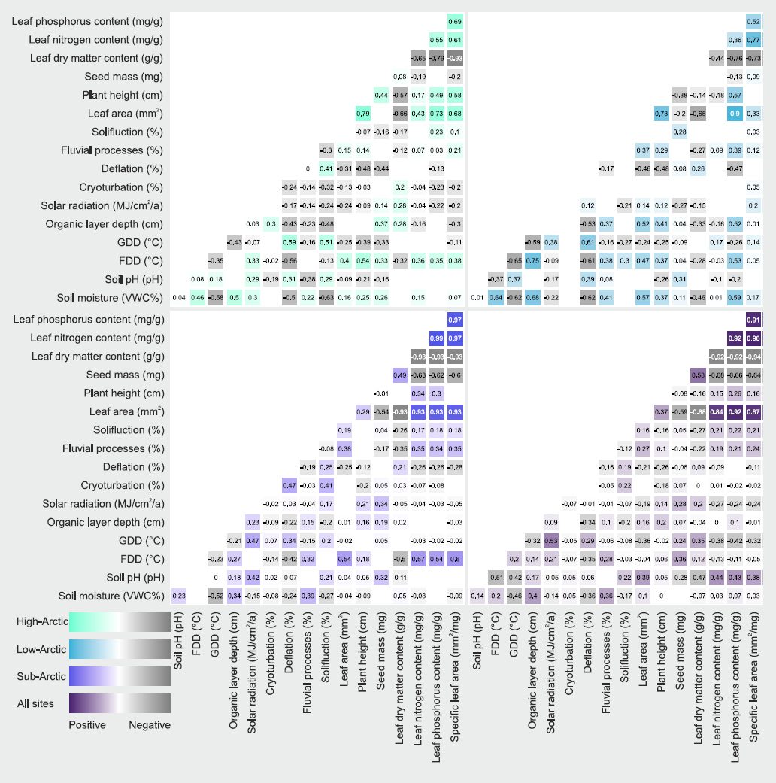

Fig. S3. Bivariate correlations. The correlation matrix shows the Spearman’s correlations between variables (n = 5280 for all sites). Statistically significant (P < 0.05) correlations are shown as squares, whereas non-significant correlations (P ≥ 0.05) are blank.

Table S1. Results of a systematic literature review on how geomorphological processes influence plant functional traits. We carried out the review following the PRISMA 2020 method (see Supplementary Text 1 for details) and we report the methodological details of our review in Supplementary Figure 1.
Biome | Plant functional trait | Geomorphological process and data source | Trait-geomorphology relationship | Number of plots | Article
Tundra (alpine) | plant height, stem diameter, eccentricity index, bark and secondary xylem thickness | slope processes based on field observations and aerial imagery | slope processes slow vegetation restoration | 9 | Kopanina et al. 2020
Tundra (alpine) | taxonomic group, evergreen leaves, leaf shape, morphology, mycorrhizal and N-fixing symbioses, root type, clonality, Raunkiaer classification | patterned ground and cryoturbation based on field observations | patterned ground influence trait variation | 80 | Apple et al. 2019
Temperate seasonal forest | specific leaf area, plant height, seed mass | fluvial processes based on field observations | fluvial processes influence functional composition | 17 | Janssen et al. 2019
Greenhouse | root:shoot ratio, aboveground biomass, root mass, elongation, root and leaf 15N:14N isotope ratio (δ15N), root and leaf nitrogen content (%N in roots and leaves), 13C:12C isotope ratio (δ13C), and root and leaf carbon:nitrogen ratio (C:N ratio) | dune processes based on experiments | dune processes increase rapid growth strategy | 30 | Brown & Zinnert 2018
Greenhouse | stiffness, root growth | fluvial processes based on experiments | fluvial processes influence seedling establishment | NA | Schwarz et al. 2015
Temperate seasonal forest | tiller density, inflorescence density | dune processes based on experiments | dune processes influence traits | 90 | Emery et al. 2015
Woodland | seed mass, specific leaf area, lead force of fracture, lead toughness, maximum canopy height, flowering period, longevity, grasses, woody, specialized dispersal, wind dispersal, vegetative spread | fluvial processes based on field observations | fluvial processes influence trait assemblages | 15 | Kyle & Leishman 2009
Woodland | life cycle, woodiness, SLA, seed production, seed mass, dispersal mode, propagule shape, propagule size, mucilage production, morphological dispersal syndromes, root morphology, sprouting capacity | slope processes based on field observations | slope processes slow vegetation restoration | 156 | Bochet et al. 2009
Tropical seasonal forest | plant height, shape, size and number of fruit | slope processes based on field observations | slope processes influence traits | 28 | Velazquez & Gomez-Sal 2009

Table S3. Species list.
Species | High-Arctic | Low-Arctic | Sub-Arctic |  | Linnaea borealis | 0 | 0 | 1
In total | 61 | 75 | 134 |  | Luzula arctica | 1 | 1 | 0
Achillea millefolium | 0 | 0 | 1 |  | Luzula arcuata | 0 | 0 | 1
Agrostis mertensii | 0 | 0 | 1 |  | Luzula confusa | 1 | 1 | 1
Alchemilla | 0 | 0 | 1 |  | Luzula multiflora | 0 | 1 | 1
Alopecurus magellanicus | 1 | 0 | 0 |  | Luzula parviflora | 0 | 0 | 1
Andromeda polifolia | 0 | 0 | 1 |  | Luzula spicata | 0 | 0 | 1
Angelica archangelica | 0 | 0 | 1 |  | Luzula sudetica | 0 | 0 | 1
Antennaria alpina | 0 | 1 | 1 |  | Luzula wahlenbergii | 0 | 0 | 1
Antennaria canescens | 0 | 0 | 1 |  | Lycopodium clavatum | 0 | 0 | 1
Antennaria dioica | 0 | 0 | 1 |  | Lysimachia europaea | 0 | 0 | 1
Anthoxanthum monticola | 0 | 1 | 1 |  | Micranthes foliolosa | 1 | 0 | 1
Anthoxanthum odoratum | 0 | 0 | 1 |  | Micranthes nivalis | 1 | 0 | 1
Arctostaphylos uva-ursi | 0 | 0 | 1 |  | Micranthes tenuis | 1 | 0 | 0
Arctous alpina | 0 | 0 | 1 |  | Nardus stricta | 0 | 0 | 1
Artemisia borealis | 0 | 1 | 0 |  | Neottia cordata | 0 | 0 | 1
Astragalus alpinus | 0 | 0 | 1 |  | Omalotheca norvegica | 0 | 0 | 1
Astragalus frigidus | 0 | 0 | 1 |  | Omalotheca supina | 0 | 0 | 1
Avenella flexuosa | 0 | 0 | 1 |  | Orthilia secunda | 0 | 0 | 1
Bartsia alpina | 0 | 0 | 1 |  | Oxyria digyna | 1 | 1 | 1
Betula nana | 0 | 1 | 1 |  | Papaver radicatum | 1 | 0 | 0
Betula pubescens | 0 | 0 | 1 |  | Parnassia palustris | 0 | 0 | 1
Bistorta vivipara | 1 | 1 | 1 |  | Pedicularis dasyantha | 0 | 1 | 0
Botrychium lunaria | 0 | 0 | 1 |  | Pedicularis flammea | 0 | 1 | 0
Calamagrostis canadensis | 0 | 1 | 0 |  | Pedicularis hirsuta | 1 | 0 | 0
Calamagrostis lapponica | 0 | 0 | 1 |  | Pedicularis lapponica | 0 | 1 | 1
Calamagrostis neglecta | 0 | 1 | 0 |  | Phleum alpinum | 0 | 0 | 1
Campanula rotundifolia | 0 | 1 | 1 |  | Phyllodoce caerulea | 0 | 0 | 1
Cardamine bellidifolia | 1 | 1 | 1 |  | Pinguicula alpina | 0 | 0 | 1
Carex aquatilis | 0 | 1 | 0 |  | Pinguicula vulgaris | 0 | 0 | 1
Carex arctogena | 0 | 0 | 1 |  | Poa alpigena | 0 | 1 | 1
Carex atrata | 0 | 0 | 1 |  | Poa alpina | 1 | 1 | 1
Carex bigelowii | 0 | 1 | 1 |  | Poa arctica | 1 | 1 | 1
Carex canescens | 0 | 1 | 1 |  | Poa glauca | 1 | 1 | 0
Carex capillaris | 0 | 0 | 1 |  | Poa nemoralis | 0 | 0 | 1
Carex glacialis | 0 | 1 | 0 |  | Poa pratensis | 1 | 0 | 0
Carex lachenalii | 1 | 0 | 1 |  | Polemonium boreale | 1 | 0 | 0
Carex myosuroides | 0 | 1 | 0 |  | Potentilla crantzii | 0 | 0 | 1
Carex nardina | 0 | 1 | 0 |  | Potentilla hyparctica | 1 | 0 | 0
Carex norvegica | 0 | 0 | 1 |  | Potentilla nivea | 0 | 1 | 0
Carex panicea | 0 | 0 | 1 |  | Pyrola grandiflora | 0 | 1 | 0
Carex parallela | 0 | 0 | 1 |  | Pyrola minor | 0 | 0 | 1
Carex rariflora | 0 | 1 | 0 |  | Pyrola rotundifolia | 0 | 0 | 1
Carex rupestris | 1 | 1 | 1 |  | Ranunculus acris | 0 | 0 | 1
Carex saxatilis | 0 | 1 | 0 |  | Ranunculus nivalis | 1 | 0 | 1
Carex supina | 0 | 1 | 0 |  | Ranunculus pygmaeus | 1 | 1 | 0
Carex vaginata | 0 | 0 | 1 |  | Ranunculus sulphureus | 1 | 0 | 0
Cassiope tetragona | 1 | 1 | 1 |  | Rhodiola rosea | 0 | 0 | 1
Cerastium | 0 | 0 | 1 |  | Rhododendron lapponicum | 0 | 1 | 1
Cerastium alpinum | 0 | 1 | 1 |  | Rhododendron tomentosum | 0 | 1 | 0
Cerastium arcticum | 1 | 0 | 0 |  | Rubus saxatilis | 0 | 0 | 1
Cerastium cerastoides | 0 | 1 | 0 |  | Rumex acetosa | 0 | 0 | 1
Cerastium regelii | 1 | 0 | 0 |  | Sabulina rubella | 1 | 1 | 0
Cherleria biflora | 1 | 1 | 1 |  | Sagina nivalis | 1 | 0 | 0
Cystopteris fragilis | 0 | 0 | 1 |  | Sagina saginoides | 0 | 0 | 1
Dactylorhiza viridis | 0 | 0 | 1 |  | Salix arctophila | 0 | 1 | 0
Deschampsia alpina | 1 | 0 | 0 |  | Salix glauca | 0 | 1 | 1
Deschampsia cespitosa | 0 | 0 | 1 |  | Salix hastata | 0 | 0 | 1
Diapensia lapponica | 0 | 1 | 1 |  | Salix herbacea | 0 | 1 | 1
Diphasiastrum alpinum | 0 | 0 | 1 |  | Salix lapponum | 0 | 0 | 1
Draba | 0 | 1 | 0 |  | Salix myrsinifolia | 0 | 0 | 1
Draba alpina | 1 | 0 | 0 |  | Salix myrtilloides | 0 | 0 | 1
Draba arctica | 1 | 0 | 0 |  | Salix phylicifolia | 0 | 0 | 1
Draba fladnizensis | 1 | 0 | 0 |  | Salix polaris | 1 | 0 | 1
Draba glabella | 1 | 1 | 1 |  | Salix reticulata | 0 | 0 | 1
Draba lactea | 1 | 0 | 0 |  | Saussurea alpina | 0 | 0 | 1
Draba micropetala | 1 | 0 | 0 |  | Saxifraga cernua | 1 | 1 | 0
Draba nivalis | 1 | 1 | 1 |  | Saxifraga cespitosa | 1 | 0 | 1
Draba norvegica | 1 | 0 | 0 |  | Saxifraga hieracifolia | 1 | 0 | 0
Draba pauciflora | 1 | 0 | 0 |  | Saxifraga hirculus | 1 | 0 | 0
Draba subcapitata | 1 | 0 | 0 |  | Saxifraga hyperborea | 1 | 0 | 0
Dryas integrifolia | 0 | 1 | 0 |  | Saxifraga oppositifolia | 1 | 1 | 0
Dryas octopetala | 1 | 0 | 1 |  | Saxifraga platysepala | 1 | 0 | 0
Empetrum nigrum | 0 | 1 | 1 |  | Saxifraga rivularis | 0 | 1 | 0
Epilobium angustifolium | 0 | 0 | 1 |  | Saxifraga svalbardensis | 1 | 0 | 0
Epilobium latifolium | 0 | 1 | 0 |  | Saxifraga tricuspidata | 0 | 1 | 0
Equisetum arvense | 1 | 1 | 0 |  | Scorzoneroides autumnalis | 0 | 0 | 1
Equisetum palustre | 0 | 0 | 1 |  | Selaginella selaginoides | 0 | 0 | 1
Equisetum pratense | 0 | 0 | 1 |  | Sibbaldia procumbens | 0 | 0 | 1
Equisetum scirpoides | 1 | 0 | 1 |  | Silene acaulis | 1 | 1 | 1
Equisetum variegatum | 1 | 0 | 0 |  | Silene involucrata | 1 | 1 | 0
Erigeron humilis | 0 | 1 | 0 |  | Silene suecica | 0 | 0 | 1
Erigeron uniflorus | 0 | 0 | 1 |  | Silene uralensis | 0 | 0 | 1
Eriophorum angustifolium | 0 | 1 | 1 |  | Solidago virgaurea | 0 | 0 | 1
Euphrasia wettsteinii | 0 | 1 | 1 |  | Spinulum annotinum | 0 | 0 | 1
Festuca brachyphylla | 0 | 1 | 0 |  | Stellaria humifusa | 0 | 1 | 0
Festuca edlundiae | 1 | 0 | 0 |  | Stellaria longipes | 1 | 1 | 0
Festuca ovina | 0 | 0 | 1 |  | Taraxacum | 0 | 1 | 1
Festuca rubra | 1 | 1 | 0 |  | Thalictrum alpinum | 0 | 1 | 1
Festuca viviparoidea | 1 | 0 | 0 |  | Tofieldia coccinea | 0 | 1 | 0
Gentiana nivalis | 0 | 0 | 1 |  | Tofieldia pusilla | 0 | 1 | 1
Geranium sylvaticum | 0 | 0 | 1 |  | Trichophorum cespitosum | 0 | 0 | 1
Harrimanella hypnoides | 0 | 1 | 1 |  | Trisetum spicatum | 1 | 1 | 1
Hieracium | 0 | 0 | 1 |  | Vaccinium myrtillus | 0 | 0 | 1
Huperzia selago | 0 | 0 | 1 |  | Vaccinium uliginosum | 0 | 1 | 1
Juncus biglumis | 1 | 1 | 1 |  | Vaccinium vitis-idaea | 0 | 1 | 1
Juncus castaneus | 0 | 1 | 0 |  | Vahlodea atropurpurea | 0 | 0 | 1
Juncus trifidus | 0 | 1 | 1 |  | Veronica alpina | 0 | 0 | 1
Juniperus communis | 0 | 0 | 1 |  | Veronica fruticans | 0 | 0 | 1
Kalmia procumbens | 0 | 0 | 1 |  | Viola biflora | 0 | 0 | 1
Koenigia islandica | 1 | 0 | 0 |  | Woodsia alpina | 0 | 0 | 1

Table S3. The r2 values for the models divided between the random effect, the global trait–environment relationship and the local trait–environment relationship. In the leaf area, plant height, leaf dry matter content, and leaf phosphorus content models the global trait-environment relationship was more influential than any local site-specific relationships.
Plant trait | Site | Random effect | Global relationship | Local relationship
Leaf area | High-Arctic | 0.29 | 0.25 | 0.05
Leaf area | Low-Arctic | 0.00 | 0.52 | 0.07
Leaf area | Sub-Arctic | 0.28 | 0.29 | 0.02
Plant height | High-Arctic | 0.28 | 0.35 | 0.07
Plant height | Low-Arctic | 0.01 | 0.40 | 0.06
Plant height | Sub-Arctic | 0.20 | 0.09 | 0.05
Seed mass | High-Arctic | 0.09 | 0.30 | 0.12
Seed mass | Low-Arctic | 0.08 | 0.04 | 0.32
Seed mass | Sub-Arctic | 0.19 | 0.15 | 0.05
Leaf dry matter content | High-Arctic | 0.39 | 0.11 | 0.10
Leaf dry matter content | Low-Arctic | 0.20 | 0.21 | 0.11
Leaf dry matter content | Sub-Arctic | 0.18 | 0.30 | 0.11
Leaf nitrogen content | High-Arctic | 0.14 | 0.15 | 0.19
Leaf nitrogen content | Low-Arctic | 0.09 | 0.15 | 0.20
Leaf nitrogen content | Sub-Arctic | 0.29 | 0.31 | 0.04
Leaf phosphorus content | High-Arctic | 0.22 | 0.03 | 0.17
Leaf phosphorus content | Low-Arctic | 0.33 | 0.30 | 0.06
Leaf phosphorus content | Sub-Arctic | 0.30 | 0.31 | 0.03
Specific leaf area | High-Arctic | 0.33 | 0.14 | 0.14
Specific leaf area | Low-Arctic | 0.07 | 0.08 | 0.20
Specific leaf area | Sub-Arctic | 0.32 | 0.32 | 0.03

Supplementary Information References

Page, M. J. et al. The PRISMA 2020 statement: an updated guideline for reporting systematic reviews. Syst. Rev. 10, 89 (2021).

