De novo assembled salivary gland transcriptome and expression pattern analyses for Rhipicephalus evertsi evertsi Neuman, 1897 male and female ticks

*Ronel Pienaar^{1,2}, Daniel G. de Klerk¹, Minique H. de Castro³, Jonathan Featherston³, *Ben J. Mans^{1,2,4}

¹Epidemiology, Parasites and Vectors, Agricultural Research Council-Onderstepoort Veterinary Research, Onderstepoort, South Africa, ²Department of Veterinary Tropical Diseases, University of Pretoria, Pretoria, South Africa, ³Agricultural Research Council-Biotechnology Platform, ⁴Department of Life and Consumer Sciences, University of South Africa, Pretoria, South Africa

*Corresponding authors: volschenkr@arc.agric.za; mansb@arc.agric.za

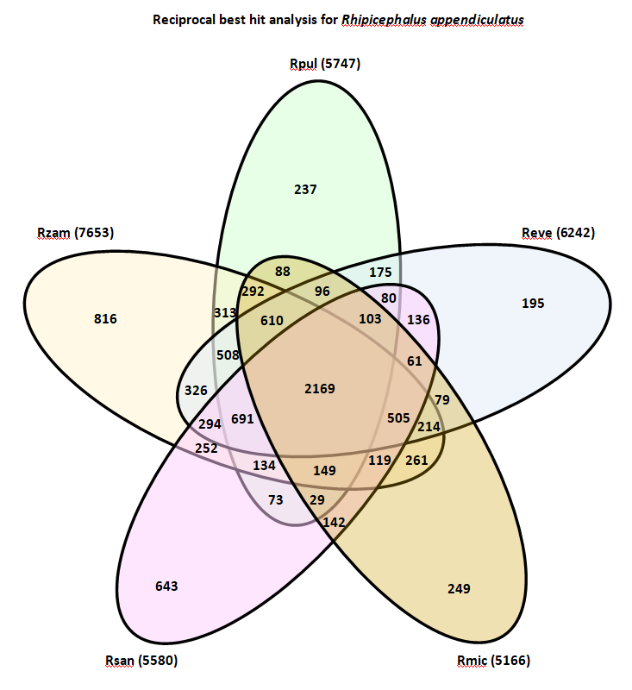

Figure 1: Venn diagram to show the number of shared orthologs found for the Rhipicephalus appendiculatus transcriptome based on reciprocal best hits with the other publically available transcriptomes for Rhipicephalus microplus (Rmic), Rhipicephalus pulchellus (Rpul), Rhipicephalus sanguineus (Rsan), Rhipicephalus zambeziensis (Rzam) and for Rhipicephalus evertsi evertsi (Reve) (this study). Numbers in parenthesis indicate total number of reciprocal best hits for each transcriptome and while those shared among transcriptomes are indicated in numbers.

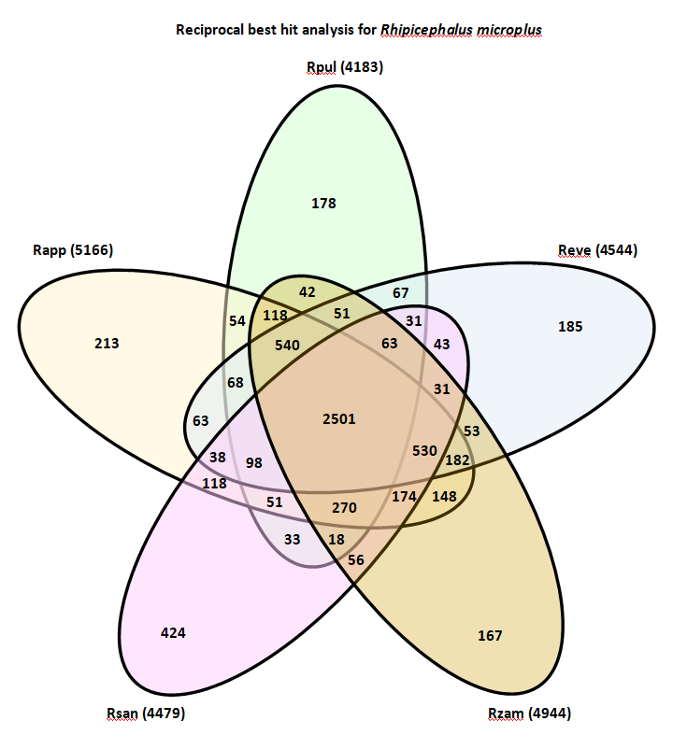

Figure 2: Venn diagram to show the number of shared orthologs found for the Rhipicephalus microplus transcriptome based on reciprocal best hits with the other publically available transcriptomes for Rhipicephalus appendiculatus (Rapp), Rhipicephalus pulchellus (Rpul), Rhipicephalus sanguineus (Rsan), Rhipicephalus zambeziensis (Rzam) and for Rhipicephalus evertsi evertsi (Reve) (this study). Numbers in parenthesis indicate total number of reciprocal best hits for each transcriptome and while those shared among transcriptomes are indicated in numbers.

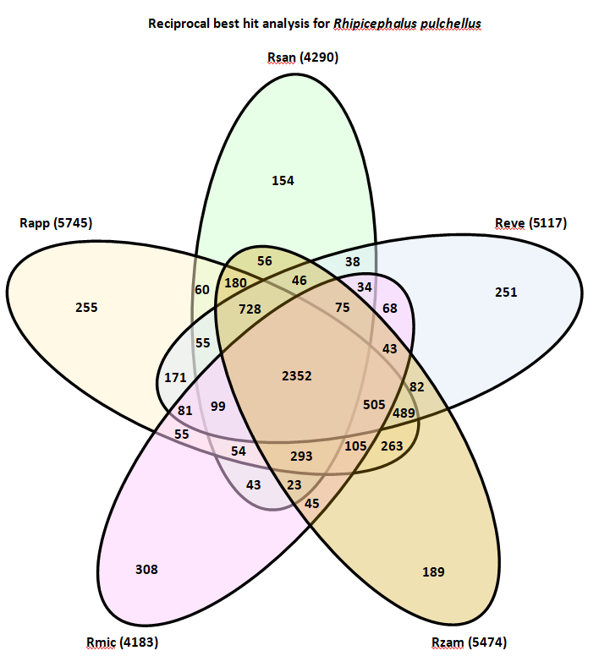

Figure 3: Venn diagram to show the number of shared orthologs found for the Rhipicephalus pulchellus transcriptome based on reciprocal best hits with the other publically available transcriptomes for Rhipicephalus appendiculatus (Rapp), Rhipicephalus microplus (Rmic), Rhipicephalus sanguineus (Rsan), Rhipicephalus zambeziensis (Rzam) and for Rhipicephalus evertsi evertsi (Reve) (this study). Numbers in parenthesis indicate total number of reciprocal best hits for each transcriptome and while those shared among transcriptomes are indicated in numbers.

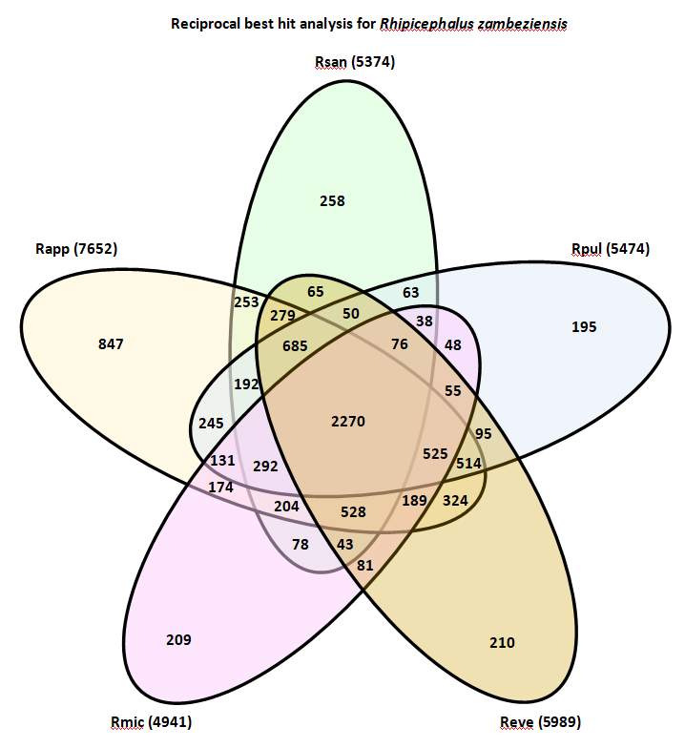

Figure 4: Venn diagram to show the number of shared orthologs found for the Rhipicephalus zambeziensis transcriptome based on reciprocal best hits with the other publically available transcriptomes for Rhipicephalus appendiculatus (Rapp), Rhipicephalus microplus (Rmic), Rhipicephalus pulchellus (Rpul), Rhipicephalus sanguineus (Rsan), and for Rhipicephalus evertsi evertsi (Reve) (this study). Numbers in parenthesis indicate total number of reciprocal best hits for each transcriptome and while those shared among transcriptomes are indicated in numbers.

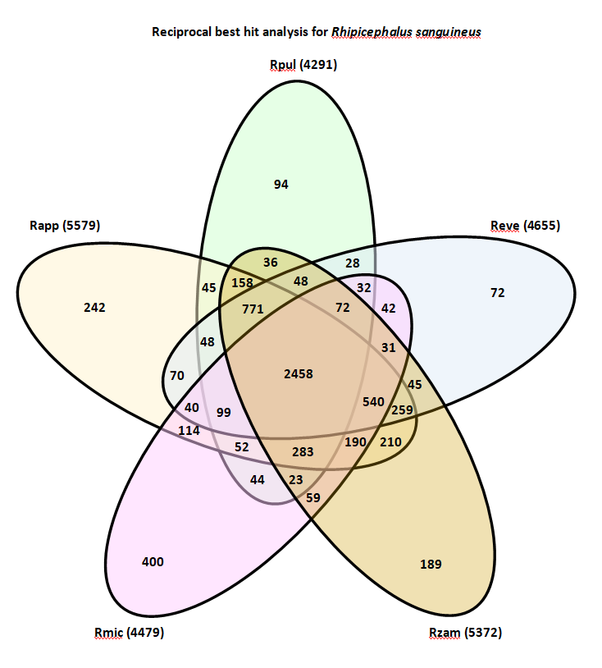

Figure 5: Venn diagram to show the number of shared orthologs found for the Rhipicephalus sanguineus transcriptome based on reciprocal best hits with the other publically available transcriptomes for Rhipicephalus appendiculatus (Rapp), Rhipicephalus microplus (Rmic), Rhipicephalus pulchellus (Rpul), Rhipicephalus zambeziensis (Rzam) and for Rhipicephalus evertsi evertsi (Reve) (this study). Numbers in parenthesis indicate total number of reciprocal best hits for each transcriptome and while those shared among transcriptomes are indicated in numbers.

