Online Resource 1: A Systematic Review of Longitudinal Trajectories of Mental Health Problems in Children with Neurodevelopmental Disabilities
This document contains material supplementary to the article entitled “A Systematic Review of Longitudinal Trajectories of Mental Health Problems in Children with Neurodevelopmental Disabilities”, which was published in the Journal of Developmental and Physical Disabilities.

Supplementary Table 1 Search Strategy Completed in PubMed
Concept | Type | Term
Mental health | Free text | “mental health problem”
Mental health | Free text | “mental health problems”
Mental health | MeSH | “mental health”
Mental health | Free text | “mental problem”
Mental health | Free text | “mental problems”
Mental health | Free text | “psychiatric problem”
Mental health | Free text | “psychiatric problems”
Mental health | MeSH | “anxiety”
Mental health | Free text | anxiety
Mental health | Free text | “conduct problem”
Mental health | Free text | “conduct problems”
Mental health | MeSH | “conduct disorder”
Mental health | MeSH | “behavioral symptoms”
Mental health | Free text | “behavior problems”
Mental health | Free text | “behavior problem”
Mental health | Free text | “behaviour problems”
Mental health | Free text | “behaviour problem”
Mental health | Free text | depression
Mental health | MeSH | “depression”
Mental health | Free text | “mood problem”
Mental health | Free text | “mood problems”
Mental health | MeSH | “mood disorders”
Mental health | Free text | “emotional problem”
Mental health | Free text | “emotional problems”
Mental health | MeSH | “behavior, addictive”
Mental health | Free text | addiction
Mental health | MeSH | “stress, psychological”
Mental health | Free text | stress
Mental health | MeSH | “self-injurious behavior”
Mental health | Free text | “self-harm”
Mental health | Free text | “self harm”
Mental health | Free text | “selfharm”
Mental health | Free text | “self-injury”
Mental health | Free text | “self injury”
Mental health | Free text | “selfinjury”
Mental health | MeSH | “loneliness”
Mental health | Free text | loneliness
Mental health | MeSH | “anxiety disorders”
Mental health | MeSH | “feeding and eating disorders”
Disability | Free text | disab*
Disability | MeSH | “disabled persons”
Disability | Free text | “brain injury”
Disability | MeSH | “brain damage, chronic”
Disability | Free text | “cerebral palsy”
Disability | MeSH | “neurobehavioral manifestations”
Disability | Free text | impairment
Disability | Free text | autism
Disability | Free text | ADHD
Disability | Free text | syndrom*
Disability | MeSH | “syndrome”
Longitudinal | Free text | longitudinal
Longitudinal | MeSH | “longitudinal studies”
Longitudinal | Free text | over time
Longitudinal | Free text | cohort
Longitudinal | MeSH | “cohort studies”
Longitudinal | Free text | RCT
Longitudinal | Free text | “randomized controlled trial”
Longitudinal | Free text | “randomised controlled trial”
Longitudinal | MeSH | “randomized controlled trials as topic”
Child | Free text | child*
Child | MeSH | “child”
Child | MeSH | “child, preschool”
Child | Free text | adolescen*
Child | Free text | teen*
Child | MeSH | “adolescent”
Child | Free text | “young adult”
Child | Free text | “young adults”
Child | MeSH | “young adult”
Note. Terms were combined with the ‘OR’ argument within each concept and with the ‘AND’ argument between concepts.

Supplementary Table 2 Main purposes, results, and implications of the included studies
 | Participants
Study | Diagnosis | Ageª | Purpose | Main results | Implications
Alsem 2013 | CP | 2.5 | Describe course of, and identify characteristics predictive of, HR-QoL in young children with CP. | HR-QoL of children with CP stable between 2.5-4.5 years with individual variation. No assoc. between motor function, limb distribution and HR-QoL, except for in 3 psychosocial domains. | HR-QoL not easily predicted so should be assessed directly. Knowing HR-QoL may improve communication and outcomes as domains of concern highlighted. Clinical use of HR-QoL questionnaires needs further investigation.
Anderson 2011 | ASD | 9.75 | Symptom trajectories (irritability, hyperactivity, social withdrawal) in youth with ASD cf non-spectrum comparison group with DD. | Higher irritability and hyperactivity in severe ASD cf all ASD and other DD. Hyperactivity improved the most for all, social withdrawal worsened with age in ASD. Greater heterogeneity in trajectories for maladaptive behaviours in ASD. | Need for attention to maladaptive behaviours starting in early childhood; services and interventions aimed at enhancing social functioning for adolescents and young adults with ASD at critical developmental milestones; and the need for continued services and support.
Auerbach 2008 | Dyscalculia - Dyscalculia-NP | 11.1 | Examine the continuity of behavior problems in adolescence in a sample of youths with persistent dyscalculia and nonpersistent dyscalculia. | More parent-reported problems for persistent dyscalculia, cf to non-persistent, at age 16–17. Difference in youth-reported attention problems at 16–17 years only. | Therapeutic interventions should focus on the academic domain and improving behavioural patterns. Inattention and externalizing problems have to be addressed for children with dyscalculia.
Baribeau 2021 | ASD | 3.34 | Describe the joint longitudinal trajectories of ‘insistence on sameness’ and anxiety in children with ASD and characterise subgroups at higher risk for anxiety. | Three ‘insistence on sameness’ trajectories: (a) ‘low-stable’ (41.7% of participants), (b) ‘moderate-increasing’ (52.0%) and (c) ‘high-peaking’ (i.e. increasing then stabilising/decreasing behaviour) (6.3%). Four anxiety trajectories: (a) ‘low-increasing’ (51.0%), (b) ‘moderate-decreasing’ (16.2%), (c) ‘moderate-increasing’ (19.6%) and (d) ‘high-stable’ (13.1%). ‘Insistence on sameness’ and ‘anxiety’ trajectories were similar in severity and direction for 64%. | Prevention of, and/or early intervention for, anxiety in ASD is warranted, beginning in preschool or early school-aged children.
Biederman 1996 | ADHD | 10.6 | Describe adolesecent outcomes of children with ADHD and a comorbid antisocial or psychiatric disorder cf with ADHD alone. | Differences between ADHD and controls in behaviour, mood and anxiety disorders, that increased over time. ADHD children more impaired cognitive, family, school, and psychosocial functioning. Baseline diagnosis predicted disorders at follow up. | Importance of early recognition of comorbid disorders for prevention and early intervention. Consideration of psychiatric comorbidity in assessment and research, including validity of considering comorbidity as a diagnostic option.
Ciciolla 2014 | Delay | 3 | Explore associations between child internalizing/externalizing symptoms, maternal distress and maternal sensitivity, and whether moderated by DD. | Maternal psychological and child internalizing symptoms are stable over time, and show a reciprocal pattern of influence affecting ongoing mother and child wellbeing. Child internalizing / maternal distress symptoms important in DD. | Need early screening and prevention practices for families with young children and specific family-centred treatments. Important to consider parental/maternal psychopathology when addressing issues related to parenting and child behaviour.
Colvert 2021 | ASD | 4 | Examine risk factors and longitudinal course of difficulties in ASD and comparison twins. | High level comorbid difficulties in ASD. The profile, associated risk factors and longitudinal course of additional difficulties in ASD may differ from TD. | Not reported
Cornish 2012 | Fragile X | 8.17 | Explore development of attention processing in young boys with FX and how attentional processes impact behavioral outcomes. | Improvement in nonverbal growth and cognitive attention, decline in nonverbal IQ, behavioural difficulties stable in Fr-X. Visual and auditory attentional markers predict intellectual ability and classroom behaviour, auditory markers predict autistic symptomatology. | Need to recognise the potential impacts of gene expression on brain development across and within cognitive domains (i.e., attention), which drive cognitive attention outcomes. Distinct modalities are potential risk markers of interest.
Fielding-Gebhardt 2020 | Fragile X | 9.13 | Provide longitudinal evidence for the association between mother-child relationship quality, child challenging behaviors, and maternal mental health, while considering maternal genetic susceptibility to mental health disorders. Determine impact on mother–child relationship quality of interactions. | Child challenging behaviours, maternal mental health, and mother–child relationship quality were stable. Elevated child challenging behaviours negatively impacted maternal mental health. Child challenging behaviours, combined with maternal mental health, influenced mother–child relationship quality. | Clinical interventions might focus on ensuring that child challenging behaviours, maternal mental health, and mother–child relationship quality remain positive and stable in families with Fr-X.
Flouri 2015 | ASD - ASD+ADHD | 3.13 - 3.11 | Examine longitudinal relationship between socio-economic disadvantage (SED) and trajectories of emotional and conduct problems in children with ASD+ADHD, cf with ASD alone. | ASD+ADHD had elevated conduct problems and experiences of harsh parenting and maternal psychological distress cf ASD-ADHD. SED more important for ASD than non-ASD, but no difference in SED between ASD + ADHD and ASD-ADHD. | NR
Gotham 2015 | DD | 12.3 | (1) Model growth in anxiety and depressive symptoms from late school age to young adulthood in DD; (2) evaluate differences in developmental patterns of internalizing symptoms; (3) assess relations between internalizing growth patterns, baseline covariates and distal outcomes. | Anxiety was positively associated with Verbal IQ. Controlling for Verbal IQ, anxiety and depressive symptoms were greater in ASD than non ASD participants. Female gender predicted greater increases in anxiety and depressive symptoms. Lower maternal education associated with increasing symptoms in less verbal ASD subset. | Need to screen for anxiety and depression in ASD, particularly those with emotion regulation difficulties.
Green 2005 | DD | 3.9 | Examine the persistence of early emerging aberrant behavior in preschool children with DD. | Problem behaviours present in whole sample (n=13). Nine had high levels of aberrant behaviours with little change. Aberrant behaviours emerged early and persisted. | Early intervention (before age 4years) needed to prevent and reduce aberrant behaviour. Interventions to provide strategies to replace early and less serious aberrant behaviour, and the prelinguistic acts that could be precursors to aberrant behaviour.
Harvey 2015 | ADHD | 3.68 | Examine trajectories and predictive power of individual hyperactivity/impulsivity and inattention symptoms among children later diagnosed with ADHD. | Children with ADHD had stable levels of hyperactivity/impulsivity, increased inattention and increased ODD symptoms over time. | Early identification and intervention for children with ADHD may be crucial in preventing the development of ODD. Need more sensitive methods of identifying pre-schoolers at risk of ADHD.
Hauser-Cram 2016 | DD | 3 | Examine trajectory patterns of internalizing and externalizing behaviour problems in children with DD. | Internalizing and externalizing problem trajectories identified by age 3 years in DD. Child and family characteristics not related to differences but family processes predictive of more adverse trajectories. | Service providers actively emphasising family well-being will likely benefit DD during early childhood: more focus on family needs, addressing maternal depressive symptoms and children’s behaviour problems.
Hickey 2020 | ASD | 9.07 | Examined bidirectional associations between warmth and criticism in the mother-child and father-child relationship and severity of ASD symptoms, emotional and behavioral problems. | The emotional quality of the parent-child relationships are bidirectionally related to the symptoms and emotional and behavioural problems of children with ASD. | Interventions should educate and support parents (both mothers and fathers) to develop warm emotional parent-child relationships. Direct (parent education) and indirect (financial support, stress management) strategies needed.
Hogan 2014 | Hearing problems | 4.75 | Examine longitudinal impact of ear infection and hearing problems on psychosocial outcomes in children, | Children with ear infections or hearing problems at earlier age more likely to have poor psychosocial outcomes. Younger cohort only had poorer outcomes associated with earlier hearing problems. | Possible relationship between ongoing ear infections or hearing problems and long-term psychosocial health. Further investigation justified.
Holmbeck 2010 | Spina bifida | 8.34 | Compare psychosocial adjustment trajectories of adolescents with SB and those without chronic illness. | Adolescents with SB have enduring academic and attention problems and difficulties with social development cf TD, albeit some areas of resilience. Girls with SB at risk of increased social difficulties and negative perceptions of physical appearance, depression seems not a problem. | Prevention efforts, for psychosocial difficulties, should begin in childhood and target specific developmental challenges. Parent and peer involvement should be considered, as well as gender-specific components based on observed differences in girls with SB.
Horbach 2020 | SLD - SLD+ADHD - ADHD | 6.21 | Investigate development of emotional and behavioral problems in children with and without SLDrs, and if ADHD moderates this association. | No difference in behaviour problems before school entrance: children with SLDrs have higher behavioural problems after school entrance. Comorbid ADHD may explain differential problem behaviour ratings. | Comorbidity of ADHD and SLDrs = higher behaviour problem symptoms, stressing the urgency of early intervention.
Hoza 2010 | ADHD | 9.97 | Evaluate association between biased self-perceptions and adjustment in children with ADHD cf comparison children. | ADHD had more self-perception bias than comparison. Increase in positive bias predicts aggression. ADHD status moderated assoc. between bias and adjustment; bidirectional relationship between biases and aggression, depressive symptoms inversely predicted later bias. | Treatments to encourage greater self-insight and strategies for dealing with awareness. Consider ways to decrease positive bias; e.g., reality orientation, increasing competence. Positive bias present by age 8 years suggests need for early support.
Hunsche 2020 | ASD | 7.7 | Examine if children with ASD and suicidal ideation (SI) and self-injurious behaviour (SSIB) during middle childhood have greater internalizing or externalizing behaviours than children with ASD without SI and SSIB. | SI occurred in 9.6% and was associated with fewer ASD symptoms and better adaptive functioning at age 7years. SSIB occurred in 14.6% and was associated with poorer adaptive functioning and more externalizing behaviour at age 7. Internalizing problems were not associated with SI or SSIB at any time point. SI and SSIB rarely co-occurred (4%). | High rates of suicidality in young people with ASD suggest need for better support these children and their families.
Kates 2019 | 22q11.2DS | 11.87 | Describe the trajectories of major psychiatric diagnoses in those with 22q11DS and controls, determine predictors of persistence of psychiatric diagnoses, and rates and trajectories of pharmacological treatment. | Baseline age and parent-rated hyperactivity scores predicted ADHD persistence (AUC=0.8). Family conflict predicted persistence of anxiety disorders. Child internalizing symptoms predicted persistence of anxiety (AUD=0.84) and mood disorders (AUC=0.83). Baseline prodromal symptoms predicted persistent and emergent PSDs (AUC = 0.83). Use of anti-depressants/anxiolytics increased from T1 to T4. | Parent-rated measures of child behaviour and family environment predicted persistence of ADHD, AD, and MD. Early predictors of persistent PSD require a psychiatric evaluation and intelligence test, which may be cost-effective if they result in early intervention that reduces the burden of psychosis. Children at risk should be monitored intensively and provided with integrated evidence-based treatments.
Lahey 2016 | ADHD | 5.24 - 9.24 - 10.24 | Compare symptom and functional trajectories of those with ADHD with matched healthy children. Identify predictors of individual differences in developmental outcomes. | Children with ADHD improved despite enduring symptoms, impairment and increased risk of criminal arrest, injuries and risky behaviour. Higher no. of symptoms predicted higher future no. and greater impairment. Girls and children from low-income families had poorer outcomes. | Consider risk/benefit of labelling and treatment against the expectation of long-term symptoms and impairment if interpreted with caution. Level of prediction of future outcomes is unlikely to allow clinical prognosis that is accurate enough to make treatment decisions.
Li 2020 | ASD | 4.56 | Examine association between development of internalizing and externalizing problems and emotional functioning in preschool boys with ASD. | The early development of internalizing and externalizing problems did not differ between boys with and without ASD. Problems more pronounced in ASD. More negative emotion expressions at Time 1 associated with increased problems in both groups; Improved emotion recognition associated with decreased internalizing problems. Improved emotion vocabulary associated with decreased externalizing problems in ASD. | It is important to address the underlying problems with emotional functioning and parent–child relationship at the earliest age possible. Children with ASD might need extra parental support and scaffolding to improve their emotion control and recognition.
Lindsay 2007 | SSLD | 8.25 | Explore the relationship between, and course of, behavioural, emotional and social difficulties in children with SSLD and examine impact of setting on difficulties. | High levels of behaviour/emotional/social difficulties at all ages in SLD, with different patterns of trajectories for parents’ and teachers’ ratings. Language ability predicted teacher but not parent-rated difficulties. | Monitoring and targeted support during the enhanced risk period 8–12 years for children with SSLD. Support teachers to aid children negotiate the curriculum and understand problems; support parents to aid children with emotional difficulties and support both to aid children to develop peer relationships.
Midouhas 2013 | ASD | 3 | Examine effect of family poverty on psychopathology trajectories in young children with ASD, and whether effect moderated by parental behaviour. | High and increasing rates of psychopathology in ASD. Poverty assoc. with broad and specific psychopathology. Warmth assoc. less conduct problems and hyperactivity. Household chaos a risk factor for conduct problems, as was maternal involvement for peer problems. | Maternal warmth may be a key target for intervention, particularly in poorer families of children with ASD.
Moskowitz 2020 | Fragile X | 6.71 | To characterise restricted and repetitive behaviors (RRBs) in Fr-X across age, sex, and RRB subtype. | Fr-X showed developmental stability in Restricted Interests, Compulsive Behaviours, and Ritualistic/Sameness Behaviours, in males and females with Fr-X. Both males and females decreased Sensory Motor behaviours over time. Females had a sharp decrease in Self-Injury over time. | Higher-order RRBs might be particularly important to target in intervention. Developing interventions to address these specific subtypes of RRBs might be the most beneficial.
Mrug 2012 | ADHD | 10.35 | Evaluate contribution of peer rejection and friendships to externalizing and internalizing problems in ADHD. | After controlling for key variates, peer rejection predicted cigarette smoking, delinquency, anxiety, and global impairment at 6 years and global impairment at 8 years after baseline. Having a reciprocal friend was not predictive nor protective of effects of peer rejection. | Peer relationship problems should be routinely assessed in ADHD. Early interventions to improve social skills, compensate for relationship difficulties and regular monitoring is recommended.
Murray-Close 2010 | ADHD | 10 | Explore developmental processes involved in severe and persistent peer problems in children with ADHD. | Children with ADHD had difficulties in aggression, social skills, positive illusory biases and peer rejection. Vicious cycles among problems and negative cascades of problems over time evident. | Need to recognise the ways children with ADHD struggle with normative developmental processes. Intervention needed at multiple levels and areas of functioning, through a school-based comprehensive social–behavioural curriculum.
Musser 2016 | ADHD | 9.53 | Examine associations between parental expressed emotions and different ADHD and ODD symptom trajectories. | Link between emotional climate of the home (parental expressed emotion - criticism and variability) and developmental course of ADHD and ODD symptoms. | Intervention to reduce high parental criticism could assist children and improve course of development. Improving severe symptoms could enable a “virtuous cycle” in which parental criticism improves along with child symptoms.
Peverill 2019 | ASD | 3.41 | Examine developmental progression of feeding problems in preschoolers with ASD and predictors of trajectory group membership. | Majority ASD showed low and stable levels of initial feeding problems, or moderate and declining. Feeding problems more highly correlated with general behaviour than ASD severity. Internalizing symptoms positively associated for all, externalizing problems only assoc. with most severe and stable group. | Consider feeding problems in ASD against backdrop of typical development. Children with very high levels and externalizing behaviour may be of more concern. Interventions to be considered in broader context of behavioural or self-regulatory difficulties.
Rai 2018 | ASD | 10 | Compare trajectories of depressive symptoms in children with or without ASD and the role of genetic confounding and bullying in any associations. | Higher depressive symptoms by age 10 persisting to age 18 in ASD, particularly in context of bullying. Social communication impairments important for later diagnosis of depression; bullying in adolescence plays a role. | Highlights burden of depression and potentially modifiable pathway through bullying as target for interventions. Research priorities are: understanding depression in ASD, management of depression in ASD, the role of traumatic experiences (bullying) and utility of interventions to address its adverse effects.
Rosema 2015 | TBI mild -  TBI moderate - TBI severe | 5.19 - 4.89 - 5.09 | Track the long-term psychosocial outcomes of children with CTBI cf healthy controls. | No differences in trajectory of social skills or internalizing and externalizing symptoms. Severe CTBI group had trend of lower social skills, mild CTBI group had trend of higher internalizing and externalizing skills post-event. | Following CTBI, children and adolescents should be monitored for early detection of increased levels of psychosocial symptoms.
Sigafoos 2000 | DD | 3.9 | Examine relationship between communication development and emergence of aberrant behavior in children with DD. | Strong inverse relation between communication and severity of aberrant behaviour in DD. Higher communication age = less severe aberrant behaviour. Trajectory suggests aberrant behaviour reduces over time. | Early communication intervention including receptive language training to prevent or pre-empt emergence of severe behaviour problems among young children with DD.
Sipal 2010 | CP | 11.23 | Test whether parental stress and support play a significant role in the course of behaviour problems in children witih CP. | Behaviour problems of children with CP started higher but diminished over time. Girls showed less externalizing problems and most severe CP showed more. Excess of parental stress positively related to behaviour problems. | Addressing social support and support for financial, neighbourhood and living circumstances as avenues for positively influencing the course of behaviour problems.
St Clair 2011 | SLI | 7 | Examine longitudinal development of behavioural, emotional and social difficulties in children with SLI and how language and reading abilities relate to the developmental course of other difficulties. | Poorer long term social and emotional outcomes in SLI, with behavioural difficulties decreasing to normative levels by adolescence. Different aspects of early language and reading skills exert different types and degrees of influence. | Individuals with SLI may not exhibit sufficient difficulties to alert professionals to the need for referral and are living with difficulties, not receiving support.
Steinhausen 2003 | ADHD | 10.2 | Assess symptomatic, syndromal, and behavioral changes and their interplay in ADHD during the transition from late childhood to adolescence. | Significant behavioural differences between persistent ADHD cf non-persistent. 46% persistent ADHD after 2.6 years. Good fit between interview scores and parent and youth questionnaires, poor fit with teacher ratings. | Study of ADHD should be based on interview and questionnaire and include several informants. Operationally defined diagnoses alone may underestimate persistent behaviour problems.
Stringer 2020 | ASD | 11.6 | Explore mental health symptom trajectories in ADHD. | Symptoms decreased over time, but many remained above the published cut-offs for likely disorder. Individual trajectories showed high levels of persistence. Higher initial adaptive function and language levels predicted greater decline in conduct and ADHD symptoms. Increased emotional symptoms predicted by higher language functioning, lower autism symptom severity and higher parental education. Greater neighbourhood deprivation was associated with more conduct problems and greater decline over time. | It may be possible to accurately predict mental health trajectories over this time period, which could help parents and carers in planning and help professionals target resources more efficiently.
Tan 2014 | CP 1-4 years - CP 5-8 years - CP 9-15 years | 1.5 - 6.25 - 11 | Determine trajectory and variability over time of HRQOL in individuals with CP aged 1 to 24 years cf typically developing individuals. | HRQOL in CP is lower than TD and stable over time. Variability similar to TD individuals. HRQoL explained by CP type, gross motor function and ID. | As individuals with CP grow, expectations change which may result in an HRQOL that remains fairly stable over time.
Vaillancourt 2017 | ASD | 3.19 | Examine development and predictors of internalizing and externalizing problems in preschool inception cohort of children with ASD. | Internalizing and externalizing problems stable and highly comorbid in ASD. High risk linked to lower income and gender (more girls), not intellectual ability or ASD symptom severity. Rate of clinically elevated internalizing and/or externalizing problems was 1 in 4. | Clinicians need to take these comorbidities and their prognostic implications into account in treatment planning.
Van keer 2021 | SDD | 3.1 | Examine changes in social-emotional functioning of young children with SDD. | Great variation in individual and group patterns of change over two-years. Charting the social-emotional development in SDD is challenging. In-depth analysis of individual trajectories and fine-grained long-term data collection is needed. | A general support approach to social-emotional development may not be sufficient. Gaining detailed information, and paying attention to smaller intermediate developmental steps may support parent/professional engage children within the zone of proximal development.
Vaughn 1993 | LD | 6 | Compare LD with low achievement (LA) and average/high achievement (A/HA) students on social skills and behavior problems prior to and following identification of group with LD. | LD and LA had lower social skills and higher levels of behaviour problems than A/HA peers but no significant difference between LD and LA. | Patterns of social difficulty in LD may be part of a more general pattern among LA children regardless of LD status.
Vaughn 1994 | LD | 6 | Explore degree to which children with LD differ on measures of social competence over time and in relation to low achievement (LA) and average/high achievement (A/HA) children. | Same trend in social competence between LD/non-LD. No difference between LD and LA/non-LD; significant difference between LD and A/HA non-LD in social skills and behaviour problems. | Need to document social functioning of students with LD in naturalistic settings within and outside the classroom.
Wall 2019 | Fragile X | 0.51 | Determine differences in trajectories of negative affect between Fr-X and TD; examine sex effects in Fr-X; and relationships between negative affect and anxiety or ASD symptomatology in Fr-X. | Fr-X trajectory of increasing negative affect across age was distinct from typical controls. Fr-X males showed lower negative affect during infancy followed by steep increases across the toddler and preschool years. Females displayed a flatter trajectory. Elevated negative affect predicted anxiety symptoms in males, but not females, with no relationship to ASD in males or females with Fr-X. | Temperamental negative affect can be an important early marker for anxiety in Fr-X. Females with Fr-X and a subset of males with high negative affect may be especially susceptible to comorbid anxiety symptoms. Early detection and intervention is warranted.
Wei 2014 | LD - LD+ADHD - ADHD+ED | 11.59 - 11.63 - 11.17 | Compare academic, social skill and behavioural trajectories of LD+ADHD cf LD alone; ED+ADHD and ED alone. | ADHD+LD: poorer reading and social skills, more behaviour problems cf LD alone. ADHD+ED: poorer social and behavioural outcomes cf ED alone. Poorer outcomes persist. | Early identification and close monitoring of ADHD needed. Individual education plans should consider comorbid conditions.
Williams 2016 | ADHD - ADHD-S | 0.7 - 0.74 | Explore longitudinal and reciprocal relationships between sleep problems, emotional and attentional regulation in children with and without ADHD. | Elevated sleep problems and emotional and attentional dysregulation in ADHD cf controls. Both groups stable over time. Sleep problems assoc. with greater emotional dysregulation, further assoc. with poorer attentional regulation. | Identify and manage sleep problems in all children. Future research should focus on risk prediction tools to determine risk of ADHD/other developmental or mental health conditions for those with early markers.
Woodman 2015 | DD | 3 | Examine transactional relations between parenting stress and child behaviour problems in families of children with DD over time. | Internalizing and externalizing behaviour relatively stable in DD. Parent-child transactions varied across life phases and domains of behaviour problems. Child and parent factors impact internalizing behaviour, whereas child factors are evident in externalizing behaviour, except in late adolescence. | Target DD interventions to specific life phases. Early childhood - reduce parenting stress and children’s behaviour problems. Childhood - reduce levels of behaviour problems to lessen parenting stress. Adolescence - reduce parenting stress.
Woodruff-Borden 2010 | WS | 6.67 | Examine longitudinal course of anxiety in children and adolescents with WS and the relationship between anxiety and IQ, controlling for CA. | 60% WS had anxiety diagnosis at first assessment; 82.2% received diagnosis during study. 62.2% had persistent anxiety. Significant relation between executive functioning and anxiety. | Need to develop and test interventions to address the high levels of anxiety experienced by children and adolescents with Williams syndrome.
Yeates 2006 | TBI severe - TBI moderate | 9.9 - 10.5 | Explore prevalence and changes in behaviour problems in school in children with TBI cf children with orthopaedic injuries. | Elevated and persistent emotional and behavioural problems in severe TBI. Poorer adjustment predicted poorer classroom performance and increased likelihood of educational intervention. | Behavioural adjustment after childhood TBI should be an ongoing focus of assessment and intervention beginning prior to school re-entry. Future efforts needed to inform teachers about the consequences of TBI.
Zendarski 2021 | ADHD | 10.7 | Identify distinct emotional and conduct problem trajectories in adolescents with ADHD and whether these trajectories predict academic achievement and engagement. | Four distinct trajectories within internalizing and externalizing domains. High-persistent problem trajectories associated with poorer achievement and lower school engagement compared with persistent-low problem trajectories. | Importance of early assessment and treatment of comorbid emotional and conduct problems for children with ADHD
Note. Disabilities/diagnoses abbreviations: 22q11.2 deletion syndrome (22q11.2DS), attention-deficit hyperactivity disorder (ADHD), ADHD symptomatic (ADHD-S), autism spectrum disorder (ASD), cerebral palsy (CP), developmental delays (delay), developmental disabilities (DD), emotional disturbances (ED), learning disabilities (LD), nonpersistent dyscalculia (Dyscalculia-NP), oppositional defiant disorder (ODD), significant cognitive and motor developmental delay (SDD), specific language impairment (SLI), specific learning disorder (SLD), specific speech and language difficulty (SSLD), traumatic brain injury (TBI), Williams syndrome (WS).
ªIn years.
Supplementary Table 3 Selected mental health problem outcomes of the included studies across the first three and the last time points sorted by study
 |  | Outcome
Study | Diagnosis | Test | Scale | T1 | T2 | T3 | Tlast | Trend
Alsem 2013 | CP | TAPQOL-PF | Anxiety | 66.70 | 66.70 | 66.70 | 66.70 | $$→$$
 |  |  | Behaviour problems | 78.60 | 71.40 | 64.30 | 64.30 | $$↗^{e}$$
 |  |  | Sleep problems | 81.30 | 84.40 | 87.50 | 87.50 | $$→$$
Anderson 2011 | ASD | ABC | Hyperactivity | 17.90 | 16.20 | 15.00 | 10.60 | $$↘$$
 |  |  | Irritability | 11.20 | 10.60 | 10.00 | 8.40 | $$↘$$
 |  |  | Lethargy | 10.50 | 9.90 | 9.40 | 10.10 | $$→$$
Auerbach 2008 | Dyscalculia | CBCL | Emotional+behavioural problems$​^{T}$ | 54.70 | 52.70 | 55.20 | 55.20 | $$→$$
 | Dyscalculia-P | CBCL | Emotional+behavioural problems$​^{T}$ | 51.50 | 47.70 | 48.10 | 48.10 | $$→$$
Baribeau 2021 | ASD | CBCL | Anxiety$​^{T}$ | 57.10 | 55.90 | 55.70 | 57.50 | $$→$$
Biederman 1996 | ADHD | K-SADS-E | Anxiety$​^{g}$ | 27.00 | 34.00 | 35.00 | 35.00 | NR
 |  |  | Agoraphobia$​^{g}$ | 9.00 | 15.00 | 20.00 | 20.00 | NR
 |  |  | Alcohol/drug abuse$​^{g}$ | 2.00 | 5.00 | 16.00 | 16.00 | NR
 |  |  | Bipolar$​^{g}$ | 11.00 | 18.00 | 23.00 | 23.00 | NR
 |  |  | Conduct disorder$​^{g}$ | 22.00 | 24.00 | 28.00 | 28.00 | NR
 |  |  | Enuresis$​^{g}$ | 30.00 | 34.00 | 33.00 | 33.00 | NR
 |  |  | Depression$​^{g}$ | 29.00 | 42.00 | 45.00 | 45.00 | NR
 |  |  | OCD$​^{g}$ | 3.00 | 4.00 | 11.00 | 11.00 | NR
 |  |  | Oppositional behaviour$​^{g}$ | 65.00 | 71.00 | 73.00 | 73.00 | NR
 |  |  | Overanxious$​^{g}$ | 19.00 | 25.00 | 26.00 | 26.00 | NR
 |  |  | Panic disorder$​^{g}$ | 1.00 | 2.00 | 5.00 | 5.00 | NR
 |  |  | Separation anxiety$​^{g}$ | 29.00 | 30.00 | 30.00 | 30.00 | NR
 |  |  | Phobia$​^{g}$ | 13.00 | 19.00 | 24.00 | 24.00 | NR
 |  |  | Tics$​^{g}$ | 17.00 | 30.00 | 33.00 | 33.00 | NR
Ciciolla 2014 | Delay | CBCL | Externalizing problems | 17.10 | 16.00 | 16.00 | 16.00 | $$→$$
 |  |  | Internalizing problems | 12.00 | 11.70 | 12.10 | 12.10 | $$→$$
Colvert 2021 | ASD | SDQ | Emotional problems | 2.21 | 3.86 | 3.86 | 3.86 | $$↗$$
 |  |  | Conduct problems | 2.91 | 3.04 | 2.33 | 2.33 | $$↘$$
 |  |  | Hyperactivity | 5.24 | 6.42 | 5.51 | 5.51 | $$→$$
 |  |  | Peer problems | 3.68 | 3.98 | 4.27 | 4.27 | $$↗$$
Cornish 2012 | Fragile X | CTRS | Oppositional behaviour$​^{T}$ | 62.64 | 59.50 | 62.21 | 62.21 | $$→$$
Fielding-Gebhardt 2020 | Fragile X | CBCL | Emotional+behavioural problems | 40.22 | 39.19 | 33.33 | 33.33 | $$↘$$
Flouri 2015 | ASD | SDQ | Conduct problems | 3.72 | 2.57 | 2.76 | 2.76 | $$↘$$
 |  |  | Emotional problems | 1.99 | 2.53 | 3.37 | 3.37 | $$↗$$
 |  |  | Peer problems | 3.26 | 3.58 | 4.20 | 4.20 | $$↗$$
 | ASD+ADHD | SDQ | Conduct problems | 4.70 | 3.93 | 4.70 | 4.70 | $$→$$
 |  |  | Emotional problems | 1.84 | 2.69 | 4.68 | 4.68 | $$↗$$
 |  |  | Peer problems | 2.68 | 3.48 | 4.20 | 4.20 | $$↗$$
Gotham 2015 | DD | CBCL/ABCL | Anxiety | NR | NR | NR | NR | NR
 |  |  | Depression | NR | NR | NR | NR | NR
Green 2005 | DD | ABC | Aberrant behaviour | 50.92 | 53.59 | 55.46 | 45.77 | $$↘$$
Harvey 2015 | ADHD | DBRS | Oppositional behaviour | 1.32 | 1.46 | 1.43 | 1.47 | $$↗$$
Hauser-Cram 2016 | DD | CBCL | Externalizing problems$​^{T}$ | 48.28 | 48.13 | 51.01 | 50.11 | $$→$$
 |  |  | Internalizing problems$​^{T}$ | 54.99 | 54.75 | 52.46 | 52.78 | $$→$$
Hickey 2020 | ASD | TRF | Emotional+behavioural problems$​^{T}$ | 62.03 | 62.22 | 62.13 | 62.13 | $$→$$
Hogan 2014 | Hearing problems | SDQ | Emotional+behavioural problems$​^{c}$ | 40.80 | 20.30 | 31.50 | 29.30 | $$↘$$
Holmbeck 2010 | Spina bifida | CDI | Depression | 0.21 | 0.20 | 0.18 | 0.17 | $$↘$$
Horbach 2020 | ADHD | CBCL | Emotional+behavioural problems | 29.71 | 41.29 | 36.00 | 33.93 | $$→$$
 |  |  | Externalizing problems | 12.71 | 16.93 | 13.64 | 12.50 | $$→$$
 |  |  | Internalizing problems | 5.71 | 8.43 | 8.14 | 8.21 | $$↗$$
 | SLD | CBCL | Emotional+behavioural problems | 16.93 | 19.48 | 18.92 | 16.48 | $$→$$
 |  |  | Externalizing problems | 7.00 | 8.11 | 7.46 | 5.07 | $$↘$$
 |  |  | Internalizing problems | 3.52 | 4.56 | 5.00 | 4.96 | $$↗$$
 | SLD+ADHD | CBCL | Emotional+behavioural problems | 28.69 | 36.38 | 41.46 | 35.54 | $$↗$$
 |  |  | Externalizing problems | 10.23 | 15.08 | 17.62 | 13.54 | $$↗$$
 |  |  | Internalizing problems | 5.85 | 7.69 | 8.08 | 7.77 | $$↗$$
Hoza 2010 | ADHD | CD checklist | Conduct disorder | 42.20 | 43.87 | 43.87 | 43.62 | $$→$$
 |  | CDI | Depression | 6.11 | 5.49 | 6.10 | 7.34 | $$↗$$
Hunsche 2020 | ASD | CBCL | Suicidal ideation$​^{f}$ | 4.00 | 2.00 | 6.00 | 5.00 | $$↗$$
 |  |  | Self-injury$​^{f}$ | 7.00 | 3.00 | 5.00 | 7.00 | $$→$$
Kates 2019 | 22q11.2DS | K-SADS-PL/SCID | Anxiety$​^{d}$ | 29.87 | 28.40 | 39.47 | 35.59 | $$↗$$
 |  |  | Mood disorders$​^{d}$ | 16.88 | 17.28 | 19.74 | 16.95 | $$→$$
 |  |  | Psychosis$​^{d}$ | 5.19 | 11.11 | 13.16 | 32.20 | $$↗$$
Lahey 2016 | ADHD | DISC parent | Anxiety$​^{a}$ | 3.09 | 2.97 | 3.54 | 0.77 | $$↘$$
 |  |  | Depression$​^{a}$ | 1.42 | 1.47 | 1.67 | 1.33 | $$→$$
 |  | DISC/DBD parent+teacher | Conduct disorder$​^{a}$ | 1.58 | 1.64 | 1.41 | 0.95 | $$↘$$
 |  |  | Oppositional behaviour$​^{a}$ | 4.53 | 4.34 | 4.27 | 1.38 | $$↘$$
 |  | DISC self | Anxiety$​^{a}$ | 2.37 | 2.91 | 2.37 | 1.22 | $$↘$$
 |  |  | Conduct disorder$​^{a}$ | 0.38 | 0.25 | 0.14 | 1.27 | $$↗$$
 |  |  | Depression$​^{a}$ | 4.82 | 3.92 | 2.93 | 1.51 | $$↘$$
Li 2020 | ASD | ECI-4 | Externalizing problems | 15.92 | 13.88 | 13.84 | 13.84 | $$↘$$
 |  |  | Internalizing problems | 5.05 | 7.61 | 5.98 | 5.98 | $$↗$$
 |  | EEQ | Negative emotion | 33.14 | 32.90 | 33.08 | 33.08 | $$→$$
Lindsay 2007 | SSLD | SDQ parent | Emotional+behavioural problems | 14.76 | 14.42 | 16.23 | 16.23 | $$→$$
 |  | SDQ teacher | Emotional+behavioural problems | 13.14 | 12.89 | 10.53 | 10.53 | $$↘$$
Midouhas 2013 | ASD | SDQ | Emotional+behavioural problems | 14.95 | 15.53 | 18.21 | 18.21 | $$↗$$
Moskowitz 2020 | Fragile X | RBS-R | Self-injurious behaviour | NR | NR | NR | NR | NR
 |  |  | Compulsive behaviour | NR | NR | NR | NR | NR
Mrug 2012 | ADHD | CDI/BDI | Depression | 0.22 | 0.19 | 0.22 | 0.22 | $$→$$
 |  | MASC/BAI | Anxiety | 2.27 | 1.91 | 1.75 | 1.75 | $$↘$$
Murray-Close 2010 | ADHD | CD checklist | Conduct disorder | 1.16 | 1.16 | 1.15 | 1.15 | $$→$$
Musser 2016 | ADHD | K-SADS-E | Oppositional behaviour | 1.50 | 1.20 | 1.20 | 1.20 | $$↘$$
 |  | ODD checklist | Oppositional behaviour | 1.30 | 1.00 | 0.70 | 0.70 | $$↘$$
Peverill 2019 | ASD | CBCL | Externalizing problems$​^{T}$ | 56.13 | 54.36 | 52.88 | 51.46 | $$→$$
 |  |  | Internalizing problems$​^{T}$ | 60.22 | 58.00 | 56.91 | 55.62 | $$→$$
 |  | CSHQ | Sleep problems | 44.86 | 44.16 | 44.24 | 42.01 | $$→$$
 |  | RBS-R | Repetitive behaviours | 25.44 | 23.85 | 22.19 | 21.17 | $$↘$$
Rai 2018 | ASD | SMFQ | Depression$​^{b}$ | 35.40 | 25.50 | 20.40 | 25.00 | $$↘$$
Rosema 2015 | TBI mild | PIC-R/BASC/ABCL | Externalizing problems$​^{T}$ | 61.74 | 68.31 | 59.08 | 48.00 | $$↘$$
 |  |  | Internalizing problems$​^{T}$ | 56.88 | 61.85 | 57.41 | 52.26 | $$→$$
 | TBI moderate | PIC-R/BASC/ABCL | Externalizing problems$​^{T}$ | 57.64 | 59.49 | 54.36 | 49.43 | $$↘$$
 |  |  | Internalizing problems$​^{T}$ | 54.21 | 55.10 | 53.86 | 50.13 | $$→$$
 | TBI severe | PIC-R/BASC/ABCL | Externalizing problems$​^{T}$ | 56.82 | 59.08 | 56.21 | 49.03 | $$↘$$
 |  |  | Internalizing problems$​^{T}$ | 54.92 | 57.06 | 55.28 | 54.75 | $$→$$
Sigafoos 2000 | DD | ABC | Aberrant behaviour | 50.92 | 53.59 | 55.46 | 45.77 | $$↘$$
Sipal 2010 | CP | CBCL | Emotional+behavioural problems | 34.65 | 27.56 | 25.81 | 25.81 | $$↘$$
 |  |  | Externalizing problems | 9.06 | 6.95 | 6.49 | 6.49 | $$↘$$
 |  |  | Internalizing problems | 9.57 | 7.79 | 7.51 | 7.51 | $$↘$$
St Clair 2011 | SLI | SDQ | Emotional+behavioural problems | 11.05 | 11.79 | 10.72 | 9.62 | $$↘$$
Steinhausen 2003 | ADHD | CBCL | Emotional+behavioural problems$​^{T}$ | 63.30 | 59.00 | 56.80 | 56.80 | $$↘$$
Stringer 2020 | ASD | SDQ | Conduct problems | 3.40 | 1.80 | 2.10 | 2.10 | $$↘$$
 |  |  | Emotional problems | 4.60 | 3.50 | 3.90 | 3.90 | $$↘$$
Tan 2014 | CP 9-15 y | TACQOL-CF | Psychological functioning | 72.73 | 73.78 | 74.83 | 79.02 | $$→$$
 | CP 5-8 y | TACQOL-PF | Psychological functioning | 80.87 | 80.54 | 79.87 | 78.52 | $$→$$
 | CP 1-4 y | TAPQOL-PF | Psychological functioning | 85.23 | 83.89 | 82.55 | 81.54 | $$→$$
Vaillancourt 2017 | ASD | CBCL | Externalizing problems | 17.86 | 16.37 | 15.26 | 14.12 | $$↘$$
 |  |  | Internalizing problems | 16.70 | 14.49 | 13.78 | 12.82 | $$↘$$
Van keer 2021 | SDD | SED-R | Anxiety | NR | NR | NR | NR | NR
 |  |  | Aggression regulation | NR | NR | NR | NR | NR
 |  |  | Emotion regulation | NR | NR | NR | NR | NR
Vaughn 1993 | LD | RBPC | Anxiety$​^{T}$ | 48.10 | 51.80 | 52.20 | 48.30 | $$→$$
 |  |  | Attention problems$​^{T}$ | 51.24 | 55.05 | 58.30 | 49.90 | $$→$$
 |  |  | Conduct disorder$​^{T}$ | 49.10 | 48.90 | 49.45 | 46.40 | $$→$$
 |  |  | Motor excess$​^{T}$ | 48.10 | 49.95 | 52.60 | 48.00 | $$→$$
 |  |  | Socialized aggression$​^{T}$ | 48.10 | 50.15 | 52.15 | 49.00 | $$→$$
Vaughn 1994 | LD | RBPC | Anxiety$​^{T}$ | 48.10 | 51.80 | 52.20 | 49.33 | $$→$$
 |  |  | Attention problems$​^{T}$ | 51.53 | 55.05 | 58.30 | 51.67 | $$→$$
 |  |  | Conduct disorder$​^{T}$ | 49.10 | 48.90 | 49.45 | 46.44 | $$→$$
 |  |  | Motor excess$​^{T}$ | 48.10 | 49.95 | 52.60 | 48.00 | $$→$$
 |  |  | Socialized aggression$​^{T}$ | 48.20 | 50.15 | 52.15 | 49.00 | $$→$$
Wall 2019 | Fragile X | IBQ-R/ECBQ/CBQ | Negative affect | 2.64 | 2.92 | 3.12 | 3.81 | $$↗$$
Wei 2014 | ADHD+ED | School records | Absences | 1.57 | 1.46 | 1.46 | 1.46 | $$→$$
 |  |  | Disciplinary actions | 5.69 | 7.87 | 4.05 | 4.05 | $$↘$$
 |  |  | Suspensions | 2.90 | 1.25 | 1.72 | 1.72 | $$↘$$
 | LD | School records | Absences | 1.22 | 1.36 | 1.47 | 1.47 | $$↗$$
 |  |  | Disciplinary actions | 0.87 | 2.11 | 1.12 | 1.12 | $$↗$$
 |  |  | School suspensions | 0.29 | 0.61 | 0.75 | 0.75 | $$↗$$
 | LD+ADHD | School records | Absences | 0.83 | 1.05 | 1.25 | 1.25 | $$↗$$
 |  |  | Disciplinary actions | 1.74 | 1.21 | 1.53 | 1.53 | $$↘$$
 |  |  | School suspensions | 0.68 | 0.39 | 0.80 | 0.80 | $$↗$$
 | ADHD+ED | SSRS | Problem behaviour | 15.90 | 15.21 | 15.20 | 15.20 | $$→$$
 | LD | SSRS | Problem behaviour | 12.49 | 12.76 | 11.98 | 11.98 | $$→$$
 | LD+ADHD | SSRS | Problem behaviour | 13.91 | 13.44 | 13.48 | 13.48 | $$→$$
Williams 2016 | ADHD | ATS-SF IC | Emotional dysregulation | 2.50 | 3.52 | 3.18 | 3.50 | $$↗$$
 | ADHD-S | ATS-SF IC | Emotional dysregulation | 2.54 | 3.26 | 2.87 | 2.72 | $$→$$
 | ADHD | Single item | Sleep problems | 1.81 | 1.77 | 1.70 | 1.71 | $$→$$
 | ADHD-S | Single item | Sleep problems | 1.73 | 1.70 | 1.55 | 1.55 | $$↘$$
Woodman 2015 | DD | CBCL | Externalizing problems$​^{T}$ | 48.39 | 48.08 | 51.00 | 49.94 | $$→$$
 |  |  | Internalizing problems$​^{T}$ | 55.15 | 54.69 | 52.64 | 52.85 | $$→$$
Woodruff-Borden 2010 | WS | ADIS-P | Anxiety | NR | NR | NR | NR | NR
Yeates 2006 | TBI moderate | TRF | Emotional+behavioural problems$​^{T}$ | 49.78 | 49.35 | 51.11 | 51.11 | $$→$$
 |  |  | Externalizing problems$​^{T}$ | 51.66 | 49.56 | 52.17 | 52.17 | $$→$$
 |  |  | Internalizing problems$​^{T}$ | 48.32 | 49.59 | 48.92 | 48.92 | $$→$$
 | TBI severe | TRF | Emotional+behavioural problems$​^{T}$ | 53.23 | 54.91 | 57.02 | 57.02 | $$→$$
 |  |  | Externalizing problems$​^{T}$ | 51.95 | 54.06 | 54.71 | 54.71 | $$→$$
 |  |  | Internalizing problems$​^{T}$ | 51.69 | 52.43 | 55.29 | 55.29 | $$→$$
Zendarski 2021 | ADHD | SDQ | Conduct problems | 4.35 | 3.81 | 3.71 | 3.71 | $$↘$$
 |  |  | Emotional problems | 4.52 | 3.97 | 4.48 | 4.48 | $$→$$
Note. The outcomes reported in the table represent the most general scale(s) per outcome measure reported in each included study. Reported scores are mean raw scores unless marked with a ‘T’ (i.e., T-score) or a specific note. An upwards or downwards pointing arrow under ‘Trend’ indicates that there is a >10% change between the first and last data points. Disabilities/diagnoses abbreviations: 22q11.2 deletion syndrome (22q11.2DS), attention-deficit hyperactivity disorder (ADHD), ADHD symptomatic (ADHD-S), autism spectrum disorder (ASD), cerebral palsy (CP), developmental delays (delay), developmental disabilities (DD), emotional disturbances (ED), learning disabilities (LD), nonpersistent dyscalculia (Dyscalculia-NP), significant cognitive and motor developmental delay (SDD), specific language impairment (SLI), specific learning disorder (SLD), specific speech and language difficulty (SSLD), traumatic brain injury (TBI), Williams syndrome (WS). Outcome measures abbreviations: Aberrant Behavior Checklist (ABC), Adult Behavior Checklist (ABCL), Anxiety Disorders Interview Schedule for DSM-IV—Parent Version (ADIS-P), Australian Temperament Scale—Short Form, Infant and Child Version (ATS-SF IC), Beck Anxiety Inventory (BAI), Behavior Assessment Scale for Children (BASC), Beck Depression Inventory (BDI), Child Behavior Checklist (CBCL), Children’s Behavior Questionnaire (CBQ), Children’s Depression Inventory (CDI), Children’s Sleep Habits Questionnaire (CSHQ), Conners Teacher Rating Scales—Revised (CTRS), Diagnostic Interview Schedule for Children (DISC), DSM Based Oppositional Defiant Disorder Checklist (ODD checklist), DSM-IV Conduct Disorder Checklist (CD Checklist), Disruptive Behavior Disorders Rating Scale—DSM-IV Version (DBD), Disruptive Behavior Rating Scale (DBRS), Early Childhood Behavior Questionnaire (ECBQ), Early Childhood Inventory—4 (ECI-4), Emotion Expression Questionnaire (EEQ), Infant Behavior Questionnaire—Revised (IBQ-R), Kiddie Schedule for Affective Disorders and Schizophrenia—Epidemiological (K-SADS-E), Kiddie Schedule for Affective Disorders and Schizophrenia for School-Age Children—Present and Lifetime Version (K-SADS-PL), Multidimensional Anxiety Scale for Children (MASC), Personality Inventory for Children—Revised (PIC-R), Revised Behavior Problem Checklist (RBPC), Repetitive Behavior Scale—Revised (RBS-R), Scale for Emotional Development—Revised (SED-R), Short Mood and Feelings Questionnaire (SMFQ), Social Skills Rating Systems (SSRS), Strengths and Difficulties Questionnaire (SDQ), Structured Clinical Interview for DSM-IV-TR axis I Disorders (SCID), Teacher Report Form (TRF), TNO-AZL Preschool Children Quality of Life Parent Form (TAPQOL-PF), TNO-AZL Children’s Quality of Life Parent Form (TACQOL-PF), TNO-AZL Children’s Quality of Life Child Form (TACQOL-CF). Other abbreviations: not reported (NR).
$​^{a}$Mean number of symptoms
$​^{b}$Scoring 10 or above (%)
$​^{c}$Subclinical and clinical (%)
$​^{d}$Proportion (%) meeting diagnostic criteria
$​^{e}$Reversed since a higher score on the TAPQOL-PF indicates less problems
$​^{f}$Proportion (%) endorsing specific item
$​^{g}$Cumulative prevalence rate (%)

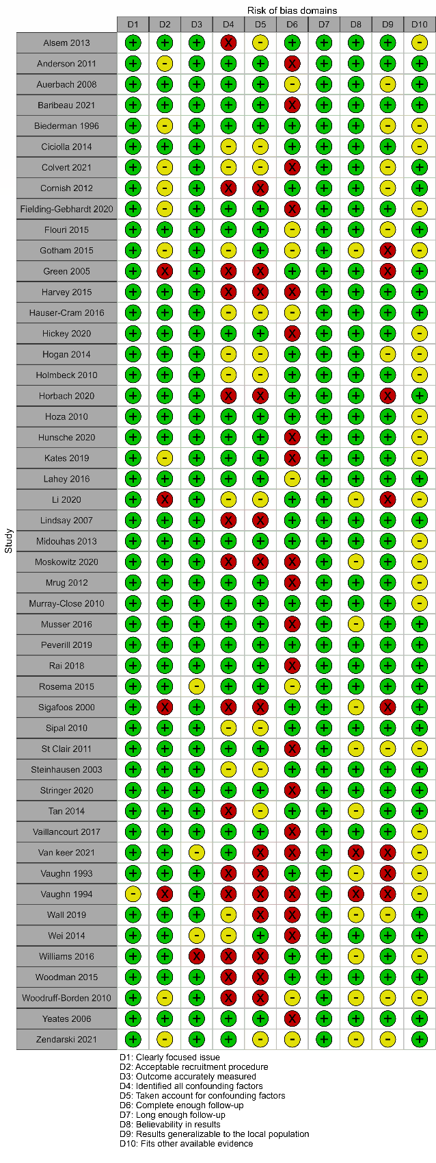
Supplementary Fig. 1 Assessment of the risk of bias following the CASP Checklist for the included studies
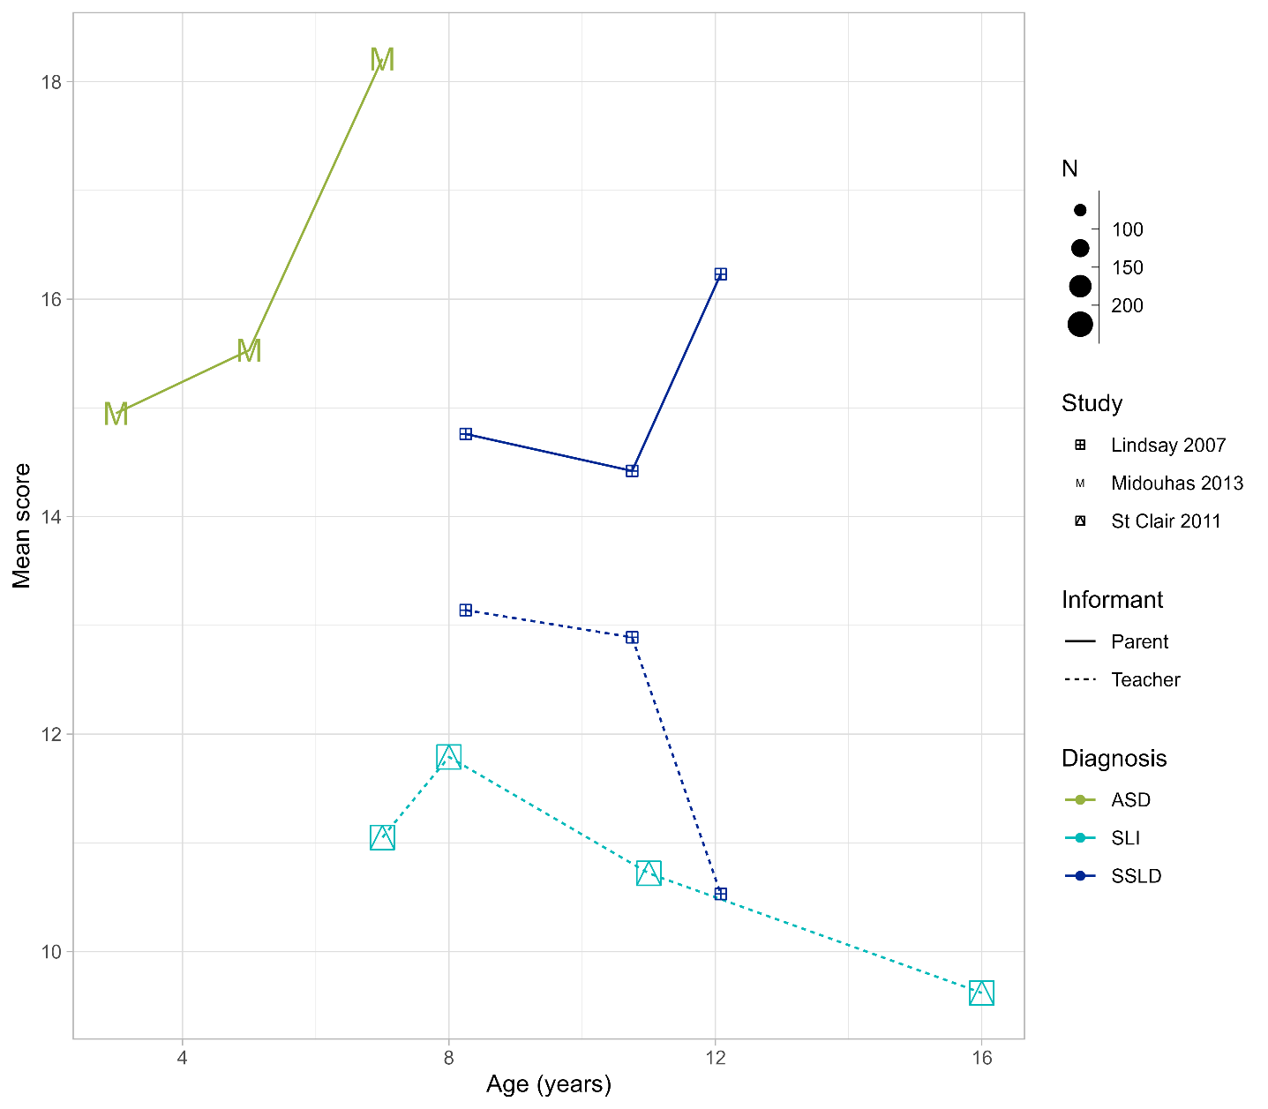
Supplementary Fig. 2 SDQ Total Scores
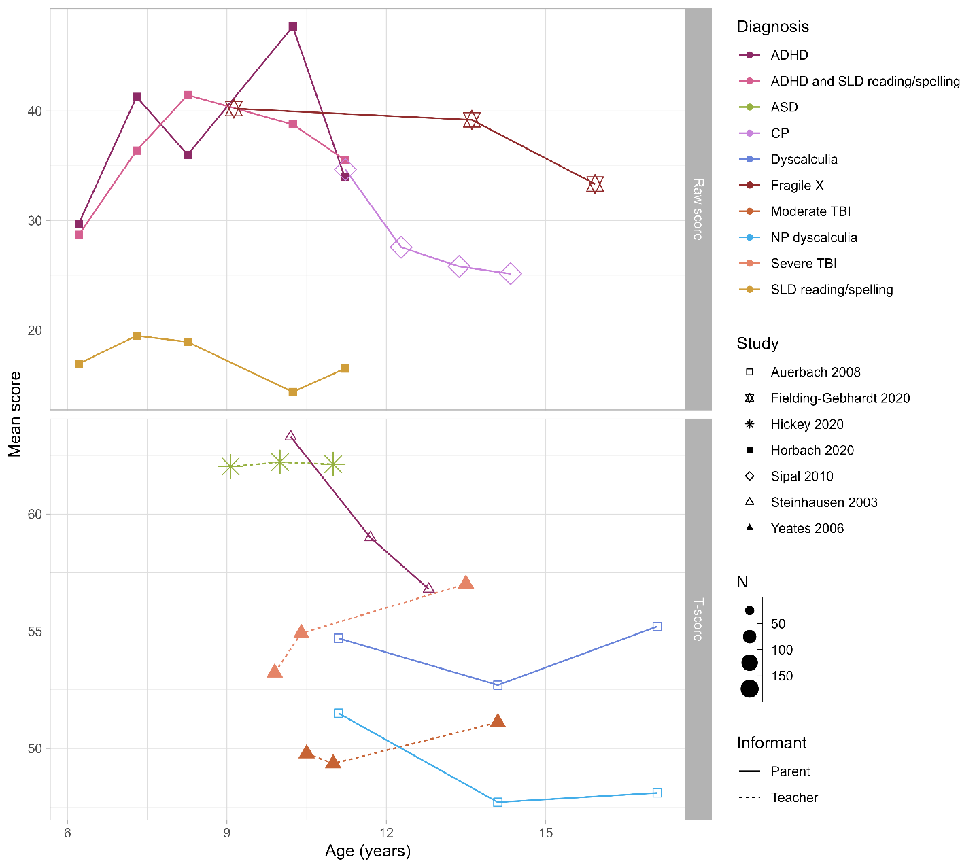
Supplementary Fig. 3 CBCL and TRF Total Scores
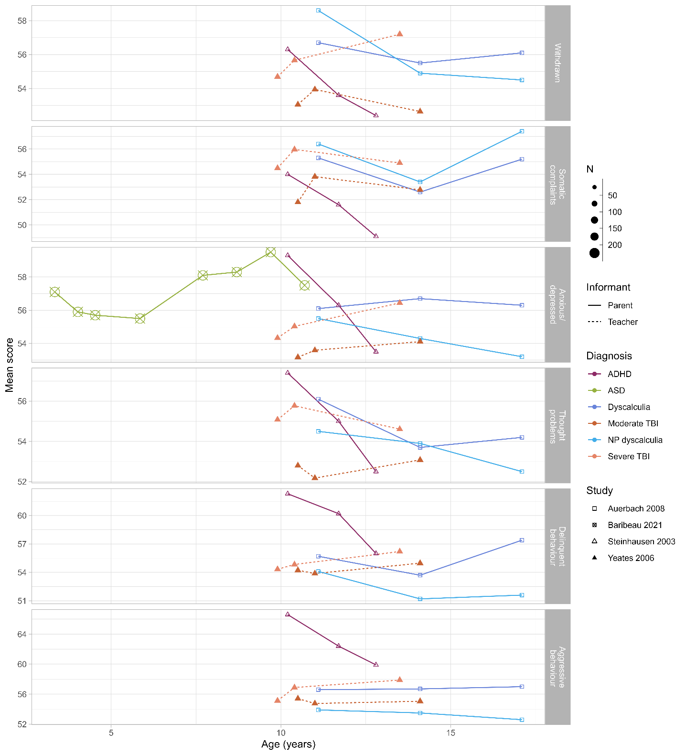
Supplementary Fig. 4 CBCL and TRF Subscales T-Scores

