Appendix

A Survey
Although all surveys were conducted in French, it was also translated into the local language Mooré for training purposes. During training, enumerators used the Mooré translation to standardise the questions if a participant wanted to be interviewed Mooré. Although all reference made to the survey in this article is given in English, no participant answered the survey in English.
The in-person survey included 121 questions on participants’ socio-demographics; how participants use mercury, equipment, specifically masks and gloves, and other mining equipment; participants’ general health and well-being; participants’ knowledge of mercury; participants’ attitude towards mercury, cyanide and technology; and participants’ contact details, which allows us to understand miners’ knowledge, use, attitudes, and perception of danger of mercury.
The first phone survey took on average 36 minutes to complete and included 22 questions over- lapped with the baseline survey, including questions on demographics to check if we surveyed the same person, equipment uses and perceptions of dangers of mercury. We included an additional 20 detailed questions on the use of masks and gloves, in order to measure changes in reported usage after receiving masks and gloves in the field experiment. Lastly, we included 18 questions on local gold markets and the COVID-19 pandemic for a separate research project.
The second phone survey took on average, 22 minutes to complete and included 23 questions. Five questions that overlapped with the baseline survey was used to check that we surveyed the same individual, including questions on demographics and the gift they received. Another 10 questions that overlapped with previous surveys focused on reported usage of masks and gloves, and the perception of mercury’s health risks. We gave participants information about when and where we will visit the mines to give feedback on the study. We also included two questions about their availability to attend the feedback sessions. Lastly, we included six questions on local gold markets and COVID-19 for a separate research project.

Baseline questionnaire
Section A: Introduction and consent
A1 Welcome to our study and thank you for showing interest in our project. We are a group of researchers and health workers working with ORCADE and the Swiss NGO Action de Carême and the Swiss university ETH Zurich. We are very interested to learn more about your work on the gold mine. By participating in this survey, you are contributing to a better understanding of the situation working on a mine in Burkina Faso and improving the lives of miners. We guarantee that your identities will be treated in strict confidentiality. If you are willing, we would like you to take part in our survey. The survey should take about 30 minutes. You are free not to take part in our survey or stop the survey at any time; you do not have to give a reason why. We will be at the mining site for a couple of days, and we will return to inform you of some of the results of the study next year in March. If you will not be here next year March or you have any other questions regarding our study, you can contact us the numbers on the business card. (GIVE BUSINESS CARD). The Swiss NGO Action de Carême and the Swiss university ETH Zurich fund this study.
A2. Are you willing to take part in our study?
A3. How old are you?
Section B: Demographics
B1 What is your gender?
B2 Are you expecting a child?
B3 Are you currently breastfeeding?
B4 What is your ethnicity?
B5 Can you read and write (any language)?
- I can write
- I can read
- I can read and write
- I cannot read and write
B6 On how many days did you listen to the radio in the last week?
B7 On how many days did you read the newspaper in the last week?
B8 What is the highest level of education?
- None / Did not attend school
- Primary education incomplete
- Primary education complete
- Secondary education incomplete
- Secondary education complete
- Technical school
- University incomplete
- University complete
- Other
B9 Where do you currently live?
- On the mine
- less than 1 hour from the mine
- 1 hour from the mine
- 2-5 hours from the mine
- more than 5 hours from the mine
B10 Do you have children younger than 15 years old?
B10.1 Do your children live with you?
- All of my children live with me
- Some of my children live with me
- None of my children live with me
- Rather not say
B11 Where are your children currently living?
- On the mine
- less than 1 hour from the mine
- 1 hour from the mine
- 2-5 hours from the mine
- more than 5 hours from the mine
B12 How many people - including you and children - live from the income you earn on this mine?
Section C: Health
C1 How do you feel today?
- I feel extremely well
- I feel very well
- I feel moderately well
- I feel slightly unwell
- I feel very unwell
C2 Did you feel sick during the last week?
C3 What symptoms have you had? Multiple options possible
- Chest tightness
- Respiratory infections (e.g. coughing, sore throat)
- Nausea
- Vomiting
- Headache
- Fever
- Diarrhoea
- Stomach cramps
- Fatigue
- Insomnia
- Difficulty remembering things
- Problems with breathing
- Problems with my eyes
- Other
C4 What do you think caused these symptoms? Multiple options possible
- Not enough food
- Dirty water
- Cold or flu
- Malaria
- Yellow fever
- The cold
- The heat
- Work on the mine
- Other
C5 What on the mine made you sick?
- Dust
- Cyanide
- Mercury
- Heavy work
- Bad air
- Humidity/moisture in the shafts
- Noise
- Other
Section D1: Daily activities
D1 What year did you start working on THIS mining site?
- before 2005
- ...
- 2019
D2 Have you worked on another mine before?
D2.1 Is this the primary mine you work on?
D3 On how many other mines have you worked before?
- 10 or more
- 9
- ...
- 1
D4 What year did you start working on artisanal gold mines?
- 2000 or before
- ...
- 2019
D4.1 Have you ever worked on large-scale mines?

D5 How often do you work on THIS mine?
- Almost every day
- 4-5 days a week
- Once a week
- Once every month
- Only once or twice before
- Rather not say
D5.1 Not considering today, when was the last day you worked on this mine?
- yesterday
- the day before yesterday
- 3 days ago
- last week
- last month
- can’t remember
D6 How many hours did you spend on the mine on that day?
- 1
- ...
- 12 or more hours
D7 Which of the following tasks do you perform on the mine? Please name all you are engaged in. Surveyor: READ out options - multiple option possible.
- Stabilise shafts
- Dynamite expert
- Excavating/digging
- Crushing
- Milling
- Cyanide leaching
- Concentrating
- Squeezing amalgamation
- Burning amalgamation
- Selling mercury
- Selling cyanide
- Selling gold
- Buying gold
- Selling mining equipment
- Selling water and food
- Coiffeur
- Transportation services
- Pit owner
- I do not perform any tasks on the mine
- Other
D8 How do you get paid for your main work on the mine? (Multiple option possible)
- In cash, daily salary
- In cash, weekly salary
- In cash, monthly salary
- In cash, per task
- In gold
- In ore
- Other
- Rather not say
Section D0: Gold
D0.1 Have you sold gold to a trader during the last month?
D0.4 Where did you sell the gold?
- At home
- On the mine
- Nearby processing center
- In the nearest village
- In the next town
- In another larger city
- in Ouagadougou
- Do not know
- Don’t want to say
D0.5 How many gold traders do you know to whom you can sell gold to?
- Only one
- 2
- ...
- 5
- More than 6
D0.6 Do you usually sell gold to the same person?
- Yes
- Most of the time
- Sometimes
- I always sell to someone else
D0.7 How much XOF did you get per gram for the gold the last time you sold gold?
- Less than XOF 20 000 per gram
- XOF 20,000-24,999 per gram
- XOF 25,000-29,999 per gram
- XOF 30,000-34,999 per gram
- XOF 35,000-39,999 per gram
- more than XOF 40,000 per gram
- Can’t remember
D0.8 How does the trader pay for the gold? Multiple options possible
- In cash
- Loan/credit
- Mercury
- I don’t know
- Rather not say
Sections D1: Cyanide /D2: Mercury /D3: Borax
(Only showing questions regarding mercury, same questions asked about cyanide and borax)
D2.1 Have you used mercury during the last month?
D2.2 How often do you use mercury?
- Almost everyday
- At least once per week
- Once every two weeks
- Once a month
- Only used it once or twice
- Don’t know
- Don’t want to say
D2.3 Where do you store mercury?
- On your person
- At home
- With the mercury trader
- At the site
- With a friend
- With the patron
- I do not store any mercury
- Don’t want to say
- Other
D2.4 The last time you got mercury, where did you get it?
- On the mine from a gold buyer
- On the mine from a friend
- On the mine from the patron
- On the mine from the mercury seller
- In the nearest village
- In the next town
- In a larger city
- A nearby processing center
- Do not know
- Don’t want to say
- Other
D2.5 How many mercury dealers do you know that you can get mercury from?
- Only one
- ...
- More than 6
D2.5.1 Do you always buy mercury from the same trader?
- Yes
- Most of the time
- Sometimes
- I always buy from someone else
D2.6 How much per ball did the mercury cost the last time you got it? (price ranges differ for mercury, cyanide and borax)
- It was for free
- ...
- Can’t remember
D2.6.1 How big is the ball of mercury?
- In grams:
- I do not know
- I do not want to say
D2.6.1 How do you get mercury?
D2.7 Is the person you get mercury from the same person that buys your gold?
D2.8 How much of the gold can you get out of ore using mercury? (one answer - READ answers)
- Almost all of the gold
- A lot of the gold
- About half
- Very little
- Don’t know
- Don’t want to say
Section E: Equipment
E0 What method do you think extract the most gold, mercury or cyanide?
- Mercury
- Cyanide
- I don’t know
- Rather not say
E1 Which of the following equipment have you used last month and/or own personally? Surveyor: Please READ out. Have you used one in the last month? Do you own one ?
- Shovel  - Pick axe  - Mill/Grinder  - Sluices boxes  - Shaking tables  - Gold washing pans | - Gas torch  - Goggles  - Masks  - Gloves  - Rope  - Retort | - Hammer  - Helmet  - Bags  - Crushing machine  - Scale  - None of the above

E2.1 Which of those items can you currently purchase on the mine from a trader or the patron? Surveyor: Please READ out answers. Multiple choice possible
- Shovel  - Pick axe  - Mill/Grinder  - Sluices boxes  - Shaking tables  - Gold washing pans | - Gas torch  - Goggles  - Masks  - Gloves  - Rope  - Retort | - Hammer  - Helmet  - Bags  - Crushing machine  - Scale  - None of the above

Sections F: Mask /G: Gloves /H: Retorts.
(Only showing questions regarding masks, same questions asked about gloves and retorts)
F1 Where can you buy a mask?
- On the mine
- In the nearest village
- In the next town
- In larger cities
- I do not know
- Other
F2 How much does a mask cost in XOF? (price ranges differ for question regarding gloves and retort)
- Less than XOF 300
- XOF 300- 390
- XOF 400-490
- XOF 500-590
- XOF 600-690
- XOF 700-790
- XOF 800 or more
- Do not know
F3 Do you or have you ever owned a mask?
- Yes, I currently own a mask
- Yes, I owned a mask in the past
- No, I do not and have never owned a mask
F3.1 Do you still use it?
F4 Why did you stop using the mask?
- I lost it
- It was stolen
- It broke
- It belonged to my previous patron
- It was not comfortable
- It did not work
- It was difficult to use
- It was not safe
- I borrowed it to somebody else
- My job changes
- Don’t know
- Don’t want to say
- Other
Additional question regarding retort: H1 Do you know what a retort is used for?
Section J: Mercury knowledge and perception
J1 What is the most dangerous thing on a mine site for you?
- Digging
- Mercury
- Cyanide
- Blasting
- Dust
- Landslides
- Machinery
- Shaft collapse
- Terrorists
- Contaminated water
- Crushing ore
- Other
J2 How dangerous is mercury on this mine to your health?
- Not at all dangerous
- Barely dangerous
- Somewhat dangerous
- Quite dangerous
- Very dangerous
- Don’t know
J2.1 What do you do to protect yourself from mercury? Multiple choice possible
- Stand clear from burning mercury
- Stand in opposite wind direction when burning mercury
- Do not attend mercury burning
- Never suck mercury out of ore
- I wear a mask on the mine
- I put my T-Shirt over my mouth on the mine
- I tie a piece of cloth around my nose and mouth
- I wear a mask when burning
- I use gloves when burning
- I put my T-Shirt over my mouth when burning
- I wash my hands after using mercury
- Nothing
- Other: _________________
J3 Which answers are true? (READ answers)
- If mercury is thrown into the water, it disappears
- If mercury is discarded in soil, it disappears
- If mercury is burnt, it disappears
- Mercury never disappears
J4 When is mercury the most dangerous? (one answer - READ answers)
- When touching it
- When washing it into ore
- When burning it
- Mercury is always equally dangerous
- Mercury is never dangerous
- Do not know
J5 Where is the safest place to burn mercury?
- Indoors
- Well-ventilated house
- Outdoors anywhere on the mine site
- Outdoors, away from other people
- Do not know
- Other
J6 What is in your opinion the biggest negative impact of mercury? (one answer - READ answers)
- Polluting the water
- Polluting the soil
- Polluting the air
- Polluting food
- Poisoning people
- Don’t know
J10 Have you ever heard of mercury poisoning?
J11 What are the symptoms? Multiple choice possible
- Chest tightness  - Rapid heartbeat  - Respiratory issues (incl. coughing)  - Kidney failure  - Madness  - Nausea  - Vomiting | - Headache  - Fever  - Diarrhoea  - Stomach cramps  - Fatigue  - Insomnia  - Difficulty remembering things | - Impotence  - Excessive saliva  - Bleeding gums  - Metal taste  - Difficulty moving  - Tremors | - Numbness  - Weight loss  - Skin rash  - Hair fall out  - Mood swings  - Other

J12 How can it be treated?
- With medication from health center
- Traditional healer
- Sleeping and resting
- It cannot be treated
- Don’t know
- Other
Section L: Education and training
L1 Have you ever attended a training about safety on the mines?
L3 Have you ever attended a theatre about safety on the mines?
L5 Have you ever heard information about safety on mines in the radio?

B Balance table for randomisation in experiment
Variable | (1)  Masks | (2)  Gloves | p-value
Age in years | 33.7 | 31.8 | 0.17
Received any education (binary) | 0.28 | 0.34 | 0.36
Listen to the radio (days per week) | 3.19 | 2.97 | 0.50
Know that mercury is not biodegradable (binary) | 0.23 | 0.26 | 0.64
Total symptoms of mercury poisoning known | 0.73 | 0.78 | 0.83
Years working in artisanal mining | 11.45 | 11.03 | 0.66
Use mercury at least once per week (binary) | 0.41 | 0.49 | 0.27
Have job that involves mercury (binary) | 0.50 | 0.54 | 0.55
Think mercury poisoning has treatment (binary) | 0.57 | 0.80 | 0.25
Exercise protection against mercury (binary) | 0.84 | 0.87 | 0.57
Children live with them, pregnant (binary) | 0.76 | 0.67 | 0.14
Know someone with mercury poisoning (binary) | 0.11 | 0.17 | 0.58
More than five dependants (binary) | 0.60 | 0.52 | 0.23
Get mercury for free (binary) | 0.32 | 0.31 | 0.92
Mercury is effective to extract gold (binary) | 0.85 | 0.83 | 0.82
Table B.1: Differences in samples receiving gloves and masks. P-values show if the mean of the sample who received masks and the sample who received gloves are significantly different.

C Information on mercury exposure given to miners
During the final visit to miners, we recorded the gift that miners chose (as indication of their PPE preferences). During this final field visit, miners could choose another gift (mask, gloves or soap), and miners involved in the burning of a gold amalgam receive a mask with activated carbon filters. We gave miners feedback on the results of the study, and how they could protect themselves in future against mercury, using the following materials. The impact of the information sessions is outside the scope of this study and has not been evaluated.
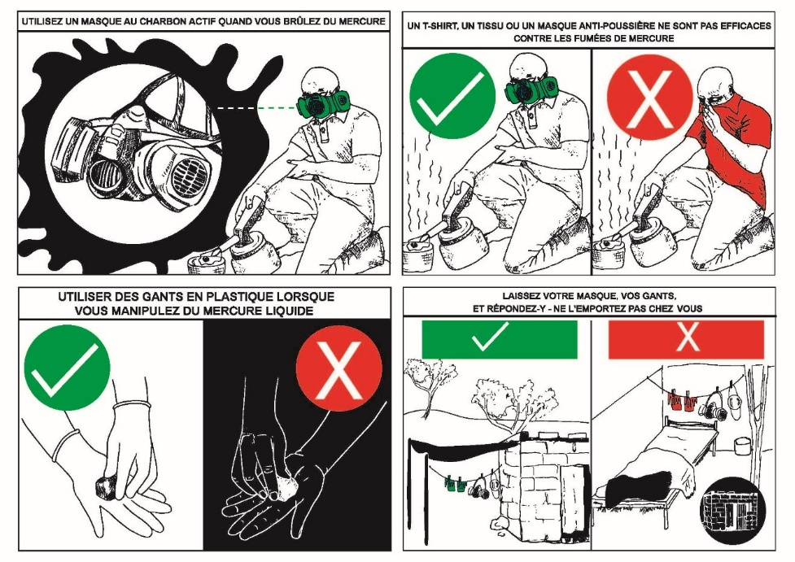
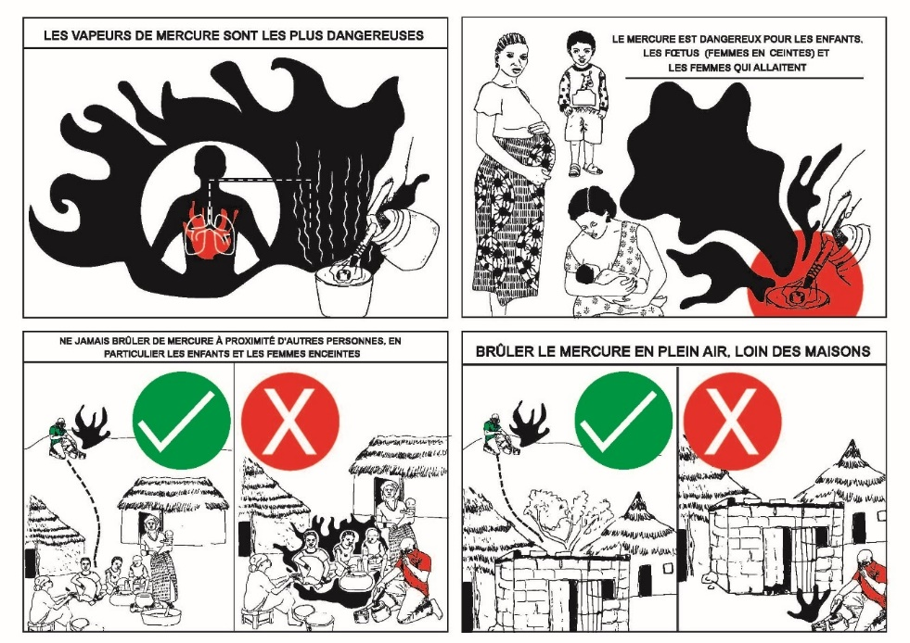
Figure C.1: Information given to miners. After study, miners were given more information on mercury, mercury exposure and how to protect themselves. Miners involved in burning gold amalgams were given masks with replaceable activated carbon filters.

D Inverse probability weighting
Inverse probability weights are used to address potential biases arising from attrition between survey rounds. This correction method is grounded on the assumption that selection into subsequent surveys is linked to specific individual characteristics recorded in the baseline survey. Inverse probability weights will give a higher weight to observations from participants that had characteristics that were significantly more likely to not complete surveys rounds.
To create the inverse probability weights, we create a variable for every participant in the baseline survey showing if they took part in each of the three follow-up surveys. We then run a logit regression for the probability of responding to follow-up surveys as a function of certain characteristics in the baseline survey. Then we estimate the fitted probabilities of these estimates, and lastly, we created weights with the inverse of the fitted probabilities in any analysis using data from follow-up surveys.
 | (1)  Did not complete round 2 | (2)  Did not complete round 3 | (3)  Did not attend feedback
Reference mine site: Sandouré
Ronguin | -0.042 | -0.496*** | -0.217**
 | (0.075) | (0.072) | (0.087)
Balaam-Tenga | 0.067 | -0.078 | 0.128
 | (0.085) | (0.113) | (0.112)
Zomkalga | 0.193*** | -0.060 | 0.099
 | (0.064) | (0.101) | (0.091)
Age in years | -0.003 | 0.001 | 0.007*
 | (0.003) | (0.005) | (0.004)
Participant is female | -0.088 | -0.194 | 0.015
 | (0.166) | (0.151) | (0.173)
Can read and write | 0.094 | 0.046 | 0.129
 | (0.063) | (0.088) | (0.083)
Years’ experience in artisanal mining | 0.001 | 0.005 | -0.007
 | (0.007) | (0.008) | (0.007)
Have children younger 15 | 0.256*** | 0.113 | 0.168*
 | (0.095) | (0.105) | (0.092)
Observations | 240 | 240 | 240
Table D.1: Balance table for attrition between rounds. Mean of selected baseline variables to determine possible attrition bias.

E Knowledge of mercury index
Using the six factual questions asked to miners about mercury (as shown in Table 2, Section 3.2), we applied Principal Component Analysis (PCA) to construct a composite variable representing the miners' knowledge of mercury. We used the “factor” package in Stata 17.0, specifying a principal-component factor.
Since PCA is sensitive to the scale of input variables, we transformed all the input variables into binary form. The only exception was the total number of symptoms identified, which we standardized by dividing the variable by seven (the maximum number of symptoms reported by any single miner), scaling it to a range from zero to one. We first standardised all variables from zero to one, since a principal component analysis is sensitive to the range of input variables. Figure E.1 shows the mean of all the input variables.
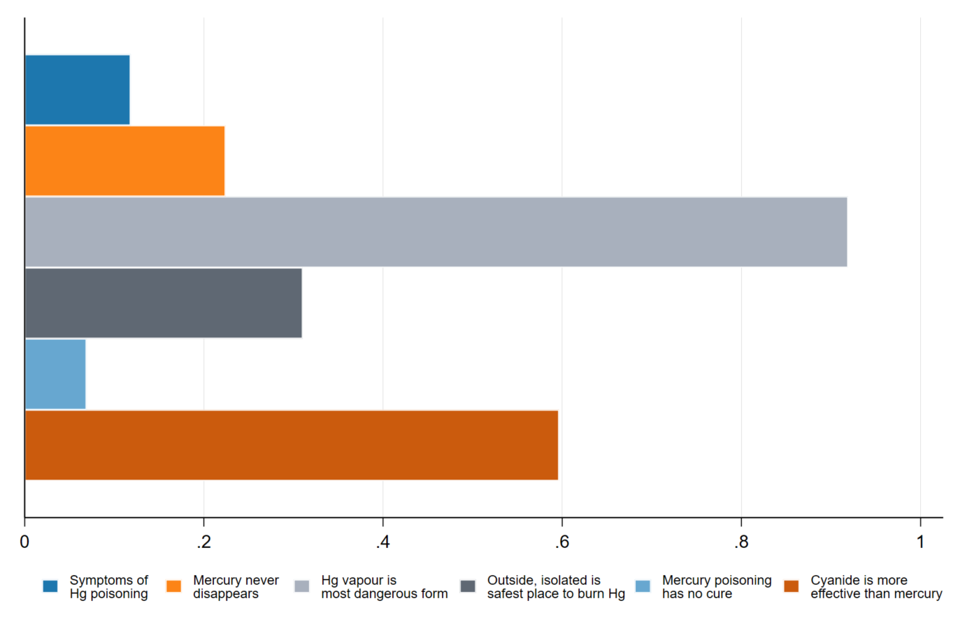
Figure E.1: The mean of all input variables for the PCA to calculate the Index of Mercury Knowledge
Table E.1 shows a correlation matrix between the input variables, to show how they relate to each other. The p-values to show if each correlation is significant is also included.
 | Symptoms mentioned | Hg never disappears | Hg vapour is most dangerous | Burning outside is safest | Hg poisoning has no cure | Cyanide is more effective
Symptoms mentioned | 1.0000
Hg never disappears | 0.3084  (0.0000) | 1.0000
Hg vapour is most dangerous | -0.0966  (0.1101) | -0.1221  (0.0431) | 1.0000
Burning outside is safest | -0.0706  (0.2424) | -0.0249  (0.6810) | 0.1157  (0.0554) | 1.0000
Hg poisoning has no cure | 0.2632  (0.0000) | -0.0686  (0.2562) | -0.0862  (0.1539) | 0.0715  (0.2363) | 1.0000
Cyanide is more effective | 0.0041  (0.9474) | 0.0032  (0.9594) | 0.1020  (0.1002) | -0.0781  (0.2076) | 0.1558  (0.0116) | 1.0000
Table E.1 Correlation matrix between input variables with p-values in parentheses
After analysing the PCA, using Stata software (17.0) with the “factor” command, specifying Stata to generate five factors. This was then followed by the post-estimation command “predict”. Table E.2 shows the Eigenvalues for each factor generated.
Factor | Eigenvalue | Difference | Proportion | Cumulative
Factor 1 | 1.385 | 0.153 | 0.231 | 0.231
Factor 2 | 1.232 | 0.153 | 0.205 | 0.436
Factor 3 | 1.079 | 0.114 | 0.180 | 0.616
Factor 4 | 0.964 | 0.173 | 0.161 | 0.777
Factor 5 | 0.791 | 0.243 | 0.132 | 0.909
Factor 6 | 0.548 | . | 0.091 | 1.000
Table E.2: Factor loadings for principal component analysis on knowledge of mercury
Similar to Table E.2, Figure E.2 shows the scree plot for the values. A scree plot is a line graph that shows Eigenvalues in descending order. One method to determine which Eigenvalue is significant is to identify any Eigenvalues in the scree plot above the “elbow”. An elbow of the graph is where the Eigenvalues have a substantial drop in value. However, in Figure E.2, there is no clear “elbow”.
In order to select the most appropriate factor of the PCA, we rather follow the Kaiser Criterion, we consider the first three factors, since they have an Eigenvalue larger than 1.
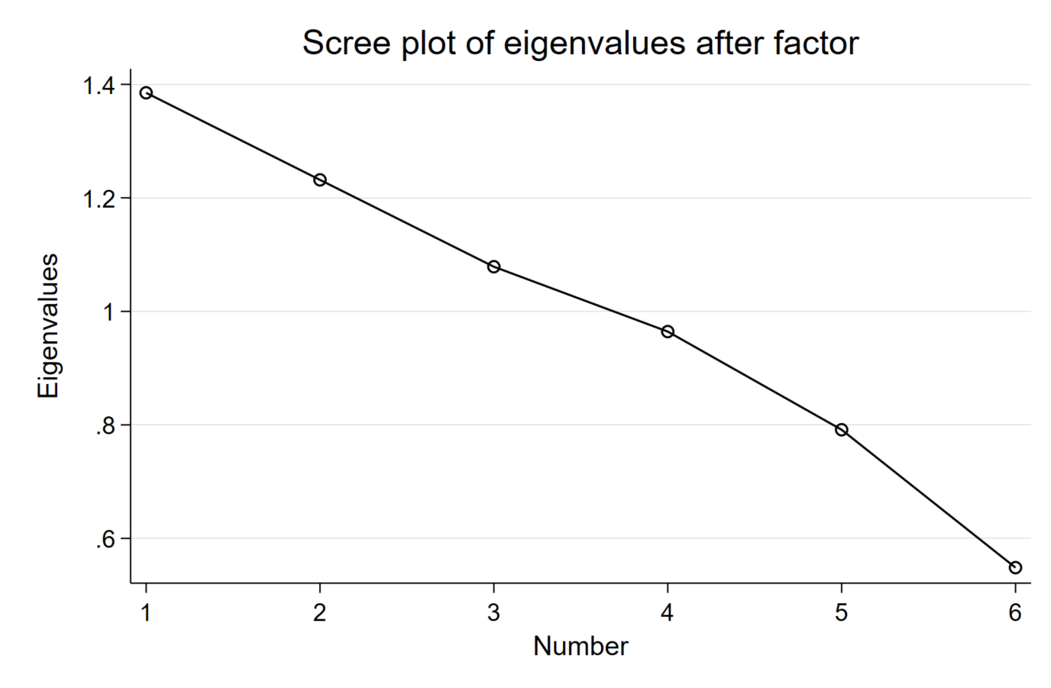
Figure E.2 Scree plot for Eigenvalues after factor
Lastly, in order to select the most appropriate factor, we selected the PCA based on its distribution. Since Index 1 and Index 2 had similar Eigenvalues, but Index 2 shown a more normal distribution, we used Index 2 in our analyses. We do not find any significant difference when using Index 1 as a control variable in any of the analyses, except that Index 1 does not show significant correlations with reported glove usage, while Index 2 does show a positive correlation (see Table 5, column 3).
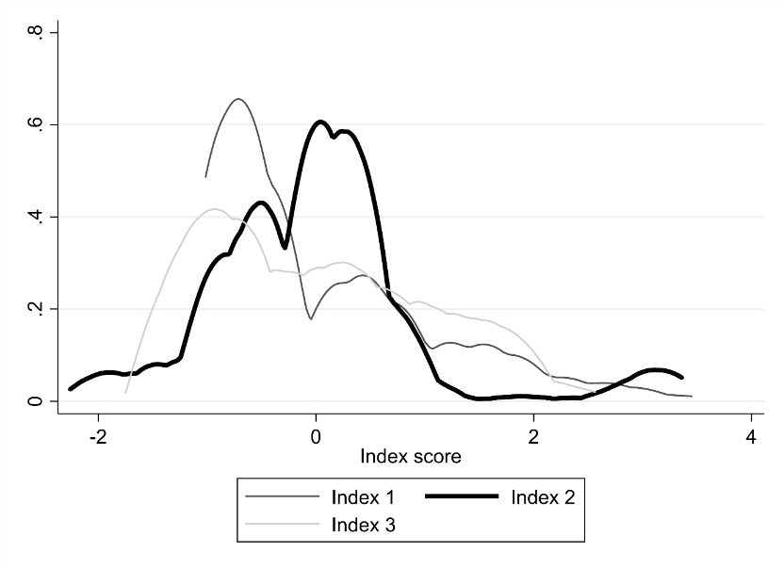
Figure E.3: Distribution of Index Scores. Density distribution of the index scores of the first three factor analyses, with Eigenvalues larger than one.

F Testing mercury’s perceived danger
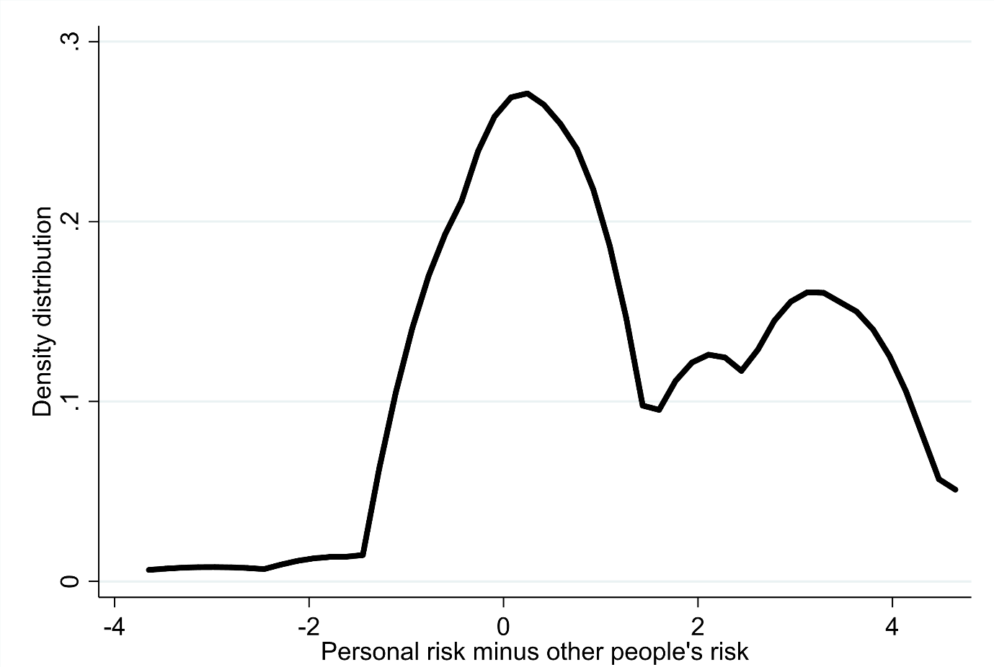
Figure F.1: Difference between perception of personal and general risk of mercury contamination. We asked participants on a five-point scale both what their person risk of mercury contamination is and what the contamination risk is of other people on the mine. The graph shows the difference between personal risk and other people’s risk.

