Supplementary Tables
Table 1: Combination index values for the compounds containing ≥ 60% acetylcholinesterase inhibitory activity. Combination index values that are bolded indicated synergistic activity.
Compounds |  | CI values when combined with donepezil
 |  | ¼ IC₅₀ | ½ IC₅₀ | IC₅₀
A8 | ¼ IC₅₀ | 0.97315 | 1.10127 | 1.36008
A8 | ½ IC₅₀ | 1.13606 | 1.14178 | 1.35792
A8 | IC₅₀ | 1.34679 | 1.2734 | 1.38135
A73 | ¼ IC₅₀ | 1.49738 | 1.07627 | 1.31801
A73 | ½ IC₅₀ | 1.11742 | 1.42789 | 1.28898
A73 | IC₅₀ | 1.52648 | 1.30244 | 1.55634
A136 | ¼ IC₅₀ | 2.6799 | 1.16448 | 1.22352
A136 | ½ IC₅₀ | 0.61572 | 0.81085 | 1.03392
A136 | IC₅₀ | 0.81611 | 0.69063 | 1.00737
C53 | ¼ IC₅₀ | 0.82461 | 1.11644 | 3.26654
C53 | ½ IC₅₀ | 1.20981 | 1.66732 | 1.80658
C53 | IC₅₀ | 1.36329 | 1.92501 | 2.63125
C129 | ¼ IC₅₀ | 1.24306 | 0.98440 | 1.88882
C129 | ½ IC₅₀ | 1.20119 | 1.57913 | 2.81944
C129 | IC₅₀ | 1.84031 | 2.70451 | 3.86729
CI: combination index; IC₅₀: concentration resulting in 50% inhibition. CI < 1 indicates synergism, equal to 1 indicates additive activity, and > 1 indicates antagonism.

Supplementary Figures
Figure 1: Plate layout used to determine the combinatorial effect of donepezil and the active compound. IC₅₀: concentration resulting in 50% inhibitory effect.
Figure 2: Lineweaver-Burk plot for enzyme inhibition. Graph A: competitive inhibition; B: uncompetitive inhibition; C: noncompetitive inhibition and D: mixed inhibition. V_{max}: maximum rate of reaction when the enzyme is saturated with substrate. K_{m}: concentration of substrate which permits the enzyme to achieve half V_{max}. v: reaction velocity; [S]: substrate concentration. [Reproduced with permission from Lopina, 2017 (author), licensed under Creative Commons Attribution License (http://creativecommons.org/licenses/by/3.0)].
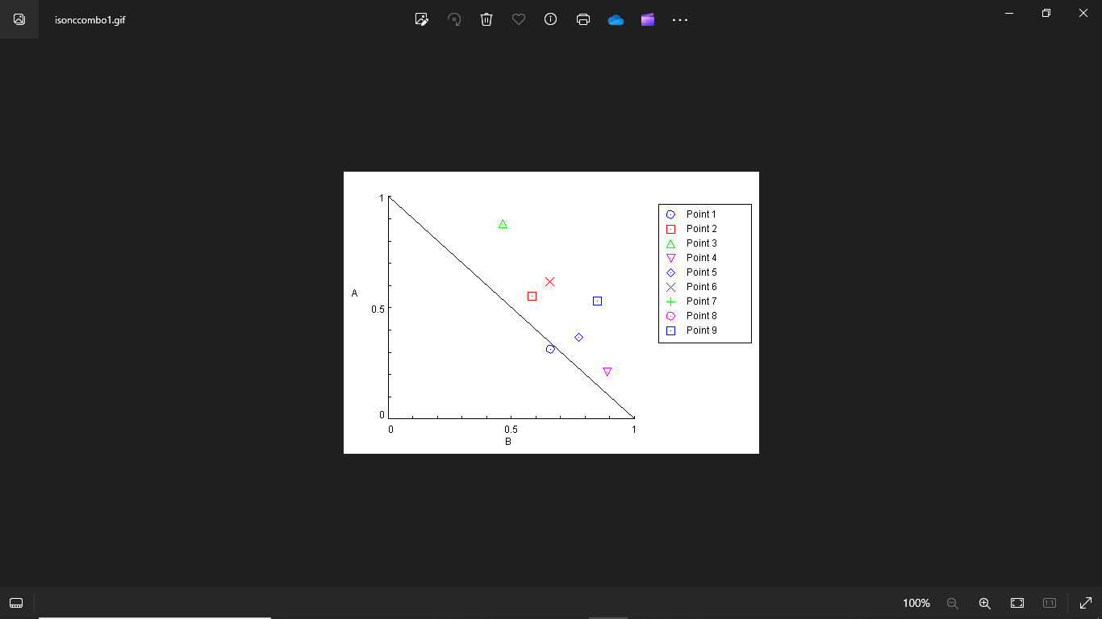
Compound A8 (µM)

¼ IC₅₀ D + ¼ IC₅₀ A8
¼ IC₅₀ D + ½ IC₅₀ A8
¼ IC₅₀ D + ½ IC₅₀ A8
½ IC₅₀ D + ¼ IC₅₀ A8
½ IC₅₀ D + ¼ IC₅₀ A8
½ IC₅₀ D + ¼ IC₅₀ A8 IC₅₀ D + ¼ IC₅₀ A8
IC₅₀ D + ½ IC₅₀ A8
IC₅₀ D + IC₅₀ A8

Donepezil (µM)

Figure 3: Normalized isobologram for the combination of compound A8 and donepezil. D: donepezil, IC₅₀: concentration resulting in 50% inhibitory effect.
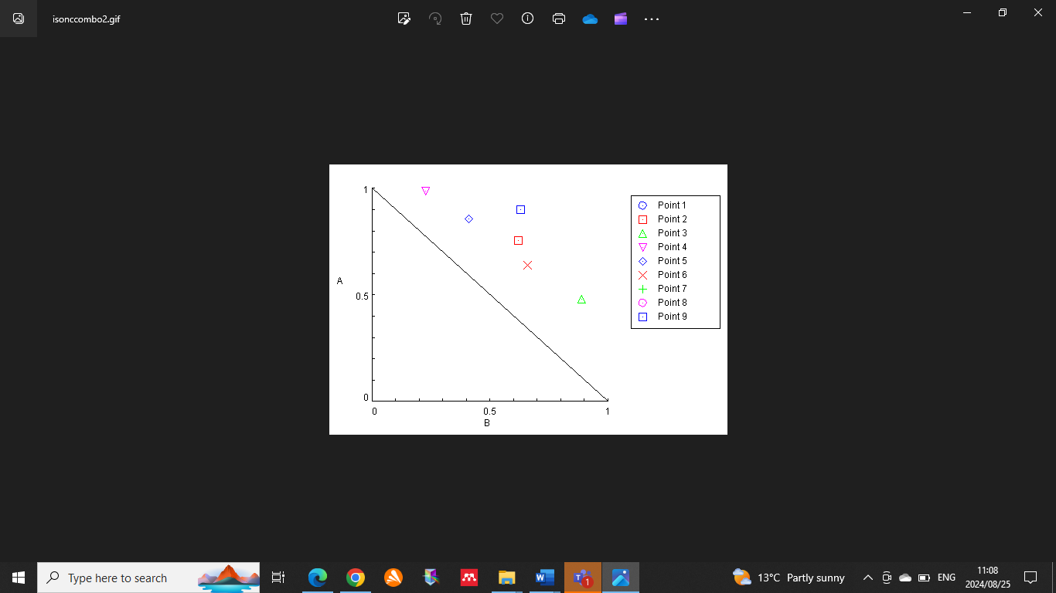
Compound A73 (µM)

¼ IC₅₀ D + ¼ IC₅₀ A73
¼ IC₅₀ D + ½ IC₅₀ A73
¼ IC₅₀ D + ½ IC₅₀ A73
½ IC₅₀ D + ¼ IC₅₀ A73
½ IC₅₀ D + ¼ IC₅₀ A73
½ IC₅₀ D + ¼ IC₅₀ A73 IC₅₀ D + ¼ IC₅₀ A73
IC₅₀ D + ½ IC₅₀ A73 IC₅₀ D + IC₅₀ A73

Donepezil (µM)

Figure 4: Normalized isobologram for the combination of compound A73 and donepezil. D: donepezil, IC₅₀: concentration resulting in 50% inhibitory effect.

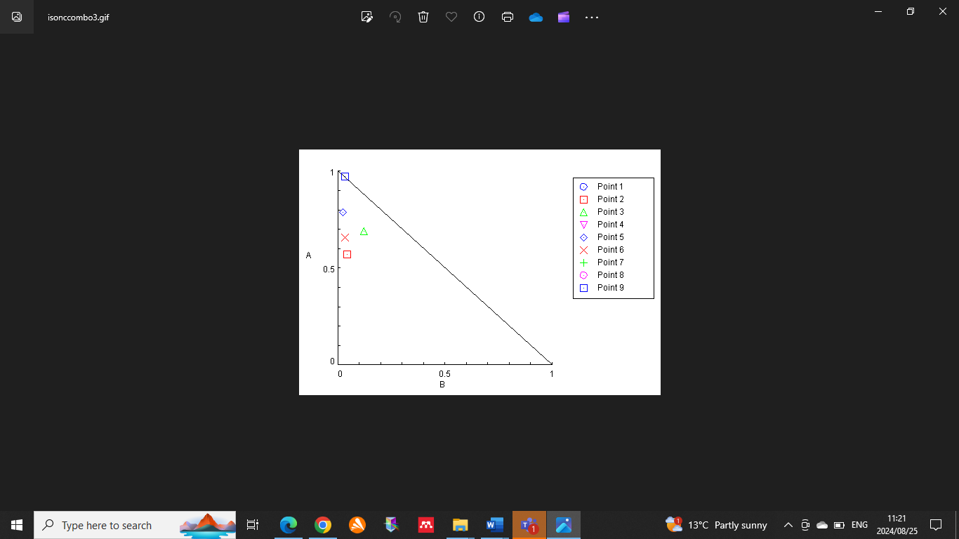
Compound A136 (µM)

¼ IC₅₀ D + ¼ IC₅₀ A136
¼ IC₅₀ D + ½ IC₅₀ A136
¼ IC₅₀ D + ½ IC₅₀ A136
½ IC₅₀ D + ¼ IC₅₀ A136
½ IC₅₀ D + ¼ IC₅₀ A136
½ IC₅₀ D + ¼ IC₅₀ A136
IC₅₀ D + ¼ IC₅₀ A136
IC₅₀ D + ½ IC₅₀ A136
IC₅₀ D + IC₅₀ A136

Donepezil (µM)

Figure 5: Normalized isobologram for the combination of compound A136 and donepezil. D: donepezil, IC₅₀: concentration resulting in 50% inhibitory effect.
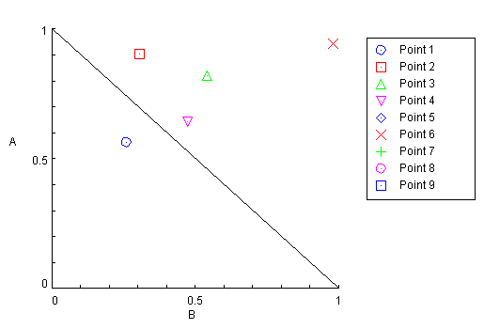
Compound C53 (µM)

Donepezil (µM)

¼ IC₅₀ D + ¼ IC₅₀ C53
¼ IC₅₀ D + ½ IC₅₀ C53
¼ IC₅₀ D + ½ IC₅₀ C53
½ IC₅₀ D + ¼ IC₅₀ C53
½ IC₅₀ D + ¼ IC₅₀ C53
½ IC₅₀ D + ¼ IC₅₀ C53 IC₅₀ D + ¼ IC₅₀ C53
IC₅₀ D + ½ IC₅₀ C53 IC₅₀ D + IC₅₀ C53

Figure 6: Normalized isobologram for the combination of compound C53 and donepezil. D: donepezil, IC₅₀: concentration resulting in 50% inhibitory effect.
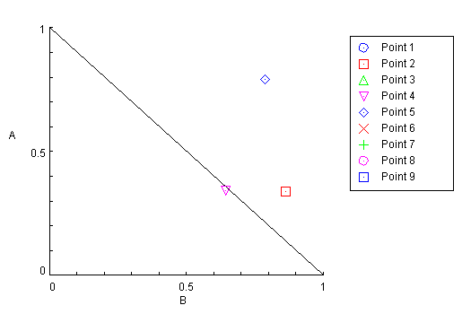
Compound C129 (µM)

Donepezil (µM)

¼ IC₅₀ D + ¼ IC₅₀ C129
¼ IC₅₀ D + ½ IC₅₀ C129
¼ IC₅₀ D + ½ IC₅₀ C129
½ IC₅₀ D + ¼ IC₅₀ C129
½ IC₅₀ D + ¼ IC₅₀ C129
½ IC₅₀ D + ¼ IC₅₀ C129 IC₅₀ D + ¼ IC₅₀ C129
IC₅₀ D + ½ IC₅₀ C129
IC₅₀ D + IC₅₀ C129

Figure 7: Normalized isobologram for the combination of compound C129 and donepezil. D: donepezil, IC₅₀: concentration resulting in 50% inhibitory effect.

Figure 8: The effect of amenable compounds on bEnd.5 cell density after 72 h exposure. Amenable compounds were defined as those possessing acetylcholinesterase inhibitory activity but no SH-SY5Y cytotoxicity and were blood-brain barrier permeable as predicted in silico.

Figure 9: The effect of donepezil (D) and compound C53 individually or in combination on bEnd.5 cells. IC₅₀: concentration resulting in 50% inhibition; NC: negative control.

Figure 10: Lineweaver-Burk plots of the compounds that contained acetylcholinesterase inhibitory activity and predicted blood-brain barrier permeability. A) donepezil (competitive and non-competitive inhibition), B) A8 (uncompetitive inhibition), C) A73 (mixed inhibition) and D) C53 (mixed inhibition). v: reaction velocity; [s]: substrate concentration.

Figure 11: Cellular acetylcholinesterase inhibitory activity of donepezil (D) and compound C53 individually and in combination in SH-SY5Y cells. Significance of inhibition relative to negative control is indicated as * p < 0.1. IC₅₀: concentration resulting in 50% inhibition; NC: negative control.

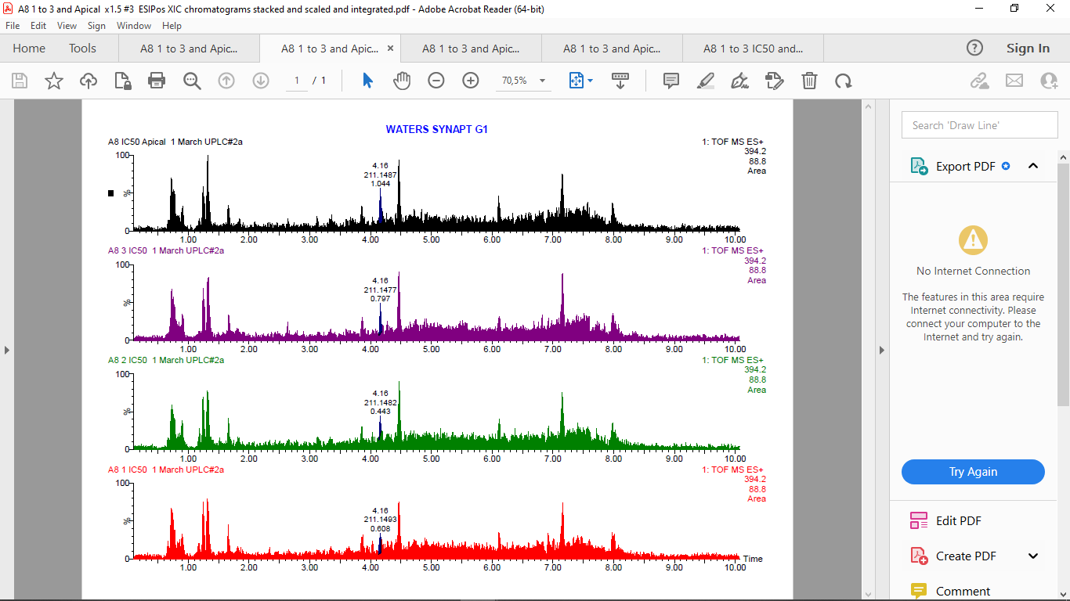
A8 (IC₅₀)
A8 (IC₅₀)
Basolateral chamber

Apical chamber
Apical chamber

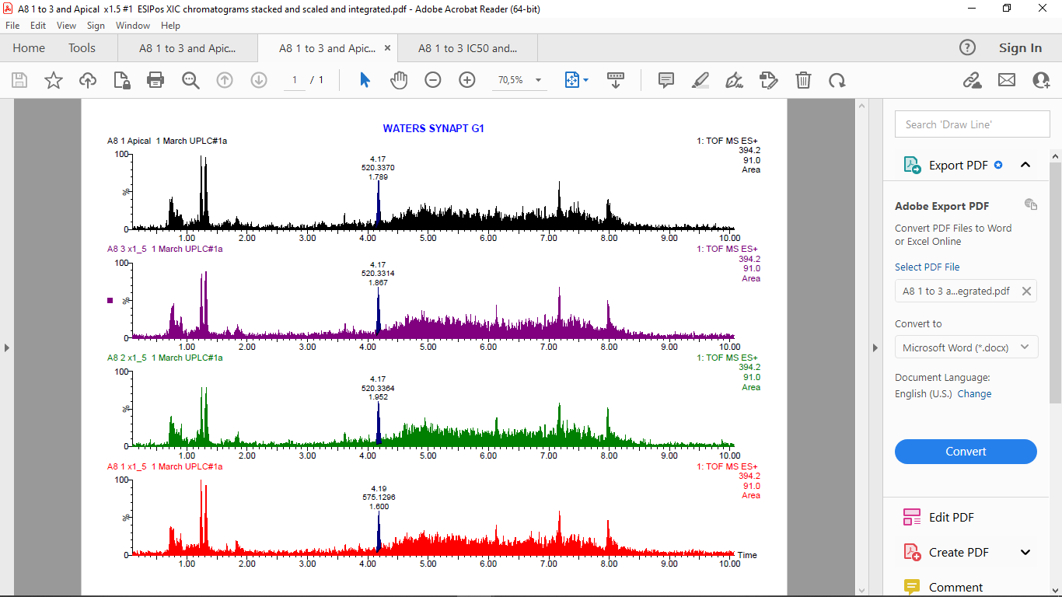
A8 (1.5 × IC₅₀)
A8 (1.5 × IC₅₀)

Basolateral chamber

Figure 12: The positive electrospray ionisation chromatograms for A8 at half maximal inhibitory concentration and 1.5 × half maximal inhibitory concentration.
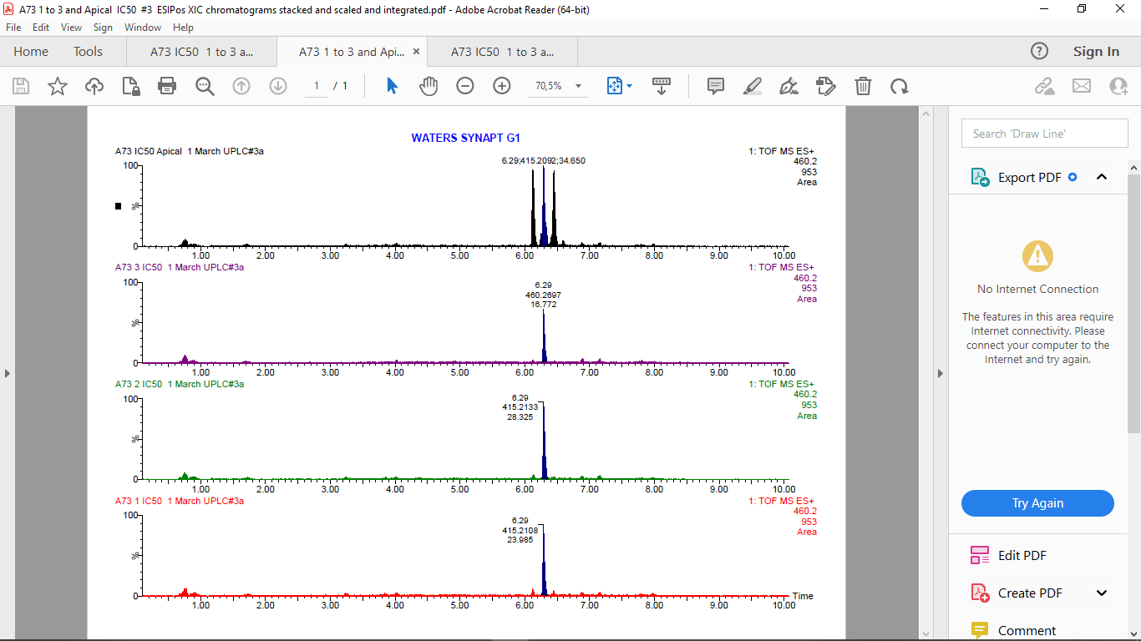
A73 (IC₅₀)
Basolateral chamber

A73 (IC₅₀)
Apical chamber

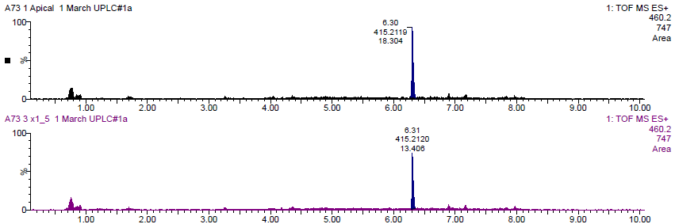Figure 13: The positive electrospray ionisation chromatograms for A73 at half maximal inhibitory concentration and 1.5 × half maximal inhibitory concentration.

Basolateral chamber
A73 (1.5 × IC₅₀)

A73 (1.5 × IC₅₀)
Apical chamber

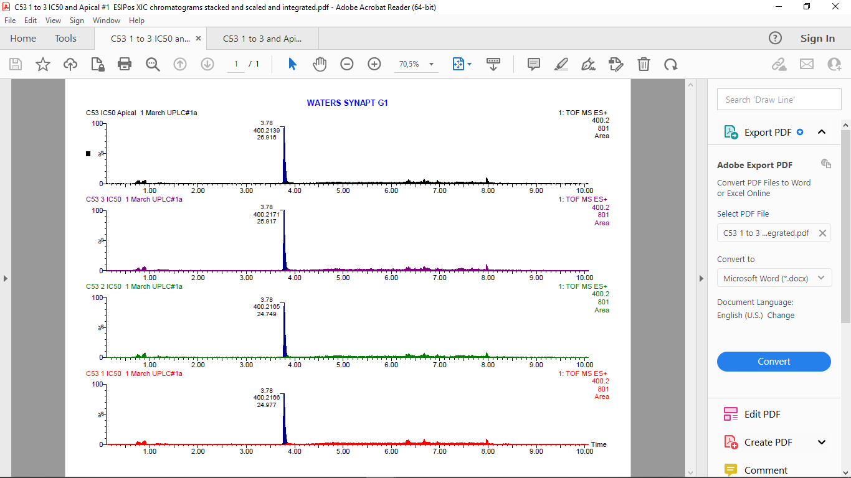
Apical chamber

Basolateral chamber

C53 (IC₅₀)
C53 (IC₅₀)
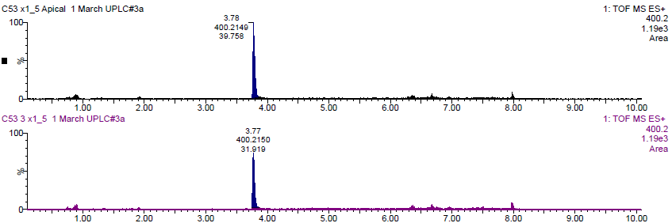
Basolateral chamber

Apical chamber
C53 (1.5 × IC₅₀)

C53 (1.5 × IC₅₀)
Figure 14: The positive electrospray ionisation chromatograms for C53 at half maximal inhibitory concentration and 1.5 × half maximal inhibitory concentration.
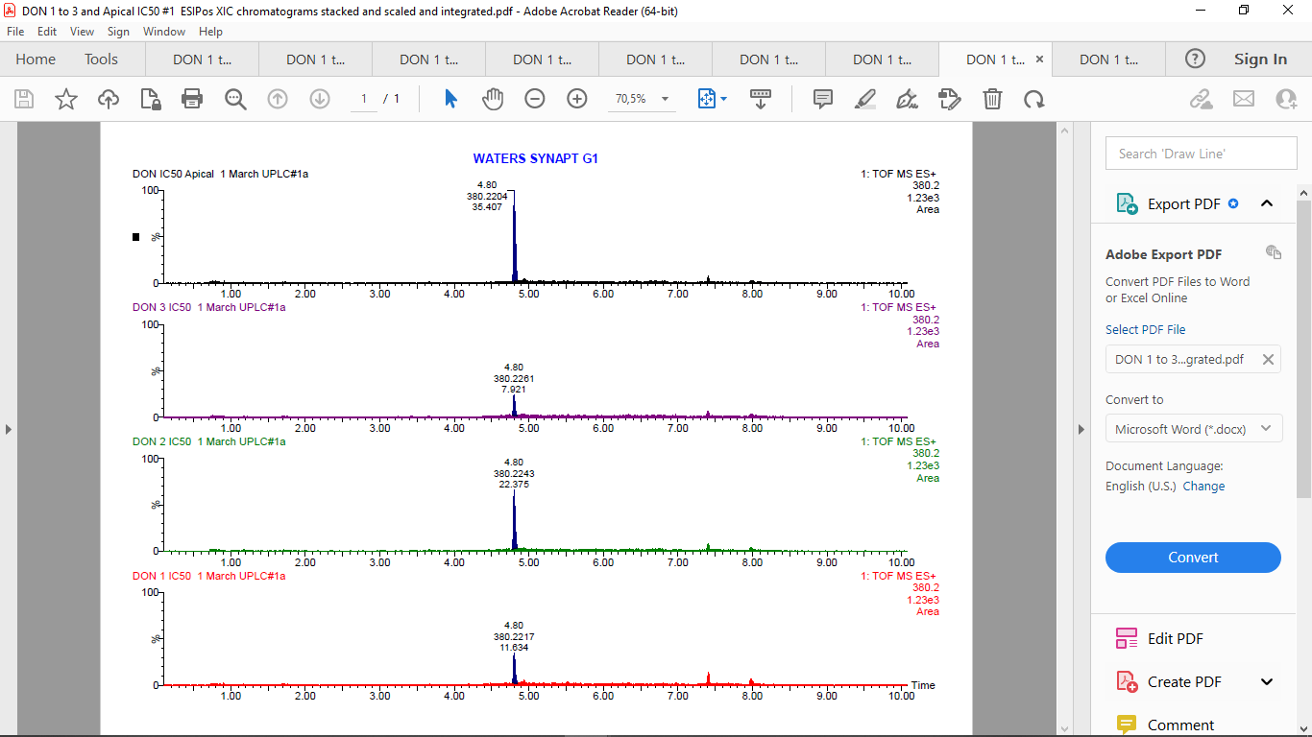
Basolateral chamber
Donepezil (IC₅₀)
Donepezil (IC₅₀)
Apical chamber

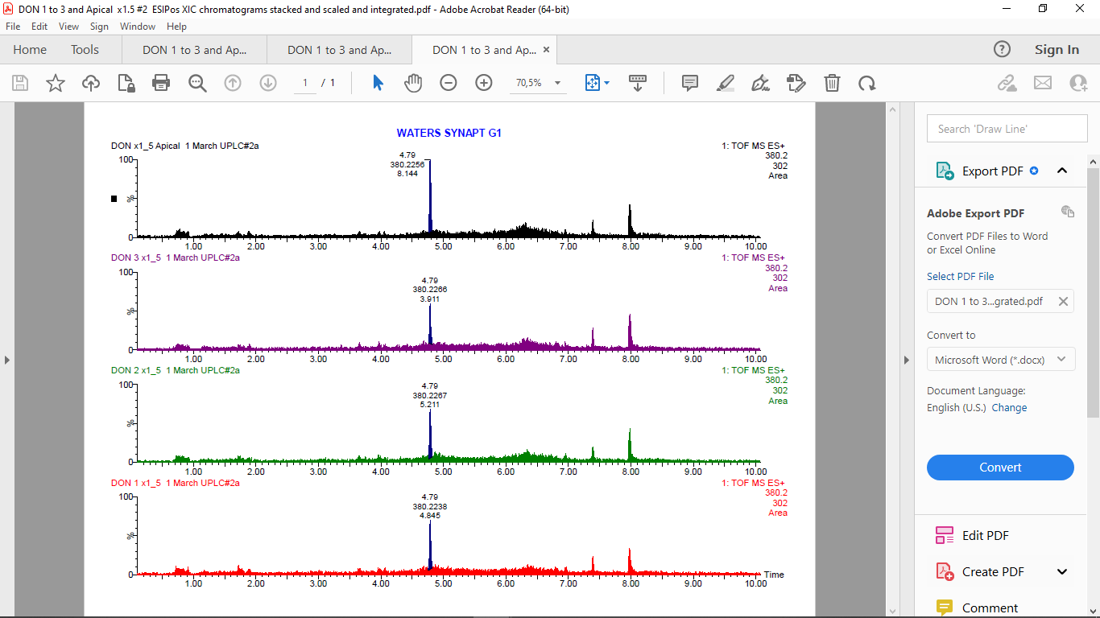Figure 15: The positive electrospray ionisation chromatograms for donepezil at half maximal inhibitory concentration and 1.5 × half maximal inhibitory concentration.
Basolateral chamber
Apical chamber
Donepezil (1.5 × IC₅₀)
Donepezil (1.5 × IC₅₀)

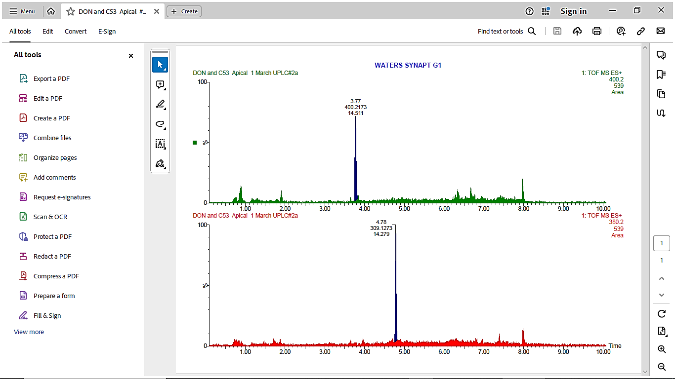
Apical chamber
Apical chamber

Donepezil (¼IC₅₀)

C53 (¼IC₅₀)
Figure 16: The positive electrospray ionisation chromatograms for the combination of donepezil and C53 in the apical chamber. IC₅₀: half maximal inhibitory concentration.

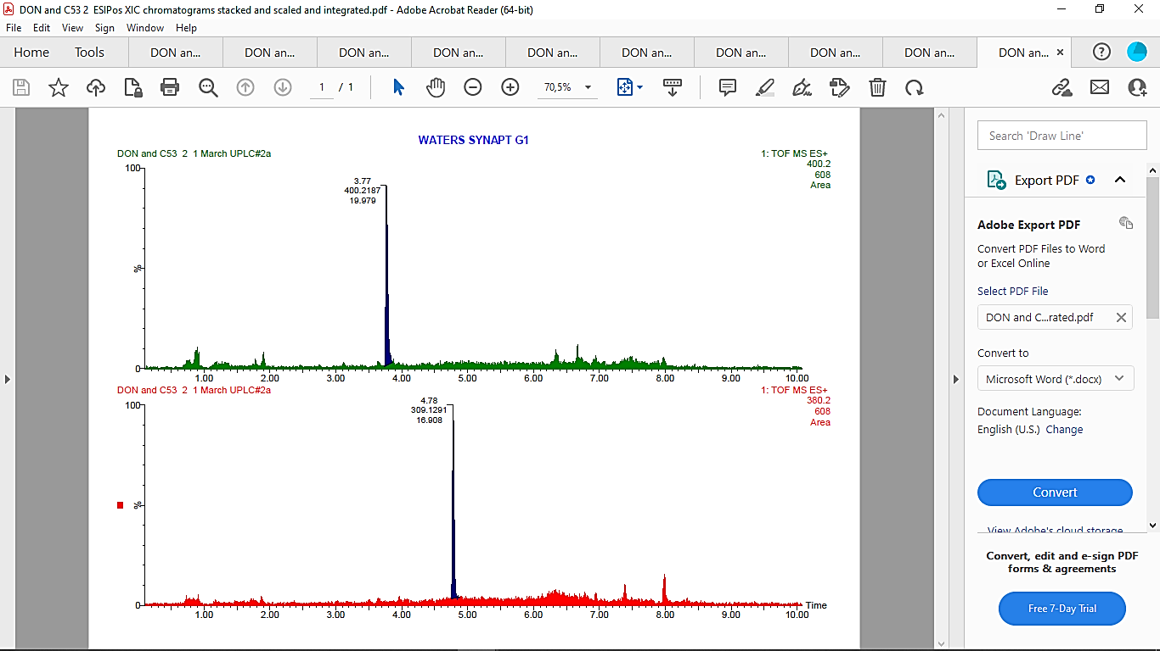
Basolateral chamber
Basolateral chamber

Donepezil (¼IC₅₀)
C53 (¼IC₅₀)
Figure 17: The positive electrospray ionisation chromatograms for the combination of donepezil and C53 in the basolateral chamber. IC₅₀: half maximal inhibitory concentration.

