Insider Threat Discovery Model for Vehicle Tracking (ITDMVT)

by

DANIËL JACOBUS JOUBERT

Submitted in fulfilment of the requirements for the degree
Magister Scientia (Computer Science)

in the

FACULTY OF ENGINEERING, BUILT ENVIRONMENT AND INFORMATION TECHNOLOGY

at the

UNIVERSITY OF PRETORIA
PRETORIA, SOUTH AFRICA

SUPERVISOR: Prof. J.H.P. Eloff

Date of submission
15-07-2019

Abstract
A number of simplistic and practical rule-based approaches are already in place to discover possible insider threat scenarios by using data from vehicle-tracking systems. Most of these approaches focus on known insider threat scenarios and are extended when unknown scenarios are discovered accidently or after extensive investigation. Thus, a significant landscape of insider threats scenarios remains undiscovered. Adding to this, insider threats find creative ways to inflate this undiscovered landscape. Another problem is that the cost associated with employing and training a sufficient number of people to work through the data records generated by vehicle-tracking devices is prohibitively high, if not impossible. Because of these problems, it is nearly impossible to calculate the total revenue and productivity loss as a result of insider threat activity in commercial fleets. Although various research studies indicate that anomaly detection is a valid generic approach to discover insider threats, there is unfortunately no practical evidence available to indicate that it has been used with success in a commercial environment.
The current research set out to utilise anomaly detection – a field of study within data science and machine learning – to investigate irregularities in respect of vehicle-tracking data that may lead to the discovery of insider threats. Because vehicle-tracking providers have large datasets, it was suggested that Big Data be factored in with the process of discovering insider threats.
The research in this document investigated the available data within the vehicle-tracking industry, general approaches towards the management of insider threats, and the application of anomaly detection to vehicle-tracking data. Based on this investigation, a prototype design was developed and applied to data from the vehicle-tracking industry. This application of the process model demonstrated that applying anomaly detection to vehicle-tracking data is a valid approach to discover insider threats.
The research discussed here demonstrated that using anomaly detection to discover insider threats had both advantages and disadvantages. The advantages included amongst other, being able to find undiscovered insider threat activity, whereas the disadvantages were the complexity and time-consuming nature of the processes.

Acknowledgements
I want to thank the following persons for their contribution towards the success of this dissertation:
- As a Bible-believing Christian, I want to give all the glory and honour to God, the Creator of all things, for making the completion of this work possible.
- I wish to thank Prof. J.H.P. Eloff, who masterfully assisted to craft this document, for his continued patience and enormous expertise. He not only provided assistance and mentorship to enrich the content of my research, but also enhanced my personal experience and exposure as a researcher.
- My wife and children who inspired me to improve and invest in myself and them.
- My employer Netstar (Pty) Ltd, who assisted financially and allowed me to utilise available infrastructure and data.

Abstract 2
Acknowledgements 3
Chapter 1 8
1.1 Introduction 8
1.2 Dissertation Statement 12
1.3 Problem Statement 13
1.4 Research Questions 13
1.5 Scope and Context of Study 15
1.6 Research Methodology 15
1.7 Terminology Used 16
1.8 Layout of Dissertation 18
Chapter 2 20
2.1 Introduction 20
2.2 Company Profile 20
2.3 Products and Services 21
2.4 Types of Vehicle-tracking Devices 22
2.5 Data Description 23
2.6 Data Structure and Logical Data Flow 26
2.7 Known System and Vehicle-Tracking Device Data Issues 27
2.8 Management of Vehicle Abuse 29
2.9 Conclusion 33
Chapter 3 34
3.1 Introduction 34
3.2 Insider Threat Overview 34
3.3 Insider Threat Prevention, Discovery and Prediction 37
3.4 Conclusion 48
Chapter 4 49
4.1 Introduction 49
4.2 Introduction to Anomalies 50
4.3 Discovering Insider Threats by using Anomaly Detection 55
4.4 Related Work: Research Discussion 72
4.5 Conclusion 79
Chapter 5 81
5.1 Introduction 81
5.2 Selecting Algorithms 82
5.3 Implementation 83
5.4 Observations 94
5.5 Conclusion 95
Chapter 6 96
6.1 Introduction 96
6.2 ITDMVT – Process Model 96
6.3 ITDMVT Overview 98
6.4 ITDMVT Detail Description 98
6.5 Feedback loops 104
6.6 Conclusion 104
Chapter 7 105
7.1 Introduction 105
7.2 Experimental Design 105
7.3 Experimentation 107
7.4 Observations 121
7.5 Verification 122
7.6 Conclusion 122
Chapter 8 124
8.1 Introduction 124
8.2 Selecting a Fleet of Vehicles 124
8.3 Experimental Design 125
8.4 Design Implementation 126
8.5 Observations 149
8.6 Verification 150
8.7 Conclusion 150
Chapter 9 152
9.1 Introduction 152
9.2 Addressing the Problem Statement 152
9.3 Main Contributions 157
9.4 Future Research 159
Appendix A 161
Appendix B 166
Appendix C 167
Appendix D 168
Appendix E 173
1. Common Script 173
2. R Script for Chapter 7 174
3. R Script for Chapter 8 – Experiment 1 177
4. R Script for Chapter 8 – Experiment 2 180
5. R Script for Chapter 8 – Experiment 3 183
6. R Script for Chapter 8 – Experiment 4 186
Appendix F 191
1. Detail Search Results 191
2. High-Level Algorithm Investigation 208
Appendix G 221
1. April to June 2015 221
2. July to September 2015 233
3. October to December 2015 235
4 January – March 2016 238
5 April – June 2016 239
Appendix H 242
1. Experiment 1 242
2 Experiment 2 254
3 Experiment 3 265
4 Experiment 4 273
Bibliography 291

Chapter
  - Introduction

Introduction
Corporates as well as individuals benefit from the continued reduction in cost of modern Internet of Things (IoT) devices, and they profit from the usefulness of the data obtained from these devices. IoT devices automate what used to be expensive and laborious tasks, such as taking systematic measurements and performing various mechanical and electrical tasks. A simple example is that of a thermostat device that measures temperature, adjusts a cooling device accordingly, displays the current temperature, and may even keep a historical record of previous measurements.
This automation allows humans to focus on the task at hand by rendering the manual capturing of data and the auditing of such captured data totally unnecessary. An IoT device such as a vehicle-tracking device with an electronic key identifier, removes the necessity for drivers to capture their use of a particular corporate vehicle in a logbook at all. Even private individuals can obtain a logbook of their vehicle utilisation for business and tax purposes with little effort (Altech Netstar (Pty) Ltd, 2017, p. Tax Logbook).
Other benefits derived from utilising IoT devices for automation include a range of low-cost services that allow both corporates and individuals to increase profit margins, reduce expenditure, manage and assess risk, as well as enhance the visibility and control of vehicles. An example of risk management is where vehicle-tracking data is used to motivate drivers to adhere to road speed limits when driving (Altech Netstar (Pty) Ltd, 2017, p. Overspeeding).
The high number of connected IoT devices, the broad range of IoT devices with various sensors and actuators (Flesca et al., 2018), as well as the ability to process data on a large scale, brought great advancement in the areas of machine learning, robotics and production techniques. This progress has led to the creation of a wide range of new and advanced services (Flesca et al., 2018) and a new group of stakeholders who can benefit from the newly available range of services. An example of these advanced services is the delivery of traffic data. Traffic data, an aggregation of the Global Positioning System (GPS) data received from a large number of vehicle-tracking devices, is in turn used by GPS routing applications, such as the Garmin routing device (TechSmart, 2010) to suggest alternative traffic-optimised routes. Another example of an advanced service is where a modern vehicle-tracking device detects an accident by monitoring the data from an accelerometer sensor (Altech Netstar (Pty) Ltd, 2017, pp. Accident Alert, Accident Management). This accident is communicated to a service provider, which in turn phones the driver, dispatches an ambulance and towing service, and submits an accident claim, together with an accident reconstruction report (Appendix A), to the insurance service provider – all within a short time span.
The IoT industry is not without problems. One obvious problem with the IoT devices and the services derived from them is that we are becoming increasingly dependent on the services provided (Shu et al., 2011). Moreover, when the devices or services are not operational or the data they provide is not available or lost, we experience a crisis. Before the availability of GPS services, we used street maps to plan our trips sufficiently in advance. With GPS services, a destination can be provided to a navigation application seconds before departure, which means if the GPS service fails, the travel time will increase and the driver will either arrive late at his destination or not at all.
Other problems as discussed by Schneider (2018) include privacy concerns with IoT devices and the fact that IoT devices provide additional attack opportunities. This implies that services may be compromised (Pa et al., 2015). Private data, or data from which private data can be inferred, is communicated through installed applications on the device to the authors of the applications (Tonyali et al., 2018). In some instances, IoT devices that have been compromised through default credentials or a vulnerability, were used as botnets to attack technology targets (Pa et al., 2015). For example, the Marai botnet was used to perform a distributed denial-of-service attack (DDOS) on various targets (Forrest, 2016; Ninja, 2016).
The amount of data, as well as the detail provided by vehicle-tracking devices, allows various businesses such as insurers to build innovative business models and offerings that were not previously available (Siegel, 2013). Offerings include insurance packages based on actual distances travelled, actual driver behaviour or risk profile (Zhou et al., 2017; Wikipedia, 2017). At the same time, this allows the insurer to calculate and manage the company’s risk with a higher degree of precision (Siegel, 2014). Insurance companies can provide incentives such as reduced monthly premiums to reward drivers who are risk averse, while at the same time measuring the effect of incentive efforts (Zhou et al., 2017; Wikipedia, 2017; Siegel, 2013). Insurers can now validate claim information with actual vehicle-tracking information at a lower cost and discover fraud in a shorter space of time (Hassan & Abraham, 2015). One insurance provider with whom the researcher has a working relationship estimates that approximately 80% of their claim pay-outs are related to vehicle accident claims. Having relevant and actuate data available in the shortest amount of time ensures a pleasant customer experience, because legitimate claims are paid out within the shortest possible time, and at the same time fraudulent pay-outs are minimised.
Companies such Altech Netstar (2018) that specialise in vehicle-tracking and recovery provide their customers with an ever-increasing range of products as the IoT industry develops. Product offerings originally included stolen vehicle recovery, basic vehicle tracking (where is my vehicle?) and trip logbook (where has my vehicle been?). Later on, more advanced features appeared, such as alerts (notify me via email, SMS or push notification) on speeding, entering and exiting of safe and prohibited areas, as well as accident alerts. Some of the other services that have become available include vehicle utilisation monitoring, camera solutions, fuel utilisation monitoring, fuel theft detection and driver behaviour profiling – by utilising factors such as harsh acceleration, harsh braking and harsh cornering.
The visibility of fleet vehicles and the opportunity to optimise their utilisation are some of the reasons why corporates install vehicle-tracking devices. One area of optimisation is dispatch management, where drivers are dispatched to deliver cargo while adhering to a detailed itinerary. The itinerary is carefully planned to ensure that the driver follows a route that is optimised for a mixture of factors that may include time, distance and vehicle maintenance (Altech Netstar (Pty) Ltd, 2015).
Another reason for installing vehicle-tracking devices in a fleet is to monitor drivers and discourage them from abusing vehicles, whether deliberately or unintentionally. It happens from time to time that drivers abuse their employers’ trust by stealing fuel, utilising the vehicles for personal use or driving the vehicle in a reckless, dangerous or careless way (Altech Netstar (Pty) Ltd, 2016, p. 4). Drivers who abuse vehicles are also considered insiders or insider threats, which is a general term for people who abuse the trust of the organisation they belong to.
Insiders threats are a small percentage of people in an organisation and in most cases only a small percentage of their actions can be deemed abusive (Azaria et al., 2014; Senator et al., 2013). Since employing dedicated staff to search for all forms of vehicle abuse is prohibitively expensive and time consuming, corporates choose to focus on income-generating activities and mitigate the losses caused by insubordinate drivers with mechanisms such as insurance.
Mechanisms such as the rule-based systems that are currently in use, have been used to discover insider threats with limited success. Rule-based systems (Senator et al., 2013) produce driver behaviour profiling reports (Altech Netstar (Pty) Ltd, 2016, pp. 4, 11) to reveal dangerous, careless and reckless driving. Other approaches include comparing the total kilometres per vehicle per month to the fleet average (Chapter 2), recording average fuel usage per kilometre (Chapter 2), as well as logging the kilometres that certain components lasted such as brakes and tyres (Chapter 2).
Areas such as vehicles utilised for personal gain (Chapter 7) still need to be researched as insiders find creative ways to bypass rule-based mechanisms. On a visit to Angola, the researcher learnt that corporates are concerned about their vehicles being utilised as taxis, and that the drivers could still earn additional income while following a detailed itinerary to an official destination.
Because of the low incidence of insider threats, it is suggested that anomaly detection be investigated as a relevant and suitable generic approach to find insider threats. The assumption is that most employees will adhere to corporate policies and procedures, and that anomaly detection will expose those who deviate from the norm. It is expected that not all anomalies will be an indication of insider threat scenarios; they will merely identify those records that need in-depth investigation. It is expected that anomaly detection will provide the benefit of a shortlist of records that need to be worked through in detail in search of cases of vehicle abuse, as opposed to working through the entire dataset. Consequently, fleet managers can still remain focused on managing their fleet. It is also expected that investigating normal driver behaviour while searching for anomalies in a fleet may provide valuable insights on how a fleet of vehicles is being utilised.
This dissertation focused on analysing those data-generating IoT devices (specifically vehicle-tracking devices) that are installed in corporate vehicles to discover insider threat scenarios that are not obviously visible when a rule-based system is used. An example is where a corporate vehicle is utilised for personal gain, such as for visiting friends or taking a detour to rest at home before returning to the office.
The aim of this dissertation is to show that anomaly detection is a cost-effective and valid approach to discover insider threat by using data obtained from vehicle-tracking devices. The researcher proposes a design called Insider Threat Discovery Model for Vehicle-Tracking (ITDMVT) that utilises anomaly detection in vehicle-tracking data to find insider threats.
The research contained in this dissertation involves an intersection between the fields of security (especially regarding insider threats), anomaly detection and vehicle-tracking data.

Dissertation Statement
Keeping the above discussion in mind, the primary claim of this research study was formulated as follows: Anomaly detection can be utilised to discover insider threats by utilising the data obtained from vehicle-tracking devices.
Proving the above claim to be true was the goal of the research.

Problem Statement
The problem addressed by the research described in this dissertation was formulated as follows:
A number of simplistic and practical rule-based approaches are already in place to discover possible insider threat scenarios by using data from vehicle-tracking systems. Most of these approaches focus on known insider threat scenarios and are extended when unknown scenarios are discovered accidently or after extensive investigation. Thus, a significant landscape of insider threats scenarios remains undiscovered. Adding to this, insider threats find creative ways to inflate this undiscovered landscape. Another problem is that the cost associated with employing and training a sufficient number of people to work through the data records generated by vehicle-tracking devices is prohibitively high, if not impossible. Because of these problems, it is nearly impossible to calculate the total revenue and productivity loss as a result of insider threat activity in commercial fleets. Although various research studies indicate that anomaly detection is a valid generic approach to discover insider threats, there is unfortunately no practical evidence available to indicate that it has been used with success in a commercial environment. The objective of this dissertation was to show that anomaly detection is a valid approach for the discovery of insider threats by utilising vehicle-tracking data.

Research Questions
The research reported on in this dissertation attempted to answer the following main research question:
Is anomaly detection a valid approach to discover drivers of vehicles as insider threats utilising vehicle-tracking data?
In order to answer the main research question, research needed to be performed to answer the following five subquestions:
- What approaches exist for insider threat discovery in general?
Answering this question entailed the review of techniques and procedures that had been used successfully in insider threat discovery within a broader set of application domains reported on in the existing literature.
- Is anomaly detection an appropriate approach for the discovery of insider threats?
This required a study of scientific literature that demonstrates with one or more cases of confirmed scenarios that anomaly detection can be utilised successfully as a mechanism to discover insider threats. The experimentation that was conducted as part of this research document also confirmed this.
- Is anomaly detection an appropriate approach for the discovery of insider threats in the vehicle-tracking application domain?
Scientific research documents need to be reviewed to find confirmed case studies and scenarios where anomaly detection has been successfully utilised as a mechanism to discover insider threats in the vehicle-tracking domain or in any other domain that utilises similar data.
- Which anomaly detection techniques provide useful results in the search for insider threats in the vehicle-tracking industry?
Answering this question required the review of scientific research documents that discuss anomaly detection techniques that had been used with success in the search for insider threats.
- What data is available in the vehicle-tracking domain that can possibly play a role in anomaly-based insider threat discovery?
This entails the review of existing literature and a discussion of the available data. The researcher had access to vehicle-tracking data through his employer, a vehicle-tracking company. Available data structure could be disclosed within ethical and legal boundaries.

Scope and Context of Study
The scope of the research included the analysis of the available data obtained from the vehicle-tracking industry and the application of anomaly detection algorithms on this data in order to discover insider threats.
Analysing software systems and source code fell outside of the scope of this research.

Research Methodology
The following steps were taken to answer the questions in Section 1.4.

Investigative Study
The first step was to do an investigative study on a vehicle-tracking company. An end-to-end investigation on the infrastructure available, as well as on the data structures and life cycle of the vehicle-tracking data, was performed.
For the purpose of experimentation, ethics clearance had to be obtained, as the data that would be utilised was of a private and confidential nature. (Please see Appendix B for the approval that was obtained from the University of Pretoria and Appendix C for the authorisation obtained from the selected vehicle-tracking company to utilise their facilities and data for the purposes of this study.)

Initial Literature Survey
The next step was to conduct a literature survey aimed at defining insider threats and understanding what approaches and techniques had previously been successful in identifying insider threat scenarios. This was realised through reviewing literature on insider threats and anomaly detection and focusing on research papers from the last five years.
A comparative study was performed by critically assessing published research that discuss the discovery of insider threats through anomaly detection utilising vehicle tracking or similar data. This was done to ensure that the work in this dissertation is relevant.

Solution Design
During this step, a conceptual design was proposed to discover insider threats in the vehicle-tracking industry. The conceptual design included the following components: environmental study, data preparation, anomaly detection, visualisation and the investigation of the results. Some of the components of the design were discussed explicitly, while others were implicitly included or not discussed at all.

Solution Implementation and Experimentation
The last step was to implement the proposed design solution in several experiments. This was done to determine how much the theory and practical application correspond.
Some of the experiments were applied to the data provided by a single vehicle-tracking device of installed in a vehicle with confirmed cases of an insider threat activity, which include utilising the vehicle for personal use.
Several experiments were also conducted on a large commercial fleet of vehicles to demonstrate that it is possible to apply anomaly detection to discover previously unknown insider threat activity on large datasets.

Terminology Used
The following terms were deﬁned in advance in order to ensure a common understanding among readers of this report. This is done because the terms are sometimes used diﬀerently in the referenced literature, industry and media.

Cyber Security
Cyber security mainly comprises three areas, namely the prevention and detection of, as well as the response to security incidents (Gollmann, 2003, p. 9). Cyber security is also known as computer security or IT security (Gasser, 1988).
Prevention of security incidents focuses on ensuring that only those who are authorised to access resources can do so. Such resources consist inter alia of data, software services, communication, computing devices and physical items that interlink the physical computing devices (Wikipedia, 2017; Eloff, 1983). Accidental or malicious damage to these resources (Margaret, 2016) is prevented by approaches that also ensure the confidentiality, integrity and availability of resources (Gollmann, 2003).
The cyber security detection tries to find attempted as well as successful attacks and then provide an appropriate response to them (Sammut & Webb, 2017, pp. 788-790). An example of this is where vehicle abuse is discovered by utilising data from a vehicle-tracking device and the fleet manager applies corrective measures.

Insider Threat
An insider threat is someone such as an employee who illegitimately uses company resources that were intended to be used to perform his/her official duties. These resources or access to them is abused for personal or financial gain, they are used carelessly or recklessly, or they are used to inflict malicious damage on the employer (Young et al., 2014; Reidy, 2013; Costa, 2017). Logical and physical security access control systems cannot prevent insider threat actions such as the maliciously sabotaging, destroying or abusing resources, as no rules were broken when they obtained access to these resources (Zanero, 2008; Schneier, 2018; Reidy, 2013; Bishop et al., 2014). Resources that can be abused include physical resources such as vehicles, as well as intangible resources such as data.

Anomaly
According to the Merriam-Webster Dictionary an anomaly is something that is different, abnormal, peculiar, or not easy classifiable. It adds that it is something that deviates from the common rule (Merriam-Webster, 2018). Anomalies are also cited as outliers, peculiarities, discordant observations or exceptions (Chandola et al., 2009; Niu et al., 2011).
Anomaly detection is the process of ﬁnding anomalies that do not comply with the expected definition of normal (Chandola et al., 2009).

Vehicle-tracking Device
A vehicle-tracking device is an IoT or computerised device that collects inter alia GPS, accelerometer and engine data. Certain devices are also able to inhibit the ignition system of the vehicle unless an electronic key is presented, and this ensures that only authorised people may drive the vehicle. The collected data is communicated to a service using the internet protocol (IP) for further processing.

Vehicle-tracking System
A vehicle-tracking system is a collection of vehicle-tracking devices and software systems that receive, process and store the data from the vehicle-tracking device. The software systems provide various features to users or vehicle owners, such as visibility on their vehicle’s current location and trip replays from historical data. These features are used to recover stolen vehicles as well as to obtain trip log books for business and tax purposes.

Big Data
In this dissertation the focus was on the traditional 5Vs that are used to define big data systems, namely Volume, Velocity, Variety, Veracity and Value (Angelini et al., 2018; Catania & Guerrini, 2018).

Data Science
Data science is the scientific approach towards investigating, analysing and understanding of data from big data and traditional data systems. The objective of data science is to extract insight (Skiena, 2017). Data science encompasses a number of relevant disciplines and bodies of knowledge, such as statistics and computer science (Cao, 2017).

Layout of Dissertation
The layout of this dissertation is described below.
Chapter 1 introduces the dissertation and reveals how the research is structured.
Chapter 2 is centred around a case study and describes the data and data flow at a vehicle-tracking company. This chapter focuses on describing the environment and does not suggest any solution.
Chapter 3 introduces the concept of insider threats and its definition across a number of industries. It proposes a definition that will also apply to the vehicle-tracking industry. Different approaches to prevent, discover and predict insider threats are investigated. The focus of the chapter is showing that anomaly detection is a valid approach to discover insider threat actions.
Chapter 4 introduces the field of anomaly detection and provides a definition for anomalies. Various concepts related to anomaly detection is discussed. A critical discussion on discovering insider threats using anomaly detection is included in this chapter.
Chapter 5 attempts to identify appropriate anomaly detection algorithms that are relevant in the search for insider threats in the vehicle-tracking industry.
Chapter 6 discusses a conceptual design for a model that can be utilised for the discovery of insider threats in the vehicle-tracking industry, based on the background information presented in the previous chapters.
Chapter 7 implements a model based on the design proposed in Chapter 6. The data from a single vehicle, with confirmed insider threat activity, is utilised in the experimentation.
Chapter 8 also implements a model based on the design proposed in Chapter 6. The data from a large fleet is used in the experimentation.
Chapter 9 provides conclusions and summarises the findings of this study. It also describes the contribution of the research in hand and suggests possible future research that may emanate from this report.

Chapter
  - Case Study of a Vehicle-tracking Company

Introduction
The purpose of this chapter is to discuss background information regarding the vehicle-tracking industry in order to show that the problem as stated in Chapter 1 is relevant. A segment of the discussion focuses on insider threats, in the form of vehicle abuse, as well as the current mechanisms used to discover these insider threats. The information provided in this chapter is utilised in subsequent chapters to show that various opportunities exist to discover insider threats by utilising vehicle-tracking data and anomaly detection.
The discussion in this chapter takes the form of a case study on the data flow and processing environment of Altech Netstar (2018), a vehicle-tracking company. The researcher is an employee at Altech Netstar. Permission to conduct this research was obtained from the University of Pretoria (Appendix B) and the vehicle-tracking company (Appendix C) before this case study commenced.

Company Profile
Altech Netstar (2018) is a vehicle-tracking company that was founded in South Africa in 1993 which started with stolen vehicle recovery services. Stolen vehicle recovery was initially done using vehicle-tracking devices that communicated on a proprietary radio network.
The company has grown since its inception to include various other services such as fleet management, traffic data, insurance telemetry data and consumer self-tracking services. These services are provided utilising the data from vehicle-tracking devices that communicate data via modern Global System for Mobile communications (GSM) networks to a server to provide near real-time and pinpoint accurate location data.
Altech Netstar operates in 15 countries in Africa, as well as in Malaysia, India, United Kingdom and Australia. The head office is in South Africa.

Products and Services
Altech Netstar uses the proliferation of types of sensing devices, as well as the reduction in the cost of these devices to expand its range of products and services.
Since the business model of each customer is unique, the services provided are used differently. Some customers’ businesses run for 24 hours, 7 days a week, while others only operate Mondays to Fridays, from 9 to 5. In some of the fleets, a specific vehicle is assigned to a single employee because his role requires him to have a vehicle, while in other cases vehicles are shared between drivers. An electronic device, such as an RFID tag, is used to identify drivers of vehicles where vehicles are shared.
Basic services include the following:
- Stolen vehicle recovery: My vehicle has been stolen, please bring it back.
- Latest vehicle location: Dot on a map / Where is my vehicle?
- Trip logbook: Where has my vehicle been driven?
In its consumer products, Altech Netstar defines a trip as ignition-on to ignition-off. In its commercial products, trips are further delimited by change in driver tags.
Altech Netstar also offers the following advanced services:
- Users can subscribe to be alerted through email, SMS or push notification of various events, such as:
  - Speeding, either on a fixed speed or speed above road speed
  - Entering or exiting configured zones
  - Harsh acceleration, braking or cornering
  - Impact events like accidents
- Reporting, for example vehicle utilisation
- Fuel theft detection
- Camera systems that record events occurring in front of the vehicle, inside the cab and in the cargo bays.
- Dispatching and route optimisation.
- Fuel optimisation, as the fuel can be as much as 50% of the running cost of a vehicle.
- Accident management solutions that start with an alert when an accident occurs and includes requesting the assistance of an ambulance and tow service. The solution also assists with the logging of insurance claims and provides an accident reconstruction report.
- Collision avoidance and proximity detection solutions, which for example engage the brakes of a vehicle to avoid a collision. This solutions ensure that mines comply with some of the latest international safety regulations and legislation.

Types of Vehicle-tracking Devices
Altech Netstar started its business by using vehicle-tracking devices that operate on a national radio network owned by the company. The vehicle-tracking devices were designed and built by Altech Netstar staff. These devices were sufficiently equipped to allow the vehicle to be recovered in case it was stolen, but they were not capable of providing a pinpoint accurate location.
Around 2003, Altech Netstar started to make use of vehicle-tracking devices with GPS and GSM capabilities for its fleet customers. These devices were capable of providing the customers with near real-time and pinpoint accurate data.
Accelerometers were later added to allow for accident detection and driver behaviour profiling.
The latest vehicle-tracking device contains a combination of components, such as a GSM modem, GPS module, accelerometer and a Radio Frequency (RF) modem that communicates over the proprietary radio network. The reason for this move is that the radio network is less susceptible to RF and GSM jamming, it also provides an additional communication mechanism for recovering a vehicle when it was stolen.

Data Description

Volume
Altech Netstar has approximately 1.5 million vehicle-tracking devices installed and most of them can make use of the proprietary radio network. These devices are only used for stolen vehicle recovery. Data is sent over the proprietary radio network only when necessary, such as in the case where the vehicle-tracking device is tested, the driver of the vehicle presses the panic button, or when the vehicle is stolen. The devices on this network in total create between five and ten million records per day.
In addition to the devices on the proprietary radio network, there are also 700 000 vehicle-tracking devices installed worldwide which provide detailed positional tracking data through GSM networks. At any given time, an approximate 150 000 vehicle-tracking devices are connected and busy sending data to a back-end server. These devices generate between 180 and 250 million records daily. Data from the vehicle-tracking devices are currently kept online for five years, after which it is moved to offline storage.
The binary data from the vehicle-tracking devices is stored without any modification. The average storage is about 3 Terabytes per year for all the vehicle-tracking device data. A replication factor of 3 is used, which means that the same data exists at least at three nodes in the data storage system, which totals 9 Gigabytes of storage utilised.
The entire data centre runs on 700 Terabytes of disk space.

Velocity
All the devices on the proprietary radio network are sending data at a rate of 130 messages per second, while all the devices that utilise the GSM network create a combined data stream that consists of data packets moving at a rate of between 1500 to 2800 messages per second.

Variety
At Altech Netstar, different types of vehicle-tracking devices report data in different formats and measurements, depending on the type of installation and the device’s configuration. Data that is common to all the devices includes GPS data, and the latter contains attributes such as date and time, latitude, longitude, speed, heading and odometer. Data that can be derived from the GPS data includes address, vehicle registration and vehicle colour.
Other data that is sent by the vehicle-tracking devices includes but is not limited to the following: battery voltage; revolutions per minute (RPM), accelerometer samples and summaries, accident accelerometer samples, temperature readings.

Veracity
Quality checks are performed on the data provided by the vehicle-tracking devices to ensure that the data can be trusted as a true representation of reality.
The following are some of the tests that are performed on the data:
- Verify that the vehicle-tracking devices actually reported in the last seven days.
Vehicle-tracking devices send a heartbeat message every 24 hours, but due to GSM coverage issues, it was decided to look at a 7-day period instead of two to three days.
- Vehicle-tracking devices report at least every minute when the ignition of the vehicle is switched on. Thus, the trip information is checked for gaps observed from a time perspective .
- All the vehicle-tracking devices that provide GPS data are checked for validity.
  - Checks include the device’s date and time against the server date and time, as the device obtains its clock date and time from the GPS. It is expected that the device’s date and time should not be ahead of the server date and time, but they should not lag behind the server date and time too much either.
  - The vehicle-tracking device is expected to report in at least every minute when the vehicle’s ignition is switched on. Checks are performed to find data where the difference in time between the locations is greater than one minute.
  - Checks are done for values stuck at zero, like latitude, longitude, speed and heading.
  - Jumps of greater than five kilometres in the data. It is possible to drive two kilometres at a speed of 120 kilometres per hour; thus, under normal conditions, jumps equal to or greater than five kilometres should not appear.
  - Vehicle speed / velocity reported as being higher than 255 km/h.
  - The number of satellites and their respective positions that the GPS module is able to see and use.
  - Checks are done for devices with their GPS coordinates stuck at one place.
- Modern devices make use of virtual ignition sensing to simplify installation time and cost. Checks are performed to find locations with speed greater than 0 km/h and where the ignition is off.
- Excessive data events
  - Devices that excessively report events like impacts (e.g. accident, speedbump, pothole) per hour, per day and month. For instance, devices that report more than ten impacts per day are seen as problematic.
  - Excessive battery disconnect events are also checked for. This normally provides an indication of vehicle battery failure but may also indicate poor or incorrect installation of the vehicle-tracking device.
Altech Netstar provides telemetry data to insurance companies where the vehicle-tracking device is installed in the insured person’s vehicle as part of the insurance agreement. The data from such a device may either corroborate or contradict statements in insurance claims. It is therefore important that the information supplied by the device must be trusted as it may be challenged in court cases and claims may be repudiated.

Value
The data collected by the vehicle-tracking devices enables Altech Netstar to provide a number of services to customers for which they are willing to pay. Paying customers include private and commercial customers who own the vehicles in which the vehicle-tracking devices are installed. Anonymised traffic data is sold to city planners and GPS-enabled devices that provide routing options to drivers. Other customers include insurance providers that are interested in general anonymised driving behaviour and client-approved sharing of client driving information.

Data Structure and Logical Data Flow
The description in this section is summarised in Figure 1, which shows a high-level overview of system components involved in the creation, copying, transformation, interpretation and analysis of the vehicle-tracking data. Examples of the data that is communicated can be found in Appendix D.
Figure 1: Data Flow
Vehicle-tracking devices collect sample data every minute or when a significant event occurs for communication to the communications server. This provides for a trade-off between the costs associated for utilising the GSM network and having sufficient granular data to work with in the data centre. Some clients are willing to pay for the GSM costs so that they can have locations sampled at one-second intervals, as well as accelerometer data samples at 15 samples per second to be used for analysis.
The two most critical data features of any data sample are the identity of the devices that created the dataset, as well as the date and time the dataset was created. The international mobile equipment identifier (IMEI) of the GSM module is used as the identity of the vehicle-tracking device. Vehicle-tracking devices obtain their date and time from the GPS module. The date and time obtained from the GPS module are accurate to within 40 nanoseconds.
The odometer value that the vehicle-tracking devices communicate to the communications server is derived from the data provided by the GPS module. Most vehicles do not have or do not allow any connections to the odometer instrumentation. In a small percentage of cases, the actual vehicle odometer value can be obtained from the car area network (CAN) bus or on-board diagnostics (OBDII) port.
After the vehicle-tracking device has collected measurements and aggregated data values such as current date and time, latitude, longitude, speed and heading, it tries to communicate the data to a communications server. If this cannot happen, the data is stored locally and uploaded later. The vehicle-tracking device will keep on sending the same data to the communications server until it receives an acknowledgement, and then it proceeds to the next data.
The communications server manages the connections to the vehicle-tracking devices and allows for bidirectional communication. The communications server will pass the data to the big data system as well as to the legacy systems.
The data from the vehicle-tracking devices is stored as is in the big data system. The data is then converted to JSON (JavaScript Object Notation) and published on a message broker. Application servers that are interested in processing data as it comes, can do so. The big data system also has an application programming interface (API) that allows application servers to obtain historical data. The big data system works on a subscription model where application servers need to subscribe to get data from the big data system.
The Legacy System works on a message routing framework where data is routed to the various systems. In this configuration, the destination cannot choose what information to receive.
The application servers cater for different types of applications and provide a view of the data that is specific for that application, such as vehicle recovery, insurance, fleet and consumer applications.

Known System and Vehicle-Tracking Device Data Issues
This section provides a non-exhaustive list of known issues observed.

Odometer Drift
It is normal to have up to a 5% deviation between the odometer of the vehicle and the odometer value provided by the vehicle-tracking device. The odometer on the vehicle-tracking device is derived from the GPS data. The two most common reasons for the deviation are as follows:
- The circumference of the wheels does not align with the circumference of the vehicle’s odometer instrumentation.
- The GPS module in the vehicle-tracking device may take a few seconds to obtain a GPS fix after “ignition on”, which means the vehicle may have moved a few hundred metres by the time a GPS fix has been obtained.

Vehicle-Tracking Device Time
It has been observed that there is sometimes an issue with the time provided by the vehicle-tracking device. When the vehicle is switched off, the vehicle-tracking device switches off the GSM and GPS modules to conserve the vehicle’s battery. During this time, the device relies on its own internal clock for time, which sometimes drifts. The time issue is usually visible when a comparison is made between the date and time recorded by the vehicle-tracking device, and the date and time when the data was received. In other cases, when the vehicle-tracking device restarts, it loses its time and reverts to its default date and time setting.

Date and Time Format Inconsistency
Inconsistencies occurred because the data in the messages between the systems is text based, either XML or JSON, and the format of dates and times has not been standardised. This resulted in no less than 12 different date and time formats.

Date and Time Zone Inconsistencies
The dates and times stored in the databases contain a mixture of Coordinated Universal Time (abbreviated as UTC) and South African local date and time zones.

Data Delay Issues
Data is transferred within systems and between systems utilising queueing mechanisms, such as Microsoft Message Queue (Microsoft, 2016), Redis (Redis, 2017), Kafka (Apache Kafka, 2016) and Azure Queues (Microsoft, 2017). This has the advantage that when any of the systems or subsystems are not available or slow to process data, the data remains within the queue until the problem is resolved. Processes such as a database backup that executes during peak working time may cause such delays.
When this happens, users are not shown the actual latest available data. The effect is that the date and time recorded as the date and time when the data record was received, will not be correct.

Management of Vehicle Abuse
The information contained in this section was obtained from interviews conducted with fleet managers. Because of privacy and ethics restrictions, the names of the persons interviewed and the organisations they work for cannot be revealed.

Driver Behaviour Monitoring
One of the fleet managers who was interviewed and who manages a fleet of 3500 vehicles indicated that they only use the driver behaviour report available to fleet customers to determine if a vehicle was abused. The driver behaviour monitoring report provides data on inter alia the following driving factors: the number of harsh accelerations, harsh braking, harsh cornering, rapid lane changes, and driving at speeds that exceed the legal road speed limit.
They do have a whistle blower programme for other vehicle abuse that is not discovered by the driver behaviour report.

Location-based Monitoring
Another fleet manager indicated that monitoring the location of the vehicles is important to discover vehicle abuse. If the driver is visiting his home, this is seen as the abuse of company privileges. This type of monitoring is discussed in more detail later in this document.

Multiple Approaches to the Management of Vehicle Abuse
Altech Netstar has a fleet of vehicles that are used by technicians who install the vehicle-tracking devices. In this particular fleet, each vehicle is assigned to a specific technician who installs vehicle-tracking units. The data that is used for this fleet includes vehicle tracking, fuel transactions and HR data.

Define Expected Behaviour
Drivers are expected to adhere to the following corporate policies regarding the utilisation of the vehicles that are allocated to them to do their work:
- Adhere to the rules of the road, such as keeping to the legal road speed limits.
- Drive only during work shifts.
- Do not utilise the vehicle for personal purposes, such as making deliveries that are not related to the official business.
- Do not drive the vehicle in any way that increases the risk of damage to it, such as reckless driving.
- Ensure that you are well rested so that you are alert when driving.
- Do not leave the vehicle unattended in public places.
- The average fuel consumption is expected to be below 8.5 L / 100 km. Fuel usage above 10.5L/100Km is seen as excessive.
- Do not drive in a manner that causes higher maintenance cost, e.g. excessive, harsh braking and acceleration.
- Do not transport private goods or passengers; this includes dropping children off at school.
Not adhering to the above policies is seen as placing the vehicle and organisation at risk. The employment agreement allows for risk and damage costs to be recovered from the driver; thus, the policies are enforced when the above rules are not adhered to.
The manager of this fleet indicated that he uses the following data:
- compares the total kilometres per vehicle per month to the fleet average;
- uses the data from fuel cards to obtain an average fuel usage per kilometre;
- keeps record of the distance that certain components lasted, such as brakes and tyres;
- compares the petrol card distance with the vehicle-tracking device distance, and
- takes note of the driver behaviour report.

Proactively Prevent Insider Threats
Drivers of the vehicles are regularly reminded with instructions on how to utilise the vehicles in a manner that prolongs the life of the vehicle and that ensures reduced maintenance costs.
Drivers are reminded at regular intervals that vehicle parts such as brake pads have a life expectancy of about 40000 km. If parts are replaced earlier than their expected lifespan, it is seen as vehicle abuse.

Keep Track of Measurements
A report exists that shows driving over weekends and after hours, and therefore the drivers of the vehicles are questioned if their vehicle is utilised after hours and over weekends.
The speed provided by the vehicle-tracking units is compared with the relevant road speed limits obtained from a geospatial map server.
The values on the fuel card transactions report are examined for the following:
- Round transaction values (it is not very likely that a full tank of fuel will cause a transaction of e.g. R600).
- The difference between the current and previous odometer values (must show positive increments).
- The average fuel usage per kilometre, calculated from the odometer and total fuel dispensed (should not deviate too much from previous fuel transactions).
A driver behaviour report that contains descriptions of harsh braking, harsh acceleration, harsh cornering and rapid lane change, is also used to determine if the vehicle was abused.

Example 1: Vehicle Abuse
The technician in this case study obtained a sick note from a medical doctor and was on sick leave from Monday 20 February 2017 up to Friday 10 March 2017. The technicians receive fuel transaction cards that they can use to fill up their vehicles. With each visit to the fuel station, the driver must provide the odometer value of the vehicle to be captured as part of the fuel transaction.
By looking at the fuel transactions, the fleet manager discovered that the vehicle had been abused. The fuel tank was filled up on Monday 20 February 2017 and again on Sunday 12 March 2017, which was during the sick leave period. The records from the bank also showed that the vehicle had been driven a distance of 656km.
An investigation into the data provided by the vehicle-tracking device that was installed in the vehicle provided sufficient proof that the vehicle had been utilised during the sick leave period. Combined access to leave records and vehicle-tracking data was used to alert the fleet manager of this abuse.

Example 2: Vehicle Abuse
It is expected of the drivers not to abandon their vehicles and to keep them behind a locked gate at their home when off shift. All the locations where a particular vehicle had been parked for more than four hours at a time were selected. The latitude and longitude features of the locations were fed into a single Gaussian Mixture Model per vehicle. A convex hull was created of all the points that were within 2.9 Mahalanobis distance from the mean of the Gaussian. The total area of the convex hulls was selected as a scalar value to compare the total out-of-shift usage of the vehicle. It was found that one vehicle created a convex hull many orders greater for out-of-shift than the other vehicles. The fleet manager confirmed that this vehicle had been abused.
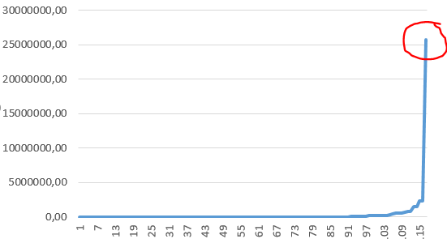
Figure 2: Out-of-shift vehicle utilisation (x – vehicle number, y – convex hull area m²)

Conclusion
This chapter presented a case study involving a vehicle-tracking company that utilises modern vehicle-tracking devices. Modern vehicle-tracking devices provide complex and useful information that has a wide range of applications. The number of issues regarding the vehicle-tracking devices that were discussed only make up a fraction of the issues experienced.
This chapter showed that within the vehicle tracking industry, data is received from a large number of vehicles at a high rate to be processed and stored in repositories containing large volumes of current and historical data. The data is received from mainly 3 different vehicle-tracking device types containing mainly location-based data, accelerometer data, as well as vehicle-tracking device software data. The implication is that it is humanly impossible to sufficiently define or discover categories of normal behaviour or detect anomalies from the data.

Chapter
  - Insider Threats

Introduction
The design, manufacturing and operating of cost-effective and sustainable systems require people who are trustworthy. When people are given access to resources, they are required to use these to benefit the organisation they represent. Access to resources enables people to be effective in the tasks assigned to them. Employees of banks, hospitals and other organisations are entrusted with money and confidential customer and patient data to do their work effectively.
There are however people within an organisation, such as employees, contractors and auditors, who abuse this trust, and they are referred to as insider threats. They understand the system because they use it and may even have been involved with its design, building or installation. They are already inside the system, which makes it difficult to discover and defend against them.
This chapter provides an overview of the insider threat problem, of approaches to reduce this problem and to discover insider threats, as well as of the complexities surrounding the prediction of insider threats. The intention is to discuss the broader insider threat problem and, where necessary, focus on the problem statement in Section 1.3, namely the discovery of insider threats by detecting anomalies in respect of vehicle-tracking data.

Insider Threat Overview
The estimated damage caused by insider threats, such as those who leak confidential documents, is much greater than the damage performed by external parties such as hackers. They know how to bypass security and abuse the trust that has been placed in them over a long period of time (Ho & Warkentin, 2017). Robert Hanssen, a previously high-ranking United States counterintelligence agent, abused his privileged access status in the FBI to supply the KBG with top secret documents over a period of 15 years (Ho & Warkentin, 2017). Edward Snowden, abused his privileged access to obtain 1.7 million classified National Security Agency (NSA) documents and disclosed it to the public, while being a contract worker at the NSA (Ho & Warkentin, 2017). Eddie Tipton, who used to be a security director at the American Multi-State Lottery Association, abused the trust placed in him by altering the random number generator so that it allowed him to select the winning numbers and profit from this over a period of more than 10 years (Pit, 2017).
Reducing access to valuable resources and monitoring such access to minimise the risk of insider threat scenarios, especially when insiders have technical skills, is a difficult task. A recent declassified report compiled by the Inspector-General of the US Department of Defence (2016) indicated that the National Security Agency (NSA) has to date not made any significant progress on a project to protect itself from insider threats. The NSA has embarked on this project after the Snowden leaks in 2013. The purpose of the project was to lower the number of privileged users, as well as to improve the monitoring of employees and contractors who have access to classified data.

Insider vs External Threats
Insider threats have access to internal systems as part of their employment and understand the context in which they operate, which means that they know where to obtain valuable resources and how to utilise them for personal gain. Insiders know where to find valuable and authentic resources, as working with these resources forms part of their daily tasks as employees. In terms of the current study, an example of an insider threat is an employee of an organisation who drives a corporate vehicle in a reckless manner or utilises the vehicle to generate additional private income from transporting people and goods. Another example is where an employee allows friends and family to drive a corporate vehicle without proper authorisation.
External threats, on the other hand, who first need to gain access to a network and then have to search and discover possible valuable resources, they do not have any context on the creation and use of these resources. They may also not be able to distinguish between authentic unaltered data and those crafted specifically to mislead attackers into thinking they have obtained access to valuable resources, the so-called honeypots (Azaria et al., 2014; Carroll, 2006). External threats can be monitored through firewall and network activity monitors, as most systems have been built to keep illegitimate (external) threats out (Carroll, 2006). Keeping vehicles within a gated area with access control and monitoring by camera reduces the likelihood that someone will try to gain unauthorised physical access to the vehicles.

Unintended Insider Threats
Insider threats may be employees who unwittingly and without intention of harm provide access to resources to third parties. Carroll (2006) indicates that third parties sometimes pretend to be legitimate inside entities and that they use social engineering and other approaches to gain access to resources. Users may receive an email or phone call that reads as follows: “Good day Sir, I am from the network administration team and need your username and password in order to resolve a system issue on your account.”
It is worthwhile to inform and train members of an organisation with regard to cybersecurity and cyber policies and to make applicable penalties known if caught behaving as an insider threat. This approach has the added benefit of ensuring and improving the level of cyber security health within an organisation (Azaria et al., 2014).

Defining Insider Threat
According to Young (2014), Reidy (2013) and Costa (2017), an insider threat occurs when someone who has legitimate access to company resources – which enables them to perform their duties – abuses this access for personal or financial gain. Insider threat also occurs when such access is used carelessly or recklessly, or to perform malicious damage to the employer. Other authors such as Zanero (2008), Schneier (2018), Reidy (2013) and Bishop (2014) also state that logical and physical security access control systems cannot prevent or limit insider threats that aim to perform malicious sabotage, use resources carelessly or share resources with outsiders, as no rules have been broken in the process of gaining access to the resources.
The definition of an insider threat provided by Mundie et al (2013) and the CERT Insider Threat Centre (CERT, 2018) refers to insiders as people who have (or used to have) authorised access to an organisation’s cyber systems and who affect these systems intentionally or unintentionally in a way that is undesirable in terms of confidentiality, integrity and availability.
The above descriptions indicate that an insider is someone within an organisation who has access to the resources of that organisation. Insiders are trusted to act in a way that is beneficial to the organisation. Mundie et al (2013) and the CERT Insider Threat Centre (CERT, 2018) limit their definition of insider threats to people working with cyber systems, while authors like Young et al (2014) are more inclusive and refer to items such as finances, vehicle, people and facilities. Both descriptions indicate that these people place organisations at risk through intentional or unintentional actions. It is also evident that the insider’s access to the resources is legitimate and authorised, thus physical and logical access control cannot prevent him/her from becoming an insider threat.
The following definition of an insider threat is applicable to this research:
An insider threat is someone within an organisation, who is entrusted with access to organisational resources, intentionally or unintentionally uses or abuses this trusted access in a way that causes damage to the organisation or places the organisation at risk. Resources include intangible resources such as data, as well as tangible resources such as finances, facilities, people and vehicles.
In terms of the current research, the focus is on drivers of vehicles being insider threats in accordance with the problem statement in Section 1.3.

Insider Threat Prevention, Discovery and Prediction
The purpose of the discussion that follows is to demonstrate that the use of anomaly detection to discover drivers of vehicles as insider threats is a valid approach, as suggested in the problem statement.

Insider Threat Prevention
This section provides information on some of the approaches currently used and shows that it is merely possible to limit the insider threat problem and not to eradicate it completely.

Introducing Policies to Dissuade Possible Insiders
Carroll (2006) indicates that policies backed by real consequences constitute one approach to dissuade employees from becoming insider threats. He argues that consequences reduce the likelihood of members of an organisation deviating from the policies. Policies describe processes and boundaries, and they indicate to employees what is expected and acceptable behaviour. Some organisations even go so far as to make a big show of the people they have caught behaving as an insider threat, as with the case of Reality Leigh Winner (Grugq, 2017).
Woods and Marshall-Mies (2003) discuss in their report the reasons as to why members of the intelligence community do not adhere to policies that require them to report to security officers any observed behaviour that is of a security concern. They conclude that policies are not adhered to because they are often misunderstood, written too broad or perceived as too difficult to implement.
In the vehicle-tracking industry, there are policies with regard to keeping to the speed limit, adhering to road signs and only utilising the vehicle for business purposes. Policies are adhered to by most drivers, however as discussed by Dexler (1999) incidences of vehicle abuse and negligence still occur.

Improving Access Control
Bishop et al (2014) suggest that insider threats can be reduced by improving access control, and quote examples such as using firewalls and access control lists. An example from the vehicle-tracking industry is that of a vehicle-tracking device configured to allow only certain drivers with specific electronic keys to drive specific vehicles. Dexler (1999) cites assigning a vehicle to a specific person, instead of giving drivers access to a pool of vehicles, have decreased maintenance cost by approximately 25%.
Reducing the number of people who have access to resources or aspects of a resource, means that the possible audit record dataset that could be created by these individuals is reduced considerably.

Introducing Process Control to Dissuade Possible Insiders
Dexler (1999) notes that in some organisations the person who drives a particular vehicle and the person who inspects the vehicle before and after it has been used is not the same person. This reduces the possibility of damage to the vehicle to go unnoticed.

Identifying Security Shortcomings
Bishop et al (2014) suggest that organisations should identify possible locations within itself where possible insider attacks can be launched successfully. They should then restructure their approach towards the handling of resources to prevent and discover such possible insider attacks. Restructuring includes inter alia approaches to prevent, discover or mitigate the insider threat risk.

Evaluating Privileges on a Regular Basis
Almehmadi and El-Khatib (2017) indicate that people within an organisation accumulate privileges during their employment, most of the time beyond the need for them to effectively do their work. Almehmadi and El-Khatib refer to this practice as “privilege creep”. It is suggested that access to resources should be regularly reviewed. When a person moves between departments, access to resources such as vehicles should be reviewed.

Insider Threat Prevention – Conclusion
The insider threat problem can be reduced by utilising insider threat prevention approaches, such as adopting appropriate policies and procedures. Unfortunately, people with legitimate access to resources, such as vehicles, continue to abuse this privilege, despite insider threat prevention approaches being in place.
Sinclair and Smit (2008) describe the complexities involved in the prevention of insider threats in their research. They particularly investigated the trade-offs of allowing employees to complete assigned work effectively and the rollout of access control technology to prevent insider threats. They concluded that insider threat prevention strategies do not replace insider threat discovery approaches, but rather reduce the problem space within which insider threat discovery mechanisms must work.
It can be concluded that insider threat prevention approaches can not entirely eradicate the insider threat problem and therefor the need for the insider threat discovery approaches remain. Thus, the research statement remain valid.

Insider Threat Discovery
If any combination of insider threat discovery approaches, apart from anomaly detection, can be used to discover all the insider threats, the problem statement of this research is invalid. This section discusses the complexities associated with discovering insider threats, existing insider threat discovery approaches, as well as the methods to validate insider threat discovery approaches. It is shown in this section that it is not possible to discover all insider threats by using any combination of insider threat discovery approaches.

Complexities of Insider Threat Discovery
Insider threat discovery is a difficult and complex problem because insiders are knowledgeable about organisational systems and procedures that protect corporate assets and they know how to bypass these systems (Senator et al., 2013; Azaria et al., 2014; William T. Young, 2014). For example, a warehouse company experienced inventory loss because workers noticed that surveillance equipment in their area of responsibility was not functioning and security guards allowed them to take stock offsite, using falsified papers that had been printed at home (Brandman, 2001).
Adding to this complexity is the fact that the number of insider threats is limited, yet the malicious insider threat actions are a small but critical part of the irregular activities that need to be discovered (Senator et al., 2013; Azaria et al., 2014).
Evidence of an insider threat is in most cases unnoticeably subtle, thus making it typically hidden and difficult to discover. One of the consequences and advantages of installing modern computer systems is their distributed nature. This means that audit records of user activity are fragmented over several servers and various application audit trail recording mechanisms. Thus, these objective data sources are often overlooked (Ho & Warkentin, 2017; Azaria et al., 2014). An example is HR data for the drivers of vehicles, which is kept separate from vehicle service records and vehicle-tracking data.
It is difficult, and in some cases impossible, to correlate the actual identity of insider threats to activities of masquerading and deception (Ho & Warkentin, 2017; Azaria et al., 2014). It is, however, possible that user accounts may be compromised by system administrators, social engineering approaches and zero-day vulnerabilities. By using compromised user accounts, threats are able to hide their true identities and the extent of their activities.
Senator et al. (2013), Azaria et al. (2014) and Greitzer and Ferryman (2013) argue that the challenge is the ratio of low number of true positives to high number of false positives that is created by these actions. Insider threat actions are in many cases similar to honest and legitimate actions. The steps taken to search for a document and printing it for a legitimate discussion within an organisation, will most probably be the exact same steps taken in the case where the intention is to share a document with a third party that does not have any right to the document.
In some cases, the insider threat scenarios keep on evolving, as insiders change their approach in an attempt to avoid being caught (Senator et al., 2013; Azaria et al., 2014). The Internet is littered with information and guides on how to effectively leak or exfiltrate data, or to cause malicious damage to an organisation without being caught. An article on the Medium (2017) website discusses possible approaches that Reality Leigh Winner (the real name of an actual person) and a news agent could have been adopted to prevent her arrest when she leaked a top secret document, thus allowing would-be leakers to learn from Reality’s mistakes (Grugq, 2017).
A group of insider threats who collude is harder to discover than a lone insider threat, as malicious insider threat activities are then spread across multiple people (Carroll, 2006; Matt Bishop, 2014; Senator et al., 2013; Bishop et al., 2014). According to Bunn and Sagan (2014), most organisations believe that it is near impossible for a group of people to collude successfully. They refer to the Northern Bank robbery as an example of two trusted officials who became insider threats when they assisting a gang to plunder the bank of £26 million when their families were held at gun point (BBC, 2005).
Greitzer and Ferryman (2013) state that there are no standard metrics or methods available to measure the current state of insider threats. One of the reasons cited is the lack of relevant and sufficient data to create a base truth in order to evaluate the discovery performance.
The above are just some of the reasons why the insider threat problem is ranked second on the 2005 INFOSEC Hard Problem List document (INFOSEC Research Council (IRC), 2005; Greitzer & Ferryman, 2013).

Approaches to Discover Insider Threats
The following non-exhaustive list of approaches have been found in literature can be used to discover possible insider threats within an organisation.

Scalar Values
Indicators such as scalar values are currently being utilised as possible indicators of insider threats (Senator et al., 2013). Examples include thresholds for the number of bytes or number of files copied to an external disk, or profit margins. When the business profit margin per customer goes down without a good reason, it may indicate that one or more insider threats are present.
Rule-based insider threat discovery mechanisms that work on scalar values are easy to implement and can be executed quickly on a large dataset; however, these rules are limited to specific insider threat cases.
Examples from the vehicle-tracking industry include the driver behaviour reports that show inter alia the number of harsh braking, harsh acceleration and harsh cornering events (Altech Netstar (Pty) Ltd, 2016). The report also provides information on the distance travelled above the legal road speed limit. Another example includes the average fuel usage per month, which may not exceed the specified value determined by the manufacturer.

Expected Behaviour
Organisations create various policies to ensure employees understand what type of behaviour is expected from them. Deviation from the expected behaviour may indicate possible insider threat activity (Sanzgiri & Dasgupta, 2016; Carroll, 2006). An example from the vehicle-tracking industry was quoted in Section 2.7.4, where an employee utilised a corporate vehicle while being on sick leave, despite the fact that the organisational policy clearly states this as vehicle abuse.
This approach can be automated to some extent, for example, where vehicle-tracking data and HR data are combined to determine if an employee is acting within the bounds of the applicable corporate policies.

Scenario Patterns or Signatures
According to Young et al. (2014), insider threats can be discovered using action patterns or signatures that are associated with specific insider threat scenarios. With this approach, specific patterns are searched for within the data to discovery possible insider threats. The obvious drawback is that slight deviations from these patterns may not be found easily.

Decoys and Honeypots
Sanzgiri and Dasgupta (2016) briefly refer to decoys and honeypots as fictitious resources that are monitored for access or use, thereby providing an indication that the resources have been stolen. Data types may include a directory or files that may contain values such as credit card numbers, phone numbers or email address.
Azaria et al. (2014) distinguish between honey tokens, honey nets and honeypots. Honey tokens are fictitious single record entries that include, but are not limited to, usernames, passwords, credit card numbers, mobile phone numbers, and identity numbers. A phone number may be reserved as a decoy number; thus, when receiving a call on the specific number, the recipient will know to ask specific questions regarding how the number was obtained. The use of honey tokens is not necessarily a reliable insider threat discovery mechanism, as a legitimate search on a network may reveal honey tokens that may be used without ill intent.
A honey net is a network of computers containing resources that may be perceived valuable, and that are configured to comprehensively monitor the activities of users. This is done to establish the identity of the attacker and, if possible, motive and intent.
A honey pot is a collection of decoy resources such as files, databases or servers with perceived value that cannot be distinguished from the real resources. An example is a specially configured mobile phone that provides its GPS location and forms part of a mobile phone consignment. When the batch of phones is stolen, the specially modified phone will also be taken and so reveal the location of the thieves.

Risk Analysis using Psychological Factors
Sanzgiri and Dasgupta (2016) as well as Bishop et al. (2014) indicate that psychological factors can be used to indicate the possible presence of insider threats.
Azaria et al. (2014) on the other hand discuss in some depth the theories on insider threat motivation, as well as the physiological and social theories regarding insider threats. They list factors that may indicate insider threat, such as disgruntlement, disengagement, poor performance, stress, disregard for authority, and conclude that these factors by themselves provide a high degree of false positives. More research is required to improve the rigour in this field of study.
Using a psychologist to search for insider threats is expensive, time consuming, and may be seen as an invasion of privacy.

Whistle Blower Programmes and Reporting Channels
Carroll (2006) indicates that whistle blower programmes provide employees with a channel to communicate activities within an organisation relating to unlawful or unethical behaviour. According to a Secret Service and CERT study of insider threats, most insider attacks were noticed by non-technical staff when there were noticeable irregularities in the information systems or when the system became unavailable (Carroll, 2006).
Some corporate vehicle fleets make use of whistle blower programmes to discover possible vehicle abuse scenarios. In some corporates, these programmes are more visible than in others.
In their research, Wood and Marshall-Mies (2003) cited a number of reasons as to why employees underreported behaviour that is of security concern. Some of the reasons they cited included a courteous workplace culture of not reporting colleagues where behaviour is not strictly a violation or of a personal nature, protection of the collective group, as well as not being able see how certain behaviour relates to security concerns. Howley (2017) indicates that people fear possible corruption within the whistleblowing programmes and made reference to William Binney, an NSA technical director, and Thomas Drake, a senior executive at the NSA, who followed proper channels to report wasteful spending – only to be expelled from the NSA. Hefferman (2011) suggests that it is human nature to be wilfully blind because of fear of conflict.

Anomaly Detection
Senator et al. (2013) indicate that anomaly detection has been used in a number of research studies – with variable levels of success. Chapter 4 of this research provides more details on this topic.

Multiple Approaches towards Insider Threat Discovery
Bunn and Sagan (2014) as well as Azaria et al. (2014) noted that each insider threat discovery approach has a limitation and that security personnel should not place too much confidence in a particular discovery approach. For instance, a specific nuclear facility solely relied on a single device to discover radioactive material being taken out of the facility, but when tested, the specific device only discovered radioactive material twice in a series of five tests (Bunn & Sagan, 2014).
It is common practice in the vehicle-tracking industry to make use of a combination of approaches to discover insider threats. Approaches include whistle blowing programmes, scalar value approaches and defining policies. Scalar value approaches include inter alia dates on leave, distance driven above the road speed limit, number of hash braking events and number of acceleration events. Policies include stating where a vehicle should be parked after hours and defining limitations on private and business usage.

Validating the Approaches towards Insider Threat Discovery
This section provides discussions on some of the approaches used in research to validate insider threat discovery implementations.

Red Team
The Red Team approach makes use of an independent expert team that performs insider threat actions based on actual case studies and other possible scenarios. The Red Team does not necessarily provide any notification of their planned attacks. They notify stakeholders of their actions after these have been performed, and then supply the details of their actions (Senator et al., 2013; Azaria et al., 2014).
This approach can be invalidated as shown in an inspection report (U.S. Department of Energy - Office of Inspector General, 2004). The Wackenhut Corporation provided security guards at the Y-12 National Security Complex. Payment and management bonuses for the guarding service were dependent on the outcome of mock assaults, which resulted in Wackenhut Corporation dishonestly obtaining detailed information on the planned mock attacks and ensuring that their guards were prepared, thus defeating the mock attackers.

Synthetic Data
Insider threat scenarios can be synthetically injected into audit logs and other data sources to test and validate insider threat discovery approaches. One of the noted issues with this test approach is that it implicitly assumes that future attacks will be based on currently known attacks (Azaria et al., 2014).

Synthetic Environment
Azaria et al. (2014), as well as Ho and Warkenton (2017), created online computer games. Participants were required to play a number of rounds. In each round the players were assigned the role of either an honest insider or a malicious insider threat within an organisation. Some of the advantages of this approach include being able to observe and measure the actions and motivations of participants. However, the scenarios available in any game are limited, meaning that they cannot prove any rigour in respect of the insider threat discovery approach.

Insider Threat Discovery – Conclusion
Insider threat discovery is a complex problem that requires both automated and manual processes. It is not possible to discover all insider threats, due to limited access to information on organisational members, shortcomings of the approaches used, as well as the lack of necessary skills to investigate possible insider threats. Furthermore, the problem with the validation of insider threat discovery approaches discussed above is that they may leave synthetic tell-tale signs and only focus on previously known insider threat scenarios.
Technologies and approaches should be carefully selected, as insider threat discovery is an imprecise problem (Senator et al., 2013; Azaria et al., 2014). An environmental and background study should assist in understanding the data and the environment from which it originated. This, in turn, should enable the investigator to select appropriate technologies and approaches in the search for insider threats, based on cost and other factors.
The information provided in Section 3.3.2 shows that the problem statement of this research is still valid.

Insider Threat Prediction
It is preferable to be in a position to predict insider threat scenarios beforehand (rather than to discovering them afterwards), so that the damage caused by insiders can be prevented from happening. Insider threat prediction is the last aspect of insider threats that needs to be explored to show that the problem statement in this research is still valid. If it can be shown that insider threat actions cannot be sufficiently predicted, the problem statement can be deemed valid.
Literature provides the following reasons as to why insider threat actions cannot be predicted and why a sufficiently accurate insider threat prediction model does not currently exist.

Inadequate Theoretical Framework
Scholarly work on insider threats, which cover the areas of psychology, criminology, organisational behaviour and computer science, is currently not mature enough to be applied to address, prevent or counter insider threat scenarios (Ho & Warkentin, 2017; Greitzer & Ferryman, 2013). Hansen (Ho & Warkentin, 2017), Snowden (Ho & Warkentin, 2017) and Tipton (Pit, 2017) are examples of high profile insiders who were exposed only after many years of privilege abuse.

Shortage of Regression Training Data
Prediction models need sufficient training datasets to build regression models that will allow them to make sufficiently accurate general predictions. Comprehensive public databases that can be used to create prediction models for insider threat do not exist, as companies are either reluctant to share the data that they have used to discover insider threats or are prohibited by law or by corporate policy to do so. The small datasets that are currently available, are flawed and contain noise (Azaria et al., 2014; Carroll, 2006).

Insider Threat Prediction – Conclusion
Currently, no approach or combination of approaches exists to sufficiently predict insider threats. It is thus concluded that the problem statement of this research study is valid.

Conclusion
This chapter investigated the validity of the problem statement of this research, namely that anomaly detection can be used as an approach to discover insider threats in the vehicle-tracking industry.
It was established within this chapter that a driver of a corporate vehicle could be considered a possible insider threat, as the vehicle can be utilised in a way that is a threat to the organisation owning the vehicle. Threats include reputational damage, revenue loss or injury to self or others, as well as legal claims against the organisation.
This chapter also verified that utilising anomaly detection to discover insider threats is a valid approach and showed the following statements to be true:
- No single approach or combination of insider threat prevention approaches exists that can eradicate insider threats sufficiently.
- No single approach or combination of insider threat discovery approaches exists that can sufficiently discover insider threats.
- It is not possible to predict insider threat actions.
- Insider threat activities are a small percentage of normal activities and are thus anomalies.

Chapter
  - Discovering Insider Threats using
Anomaly Detection

Introduction
Chapter 3 introduced insider threats and showed that various approaches attempt to prevent, discover or predict insider threats. No particular approach or combination of approaches could be identified that is comprehensive enough to either sufficiently prevent or discover all insider threats. Moreover, trying to predict insider threats requires a whole host of data, and legal and ethical issues make it an option not appealing to pursue. Chapter 3 also showed that insider threat activities are rare. This indicates that anomaly detection may be a valid approach in the search for insider threats in the vehicle-tracking industry, as defined by the problem statement in Section 1.3.
Existing insider threat discovery implementations are created from commonly known insider threat behaviour or previously known insider threat events. Driving a corporate vehicle above the legal road speed limit is an example of a commonly known insider threat behaviour. Insider threats constantly find new and innovative approaches to misuse the trust placed in them, which means that implementations based on known insider threat behaviour will not allow the discovery of new or innovative types of abuse. An example of abuse of trust that is difficult to discover is a taxi driver deliberately making small detours to overcharge passengers (Chen et al., 2011).
The use of anomaly detection to discover unknown insider threat activities is not a new topic – it is however not a well-solved problem. Advertisements for insider discovery tools such as Securionix (2018) and Absolute (2018), as well as literature on discovering insider threats by means of anomaly detection, lead readers to the conclusion that every anomaly is an indication of a malicious insider threat activity. This is however not the case. Users deleting unused or temporary files from a computer to reclaim available storage space or a taxi driver taking a different route to a destination to avoid a congested route, are examples of perfectly acceptable behaviour – even though they are anomalies. Various other complexities exist, such as organisational growth (which means that what is normal today, is not normal tomorrow), as well as drivers who interfere with the vehicle-tracking devices to prevent being discovered as insider threats. In some cases, contextual information is required before an item may be seen as an anomaly. For example, a vehicle parked at the corporate head office may not be seen as an anomaly, but when the time of day is added, it becomes evident that the vehicle is not delivering goods to customers, as expected.
This chapter introduces anomalies, discuss the discovery of insider threats using anomaly detection, and evaluate existing related research on discovering insider threats utilising vehicle-tracking and similar data. The discussions in this chapter are hoped to contribute towards designing a prototype process model to discover insider threats in the vehicle-tracking industry by means of anomaly detection.
A detailed theoretical analysis and evaluation of anomaly detection algorithms do not form part of this chapter.

Introduction to Anomalies
This section defines the concept of anomaly and normal, and also provides a discussion on the complexities related to detecting anomalies and defining normal. The section ends with a definition of the concept of anomaly relating to this research.

The Concept of Anomaly
According to the Merriam-Webster Dictionary (2018) an anomaly is something that is different, abnormal, peculiar or not easy classifiable. The Dictionary also indicates that anomalies can be something that deviate from the common rule. According to Niu et al. (2011) anomalies are also referred to as contaminants, peculiarities, surprises, aberrations, exceptions, discordant observations or as outliers.
Chandola et al. (2009) define anomalies as points in a dataset that do not fit in the pattern of normal. They also indicate that anomaly detection is both associated with and separate from:
- noise removal, which removes unwanted data that may skew results,
- noise accommodation, which immunises models against anomalous data, and
- novelty detection, which seeks for new emerging patterns and then incorporates them into the definition of normal.
Hodge and Austin (2004) state that when an anomaly detection algorithm is provided with a dataset, an anomaly will be an observation (or small percentage of observations) that deviates from the remainder of the samples, as the majority of items determine the definition of normal. Goldstein and Uchida (2016) refer to anomalies as unexpected items or events that deviate from a norm, indicating that some item sets do not necessarily have any anomalies.
The most important conclusions that can be reached from the above discussions are the following:
- Anomalies are items that differ from normal in terms of a defined set of features on the items.
- Anomalies are rare in a set of items because the majority of the items determine the norm.
- A set of items does not necessarily have any anomalies.
As highlighted above, the concept of normal is important and needs further discussion.

Normal
The Merriam-Webster Dictionary (2018) defines normal as conforming to a type, standard or normal pattern. It could also refer to following and not deviating from a norm rule or principle.
Chandola et al. (2009) indicate that the definition of normal can range from being very simplistic to extremely complex and dynamic. In some domains, the definition of normal is straightforward and can be expressed by an algorithm with a very small number of input variables and simple calculations, while in complex domains, more variables are used with more complex calculations. Consider for example Equation 1 below, which is an example of a simple algorithm with only time as input variable. This algorithm tests whether a vehicle carrying valuable ore from a mine has reached a processing plant within a specified time. If the time is exceeded, it may indicate that some of the load from the truck has been illegally offloaded. A somewhat complex example of normal is to state that the average minimum temperature for Centurion, South Africa, is 8°C in June and 24°C in December. In this example, temperature, time of year and location have been used as input variables, which requires a more involved process to validate and verify. An example of a dynamic normal is that of a rapid growing organisation where the delivery routes to customers change as more customers are signing up.
 | $$f\left(x\right)= \left\{\begin{aligned}true ∀ 0< x≤t \\ false \end{aligned}\right.$$ | ()

Corporate policies can prescribe an expected normal, and since computers are not good at interpreting policies, Li et al. (2014) advise that the expertise and experience of people be used to determine whether an item can be marked as normal or as an anomaly. For example, a person may label the trip completed by a corporate vehicle as normal or abnormal, in line with a corporate policy. However, this approach is labour intensive and when making use of experts, it may become prohibitively expensive.
According to Niu et al. (2011) mathematical models can be created from the underlying data of an item set that utilises algorithms to determine normal by selecting a set of features on the item set. The k-Means algorithm (Bechhofer, 1954) and the Gaussian Mixture Model (Sammut & Webb, 2017) algorithm are examples of algorithms that can be used to search for a norm within in a set of items. Each algorithm has its own approach of measuring the relationship between items used and properties like accuracy and computational complexity, thus each algorithm will produce its own interpretation of normal. The data analysts therefore need to carefully select relevant algorithms. This approach has the advantage that it automates the process of finding normal in a set of items.
Considering the above discussion, it is clear that there are various perspectives on what is deemed normal. Considering the vehicle-tracking problem studied in this research, it was deemed necessary to formulate a definition for normal that supports this study. The definition of normal that is relevant to this research and that borrows concepts from the above, is as follows:
Normal is defined by a description of a human expectation or can be described using a mathematical model created from a dataset.

Complexities in Defining Normal and Anomalies
This section discusses factors where the definition of what constitutes normal or what makes an item an anomaly is more challenging, making it difficult or even impossible for system stakeholders to describe or identify items as normal or anomalous. This discussion is necessary, as examples of using anomaly detection to discover insider threats in the vehicle industry are scarce, and understanding the involved complexities ensures that anomalies are discovered that otherwise would have been missed.
It may be considered normal for a bus to stop for longer than a certain time at allocated points to allow passengers to enter and exit the bus, but it may also be considered normal for the bus to stop in areas where congestion occurs during peak traffic periods. Chandola (2009) refers to this as a multitude of regions that define normal.
Contextual information assists in determining whether an item is anomalous or normal. Senator et al (2013) indicate that the usage of context information allows the distinction to be made between legitimate and insider threat activities. Additional information such as employee leave schedules, driver licence type and office hours may assist in exposing drivers of corporate vehicles as posing insider threats. A corporate vehicle driven by an employee on leave may be detected as an anomaly when the leave data is integrated into the dataset.
Hamamoto et al. (2018) note that the distinction between normal and an anomaly may not necessarily be precise. Consider for example an insider threat who steals fuel from a truck in small quantities over an extended time. The difficulty is that the fuel level values read from the modern trucks are still imprecise and the fuel slosh effect needs to be taken into consideration. Analysts may need to consider using a combination of different datasets and approaches to mitigate the issue with the imprecise values. Other data sources include records of fuel refill with associated odometer values.
Khan et al. (2017) note that insiders with in-depth knowledge of anomaly-based insider threat discovery systems are able to mimic normal usage patterns on their own and other accounts. In this way, their behaviour may be perceived as normal, thus making it difficult to find indications of possible abnormal behaviour. In the vehicle-tracking industry, it is known that drivers will leave a vehicle switched on at a shopping centre so that it will not appear as if the vehicle was parked and utilised for private gain.
Gama et al. (2014) indicate that in some domains the definition of normal may keep on evolving, which means that anomaly detection models need to be updated regularly – otherwise the input data and the anomaly detection will not correspond. The effect of not updating the anomaly detection models means that records will incorrectly be classified as normal or as anomalous. Gama et al. (2014) refer to the evolving definition of normal as concept drift. Concept drift occurs within an organisation as the organisation grows and the client base changes, thus affecting items such as the delivery routes and schedules to customers.

Defining Anomaly
The concept of an anomaly can range between very simplistic and extremely complex. It is thus necessary to understand the application domain, such as the vehicle-tracking application domain, to be able to decide which data items and features of the data items could be utilised to detect anomalies that would indicate possible insider threats.
The definition of an anomaly that is relevant to this research, which borrows concepts from the already discussed literature, is as follows:
An anomaly is an item in a set of items that does not conform to the norm of the set of items, based on a selected set of features on the items. Anomalous items are a very small percentage of the entire item set. A set of items may not contain an anomaly, or it may contain one or more anomalies.

Discovering Insider Threats by using Anomaly Detection
This section provides an introductory discussion on anomaly detection where the focus is on datasets that are relevant to the discovery of insider threats in the vehicle-tracking industry. The following three topics are discussed, namely anomaly detection concepts, anomaly detection methods and concepts around anomaly detection algorithms.

Important Anomaly Detection Concepts
This subsection provides an introductory discussion on anomaly types, data labels and the isolation approach to detect anomalies.

Types of Anomalies
Goldstein and Uchida (2016) distinguish between global and local anomalies, as well as micro clusters. Figure 3 presents an example of a simple two-dimensional dataset that will be used to describe these anomaly types. Instances x₁ and x₂ are easily identified as anomalies. Since their features differ quite a bit from the populated areas, they are called global anomalies. Instance x₃ may appear normal when looking at the entire graph, but when focusing on x₃ and c₂, it is clear that x₃ is an anomaly; hence it is called a local anomaly. However, depending on the application domain, x₃ may or may not be seen as an anomaly. An interesting observation is that cluster c₃ can either be seen as a cluster or as three anomalies, depending on the application domain. This phenomenon is called a micro cluster.
The above description illustrates that there is no clear-cut boundary between when an item is normal or when it is an anomaly; it is therefore necessary to select a relevant anomaly detection approach for the specific application domain.
Figure 3: Simple 2-dimensional example dataset
Source: Borrowed from Goldstein and Uchida (2016)
Goldstein, at al (2013) provide the same description as above, but warn that it is important to understand that not all anomaly detection algorithms can detect local anomalies, as important anomalies may be missed in some application domains.
Huang et al. (2012) describe a global anomaly as an item that is an anomaly in relation to the entire dataset. Global anomalies are the easiest to detect, as they are distinct from the entire dataset. A local anomaly is an item that is distinct in relationship to items near the items that have been classified as normal. Huang et al. (2012) also define a micro cluster as a small percentage of items that are close to each other, that may be seen as normal, as a new emerging pattern, or as an anomaly set, depending on the application domain. An example is where the delivery of services to a new client will appear anomalous immediately after the client has been signed up.
With the above in mind, it is important to understand the application domain in which the anomaly detection will be applied, as the boundary between normal and anomalous may not be as distinct as in the case of local anomalies. An example of a local anomaly is a driver of a corporate vehicle who visits a friend living across the street from an official regular delivery point.

Data Labels
The Springer Encyclopaedia of Machine Learning and Data Mining (Sammut & Webb, 2017, p. 701) defines data labels as target values associated with each data item to be used with classification and regression learning. A label value can be a feature that already exists in the dataset, such as an indication that a person had a vehicle accident within a specified time period, and this can be correlated back to his driver behaviour. In some cases, the label values can be derived or assigned by utilising the expertise of a person. Sometimes it is not possible to determine label values for a set of items.
Some researchers like Zhao et al. (2016) are quick to indicate that obtaining labelled data for anomaly detection is difficult and expensive, if not impossible, as it requires human expert involvement. This is stated, without even attempting any further investigation to find creative approaches to derive label values.
Gavia et al. (2015) agree that it is difficult to obtain labelled data to discover insider threats and suggest the use of algorithms that do not require labelled data, such as unsupervised anomaly detection, to discover insider threats.
In vehicle-tracking systems, users do not label individual location records; they rather define areas using polygons on a map where the drivers of vehicles of a corporate fleet are expected to drive. The latter is seen as normal, whereas areas where drivers are expected not to drive may be seen as an anomaly, fraudulent or suspicious. Areas where drivers are expected to drive are called keep-in areas, and areas where drivers are expected not to drive, are referred to as no-go areas (Altech Netstar (Pty) Ltd, 2016). Most managers of corporate vehicle fleets are knowledgeable about the areas where drivers should be driving and areas where prohibited activities, such as fuel theft, take place. It is estimated that approximately 80% of fleet owners make use of keep-in and no-go areas on the fleet management software that they use.
Keep-in areas can be derived from one or more completed trips. Figure 4 displays a trip that has been completed, and Figure 5 displays a keep-in area that has been derived based on the completed trip.
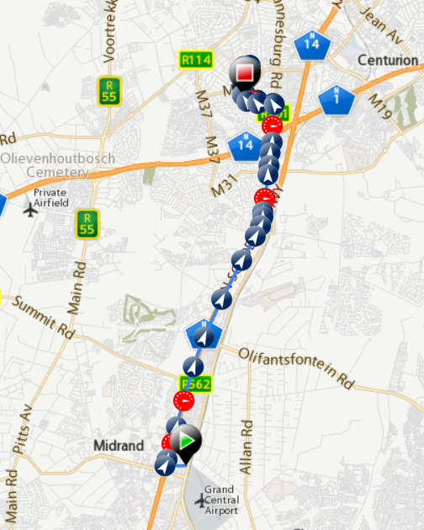  Figure 4: Completed trip | 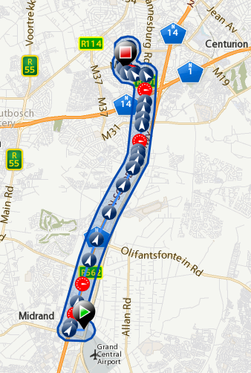  Figure 5: Keep-in area created from completed trip
Figure 6 displays an example of a keep-in area and a no-go area. When a vehicle with a vehicle-tracking device goes outside of the keep-in area or into the no-go area, then the owner of the vehicle will be notified of this.
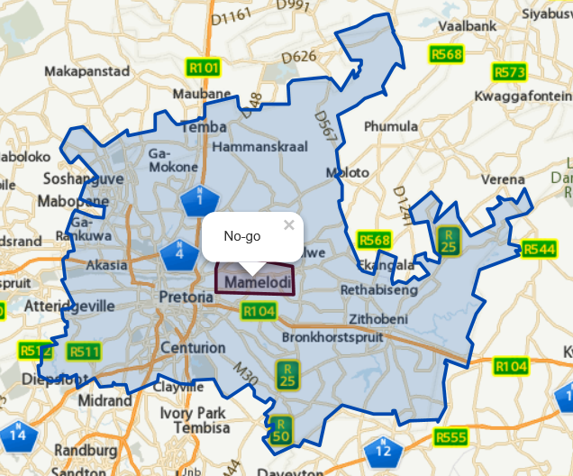
Figure 6: Example of keep-in and no-go areas
Another possible approach to labelling key areas is to use points of interest (Altech Netstar (Pty) Ltd, 2016). Points of interest are used to mark areas such as the corporate head office and branches, customers and depots.
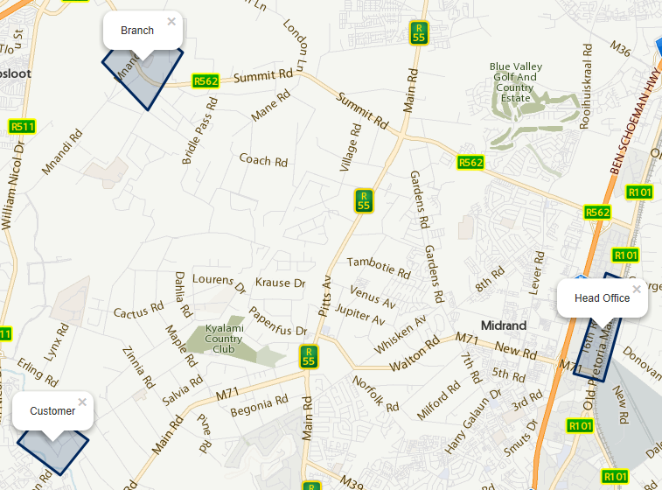
Figure 7: Example of Points of Interest
It is also possible to mark points of interest as safe areas, such as a workshop, which indicates that when the battery of the vehicle is disconnected during normal working hours, no notification will be sent to the owner of the vehicle.
Keep-in areas, no-go areas and points of interest can be used to label each item in a set as normal, prohibited or suspicious. These areas can also be used to create a set of feature values within a vehicle-tracking dataset. An example of an applicable set of features may include ‘Is at a customer’, ‘Is at customer A’, ‘Is at a branch’ or ‘Is at depot’.

Isolation Method to Detect Anomalies
The traditional approach to detect anomalies as described in this research so far is to determine one or more regions of normal and then to indicate if an item is normal or an anomaly by determining whether the item lies within or outside the defined regions of normal. The isolation method is different as it isolates anomalies.
Liu et al. (2008) indicate that the Isolation Forest algorithm drastically deviates from the traditional approach by determining if an item is anomalous by using an isolation approach (as anomalies are susceptible to isolation).
Zhang et al. (2011) introduced the iBAT algorithm to detect anomalies from GPS, latitude and longitude data points, which also use an isolation approach to detect anomalies. Chen et al. (2011) proposed the iBOAT algorithm, an improved derivative of the iBAT algorithm and indicated that they have obtained a substantial improvement on the area under the curve (UAC) value in their research.
The isolation approach to detect anomalies has been utilised with success on the vehicle-tracking data as described by Chen et al. (2011) and seems worthwhile and relevant to consider for inclusion in the experimentation of this research.

Anomaly Detection Methods and Insider Threat Discovery
In this section, the three main anomaly detection methods, namely supervised anomaly detection, unsupervised anomaly detection and semi-supervised anomaly detection are discussed, as well as how they relate to insider threat discovery.

Supervised Anomaly Detection
Timcenko and Gajin (2017) describe supervised anomaly detection as a process of mapping input data to the labels as output data. The advantage of supervised learning is that classifications can be learned, such as the correlation between driver behaviour and the likelihood of being involved in an accident, so that an insurer can adjust the monthly premiums. This method is limited to known classifications; thus, it has the disadvantage that novel insider threat behaviour cannot be identified. Timcenko and Gajin (2017) state that using a combination of algorithms improves the accuracy of the classification models obtained from the input data.
Goldstein and Uchida (2016) indicate that supervised anomaly detection consists of a configuration where the input data has been labelled and divided into a training and test dataset. These authors are of the opinion that the supervised approach is not practical or relevant for anomaly detection, because of the limited availability of labelled data. They also indicate that it cannot be assumed that the labelled data is correct and as such it needs to be verified and validated. The validity of the result set obtained from a supervised anomaly detection algorithm is dependent on the validity of the labelled data.
In their article, Liu et al. (2015) describe supervised anomaly detection as an approach to learn from real-world data and then attempt to predict a future state, such as normal or anomaly, from data presented to it.
Authors such as Görnitz et al. (2014) indicate that supervised anomaly detection is not useful, as it cannot find new or emerging anomalies. These researchers show no interest in attempting to utilise supervised anomaly detection to recognise known anomalies.
From the above it can be concluded that supervised anomaly detection is a method to create models for categorising items as normal or abnormal by using items that have been labelled normal or abnormal. Supervised anomaly detection can also be seen as a method to document known instances of what is normal, expected, prohibited, suspicious or fraudulent, based on past events.
Supervised anomaly detection has the advantage that known insider threat scenarios will most likely be classified in the correct category, allowing appropriate and immediate action to be taken. For example, when an employee uses a corporate vehicle while on leave, a supervisor will be notified to investigate by using a defined standard operating procedure (SOP) for the specific type of insider threat behaviour.
The supervised anomaly detection method has the disadvantage that it is static and does not compare users’ behaviour against their own historical behaviour (as is the custom with other insider threat approaches); thus, new or novel insider threat scenarios cannot be detected.

Unsupervised Anomaly Detection
Various reasons exist as to why items in a set cannot be labelled. One of the reasons for not labelling records is the sheer volume and velocity of the data, and the shortage of people with the necessary expertise to label it appropriately. Another reason is that by changing the selection criteria and features utilised on the item set, the context presented by the item changes. Labelling items anew for each changed context is prohibitively expensive. Examples of different contexts utilising vehicle-tracking data include the locations and duration where a vehicle has been parked during the day, as well as the last location where a vehicle is parked for the night.
Goldstein and Uchida (2016) as well as Hodge and Austin (2004) indicate that unsupervised anomaly detection does not require labelled data to detect anomalies from a set of items. A single dataset is provided as input to the anomaly detection algorithm. The idea is that the unsupervised anomaly detection algorithm calculates an anomaly score value for each record, based on the selected features of the entire set of items.
Azaria et al. (2014) argue that there is insufficient labelled data to create insider threat models that utilise regression type machine learning algorithms, such as supervised anomaly detection type of algorithms. They also cite unsupervised anomaly detection as one of the approaches already in use to discover insider threat scenarios. In many cases, malicious actions performed by insider threats tend to deviate from the normal behaviour for individuals and for the group the individual belongs to. In some cases, insiders change their approach to avoid being detected, thus deviating from their own historical norm. This indicates that unsupervised anomaly detection is a relevant method to discover insider threats.
Creating a profile for each employee in the search for insider threats by labelling their actions as normal or abnormal may not be a feasible option, thus Senator, et al. (2013) suggest the use of unsupervised anomaly detection. They indicate that to discover insider threats, the actions performed by individuals are compared to their own historical actions, as well as to those of the peer group to which the individual belongs. For example, drivers of a delivery company perform activities like collecting items from a warehouse and delivering the items at destinations. It is expected that a pattern will emerge in terms of timing, sequence, accuracy and completeness, and that the drivers should not deviate too much from their own past behaviour, as well as from that of the peer group they belong to.
Unsupervised anomaly detection allows for the detection of anomaly items on an item set where the items have not been labelled. It is therefore possible to detect new unknown insider threat activities.
Unsupervised anomaly detection is a good choice for the discovery of insider threats, as most item sets are not labelled, and it is expected that the behaviour of insider threats will deviate from their own historical norms as well as from that of their peer group.

Semi-Supervised Anomaly Detection
Görnitz et al. (2014) state that semi-supervised anomaly detection makes use of unsupervised anomaly detection, which takes available labelled data into consideration in the learning process. In their article, they indicate that they use unsupervised anomaly detection to detect novel anomalies and then they involve users to label the data items to improve the accuracy of the models.
Jadidi et al. (2015) describe semi-supervised anomaly detection as an approach where supervised and unsupervised anomaly detection approaches are combined to be trained on both labelled and unlabelled data. Their research indicates that only a small percentage of labelled data is required to improve the accuracy of the anomaly detection models; thus, a balance is found between accuracy and the high cost and time-consuming aspects of labelling real-word data.
Kim and Montgue (2017) refer to the mixture of labelled and unlabelled data as partially labelled data. They also refer to the approach of detecting anomalies on partially labelled data as semi-supervised anomaly detection. Even though the percentage of labelled data is low, it is still important, as it documents known anomalies such as cases of fraud.
From the above it can be concluded that semi-supervised anomaly detection only needs some labelled data to make use of supervised and unsupervised anomaly detection methods to obtain the following benefits:
- The anomaly detection accuracy is improved with labelled data.
- New unknown anomalies can be detected.
- Labelled data can be used to create categories so that detected anomalies can be acted upon appropriately.

Anomaly Detection Methods – Conclusion
Based on the information above, it can be concluded that semi-supervised anomaly detection seems to be the most appropriate anomaly detection method for this research.

Visualisation
Pandey et al. (2014) describe data visualisation as a mechanism to display data and models for easy interpretation, as it allows viewers to use their eyes to analyse, evaluate and verify results. Data visualisation can be a strong mechanism to convince readers of a report of the validity of the conclusions contained in the report. Viewers will notice relevant data, data patterns and anomalies with ease, in a way that allows the data to “speak for itself”.
Røsok (2014) suggests that visualising results allows people to use visual observation to evaluate and analyse the data and related models. She states that the visualisation must present the truth and allow the data to be grasped, so that observers of the visualisation can make smart and relevant decisions.
Reveiro and Falkman (2010) show in their research that visualisation is a useful approach to get users involved, especially with the process of enhancing the quality of the anomaly detection process. Consider for example the manager of a corporate vehicle fleet who regularly and iteratively creates points of interests, keep-in areas and no-go zones by using a visualisation interface and who then uses anomaly detection to adjust these areas.
Figure 8 displays a visualisation made by Stepanova and Vavrecka (2018) of the greedy Gaussian Mixture Model approach to estimate the appropriate number of clusters that exists within the data. In this case, the visualisation assists in showing that the algorithms used are working as expected.
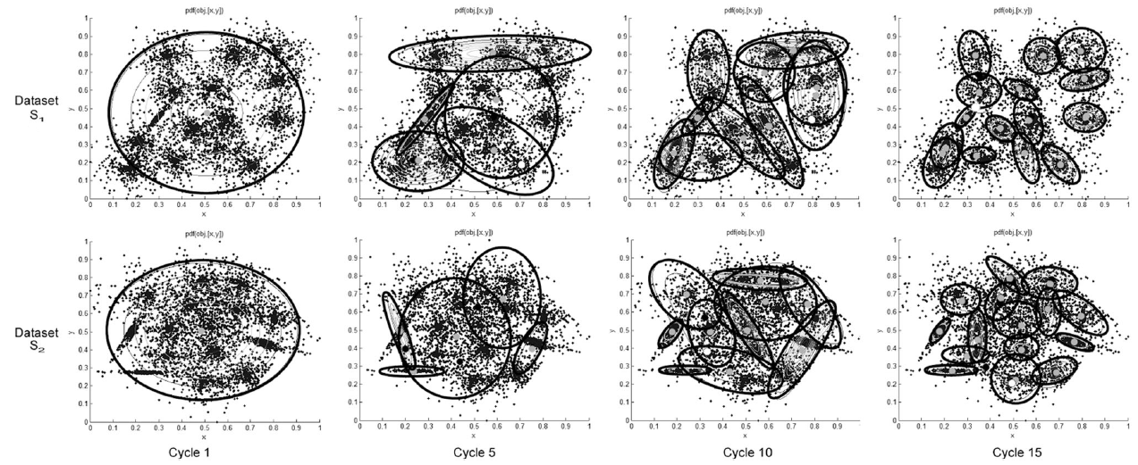
Figure 8: Process of estimating clusters for Gaussian Mixture Models
Source: (Stepanova & Vavrecka, 2018)
Data visualisation is important, as an intuitive display simplifies the processes of understanding the data and data models because it uses visual perception to observe important and relevant patterns, as well as trends in the data.
Visualisations assist in ensuring that a clearer and true picture of the data and the learned model is provided to the reader of a report. Visualisation is also used as a mechanism of proof to show that the process followed is correct.
It is expected that visualisation will assist in this research document to
- indicate if local anomalies are detected using specific algorithms;
- verify that trained data models make sense and are applicable;
- display the identified normal or anomaly items in relationship to the data models to verify that the assigned values are correct; and
- allow for further investigation of anomalies.

Anomaly Detection Algorithm Concepts
This section discusses concepts related to anomaly detection algorithms.

Anomaly Scores
In the current study, the researcher is interested to ensure that a list of anomalies obtained are worthwhile to investigate. This section investigates the value of scoring anomalies to allow them to be ranked, as well as the value of using the score to reduce false positives while at the same time not missing important anomalies.
In their article, Rashid et al (2016) indicates that utilising a general threshold on anomalies scores for different environments does not work well, as each environment follows different patterns. They present an algorithm based on the local outlier factor (LOF) algorithm to determine, as a generic approach, which items are anomalies. This algorithm ports well between different environments.
Distance and density type calculations are according to Goldstein and Uchida (2016) the two most common methods used to derive anomaly scores. Niu et al. (2011) argue that algorithms such as the k-Means algorithm make use of a distance measurement to derive an anomaly score, while the Gaussian Mixture Model algorithm uses a density measurement to determine an anomaly score.
Ting et al. (2009; 2010) claimed to have used mass as a measurement with success in their research. They describe the process of calculating the mass as the ordering of items from the core to the edge of a cluster, thus highlighting the edge items with a concave function. It is also claimed that the calculations have a linear time complexity, which means it performs better than density-based calculations. From the literature surveys it has been determined that this approach has not been generally accepted as an approach to calculate anomaly scores.
Examples of anomaly scores include inter alia the Euclidian distance measure, which is a simple vector distance equation as displayed by Equation 2, and the Mahalanobis distance equation as displayed by Equation 3 (Hodge & Austin, 2004). The Mahalanobis equation takes the covariance into account, which means it will create elliptical decision boundaries, whereas the Euclidian equation will create circular boundaries. Elliptical boundaries mean greater accuracy on the assigned anomaly score. The computational complexity of the Mahalanobis equation is nevertheless many orders higher than the Euclidian distance equation. The Mahalanobis equation measures the standard deviation from the mean of a cluster, which implies that the score is easier to interpret, whereas the Euclidian equation only measures distance between items.
 | $$d\left(p,q\right) = \sqrt{\sum_{i=0}^{n}{{\left(p_{i}- q_{i}\right)}^{2}}}$$ | ()
 | $$d\left(\vec{p}, \vec{q}\right)= \sqrt{{\left(\vec{p}-\vec{q}\right)}^{T}S^{-1}\left(\vec{p}-\vec{q}\right)}$$  S = covariance | ()

The anomaly score calculation is an important aspect of the anomaly detection algorithm, as it defines the measure or degree to which a data item is seen as normal or as an anomaly.
It is important to take note that each scoring calculation differs in units of measurement such as density, distance or standard deviation. The result is that the different anomaly score calculations will assign different scores to the same item and produce lists that differ in ranking. The different scoring calculations also differ in their accuracy and computational time complexity. It is thus important to understand the requirements of the specified application domain.

Algorithm Parameterisation
According to Niu et al. (2011), algorithms that require parameters (such as the number of clusters) assume that the person working with the algorithm has some understanding of the underlying distribution of the data and is able to guess or approximate the parameter values from the data. The Gaussian Mixture Model and the k-means algorithms are examples of algorithms that require the number of clusters, centroids and weights to be specified by the person utilising the algorithm. The classic approach is to generate models for a number of clusters, to randomly assign the centroids, covariance and cluster weights, and to expect the user of these algorithms to inspect and verify the correctness of the results obtained from having trained the model.
Laxhammer (2008) explains that the correct number of clusters allows models to provide appropriate categorisation. Too many clusters will cause the model to memorise or over-fit the data on the model, which means that a good generalised categorisation will not take place. When the number of clusters is too low, the categorisation will be too broad, or items will be miscategorised. Figure 9 shows different numbers of clusters over location points where a fleet of vehicles has been parked. As can be seen from the image, the model with one cluster is too general, while the model with six clusters over-fits the data.
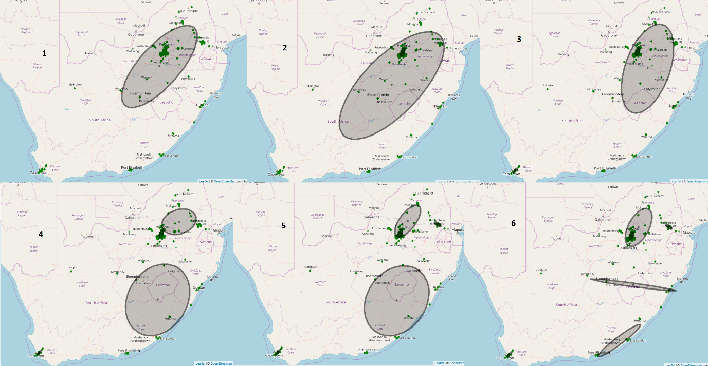
Figure 9: Example of different number of clusters
Non-parametric algorithms do not need parameters when training the algorithm. Niu et al. (2011) indicate that non-parametric algorithms determine the underlying structure and distribution of the data itself. The Isolation Forest algorithm is an example of a non-parametric algorithm.
Recent research done by Blomer and Bujna (2016) suggests an improved approach to determine the centroids, covariance and weights of the Gaussian Mixture Model algorithm by utilising the k-means++ algorithm, instead of the previously known random sampling approach. Utilising the algorithms presented by Stepanova and Vavrecka (2018) it is possible to find the optimal number of clusters for the Gaussian Mixture Model from the underlying data.
It can be concluded from the above discussion that, when selecting anomaly-detecting algorithms that require parameter values to be provided, it is important that the data analyst should have a good understanding of what the parameter values are used for, how to estimate the parameters and how to adjust them accordingly to improve results.
Utilising anomaly detection algorithms that do not require the parameter values, allows the data analyst to focus on the investigation of anomalies rather than to try and experiment with the parameter values of the algorithm. The latter is time consuming and, in some cases, requires a good understanding of the algorithm being used as well as of the underlying data structure.

Evaluating Anomaly Detection Algorithms
Sammut and Webb (2017) indicate that it is valuable to evaluate algorithms based on their suitability for a specific application. The two main approaches to evaluating algorithms are either theoretical or experimental. In the case of theoretical evaluation, formal methods are used to deduct attributes of the algorithm, such as computational complexity. Computational learning theory tools are also used to evaluate theoretical learning properties. With experimentation, the algorithm is applied to learning tasks to evaluate their performance in practice.
Sammut and Webb (2017) also argue that the intended application will determine the properties that are relevant for evaluation, such as time and space requirements. It is a good idea to evaluate the properties for when the algorithm is learning, separate from when applying it as a learned model.
Goldstein and Uchida (2016) note that comparing unsupervised anomaly detection algorithms is not a task without complexities, as some algorithms perform better in one environment than the other. The criteria that will be used to evaluate the algorithms should include the definition of normal, the type of anomaly (global or local) that is expected, as well as the duration for which the algorithm will execute to provide a good workable solution. Goldstein and Uchida (2016) also note that having the real top 10 anomalies listed in the top 15 anomalies as the result of unsupervised anomaly detection algorithms, may be considered quite good in certain application domains.
The evaluation of anomaly detection algorithms to determine the suitability of an algorithm for a particular application domain is not a trivial task, as it may not be apparent as to what defines suitable evaluation criteria. Also, it may not be obvious to determine the quality of the result set obtained from the anomaly detection algorithms.
This research focuses on the experimental evaluation of the selected anomaly detection algorithms. The two most important properties considered are the time and accuracy complexities for the creation of anomaly detection models and the calculation of anomaly scores. The calculation time is important because of the sheer volume and velocity of the data on which this research is performed. It does not fall within the scope of this research to evaluate algorithms theoretically; a high-level investigation of anomaly detection algorithms may be performed utilising literature for this research.

Receiver Operator Characteristic
Greitzer and Ferryman (2013) indicate that the ROC (Receiver Operator Characteristic) curve is a classical approach to express the correctness of a classification algorithm within an application domain. An example of this is a classification of people “posing a threat” versus those that “do not pose a threat”. The percentage or rate of false positives is plotted on the x-axis, while the percentage or rate of true positives is plotted on the y-axis. The AUROC (Area under the ROC) provides an indication of the correctness of a classification algorithm within an application domain, where one is the maximum obtainable area.
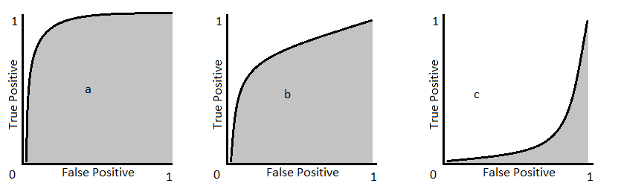
Figure 10: Example of area under the curve
Figure 10 shows examples of possible graphs depicting the relationship between true positives and false positives that can be obtained from an anomaly detection algorithm. The algorithm evaluated with Graph a is more correct than the algorithms used with Graphs b and c, as the area covered in Graph a is closer to 1 than that in the other two graphs.
Young et al. (2014) express the quality of their unsupervised anomaly detection to detect insider threats in terms of the AUC (area under the curve). They claim that in their research they were able to obtain AUC values between 0.9 and 1. They also state that the anomaly detection approaches outperformed the scenario-based insider threat discovery approaches by 40%. Their article does not indicate how they validated their findings.
It is not known if it will be practical for this research to express the accuracy of the results obtained from the selected anomaly detection algorithms in the search for insider threats in terms of the AUC unit of measurement, as the regions of normal and abnormal may not necessarily be verifiable.

Discovering Insider Threats using Anomaly Detection – Conclusion
Anomaly detection is a complex subject where the distinction between what is normal and an anomaly can vary between simple and quite obvious, to very subtle and complex, depending on the application domain. It is important to understand the application domain from where the data originated to select an appropriate anomaly detection approach. It is important to use a mixture of appropriate algorithms and approaches to detect anomalies.
A broad range of algorithms and approaches are available to detect anomalies, each with its own set of advantages and disadvantages. It is even possible to combine algorithms to make use of the advantages available in these algorithms.
Vehicle-tracking data is by nature unlabelled, but it seems possible to derive some labels from configured keep-in areas, no-go areas, as well as points of interest. Semi-supervised anomaly detection allows for the use of labelled and unlabelled data, meaning the known insider threats can be documented from lessons learned and acted upon immediately and appropriately.
With the vast amount and fast flowing data in the vehicle-tracking systems, trade-offs need to be made in various areas, inter alia in terms of computational complexity, computational time, memory footprint and accuracy.
The semi-supervised learning method is considered the most appropriate method for this research, as it allows for the fast detection of known anomalies. Appropriate action can be taken in the shortest amount of time, and it also allows for the detection of novel unknown anomalies.

Related Work: Research Discussion
The problem statement of this research combines the fields of vehicle tracking, anomaly detection and the discovery of insider threats. This section discusses related research articles selected by the researcher to demonstrate that similar research has been done on the same combination of research fields, as well as on a combination of broader research fields that include object tracking and discovering threats. The discussion on the related work is included in this dissertation to show that that the problem statement of this research is valid.

Anomaly Detection to Discover Fraud utilising Vehicle Data
This section contains a high-level discussion of the article Real-time Detection of Anomalous Taxi Trajectories from GPS Traces, written by Chen et al. (2011). Their article discusses the use of vehicle-tracking data and anomaly detection to discover drivers who are committing fraud. An example of such fraud is drivers who deliberately take passengers on extended routes, thus charging them unnecessarily high fees. These taxi drivers are seen as insider threats, because their actions do not only cause reputational and brand damage to the taxi organisation they belong to, but they also generate income in an unethical and possibly unlawful manner.
Chen et al.’s (2011) article proposes the iBOAT anomaly detection algorithm, which is an isolation type of algorithm to calculate an anomaly score between zero and one for a route taken. A route consists of a source and destination location pair, and each of these is a subpart of the journey that a passenger will be taken on.
The iBoat algorithm requires human experts to label the routes that are accepted as normal. In essence, these experts create the data model that the algorithm used to determine if a route is anomalous – thus no machine or statistical learning is involved.
In their experimentation, Chen et al. (2011) divided the area in which the taxi drove into blocks of 250m² and mapped the GPS coordinates of the trips that were indicated to be normal to these blocks. The iBoat algorithm calculates an anomaly score for a trip by determining how well it matches one of the trips in the normal model.
The algorithm described in their article Chen et al. (2011) has the advantages that it is sufficiently fast to discover possible fraudulent behaviour using a real-time data stream and that it can be updated from recent data. The disadvantage of their algorithm is that in some cases it cannot determine if an entire route is fraudulent, as shown in Figure 11 below.
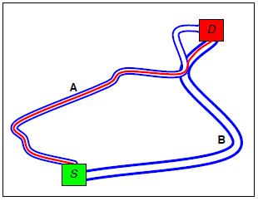
Figure 11: Source and destination routes with an anomalous journey
Source: (Chen et al., 2011)
Chen et al. (2011) indicate that the AUC values obtained from their experimentation ranged between 0.8 and 0.9995. Their article does not discuss how they determined the applicability of the algorithm used in the research to the application domain.
It can thus be concluded that, according to Chen et al. (2011), anomaly detection on vehicle-tracking data can be utilised to discover insider threats, which indicates that the problem statement in the current research is valid.

Discovering Maritime Threats by using Anomaly Detection on Surveillance Data
This section briefly discusses an article by Laxhammar (2008), entitled Anomaly detection for sea surveillance, in relation to the work discussed in this chapter. The article discusses the detection of anomalies in the search for maritime threats such as criminal activities, prohibited anchoring, sea drunkenness and grounding.
The article uses data obtained from the monitoring of moving objects in a maritime area, their relationship to other objects and their environment. Laxhammar (2008) does not provide any details on the layout of the data or its source, but from the article it is evident that he used data on location, speed and heading, which is similar to the data used in the vehicle-tracking industry.
The article discusses the use of two algorithms, the Holst Model and the Gaussian Mixture Model. Laxhammar (2008) notes that there is a 57% overlap of anomalies detected between the algorithms and therefore he is of the opinion that the algorithms complement each other. Unfortunately, he does not provide any evidence of this claim, such as AUROC values for the results of the algorithms – individually and combined.
Laxhammar (2008) also did not investigate or evaluate the algorithms used in his research to determine if the algorithms used were appropriate for this particular application domain. The article claims that the greedy version of the expectation maximisation algorithm has been used to train the Gaussian Mixture Model. According to Laxhammar (2008), the greedy expectation maximisation algorithm has the benefit of determining an efficient number of clusters that the Gaussian Mixture Model should have.
One important issue raised in Laxhammar’s (2008) article is that of an appropriate anomaly threshold, as it determines the usability of the detected anomalies. Setting the threshold too low will provide various false alarms that are of no interest to the user of the system and may cause users of the system to lose interest in it. On the other hand, setting the threshold too high means that subtle anomalies that may be of interest to the user are not detected. Laxhammar (2008) suggests that this issue may be resolved by allowing the user to adjust the threshold.
One of the limitations that Laxhammar (2008) acknowledges in his research is that it only considers momentary states – it does not consider object movement over time. The article shows that applying anomaly detection to data similar to that found in the vehicle-tracking industry can be utilised to discover threats. Although Laxhammar (2008) and other researchers indicate that it is a good idea to combine algorithms, he did not show how this particular combination of algorithms improved the detection of anomalies.
The article Anomaly detection for sea surveillance also shows that the number of clusters for the Gaussian Mixture Model can be derived from the data, allowing users of the algorithm to focus on the search of threats from the detected anomalies.

Anomaly Detection and Visualisation
This section deals with the article entitled Anomaly Detection in GPS Data Based on Visual Analytics, in which Liao et al. (2010) argued that the two extremes of assigning labels to GPS data, namely manually and automatically, are unrealistic. Manual assignment is slow and tedious, whereas an automated approach has no contextual understanding of the applied domain and therefore requires the assistance of a human expert to confirm that the assigned labels are correct. Liao et al. (2010) therefore proposed a system where humans and automated processes are used iteratively to improve the accuracy of the automated anomaly detection approach. They focused in their research on the subset of areas where there is uncertainty between what is normal and abnormal, as well as on the visualisation that is necessary to enable domain experts to label data. The reason for this is that only a small subset of labelled data is required to make a big improvement in the quality of the categorisation process.
The data used in the research conducted by Liao et al. (2010) was collected from vehicle-tracking devices installed in taxis. The objective of the research was to monitor traffic, improve the safety of pedestrians and taxi passengers, and to discover reckless driving by taxi drivers, as well as other abnormal and emergency situations. Although the process described in their article is equivalent to semi-supervised learning and labelling, the term semi-supervised learning is never used. They explicitly included human interaction in their scope of work, especially the visualisation of the data, evaluation and feedback from humans, whereas other articles only imply this interaction.
The GPS data attributes used in Liao et al.’s (2010) article are similar to the data that was used for experimentation later in the current research. They discuss three important visualisations, namely displaying the unprocessed GPS data on a map, displaying anomalies as detected by anomaly detection algorithms, and the interface that allows users to label GPS location records. The visualisation of data allows humans as contextual experts to explore and guide the machine learning process and also to gain insights from the visualisation provided.
Liao et al. (2010) used the conditional random field (CRF) algorithm in their research. They indicated that five CFR models are trained and then used a query-by-committee strategy to determine the anomaly score. According to this strategy, each of the five models calculate an anomaly score for the location presented to it and the score that is obtained from the model with the highest confidence is used.
Since the GPS data attributes and processes used in the article by Liao et al. (2010) are similar to the data and processes that the researcher planned to use in his experiments for the current research, there is a good probability of their successful use in the experimentation section of this research.
Liao et al.’s (2010) article is also relevant to this research as it investigated the use of GPS data to expose vehicle drivers as insider threats. The article underlined the importance of visualising data, so that humans as contextual experts can participate in improving the quality of the models obtained from the process.

Road Traffic Anomaly Detection
This section reviews the article named Road Trafﬁc Anomaly Detection via Collaborative Path Inference from GPS Snippets, written by Wang et al. (2017). The objective of their research was to find anomalies in road segments using GPS data obtained from vehicle-tracking devices installed in taxis.
The first step in their research process was to infer on which road segments the vehicles were driven, due to the fact that low sample rates and inaccurate GPS locations were obtained (see Figure 12). The conditional field random (CRF) algorithm was used to infer the most likely road segment used by the taxis.
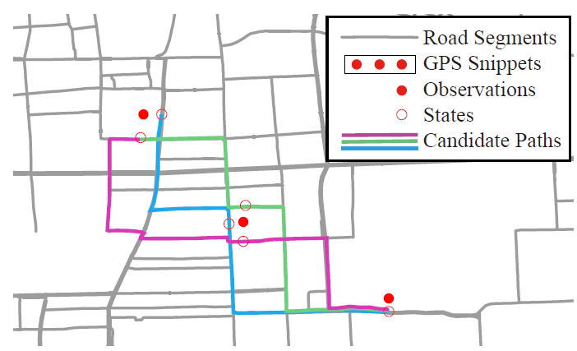
Figure 12: Example of path inference
Source: Wang et al. (2017)
Next, they built a model for each road segment and then tried to detect anomalies from a data stream for each road segment. In their article, Wang et al. (2017) proposed two types of anomaly detection processes: the first for the road segments where data from vehicles was given an anomaly score based on a model for the particular road segment, and the second where the average anomaly score for one road segment was compared to the average anomaly score for a neighbouring road segment.
Human subject matter experts were involved to improve the learning process aimed at inferring which road segments had been utilised and anomalies detected on the road segments.
The data in Wang et al.’s (2017) article focused on anomalies on specific road segments rather than anomalies for a specific vehicle. Traffic conditions affect the behaviour of a driver of a vehicle and may even cause a driver to deviate from his/her normal driver behaviour. Traffic attributes such as the average speed may even be considered to be included as a dimension of the model proposed in the current research.
In the vehicle-tracking industry, the problem of obtaining the road segments driven on is usually solved by recording location samples when the direction in which the vehicle is travelling changes. Anomalous traffic conditions may indicate accidents, stationary vehicles or just slow-moving traffic.

Detection Anomalies using Ship Movement Data
This section deals with the article written by Liu et al. (2015), namely Ship Movement Anomaly Detection Using Specialised Distance Measure, which focuses on detecting local anomalies or anomalies close to normal.
The article discusses mechanisms that were provided to detect anomalies from low granularity data. The intention is to allow employees who monitor ships to be able to detect anomalous items earlier and react to them appropriately.
In their article, Liu et al. (2015) discussed two sets of data, namely ships that are moving and ships that are not moving, which represent two different contexts. The applicable features used by these two sets differed.
One interesting observation to note was that the authors chose to use the phrase statistical modelling to refer to the supervised anomaly detection method and predictive modelling to refer to the supervised anomaly detection method. In their opinion it was necessary to utilise the expertise of a subject matter expert to improve the accuracy of the anomaly detection model. It is interesting to note that the article indicated that the subject matter experts did not draw on all the attributes used by the learning algorithm to label the data.
Liu et al. (2015) suggest that it is not necessary to attempt to detect all anomalies with a single model. The training data can be broken down into different sets to present different contextual models and so improve anomaly detection.

Related Work: Research Discussion – Conclusion
From the above discussion, it can be concluded that it is possible to discover insider threats by utilising anomaly detection on vehicle-tracking data. Human involvement is evidently an important aspect of anomaly detection approaches that aim to improve the accuracy of the anomaly scoring models by means of semi-supervised anomaly detection methods.

Conclusion
This chapter introduced the concept of anomaly and determined that the complexities involved in defining an anomaly can range from being very simplistic to being extremely complex.
It has been shown that it is possible to derive labelled data or create models by utilising the expertise of fleet managers as to what represents normal, anomalous, suspicious or fraudulent. It is therefore suggested that the research in hand focus on the semi-supervised anomaly detection method where possible. Semi-supervised anomaly detection has the advantage that known regions of normal and anomalous are documented with the assistance of a domain expert. This prevents false alarms and provides the benefit that appropriate action can be taken on known suspicious activities. The disadvantage is that labelled data or user-defined models need to be updated regularly as an organisation grows and changes.
Data visualisation also plays an important role in the detection of anomalies, as it allows the data analyst to define specific regions as safe areas (normal), keep-in areas (normal), no-go areas (prohibited or suspicious), or points of interest (customers, branches and other places of interest - normal). Visualisation is also useful in displaying the resulting trained model, as it allows the data analyst to assert if the data model aligns with the expected idea of normal. Another important role of data visualisation is that it allows application domain experts to provide feedback to anomaly detection algorithms by means of an iterative approach that improves the accuracy of the anomaly detection models.
Chapter 4 ended with a critical discussion on articles that describe similar research conducted in the past and concluded that anomaly detection is a valid approach to be used in this research.

Chapter
  - Selecting Anomaly Detection Algorithms to Discover Insider Threats by using Vehicle-Tracking Data

Introduction
Chapter 3 focused on insider threats and showed that anomaly detection is a valid approach in the search for insider threats in the vehicle-tracking industry. The discussion in Chapter 4 followed by introducing anomalies and applying anomaly detection concepts to discover insider threats in the vehicle-tracking industry.
This chapter continues from the previous chapters by identifying appropriate anomaly detection algorithms that may be used in the experimentation process of this research and that allow for the discovery of insider threats by using vehicle-tracking data.
This chapter demonstrates that a whole host of anomaly detection algorithms are available, but that selecting an appropriate algorithm is a complex and important undertaking in the quest to discover insider threats related to vehicle tracking. This study seeks to contribute to the body of knowledge regarding the discovery of insider threats in general by applying existing anomaly detection algorithms to the vehicle-tracking domain. There is no intention to invent a new anomaly detection algorithm or to modify existing anomaly detection algorithms for any purpose.
Chapter 5 is structured to first present a high-level layout of the process that was followed to select anomaly detection algorithms, which is then followed by a detailed discussion of the process that was followed, and lastly a discussion of the results and observations that were obtained during the process.

Selecting Algorithms
This section discusses the process followed in this chapter to select anomaly detection algorithms for the research phase of this research. The process attempts to ensure that anomaly detection algorithms that have been selected are known and have been implemented and tested within the insider threat research domain. The process should assist in avoiding unknown, untested and possibly irrelevant anomaly detection algorithms.

Requirements
The selected anomaly detection algorithms must comply with the set of requirements compiled and listed below. The requirements are based on the discussions in the previous chapters, to ensure that the insider threat can be discovered by using vehicle-tracking data.
- REQ 1: Work on GPS data. This includes inter alia longitude and latitude values that are continuous decimal values that constitute the focus of the experimentation in this research.
- REQ 2: Be statistically robust. The algorithm should not be sensitive to outliers or expect data where outliers have been removed.
- REQ 3: Work with unlabelled data. The data obtained from the vehicle-tracking industry is almost always unlabelled, although labels can be obtained to a certain extent. It is not possible to label a significant percentage of the data, as constraints in respect of cost, time and availability of domain experts do not allow this. Effectively the algorithm must be able to work unsupervised.
- REQ 4: Must be a well-known algorithm within the insider threat research community. There is no intention to create a new or optimise an existing anomaly detection algorithm to discover insider threats in the vehicle-tracking industry, but rather to select and use existing algorithms.
- REQ 5: Allow users to focus on discovering insider threats. Typical users of vehicle-tracking systems are experts on managing fleets of vehicles and have little or no expertise in discovering insider threats using anomaly detection. Thus, it is imperative that the number of parameter values supplied by the user should be kept to an absolute minimum; preferably the user should not supply any parameters.
- REQ 6: Algorithm must be available in R language. The researcher is familiar with and has access to the R language and data analytics environment. The focus of this research is on the output or result of the algorithm and not the implementation of the algorithms. The time available to conduct the research does not permit implementing and validating the correctness of the implementation.

Detailed Description of the Process
The following high-level process was followed in the selection of anomaly detection algorithms to identify insider threats:
- Select relevant academic journals and database systems to be searched.
- Search for algorithms used between 2013 and 2018 in the academic journal databases.
- Select algorithms that comply with the requirements, as discussed in Section 5.2.1.
- Determine the number of times the algorithms were utilised for insider threat research between 2013 and 2018.
- Score the algorithms according to the number of references in academic document search engines and select the most relevant algorithms.
- Confirm that the top selected algorithms comply with all of the requirements.

Implementation

Selected Relevant Academic Journal and Database Searches
The following academic journal search engines were selected to identify relevant anomaly detection algorithms to be used in the experimentation phase of this research.
- DBLP (Schloss Dagstuhl – Leibniz-Zentrum für Informatik, Tier University, 2018): an academic index database to search for computer bibliography; the site has indexed 4.1 million documents. Searches are based on the title string of the journal and other metadata, and full text searches are not performed. This academic search engine was recommended by the study leader and the researcher found it to be efficient.
- Microsoft Academic (Microsoft, 2018): The Microsoft Academic website is a well-known site that provides search access to 174 million academic articles. This academic search engine was recommended by Olivier (Olivier, 2009) and DBLP (Schloss Dagstuhl – Leibniz-Zentrum für Informatik, Tier University, 2018), as it searches the content/text of journals.
- Google Scholar (Google, 2018): The Google Scholar website is a well-known site that provides search access to academic articles. This academic search engine was recommended by Olivier (Olivier, 2009) and DBLP (Schloss Dagstuhl – Leibniz-Zentrum für Informatik, Tier University, 2018), as it searches the content/text of journals. No indication is given as to the number of academic and internet articles the search engine has access to search.
- Sematic Scholar (Semantic Scholar, 2018): This academic search engine was recommended by DBLP (Schloss Dagstuhl – Leibniz-Zentrum für Informatik, Tier University, 2018), as it searches the content/text of journals. The website claims to have access to the content/text of approximately 40 million articles.
- IEEE (IEEE, 2018): A website well-known in the computer science community for hosting academic articles. The website claims to host approximately 4.5 million articles that members can access.
- Science Direct (Elsevier, 2018): A website well-known in the computer science community for hosting academic articles.
- Springer Link (Springer, 2018): A website well-known in the computer science community for hosting academic articles. The website claims to host approximately 10 million scientific articles.

Search for Anomaly Detection Algorithms used to Discover Insider Threats
This section discusses the process used to compile a list of anomaly detection algorithms that have recently been used in research to discover insider threats. The only filter criterion that was used is that the algorithms must have been used between 2013 and 2018.
DBLP (Schloss Dagstuhl – Leibniz-Zentrum für Informatik, Tier University, 2018), Microsoft Academic (Microsoft, 2018) and Google Scholar (Google, 2018) were selected to search academic journal articles containing information on anomaly detection to discover insider threats. These academic journal search engines were selected as they search across multiple journal databases. The available time was the other reason why the search was limited to these journal search engines.
This discussion that follows consists of two parts – firstly, a summary of the search process and results obtained, and secondly, details of the search process and results.

Search Summary
The search terms “insider threat” and “anomaly detection” were provided to the following academic search engines, with a search filter for journals published between 2013 and 2018:
- DBLP (Schloss Dagstuhl – Leibniz-Zentrum für Informatik, Tier University, 2018): The search returned three documents and three distinct anomaly detection algorithms were obtained.
- Microsoft Academic (Microsoft, 2018): The search returned 37 documents and 29 distinct anomaly detection algorithms were obtained.
- Google Scholar (Google, 2018): The search returned 907 documents, excluding patents and citations. Because of time constraints, only 32 articles were investigated, and 19 distinct anomaly detection algorithms were found.
From the above searches and reading of articles, 37 distinct anomaly detection algorithms that had been used in insider threat research were identified.
The fact that different search results were obtained from the above search engines can be attributed to the data to which each search engine had access to and permission to search. The FAQ page on DBLP (Schloss Dagstuhl – Leibniz-Zentrum für Informatik, Tier University, 2018, pp. FAQ: How to perform a search within the full-texts?), indicates that the search engine only has access to the meta-data of documents. According to Ortega and Aguillo (2014) the Microsoft Academic (2018) search engine is more focused on academic material, whereas Google Scholar (2018) is more inclusive of Internet material.

Search Detail
Table 1 shows a subset of the results obtained from the article search engines and the algorithms obtained from the specified documents. The complete table (Table 13) which is available in Appendix F, provides the detail of these search results. The ‘Article’ column provides the name of the article and the ‘Algorithm’ column provides the names of the anomaly detection algorithms (where possible).
Table 1 – Search results for anomaly detection usage in insider threat research
Article | Algorithms
DBLP - 3 documents
Detecting Insider Threats Using RADISH: A System for Real-Time Anomaly Detection in Heterogeneous Data Streams (Bose et al., 2017) | kNN algorithm
AD2: Anomaly detection on active directory log data for insider threat monitoring (Hsieh et al., 2015) | Markov Model algorithm
Microsoft Academic - 37 documents
Insider-Threat Detection using Gaussian Mixture Models and Sensitivity Profiles (Al tabash & Happa, 2018) | Gaussian Mixture Model algorithm
Approach for the analysis of the contacts of the critical infrastructure employees (Novikova et al., 2018) | k-means
Insider Threat Detection Through Attributed Graph Clustering (Gamachchi & Boztas, 2017) | EDCAR algorithm  GAMER algorithm  (Attributed graph-clustering type of algorithms.)
Detecting Insider Threats Using RADISH: A System for Real-Time Anomaly Detection in Heterogeneous Data Streams (Bose et al., 2017) | kNN algorithm
Deep Learning for Unsupervised Insider Threat Detection in Structured Cybersecurity Data Streams (Tuor et al., 2017) | Focus:  Deep Neural Network algorithm  Recurrent Neural Network algorithm  Compare Results to:  Once Class Support Vector Machine (SVM) algorithm  Isolation Forest algorithm  Principal Component Analysis (PCA) algorithm

High-Level Algorithm Investigation
This section presents a high-level investigation of the list of algorithms obtained in the previous section so that the list can be shortened based on the appropriateness and relevance of the identified algorithms to the research in hand. Each algorithm is also investigated for the type of learning (supervised, unsupervised and semi-supervised) (REQ 3) and availability in the R analytics language (REQ6), which refers back to the requirements specified at the beginning of this chapter.
Table 2 provides the name of the algorithm, a short description of the algorithm, the type of learning that is applied, the type of measurement or structure used by the algorithm and if the algorithm has been implemented in the analytical language R. The short descriptions were obtained from various sources such as Internet blogs and wikis, as such references to sources are not necessarily provided for each description. Table 2 contains a subset of all the algorithms investigated, whereas Table 14 in Appendix F contains the entire list of algorithms investigated.
Table 2: High-Level Algorithm Investigation
Algorithm | Short Description | Type of Learning | Measurement  / Structure | In R
k-Nearest Neighbour (k-NN) algorithm (Ford et al., 1970) | The k-Nearest Neighbour algorithms is a regression or classification type of algorithm. The algorithm can make use of the various distance functions to determine similarity such as Euclidean, Manhattan, Minkowski and Hamming. The parameter k (number of classifications) must be supplied to the algorithm. An item is classified by majority vote to its closest neighbours. | Supervised | Distance | Yes
K-Means algorithm (Bechhofer, 1954) | The k-means algorithm is a clustering algorithm that partitions data into k number of clusters. The algorithm makes use of distance functions such as Euclidean, Manhattan, Minkowski and Hamming to determine similarity. The distance functions are spherical, which means distance in all directions are the same. | Unsupervised | Distance | Yes
Cobweb algorithm (Klimesova & Saic, 1998) | The algorithm builds a classification tree based on the data presented to it during training. The training starts with an empty tree and adds branches incrementally. The branching structure depends on the evaluation metric called the category utility (CU), which measures the quality of the resulting tree. With each item processed, branches are added, combined or split, depending on the best resulting CU. | Unsupervised | Tree | Yes
GAMER (Graph & Attribute Miner) algorithm (Gunnemann et al., 2014) | The GAMER algorithm builds a tree from the data. The algorithm early prunes vertexes that cannot lead to valid clusters. The tree is grown from the data and end nodes are created as clusters are discovered. The algorithms create clusters that are redundancy free and maximised. | Unsupervised | Tree | No
Isolation Forest algorithm (Liu et al., 2008) | The isolation forest algorithm is based on a model that deliberately isolates anomalies without creating a normative profile. Vast quantities of data can be analysed because of a linear time complexity combined with a small memory footprint. | Unsupervised | Tree | Yes

Anomaly Detection Algorithm Usage in Insider Threat Research
This section continues from the previous section by selecting the algorithms that apply unsupervised learning (REQ 3) and are available in the R analytics language (REQ6). This is done in accordance with the requirements set for the anomaly detection algorithms at the beginning of this chapter.
The short-listed algorithms are searched concatenated with the term “insider threat” in the selected academic document search engines described at the beginning of this chapter. The number of articles published between 2013 and 2018 in which the algorithm appears, is noted in Table 3.
Table 3: Short-listed algorithms appearing in academic document search engines
Algorithm | Search Articles | DBLP | Microsoft Academic | Google Scholar | IEEE Explore | Science Direct | Springer | Semantic Scholar
k-means Algorithm | 3 | 0 | 3 | 187 | 3 | 5 | 16 | 129
COBWEB Algorithm | 1 | 0 | 0 | 2 | 0 | 0 | 0 | 3
Isolation Forest Algorithm | 4 | 1 | 2 | 19 | 25 | 1 | 0 | 11
Deep Neural Network Algorithm | 1 | 0 | 0 | 11 | 0 | 0 | 2 | 23
Recurrent Neural Network Algorithm | 1 | 0 | 0 | 17 | 0 | 0 | 2 | 16
Gaussian Mixture Model | 5 | 0 | 6 | 40 | 10 | 2 | 4 | 49
DBSCAN Algorithm | 1 | 0 | 0 | 18 | 0 | 2 | 5 | 19
Decision Stump Algorithm | 1 | 0 | 1 | 8 | 1 | 4 | 1 | 6

Anomaly Detection Algorithm Scoring
The columns in Table 3 were subsequently normalised, a score column was added to indicate the sum of the normalised values, and then the rows were arranged from the highest score to the lowest to produce Table 4. The scores assess how well an anomaly detection algorithm is known within the research community (REQ 4).
Table 4: Short-listed algorithms normalised
Algorithm | Search Articles | DBLP | Microsoft Academic | Google Scholar | IEEE Explore | Science Direct | Springer | Semantic Scholar | Score
Isolation Forest Algorithm | 0,18 | 0,00 | 0,25 | 0,62 | 0,08 | 0,36 | 0,53 | 0,50 | 2,52
k-means Algorithm | 0,24 | 1,00 | 0,17 | 0,06 | 0,64 | 0,07 | 0,00 | 0,04 | 2,22
Gaussian Mixture Model | 0,29 | 0,00 | 0,50 | 0,13 | 0,26 | 0,14 | 0,13 | 0,19 | 1,65
Decision Stump Algorithm | 0,06 | 0,00 | 0,08 | 0,03 | 0,03 | 0,29 | 0,03 | 0,02 | 0,54
DBSCAN Algorithm | 0,06 | 0,00 | 0,00 | 0,06 | 0,00 | 0,14 | 0,17 | 0,07 | 0,50
Deep Neural Network Algorithm | 0,06 | 0,00 | 0,00 | 0,04 | 0,00 | 0,00 | 0,07 | 0,09 | 0,25
Recurrent Neural Network algorithm | 0,06 | 0,00 | 0,00 | 0,06 | 0,00 | 0,00 | 0,07 | 0,06 | 0,24
COBWEB algorithm | 0,06 | 0,00 | 0,00 | 0,01 | 0,00 | 0,00 | 0,00 | 0,01 | 0,08

Based on the scores in Table 4, the following anomaly detection algorithms were selected to be examined in more detail:
- K-means Algorithm (Bechhofer, 1954)
- Isolation Forest Algorithm (Liu et al., 2008)
- Gaussian Mixture Model Algorithm (Mike, 1967)

Discussion of the Selected Algorithms
The previous sections followed a process to find relevant anomaly detection algorithms that comply with the requirements, namely the algorithms can work with unlabelled data (REQ 3), they are well known (REQ 4), and available in R (REQ 6). This section determines if the selected algorithms comply with the remaining requirements, namely they work on GPS data (REQ 1), they are statistically robust (REQ 2), and they allow users to focus on discovering insider threats with minimal parameters (REQ 5).
The next subsections present an in-depth discussion of the algorithms, as the interest of this research has been to determine whether the algorithms are relevant and comply with the requirements set out in Section 5.2.1.

K-means Algorithm
Bechhofer (1954), the inventor of the k-means algorithm, indicates that the k-means algorithm determines the means of normal populations by using the average distance between items. The algorithm works with a continuous number types and can thus be applied to GPS data (REQ 1).
According to Bechhofer (1954) the data analyst is required to provide the number of clusters. However, recent work done by Blömer and Bujna (2016) shows that it is possible to determine the number of clusters and thus users do not need to supply any parameters to the K-means algorithm (REQ 5).
Hodge and Austin (2004) indicate that the measurement’s ellipsoid is spherical, which means that the algorithm is not statistically robust (REQ 2).
It was concluded that since the k-means algorithm does not comply with all the requirements set out above, it would not be considered for the experimentation in this research.

Gaussian Mixture Model Algorithm
According to the Encyclopaedia of Machine Learning and Data Mining (Sammut & Webb, 2017), the Gaussian distribution is rated as one of the most meaningful distributions in statistics. The Gaussian distribution is used to approximately describe data with the mass of the values that concentrate around a mean. The values obtained from the function that describes the density of the data are bell-shaped, peak at the mean of the data and work with continuous data values, which means that the algorithm can work with GPS data values (REQ 1).
Blömer and Bujna (2016) refer to the Gaussian Mixture Models (GMM) as the sum of weighted Gaussian densities. The objective is to find a mixture of K models with means and weights over a set of items, so that the log likelihood of the models is maximised. The estimation-maximisation (EM) algorithm is used to train the Gaussian Mixture Models. The EM algorithm is sensitive to the initialisation data as it converges easily to a local maximum.
Although the algorithm requires users to supply the number of clusters, recent work done by (2016) shows that it is possible to determine the number of clusters. This means that users do not need to supply any parameters for the algorithm (REQ 5).
Hodge and Austin (2004) indicate that the measurement’s ellipsoid is elliptical, which means that the algorithm is statistically robust (REQ 2).
It can thus be concluded that the Gaussian Mixture Model algorithm complies with all the requirements set out in Section 5.2.1 and as such is selected to be utilised in the experimentation of this research.

Isolation Forest Algorithm
Liu et al. (2008), the inventors of the Isolation Forest algorithm, describe the algorithm as one that explicitly isolates anomalies, instead of estimating normal first. The algorithm works with continuous data value types, which means that it can work on GPS data values (REQ 1). The algorithm does require some parameters, however the authors indicated that these could be defaulted to values that they determined as sufficiently accurate through their experimentation (REQ 5).
Gavai et al. (2015) indicate that the isolation forest algorithm is statically robust (REQ 2).
The Isolation Forest algorithm complies with all the requirements set out at the beginning of this chapter, thus this algorithm was selected to be used in the experimentation of this research.

Observations
This section discusses interesting observations that were made in the previous sections.
The different academic document search engines returned different results, as the search algorithms, databases and content searched were different.
It is possible that the number of times an algorithm was mentioned may indicate its popularity, ease of use, sufficient accuracy or computational time, but this may not necessarily be an indication that it is an appropriate choice for detecting insider threats in the vehicle-tracking application domain. An example of this, as note by Gheyas and Abdallah (2016) is the correlation between the year when Snowden leaked classified documents and the upward trend in the number of articles published on the topic in that year. It is for this reason that various academic document search engines were utilised, specifically to counter this bias.

Conclusion
This chapter searched for anomaly detection algorithms that are the best fit for identifying insider threats by using vehicle-tracking data. A set of requirements was identified, and the Gaussian Mixture Model and Isolation Forest algorithms were found to satisfy all the pre-set requirements. These two algorithms were subsequently utilised in the experimentation in this research.
Chapter 5 demonstrated that a large number of algorithms was available to solve different insider threat problems and demonstrated that selecting appropriate algorithms is not necessarily a straightforward task.

Chapter
  - A Process Model to Discover Insider Threats by Utilising Anomaly Detection on Vehicle-Tracking Data

Introduction
The previous chapters provided an overview of the vehicle tracking industry, insider threats and anomaly detection.
This chapter utilises the information discussed in the previous chapters to propose a process model to discover insider threats by means of vehicle-tracking data. It also provides a high-level overview of the proposed model called the Insider Threat Discovery Model for Vehicle-Tracking (ITDMVT), followed by a detail discussion of the model.

ITDMVT – Process Model
Figure 13 displays a high-level view of the proposed process model for ITDMVT. It consists of a number of subprocesses that can be applied iteratively and in a nonlinear fashion, starting with an Environmental Study process.
Figure 13: Proposed process model - ITDMVT to discover insider threats in vehicle-tracking industry

ITDMVT Overview
The objectives of the ITDMVT process model are to guide the data analyst through a process to discover previously unknown insider threat scenarios and to manage known insider threat scenarios.
Within this process model, it is suggested that the data analyst starts with the Environmental Study process to get a good understanding of what is considered normal, suspicious and prohibited, as well as to study known insider threat scenarios. The Perception, Supervised and Unsupervised Models are built and visualised to show the fleet manager how these models align, differ and change over time. The models are merged to create an anomaly detection model that can be placed in a production environment to discover insider threat scenarios.
It is important to note the feedback loops within the process model. The intent is to ensure that the Perception Model and the Production Insider Threat Discovery Model are kept up to date as the environment changes.

ITDMVT Detail Description
This section describes the ITDMVT process model in detail. The heading numbers correspond to the numbers in Figure 13.

Environmental Study
The purpose of the environmental study is to understand the environment in which the fleet of vehicles operate. This includes what is expected from the drivers of the vehicles, what defines the boundaries of normal and what is considered prohibited or suspicious behaviour. In essence, the data analyst will seek to familiarise himself with what is already known.
The staff involved with the management of fleets are knowledgeable about the vehicles they manage, and they can provide insightful information regarding both the vehicles and the people who drive them. For example, fleet managers can provide information on known cases of vehicle abuse and ongoing measurements that are used to manage and reduce the abuse of vehicles. This will help the analyst to know which mechanisms and data are utilised to prevent and discover insider threats and how the data in these approaches may be applied in the anomaly detection phase to discover insider threats.
Senator et al. (2013) state that it may be necessary to add contextual data to discover actual anomalies, for example time of day, shift times and leave schedules.
According to Goldstein and Uchida (2016) it may be necessary to transform the original data into a different dataset before an anomaly detection algorithm can be utilised to discover anomalies. This transformation is in most cases dependent on a detailed understanding of the environment. An example of such a transformation is where a location mean and area are calculated for a number of vehicles. This new dataset is used as input to an anomaly detection algorithm.

Perception Model
The perception model is a new concept introduced in this research and has not been encountered in related research involving insider threats and anomaly detection. The Merriam-Webster Dictionary (Merriam-Webster, 2018) defines the term ‘perception’ as a mental image, therefore the definition of a perception model for the purpose of the study at hand is a model based on the stakeholders’ understanding (perception) of what normal and abnormal is.
The perception model is initially built from the environmental study based on what is perceived as normal, prohibited and suspicious behaviour. This model is built from data which may include known locations such as the location where the vehicles are kept after hours and where deliveries are made, as well as times when the vehicles should be at these locations.
The perception model, which is adjusted by comparing it to the models built from the vehicle-tracking data, matures as feedback loops are utilised (see Figure 13). For example, where it is considered normal for a vehicle to be at the head office, adding contextual data such as the time of day may indicate an anomaly, as the vehicle usually makes deliveries at another location at the specified time of day.

Data Preparation
According to Sammut and Webb (2017, p. 318) data stored in operational systems are plagued with various issues, such as incomplete records, missing records, incorrect values, duplication, noise and inconsistency. Providing quality input data to machine learning algorithms ensures output models that are relevant and valid with regard to the problem explored (Xie et al., 2017; Lazarova-Molnar et al., 2016). Thus, it is necessary to spend a considerable amount of time to clean up and validate the data before machine learning algorithms can be applied to it.
Data preparation include processes such as the following: data collection and integration, data cleaning, feature engineering, data transformation and data reduction. These processes have not been discussed in the previous chapters; thus they are discussed briefly below.

Data collection and Integration
Data is collected either from a single source or from multiple sources (Rahm & Do, 2000). The process of adding related attributes, such as a street name, to a coordinate, is referred to as data integration or enrichment (Sammut & Webb, 2017, p. 317). Part of the data collection and integration process is assessing the trustworthiness of the data by understanding the origin, copying and transformation of the data, which is referred to as data provenance (Buneman & Davidson, 2010).

Data Cleaning
The Springer Encyclopaedia of Machine Learning and Data Mining (Sammut & Webb, 2017, p. 317) indicates that data cleaning is the process of detecting invalid data records or attribute values, removing duplicate and unusable records, correcting invalid attribute values, and assigning derived or default values to these attributes. Data cleaning is also referred to as data cleansing or data scrubbing (Sammut & Webb, 2017, p. 327).

Feature Engineering
Yang et al. (2013) describe feature engineering as the process of finding values that describe records in such a way that it improves the descriptiveness of the data and eventually also the results that are to be obtained from machine learning algorithms. The selected features are also referred to as dimensions by Hodge and Austin (2004).
One of the purposes of feature engineering, according to Sammut and Webb (2017, p. 498), is to extract features from data types such as text, images and audio that cannot be processed directly by machine learning algorithms. The extracted features are used as input to the selected machine learning algorithms.

Data Transformation
Navarro et al. (2016) suggest normalisation as one of the processes of transforming feature values into suitable ranges of values so that machine learning algorithms can work. Background knowledge of the data is an important factor as applying normalisation without any consideration can be counterproductive in terms of the results.

Data Reduction
Data reduction attempts to ensure that only the important or most descriptive features of the original record remain. Data reduction also attempts to ensure that the feature set only contains dimensions that uniquely describe the records. This reduction is done by joining correlated features with projection approaches (Sammut & Webb, 2017, p. 354).
Raman et al. (2017) indicate that data reduction has the benefit that the reduced dataset obtained should reduce the search space and computational time that machine learning algorithms need to work through the data. At the same time the reduced data produces the same or similar analytical results as to when unmodified datasets were used.
The Principal Component Analysis (PCA) (Soh et al., 2018) is a popular data reduction approach to project correlated features into a new single feature.

Creation of Labelled Data
Supervised anomaly detection requires labelled data to be trained on (Timcenko & Gajin, 2017). Domain experts such as fleet managers are consulted to indicate if the records in the dataset are perceived as normal, suspicious or prohibited.
Vehicle-tracking systems allow fleet managers to define keep-in areas, no-go areas and approved routes as part of their processes to be notified when a driver exits an area that is approved or enters a suspicious or prohibited area. These areas can be utilised to label records.

Creation of Unsupervised Models and Detection of Anomalies
The prepared data is given to the unsupervised anomaly detection algorithm to learn from the data and to discover a machine learning model. The discovered model is utilised to calculate an anomaly score for each record.
The anomalies presented to the user can either be all anomalies above a specified threshold or a selected number of the items with the highest anomaly score (Goldstein & Uchida, 2016).
Authors such as Laxhammar (2008) recommend utilising more than one anomaly detection algorithm and merging the result set. It is also recommended to use anomaly detection algorithms with as few as possible parameters to allow the data analyst to focus on the investigation of the anomaly result set and not the processing of detecting anomalies or the fine-tuning of the anomaly detection algorithm.

Creation of Supervised Models and Detection of Anomalies
The labelled data from the Creation of Labelled Data step is presented to the anomaly detection algorithm to learn from the data.

Visualisation of Models and Anomalies, then Merging of Models
The visualisation process assists in the alignment of the perceived normal and actual normal by using the data from the vehicle-tracking device and other sources. The visualisation process also assists in analysing the models and anomalies present in the data. A region of normal may be added to the perception model to indicate that certain items found to be anomalous are actually normal. A vehicle parked at a workshop for a service may appear as an anomaly in the data; however, this is considered acceptable in most cases.
The visualisation process can also be used to visualise trends of how the machine learning model change over time. The anomaly detection model may change as new customers are coming on board and older customers are dropped.
Visualisation should furthermore be utilised to investigate areas that are indicated as normal by the anomaly detection algorithm, as these could indicate regular suspicious or prohibited activity performed by the drivers within the fleet.

Production Insider Threat Discovery Model
After an anomaly detection model has been identified, the model may be migrated to the production environment where a stream of near real-time data is presented to the model. Fleet managers can then be notified of records where the anomaly score exceeds a threshold. According to Laxhammar (2008) it is important to allow recipients of alerts to adjust the anomaly score threshold. Otherwise they may get overwhelmed by the number of alerts when these are set too sensitive or miss important anomalies when the threshold is set too high.

Definition of Actions that point to Known Insider Threat Behaviour
The Environmental Study process and anomaly detection processes reveal behaviour that will become known insider threat behaviour. Actions need to be specified that will be performed after the known insider threat behaviour occurred, so that the impact of the possible threat can be minimised. Appropriate actions may include notification, collection of information and other actions to stop and minimise the potential damage caused by the insider threat.

Taking Appropriate Action against Known Insider Threat Behaviour
In this process, actions that have been defined when a known insider threat activity occurred are taken.

Investigating Anomalies
Some of the detected anomalies may be obvious vehicle abuse, while in other cases a more in-depth investigation needs to be performed by an experienced domain expert.
The data analyst should visualise and provide as much detail on the discovered anomalies to simplify the process and determine if a record indicates a legitimate actual insider threat scenario.
It is expected that some of the discovered anomalies will point to acceptable behaviour and others will reveal previously unknown insider threat scenarios. These newly discovered insider threats will be added to the known insider threat behaviour.

Feedback loops
It is important to note the feedback loops in the process model. One of the feedback loops from the Visualisation and Merge process goes to the Perception Model as it may be necessary to understand shifts in trends in the organisation. Another feedback is from the production environment where concept drift needs to be monitored. The environment in which the process model is applied will most likely change and produce false positives, or true positives may be missed as a result of the models not being updated. It is therefore essential that data analysts update the models they have been using to detect anomalies on a regular basis, as the environment in which the fleet operates will change over time.

Conclusion
This chapter presented a process model to guide engineers in the design and implementation of systems to discover insider threats by means of anomaly detection and vehicle-tracking data. It was an attempt to provide and design a process model to address the problem statement of this research.
The ITDMVT process model utilises the expertise of the fleet manager, as well as the models discovered by the machine learning anomaly detection algorithms, as an approach to detect anomalies and discover insider threats. The utilisation of humans and algorithms to detect anomalies corresponds with the definition of anomalies as defined in this document.
It is expected that implementing the ITDMVT process model will lead to actionable outcomes for the stakeholders involved and that it will allow the management of known insider threat scenarios and the discovery of previously unknown insider threat scenarios.

Chapter
  - Experimentation on the Data
  - Obtained from a Single Vehicle

Introduction
This chapter describes experiments performed on vehicle-tracking data while following the guidelines provided by the ITDMVT process model to determine if the model can be utilised to discover previously unknown insider threat scenarios. This was done to confirm the validity of the problem statement, namely that anomaly detection can be applied to discover insider threats using vehicle-tracking data.
The experiment discussed in this chapter is based on a case study of a single vehicle with confirmed incidents where the vehicle was abused for personal use. Using a vehicle for personal gain complies with the definition of an insider threat as discussed in this research. This chapter attempts to discover other previously unknown insider threat activity based on the data obtained from the vehicle-tracking device installed in a single vehicle.
The reason for using the data from a single vehicle is to simplify the experimentation domain so that the ITDMVT process model can be validated. The next chapter will apply the IDMVT process model to the data from vehicle-tracking devices installed in a large fleet of vehicles.
This chapter starts with the experimental design and implementation and concludes with a discussion of the results and insights gained by following the process suggested in the ITDMVT design process model.

Experimental Design
The vehicle-tracking device in the selected vehicle recorded data between April 2015 and August 2016. The data was divided into five periods of three months at a time, namely April to June 2015, July to September 2015, October to December 2015, January to March 2016 and April to June 2016. Experiments were performed for each period.
The data relating to each period was investigated and experiments were performed utilising the suggested ITDMVT process model. Because of the time constraints to complete the experiments and the fact that the manager of the vehicle had neither the time nor the desire to label the data, a scaled-down ITDMVT process model, as shown in Figure 14, was implemented by performing unsupervised anomaly detection. Also, the allotted time did not allow for a full-scale implementation of the ITDMVT process model.
It was expected that with the scaled-down implementation of the ITDMVT process model, it would be possible to determine if anomaly detection using vehicle-tracking data is a valid approach for the discovery of insider threats. This expectation was aligned with the problem statement of this research. To prove this, it was necessary to find at least one insider threat scenario utilising the scaled-down ITDMVT process model.
The headings used in this chapter correspond with the processes displayed in Figure 14. However, the flow of the experimentation may not necessarily follow the sequence set out in the diagram.
Figure 14: Scaled-down ITDMVT process model
The data used to perform the experimentation originated from an actual vehicle-tracking device and no data was added, removed or modified.

Research Question
The experiment described in this chapter attempted to answer the following research question, which is aligned with the problem statement of this research.
Can previously unknown insider threats be discovered by using the scaled-down ITDMVT process model and vehicle-tracking data?

Experimentation
This section describes the experiments that implemented the scaled-down ITDMVT and the vehicle-tracking data from the selected vehicle per period. For the sake of brevity, only the periods April to June 2015 and October to December 2015 are included for discussion. The detailed discussion for all the periods is available in Appendix G.

Experimentation Environment
The experimentation was performed on a server with 8x Intel(R) Xeon(R) CPU E5640 @ 2.67GHz Processors and 32GB of RAM.
RStudio (RStudio, 2018) was used to collect and prepare the data, to apply anomaly detection on the data and to display the data model and anomalies.

April to June 2015
This section pertains to the period April to June 2015 and describes the experiment with the location data where the ignition of the vehicle was switched off, utilising the scaled-down ITMDVM process model.

Environmental Study
The known abuse of the selected vehicle was discovered when the responsible manager was alerted that the vehicle had entered a no-go area. This area is displayed in Figure 15 and Figure 16.
The vehicle in this experiment was shared among employees within the organisation.
Two distinct groups of drivers were involved. The one group utilised the vehicle during office hours and the other group after hours. Office hours run from Monday to Friday between 08:00 to 16:00, and during this time, drivers are required to make deliveries and collect items as part of their work. These drivers have been instructed not to visit their homes, which are in a suburb called Mamelodi. After hours, the vehicle is utilised by the facility guards to travel to the office or home, and they were not of concern at the time.

Perception Model
As can be seen from Figure 15, the ignition of the vehicle was switched off several times in the no-go area. The data is displayed on a map using the leaflet (Cheng et al., 2017) packet in R.
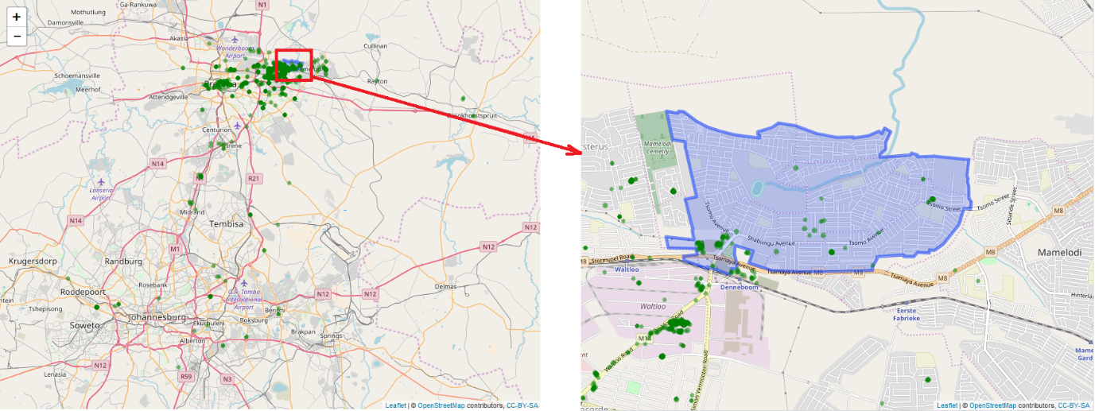
Figure 15: Green points indicate where the ignition of the vehicle was switched off. No-go area enlarged on right
When viewing the no-go area and the locations where the ignition of the vehicle was switched off, it is clear that the entire Mamelodi suburb was not covered by the no-go area. This implies that the manager of the vehicle did not receive all the alerts that he should have received.
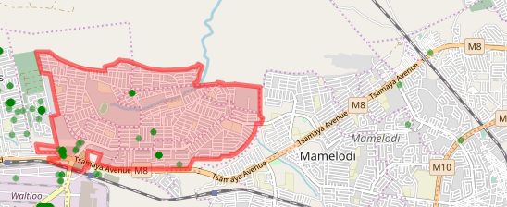
Figure 16: Initial Mamelodi no-go area
The no-go area was increased to include the entire Mamelodi area as originally expected by the relevant manager. The Wicket (Endsley, 2013) web page was used to change the well-known text (WKT) that describes the area, as shown in Figure 17. Locations within this no-go area were labelled as known insider threat activity locations and as such should not appear in the anomaly list for further analysis.
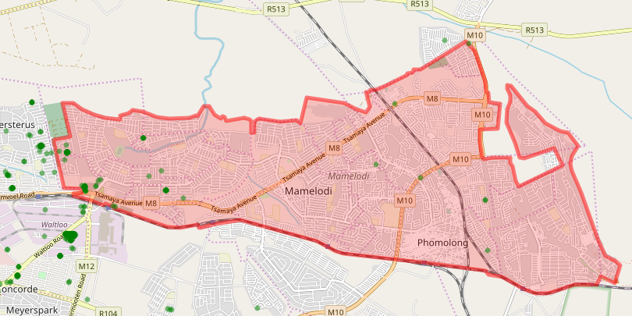
Figure 17: Updated Mamelodi no-go area

Data Preparation

Data Collection and Integration
The selected vehicle had a Meta System (Meta System, 2004) T30 vehicle-tracking device installed to collect GPS location data between 2015-03-25 and 2016-08-09. The vehicle-tracking device recorded 158 000 location records and provided GPS and accelerometer data, as well as aggregated and meta-data on the GPS and accelerometer data. The data for this vehicle is stored in a Microsoft SQL (Microsoft, 2017) database table named Location, whereas only a subset of the available attributes is stored for the vehicle-tracking device. Table 5 describes the attributes of the Location table, and provides the name and description of each attribute.
Table 5: Vehicle Data Attribute Names
Attribute | Description
Id | Unique integer value for each row in the table
DateTime | The date and time the vehicle-tracking device recorded the location, in Universal Time Constant (UTC)
Longitude | The GPS longitude value recorded by the vehicle-tracking device
Latitude | The GPS latitude value recorded by the vehicle-tracking device
Speed | The speed the vehicle was travelling, in kilometres per hour (km/h)
Heading | 0 to 359 degrees indicating the direction the vehicle was travelling, with zero being north
Odometer | The odometer value as kept on the vehicle-tracking device, in kilometres (km)
IsGpsPosition | True when the vehicle-tracking device was able to get its location utilising the GPS module (when false, the latitude and longitude are the last available valid latitude and longitude values)
IsIgnitionOn | True when the ignition of the vehicle is switched on; false otherwise
RoadId | Foreign key to a table that contains geographical shapes for the roads (the Road table contains the name of the road, suburb and city name, as well as the road speed limit)
EventId | The vehicle-tracking device sends a location message based on a range of defined events (inter alia vehicle ignition switched on, vehicle ignition switched off, heading change, no change for 1 minute, harsh braking and hash acceleration)
ServerDateTime | The date and time the records were written to the Location table, in Universal Time Constant (UTC)
AccidentId | Foreign key to the Accident table with more data about an accident (when this value is not null, it indicates that accident data is available)
Logical Status | Status bits indicating the logical status of the vehicle-tracking device (i.e. the status of certain digital inputs)

The location data where the ignition-off occurred during office hours was selected and equated to 3750 location records. The researcher realised during experimentation that public holidays needed to be excluded as the locations on these days appeared as anomalies, and this brought the number of location records down to 3663. The locations at the factory from where the vehicle operated were also excluded as it was considered normal for the vehicle to be at this location. Also removing the possibility that these records may skew the anomaly detection results. The remaining number of locations was reduced to 2489.
The vehicle-tracking device records the date and time of locations in Universal Time Constant (UTC), which means that two hours need to be added to the date and time to convert it to local South African date and time.
Table 6 displays the number of locations where the ignition was switched off for the period indicated.
Table 6: Locations per period
Period | Number of locations where the ignition was switched off
April to June 2015 | 511
July to September 2015 | 497
October to December 2015 | 431
January to March 2016 | 467
April to June 2016 | 380

Data Cleaning
It was confirmed that the data provided by the vehicle-tracking device was free from the following:
- Latitude and longitude values of zero
- Longitude values smaller than -180° and larger than 180°
- Latitude values smaller than -90° and larger than 90°
- Values where the location date and time of the vehicle-tracking device were ahead of the server date and time
The entire dataset for the vehicle-tracking device had 142 locations that were duplicates of other locations. These duplicates were removed using the unique function in R.

Attribute Selection
The latitude and longitude attributes were selected to form the dataset that would be utilised in the unsupervised anomaly detection.

Feature Engineering
No feature engineering was performed to ensure the experimentation domain was kept as simple as possible.

Transformation
There was no indication from the Environmental Study or study of the data that indicated any necessity to transform the data. Also, the transformation of the data was avoided to ensure the experimentation domain was kept as simple as possible.

Data Reduction
A principal component analysis (PCA) (Soh et al., 2018) was performed on the data using the princomp (R Foundation for Statistical Computing, 2017) function in R to determine if the obtained dataset could be reduced. The result of the PCA, as shown in Figure 18, indicates that the longitude and latitude values could not be reduced to a single dimension. The results also indicated that there were no redundant attributes or features in the dataset.
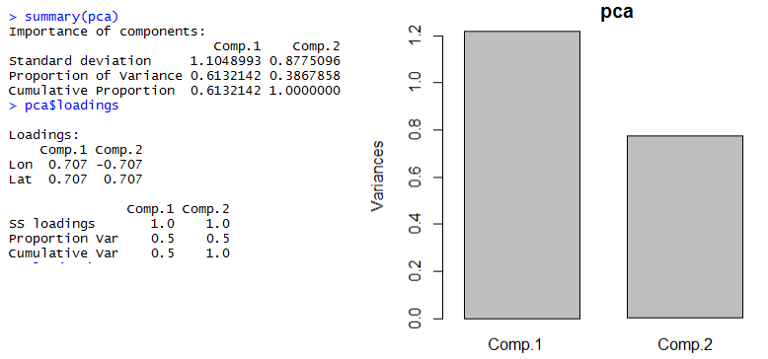
Figure 18: Principal Component Analysis result of the dataset

Creation of Unsupervised Model and Detection of Anomalies
The mclust (Fraley et al., 2012) R package was used to create a Multivariate Gaussian Mixture Model from the data. Using a single Multivariate Gaussian Mixture Model, most locations where the vehicle made deliveries and collections were found to be close to the factory. The R script completed within 7 seconds (see Figure 19).
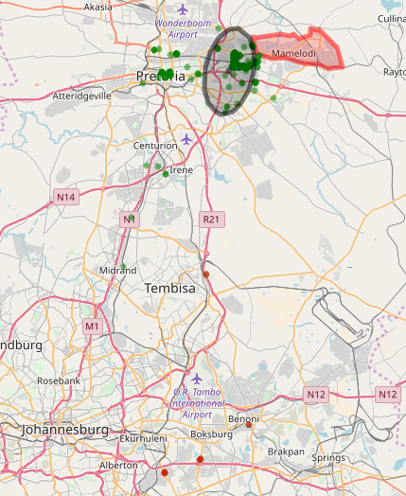
Figure 19: Single Gaussian Mixture Model describing the data
Custom R functions were developed to calculate the location points for the polygon that displayed the Gaussian ellipses on a map, as can be seen in Figure 19. This was done as no implementation or functions could be found in academic literature or on the Internet on how to do this. The longitude and latitude values for the ellipse were calculated using Equations 4, 5, 6, 7, 8 and 9, iterating from 0° to 360°.
()
()
()
()
()
()
With experimentation, it was found that a 10-cluster Multivariate Gaussian Mixture Model sufficiently described the data. The entire R script completed within 8 seconds (see Figure 20).
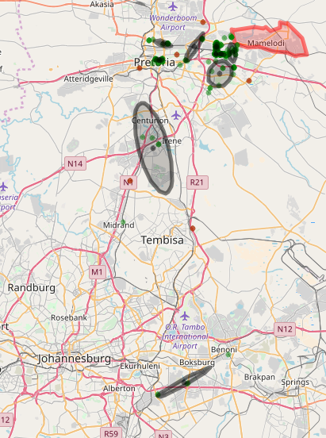
Figure 20: Visualising a 10-cluster Multivariate Gaussian Mixture model
The anomaly score for each location was calculated using the density value of that location on the discovered GMM model. The density function dens, part of the Mclust (Fraley et al., 2012) R package was used to calculate the density score for each location in relation to the discovered model. The locations were arranged from the one with the smallest score to the one with the highest score, after which the 20 locations with the lowest scores were selected.
The top two anomalies as displayed in Table 7 and Figure 21 were investigated and it was found that they were fuel stations. As the vehicle travelled short distances between ignition-on and ignition-off, it made sense that the fuel stations would show up as anomalies.
Table 7: Top 2 most anomalous locations
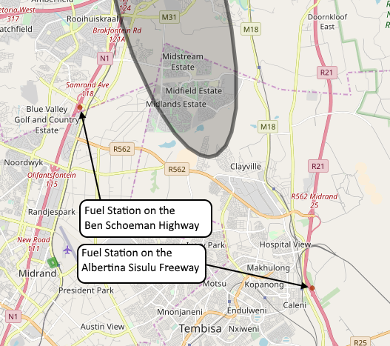
Figure 21: Investigating anomalies

Data Preparation – Data Collection and Integration
The locations where the vehicle stopped for fuel were removed using a shape file downloaded from the MapCruzin (MapCruzin, 2018) website. Table 8 displays the number of locations before and after the locations at fuel stations had been removed.
Table 8: Number of locations before and after locations at fuel stations were removed
Period | Number of locations at fuel stations included | Number of locations at fuel stations excluded
April to June 2015 | 511 | 399
July to September 2015 | 497 | 393
October to December 2015 | 431 | 300
January to March 2016 | 467 | 371
April to June 2016 | 380 | 296

Creation of Unsupervised Model and Detection Anomalies
The R script was executed again, and it completed within 8 seconds.

Visualisation of Models and Anomalies
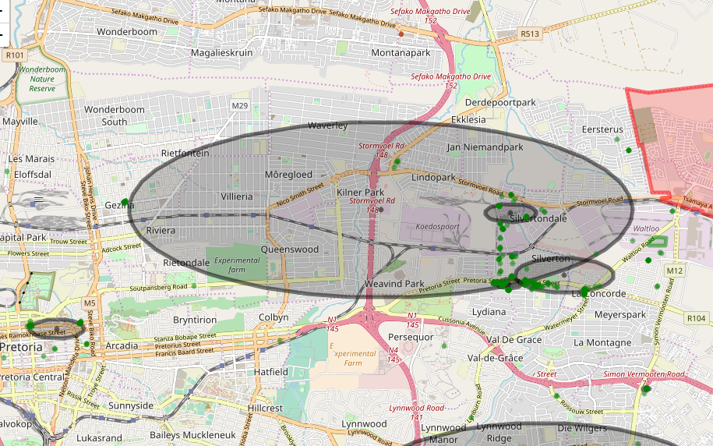
Figure 22: Visualising a 10-cluster Multivariate Gaussian Mixture model
As can be seen from Figure 22, the clusters over-fit the data and thus the number of clusters was reduced to seven, using experimentation.

Investigation of Anomalies
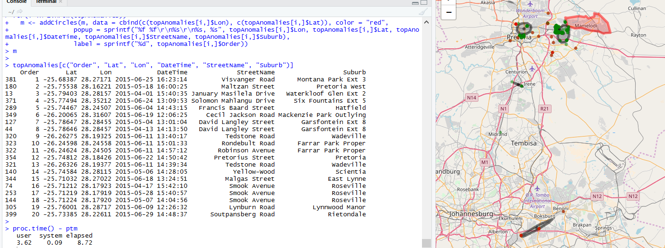
Figure 23: Visualising a 7-cluster Multivariate Gaussian Mixture model and Anomalies
The anomalies as well as the seven clusters were investigated, and no irregularities were found.

Creation of Unsupervised Model and Detection of Anomalies
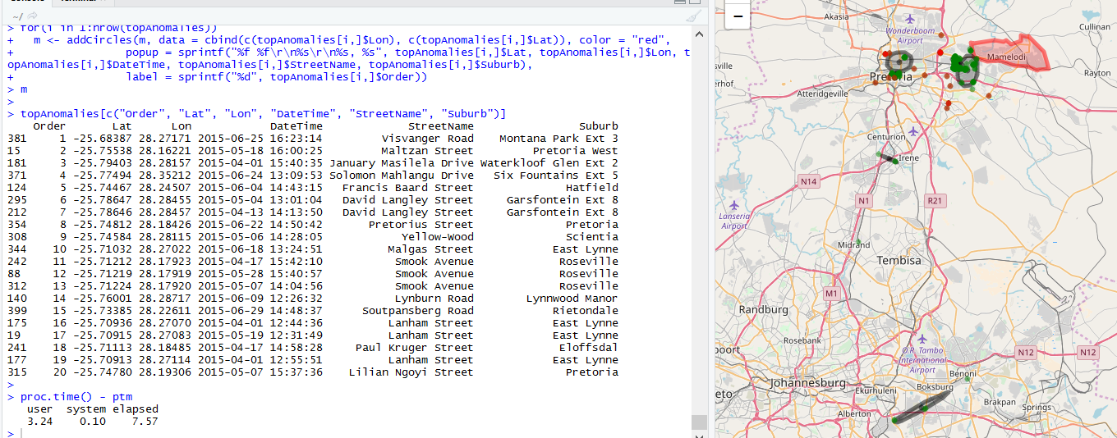
Figure 24: GMM, detected anomalies listed and visualised
The Isolation Forest package (Liu, 2009) was used to detect anomalies. The R script completed in 8 seconds.
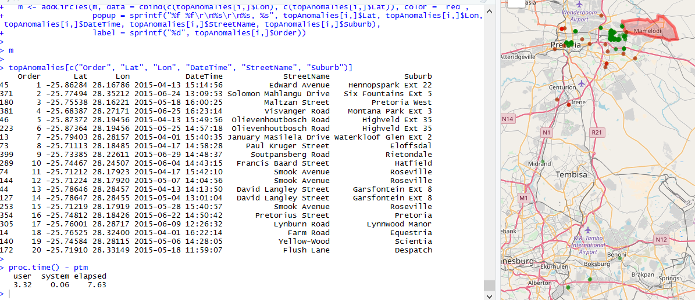
Figure 25: Isolation Forest: Detected anomalies listed and visualised
The anomalies were investigated, and no indication of insider threat scenarios was found.
The list of top 20 anomalies obtained from the Isolation Forest algorithm was compared to the list of top 20 anomalies using the GMM algorithm. It was found that 15 locations appeared in both lists.

Perception Model
Areas were created for some of the anomalies to allow for locations falling within these areas to be labelled as normal. Thus, these points could be excluded from the list of top anomalies and allowed other points to be investigated as anomalies.

October to December 2015
This section continues from the previous section by selecting the next range of locations from October to December 2015. The experiment continued to utilise the scaled-down ITMDVT process model.

Data Preparation
The locations where the vehicle was in switch-off mode between October and December 2015 were selected. The same data preparation process as in Section 7.3.2.3 was used.

Create Unsupervised Model and Detect Anomalies
The location data was presented to the mclust (Fraley et al., 2012) Gaussian Mixture Model algorithm with seven clusters.

Visualisation of Models and Anomalies
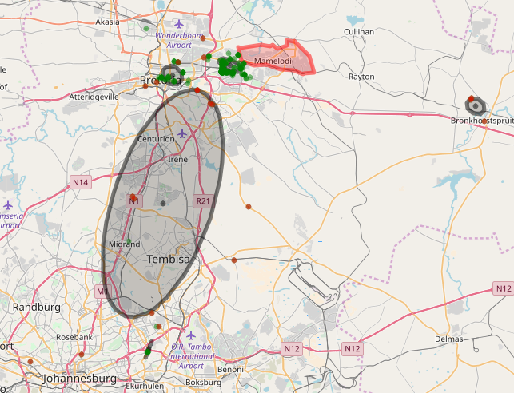
Figure 26: Visualising a 7-cluster Multivariate Gaussian Mixture model
It is apparent from Figure 26 that the definition of normal changed and that, in this case, seven clusters over-fitted the data as three locations were seen as a cluster.

Creation of Unsupervised Model and Detection of Anomalies
With experimentation it was found that three clusters sufficiently described the data. The R script completed within 6 seconds.

Visualisation of Models and Anomalies
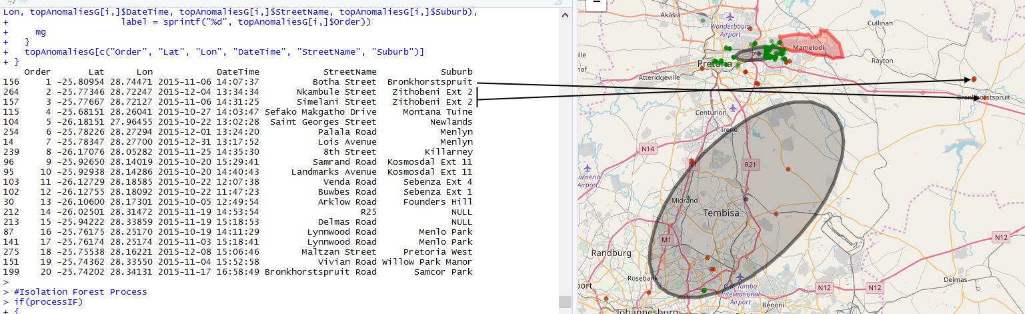
Figure 27: Visualising a 3-cluster Multivariate Gaussian Mixture model

Investigation of Anomalies
The second and third anomaly were marked on a satellite image, as shown in Figure 28. This made it easy to see that these stops occurred inside an informal settlement, which means that it was unlikely that the vehicle had been utilised for official business purposes. The fleet manager confirmed that there had been no prearranged approval for these stops and indicated that this was seen as private usage and abuse of the vehicle.
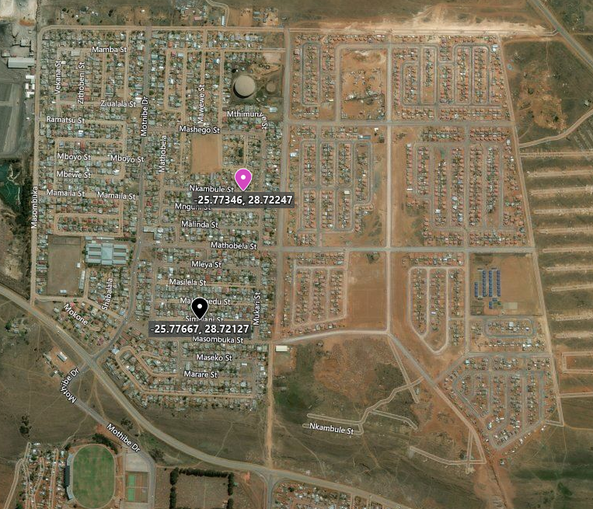
Figure 28: Unauthorised stops by the driver

Creation of Unsupervised Models and Detection of Anomalies
The Isolation Forest package (Liu, 2009) was used to detect anomalies. The R script completed within 6 seconds.
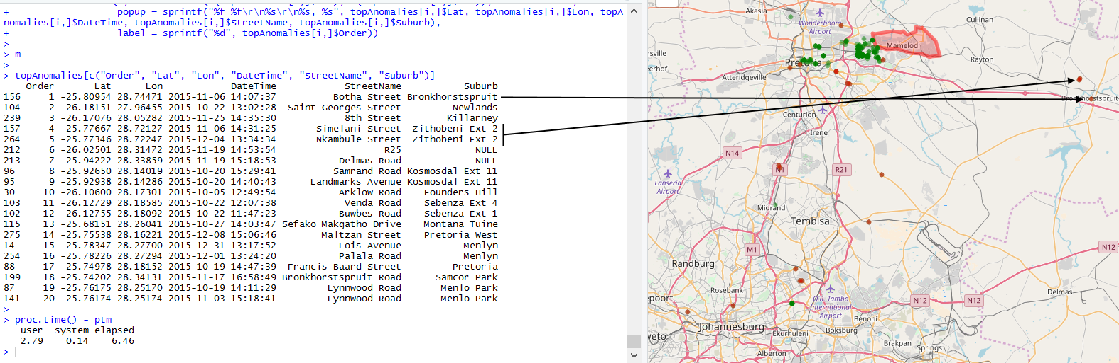
Figure 29: Visualisation of anomalies and unauthorised stopped obtained through the Isolation Forest implemenation
Figure 29 displays the list of anomalies detected by the Isolation Forest algorithm. The same two anomalies were found by the Gaussian Mixture Model.
The list of top 20 anomalies obtained from the Isolation Forest algorithm was compared to the list of top 20 anomalies using the GMM algorithm. It was found that 19 locations appeared in both lists.

Observations
Collecting the data for the vehicle and making it available was a slow process. However, once data was available, the experiments were executed quite quickly.
A comparison of the visualised models displayed in this chapter over the periods indicated demonstrated the concept of drift as discussed by Gama et al. (2014).
The Gaussian Mixture Model has the advantage that normal usage patterns can be investigated. Thus, patterns of normal abuse by employees can be discovered using the normal data patterns. No pattern of normal abuse was discovered.
It was found that the mclust (Fraley et al., 2012) R package provided consistent results when executed multiple times.
It was also discovered that some anomalies detected by the anomaly detection algorithms –such as location data for public holidays and fuel refills – were normal behaviour and as such were removed from the dataset presented to the anomaly detection algorithms. Other anomalies that were detected included data quality issues (see Appendix H for detail) such as instances where the GPS module in the vehicle-tracking device was not able to obtain a valid location. The data quality issue discovered in the anomaly list was an indication that not all the data quality issues could be effectively addressed in the first iteration of the data preparation process.
Following the process, allowed for a deeper understanding of how the vehicle was utilised and prompted discussions between the researcher and the manager of the vehicle. Collaboration between the data analyst and fleet manager was necessary to understand the environments and ensure that anomaly detection was applied correctly. The feedback from the fleet manager was necessary to determine if the detected anomalies were actually related to insider threat behaviour.
The Isolation Forest algorithm was found to be easy to use, as the default values for the parameters worked sufficiently.

Verification
The results from the experiments were verified by discussions with the fleet manager, using visualisation, and utilising more than one algorithm.
Where possible, the data and the discovered models obtained were visualised on a map. This included displaying the locations from the vehicle-tracking device as well as the elliptical boundaries of the Gaussian Mixture Model clusters. With visual inspection, it was found that the elliptical boundaries contained data and sufficiently described the cluster of locations they contained.
The locations that were detected as anomalies were discussed with the fleet manager and he assisted in identifying which of these locations were related to vehicle abuse or should be seen as acceptable.
More than one anomaly detection algorithm was used in the experimentation to verify that the results from the experimentation were valid. The results from the two algorithms were sufficiently similar.

Conclusion
A large percentage of anomalies detected by anomaly detection algorithms was part of the normal workday for a driver, such as taking a vehicle to a fuel station. The experiments showed that the existence of anomalies in a dataset is in no way an indication of insider threat behaviour. The anomalies found to be related to insider threat behaviour did not even yield the highest anomaly score.
It became apparent early in the experimentation that supervised anomaly detection would not be a viable option – as had been anticipated in the literature survey. This was due to an insufficient number of defined areas, complexity, lack of time and lack of interest from the fleet manager to label the data.
The resulting anomaly list from the Gaussian Mixture Model algorithm and the Isolation Forest algorithm was found to be between 50% and 95% similar. This finding corresponds with the theory discussed in Chapter 4, which concluded that the reason for these differences were that anomaly detection algorithms differ in their internal mechanisms and measurements, and as such they will assign different anomaly scores.
Only four of the 100 anomalies detected and investigated were found to be valid previously unknown insider threat scenarios, such as utilising the vehicle for personal use. This corresponded with the findings in the literature survey in Chapter 3, which also concluded that insider threat scenarios are indeed rare. Thus, applying anomaly detection is not necessarily a simple and efficient approach to finding insider threats.
The experiments could not prove that insider threat behaviour existed within the data or that anomaly detection would find any or all insider threat instances in the data.
The insider threat behaviour discovered in this chapter relates to an individual utilising a corporate vehicle for private purposes, which is considered a threat, as it entails costs to the corporate regarding fuel, maintenance and productivity loss. Also, the vehicle was exposed to additional risks such as accident damage and theft.
This chapter contributed to the general body of knowledge by defining equations to calculate the ellipses for the Gaussian Mixture Model as a polygon on a map. Although searching the Internet and academic databases for these equations did not provide any results, the equations can be utilised in other research describing geographical data.
The experiments discussed in this chapter conclusively answered the research question by demonstrating that previously unknown insider threat behaviour can be discovered when the ITDMVT process model and vehicle-tracking data are used.
To summarise – Chapter 7 demonstrated that anomaly detection could be utilised to discover insider threats in the vehicle-tracking industry and proved that the problem statement of this dissertation is valid.

Chapter
  - Experimentation involving a Fleet of Vehicles

Introduction
The previous chapter demonstrated that the ITDMVT process model is a valid approach towards discovering previously unknown insider threats by utilising the data from a single vehicle-tracking device. This chapter builds on the previous chapter to show that the ITDMVT process model is a valid approach in the discovery of previously unknown insider threats as it allows the analysis of data obtained from the vehicle-tracking devices in a large fleet of vehicles.
This chapter discusses the selection of a fleet of vehicles, the experimental design used in this study and the design implementation.

Selecting a Fleet of Vehicles
Fleet vehicles are applied and utilised differently in various environments. Fleet managers also view threats differently, as the business model differs from business to business. Some fleet managers view speeding as a dismissible offence, whereas other fleet managers are more concerned about the hefty penalties of late deliveries than about speeding fines.
Commercial fleets such as buses and delivery vehicles have set routes and timetables that need to be adhered to, to the nearest 10 minutes, whereas the vehicles in a fleet of plumbers and electricians seldom visit the same location twice.
Due to the above reasons, the researcher decided to select a single fleet of vehicles, instead of trying to build a generic model or set of models to detect anomalies to discover insider threats for all types of commercial fleets. Another challenge involves obtaining feedback from a sufficient number of fleet managers to measure the quality of the results obtained from the generic model. Thus, a single fleet of vehicles was selected for this research.
Altech Netstar (2018), a vehicle-tracking provider, estimates that approximately 80% of the fleets that utilise its services consist of 100 or fewer vehicles, as demonstrated in Figure 30.
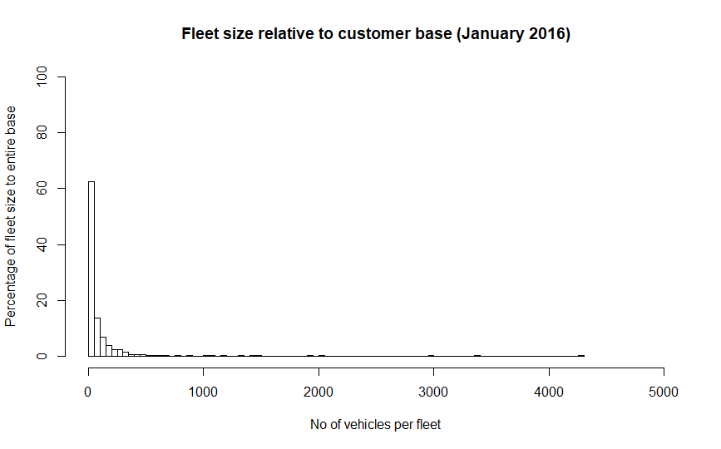
Figure 30: Histogram of fleet size relative to customer base
The researcher selected a fleet with 1200 vehicle-tracking devices that generates approximately 15 to 20 million location records a month. An important reason for selecting this particular fleet was the fact that the fleet manager agreed to provide feedback on the researcher’s findings.
For the purposes of the current research, if the ITDMVT process model could be applied to a fleet utilising 1200 vehicle-tracking devices, it would be considered sufficiently large to demonstrate that the process can be scaled and considered a suitable approach to discover insider threats utilising vehicle-tracking data within the big data and data science space (Daniel, 2017).

Experimental Design
Because of the time constraints to complete the experimentation and the fact that the fleet manager had neither the time nor the desire to label the data, a scaled-down version of the ITDMVT was implemented. The researcher thus implemented only unsupervised anomaly detection, using the Gaussian Mixture Model (Mike, 1967) and the Isolation Forest (Liu et al., 2008) anomaly detection algorithms as shown in Figure 31.
The purpose of the experimentation in this chapter was to determine if anomaly detection using vehicle-tracking data is a valid approach in the search for previously unknown insider threats. It was thus necessary to discover at least one previously unknown insider threat scenario using anomaly detection.
Figure 31: Scaled-down ITDMVT process model
The experimentation in this chapter does not modify the data from the vehicle-tracking devices in any way.

Research Question
The experimentation in this chapter attempted to answer the following research question:
Can previously unknown insider threat scenarios be discovered by using the ITDMVT process model and vehicle-tracking data for a large fleet?

Design Implementation
This section describes one of the four experiments in which the ITDMVT process model was implemented. The detailed findings of the four experiments can be found in Appendix H. The R scripts that were used for the experimentation in this chapter can be found in Appendix E.
To prevent the repetition of detailed implementation discussions in the experiments, the following is stated beforehand:
- In the previous chapter it was possible to determine the number of clusters for the Gaussian Mixture Model (GMM) using experimentation and visual inspection. Because of the sheer volume of data in this chapter, the number of clusters could not be discovered visually and as such the appropriate number of clusters for the Gaussian Mixture Model (GMM) was discovered using the greedy search algorithm (Stepanova & Vavrecka, 2018) implemented in the mclust (Fraley et al., 2012) R function. The mclust R function was then used to discover a GMM model using the number of clusters from the greedy search. The GMM algorithm is slow on large volumes of data and as such a sample set of data was used in the process to discover the number of clusters and the GMM model. An equal opportunity random selection of 20,000 locations was used in each experiment as input data to the GMM algorithm.
- In this chapter, the IsolationForest (Liu, 2009) R function was used to discover Isolation Forest anomaly detection models. The default number of trees was set to 250. Because the Isolation Forest is a fast algorithm, the entire dataset was given to the algorithm as input.
- The memory utilised by models was obtained utilising the object.size function in the utils (R Foundation for Statistical Computing, 2017) R library.
- A principal component analysis (PCA) (Soh et al., 2018) was performed using the princomp (R Foundation for Statistical Computing, 2017) function.

Experiment
This section describes the last of four experiments that implemented the scaled-down ITDMVT process model. All four experiments are discussed in detail in Appendix H.

Environmental Study
The corporate that manages this fleet insisted that their intellectual property and the trade secrets that provide them a competitive advantage may not be shared. The current study therefore attempted to provide as much detail as possible, without violating the confidentiality agreement.
The drivers of the vehicles were unionised, which provided another reason why the identity of the fleet company could not be revealed. Although the intention is not to commercialise this study, the unions involved might abuse this research.
The fleet manager indicated that the vehicle drivers had designated areas where they were allowed to stop and switch the vehicle’s ignition on and off. These designated areas included fuel stations. The following areas were also configured for this fleet:
- 120 toll gates
- 110 keep-in routes
- 4600 point-of-interest (safe) areas, which included branches, offices, distribution centres and delivery points
- 70 no-go areas, which included prohibited, suspicious areas of possible fuel theft and areas where hijackings occurred previously
The devices fitted in the fleet consisted of vehicle-tracking devices manufactured and supplied by CalAmp (CalAmp, 2018), Meta System (Meta System, 2004) and Altech Netstar (Altech Netstar (Pty) Ltd, 2018).
The fleet manager also indicated that vehicles were allowed to stop at shopping centres or businesses, but not at private residential areas such as private estates.

Perception Model
Figure 32 shows the areas mentioned above. The areas in red are the no-go areas, the purple lines are the keep-in routes and blue areas the point-of-interest (safe) areas.
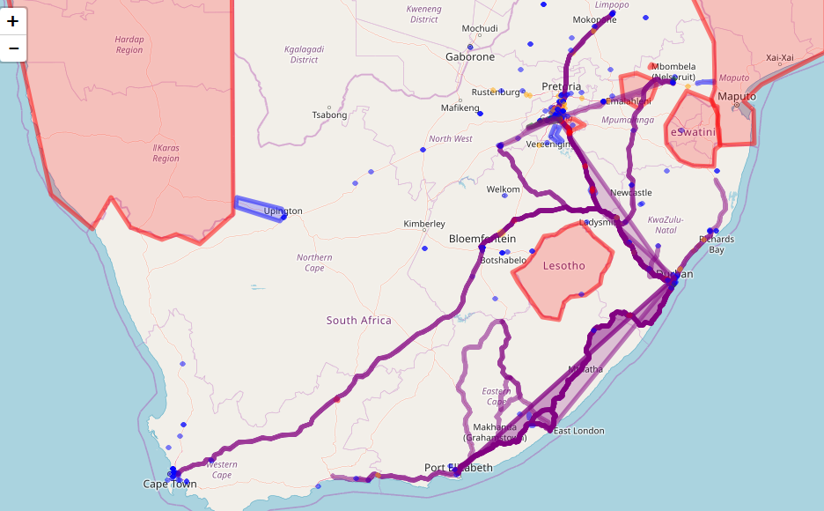
Figure 32: Visualisation of configured areas

Data Preparation

Data Collection and Integration
The data of interest was all the location-related data received for the selected fleet from 1 June 2018 to 30 September 2019 and it was stored in the big data system described in Chapter 2.
The data was obtained using a REST service, which provides the data as a JSON string per vehicle. Examples of the JSON data structures can be found in Appendix D for the three most commonly used vehicle-tracking device types. The JSON data of interest for the experimentation in this chapter was the location data, as this is the only type of data sampled at regular intervals by the different vehicle-tracking device types when the ignition of the vehicle was switched on. Other types of data such as accelerometer values and configuration settings were discussed in more detail in Chapter 2.
Table 9 provides a subset of the significant attributes that were available in the JSON-formatted location data.
Table 9: Description of JSON attributes
Attribute | Description
Vbu | The IMEI number that globally and uniquely identifies the vehicle-tracking device
Hardware | The type of device that sent the data
Datetime | The date and time (UTC) when the vehicle-tracking device recorded the location
Latitude | The latitude of the GPS coordinate
Longitude | The longitude of the GPS coordinate
Altitude | The height above sea level
EventId | The number to indicate what caused the vehicle-tracking device to send a location such as ignition-on, ignition-off or heading change
Speed | The speed of the vehicle
Heading | A value between 0 and 359 degrees, where 0 degree is North, indicating the direction the vehicle is travelling
Satellites | The number of satellites that the GPS module on the vehicle-tracking device used to determine its current location (the GPS module needs at least four satellites to obtain an accurate location)
ServerDateTime | The date and time (UTC) of the server that received the data in the data centre
Battery voltage | The voltage of the vehicle’s battery
Internal battery voltage | The voltage of the battery within the vehicle-tracking device
Ignition status | 1 indicates that the ignition is switched on and 0 indicates that it is switched off
Rpm | The revolutions per minute the engine is turning (this value is recorded only when a tachograph device has been installed)

The location data was converted into a fixed-column structure and inserted into a Microsoft SQL (Microsoft, 2017) table. The table was named Locations and attributes as described in Table 10. The Locations table has 64 million location rows.
Table 10: Location table attributes
Attribute | Description
Id | Integer to uniquely identify the row
Imei | The IMEI number which globally uniquely identify the vehicle-tracking device (this is the vbu attribute from Table 9)
DateTime | The date and time (UTC) the location was recorded by the vehicle-tracking device (this is the DateTime attribute from Table 9)
Latitude | The latitude of the GPS coordinate (this is the latitude attribute from Table 9)
Longitude | The longitude of the GPS coordinate (this is the longitude attribute described in Table 9)
EventId | The number to indicate what caused the vehicle-tracking device to send a location such as ignition-on, ignition-off or heading change (this is the EventId attribute from Table 9)
NoOfGpsSatellites | The number of satellites that the GPS module on the vehicle-tracking device used to determine its current location (the GPS module needs at least four satellites to obtain an accurate location – this is the satellites’ attribute from Table 9)
ServerDateTime | The date and time (UTC) of the server that received the data in the data centre (this is the ServerDateTime attribute from Table 9)

Data Cleaning
Figure 33 presents a sample set of the locations from the IgnitionOff table. As can be seen from the image, some locations are obviously incorrect, such as the ones in the oceans.
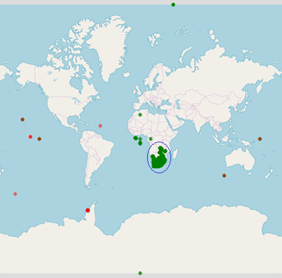
Figure 33: Ignition-off locations for the fleet
The following rules were applied to ensure that the dataset only contained valid location rows:
- Rule 1: Only include records where the date recorded by the device was between 01 June 2018 and 30 September 2018. (The vehicle-tracking device uses the GPS module to obtain the current date and time. If there is an issue with GPS reception or if there are issues with the device, the date and time will be close to a default value or differ drastically from the date and time they have been received.)
- Rule 2: Include locations where the GPS module on the vehicle-tracking device was able to utilise four or more satellites to obtain the location data.
- Rule 3: Include locations between Longitude > 5° and Longitude < 44°. The area of interest.
- Rule 4: Include locations between Latitude > -38° and Latitude < 0°. The area of interest.
- Rule 5: Remove duplicate locations. A location is seen as duplicate of another when latitude and longitude values are the same. The vehicle-tracking devices in this study only send the same GPS coordinates if they cannot obtain a location from their GPS module.
- Rule 6: Remove locations with Latitude and Longitude values of zero.
Interestingly, four locations were provided by the vehicle-tracking devices where the date values were invalid. One of these dates was 2018-09-31, and since September only has 30 days, the date was changed to 2018-09-30. This can happen because the vehicle-tracking devices communicate the year, month, day, hour, minute and second as separate fields to the backend server and no complex validation is performed on this date.

Data Visualisation
Visualising the locations within the defined areas as shown in Figure 34 revealed that the defined areas were not well maintained and up to date. A telephonic conversation with the fleet manager confirmed this.
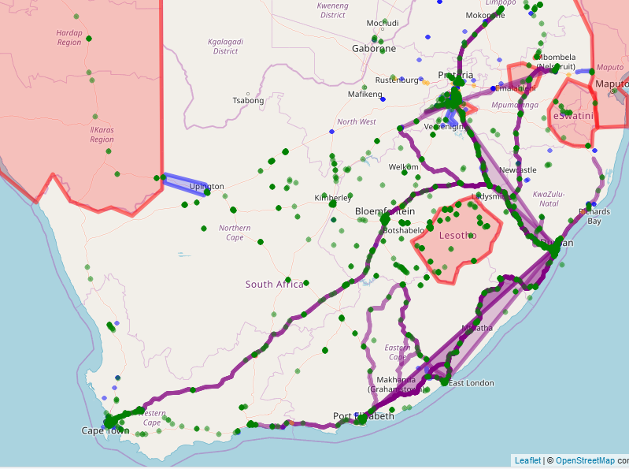
Figure 34: Displaying ignition-off locations in defined areas

Data Transformation.
Within this experiment, trips were utilised as the input dataset to the anomaly detection algorithm. The location where a vehicle’s ignition is switched on was paired with the corresponding ignition-off location; this corresponded with the definition of a trip as described in Chapter 2.
A total of 1 059 207 trips were obtained from the fleet by pairing the corresponding ignition-on locations next to each ignition-off location per vehicle. The resulting trips were written to a Microsoft SQL database table call Trip.
Table 11 provides a description of each attribute presented in the Trip table.
Table 11: Trip attributes
Attribute | Description
StartLongitude | The longitude of the location where the trip started
StartLatitude | The latitude of the location where the trip started
EndLongitude | The longitude of the location where the trip ended
EndLatitude | The latitude of the location where the trip ended
StartDateTime | The date and time when the trip started
EndDateTime | The date and time when the trip ended
StartOdometer | The odometer value at the start of the trip.
EndOdometer | The odometer value at the end of the trip.

Feature Engineering - Trips
The features described in Table 12 were extracted from the attributes described in Table 11 and added to the Trip table.
Table 12: Trip features
Feature | Description
StartTimeOfDay | The time of day when the trip started (this value was obtained by converting the StartDateTime value from UTC to South African local time and selecting the Time part of the value)
EndTimeOfDay | The time of day when the trip ended (this value was obtained by converting the EndDateTime value from UTC to South African local time and selecting the Time part of the value)
StartIsWorkDay | Indicates if the day when the trip started was a workday – 1 for workdays and 0 for weekends and public holidays (this value was obtained by converting the StartDateTime value from UTC to South African local time and selecting the Date part of the value)
EndIsWorkDay | Indicates if the day when the trip ended was a workday – 1 for workdays and 0 for weekends and public holidays (this value was obtained by converting the EndDateTime value from UTC to South African local time and selecting the Date part of the value)
Distance | Calculated by subtracting the StartOdometer attribute from the EndOdometer attribute described in Table 11
DurationSeconds | Calculated by subtracting the DateTime value for the trip start location from the DateTime value for the trip end location for each trip
StartEndDistance-Metre | Obtained by calculating the straightline distance in metres between the StartLongitude and StartLatitude and the EndLongitude and End Latitude values

Data Cleaning
The following rules were used to remove trip rows with invalid or useless data.
- Rule 1: Remove trips where trip ended with less than four satellites visible to the GPS.
- Rule 2: Remove trips where the distance between the start and end location was less than 1 metre.
- Rule 3: Remove trips where the trip duration was less than 60 seconds.
- Rule 4: Remove trips where the trip duration exceeded 8 hours.
- Rule 5: Remove trips with negative distance values. (Negative odometer values can occur when the odometer on the vehicle-tracking device is updated during a trip or the vehicle-tracking device is restarted.)
After the cleaning process, there were 807 715 trips to work with.

Selected Attributes and Features for Anomaly Detection
The StartLongitude, StartLatitude, EndLongitude, EndLatitude, StartTimeOfDay, EndTimeOfDay, StartIsWeekDay, EndIsWeekDay, Distance, DurationSeconds and StartEndDistanceMetre values were selected from the above locations’ dataset to constitute the dataset on which the anomaly detection would be performed.

Data Reduction
A principal component analysis (PCA) (Soh et al., 2018) was performed on the input dataset to determine if the obtained dataset could be reduced. The result of the PCA, as shown in Figure 35 and Figure 36, indicates that the dataset columns could be reduced to a smaller number of columns without a significant loss in accuracy. The results also indicated that there were no redundant attributes or features in the dataset.
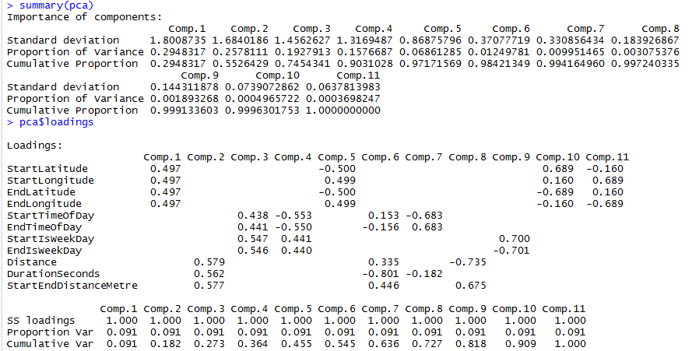
Figure 35: Summary and Loadings of the Principal Component Analysis performed on the dataset
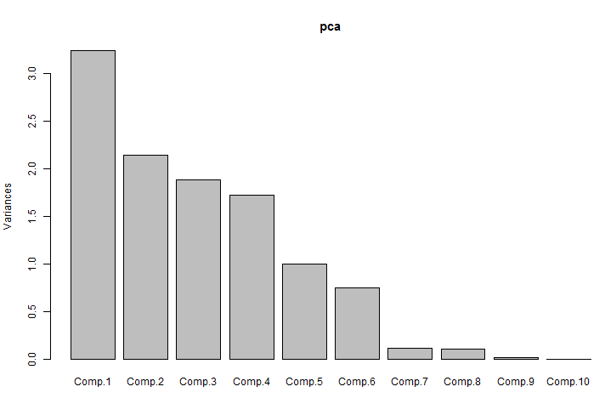
Figure 36: Plot of the Principal Component Analysis on the dataset

Analyse Feature Values
Density plots were created to investigate the feature values contained in the dataset.
Figure 37 and Figure 38 look similar because of the short duration of a high percentage of trips, as can be deducted from Figure 42.
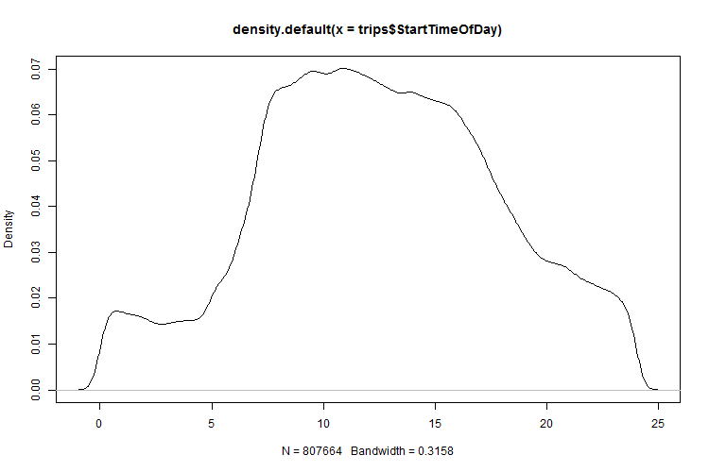
Figure 37: Density plot for the trip StartTimeOfDay feature
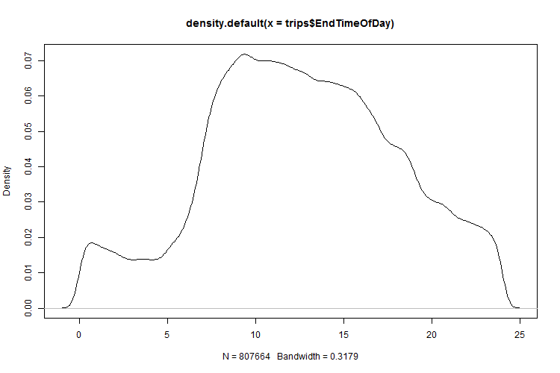
Figure 38: Density plot for the trip EndTimeOfDay feature
Figure 39 and Figure 40 indicate that most trips start and end on weekdays.
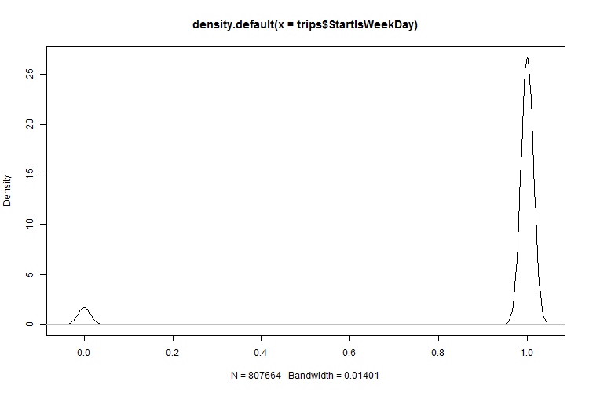
Figure 39: Density plot for the trip StartIsWeekDay feature
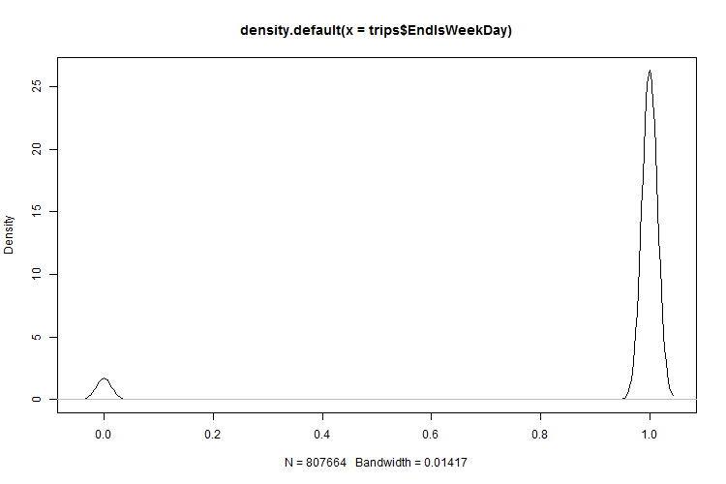
Figure 40: Density plot for the trip EndIsWeekDay feature
Using the density plot approach to visualise the trip duration, as displayed in Figure 41, it was noticed that some trips had a negative distance, because the odometer values on the vehicle-tracking devices had been changed. Those trips with a negative distance were removed in the data-cleaning process and as such, do not appear in the density plot any more.
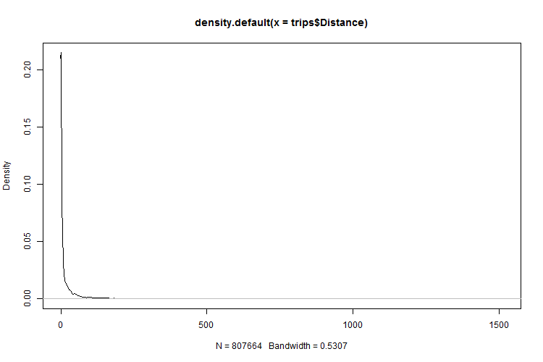
Figure 41: Density plot for the trip Distance feature
By using the density plot approach to visualise the trip duration, as displayed in Figure 42, it was found that some trips exceeding 8 hours. A total of 40 trips exceeded 8 hours and were removed from the dataset.
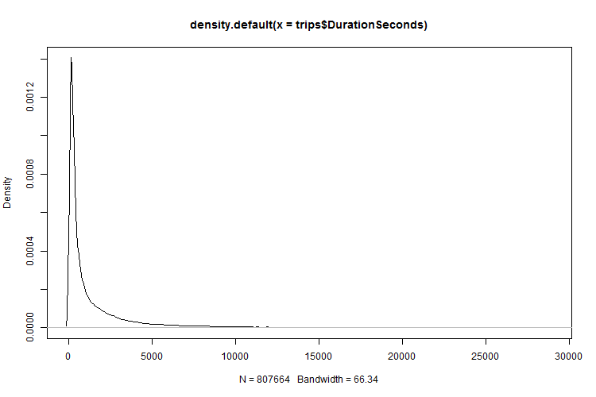
Figure 42: Density plot for the trip DurationSeconds feature
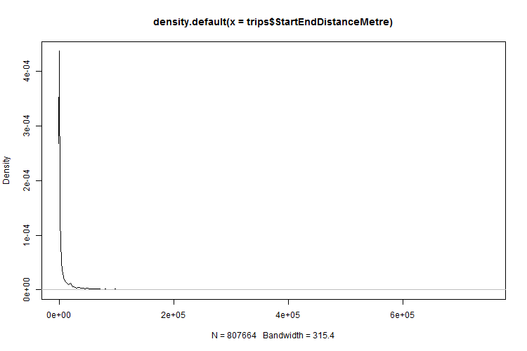
Figure 43: Density plot for the straightline distance between the start and end location

Data Labels
It was decided not to utilise the predefined no-go and keep-in areas, as the dataset would not be based on longitude and latitude values only and important anomalies may be missed, as contextual data had been added to the dataset.

Creation of Unsupervised Model and Detection of Anomalies
A greedy search estimated that seven clusters describe the data for the GMM model. The GMM model was created within 1 hour and 30 minutes and it used 8.0 MB memory.
The Isolation Forest model, which was created within 42 minutes, used 16.9 MB memory.
The dataset was passed to the above models and the top 100 anomalies from each model were selected. Twelve of the anomalies were found to be in both anomaly lists.

Visualisation of Anomalies
The trips that were identified as anomalies were visualised in R using straight lines between the start and end location as shown in Figure 44 and Figure 45.
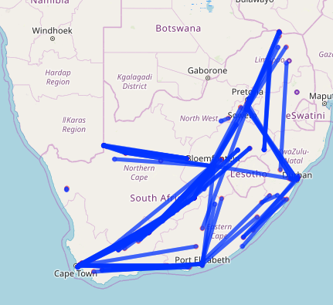
Figure 44: Trips detected as anomalies by the Isolation Forest algorithm
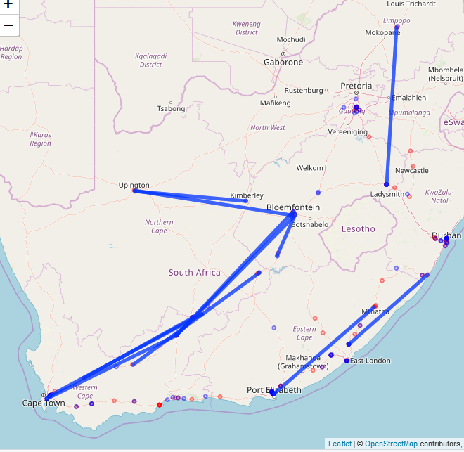
Figure 45: Trips detected as anomalies by the GMM algorithm

Investigation of Anomalies
The list of anomalies was presented to the fleet manager and each anomaly was investigated manually. Figure 46 displays the top entries on the list of anomalies that was presented to the fleet manager.
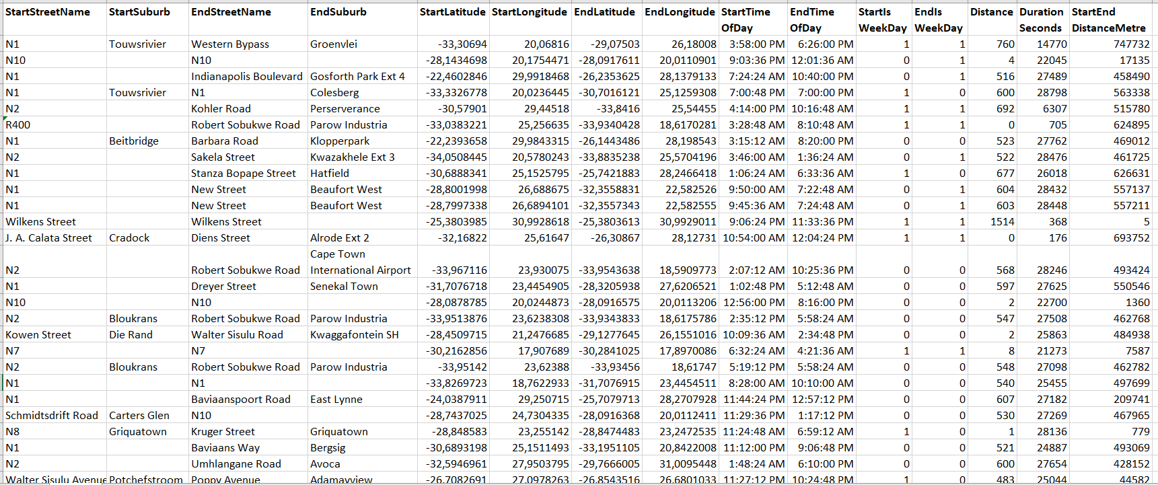
Figure 46: Screen capture of list of anomalies investigated
Figure 47 and Figure 48 display two of the anomalies in the trips that were investigated where the drivers of the vehicles stopped without approval.
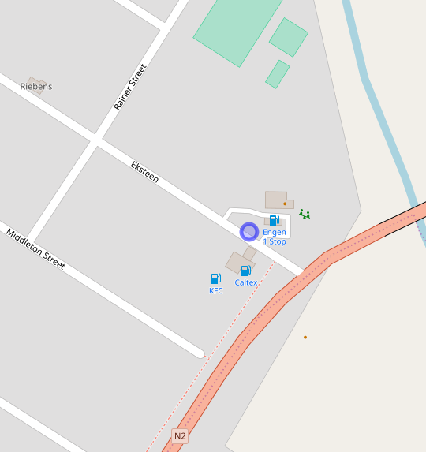
Figure 47:Unauthorised stop
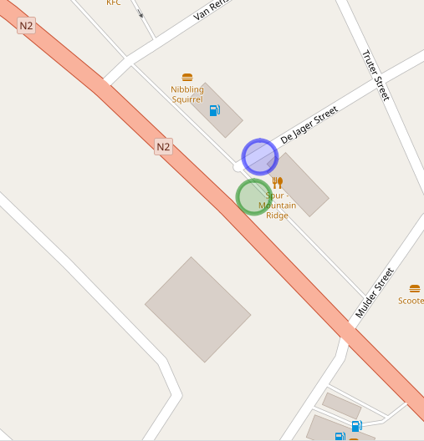
Figure 48: Unauthorised stop
The threat in this case was that the drivers deviated from a route plan, placing the vehicle and cargo at risk.

Data Analysis of Anomalies
A principal component analysis (PCA) (Soh et al., 2018) was performed on the anomalies obtained through the Isolation Forest algorithm as shown in Figure 49 and Figure 50. The PCA analysis indicates that all of the dimensions of the anomaly dataset contributed to the variability of the dataset.
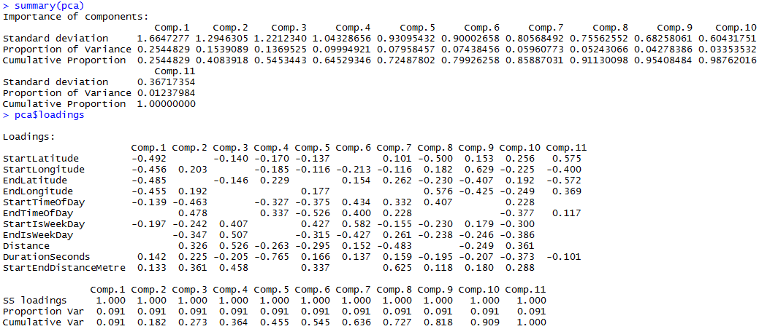
Figure 49: PCA for Isolation Forest anomalies
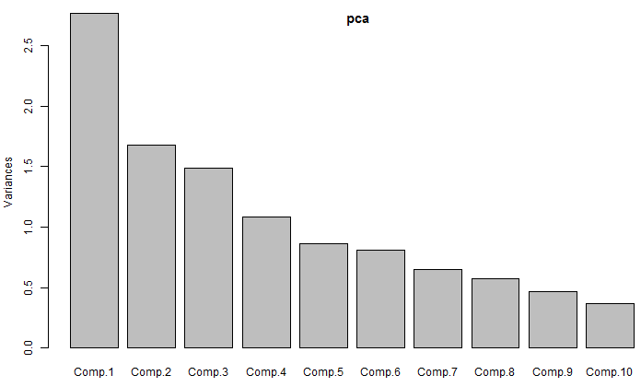
Figure 50: PCA Plot for the Isolation Forest anomalies
The principal component analysis (PCA) (Soh et al., 2018) was also performed on the anomalies obtained by means of the GMM algorithm shown in Figure 51 and Figure 52. The PCA analysis indicates that all of the dimensions of the anomaly dataset contributed to the variability of the dataset.
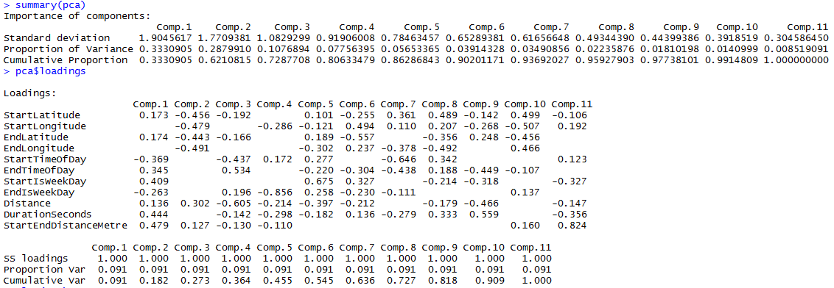
Figure 51: PCA for GMM anomalies
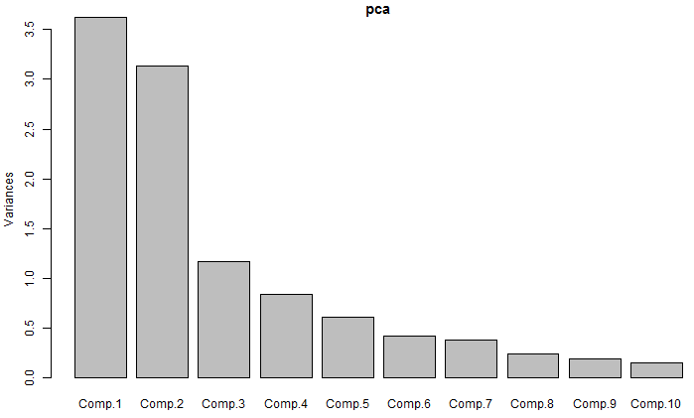
Figure 52: PCA Plot for the GMM anomalies
Using the greedy search, it was determined that six clusters describe the Isolation Forest algorithm anomalies. The clustered data is shown in Figure 53.
The greedy search was used again and it was found that 11 clusters describe the GMM algorithm anomalies. The clustered data is shown in Figure 54.

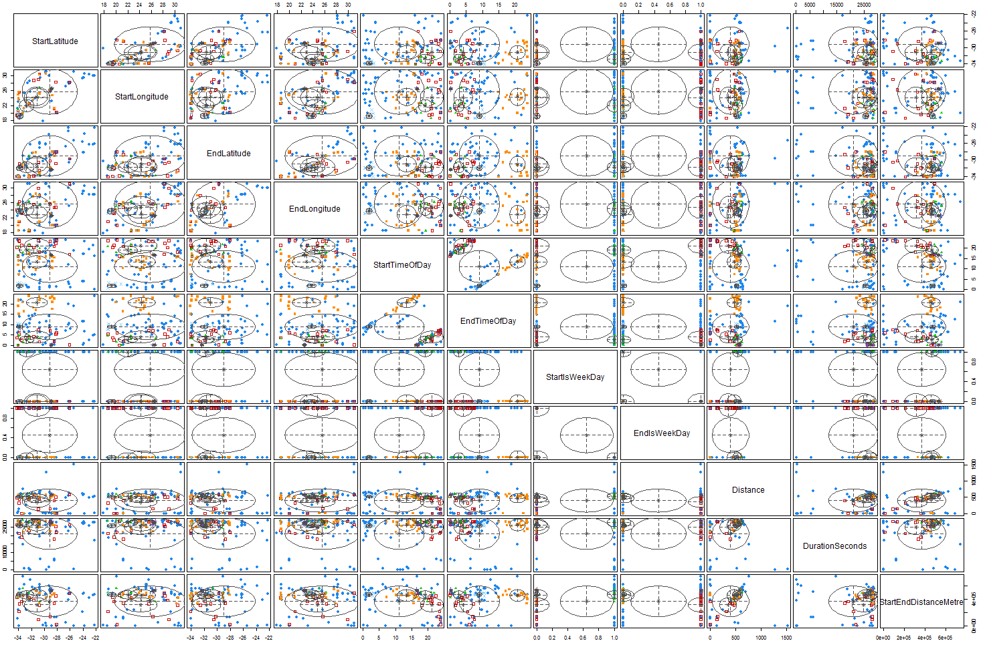
Figure 53: Cluster plot for the Isolation Forest anomalies
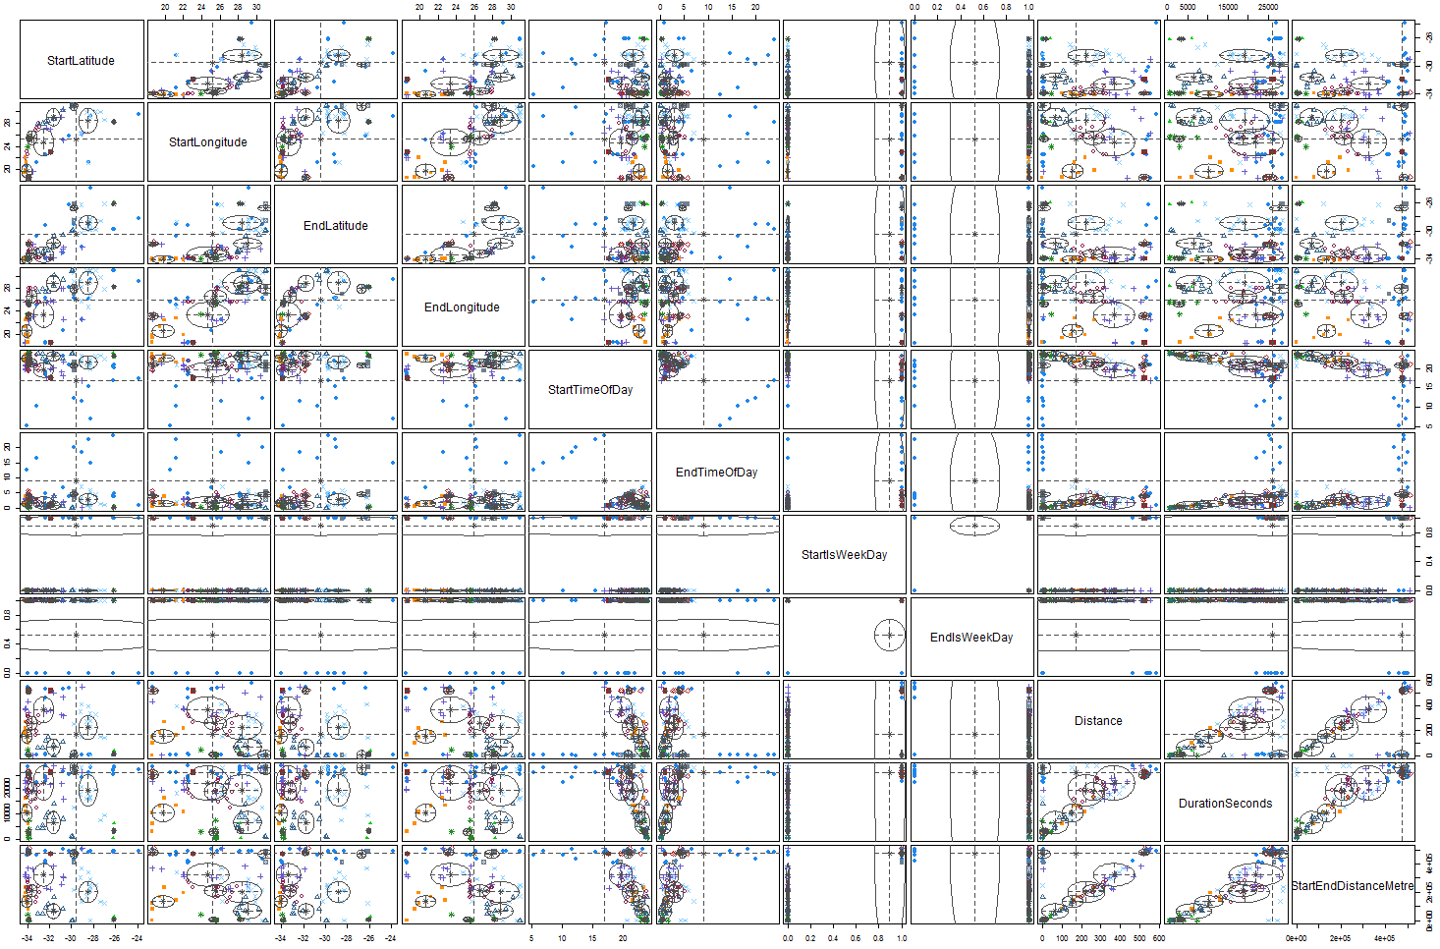
Figure 54: Cluster plot for GMM anomalies
The anomalies were further analysed by creating density plots for the features that emerged from the anomalies in the Isolation Forest algorithm and GMM algorithm. Figure 55 to Figure 60 show some of these density plots, and the complete list of plots can be found in Appendix H. The density plot for each feature of the anomalies for the two algorithms was placed next to each other for the sake of comparison.
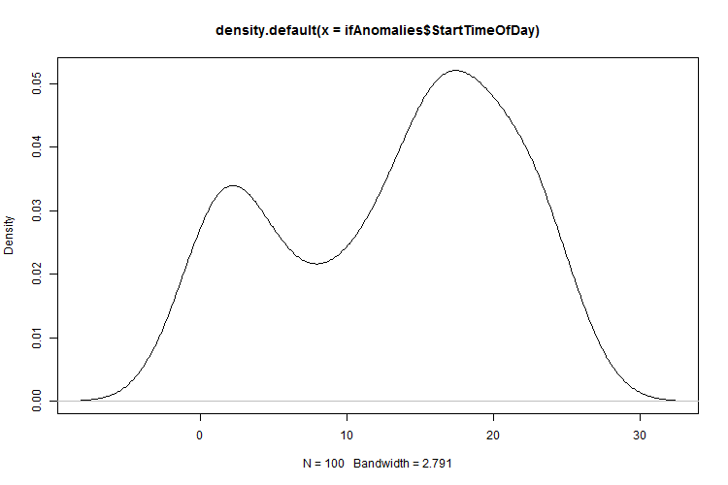  Figure 55: Density plot for trip Isolation Forest anomalies StartTimeOfDay | 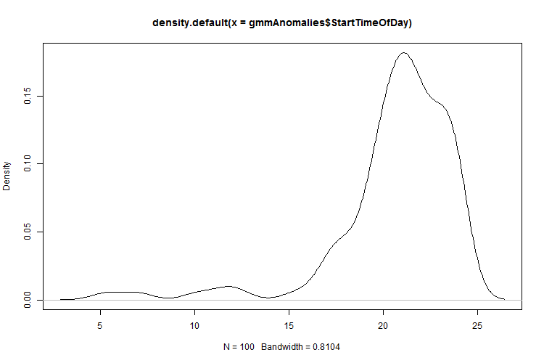  Figure 56: Density plot for the GMM anomalies trip StartTimeOfDay
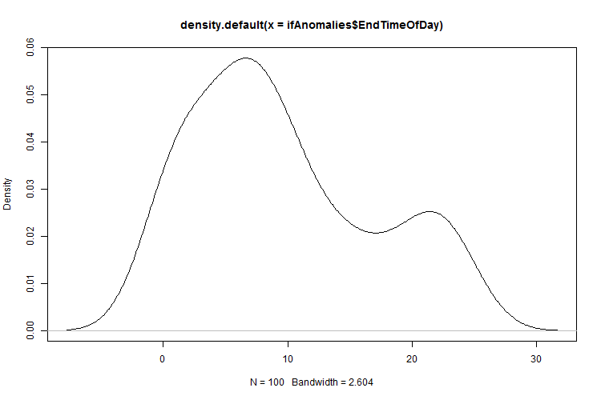  Figure 57: Density plot for the Isolation Forest anomalies trip EndTimeOfDay | 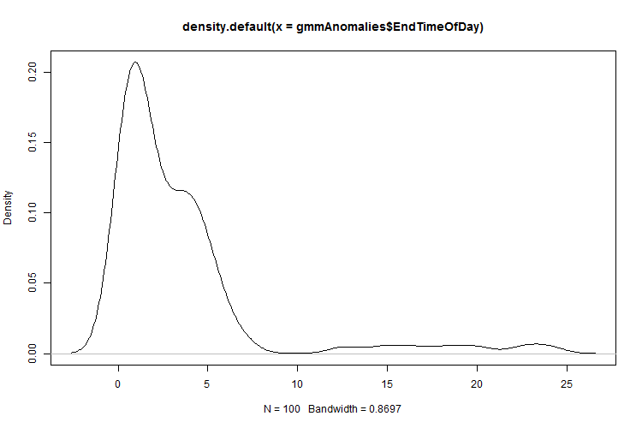  Figure 58: Density plot for the GMM anomalies trip EndTimeOfDay
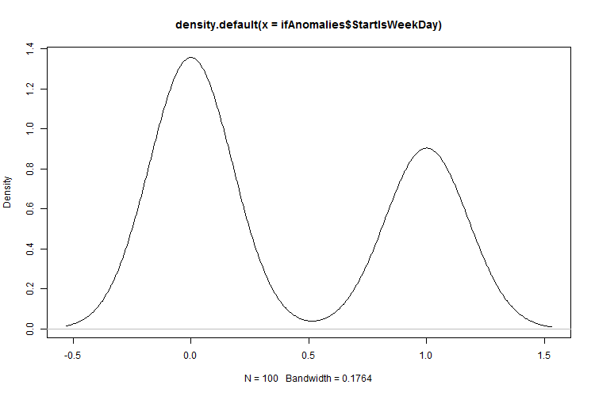  Figure 59: Density plot for the Isolation Forest anomalies trip StartIsWeekDay | 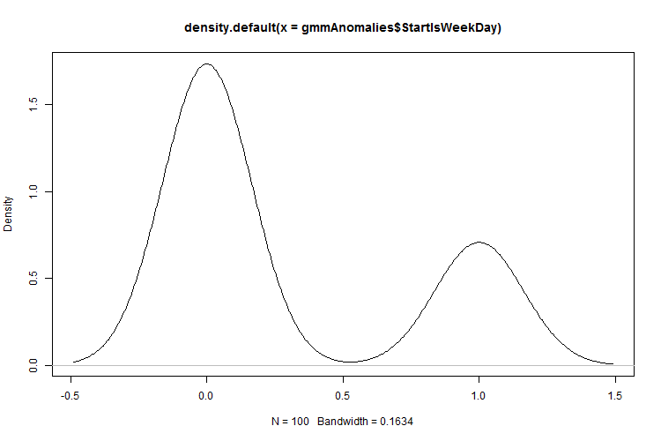  Figure 60: Density plot for the GMM anomalies trip StartIsWeekDay

Experiment - Conclusion
This section showed that the ITDVMT process model is a valid approach in the search for previously unknown insider threats, as it was successful in finding previously unknown insider threat scenarios. The insider threat discovered was related to two drivers who deviated from their route plans, thus placing their vehicles and cargo at risk.
The data analysis of the anomalies indicated that the two anomaly detection algorithms ranked anomalies differently.

Observations
One of the interesting anomalies found are displayed in Figure 61, which prompted an investigation. It was found that the owner of the business had instructed goods to be delivered to his home. Thus, it was an authorised stop.
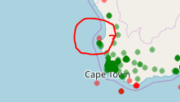
Figure 61: Approved anomaly
The density graphs provided value in interpreting the data, whereas the clustered data graphs were difficult to interpret and did not show the density of the clusters.
Because of the sheer volume of data, the collection and preparation of data were slow and tedious. Not all processes are able to process data in parallel, because of technology limitations. In some cases, a process in the data preparation took up to 8 hours to complete. It was estimated that the data preparation time was between 80% and 90% of all the time spent.
With the first trial of the experiment, it was discovered that the anomalies that had initially been detected were related to data-cleaning issues and as the data cleaning effort improved, the quality of the anomaly detection also improved.

Verification
The results from the experiments were verified by means of visualisation, discussions with the fleet manager and the use of more than one anomaly detection algorithm.
Where possible, the data and the discovered models were visualised on a map. This included displaying the locations obtained from the vehicle-tracking device, as well as the elliptical boundaries of the Gaussian Mixture Model clusters. With visual inspection, it was found that the elliptical boundaries contained data and sufficiently described the cluster of locations they contained.
The locations that had been detected as anomalies were discussed with the fleet manager and he assisted in identifying which of these locations were related to vehicle abuse or which should be seen as acceptable.
More than one anomaly detection algorithm was used in the experimentation to verify that the results from the experimentation were valid. The results obtained from the two algorithms were 10% to 15% similar.
Further analysis was performed on the anomalies obtained, which included clustering, principal component analysis and the creation of density plots, to enable the researcher to investigate and verify the anomalies.

Conclusion
Anomaly detection highlighted records with invalid data that should have been removed or repaired in the data-cleaning process.
It became apparent early in the experimentation that supervised anomaly detection would not be a viable option, as had been anticipated in the literature survey. This was due to the defined areas not being maintained, complexity, as well as lack of time and lack of interest from the fleet manager to label the data.
Of the over 700 anomalies that were investigated, five were considered suspicious and prompted further investigation to confirm whether they were related to insider threat behaviour. This finding corresponds with the findings in the previous chapter and the literature survey in chapter 3, which also concluded that insider threat scenarios are rare.
The experimentation showed that insider threats could not be discovered with the anomaly detection algorithms alone. Feedback was required from the fleet manager to determine if the anomalies detected were related to insider threat. The anomalies detected provided an opportunity to ask questions about the data to the fleet manager, who in response provided more contextual information. Following the ITDMVT process allowed the researcher and fleet manager to understand how the fleet actually operates.
The study found that applying anomaly detection was not necessarily a simple and efficient approach towards finding insider threats. Moreover, the experiments could not prove that insider threat behaviour existed within the data or that anomaly detection would find any or all insider threat instances in the data.
The experimentation corresponded with the theory discussed in chapter 4, which stated that the different anomaly detection algorithms use different measurements to determine the degree to which an item is seen as an anomaly.
Furthermore, the experimentation discussed in chapter 8 conclusively answered the research question posed in this study, since it demonstrated that previously unknown insider threat behaviour could be discovered by using the ITDMVT process model and vehicle-tracking data.
This chapter also demonstrated that anomaly detection could be utilised to discover insider threats in the vehicle-tracking industry and proved that the research problem stated in this dissertation is indeed valid.

Chapter
  - Conclusion

Introduction
The research described in this dissertation investigated how anomaly detection could be applied to vehicle-tracking data to discover insider threats. An overview was provided of the vehicle-tracking industry, vehicle-tracking data, insider threats and anomaly detection. A process model to discover insider threats by means of anomaly detection and vehicle tracking was suggested in this dissertation. This process model allowed the vehicle-tracking data to be investigated for a single vehicle as well as for large fleets by using Big Data frameworks and data science platforms.
This closing chapter establishes whether the research presented in this document meets the criteria specified in the original research question and answers the secondary questions stated.

Addressing the Problem Statement
The primary objective of this research was to determine whether utilising anomaly detection on vehicle-tracking data was a valid approach to discover insider threats. The approach was limited by the fact that vehicle-tracking data was considered confidential information and had to be treated with due care. The problem statement for this dissertation was phrased as follows:
Anomaly detection can be utilised to discover insider threats by utilising the data obtained from vehicle-tracking devices.
In order to demonstrate that this statement was valid, the following main and subquestions needed to be answered.

The Main Research Question and Subquestions
The main research question was as follows:
Is anomaly detection a valid approach to discover insider threats by utilising vehicle-tracking data?
To verify whether this question was successfully answered, the question had to be divided into its separate components. These components related to the secondary research questions. It was thus necessary to:
- have a look at the available vehicle-tracking data,
- determine what insider threats are and how they are discovered,
- determine what anomalies are and how are they detected, and
- determine how insider threats can be discovered by utilising vehicle-tracking data.
Chapter 2 provided a broad overview of the vehicle-tracking industry, gave a high-level introduction to vehicle-tracking devices, stated what data was collected, indicated how the data was communicated from the vehicle-tracking device to the data centre, as well as how the data was processed and stored. This chapter also discussed issues with the vehicle-tracking devices and the data provided by them to demonstrate the need for the data-cleaning process. Chapter 3 provided a definition of what an insider threat is and mentioned existing approaches used to discover insider threats. Chapter 3 showed that anomaly detection was a valid approach to discover insider threats. Chapter 4 focused on anomaly detection, provided a definition of anomalies and illustrated that the difficulty of discovering anomalies can range from very simplistic to extremely complex.
In conducting a literature survey on insider threats and anomaly detection, the researcher attempted to answer the following subquestions:
- What approaches exist for insider threat discovery in general?
Chapter 3 approached the question more holistically to first determine if it was possible to prevent insider threat scenarios from occurring at all. If prevention was found to be efficient, then there would be no need to focus on discovering insider threats. A number of prevention approaches were investigated, such as policies, access control and process control. It was concluded that no effective mechanism exists to prevent insider threat scenarios from occurring. Chapter 3 also investigated the possibility of predicting insider threat scenarios, because effective insider threat prediction would render discovery obsolete. The investigation concluded that insider threat prediction is not a viable option as it is plagued with ethical and legal issues.
Chapter 3 furthermore examined the discovery of insider threats by using scalar values, behaviour profiling, insider threat scenario patterns or signatures, decoys, whistle blower programmes and anomaly detection. It concluded that a large number of insider threat discovery approaches exists and each one only addresses a specific aspect of the insider threat landscape. As such, a combined approach should be considered.
- Is anomaly detection an appropriate approach for the discovery of insider threats?
Chapter 3 concluded that anomaly detection is a valid approach for the discovery of insider threats, as various scientific documents indicated that research projects utilising anomaly detection in the search for insider threats had been conducted successfully.
- Is anomaly detection an appropriate approach for the discovery of insider threats in the vehicle-tracking application domain?
Chapter 4 built on Chapter 3 by investigating anomaly detection and applying the anomaly detection concepts to the vehicle-tracking industry and insider threats. Chapter 4 also studied research similar to the current research and found that one of the research articles described the discovery of taxi drivers as insider threats by means of anomaly detection and vehicle-tracking data. Another article discussed the tracking of marine vessels as threats utilising radar data and anomaly detection. The conclusion from this study was that anomaly detection is a valid approach for the discovery of insider threats. The experiments confirmed that anomaly detection and vehicle-tracking data can be used to discover insider threats.
- Which anomaly detection techniques provide useful results in the search for insider threats in the vehicle-tracking industry?
Chapter 4 concluded with a literature survey on the use of anomaly detection and indicated that the iBoat algorithm provided useful results in the search for insider threats in the vehicle industry. The algorithm requires labelled data, which is unfortunately not available in this study.
Chapter 5 described the process that was used to find the most appropriate anomaly detection algorithms for the discovery of insider threats in the vehicle-tracking industry, as part of this research. The chapter started with a list of requirements that flowed from the information in the previous chapters. It followed a process where a list of anomaly detection algorithms was compiled in cases where the algorithms had been utilised in research between 2013 and 2018. The algorithms were evaluated on a high level to determine appropriateness. The next step was to compare the algorithms on a utilisation basis and lastly to perform an in-depth literature study of the last remaining algorithms. The two anomaly detection algorithms that were selected were the Gaussian Mixture Model and the Isolation Forest algorithms.
Chapter 7 and Chapter 8 discussed experimentation that was performed by applying the Isolation Forest algorithm and Gaussian Mixture Model to vehicle-tracking data in the search for insider threats. A small number of insider threat scenarios were discovered. It was concluded that the Isolation Forest and the Gaussian Mixture Model provided useful results in the search for insider threats.
- What data is available in the vehicle-tracking domain that can possibly play a role in anomaly-based insider threat discovery?
Chapter 2 indicated that the vehicle-tracking devices provided mainly accelerometer and GPS-based location type of data. The location data is continually sampled and sent to a backend server, whereas the accelerometer data is not. Measurement devices could be added to include temperature and engine RPM data, and these could be enriched with details on employee leave, fuel transactions and vehicle maintenance. In Chapter 4, it was indicated that the locations from vehicle-tracking devices could be enriched and labelled with address data, road speed, no-go areas, keep-in routes and points of interest. Features could also be extracted from the date and time on the location data, such as time of day, office-hours time and after-hours time. Also discussed, was the option to create areas from recorded location data, such as a keep-in area from a completed trip. Chapter 7 and Chapter 8 demonstrated that a simplistic dataset that contains only the longitude and latitude values and anomaly detection are useful in the search for insider threats. The experimentation in Chapter 8 demonstrated that date and time attributes and features such as the time of day and an indication of whether the date is a workday, are useful in the search for insider threats by using anomaly detection. It was also demonstrated in Chapter 8 that location data could be transformed into trips, where the ignition-on and -off locations were used. The trip data also proved to be valuable in the search for insider threats.

Final Conclusion
The study showed that it is necessary to have a proper understanding of the environment in which a fleet of vehicles operates to effectively apply machine-learning algorithms to detect anomalies and provide useful results based on vehicle-tracking data.
It became apparent from the literature survey and the experimentation that a human expert still needs to evaluate and verify whether the anomalies relate to insider threat activities, as most of the anomalies that were detected had nothing to do with threat or insider threat behaviour.
Supervised machine learning was not used in the experimentation because of the complexity of the data, or the lack of time or interest from fleet managers to label the data. Also, using the defined areas as suggested during the literature survey proved to be not a viable option as initially anticipated, as the areas were incomplete or not well maintained.
In most cases, once the anomalies were understood, rules could be formulated either to remove the type of data from the dataset presented to the anomaly detection algorithm, or for the data to be labelled as normal or suspicious.
Using anomaly detection and vehicle-tracking data to discover insider threats is not a trivial task and it was found that there is no guarantee that existing insider threats will be discovered.
It was concluded that anomaly detection is a valid approach to discover insider threats by utilising vehicle-tracking data.

Main Contributions

Advancing the State of the Art
A number of important contributions that were made by this research contributed towards advancing the state of the art:
- The development of a process model to select anomaly detection algorithms based on a set of requirements. Although the process model was applied to the discovery of insider threats in the vehicle-tracking industry, it can easily be modified and applied in other domains.
- The proposition of the ITDMVT process model for the discovery of insider threats by means of anomaly detection and vehicle-tracking data. This process model can be modified to be applied to other application domains, such as the search for insider threats using the messages stored on an email database.
- The demonstration of anomaly detection as a valid approach to the discovery of insider threats in the vehicle-tracking industry.
- Functions to calculate the longitude and latitude values for the polygon ellipse from a Gaussian Mixture Model mean and sigma value to display on a map. Such functions could not be found in academic literature or on the Internet in general.

Work Flowing this Research
Some of the concepts discussed in this research have already been applied in a production environment or are in the process of being developed, as they have commercial value. The two most significant applications involve the detection of anomalies in system performance monitoring and the discovery of areas with poor digital cellular network coverage.

System Monitoring
System monitoring is an important facet of a production environment as it allows the system support teams to proactively discover faulty system components and resolve problem issues within the shortest possible time. One of the applications that emerged from the monitoring environment was the building of a model of normal data process rates over a normal day.
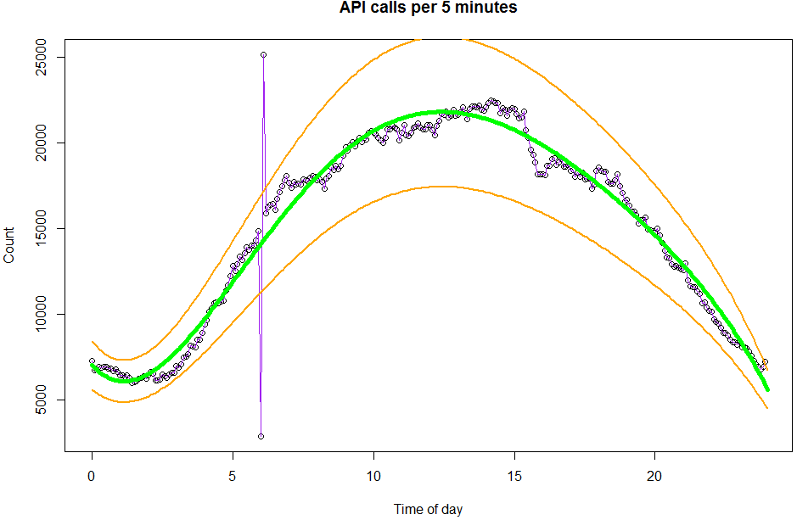
Figure 62: Example of anomaly detection applied to system monitoring
Figure 62 displays the number of calls per 5-minute period to an API backend system over a day. The green line shows a line fitted on historical data, while the orange lines indicate the upper and lower bands of normal usage.

Discovery of Poor Digital Cellular Network Coverage Areas
Modern vehicle-tracking devices utilise the GSM network and thus they depend on the availability of the GSM network for near real-time communication. The vehicle-tracking devices will appear to be offline in the areas with no or poor GSM coverage. This data will be utilised for discussion with the GSM service providers and to explain to a customer why he is not able to see movement of his vehicle or why the transfer of location data to the backend server has been delayed.
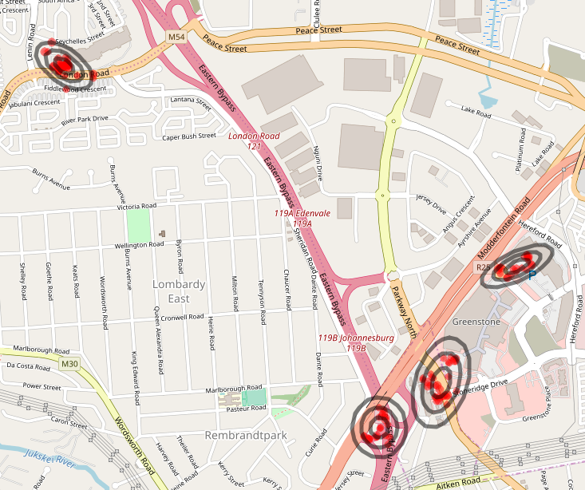
Figure 63: Areas discovered with poor GSM coverage

Work Flowing this Research – Conclusion
This section demonstrated that the work reported on in this research document has value for application within a commercial environment.

Future Research
The research described in this document was a first attempt to show that anomaly detection is a cost-effective and valid approach towards the discovery of insider threats by using data obtained from vehicle-tracking devices. The issue described in the problem statement was addressed through a study of the existing literature, a proposed process model and experimentation. A number of limitations were however identified, and the following issues still need to be addressed in future research:
- There was a gap in the research regarding the effective preparation of vehicle-tracking data for machine learning. Future research may focus on the quality of the data and the effect of the machine-learning algorithm on the processing of data.
- Driver profiling could assist in the search for insider threats. It was suggested that comparing drivers with their own historical driver information might be used to predict insider threats.
- Collaboration with fleet managers over a longer period of time may be necessary to understand insider threats and to document historical insider threats.
- It may be necessary to investigate normal patterns as indicators of insider threat activity. These may include insider threat activities that have always existed, such as drivers stopping at a location where alcoholic drinks are served before taking the corporate vehicle back to the corporate parking area.
- The labelling of vehicle-tracking data is not an intuitive exercise as was originally anticipated; in fact, more research is required on how to effectively label this data.
- Further research may be required on parked vehicles to determine if this data may prove useful in the discovery of insider threats.
- Opportunities exist to combine vehicle-tracking data with other data sources such as employee data (e.g. leave), vehicle maintenance records, fuel data and insurance claims in the search for insider threats using anomaly detection.
- Visualisation such as the clustering of data and graphs is difficult to read and interpret. Research may be conducted to improve the readability of the graphs.

Appendix
  - Example of an Accident Report
The accident report (also referred to as an impact report) presented here, is an example of an actual accident. The information presented contains discussions and extracts from a report. Any information that could identify a private entity or vehicle has been removed.
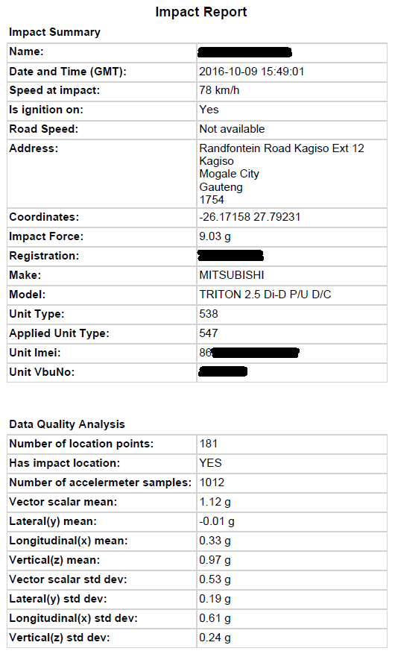
Figure 64: Accident Summary Page
When a vehicle-tracking device detects an accident, it uploads detailed accelerometer data as well as detailed GPS location data. The accelerometer samples include 5 seconds before and 5 seconds after the accident, taken at a sample interval of 10 milliseconds. The location data records 60 seconds before the accident and 120 seconds after the accident, taken at a sample interval of 1 second.
Figure 65 displays the acceleration the vehicle experienced by using the accelerometer data.
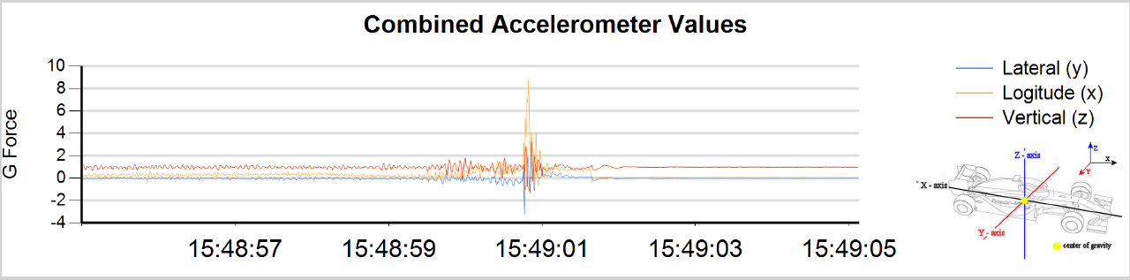
Figure 65 Accelerometer graph over time
Figure 66 displays the speed at which the vehicle was moving by using the GPS location data.
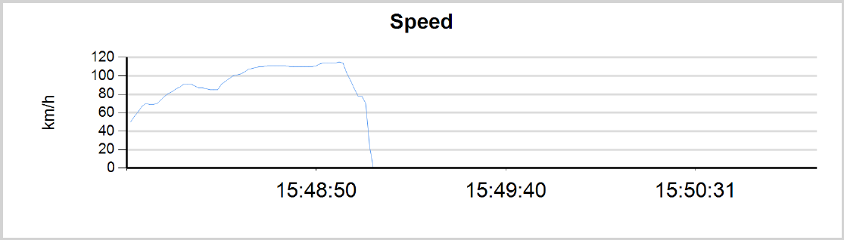
Figure 66: Speed over time

The direction and magnitude of the accelerometer samples are plotted on an accelerometer graph as displayed in Figure 67. In this example it is clear that the impact occurred on the right front of the vehicle. The graph in this case draws all vectors linearly relative to the maximum vector.
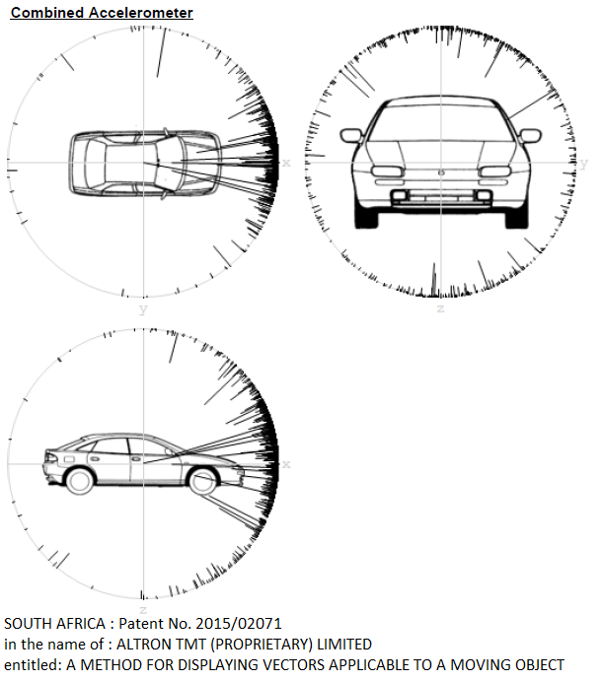
Figure 67: Accelerometer graph

When inspecting the second-by-second breakdown, it is clear that the vehicle was decelerating before the impact by looking at the acceleration direction and noting the speed of the vehicle (see Figure 68).
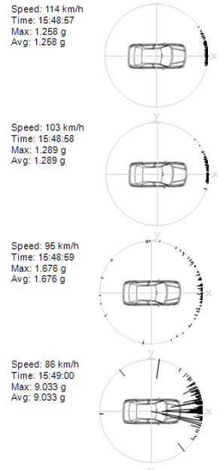
Figure 68: Second-by-second breakdown

The location where the accident occurred can also be displayed on a map. The maps in Figure 69 and Figure 70 were edited to save space. However, ensure copyright notices remain intact and show the direction of travel.
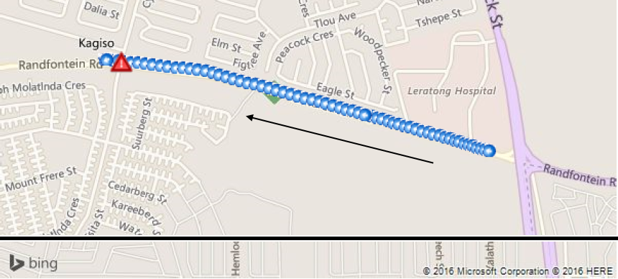
Figure 69: Location points 2 minutes before and 1 minute after impact
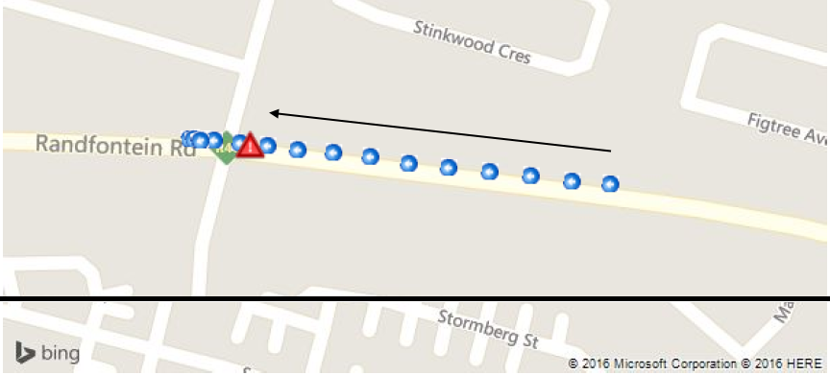
Figure 70: Locations 10 seconds before and 10 seconds after impact

Appendix
  - Ethics Approval Clearance
Figure 71 below is a screen copy of the letter received from the EBIT Research Ethics committee. The original letter is available on request.

Figure 71: Ethics Clearance

Appendix
  - Permission Letter
Figure 72 below is a screen copy of the letter received from Altech Netstar giving permission to utilise their facilities and data. The original letter is available on request.
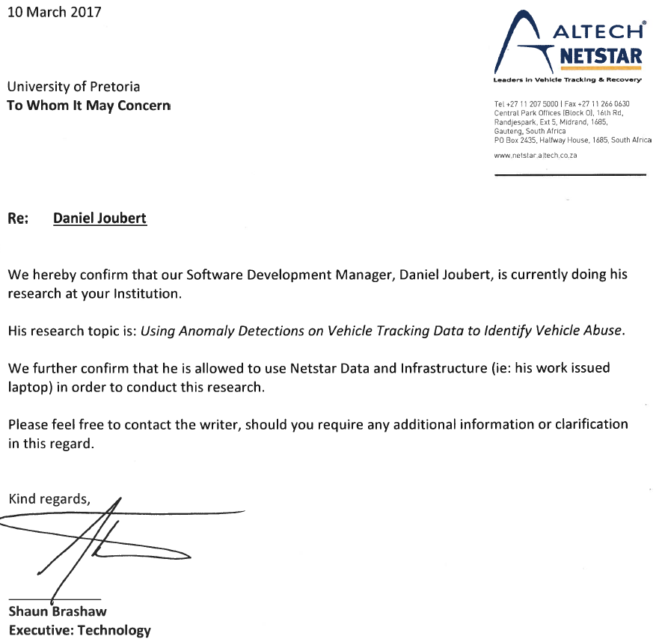
Figure 72: Permission Letter from Altech Netstar

Appendix
  - Data Examples
The data examples in this appendix are from vehicle-tracking devices showing location information. The examples are only a subset of all the available data.
The data example in the following table is from a device designed and manufactured by Altech Netstar.
{
"unitMessage": {
"refno": "3xx",
"messagedetail": {
"battery_voltage_value": 11.4,
"hardware_attached": "90",
"hardware_attached_no_gsm_international_roaming": 0,
"diagnostic_data": "0",
"external_battery_voltages_present": 0,
"hardware_attached_uptime": "0",
"type_msg": "13",
"locations": [{
"initial_status": {
"go_zone_violation": 0,
"gforce_forward": 0,
"gforce_backward": 0,
"data": "2000",
"gforce_up": 0,
"gforce_right": 0,
"gforce_left": 0,
"analogue_input_4": 0,
"nbu_activated": 0,
"analogue_input_1": 0,
"digital_input_4": 0,
"analogue_input_2": 0,
"analogue_input_3": 0,
"output_4": 0,
"gforce_down": 0,
"output_2": 0,
"output_3": 0,
"digital_input_1": 0,
"ignition_on": 1,
"no_go_zone_violation": 0,
"output_1": 0,
"digital_input_3": 0,
"digital_input_2": 0
},
"altitude": 495.0,
"gforce_forward": 0,
"gforce_backward": 50,
"odometer": 6162,
"heading": 0,
"latitude": -24.______,
"event_description": "Ignition - On",
"gforce_up": 0,
"gforce_right": 0,
"gforce_left": 0,
"engine_hours": 17936,
"speed": 0,
"datetime": "2016-01-01 12:00:00 AM",
"gforce_down": 1050,
"event": "01",
"longitude": 31.______
}],
"battery_voltage_present": 0,
"version": "12",
"hardware_attached_gps_not_present": 1,
"hardware": "3XX"
},
"messageheader": {
"dateTime": "2016\/10\/27 10:50:33 AM",
"sourceid": "863833020735486",
"driverid": "",
"sourceimei": "863833020735486",
"conduit": "GPRS"
}
},
"vbu": "863833020735486",
"serverdatetime": 1472703444324
}

The data in the following table is from a CalAmp vehicle-tracking device.
{
"unitmessages": [{
"unitMessage": {
"refno": "Calamp",
"messagedetail": {
"locationOptionalFieldsOfAccumulators": { },
"locationAccumulator": {
"accumulators": [42926161, 2517391, 2, 0, 26800, 165590, 0, 3837, 0, 0, 39186, 0, 0, 0, 0, 0]
},
"locationMessageEvent": {
"accum_count": 16,
"event_code": 65,
"event_index": 47,
"spare": 0
}
},
"messagecore": {
"satellites": 10,
"altitude": 5165,
"isLoggedByUnit": false,
"rssi": 65475,
"threeOrLessSatellites": false,
"heading": 348,
"inputs": 22,
"latitude": -29._______,
"fixTime": "2018-09-25 14:59:10",
"updateTime": "2018-09-25 14:59:10",
"commState": 15,
"hdop": 10,
"speed": 40.391999999999996,
"unitStatus": 0,
"carrier": 10,
"waasDgpsIsEnabled": false,
"hasValidTimeSync": false,
"currentFixIsInvalid": false,
"isHighAccuracy": false,
"waitForValid": false,
"longitude": 31._______
},
"messageheader": {
"serviceType": 1,
"sequence": 154,
"messageType": 2,
"mobileId": "357207059535963",
"mobileIdType": 2
}
},
"vbu": "357207059535963",
"serverdatetime": 1537887549505
}]
}

The data in the following table is from a MetaSystem vehicle-tracking device.
{
"unitmessages": [{
"unitMessage": {
"metaHeader": { "identifier": 85, "imei": "357543050132818" },
"refno": "Meta",
"metaBody": {
"fields": [{
"id": { "headerVal": { "id": 46, "operation": 2 } },
"subField": {
"availabilityMask": 23,
"CANodo": 322581,
"CANwheelSpeed": 0,
"RPM": 0,
"CANtachoSpeed": 0
}
},
{
"id": { "headerVal": { "id": 25, "operation": 2 } },
"subField": { "ODOmeterReading": 322581580 }
},
{
"id": { "headerVal": { "id": 32, "operation": 2 } },
"subField": { "EventCode": 94, "EventData": 255 }
},
{
"id": { "headerVal": { "id": 19, "operation": 2 } },
"subField": {
"altitude": 0,
"coordinateFormatFlag": false,
"heading": 0,
"gpsNibbleNoOfSatelites": 0,
"modeFlag": true,
"latitude": -33.______,
"speed": 0,
"timeStamp": "2018-06-01 00:18:46",
"glonassNibbleNoOfSatelites": 0,
"spareFlag": false,
"timevalidFlag": true,
"posvalidFlag": false,
"longitude": 25.______,
"fixmodeFlag": 0
}
},
{
"id": { "headerVal": { "id": 16, "operation": 2 } },
"subField": {
"Ignition_logicalFlag": false,
"ExternalbatterylowFlag": false,
"AuxAccelOpStatus": false,
"SATprogrammerconnectedFlag": false,
"WaypointStatus": false,
"InternalbatterypresentFlag": true,
"UnitregisteredonGSMnetworkFlag": true,
"ExternalTempConnect": false,
"GoZoneStatus": false,
"GPSantennaabsentFlag": false,
"DigitalOutput1": false,
"IDTagpresentFlag": true,
"SpeedZoneStatus": false,
"DigitalInput2": false,
"AutoAxisLearned": false,
"DriverIDConnect": false,
"NoGoZoneStatus": false,
"Ignition_hardwareFlag": false,
"GPRSconnectionestablishedFlag": false,
"ExternalGSMantennaabsentFlag": true,
"OUTFlag": false,
"IntAccelOpStatus": false,
"CANbusmessagestatusFlag": false,
"Spares": false,
"InternalbatterylowFlag": false,
"CANbusconnectionstatusFlag": false,
"PanicbuttonpressedFlag": false,
"AccelerometerconnectedFlag": false,
"Engineon_IN1Flag": true,
"VoiceCall": false,
"VigilSmartConnect": false,
"ExternalbatterypresentFlag": true
}
},
{
"id": { "headerVal": { "id": 18, "operation": 2 } },
"subField": { "cellID": 16163, "LAC": 414 }
},
{
"id": { "headerVal": { "id": 44, "operation": 2 } },
"subField": {
"gpsQualityClassificationFlag": 0,
"PDOP": 1,
"theoreticalAccelerationFlag": true,
"theoreticalChangInAltitudeFlag": true,
"VDOP": 0,
"rmcValidPositionFlag": false,
"gpsSatelitesFlag": false,
"theoreticalSpeedFlag": true,
"positionalValueFlag": true,
"HDOP": 0
}
},
{
"id": { "headerVal": { "id": 39, "operation": 2 } },
"subField": { "availabilityMask": 2, "engineLoadPercentage": 0 }
},
{
"id": { "headerVal": { "id": 40, "operation": 2 } },
"subField": { "availabilityMask": 6, "fuelEconomy": 0.0, "fuelRate": 0.0 }
}]
}
},
"vbu": "357543050132818",
"serverdatetime": 1527812356524
}]
}

Appendix
  - R Scripts
This appendix contains the R scripts that were used for the experimentation in Chapter 7 and Chapter 8.

Common Script
The following script was shared between the scripts for the experimentation.
library(odbc)
library(DBI)

getDbData <-function (sql, server = ".", database){
con <- dbConnect(odbc(),
Driver = "SQL Server Native Client 11.0; Trusted_Connection=yes",
Server = server,
Database = database,
Port = 1433)
query <- dbSendQuery(con, sql)
result <- dbFetch(query)
dbClearResult(query)
dbDisconnect(con)
return (result)
}

getDbData2 <-function (sql, server, database, un, pw){
con <- dbConnect(odbc(),
Driver = "SQL Server Native Client 11.0",
Server = server,
Database = database,
Port = 1433,
UID = un,
PWD = pw)
query <- dbSendQuery(con, sql)
result <- dbFetch(query)
dbClearResult(query)
dbDisconnect(con)
return (result)
}

xEllipse <- function(t, eigenValue){
r = t * pi / 180
value <- sqrt( (eigenValue$values[1] * eigenValue$values[2] * cos(r) * cos(r)) /
(eigenValue$values[1] - eigenValue$values[1] * cos(r) * cos(r) + eigenValue$values[2] * cos(r) * cos(r)) )
return (value)
}

yEllipse <- function(t, eigenValue){
r = t * pi / 180
value <- sqrt( (eigenValue$values[1] * eigenValue$values[2] * sin(r) * sin(r)) /
(eigenValue$values[2] - eigenValue$values[2] * sin(r) * sin(r) + eigenValue$values[1] * sin(r) * sin(r)) )
return (value)
}

distance <- function(vector){
return (sqrt( vector[1] * vector[1] + vector[2] * vector[2] ))
}

calcGaussianEllipse <- function(eigenValue, meanLon, meanLat, deviation = 1){
if(distance(eigenValue$vectors[1, 1:2]) > distance(eigenValue$vectors[2, 1:2])) {
largestVector <- eigenValue$vectors[1, 1:2]
} else {
largestVector <- eigenValue$vectors[2, 1:2] }
ellipseAngle <- atan(largestVector[2] / largestVector[1]) * 180 / pi
d <- data.frame(Angle = 0:359)
d$x <- xEllipse(d$Angle, eigenValue) * deviation
d$x <- ifelse(d$Angle < 90 | d$Angle > 270, d$x, d$x * -1)
d$y <- yEllipse(d$Angle, eigenValue) * deviation
d$y <- ifelse(d$Angle < 180, d$y, d$y * -1)
d$r <- distance2(d$x, d$y)
d$x2 <- cos( (d$Angle + ellipseAngle) * pi / 180 ) * d$r
d$y2 <- sin( (d$Angle + ellipseAngle) * pi / 180 ) * d$r
d$Lon <- d$x2 + meanLon
d$Lat <- d$y2 + meanLat
return (d[c("Lat", "Lon")])
}

R Script for Chapter 7
The following R script was used for experimentation in chapter 7.
library(leaflet)
library(sp)
library(rgeos)
library(mclust)
library(mixpack)
library(jsonlite)
library(IsolationForest)
source("functions.R")

#experiment values
numberOfClusters <- 4
fromDate <- '2015-04-01'
toDate <- '2015-07-01'
displayMaps <- TRUE
processGMM <- TRUE
processIF <- TRUE
compareLists <- TRUE

#get current time
ptm <- proc.time()

MahalanobisDist <- function(x, y, sigma){
return ( t(x - y) %*% solve(sigma) %*% (x - y) )
}

ignoff <- getDbData(sprintf("
select Latitude [Lat], Longitude [Lon], DateAdd(hour, 2, DateTime) as DateTime,
case when exists(select * from Area where Type = 'Normal' and Geom.STIntersects(geometry::Point(Longitude, Latitude, 4326)) = 1) then 'Normal' else '' end [Label]
from Location
where VehicleId = 1695
and EventId = 0 --Ignition off
and DatePart(weekday, DateAdd(hour, 2, datetime)) not in (1, 7) --Exclude Sundays and Saturdays
and cast(DateAdd(hour, 2, DateTime) as time) > '08:00'
and cast(DateAdd(hour, 2, DateTime) as time) < '16:00'
and DateAdd(hour, 2, DateTime) > '%s'
and DateAdd(hour, 2, DateTime) < '%s'
and cast(DateAdd(hour, 2, DateTime) as date) not in (select Date from PublicHoliday)
and not exists(select * from Area t where Active = 1 and Geom.STIntersects(geometry::Point(Longitude, Latitude, 4326)) = 1)",
fromDate, toDate
))

ignoff <- unique(ignoff)

poly <- getDbData("select [Wkt], [Name], [Type] from [Area] where Active = 1 and Type <> 'Fuel'")
poly$colour <- ifelse(poly$Type == "Safe", "Green",
ifelse(poly$Type == "NoGo", "Red",
ifelse(poly$Type == "Fuel", "Blue", "Orange")))

# Gaussian Mixture Model Process
if(processGMM == TRUE)
{
clust <- Mclust(ignoff[c("Lat", "Lon")], G = numberOfClusters)
ignoff$Density <- dens(modelName = clust$modelName, data = ignoff[ , 1:2], parameters = clust$parameters)
topAnomaliesG <- head(subset(ignoff[order(ignoff["Density"]), ], Label != 'Normal'), 20)
topAnomaliesG$AddressUrl <- sprintf("http://maps.netstar.co.za/v1/11111111111111111111111111111111/reverseGeocode/%f,%f.json?returnSpeedLimit=true", topAnomaliesG$Lat, topAnomaliesG$Lon)
topAnomaliesG$Address <- lapply(topAnomaliesG$AddressUrl, function(x) fromJSON(x)$addresses$address)
topAnomaliesG$StreetName <- sapply(topAnomaliesG$Address, function(x) x$streetName)
topAnomaliesG$Suburb <- sapply(topAnomaliesG$Address, function(x) x$municipalitySubdivision)
topAnomaliesG$AddressUrl <- NULL
topAnomaliesG$Address <- NULL
topAnomaliesG$Order <- 1:20

if(displayMaps == TRUE)
{
mg <- NULL
mg <- leaflet()
mg <- addTiles(mg) # Add default OpenStreetMap map tiles
for(i in 1:nrow(poly))
mg <- addPolygons(mg, data = readWKT(poly[i,]$Wkt), color = poly[i,]$colour, popup = poly[i,]$Name)

for(i in 1:(length(clust$parameters$variance$sigma)/4))
{
sigma <- clust$parameters$variance$sigma[,,i]
eigenValue = eigen(sigma)
mg <- addCircles(mg, data = cbind(c(clust$parameters$mean[,i]["Lon"]), c(clust$parameters$mean[,i]["Lat"])),color = "black")
ellipsePoints <- calcGaussianEllipse(eigenValue$vectors, meanLon = clust$parameters$mean[,i]["Lon"], meanLat = clust$parameters$mean[,i]["Lat"])
ellipse = Polygons(list(Polygon(cbind(c(ellipsePoints$Lon), c(ellipsePoints$Lat)))), "1")
mg <- addPolygons(mg, data = SpatialPolygons(list(ellipse)), color = "black", fill = "none")
}

for(i in 1:nrow(ignoff))
mg <- addCircles(mg, data = cbind(c(ignoff[i,]$Lon), c(ignoff[i,]$Lat)), color = "green",
popup = sprintf("%f %f\r\n%s", ignoff[i,]$Lat, ignoff[i,]$Lon, ignoff[i,]$DateTime),
popupOptions = popupOptions())

for(i in 1:nrow(topAnomaliesG))
mg <- addCircles(mg, data = cbind(c(topAnomaliesG[i,]$Lon), c(topAnomaliesG[i,]$Lat)), color = "red",
popup = sprintf("%f %f\r\n%s\r\n%s, %s", topAnomaliesG[i,]$Lat, topAnomaliesG[i,]$Lon, topAnomaliesG[i,]$DateTime, topAnomaliesG[i,]$StreetName, topAnomaliesG[i,]$Suburb),
label = sprintf("%d", topAnomaliesG[i,]$Order))
mg
}
topAnomaliesG[c("Order", "Lat", "Lon", "DateTime", "StreetName", "Suburb")]
}

#Isolation Forest Process
if(processIF == TRUE)
{
data <- ignoff[c("Lon", "Lat")]
forest <- IsolationTrees(data, ntree=100,
hlim=as.integer(ceiling(log2(nrow(data)))),
rowSamp=F,
nRowSamp=nrow(data),
nmin=1,
rFactor=1,
colSamp=F,
nColSamp=ncol(data),
colWeight=c(rep(1,ncol(data))))
ignoff$score <- 1 - AnomalyScore(ignoff[c("Lon", "Lat")], forest, ntree = forest$ntree, hlim = forest$hlim, appRange = F)$outF
topAnomaliesIF <- head(subset(ignoff[order(ignoff["score"]), ], Label != 'Normal'), 20)
topAnomaliesIF$AddressUrl <- sprintf("http://maps.netstar.co.za/v1/*******************/reverseGeocode/%f,%f.json?returnSpeedLimit=true", topAnomaliesIF$Lat, topAnomaliesIF$Lon)
topAnomaliesIF$Address <- lapply(topAnomaliesIF$AddressUrl, function(x) fromJSON(x)$addresses$address)
topAnomaliesIF$StreetName <- sapply(topAnomaliesIF$Address, function(x) x$streetName)
topAnomaliesIF$Suburb <- sapply(topAnomaliesIF$Address, function(x) x$municipalitySubdivision)
topAnomaliesIF$AddressUrl <- NULL
topAnomaliesIF$Address <- NULL
topAnomaliesIF$Order <- 1:20

sprintf("displayMaps == : %d", displayMaps)
#if(displayMaps == TRUE)
{
mIF <- NULL
mIF <- leaflet()
mIF <- addTiles(mIF) # Add default OpenStreetMap map tiles
for(i in 1:nrow(poly))
mIF <- addPolygons(mIF, data = readWKT(poly[i,]$Wkt), color = poly[i,]$colour)
for(i in 1:nrow(ignoff))
mIF <- addCircles(mIF, data = cbind(c(ignoff[i,]$Lon), c(ignoff[i,]$Lat)), color = "green",
popup = sprintf("%f %f\r\n%s", ignoff[i,]$Lat, ignoff[i,]$Lon, ignoff[i,]$DateTime),
popupOptions = popupOptions())

for(i in 1:nrow(topAnomaliesIF))
mIF <- addCircles(mIF, data = cbind(c(topAnomaliesIF[i,]$Lon), c(topAnomaliesIF[i,]$Lat)), color = "red",
popup = sprintf("%f %f\r\n%s\r\n%s, %s", topAnomaliesIF[i,]$Lat, topAnomaliesIF[i,]$Lon, topAnomaliesIF[i,]$DateTime, topAnomaliesIF[i,]$StreetName, topAnomaliesIF[i,]$Suburb),
label = sprintf("%d", topAnomaliesIF[i,]$Order))

mIF
}
topAnomaliesIF[c("Order", "Lat", "Lon", "DateTime", "StreetName", "Suburb")]
}

# Combined anomalies
if(compareLists == TRUE)
{
anomaliesCombined <- rbind(
topAnomaliesG[c("Lat", "Lon", "DateTime", "StreetName", "Suburb")],
topAnomaliesIF[c("Lat", "Lon", "DateTime", "StreetName", "Suburb")]
)
anomaliesDuplicated <- anomaliesCombined[which(duplicated(anomaliesCombined[c("Lat", "Lon", "DateTime")])),]
anomaliesDuplicated
sprintf("Corrosponding locations: %d", nrow(anomaliesDuplicated))
}
merged <- unique(anomaliesCombined)
merged
nrow(merged)

proc.time() - ptm

data <- ignoff[c("Lon", "Lat")]
pcadata <-as.data.frame(scale(data))
pca <- princomp(formula = ~., data = pcadata, cor = FALSE)
pcaScores <- as.data.frame(pca$scores)
pca
summary(pca)
pca$loadings
pca$scores
plot(pca)

R Script for Chapter 8 – Experiment 1
setwd("C:\\Users\\daniel\\Documents")
library(clustvarsel)
library(mclust)
library(leaflet)
library(sp)
library(rgeos)
library(IsolationForest)
source("functions.R")
setwd("Z:\\Iteration 1")

if(exists("locations") == FALSE)
{
if(file.exists("locations.rds") == TRUE)
{
locations = readRDS("locations.rds")
}
else
{
locations <- getDbData(sql = "
select distinct Latitude, Longitude, Label
from IgnitionOff
where Latitude <> 0
and Longitude <> 0
and Latitude between -38 and 0
and Longitude between 4 and 44
",
server = ".",
database = "cc")
saveRDS(locations, "locations.rds")
}
}

pcadata <- as.data.frame(scale(locations[c("Latitude", "Longitude")]))
pca <- princomp(pcadata)
summary(pca)
pca$loadings
plot(pca)

### --- GMM --- ####
gdata <- locations[sample(nrow(locations), 20000), ][c("Latitude", "Longitude")]
ptm <- proc.time()
k_clust <- Mclust(gdata, G=22:45, modelNames = mclust.options("emModelNames"))
#c <- clustvarsel(G=85:95, data = greedydata, search = c("greedy"), parallel = TRUE)
k_clust
proc.time() - ptm #==> 45 minutes, 48 minutes, 9 hours
saveRDS(k_clust, "k_clust")

gdata <- locations[sample(nrow(locations), 20000), ][c("Latitude", "Longitude")]
ptm <- proc.time()
clust <- Mclust(gdata, k_clust$G)
proc.time() - ptm #==> 2 minutes, 10 minutes, 400clusters -> 31 minutes, 40 clusters -> 15 minutes, 4 hours
saveRDS(clust, "clust")
clust <- readRDS("clust")

locations$density <- dens(modelName = clust$modelName, data = locations[c("Latitude", "Longitude")], parameters = clust$parameters)

ptm <- proc.time()
ifdata <- locations[c("Latitude", "Longitude")]
forest <- IsolationTrees(ifdata, ntree=250,
hlim=as.integer(ceiling(log2(nrow(ifdata)))),
rowSamp=F,
nRowSamp=nrow(ifdata),
nmin=1,
rFactor=1,
colSamp=F,
nColSamp=ncol(ifdata),
colWeight=c(rep(1,ncol(ifdata))))
proc.time() - ptm #==> 60 seconds # 30 seconds #24 seconds #37 seconds
#rm(data)
# memory.limit(size=200000)
ptm <- proc.time()
locations$ifScore <- AnomalyScore(ifdata, forest, ntree = forest$ntree, hlim = forest$hlim, appRange = F)$outF
proc.time() - ptm #==> 26 seconds # 22 seconds # 17 second

saveRDS(locations, "locations.rds")
locations <- subset(locations, Label == "")
locations <- locations[order(locations["density"]), ]
locations$densityOrder <- 1:nrow(locations)
locations <- locations[order(locations["ifScore"], decreasing = TRUE), ]
locations$ifScoreOrder <- 1:nrow(locations)

nrow(subset(locations, densityOrder <= 100))
nrow(subset(locations, ifScoreOrder <= 100))
nrow(subset(locations, densityOrder <= 100 | ifScoreOrder <= 100))
nrow(subset(locations, densityOrder <= 100 & ifScoreOrder <= 100))

m <- NULL
m <- leaflet()
m <- addTiles(m) # Add default OpenStreetMap map tiles

ifAnomalies <- subset(locations, ifScoreOrder <= 100)
m <- addCircles(m, data = cbind(longitude = c(as.numeric(ifAnomalies$Longitude)),
latitude = c(as.numeric(ifAnomalies$Latitude))),
color = "red")
m

m <- NULL
m <- leaflet()
m <- addTiles(m) # Add default OpenStreetMap map tiles
gmmAnomalies <- subset(locations, densityOrder <= 100)
m <- addCircles(m, data = cbind(longitude = c(as.numeric(gmmAnomalies$Longitude)),
latitude = c(as.numeric(gmmAnomalies$Latitude))),
color = "red")
for(i in 1:clust$G)
{
sigma <- clust$parameters$variance$sigma[,,i]
eigenValue = eigen(sigma)
ellipsePoints <- calcGaussianEllipse(eigenValue, meanLon = clust$parameters$mean[,i]["Longitude"], meanLat = clust$parameters$mean[,i]["Latitude"])
ellipse = Polygon(cbind(c(ellipsePoints$Lon), c(ellipsePoints$Lat)))
ellipses <- Polygons(list(ellipse), "1")
m <- addPolygons(m, data = SpatialPolygons(list(ellipses)), color = "black", fill = "none")
}
m

overlap <- subset(locations, densityOrder <= 100 & ifScoreOrder <= 100)
m <- NULL
m <- leaflet()
m <- addTiles(m) # Add default OpenStreetMap map tiles
m <- addCircles(m, data = cbind(longitude = c(as.numeric(overlap$Longitude)),
latitude = c(as.numeric(overlap$Latitude))),
color = "red")
m

### --- Analysis of Isolation Forest anomalies --- ###
dimensions <- c("Latitude","Longitude")
pca <- princomp(ifAnomalies[dimensions])
summary(pca)
pca$loadings
plot(pca)
dev.print(device = png, filename = "Anomalies - PCA - Plot.png", width = 750, height = 500)

ptm <- proc.time()
k_clust_if <- Mclust(ifAnomalies[dimensions], G=1:40, modelNames = mclust.options("emModelNames"))
k_clust_if
proc.time() - ptm

ptm <- proc.time()
clust_if <- Mclust(ifAnomalies[dimensions], k_clust_if$G)
proc.time() - ptm

m <- NULL
m <- leaflet()
m <- addTiles(m) # Add default OpenStreetMap map tiles
m <- addCircles(m, data = cbind(longitude = c(as.numeric(ifAnomalies$Longitude)),
latitude = c(as.numeric(ifAnomalies$Latitude))),
color = "red")
for(i in 1:clust_if$G)
{
sigma <- clust_if$parameters$variance$sigma[,,i]
eigenValue = eigen(sigma)
ellipsePoints <- calcGaussianEllipse(eigenValue, meanLon = clust_if$parameters$mean[,i]["Longitude"], meanLat = clust_if$parameters$mean[,i]["Latitude"], deviation = 2)
ellipse = Polygon(cbind(c(ellipsePoints$Lon), c(ellipsePoints$Lat)))
ellipses <- Polygons(list(ellipse), "1")
df <- data.frame(Longitude = c(clust_if$parameters$mean[,i]["Longitude"]), Latitude = c(clust_if$parameters$mean[,i]["Latitude"]))

inpolygon <- sum(sapply(1:nrow(ifAnomalies), function(a){
return (point.in.polygon(ifAnomalies[a,]$Longitude, ifAnomalies[a,]$Latitude, ellipsePoints$Lon, ellipsePoints$Lat))
}))

m <- addPolygons(m, data = SpatialPolygons(list(ellipses)), color = "black", fill = "none",
label = as.character(inpolygon),
labelOptions = labelOptions(noHide = T, textOnly = F, minWidth = 10, textsize = 12))
}

m

### --- Analysis of GMM anomalies --- ###
dimensions <- c("Latitude","Longitude")
pca <- princomp(gmmAnomalies[dimensions])
summary(pca)
pca$loadings
plot(pca)
#dev.print(device = png, filename = "Anomalies - PCA - Plot.png", width = 750, height = 500)

ptm <- proc.time()
k_clust_gmm <- Mclust(gmmAnomalies[dimensions], G=1:40, modelNames = mclust.options("emModelNames"))
k_clust_gmm
proc.time() - ptm

ptm <- proc.time()
clust_gmm <- Mclust(gmmAnomalies[dimensions], k_clust_if$G)
proc.time() - ptm

m <- NULL
m <- leaflet()
m <- addTiles(m) # Add default OpenStreetMap map tiles
m <- addCircles(m, data = cbind(longitude = c(as.numeric(gmmAnomalies$Longitude)),
latitude = c(as.numeric(gmmAnomalies$Latitude))),
color = "red")
for(i in 1:clust_gmm$G)
{
sigma <- clust_gmm$parameters$variance$sigma[,,i]
eigenValue = eigen(sigma)
ellipsePoints <- calcGaussianEllipse(eigenValue, meanLon = clust_gmm$parameters$mean[,i]["Longitude"], meanLat = clust_gmm$parameters$mean[,i]["Latitude"], deviation = 2)
ellipse = Polygon(cbind(c(ellipsePoints$Lon), c(ellipsePoints$Lat)))
ellipses <- Polygons(list(ellipse), "1")
df <- data.frame(Longitude = c(clust_gmm$parameters$mean[,i]["Longitude"]), Latitude = c(clust_gmm$parameters$mean[,i]["Latitude"]))

inpolygon <- sum(sapply(1:nrow(gmmAnomalies), function(a){
return (point.in.polygon(gmmAnomalies[a,]$Longitude, gmmAnomalies[a,]$Latitude, ellipsePoints$Lon, ellipsePoints$Lat))
}))

m <- addPolygons(m, data = SpatialPolygons(list(ellipses)), color = "black", fill = "none",
label = as.character(inpolygon),
labelOptions = labelOptions(noHide = T, textOnly = F, minWidth = 10, textsize = 12))
}

m

R Script for Chapter 8 – Experiment 2
setwd("C:\\Users\\daniel\\Documents")
library(clustvarsel)
library(mclust)
library(leaflet)
library(sp)
library(rgeos)
library(IsolationForest)
library(dbscan)
source("functions.R")
setwd("Z:\\Iteration 2")

locations <- getDbData(sql = "
select distinct Latitude, Longitude, TimeOfDay, IsWeekDay, Label
from IgnitionOff
where Latitude <> 0
and Longitude <> 0
and Latitude between -38 and 0
and Longitude between 4 and 44
and DateTime > '2018-06-01'
and DateTime < '2018-10-01'
and NoOfGpsSatellites > 4
",
server = ".",
database = "cc")
saveRDS(locations, "locations.rds")

dimensions <- c("Latitude", "Longitude", "TimeOfDay", "IsWeekDay")
pcadata <- as.data.frame(scale(locations[dimensions]))
pca <- princomp(pcadata)
summary(pca)
pca$loadings
plot(pca)

plot(density(locations$TimeOfDay))
dev.print(device = png, filename = "Time of Day - Density - Plot.png", width = 750, height = 500)

plot(density(locations$IsWeekDay))
dev.print(device = png, filename = "Is Week Day - Density - Plot.png", width = 750, height = 500)

### --- GMM --- ####
#df <- data.frame(n = 1:100)
#ss <- subset(df, n %% 5 == 0)
#numbers <- sapply(ss$n, function(n) n)
gdata <- locations[sample(nrow(locations), 20000), ][dimensions]
ptm <- proc.time()
k_clust <- Mclust(gdata, G=100:140, modelNames = mclust.options("emModelNames"))
k_clust
#c <- clustvarsel(G=85:95, data = greedydata, search = c("greedy"), parallel = TRUE)
proc.time() - ptm #==> 45 minutes, 48 minutes, 9 hours
saveRDS(k_clust, "k_clust")
k_clust <- readRDS("k_clust")

gdata <- locations[sample(nrow(locations), 20000), ][dimensions]
ptm <- proc.time()
clust <- Mclust(gdata, k_clust$G)
proc.time() - ptm #==> 2 minutes, 10 minutes, 400clusters -> 31 minutes, 40 clusters -> 15 minutes, 4 hours
saveRDS(clust, "clust")
clust <- readRDS("clust")

locations$density <- dens(modelName = clust$modelName, data = locations[dimensions], parameters = clust$parameters)

ptm <- proc.time()
ifdata <- locations[sample(nrow(locations), 500000), ][dimensions]
forest <- IsolationTrees(ifdata, ntree=250,
hlim=as.integer(ceiling(log2(nrow(ifdata)))),
rowSamp=F,
nRowSamp=nrow(ifdata),
nmin=1,
rFactor=1,
colSamp=F,
nColSamp=ncol(ifdata),
colWeight=c(rep(1,ncol(ifdata))))
proc.time() - ptm #==> 60 seconds # 30 seconds #24 seconds #37 seconds
saveRDS(forest, "forest")
forest <- readRDS("forest")

#rm(data)
# memory.limit(size=200000)
ptm <- proc.time()
locations$ifScore <- AnomalyScore(locations[dimensions], forest, ntree = forest$ntree, hlim = forest$hlim, appRange = F)$outF
proc.time() - ptm #==> 26 seconds # 22 seconds # 17 second

locations <- subset(locations, Label == "")
locations <- locations[order(locations["density"]), ]
locations$densityOrder <- 1:nrow(locations)
locations <- locations[order(locations["ifScore"], decreasing = TRUE), ]
locations$ifScoreOrder <- 1:nrow(locations)

nrow(subset(locations, densityOrder <= 100))
nrow(subset(locations, ifScoreOrder <= 100))
nrow(subset(locations, densityOrder <= 100 | ifScoreOrder <= 100))
nrow(subset(locations, densityOrder <= 100 & ifScoreOrder <= 100))

### --- Overlapping Anomalies --- ###
overlap <- subset(locations, densityOrder <= 100 & ifScoreOrder <= 100)
m <- NULL
m <- leaflet()
m <- addTiles(m) # Add default OpenStreetMap map tiles
m <- addCircles(m, data = cbind(longitude = c(as.numeric(overlap$Longitude)),
latitude = c(as.numeric(overlap$Latitude))),
color = "red")
m

### --- Isolation Forest Anomalies --- ###
m <- NULL
m <- leaflet()
m <- addTiles(m) # Add default OpenStreetMap map tiles

ifAnomalies <- subset(locations, ifScoreOrder <= 100)
m <- addCircles(m, data = cbind(longitude = c(as.numeric(ifAnomalies$Longitude)),
latitude = c(as.numeric(ifAnomalies$Latitude))),
color = "red")
m

plot(density(ifAnomalies$TimeOfDay))
dev.print(device = png, filename = "Isolation Forest Anomalies - Time of Day - Density - Plot.png", width = 750, height = 500)

plot(density(ifAnomalies$IsWeekDay))
dev.print(device = png, filename = "Isolation Forest Anomalies - Is Week Day - Density - Plot.png", width = 750, height = 500)

pca <- princomp(ifAnomalies[dimensions])
summary(pca)
pca$loadings
plot(pca)
dev.print(device = png, filename = "Anomalies - PCA - Plot.png", width = 750, height = 500)

ptm <- proc.time()
k_clust_if <- Mclust(ifAnomalies[dimensions], G=1:20, modelNames = mclust.options("emModelNames"))
k_clust_if
#c <- clustvarsel(G=85:95, data = greedydata, search = c("greedy"), parallel = TRUE)
proc.time() - ptm #==> 45 minutes, 48 minutes, 9 hours

ptm <- proc.time()
clust_if <- Mclust(ifAnomalies[dimensions], k_clust_if$G)
proc.time() - ptm #==> 14 seconds

plot(clust_if)
dev.print(device = png, filename = "Isolation Forest Anomalies - Cluster - Plot.png", width = 750, height = 500)

### --- GMM Anomalies --- ###
gmmAnomalies <- subset(locations, densityOrder <= 100)

m <- NULL
m <- leaflet()
m <- addTiles(m) # Add default OpenStreetMap map tiles
m <- addCircles(m, data = cbind(longitude = c(as.numeric(gmmAnomalies$Longitude)),
latitude = c(as.numeric(gmmAnomalies$Latitude))),
color = "red")
m

plot(density(gmmAnomalies$TimeOfDay))
dev.print(device = png, filename = "GMM Forest Anomalies - Time of Day - Density - Plot.png", width = 750, height = 500)

plot(density(gmmAnomalies$IsWeekDay))
dev.print(device = png, filename = "GMM Forest Anomalies - Is Week Day - Density - Plot.png", width = 750, height = 500)

pca <- princomp(gmmAnomalies[dimensions])
summary(pca)
pca$loadings
plot(pca)
dev.print(device = png, filename = "GMM Anomalies - PCA - Plot.png", width = 750, height = 500)

ptm <- proc.time()
k_clust_gmm <- Mclust(gmmAnomalies[dimensions], G=1:20, modelNames = mclust.options("emModelNames"))
k_clust_gmm
#c <- clustvarsel(G=85:95, data = greedydata, search = c("greedy"), parallel = TRUE)
proc.time() - ptm #==> 45 minutes, 48 minutes, 9 hours

ptm <- proc.time()
clust_gmm <- Mclust(gmmAnomalies[dimensions], k_clust_gmm$G)
proc.time() - ptm #==> 14 seconds

plot(clust_gmm)
dev.print(device = png, filename = "GMM Anomalies - Cluster - Plot.png", width = 750, height = 500)

R Script for Chapter 8 – Experiment 3
setwd("C:\\Users\\daniel\\Documents")
library(clustvarsel)
library(mclust)
library(leaflet)
library(sp)
library(rgeos)
library(IsolationForest)
library(dbscan)
source("functions.R")
setwd("Z:\\Iteration 3")

locations <- getDbData(sql = "
select distinct Latitude, Longitude, TimeOfDay, IsWeekDay
from IgnitionOff
where Latitude <> 0
and Longitude <> 0
and Latitude between -38 and 0
and Longitude between 4 and 44
and DateTime > '2018-06-01'
and DateTime < '2018-10-01'
and NoOfGpsSatellites > 4
and exists(select * from SouthAfrica where Geom.Filter(point) = 1 and Geom.STContains(point) = 1)",
server = ".",
database = "cc")
saveRDS(locations, "locations.rds")
locations <- readRDS("locations.rds")

dimensions <- c("Latitude", "Longitude", "TimeOfDay", "IsWeekDay")

pcadata <- as.data.frame(scale(locations[dimensions]))
pca <- princomp(pcadata)
summary(pca)
pca$loadings
plot(pca)

### --- GMM --- ####
gdata <- locations[sample(nrow(locations), 5000), ][dimensions]
ptm <- proc.time()
k_clust <- Mclust(gdata, G=130:145, modelNames = mclust.options("emModelNames"))
k_clust
#c <- clustvarsel(G=85:95, data = greedydata, search = c("greedy"), parallel = TRUE)
proc.time() - ptm #==> 45 minutes, 48 minutes, 9 hours
saveRDS(k_clust, "k_clust")
k_clust <- readRDS("k_clust")

gdata <- locations[sample(nrow(locations), 20000), ][dimensions]
ptm <- proc.time()
clust <- Mclust(gdata, k_clust$G)
proc.time() - ptm #==> 2 minutes, 10 minutes, 400clusters -> 31 minutes, 40 clusters -> 15 minutes, 4 hours
saveRDS(clust, "clust")
clust <- readRDS("clust")

locations$density <- dens(modelName = clust$modelName, data = locations[dimensions], parameters = clust$parameters)

### --- Isolation Forest --- ###
ifdata <- locations[dimensions]
ptm <- proc.time()
forest <- IsolationTrees(ifdata, ntree=250,
hlim=as.integer(ceiling(log2(nrow(ifdata)))),
rowSamp=F,
nRowSamp=nrow(ifdata),
nmin=1,
rFactor=1,
colSamp=F,
nColSamp=ncol(ifdata),
colWeight=c(rep(1,ncol(ifdata))))
proc.time() - ptm #==> 20 minutes
saveRDS(forest, "forest")
forest <- readRDS("forest")

memory.limit(size=200000)
ptm <- proc.time()
locations$ifScore <- AnomalyScore(locations[dimensions], forest, ntree = forest$ntree, hlim = forest$hlim, appRange = F)$outF
proc.time() - ptm #==> 5 minutes

locations <- locations[order(locations["density"]), ]
locations$densityOrder <- 1:nrow(locations)
locations <- locations[order(locations["ifScore"], decreasing = TRUE), ]
locations$ifScoreOrder <- 1:nrow(locations)

nrow(subset(locations, densityOrder <= 100))
nrow(subset(locations, ifScoreOrder <= 100))
nrow(subset(locations, densityOrder <= 100 | ifScoreOrder <= 100))
nrow(subset(locations, densityOrder <= 100 & ifScoreOrder <= 100))

### --- Overlapping Anomalies --- ###
overlap <- subset(locations, densityOrder <= 100 & ifScoreOrder <= 100)
m <- NULL
m <- leaflet()
m <- addTiles(m) # Add default OpenStreetMap map tiles
m <- addCircles(m, data = cbind(longitude = c(as.numeric(overlap$Longitude)),
latitude = c(as.numeric(overlap$Latitude))),
color = "red")
m

### --- Investigate Isolation Forest Anomalies --- ###
ifAnomalies <- subset(locations, ifScoreOrder <= 100)

m <- NULL
m <- leaflet()
m <- addTiles(m) # Add default OpenStreetMap map tiles
m <- addCircles(m, data = cbind(longitude = c(as.numeric(ifAnomalies$Longitude)),
latitude = c(as.numeric(ifAnomalies$Latitude))),
color = "red")
m

plot(density(ifAnomalies$TimeOfDay))
dev.print(device = png, filename = "Isolation Forest Anomalies - Time of Day - Density - Plot.png", width = 750, height = 500)

plot(density(ifAnomalies$IsWeekDay))
dev.print(device = png, filename = "Isolation Forest Anomalies - Is Week Day - Density - Plot.png", width = 750, height = 500)

pca <- princomp(ifAnomalies[dimensions])
summary(pca)
pca$loadings
plot(pca)
dev.print(device = png, filename = "Anomalies - PCA - Plot.png", width = 750, height = 500)

ptm <- proc.time()
k_clust_if <- Mclust(ifAnomalies[dimensions], G=1:20, modelNames = mclust.options("emModelNames"))
k_clust_if
proc.time() - ptm

ptm <- proc.time()
clust_if <- Mclust(ifAnomalies[dimensions], k_clust_if$G)
proc.time() - ptm #==> 14 seconds

plot(clust_if)
dev.print(device = png, filename = "Isolation Forest Anomalies - Cluster - Plot.png", width = 750, height = 500)

### --- Investigate GMM Anomalies --- ###
gmmAnomalies <- subset(locations, densityOrder <= 100)

m <- NULL
m <- leaflet()
m <- addTiles(m) # Add default OpenStreetMap map tiles
m <- addCircles(m, data = cbind(longitude = c(as.numeric(gmmAnomalies$Longitude)),
latitude = c(as.numeric(gmmAnomalies$Latitude))),
color = "red")
m

plot(density(gmmAnomalies$TimeOfDay))
dev.print(device = png, filename = "GMM Forest Anomalies - Time of Day - Density - Plot.png", width = 750, height = 500)

plot(density(gmmAnomalies$IsWeekDay))
dev.print(device = png, filename = "GMM Forest Anomalies - Is Week Day - Density - Plot.png", width = 750, height = 500)

pca <- princomp(gmmAnomalies[dimensions])
summary(pca)
pca$loadings
plot(pca)
dev.print(device = png, filename = "GMM Anomalies - PCA - Plot.png", width = 750, height = 500)

ptm <- proc.time()
k_clust_gmm <- Mclust(gmmAnomalies[dimensions], G=1:20, modelNames = mclust.options("emModelNames"))
k_clust_gmm
#c <- clustvarsel(G=85:95, data = greedydata, search = c("greedy"), parallel = TRUE)
proc.time() - ptm #==> 45 minutes, 48 minutes, 9 hours

ptm <- proc.time()
clust_gmm <- Mclust(gmmAnomalies[dimensions], k_clust_gmm$G)
proc.time() - ptm #==> 14 seconds

plot(clust_gmm)
dev.print(device = png, filename = "GMM Anomalies - Cluster - Plot.png", width = 750, height = 500)

R Script for Chapter 8 – Experiment 4
setwd("C:\\Users\\daniel\\Documents")
library(clustvarsel)
library(mclust)
library(leaflet)
library(parallel)
library(sp)
library(dplyr)
library(rgeos)
library(IsolationForest)
source("functions.R")
setwd("Z:\\Iteration 4\\")

trips <- getDbData(sql = "
select StartLatitude,StartLongitude,EndLatitude,EndLongitude,StartTimeOfDay,EndTimeOfDay,StartIsWeekDay,EndIsWeekDay,Distance,DurationSeconds,StartEndDistanceMetre
from Trips
where EndNoOfGpsSatellites >= 4 -- 1023392
and StartEndDistanceMetre > 0 --
and DurationSeconds > 60 --812347
and DurationSeconds < 28800 --807715
and Distance >= 0
and Distance <= 2000
",
server = ".",
database = "cc")
saveRDS(trips, "trips")
trips <- readRDS("trips")

dimensions <- c("StartLatitude","StartLongitude","EndLatitude","EndLongitude","StartTimeOfDay","EndTimeOfDay","StartIsWeekDay","EndIsWeekDay","Distance","DurationSeconds","StartEndDistanceMetre")

plot(density(trips$StartTimeOfDay))
dev.print(device = png, filename = "Trips - Density - StartTimeOfDay.png", width = 750, height = 500)
plot(density(trips$EndTimeOfDay))
dev.print(device = png, filename = "Trips - Density - EndTimeOfDay.png", width = 750, height = 500)
plot(density(trips$StartIsWeekDay))
dev.print(device = png, filename = "Trips - Density - StartIsWeekDay.png", width = 750, height = 500)
plot(density(trips$EndIsWeekDay))
dev.print(device = png, filename = "Trips - Density - EndIsWeekDay.png", width = 750, height = 500)
plot(density(trips$Distance))
dev.print(device = png, filename = "Trips - Density - Distance.png", width = 750, height = 500)
plot(density(trips$DurationSeconds))
dev.print(device = png, filename = "Trips - Density - DurationSeconds.png", width = 750, height = 500)
plot(density(trips$StartEndDistanceMetre))
dev.print(device = png, filename = "Trips - Density - StartEndDistanceMetre.png", width = 750, height = 500)

pcadata <- as.data.frame(scale(trips))
pca <- princomp(pcadata)
summary(pca)
pca$loadings
plot(pca)
dev.print(device = png, filename = "PCA - Plot.png", width = 750, height = 500)

ifdata <- trips[dimensions] #as.data.frame(pca$scores)[c("Comp.1", "Comp.2", "Comp.3", "Comp.4", "Comp.5", "Comp.6", "Comp.7")]
### --- create the Isolation Forest Model --- ###
ptm <- proc.time()
forest <- IsolationTrees(ifdata, ntree=250,
hlim=as.integer(ceiling(log2(nrow(ifdata)))),
rowSamp=F,
nRowSamp=nrow(ifdata),
nmin=1,
rFactor=1,
colSamp=F,
nColSamp=ncol(ifdata),
colWeight=c(rep(1,ncol(ifdata))))
proc.time() - ptm #==> 20 minutes
saveRDS(forest, "forest")
forest = readRDS("forest")
#rm(data)
# memory.limit(size=200000)
ptm <- proc.time()
trips$ifScore <- AnomalyScore(trips[dimensions], forest, ntree = forest$ntree, hlim = forest$hlim, appRange = F)$outF
proc.time() - ptm #==> 3 minutes 40 seconds

rm(ifdata)
rm(forest)
gc()

### --- create the GMM Model --- ###
#gdata <- as.data.frame(pca$scores)[sample(nrow(trips), 400), ][c("Comp.1", "Comp.2", "Comp.3", "Comp.4", "Comp.5")]
gdata <- trips[sample(nrow(trips), 20000), ]
ptm <- proc.time()
k_clust <- Mclust(gdata, G=1:40, modelNames = mclust.options("emModelNames"))
#k_clust <- clustvarsel(G=1:100, data = gdata, search = c("greedy"), parallel = TRUE)
k_clust
proc.time() - ptm

saveRDS(k_clust, "k_clust")
k_clust <- readRDS("k_clust")

gdata <- trips[sample(nrow(trips), 20000), ][dimensions]
ptm <- proc.time()
clust <- Mclust(gdata, k_clust$G)
proc.time() - ptm
saveRDS(clust, "clust")
clust <- readRDS("clust")

trips$density <- dens(modelName = clust$modelName, data = trips[dimensions], parameters = clust$parameters)

### --- Analysing the anomalies --- ###
trips <- trips[order(trips["density"]), ]
trips$densityOrder <- 1:nrow(trips)
trips <- trips[order(trips["ifScore"], decreasing = TRUE), ]
trips$ifScoreOrder <- 1:nrow(trips)

nrow(subset(trips, densityOrder <= 100))
nrow(subset(trips, ifScoreOrder <= 100))
nrow(subset(trips, densityOrder <= 100 | ifScoreOrder <= 100))
nrow(subset(trips, densityOrder <= 100 & ifScoreOrder <= 100))

### --- Overlapping Anomalies --- ###
overlap <- subset(trips, densityOrder <= 100 & ifScoreOrder <= 100)
m <- NULL
m <- leaflet()
m <- addTiles(m) # Add default OpenStreetMap map tiles
m <- addCircles(m, data = cbind(longitude = c(as.numeric(overlap$StartLongitude)),
latitude = c(as.numeric(overlap$StartLatitude))),
color = "red")
m

### --- Investigate Isolation Forest Anomalies --- ###
ifAnomalies <- subset(trips, ifScoreOrder <= 100)

m <- NULL
m <- leaflet()
m <- addTiles(m) # Add default OpenStreetMap map tiles
m <- addCircles(m, data = cbind(longitude = c(as.numeric(ifAnomalies$StartLongitude)),
latitude = c(as.numeric(ifAnomalies$StartLatitude))),
color = "red")
m <- addCircles(m, data = cbind(longitude = c(as.numeric(ifAnomalies$EndLongitude)),
latitude = c(as.numeric(ifAnomalies$EndLatitude))),
color = "blue")
df <- lapply(ifAnomalies$ifScoreOrder, function(i)
{
a <- subset(ifAnomalies, ifScoreOrder == i)
return ( data.frame(group = i, latitude = c(a$StartLatitude, a$EndLatitude), longitude = c(a$StartLongitude, a$EndLongitude) ))
})
df <- do.call(rbind, df)

for(i in 1:100)
{ m <- addPolylines(m, data = subset(df, group == i), lat = ~latitude, lng = ~longitude, group = ~group) }
m

### --- Investigate Isolation Forest Anomalies --- ###
gmmAnomalies <- subset(trips, densityOrder <= 100)

m <- NULL
m <- leaflet()
m <- addTiles(m) # Add default OpenStreetMap map tiles
m <- addCircles(m, data = cbind(longitude = c(as.numeric(gmmAnomalies$StartLongitude)),
latitude = c(as.numeric(gmmAnomalies$StartLatitude))),
color = "red")
m <- addCircles(m, data = cbind(longitude = c(as.numeric(gmmAnomalies$EndLongitude)),
latitude = c(as.numeric(gmmAnomalies$EndLatitude))),
color = "blue")
df <- lapply(gmmAnomalies$ifScoreOrder, function(i)
{
a <- subset(gmmAnomalies, ifScoreOrder == i)
return ( data.frame(group = i, latitude = c(a$StartLatitude, a$EndLatitude), longitude = c(a$StartLongitude, a$EndLongitude) ))
})
df <- do.call(rbind, df)

for(i in 1:100)
{ m <- addPolylines(m, data = subset(df, group == i), lat = ~latitude, lng = ~longitude, group = ~group) }

m

### --- Isolation Forest - INvestigate Anomalies --- ###
pca <- princomp(scale(ifAnomalies[dimensions]))
summary(pca)
pca$loadings
plot(pca)
dev.print(device = png, filename = "Isolation Forest Anomalies - PCA - Plot.png", width = 750, height = 500)

ptm <- proc.time()
k_clust_if <- Mclust(ifAnomalies[dimensions], G=1:20, modelNames = mclust.options("emModelNames"))
k_clust_if
proc.time() - ptm

ptm <- proc.time()
clust_if <- Mclust(ifAnomalies[dimensions], k_clust_if$G)
proc.time() - ptm #==> 14 seconds

plot(clust_if)
dev.print(device = png, filename = "Isolation Forest Anomalies - Cluster - Plot.png", width = 1500, height = 1000)

plot(density(ifAnomalies$StartLatitude))
dev.print(device = png, filename = "Isolation Forest Anomalies - StartLatitude - Density - Plot.png", width = 750, height = 500)

plot(density(ifAnomalies$StartLongitude))
dev.print(device = png, filename = "Isolation Forest Anomalies - StartLLongitue - Density - Plot.png", width = 750, height = 500)

plot(density(ifAnomalies$EndLatitude))
dev.print(device = png, filename = "Isolation Forest Anomalies - EndLatitude - Density - Plot.png", width = 750, height = 500)

plot(density(ifAnomalies$EndLongitude))
dev.print(device = png, filename = "Isolation Forest Anomalies - EndLongitue - Density - Plot.png", width = 750, height = 500)

plot(density(ifAnomalies$StartTimeOfDay))
dev.print(device = png, filename = "Isolation Forest Anomalies - StartTimeOfDay - Density - Plot.png", width = 750, height = 500)

plot(density(ifAnomalies$EndTimeOfDay))
dev.print(device = png, filename = "Isolation Forest Anomalies - EndTimeOfDay - Density - Plot.png", width = 750, height = 500)

plot(density(ifAnomalies$StartIsWeekDay))
dev.print(device = png, filename = "Isolation Forest Anomalies - StartIsWeekDay - Density - Plot.png", width = 750, height = 500)

plot(density(ifAnomalies$EndIsWeekDay))
dev.print(device = png, filename = "Isolation Forest Anomalies - EndIsWeekDay - Density - Plot.png", width = 750, height = 500)

plot(density(ifAnomalies$Distance))
dev.print(device = png, filename = "Isolation Forest Anomalies - Distance - Density - Plot.png", width = 750, height = 500)

plot(density(ifAnomalies$DurationSeconds))
dev.print(device = png, filename = "Isolation Forest Anomalies - DurationSeconds - Density - Plot.png", width = 750, height = 500)

plot(density(ifAnomalies$StartEndDistanceMetre))
dev.print(device = png, filename = "Isolation Forest Anomalies - StartEndDistanceMetre - Density - Plot.png", width = 750, height = 500)

### --- GMM - INvestigate Anomalies --- ###
pca <- princomp(scale(gmmAnomalies[dimensions]))
summary(pca)
pca$loadings
plot(pca)
dev.print(device = png, filename = "GMM Anomalies - PCA - Plot.png", width = 750, height = 500)

ptm <- proc.time()
k_clust_gmm <- Mclust(gmmAnomalies[dimensions], G=1:20, modelNames = mclust.options("emModelNames"))
k_clust_gmm
proc.time() - ptm

ptm <- proc.time()
clust_gmm <- Mclust(gmmAnomalies[dimensions], k_clust_gmm$G)
proc.time() - ptm #==> 14 seconds

plot(clust_gmm)
dev.print(device = png, filename = "GMM Anomalies - Cluster - Plot.png", width = 1500, height = 1000)

plot(density(gmmAnomalies$StartLatitude))
dev.print(device = png, filename = "GMM Anomalies - StartLatitude - Density - Plot.png", width = 750, height = 500)

plot(density(gmmAnomalies$StartLongitude))
dev.print(device = png, filename = "GMM Anomalies - StartLLongitue - Density - Plot.png", width = 750, height = 500)

plot(density(gmmAnomalies$EndLatitude))
dev.print(device = png, filename = "GMMt Anomalies - EndLatitude - Density - Plot.png", width = 750, height = 500)

plot(density(gmmAnomalies$EndLongitude))
dev.print(device = png, filename = "GMM Anomalies - EndLongitue - Density - Plot.png", width = 750, height = 500)

plot(density(gmmAnomalies$StartTimeOfDay))
dev.print(device = png, filename = "GMM Anomalies - StartTimeOfDay - Density - Plot.png", width = 750, height = 500)

plot(density(gmmAnomalies$EndTimeOfDay))
dev.print(device = png, filename = "GMM Anomalies - EndTimeOfDay - Density - Plot.png", width = 750, height = 500)

plot(density(gmmAnomalies$StartIsWeekDay))
dev.print(device = png, filename = "GMM Anomalies - StartIsWeekDay - Density - Plot.png", width = 750, height = 500)

plot(density(gmmAnomalies$EndIsWeekDay))
dev.print(device = png, filename = "GMM Anomalies - EndIsWeekDay - Density - Plot.png", width = 750, height = 500)

plot(density(gmmAnomalies$Distance))
dev.print(device = png, filename = "GMM Anomalies - Distance - Density - Plot.png", width = 750, height = 500)
min(gmmAnomalies$Distance)

plot(density(gmmAnomalies$DurationSeconds))
dev.print(device = png, filename = "GMM Anomalies - DurationSeconds - Density - Plot.png", width = 750, height = 500)

plot(density(gmmAnomalies$StartEndDistanceMetre))
dev.print(device = png, filename = "GMM Anomalies - StartEndDistanceMetre - Density - Plot.png", width = 750, height = 500)

Appendix
  - Research Detail on the Selection of Anomaly Detection Algorithms to Discover Insider Threats by using Vehicle-Tracking Data

Detail Search Results
Table 13 shows the detail of the search results obtained from the article search engines and the algorithms obtained from the specified documents. The ‘Article’ column provides the name of the article, the ‘Algorithm’ column provides the names of the anomaly detection algorithms (where possible) and the ‘Notes’ column presents a short discussion – in some cases on the article, or to indicate why anomaly detection algorithms could not be obtained from the article.

Table 13 – Search results for anomaly detection usage in insider threat research
Article | Algorithms | Notes
DBLP - 3 documents
Detecting Insider Threats Using RADISH: A System for Real-Time Anomaly Detection in Heterogeneous Data Streams (Bose et al., 2017) | kNN algorithm
Anomaly Detection Techniques for Database Protection Against Insider Threats (Invited Paper) (Sallam et al., 2016) | Cobweb algorithm
AD2: Anomaly detection on active directory log data for insider threat monitoring (Hsieh et al., 2015) | Markov Model algorithm
Microsoft Academic - 37 documents
Insider-Threat Detection using Gaussian Mixture Models and Sensitivity Profiles (Al tabash & Happa, 2018) | Gaussian Mixture Model algorithm
Approach for the analysis of the contacts of the critical infrastructure employees (Novikova et al., 2018) | k-means
Insider Threat Event Detection in User-System Interactions (Moriano et al., 2017) | No name provided for the algorithm | Novel graph-based anomaly detection algorithm
Anomaly Detection as a Service: Challenges, Advances, and Opportunities (Yao et al., 2017) |  | Cannot be accessed through the university library service, behind paywall
Something Is Better Than Everything: A Distributed Approach to Audit Log Anomaly Detection (Rose et al., 2017) |  | No algorithms mentioned
Insider Threat Detection Through Attributed Graph Clustering (Gamachchi & Boztas, 2017) | EDCAR algorithm  GAMER algorithm | Attributed graph-clustering type of algorithms
An Insider Threat Detection Method Based on Business Process Mining (Zhu et al., 2017) |  | Cannot be accessed through university library service, behind paywall
Detecting Insider Threats Using RADISH: A System for Real-Time Anomaly Detection in Heterogeneous Data Streams (Bose et al., 2017) | kNN algorithm
Deep Learning for Unsupervised Insider Threat Detection in Structured Cybersecurity Data Streams (Tuor et al., 2017) | Focus:  Deep Neural Network algorithm  Recurrent Neural Network algorithm  Compare Results to:  Once Class Support Vector Machine (SVM) algorithm  Isolation Forest algorithm  Principal Component Analysis (PCA) algorithm
Graph-Based Framework for Malicious Insider Threat Detection (Gamachchi et al., 2017) | Isolation Forest
Insider Threat Detection in PRODIGAL (Goldberg et al., 2017) | Gaussian Mixture Model (GMM) algorithm  Vector Space Models algorithm  Grid-based Fast Anomaly Detection with Duplicates algorithm  Ensemble GMM  Cross Prediction (CP) algorithm  Repeated Impossible Discrimination Ensemble (RIDE) algorithm  Isolation Forest  Classifier-Adjusted Density Estimation (CADE) algorithm | Reference is made to "Temporal-Based Anomaly Detection" and "Pseudo-likelihood Density Estimator (PDE)", but no actual details are provided or could be found elsewhere to indicate if they are anomaly detection algorithms.
Insider threat detection and its future directions (Ko et al., 2017) |  | Provider not available through university library service, behind paywall
Insider threat detection using time-series-based raw disk forensic analysis (Beebe et al., 2017) |  | Provider not available through university library service, behind paywall
Human-Machine Decision Support Systems for Insider Threat Detection (Legg, 2017) |  | Provider not available through university library service, behind paywall
Outlier Detection in Random Subspaces over Data Streams: An Approach for Insider Threat Detection (Haidar & Gaber, 2017) |  | Not an academic paper
A Tripwire Grammar for Insider Threat Detection (Agrafiotis et al., 2016) |  | Reference is made to anomaly detection, but no algorithms are mentioned
Validating an Insider Threat Detection System: A Real Scenario Perspective (Agrafiotis et al., 2016) |  | No algorithms mentioned  Article focuses on selecting features in preparation for anomaly detection
A model-based approach to anomaly detection in software architectures (Lamba et al., 2016) | Model-based graph clustering algorithm
Detection and prediction of insider threats to cyber security: a systematic literature review and meta-analysis (Gheyas & Abdallah, 2016) | Suggest: Genetic Fuzzy algorithm, GBAD (Graph-Based Anomaly Detection) Algorithms | The article describes a survey and theoretical analysis to find the best algorithm to be used to discover insider threats
Removing of Anomalies in High Dimensional Data Multi Clustering Structure (Kumar & Kannan, 2015) | HilOut
Visualizing the insider threat: challenges and tools for identifying malicious user activity (Legg, 2015) |  | The article focuses on the visualisation of insider threats
Detecting Insider Threat from Enterprise Social and Online Activity Data (Gavai et al., 2015) | Isolation Forest (Modified)
AD2: Anomaly detection on active directory log data for insider threat monitoring (Hsieh et al., 2015) | Markov Model algorithm
Clustering Insider Threat Behaviour: An Ultrametric Anomaly Detection System (Contreras et al., 2015) |  | Only abstract is provided - conference paper; no anomaly detection algorithms are mentioned
DARPA ADAMS Project (Subrahmanian, 2015) |  | Refer to algorithms as entire systems to discover insiders (no mention of specific algorithms)
Caught in the act of an insider attack: detection and assessment of insider threat (Legg et al., 2015) |  | No algorithm discussed
Chapter 13 – Monitoring and Investigating (Insider Threat) (Gelles, 2016) |  | Cannot gain access through university library service, behind paywall
Chapter 12 – Workplace Violence and Insider Threat (Insider Threat) (Gelles, 2016) |  | Cannot gain access through university library service, behind paywall
Detecting Insider Information Theft Using Features from File Access Logs (Gates et al., 2014) |  | Cannot gain access through university library service, behind paywall
Detecting Unknown Insider Threat Scenarios (Young et al., 2014) | Gaussian Mixture Model Algorithm  Relational Density Estimation (RDE) algorithm  Grid-based Fast Anomaly Detection with Duplicates (GFADD)  Repeated Impossible Discrimination Ensemble (RIDE) algorithm  Relational Pseudo-Anomaly Detection (RPAD) algorithm
Applying Modified K-Nearest Neighbour to Detect Insider Threat in Collaborative Information Systems (Singh & Patel, 2014) | Modified k-nearest neighbour algorithm
Frequent Pattern Based User Behaviour Anomaly Detection for Cloud System (Chiu et al., 2013) | Frequent Pattern Outlier Factor algorithm  Longer Frequent Pattern Outlier Factor algorithm
Detecting insider threats in a real corporate database of computer usage activity (Senator et al., 2013) | Gaussian Mixture Model algorithm (Single Gaussian)  Ensemble Gaussian Mixture Model algorithm (Multiple Gaussians)  Repeated Impossible Discrimination Ensemble (RIDE) algorithm  Cross Prediction algorithm  Grid-based Fast Anomaly Detection Given Duplicates (GFADD)  Vector Space Models (VSM) algorithm  Hidden Markov models (HMMs) algorithm  STINGER algorithm
Multi-Domain Information Fusion for Insider Threat Detection (Eldardiry et al., 2013) | Gaussian Mixture Model algorithm
Use of Domain Knowledge to Detect Insider Threats in Computer Activities (Young et al., 2013) |  | No algorithm discussed
Evolving Insider Threat Detection Stream Mining Perspective (Parveen et al., 2013) |  | Provider not available through university library service, behind paywall
ADEN: Anomaly Detection Engine for Networks (Subrahmanian, 2013) |  | No algorithm discussed
Google Scholar - 907 documents
Insider-Threat Detection using Gaussian Mixture Models and Sensitivity Profiles (Al tabash & Happa, 2018) | Gaussian Mixture Model algorithm | Accepted as manuscript, not in DBLP
Evolving Business Insider Threat and Stream Mining Techniques (Rao & Tripathi, 2014) | Probabilistic Anomaly Detection algorithm
Development trend of insider anomaly detection system (Kim et al., 2018) |  | Conference paper, no algorithms discussed
Approach for the analysis of the contacts of the critical infrastructure employees (Novikova et al., 2018) | k-means algorithm
Toward Operator Access Management in SCADA System: Deontological Threats Mitigation (Nasr & Yazdian-Varjani, 2017) |  | No algorithm discussed
Insider-Threat Detection using Gaussian Mixture Models and Sensitivity Profiles (Al tabash & Happa, 2018) | Gaussian Mixture Model algorithm
An evaluation of a virtual network function for real-time threat detection using stream processing (Lopez et al., 2018) |  | No algorithm used in research
Detection of Temporal Insider Threats to Relational Databases (Sallam & Bertino, 2017) |  | Discussing a rule-based approach to discover insider threats
Deep Learning for Unsupervised Insider Threat Detection in Structured Cybersecurity Data Streams (Tuor et al., 2017) | Focus:  Deep Neural Network algorithm  Recurrent Neural Network algorithm  Compare results to:  Once Class Support Vector Machine (SVM) algorithm  Isolation Forest algorithm  Principal Component Analysis (PCA) algorithm
Something Is Better Than Everything: A Distributed Approach to Audit Log Anomaly Detection (Rose et al., 2017) |  | No algorithms mentioned
Anomaly Detection as a Service: Challenges, Advances, and Opportunities (Yao et al., 2017) |  | Cannot gain access through university library service, behind paywall
Insider Threat Event Detection in User-System Interactions (Moriano et al., 2017) | No name | Novel graph-based anomaly detection algorithm
Insider threat detection through attributed graph clustering (Gamachchi & Boztas, 2017) | EDCAR algorithm  GAMER algorithm | Attributed graph-clustering algorithms
Context-aware graph-based analysis for detecting anomalous activities (Bhattacharjee et al., 2017) | Barkov Kolmogorov algorithm
Uncovering interaction patterns between employees of the organization (Murenin et al., 2017) |  | Article on the visual discovery of anomalies
Clustering-Based IaaS Cloud Monitoring (Abdelsalam et al., 2017) | k-means algorithm
Insider threat detection and its future directions (Ko et al., 2017) |  | Cannot be accessed through university library service, behind paywall
Classification of insider threat detection techniques (Sanzgiri & Dasgupta, 2016) |  | No anomaly detection algorithms mentioned
BLITHE: Behaviour rule-based insider threat detection for smart grid (Bao et al., 2016) |  | Article on rule-based anomaly detection - only refers to anomaly detection.
Analysis of high volumes of network traffic for Advanced Persistent Threat detection (Marchetti et al., 2016) |  | No anomaly detection algorithms mentioned
Validating an Insider Threat Detection System: A Real Scenario Perspective (Agrafiotis et al., 2016) |  | No algorithms mentioned  Article focuses on selecting features in preparation for anomaly detection
Explaining and Aggregating Anomalies to Detect Insider Threats (Goldberg et al., 2016) |  | No algorithms mentioned
Industrial control system network intrusion detection by telemetry analysis (Ponomarev & Atkison, 2016) | k-means algorithm  DBSCAN algorithm  Naive Bayes classifier algorithm  Simple Logistic classifier algorithm  Ripple-Down Rule algorithm  Decision Stump algorithm  J48 algorithm
A Hybrid Framework for Data Loss Prevention and Detection (Costante et al., 2016) |  | No anomaly detection algorithms mentioned
Exploiting Bro for Intrusion Detection in a SCADA System (Udd et al., 2016) |  | No anomaly detection algorithms mentioned
PRI: Privacy Preserving Inspection of Encrypted Network Traffic (Schiff & Schmid, 2016) |  | No anomaly detection algorithms mentioned
Towards Reducing the Data Exfiltration Surface for the Insider Threat (Schlicher et al., 2016) |  | No anomaly detection algorithms mentioned
A New Take on Detecting Insider Threats: Exploring the Use of Hidden Markov Models (Rashid et al., 2016) | Hidden Markov Model algorithm
On cloud security attacks: A taxonomy and intrusion detection and prevention as a service (Iqbal et al., 2016) |  | No anomaly detection algorithms mentioned
Data security issues in MaaS-enabling platforms (Callegati et al., 2016) |  | No anomaly detection algorithms mentioned
Mining software component interactions to detect security threats at the architectural level (Yuan & Malek, 2016) | Generalized Sequential Pattern (GSP)
Pandde: provenance-based anomaly detection of data exfiltration (Fadolalkarim et al., 2016) |  | Discussion on a system detecting insider threats using anomaly detection, but no concrete algorithm mentioned

High-Level Algorithm Investigation
Table 14 provides the name of the algorithm, a short description of the algorithm, the type of learning that is applied, the type of measurement or structure used by the algorithm and if the algorithm has been implemented in the analytical language R. The short descriptions were obtained from various sources such as Internet blogs and wikis, as such references to sources are not necessarily provided for each description.

Table 14: High-Level Algorithm Investigation
Algorithm | Short Description | Type of Learning | Measurement  / Structure | In R
k-Nearest Neighbour (k-NN) algorithm (Ford et al., 1970) | The k-Nearest Neighbour algorithms is a regression or classification type of algorithm. The algorithm can make use of the various distance functions to determine similarity such as Euclidean, Manhattan, Minkowski and Hamming. The parameter k (number of classifications) must be supplied to the algorithm. An item is classified by majority vote to its closest neighbours. | Supervised | Distance | Yes
K-Means algorithm (Bechhofer, 1954) | The k-means algorithm is a clustering algorithm that partitions data into k number of clusters. The algorithm makes use of distance functions such as Euclidean, Manhattan, Minkowski and Hamming to determine similarity. The distance functions are spherical, which means distances in all directions are the same. | Unsupervised | Distance | Yes
Cobweb algorithm (Klimesova & Saic, 1998) | The algorithm builds a classification tree based on the data presented to it during training. The training starts with an empty tree and adds branches incrementally. The branching structure depends on the evaluation metric called the category utility (CU), which measures the quality of the resulting tree. With each item processed, branches are added, combined or split, depending on the best resulting CU. | Unsupervised | Tree | Yes
Markov Model algorithm (Chu & Opderbeck, 1976) | The Markov Model algorithm makes use of a tree structure to model states linked with a probability of changing from one state to the next. | Supervised | Tree | Yes
Graph based anomaly detection (GBAD) algorithm (Gheyas & Abdallah, 2016) | The graph-based anomaly detection algorithm is a combination of three algorithms to uncover three types of anomalies, namely modifications, insertions and deletions. This algorithm was developed specifically with insider threat behaviour in mind. | Unsupervised | Graph | No
EDCAR algorithm (Qi et al., 2017) | Access to the algorithm is behind a paywall, and it is also not accessible through the university library service. | - | - | -
GAMER (Graph & Attribute Miner) algorithm (Gunnemann et al., 2014) | The GAMER algorithm builds a tree from the data. The algorithm early prunes vertexes that cannot lead to valid clusters. The tree is grown from the data and end nodes are created as clusters are discovered. The algorithms create clusters that are redundancy free and maximised. | Unsupervised | Tree | No
Isolation Forest algorithm (Liu et al., 2008) | The isolation forest algorithm is based on a model that deliberately isolates anomalies without creating a normative profile. Vast quantities of data can be analysed because of a linear time complexity combined with a small memory footprint. | Unsupervised | Tree | Yes
Deep Neural Network (Iba, 2018) | Deep learning is based on learning data representations. Deep neural networks are loosely related to the way biological nervous systems process communication and data. | Supervised, Unsupervised and Semi-supervised | Neural Networks | Yes
Recurrent Neural Network (Pineda, 1987) | In a recurrent neural network, the artificial connections between the synapses form a direct sequence. Sequences of data are processed by allowing the network to keep state in memory. | Supervised, Unsupervised | Neural Networks | Yes
One Class Support Vector Machine algorithm (Burges, 1998) | The one class support vector machine algorithm is sensitive to outlier data and needs datasets to be near perfectly labelled to determine normal.  As such, this algorithm is not suitable for this research. | - | - | -
Principal Component Analysis (PCA) algorithm (Peltz, 1924) | The Principal Component Analysis algorithm is used to find patterns in data. The algorithm highlights the similarities and differences between the different dimensions. The discovered similarities between dimensions allow for dimensions to be removed from the datasets without information loss. The remaining unrelated dimensions are used to make predictions about the data.  The PCA algorithm is not suitable for this research. | - | - | -
Gaussian Mixture Model algorithm (Mike, 1967) | The Gaussian Mixture Model algorithm positions various Gaussian functions so that the sum of the Gaussians describes the density of clusters within the data presented to it. The EM algorithm is usually used to position the Gaussian models, but it is sensitive to initialisation values. The Gaussian Mixture Models are statistically robust. | Supervised, Unsupervised | Density | Yes
Vector Space Models algorithm (Wang et al., 1992) | The Vector Space Model algorithm or term vector model is a mathematical model for describing objects, such as documents containing text, as identification vectors. The algorithm is used in data filtering, indexing and ranking according to relevance.  This algorithm does not seem relevant and suitable for experimentation in this research. | - | - | -
Grid-based Fast Anomaly Detection with Duplicates algorithm (Senator et al., 2013) | Could not find any relevant information on the algorithm. | - | - | -
Cross Prediction (CP) algorithm (Goldberg et al., 2017) | Could not find any relevant information on the algorithm. | - | - | -
Repeated Impossible Discrimination Ensemble (RIDE) algorithm (Senator et al., 2013) | Could not find any relevant information on the algorithm. | - | - | -
Classifier-Adjusted Density Estimation (CADE) algorithm (Friedland et al., 2014) | The algorithm combines a probabilistic classifier and naïve density estimate to obtain a simple statistically based density estimate. The algorithm is statistically robust and scales well with a high number of dimensions, even when some of the dimensions are irrelevant. | Unsupervised, Semi-Supervised | Density | No
Model-based Graph Clustering algorithm (Lamba et al., 2016) | The algorithm creates a graph of all possible transitions by assigning the transitions to clusters and moving the transitions until the graph converged. The algorithm uses the Bayesian data criterion to find the appropriate number of clusters. | Supervised, Unsupervised | Density | No
Genetic Fuzzy Systems (Takagi & Lee, 1993) | Although not a specific algorithm, genetic fuzzy systems are included in the discussion as they seem relevant. Genetic Fuzzy systems consist of fuzzy systems that use genetic algorithms or genetic programming. Genetic algorithms mimic the theoretical natural processes of natural evolution to identify the structures of data presented to them. Genetic algorithms have the disadvantages that they are slow to converge and tend to over-fit the data. | Supervised | Fuzzy | No
HilOut algorithm (Jahanban & Singh, 2014) | The HilOut algorithm uses a space-filling curve to linearize the input data. The algorithm consists of two stages. During the first stage, a solution is estimated within an approximate factor by iteratively isolating possible outliers and removing them from the dataset. The second stage determine an accurate solution using a final examination of the data finding outliers not detected during the first phase. The algorithm has the advantage that it scales well with a high number of dimensions. | Unsupervised | Density | No
Relational Density Estimation algorithm (Cussens, 1998) | The algorithm uses a simplistic estimation of the joint probability and work under the assumption that the distribution of the features is independent from each other. Each data cluster is modelled using a core density estimation and the joint likelihood presumed a simplistic product of the peripheral distributions. The anomalies records will have a low probability estimate under the resulting joint distribution. | Unsupervised | Density | No
Relational Pseudo-Anomaly Detection (PRAD) algorithm (Young et al., 2014) | The algorithm works on the premises that anomalies are uncommon in a dataset. Sample sets from the entire dataset are selected to create the models. The selected data is seen as negatives of anomalies and is used to create an equal number of artificially generated anomaly points in the feature space, called pseudo-anomalies. The algorithm makes use of the normalisation of the dimensions of the dataset to create the pseudo-anomalies. The algorithm has been shown to have a low computational time and high AUC values. | Unsupervised | Distance | No
FindFPOF (Frequent Pattern Outlier Factor) algorithm (Feng et al., 2010) | The algorithm works on the premise that the more frequent a pattern occurs, the more likely it is for the pattern to be normal. As such, less frequent patterns will be regarded as anomalies. | Unsupervised | Frequency | No
LFP (Longer Frequent Pattern Outlier Factor) algorithm (Feng et al., 2010) | The algorithm works on the subsets of patterns. It is premised that the larger number of frequent subsets a pattern contains, the more likely it is to be normal. | Unsupervised | Frequency | No
STINGER algorithm (Ediger et al., 2012) | STINGER is an acronym for Spatio-temporal Interaction Network Graphs Extensible Representation. The STINGER data model consists of a dynamic graph containing temporal and semantic information. The training algorithms add and remove vertices and edges. The data model allows for global as well as incremental calculation of the graph. | Unsupervised | Graph | No
Probabilistic Anomaly Detection algorithm (Smyth, 1993) | Could not find sufficient and relevant information on the algorithm. | - | - | -
Min cut/max-flow algorithm (Boykov Kolmogorov) (Hoffman, 1974) | The algorithm grows two independent trees until the trees converge. | Unsupervised | Tree | No
Naïve Bayes Classifier algorithm (Kononenko, 1991) | The algorithm assumes feature independence between the selected features in the provided dataset. The model created from the algorithm depends on the frequency of reappearing features within the presented datasets. The algorithm works on conditional probability, meaning that it must have seen a related item to be able to classify it.  The algorithm requires data to be labelled, and as such does not seem relevant to this research. | Supervised | Frequency | Yes
Simple Logic Classifier algorithm (Chang et al., 2017) | The simple logic classifier algorithm uses binary logistic regression to describe two possible labels that can be assigned to an item. | Supervised | Frequency | No
Ripple-Down Rule Learner algorithm (Veeralakshmi & Ramyachitra, 2015) | The algorithm uses an incremental approach to generate a default rule and create an exception list with weighted error rates. The last step in the algorithm is to rate and filter the exception list. | Unsupervised | Weighted Error | No
Decision Stump algorithm (Oliver & Hand, 1994) | This algorithm selects a single feature to classify items from a dataset with a binary classification value. The model generated is a single node with two terminating nodes. This results in a high-speed classification process that lacks accuracy, especially given a high dimensional dataset. | Supervised | Graph | Yes
J48 algorithm (Sichani & Movaghar, 2009) | The J48 algorithm generates a decision tree. The nodes are added, based on the feature that correlates the best with the resulting classification. | Supervised | Tree | Yes
DBSCAN algorithm (Saperstein, 1975) | DBSCAN - density-based spatial clustering of applications with noise. The algorithm clusters items that belong together, using density. | Unsupervised | Density | Yes
Hidden Markov Model algorithm (Markov, 1957) | The algorithm builds a graph of observed states with various probabilities of a combination of states. The algorithm is used to recognise sequences and patterns observed from training to classify items. | Supervised | Graph | Yes
General Sequential Pattern (GSP) algorithm (Wang & Bertrand, 1992) | Data presented to the algorithm should be transformed in time series sequences. The algorithm finds common sequential patterns to predict behaviour. | Unsupervised | Tree | No

Appendix
  - Single Vehicle Experimentation

April to June 2015
This section describes the experiment with the location data, where the ignition of the vehicle was switched off from April to June 2015, utilising the scaled-down ITMDVM process model.

Environmental Study
The known abuse of the selected vehicle was discovered by identifying a no-go area that alerted the responsible manager when the vehicle entered the no-go area. This area is displayed in Figure 73 and Figure 74.
The vehicle in this experiment was shared among employees within the organisation.
Two distinct groups of drivers were involved. The one group utilised the vehicle during office hours and the other group after hours. Office hours run from Monday to Friday between 08:00 to 16:00, and during this time, drivers are required to make deliveries and collect items as part of their work. These drivers have been instructed not to visit their homes, which are in a suburb called Mamelodi. After hours, the vehicle is utilised by the facility guards to take guards to the office or home, and they were not of concern at the time.

Perception Model
As can be seen from Figure 73, the ignition of the vehicle was switched off several times in the no-go area. The data is displayed on a map using the leaflet (Cheng et al., 2017) packet in R.
Figure 73: Green points indicate where the ignition of the vehicle was switched off. No-go area enlarged on right
When visualising the no-go area and the locations where the ignition of the vehicle was switched off, it was clear that the entire Mamelodi suburb was not covered by the no-go area. This indicates that the manager of the vehicle did not receive all the alerts that he should have received.
Figure 74: Initial Mamelodi no-go area
The no-go area was increased to include the entire Mamelodi area as originally expected by the relevant manager. The Wicket (Endsley, 2013) web page was used to change the well-known text (WKT) that describes the area, as shown in Figure 75. Locations within this no-go area would be labelled as known insider threat activity locations and as such would not appear in the anomaly list for further analysis.
Figure 75: Updated Mamelodi no-go area

1.3 Data Preparation

Data Collection and Integration
The selected vehicle had a Meta System (Meta System, 2004) T30 vehicle-tracking device installed to collect GPS location data between 2015-03-25 and 2016-08-09. The device recorded 158 000 location records, and provided GPS and accelerometer data, as well as aggregated and meta data on the GPS and accelerometer data.
The data for this vehicle was stored in a Microsoft SQL (Microsoft, 2017) database where only a subset of the available fields was stored for the vehicle-tracking device. The following data fields were stored in the database table:
- Id: Unique identifier for the table row.
- DateTime: The date and time the vehicle-tracking device recorded the location, in Universal Time Constant (UTC).
- Longitude & Latitude: The GPS coordinates recorded by the vehicle-tracking device.
- Speed: The speed the vehicle was travelling at in kilometres per hour (km/h).
- Heading: 0 to 359 degrees that indicate the direction the vehicle was travelling.
- Odometer: The odometer value as kept on the vehicle-tracking device in kilometres (km).
- IsGpsPosition: True when the vehicle-tracking device was able to get its location utilising the GPS module. When false, the latitude and longitude were the last available valid latitude and longitude values.
- IsIgnitionOn: True when the ignition of the vehicle is switched on, false otherwise.
- RoadId: Foreign key to a table that contains geographical shapes for the roads. The Road table contains the name of the road, suburb and city name, as well as the road speed limit.
- EventId: The vehicle-tracking device sends a location message based on a range of defined events. These events inter alia included vehicle ignition switched on, vehicle ignition switched off, heading change, no change for 1 minute, harsh braking and hash acceleration.
- ServerDateTime: The date and time the records were written to the SQL database table, in Universal Time Constant (UTC).
- AccidentId: The database ID with more data about an accident. This indicated if the location was related to an accident.
- Logical Status: Status bits indicating the logical status of the vehicle-tracking device, which indicates the status of certain digital inputs.
The location data where the ignition-off occurred during office hours was selected and equated to 3750 location records. The researcher realised during experimentation that public holidays needed to be excluded as the locations on these days appeared as anomalies; this brought the number of location records down to 3663. The locations at the factory from where the vehicle operated were also excluded as it was seen normal for the vehicle to be at this location It also removed the possibility of these location records skewing the resulting anomaly detection models. The remaining number of locations was reduced to 2489.
The vehicle-tracking device records the date and time of locations in universal time constant (UTC), which means that two hours need to be added to the date and time to convert it to local South African date and time.
Table 15 displays the number of locations where the ignition was switched off for the period indicated.
Table 15: Locations per period
Period | Number of locations where the ignition was switched off
April to June 2015 | 511
July to September 2015 | 497
October to December 2015 | 431
January to March 2016 | 467
April to June 2016 | 380

Data Cleaning
It was confirmed that the data provided by the vehicle-tracking device was free from the following:
- Latitude and longitude values of zero
- Longitude values smaller than -180° and larger than 180°
- Latitude values smaller than -90° and larger than 90°
The entire dataset for the vehicle-tracking device had 142 locations that were duplicates of other locations. These duplicates were removed using the unique function in R.
No locations were found where the location date and time of the vehicle-tracking device were ahead of the server date and time when the location was saved in the database.

Attribute Selection
The latitude and longitude values of the locations were selected to form the dataset that would be utilised in the unsupervised anomaly detection.

Feature Engineering
No feature engineering was performed to ensure the experimentation domain was kept as simple as possible.

Transformation
There was no indication from the Environmental Study or study of the data that indicated any necessity to transform the data. Also, the transformation of the data was avoided to ensure the experimentation domain was kept as simple as possible.

Data Reduction
A principal component analysis (PCA) (Soh et al., 2018) was performed on the data using the princomp (R Foundation for Statistical Computing, 2017) function in R to determine if the obtained dataset could be reduced. The result of the PCA, as shown in Figure 76, indicates that the longitude and latitude values could not be reduced to a single dimension. The results also indicated that there were no redundant attributes or features in the dataset. This in essence means that the longitude and latitude values uniquely described the data.
Figure 76: Principal Component Analysis result of the dataset
It was decided to use the dataset with the latitude and longitude columns as is, and not the output scores from the PCA process. This was done to ensure simplicity and to be able to obtain the actual location mean values for the Gaussian Mixture Model (GMM) that would allow the discovered clusters to be displayed on a map.

Creation of Unsupervised Model and Detection of Anomalies
The mclust (Fraley et al., 2012) R package was used to create a Multivariate Gaussian Mixture Model from the data. Using a single Multivariate Gaussian Mixture Model, most locations where the vehicle made deliveries and collections were found to be close to the factory (see Figure 77). The R script completed within 7 seconds.
Figure 77: Single Gaussian Mixture Model describing the data
Custom R functions were developed to calculate the location points for the polygon that displayed the Gaussian ellipses on the maps. This was done as no implementation or functions could be found in academic literature or on the Internet on how to do this. The longitude and latitude values for the ellipse were calculated using Equations 10, 11, 12, 13, 14, iterating from 0° to 360°.
()
()
()
()
()
()
With experimentation, it was found that a 10-cluster Multivariate Gaussian Mixture Model sufficiently described the data. The entire R script completed within 8 seconds (see Figure 78).
Figure 78: Visualising a 10-cluster Multivariate Gaussian Mixture model
The anomaly score for each location was calculated using the density value of each location on the discovered GMM model. The density function of the mclust (Fraley et al., 2012) R package was used to determine the density value for each location in relation to the discovered model. The locations were arranged from the location with the least density on the model to the one with the highest density. The 20 locations with the lowest density values were displayed.
The top two anomalies as displayed in Table 16 and Figure 79 were investigated and it was found that they were fuel stations. As the vehicle travelled short distances between ignition-on and ignition-off, it made sense that the fuel stations would show up as anomalies.
Table 16: Table of Detected Anomalies

Figure 79: Investigating anomalies
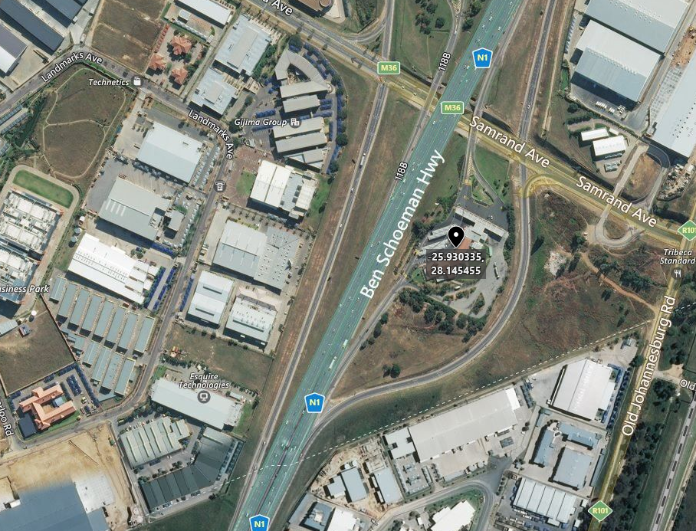
Figure 80: Fuel station on the Ben Schoeman Highway – Satellite imagery
Source: Bing Maps (Microsoft, 2018)
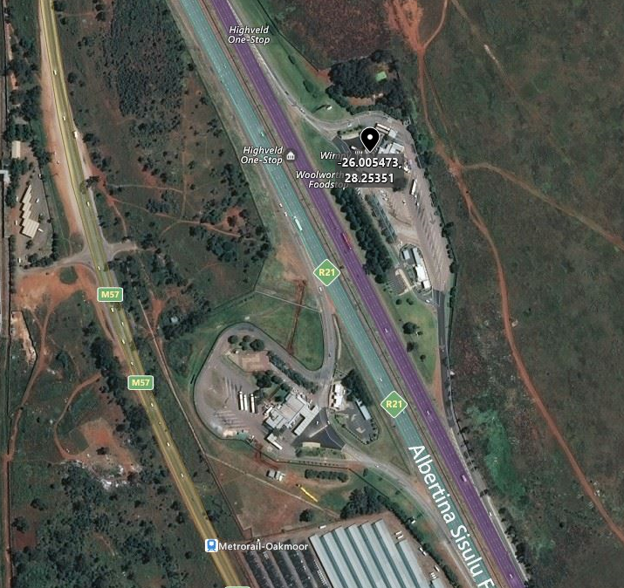
Figure 81: Fuel station on the Albertina Sisulu Freeway – Satellite imagery
Source: Bing Maps (Microsoft, 2018)

Data Preparation – Data Collection and Integration
The locations where the vehicle stopped for fuel were removed using a shape file downloaded from the MapCruzin (MapCruzin, 2018) website. Table 17 displays the number of locations before and after the locations at fuel stations were removed.
Table 17: Number of locations before and after locations at fuel stations were removed
Period | Number of locations at fuel stations included | Number of locations at fuel stations excluded
April to June 2015 | 511 | 399
July to September 2015 | 497 | 393
October to December 2015 | 431 | 300
January to March 2016 | 467 | 371
April to June 2016 | 380 | 296

Creation of Unsupervised Model and Detection of Anomalies
The R script was executed again, and it completed within 8 seconds.
Figure 82: Visualising a 10-cluster Multivariate Gaussian Mixture model
As can be seen from Figure 82, the clusters over-fit the data and thus the number of clusters were reduced to seven, using experimentation.
Figure 83: Visualising a 7-cluster Multivariate Gaussian Mixture model and Anomalies
The anomalies, as well as the seven clusters were investigated, and no irregularities were found.

Perception Model
Areas were created for some of the anomalies to allow locations falling within these areas to be labelled as normal. Thus, these points could be excluded from the list of top anomalies and allowed other points to be investigated as anomalies.

Creation of Unsupervised Model and Detection of Anomalies
The mclust (Fraley et al., 2012) function was again executed on the data to create the GMM model and the density function was used to assign anomaly scores to the data.
Figure 84: GMM, detected anomalies listed and visualised
The Isolation Forest package (Liu, 2009) was used to detect anomalies. The R script completed in 8 seconds.
Figure 85: Isolation Forest: Detected anomalies listed and visualised
The anomalies were investigated, and no indication of insider threat scenarios was found.
The list of top 20 anomalies obtained from the Isolation Forest algorithm was compared to the list of top 20 anomalies using the GMM algorithm. It was found that 15 locations appeared in both lists.

July to September 2015
This section continues from the previous section by selecting the range of locations identified during the next period, July to September 2015. The experimentation continued to utilise the scaled-down ITMDVT process model.

Data Preparation
The locations where the vehicle was switched off between July and September 2015 were selected. The same data preparation process as in 1.3.1 was used.

2.2 Creation Unsupervised Model and Detect Anomalies
The location data was presented to the mclust (Fraley et al., 2012) Gaussian Mixture Model algorithm with seven clusters.

Visualise Models and Anomalies
The no-go areas, Gaussian areas, ignition-off locations and top 20 locations were displayed using the leaflet (Cheng et al., 2017) R package.
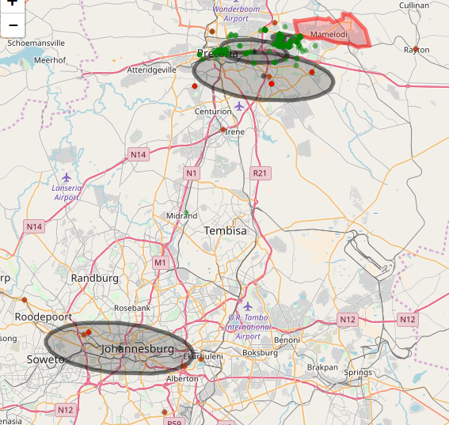
Figure 86: Visualising a 7-cluster Multivariate Gaussian Mixture model

Investigation of Anomalies
It was found that some of the areas used to label location data as normal were not used again. The top 20 anomalies were investigated, and no irregularities were found.

Isolation Forest Implementation
The Isolation Forest package (Liu, 2009) was used to detect anomalies.
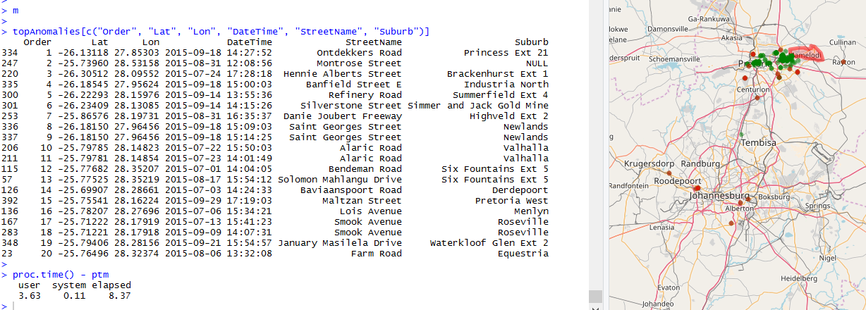
Figure 87: Visualising Isolation Forest Anomalies

The anomalies were investigated, and no indication of insider threat scenarios was found.
The list of top 20 anomalies obtained from the Isolation Forest algorithm was compared to the list of top 20 anomalies using the GMM algorithm. It was found that 17 locations appeared in both lists.

October to December 2015
This section continues from the previous section by selecting the next range of locations from October to December 2015. The experiment continued to utilise the scaled-down ITMDVT process model.

Data Preparation
The locations where the vehicle was in switch-off mode between October and December 2015 were selected. The same data preparation process as in Section 7.3.2.3 was used.

Creation of Unsupervised Model and Detection of Anomalies
The location data was presented to the mclust (Fraley et al., 2012) Gaussian Mixture Model algorithm with seven clusters.

Visualise Models and Anomalies
Figure 88: Visualising a 7-cluster Multivariate Gaussian Mixture model

It is apparent from Figure 88 that the definition of normal changed and that in this case, seven clusters over-fitted the data as three locations were seen as a cluster.

Creation of Unsupervised Model and Detection of Anomalies
With experimentation it was found that three clusters sufficiently described the data. The R script completed within 6 seconds.

Visualisation of Models and Anomalies
Figure 89: Visualising a 3-cluster Multivariate Gaussian Mixture model

Investigation of Anomalies
Upon investigating the second and third anomaly, the vehicle was shown to be at private residences where there had been no prearranged approval for this unauthorised stop, as shown in Figure 90.
Figure 90: Unauthorised stops by the driver

Isolation Forest Implementation
The Isolation Forest package (Liu, 2009) was used to detect anomalies. The R script completed within 6 seconds.
Figure 91: Visualisation of anomalies and unauthorised stopped obtained through the Isolation Forest implemenation
When the anomalies in the list of anomalous locations were investigated, the same two insider threat scenario locations were found as in the anomaly list detected by the Gaussian Mixture Model, as shown in Figure 91.
The list of top 20 anomalies obtained from the Isolation Forest algorithm was compared to the list of top 20 anomalies using the GMM algorithm. It was found that 19 locations appeared in both lists.

January – March 2016
This section continues from the previous section by selecting the next range of locations that were visited, namely from January to March 2016. The experimentation continued to utilise the scaled-down TMDVM process model.

Data Preparation
The locations where the vehicle was switched off between January and March 2016 were selected. The same data preparation process as in the previous experiment was used.

Creation of Unsupervised Model and Detection of Anomaly
A Gaussian Mixture Model with three clusters were used as in the previous implementation; this completed in 9 seconds.

Visualisation of Model and Anomalies
The Gaussian Mixture Model with three clusters were visualised as shown in Figure 92.
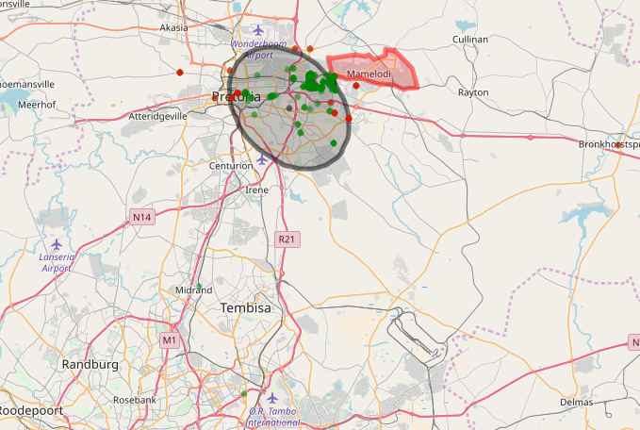
Figure 92: Visualisation of the Gaussian Mixture Model using three clusters

Investigation of Anomalies
Two anomalies were found and were considered vehicle abuse for private usage.

Isolation Forest Implementation
The Isolation Forest package (Liu, 2009) was used to detect anomalies.
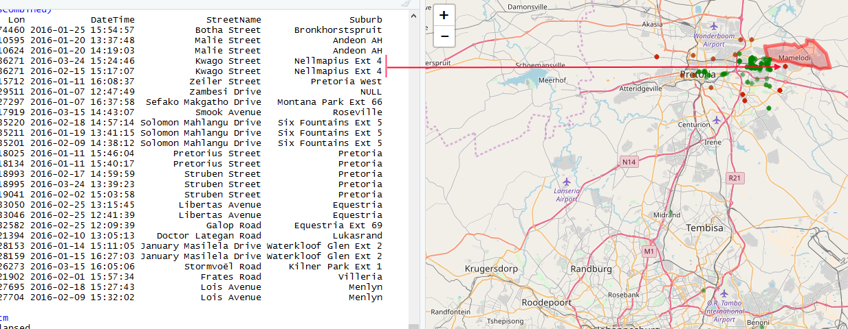
Figure 93: Anomalies from the Isolation Forest
Altogether 13 locations were detected as anomalies by the Gaussian Mixture Model that were identical to the anomalies detected by the Isolation Forest algorithm.

April – June 2016
This section continues from the previous section by selecting the next range of locations visited between April and June 2016. The experimentation continued to utilise the scaled-down ITMDVT process model.

Data Preparation
The locations where the vehicle was switched off between April and June 2016 were selected. The same data preparation process as in Section 7.3.2.3 was used.

Creation of Unsupervised Model and Detection of Anomalies
Using the Gaussian Mixture Model with three clusters completed in 9 seconds.
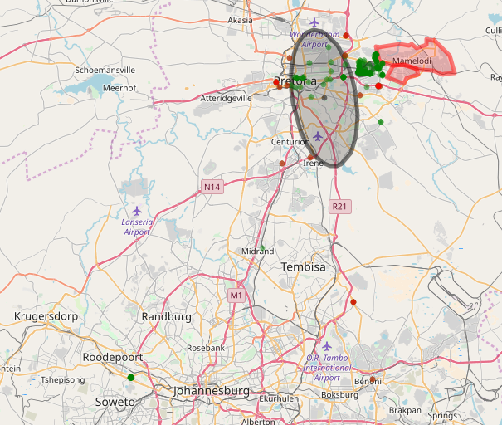
Figure 94: Visualising the Gaussian Mixture Model with three clusters

Investigation of Anomalies
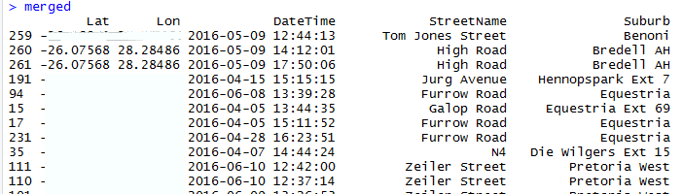
Figure 95: List of anomalies from the Gaussian Mixture Model
Inspecting the list of anomalies obtained through the Gaussian Mixture Model algorithm, two of the anomalies were found to be locations where the vehicle-tracking device lost GPS lock. The tell-tale sign was that the two anomalies had the exact GPS coordinates.

Isolation Forest Implementation
The Isolation Forest package (Liu, 2009) was used to detect anomalies.
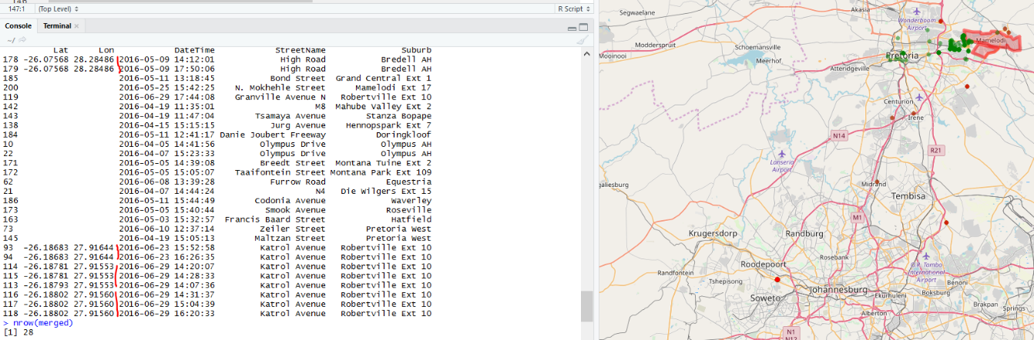
Figure 96: List of anomalies detected through the Isolation Forest algorithm as well as the visualisation of it
In this case, only nine of the anomalies from the Gaussian Mixture Model and the Isolation Forest algorithms matched. The Isolation Forest detected three other instances of GPS issues on the vehicle-tracking device that had not been found by the Gaussian Mixture Model.

Appendix
  - Fleet of Vehicles Experimentation

Experiment 1
This section describes the first experiment to implement the scaled-down ITDMVT that utilised data from the vehicle-tracking devices recorded for June 2018.

Environmental Study
The corporate that manages this fleet insisted that neither their intellectual property nor any trade secrets providing a competitive advantage may be shared. This study therefore attempted to provide as much detail as possible without violating the confidentiality agreement.
The drivers of the vehicles are unionised, which provided another reason why the identity of the fleet company could not be revealed. Although the intention was not to commercialise this study, the unions involved might abuse this research.
The fleet manager indicated that the vehicle drivers had designated areas where they were allowed to stop and switch the vehicle’s ignition on and off. These designated areas included fuel stations. The following areas were also configured for this fleet:
- 120 toll gates
- 110 keep-in routes
- 4600 point-of-interest (safe) areas, which included branches, offices, distribution centres and delivery points
- 70 no-go areas, which included prohibited, suspicious areas of possible fuel theft and previous areas where hijackings occurred
The devices fitted in the fleet consisted of vehicle-tracking devices supplied by CalAmp (CalAmp, 2018), Meta System (Meta System, 2004) and Altech Netstar (Altech Netstar (Pty) Ltd, 2018).

Perception Model
Figure 97 shows the above-mentioned areas. The areas in red are the no-go areas, the purple lines are the keep-in routes and blue areas the point-of-interest (safe) areas.
Figure 97: Visualisation of configured areas

Data Preparation

Data Collection and Integration
The data of interest was all the location-related data received for the selected fleet in June 2018. The data is stored in the big data system described in Chapter 2.
The data was obtained using a REST service, which provided the data as a JSON string. Examples of the JSON data structures can be found in Appendix D of the three most commonly used vehicle-tracking device types. The JSON data of interest for the experimentation in this chapter is the location data, as this is the only type of data sampled at regular intervals when the ignition of the vehicle is switched on for all the vehicle-tracking device types. Other types of data such as accelerometer values and configuration settings are discussed in more detail in Chapter 2.
Table 18 provides a list of some of the attributes that are contained in the JSON-formatted location data.
Table 18: Description of JSON attributes
Column Name | Description
vbu | The IMEI number that globally and uniquely identifies the vehicle-tracking device
hardware | The type of device that sent the data
datetime | The date and time (GMT time) the vehicle-tracking device recorded the location
latitude | The latitude of the GPS coordinate
longitude | The longitude of the GPS coordinate
altitude | The height above sea level
eventid | The number to indicate what caused the vehicle-tracking device to send a location such as ignition-on, ignition-off or heading change
speed | The speed of the vehicle
heading | A value between 0 and 359 degrees, where 0 degree is North, indicating the direction the vehicle is traving
satellites | The number of satellites that the GPS module on the vehicle-tracking device used to determine its current location (The GPS module needs at least four satellites to obtain an accurate location).
serverdatetime | The date and time (GMT time) of the server that received the data in the data centre.
battery voltage | The battery voltage of the vehicle’s battery.
internal battery voltage | The battery voltage of the battery within the vehicle-tracking device
ignition status | Value that indicates if the vehicle’s ignition is switched on or off
rpm | The number of revolutions per minute the engine is turning when the vehicle-tracking device is connected to the engine.

The location data is converted into a fixed-column structure and inserted into a Microsoft SQL (Microsoft, 2017) table. The table was named Locations and has columns as described in Table 19. The Locations table has 15.5 million location rows.
Table 19: Location table structure
Column Name | Description
Id | Integer to uniquely identify the row
Imei | The IMEI number that globally and uniquely identifies the vehicle-tracking device (This is the vbu attribute from Table 18)
DateTime | The date and time (GMT Time) the location was recorded by the vehicle-tracking device (This is the DateTime attribute from Table 18)
Latitude | The latitude of the GPS coordinate (This is the Latitude attribute from Table 18)
Longitude | The longitude of the GPS coordinate (This is the Longitude attribute described in Table 18)
EventId | The number to indicate what caused the vehicle-tracking device to send a location such as ignition-on, ignition-off or heading change (This is the EventId attribute from Table 18)
NoOfGpsSatellites | The number of satellites that the GPS module on the vehicle-tracking device used to determine its current location (The GPS module needs at least four satellites to obtain an accurate location – this is the satellites’ attribute from Table 18)
ServerDateTime | The date and time (GMT Time) of the server that received the data in the data centre (This is the ServerDateTime from Table 18)

A new table was created called IgnitionOff with the same schema as the Locations table. All the locations where the vehicles’ ignition was switched off were copied from the Locations table to the IgnitionOff table. The Ignition table has 265372 location rows.

Data Cleaning
Figure 98 contains a sample set of the locations from the IgnitionOff table. As can be seen from the image, some locations are obviously incorrect, such as the ones in the oceans.
Figure 98: Ignition-off locations for the fleet
The following rules were applied to remove invalid location rows:
- Rule 1: Where the latitude and longitude values are equal to zero.
- Rule 2: Where the latitude values are less than -38 and greater than zero.
- Rule 3: Where the longitude values are less than 4 and greater than 44.
Rule 2 and Rule 3 were applied to ensure that only locations within the blue oval are included as displayed in Figure 33, as the fleet only operates within the Southern Africa region.
The number of locations remaining after applying the above rules is 250 995.

Data Visualisation
Visualising the locations within the defined areas as shown in Figure 99 revealed that the defined areas were not well maintained and up to date. For the purposes of the current study, the known areas were used to label locations as locations in known areas. This means that these locations would not appear in the anomaly list.
Figure 99: Displaying ignition-off locations in defined areas

Feature Engineering
No feature engineering was performed on the first experiment to ensure that the dataset and the results are as simple as possible.

Transformation
There was no indication from the Environmental Study or study of the data that indicated any necessity to transform the data for this experiment.

Selected Attributes and Features
The Longitude and Latitude values were selected from the above locations dataset to form the dataset on which the anomaly detection would be performed.

Data Reduction
A principal component analysis (PCA) was performed on the input data and the results, which are displayed in Figure 100, indicate that the longitude and latitude values could not be reduced to a single dimension without a loss in accuracy. The results also indicated that there are no redundant attributes or features in the dataset.
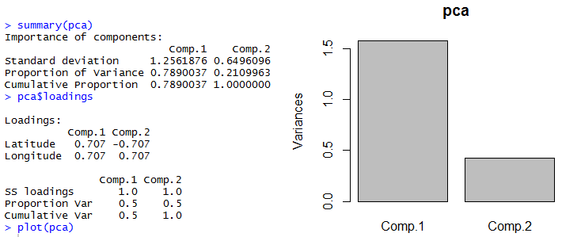
Figure 100: Principal Component Analysis result of the dataset

Creation Unsupervised Model and Detect Anomalies
A greedy search (Stepanova & Vavrecka, 2018) estimated that 37 clusters describe the data for the GMM model. The GMM model was created within 1 hours and 20 minutes. The model used 11.3 MB memory.
The Isolation Forest model was created within 1 minute. The model used 1.73 GB memory.
The locations within no-go and keep-in areas were removed from the dataset as the intention was to find previously unknown insider threat locations. This dataset was passed to the above models and the top 100 anomalies from each model were selected. 40 of the anomalies were found to be in both anomaly lists.

Visualisation
The anomaly locations identified are displayed on a map, in Figure 101, as red dots and a sample of the locations in the dataset presented to the anomaly detection algorithm are displayed as the green dots. The anomaly list and map were presented to the fleet manager. Figure 102 displays all the anomalies detected by the Isolation Forest algorithm and Figure 103 displays all the anomalies detected by the Gaussian Mixture Model (GMM) algorithm. Figure 104 displays the anomalies that appeared in the Isolation Forest and the GMM anomalies lists.
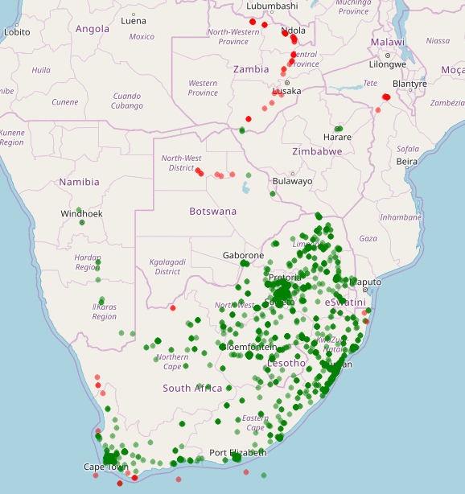  Figure 101: All Anomalies and sample of locations | 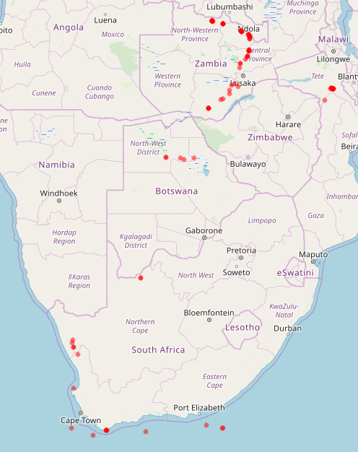  Figure 102: Anomalies from Isolation Forest
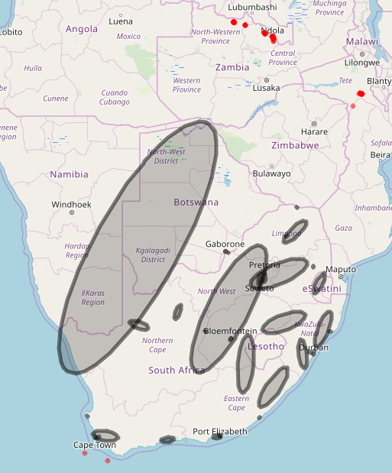  Figure 103: Anomalies from GMM | 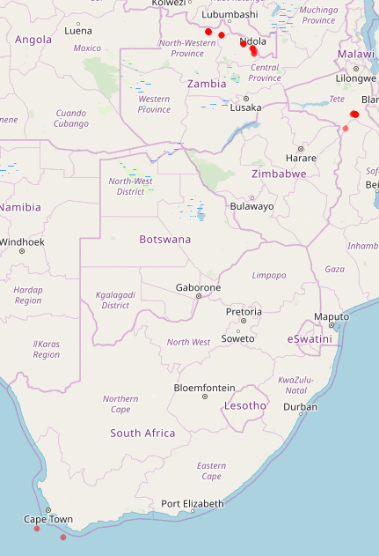  Figure 104: Overlapping anomalies
Comparing Figure 103 and Figure 104 it can be seen that there is a difference as to what the two anomaly detection algorithms rank as the top 100 anomalies.

Investigation of Anomalies
It can be seen in Figure 101 that some of the anomalies were found to be located in the ocean, which is definitely incorrect. This usually happen when the vehicle-tracking device cannot obtain a GSM lock, there are various causes for this such as poor device installation, cloud coverage and buildings. These anomalies can be filtered out as the vehicle-tracking devices does provide an indication if it did receive GPS data from a sufficient number of GPS satellites.
The list of anomalies was presented to the fleet manager and each anomaly was investigated manually.
One of the anomalies found in Figure 105 prompted an investigation. It was found that the owner of the business had instructed goods to be delivered to his home. Thus, it was an authorised stop.
Figure 105: Approved anomaly
The fleet manager confirmed that the anomaly displayed in Figure 106 was indeed an unauthorised stop. This prompted further investigation, which could lead to disciplinary action against the driver.
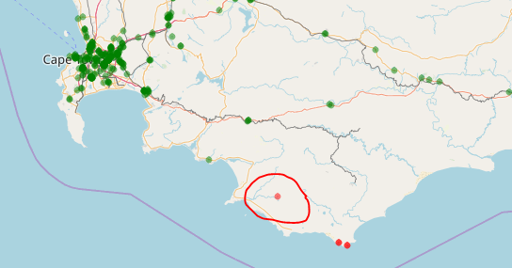
Figure 106: Unauthorised stop
The anomalies that were located in Zambia, Botswana and Mozambique were be attributed to the low activity footprint of the fleet in these areas as can be seen in Figure 107.
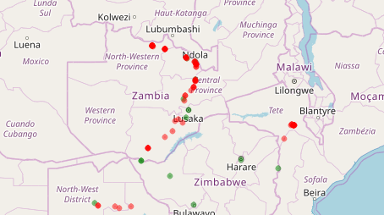
Figure 107: Locations in Zambia

Data Analysis of Anomalies
The anomalies from the Isolation Forest and the GMM algorithms were clustered using the GMM algorithm as shown in Figure 108 and Figure 109. Altogether eight clusters described the anomalies from the Isolation Forest model and six from the GMM model. The number next to each cluster is the number of anomalies within that cluster. It can be seen that the two anomaly detection algorithms ranked the top anomalies differently.
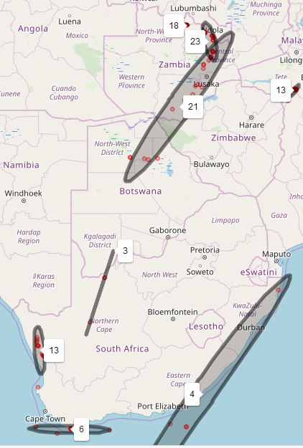  Figure 108: Clustered Isolation Forest Anomalies, with the number of anomalies per cluster | 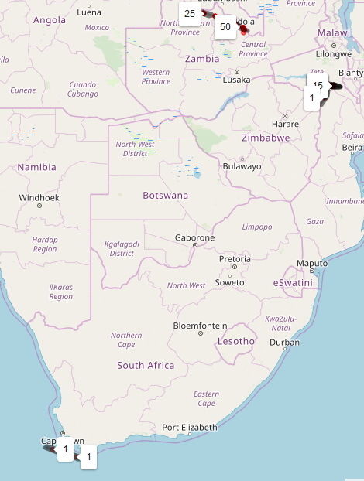  Figure 109: Clustered GMM Anomalies, with the number of anomalies per cluster
It can be seen that a high number of the anomalies is situated outside of South Africa, which correspond to Figure 108, which shows that the vehicle tracking company has a low activity footprint in these locations.
It is clear from Figure 108 and Figure 109 that the anomalies detected by the Isolation Forest algorithm and the GMM algorithm is different.
The principal component analysis (PCA) (Soh et al., 2018) of the Isolation Forest anomalies as shown in Figure 110, indicate that the longitude and latitude values contribute to the variation of the data and that the rows uniquely describe the data.
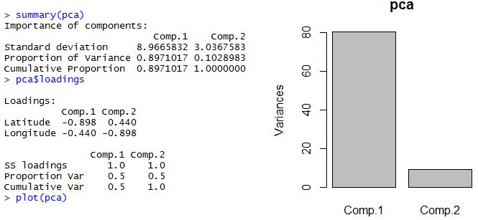
Figure 110: Principal Component Analysis (PCA) for the Isolation Forest Anomalies
The principal component analysis (PCA) (Soh et al., 2018) if the GMM anomalies as shown in Figure 111, indicate that the longitude and latitude values contribute to the variation of the data and that the rows uniquely describe the data.
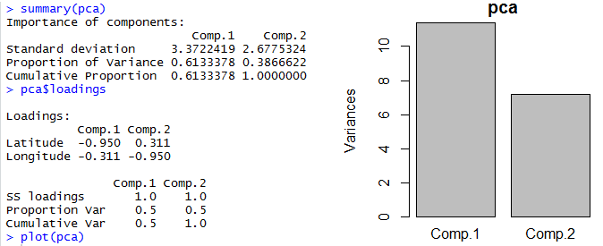
Figure 111: PCA for GMM anomalies

Experiment 1 - Conclusion
The anomaly detection algorithms highlighted location records with invalid longitude and latitude values that should have been removed in the data cleaning process by looking at the number of satellites visible to the GPS module on the vehicle-tracking device.
An insider thread scenario was discovered, as well as an interesting anomaly. This showed that the ITDVMT process model was a valid approach in the search for previously unknown insider threats.
The data analysis of the anomalies indicated that the two anomaly detection algorithms ranked anomalies differently.

Experiment 2
This experiment focused on removing invalid data highlighted in the previous experiment, increasing the number of records in the dataset presented to the detection algorithms, as well as increasing the number of features utilised in the experimentation.

Environmental Study
The fleet manager indicated that vehicles were allowed to stop at shopping centres or businesses, but not at private residential areas such as private estates.

Data Preparation

Data Collection and Integration
Vehicle-tracking data was retrieved for data received between 01 June 2018 and 30 September 2018 from the big data system, and the retrieval process is the same process as used in the previous experiment. The resulting table contained 64 million location rows. Only the location records where the vehicles ignitions had been switched off were selected. The number of the ignition-off locations totalled 1 062 116.

Data Cleaning
The following rules were applied to ensure that the dataset only contained valid location rows.
- Only include records where the date recorded by the device was between 01 June 2018 and 30 September 2018. (The vehicle-tracking device uses the GPS module to obtain the current date and time. If there is an issue with GPS reception or if there are issues with the device, the date and time will be close to a default value or differ drastically from the date and time it was received.)
- Locations where the GPS module on the vehicle-tracking device was able to utilise four or more satellites to obtain the location data.
- Longitude > 5° and Longitude < 44°. The area of interest.
- Latitude > -38° and Latitude < 0°. The area of interest.
Interestingly, there were four locations provided by the vehicle-tracking devices where the date values were invalid. One of these dates was 2018-09-31, since September only has 30 days, the date was changed to 2018-09-30. This can happen because the vehicle-tracking devices communicate the year, month, day, hour, minute and second as separate fields to the backend server and no complex validation is performed on this date.
The total number of records in the dataset after the above filter rules have been applied is 1 080 000.

Data Visualisation
Visualising the date, it appeared that all the locations points appeared on land and no defective data was immediately apparent.
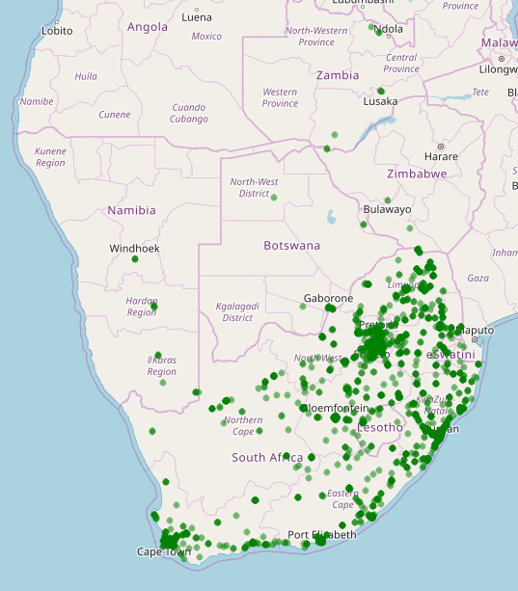
Figure 112: Sample set visualisation

Feature Engineering
The TimeOfDay and IsWorkDay features were extracted from the DateTime value and added to the dataset.
The first step was to convert the DateTime values from UTC to local South African date and time values. The next was to extract the time portion for the TimeOfDay value. Lastly, the IsWorkDay feature was determined from the day of the week from the date portion of the DateTime value. Monday to Friday are workdays and Weekend and public holidays are not.
The IsWorkDay is using 1 to present working days and 0 for weekends and public holidays. The TimeOfDay feature is using decimal hour value to present the hour of the day and parts thereof.

Transformation
There was no indication from the Environmental Study or study of the data that indicated any necessity to transform the data for this experiment.

Selected Attributes and Features
The Longitude, Latitude, TimeOfDay and IsWeekDay values were selected from the above locations dataset to form the dataset on which the anomaly detection would be performed.

Data Reduction
A principal component analysis (PCA) (Soh et al., 2018) was performed on the input data to determine if the obtained dataset could be reduced. The result of the PCA, as shown in Figure 113, indicates that the dataset could not be reduced to a smaller number of columns without a significant loss in accuracy. The results also indicated that there were no redundant attributes or features in the dataset.
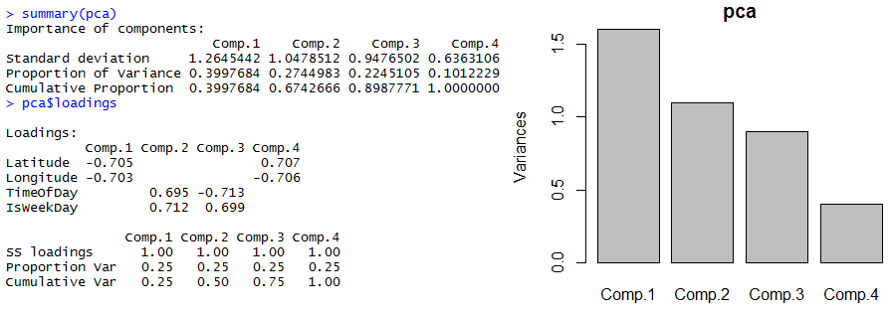
Figure 113: Principal Component Analysis result of the dataset

Analysing Feature Values
A density plot was generated for the TimeOfDay feature, displayed in Figure 114. As can be gathered from the plot, most activity occurred between 7:30 and 17:00.
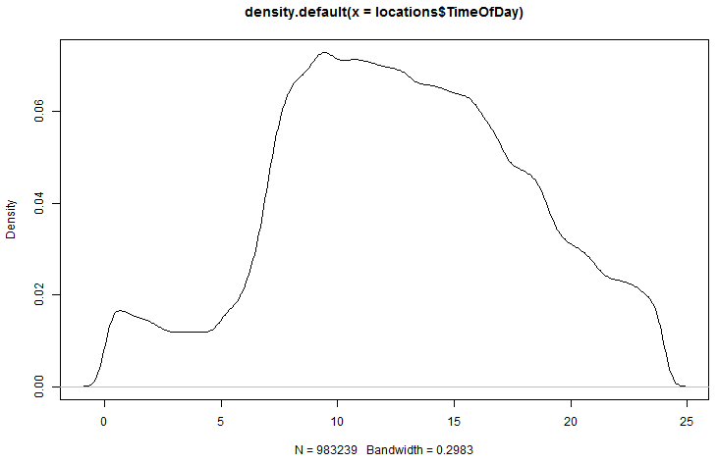
Figure 114: Density plot for the TimeOfDay feature
A density plot was generated for the IsWorkDay feature, displayed in Figure 115. The plot shows that most of the activity occurred during the week.
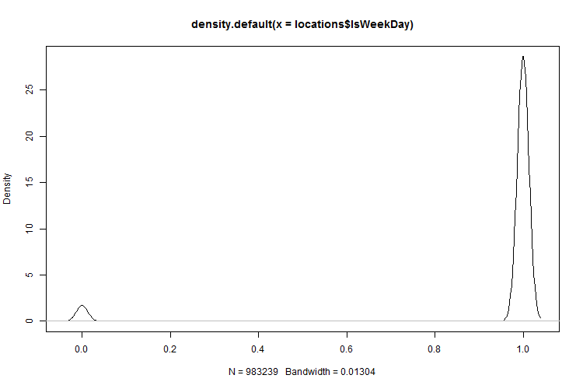
Figure 115: Density plot for the IsWorkDay feature

Data Labels
A label was added to each location row to indicate if it was in a known area, such as a no-go or keep-in area. These locations would not appear in the anomaly list as the fleet manager already knew if the area was safe, suspicious or prohibited.

Perceptual Model
The area within which each vehicle operated was estimated using a single Gaussian Mixture Model cluster. In a conversation with the fleet manager, he confirmed that the vehicles were operating in an area less than 5km², which could be seen as normal or safe areas. The location records that fell within these areas were also labelled as known areas.
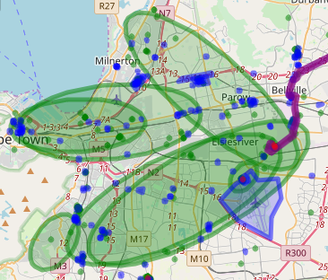
Figure 116: The green ellipses show examples of vehicles normally operating in small operating areas

Creation Unsupervised Model and Detect Anomalies
A greedy search (Stepanova & Vavrecka, 2018) estimated that 137 clusters describe the data for the GMM model. The GMM model was created within 1 hours and 30 minutes and it used 27.2 MB memory.
The Isolation Forest model was created within 10 minutes and it used 10.4 GB memory.
The locations within no-go and keep-in areas were removed from the dataset. This dataset was passed to the above models and the top 100 anomalies from each model were selected. Altogether 13 of the anomalies were found to be in both anomaly lists.

Visualisation
All the data, which includes the areas, locations and anomalies, was visualised. The anomaly location records are displayed as red dots in Figure 117.
Figure 117 displays all the no-go areas (red polygons), keep-in routes (purple lines), safe areas (blue polygons), locations where the vehicles ignitions had been switched off (green dots) and the detected anomalies (red dots).
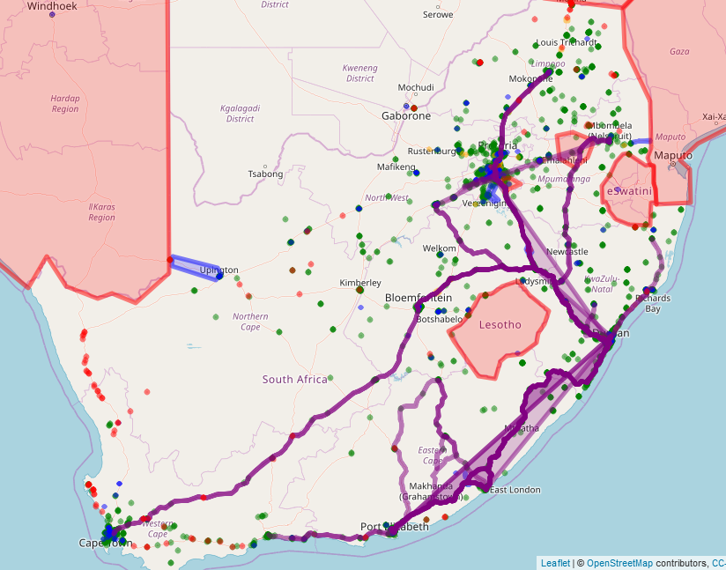
Figure 117: Visualisation of anomalies, locations and areas
Figure 118 displays only the anomalies (red dots) obtained through utilising the Isolation Forest algorithm.
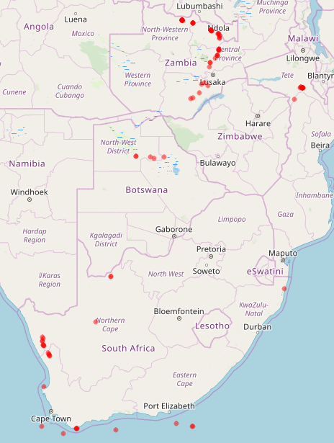
Figure 118: Anomalies obtained through the Isolation Forest algorithm
Figure 119 displays the anomalies (red dots) obtained through the GMM algorithm and the discovered clusters.
Figure 119: Anomalies detected through the GMM algorithm

Investigation of Anomalies
The list of anomalies was presented to the fleet manager and each anomaly was investigated manually.
Only one anomaly location was identified as suspicious and the fleet manager confirmed that it required further investigation, as shown in Figure 120.
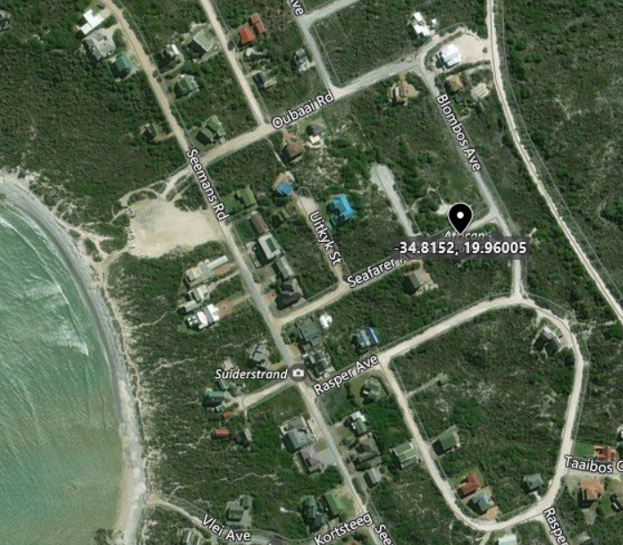
Figure 120: Suspicious Location

Data Analysis of Anomalies
Figure 121 presents the principal component analysis (PCA) (Soh et al., 2018) that was performed on the anomalies obtained by means of the Isolation Forest algorithm. As can be seen from the analysis, the IsWeekDay feature did not contribute to the variability of the anomalies.
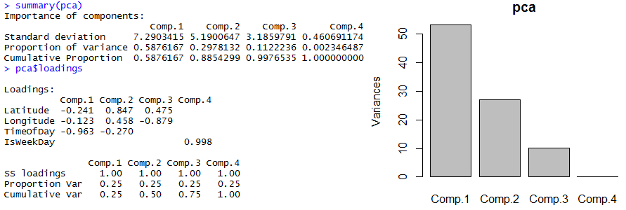
Figure 121: PCA for Isolation Forest anomalies
Figure 122 in turn presents the principal component analysis (PCA) (Soh et al., 2018) that was performed on the anomalies obtained through the Gaussian Mixture Model algorithm. As can be seen from the analysis, the IsWeekDay feature did not contribute to the variability of the anomalies.
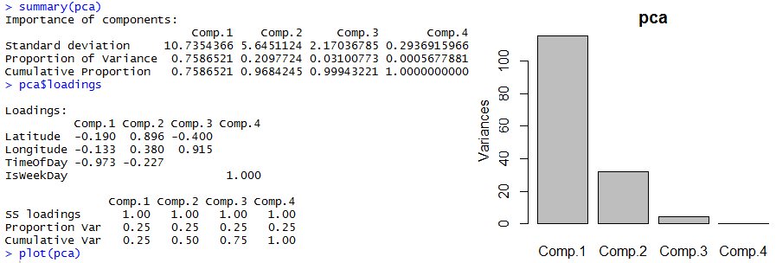
Figure 122: PCA for GMM anomalies
A greedy search was performed on the anomalies obtained from the Isolation Forest algorithm and it was found that 11 clusters described the data. These clusters are visualised in Figure 123.
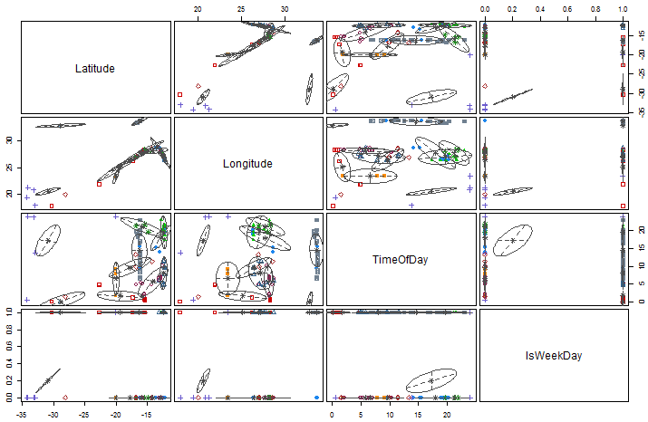
Figure 123: Clustering of Isolation Forest Anomalies
A greedy search was performed on the anomalies obtained from the GMM algorithm and it was found that 8 clusters described the data. These clusters are visualised in Figure 124.
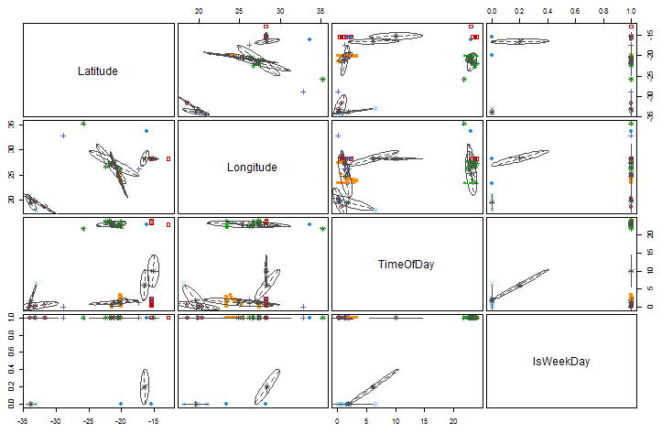
Figure 124: Clustering of GMM Anomalies
The anomalies were further analysed by creating density plots for the TimeOfDay and IsWeekDay features as can be seen in Figure 125, Figure 126, Figure 127 and Figure 128. A comparison of these plots shows that the TimeOfDay plot for the Isolation Forest anomalies described in Figure 125 follows the curve of the input data displayed in Figure 114, whereas the TimeOfDay density feature plot for the GMM anomalies in Figure 127 is almost the inverse of Figure 114.
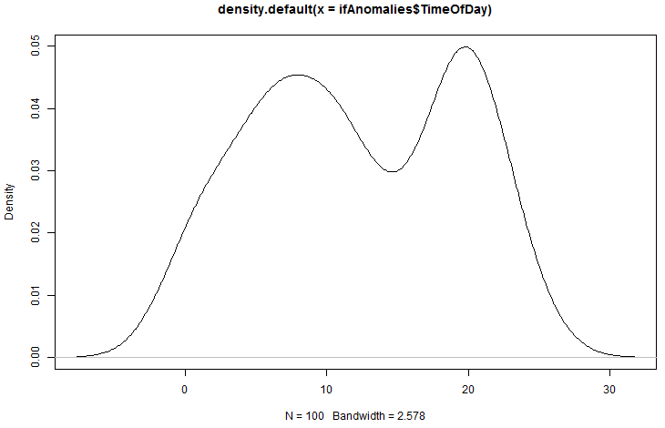
Figure 125: Isolation Forest Anomalies density plot for TimeofDay
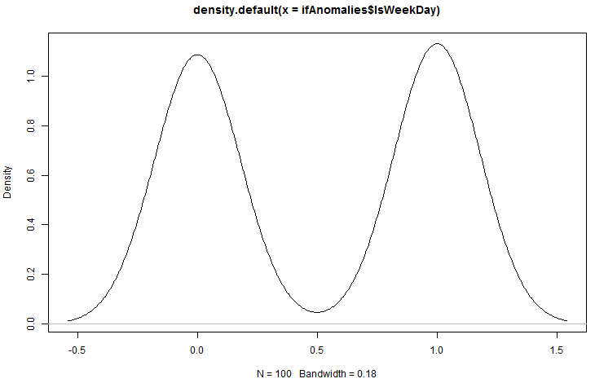
Figure 126: Isolation Forest Anomalies density plot for IsWeekDay
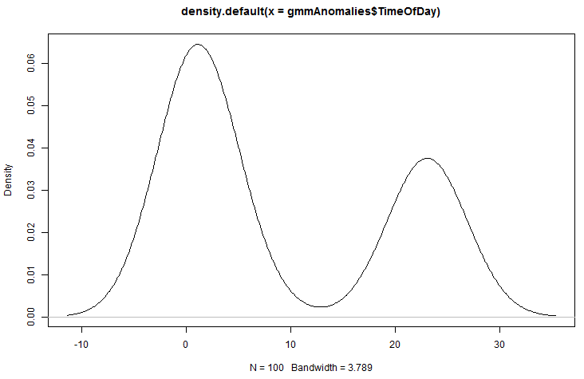
Figure 127: GMM Anomalies density plot for TimeOfDay feature
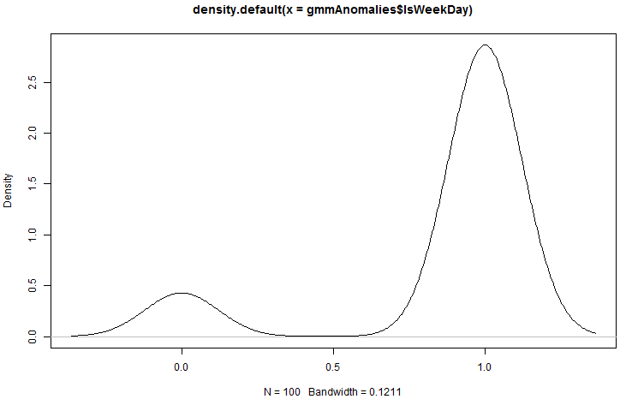
Figure 128: GMM Anomalies density plot for IsWeekDay feature

Experiment 2 - Conclusion
An insider thread scenario as well as an interesting anomaly was discovered, which showed that the ITDVMT process model is a valid approach in the search for previously unknown insider threats.
The data analysis of the anomalies indicated that the two anomaly detection algorithms ranked anomalies differently.

Experiment 3
Within this experiment, the locations were limited to locations in South Africa because of the low activity footprint outside of South Africa. The dataset presented to the anomaly detection algorithm was used to determine if value could be derived from a dataset containing contextual information.

Data Preparation

Data Collection and Integration
The data used in this experiment was the same as in the previous experiment, except that all locations outside of South Africa were excluded. The total number of locations in the dataset was 961 990.

Data Cleaning
The same filters as in the previous experiment were applied.

Feature Engineering
The TimeOfDay and IsWeekDay features were included as described in the previous experiment.

Transformation
There was no intent in this experiment to transform the data.

Selected Attributes and Features
The Longitude, Latitude, TimeOfDay andIsWeekDay values were selected from the above locations dataset to form the dataset on which the anomaly detection would be performed.

Data Reduction
A principal component analysis (PCA) (Soh et al., 2018) was performed on the input dataset to determine if the obtained dataset could be reduced. The result of the PCA, as shown in Figure 129, indicates that the dataset columns could not be reduced to a small number of columns. The results also indicated that there were no redundant attributes or features in the dataset.
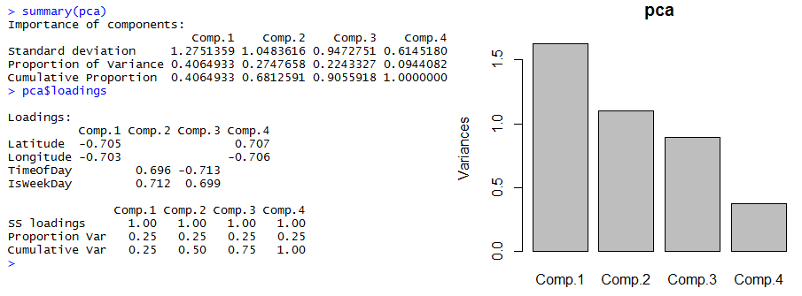
Figure 129: Principal Component Analysis (PCA) result of the dataset

Analysis of Features
Density plots were created for the features in the dataset. As can be seen from these plots, the data is the same as in the previous experiment and no new discoveries were made.
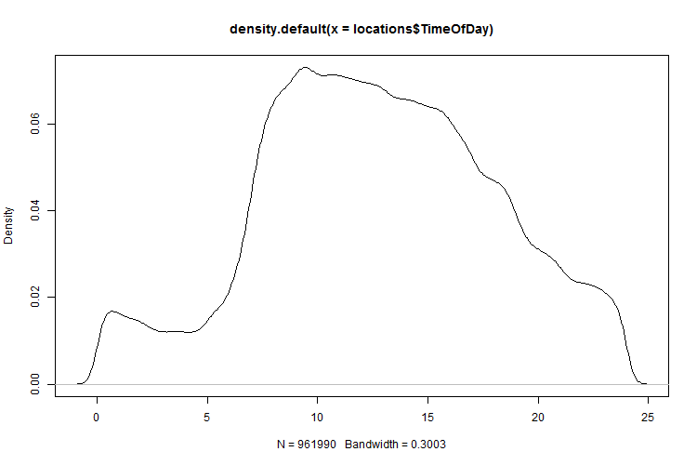
Figure 130: Density plot for the TimeOfDay feature
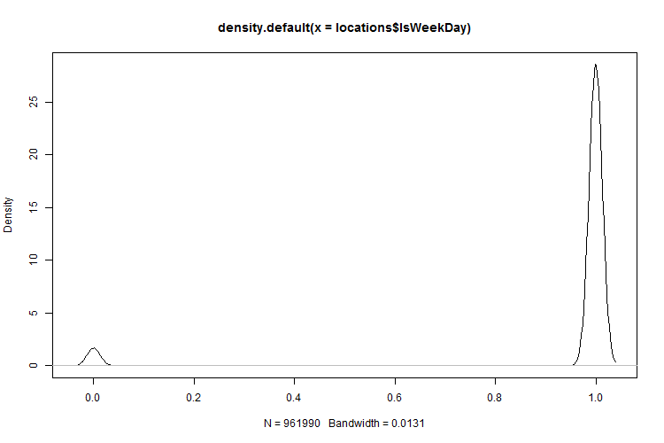
Figure 131: Density plot for IsWeekDay feature

Data Labels
It was decided not to utilise the predefined no-go and keep-in areas, as the dataset would not be based on longitude and latitude values only. Important anomalies could also be missed, as contextual features such as the TimeOfDay and IsWeekDay had been added to the dataset.

Creation of Unsupervised Model and Detection of Anomalies
A greedy search (Stepanova & Vavrecka, 2018) estimated that 136 clusters describe the data for the GMM model. The GMM model was created within 1 hours and 30 minutes and it used 27.1 MB memory.
The Isolation Forest model was created within 10 minutes and it used 20.2GB memory.
The dataset was passed to the above models and the top 100 anomalies from each model were selected. Altogether 14 of the anomalies were found to be in both anomaly lists.

Visualisation
Figure 132 shows the anomalies (red dots) that were obtained using the Isolation Forest algorithm and Figure 133 shows the anomalies (red dots) obtained using the GMM algorithm.
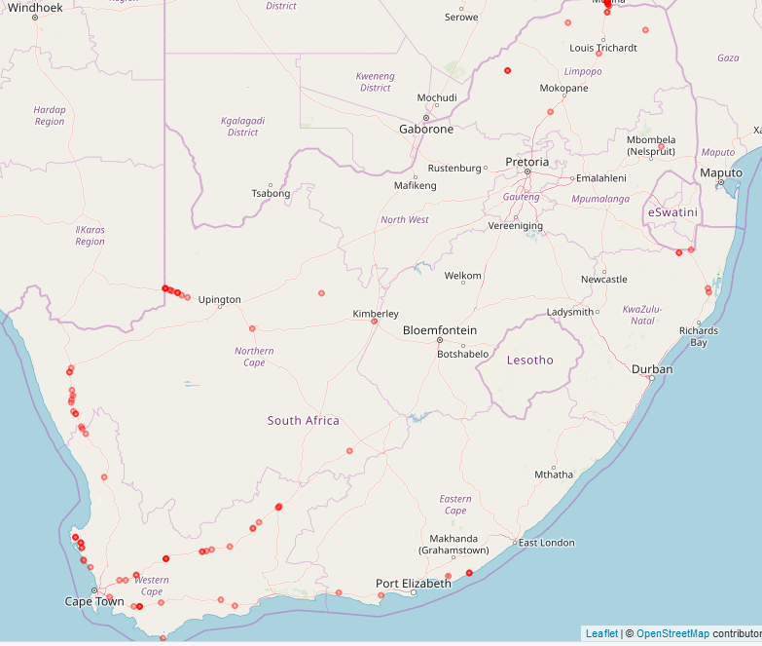
Figure 132: Visualisation of anomalies obtained through the Isolation Forest algorithm
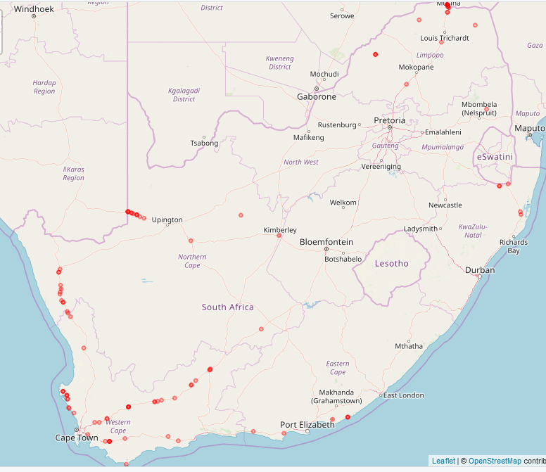
Figure 133: Visualisation of anomalies obtained through the GMM algorithm

Investigation of Anomalies
The list of anomalies was presented to the fleet manager and each anomaly was investigated manually.
Only one location was found where the driver of vehicle had performed an unauthorised stop as displayed in Figure 134. The fleet manager confirmed that this location required further investigation.
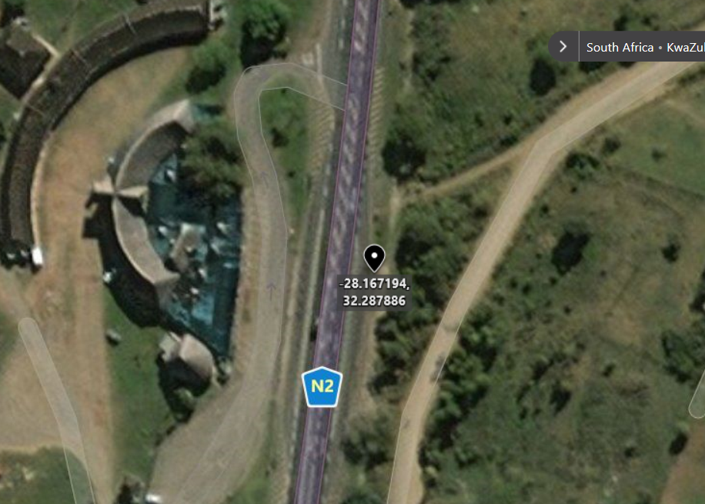
Figure 134: Unauthorised stop

Data Analysis of Anomalies
A principal component analysis (PCA) (Soh et al., 2018) was performed on the anomalies obtained through the Isolation Forest algorithm as displayed in Figure 135. As can be seen from the analysis, the IsWeekDay feature did not contribute to the variability of the anomalies.
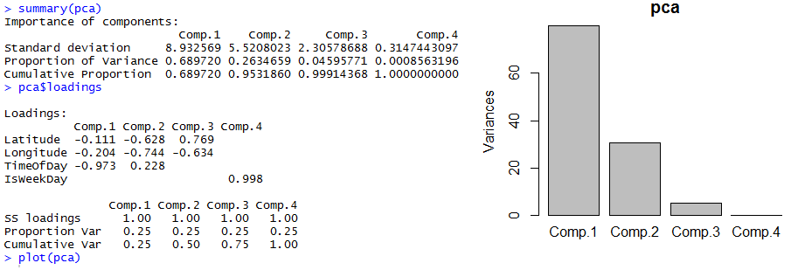
Figure 135: PCA for the Isolation Forest anomalies
A principal component analysis (PCA) (Soh et al., 2018) was performed on the anomalies obtained through the GMM algorithm as displayed in Figure 136. As can be seen from the analysis, the IsWeekDay feature did not contribute to the variability of the anomalies.
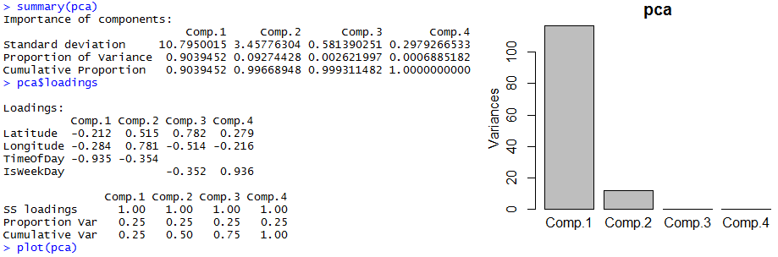
Figure 136: PCA for the GMM anomalies
The greedy search that was used, determined that two clusters sufficiently described the Isolation Forest algorithm anomalies.
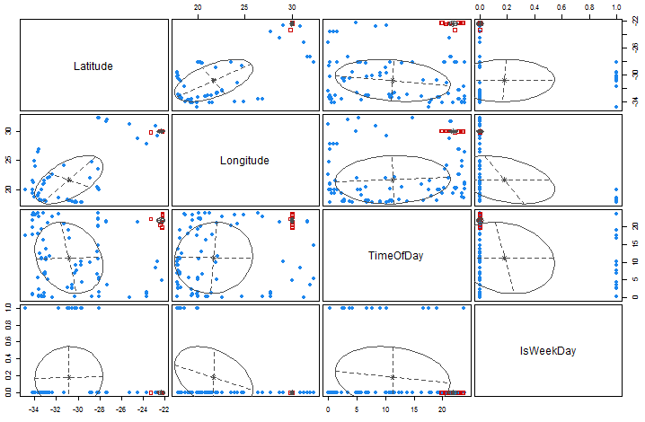
Figure 137: Clustering the Isolation Forest anomalies using the GMM algorithm
The greedy search that was used determined that six clusters sufficiently described the GMM algorithm anomalies.
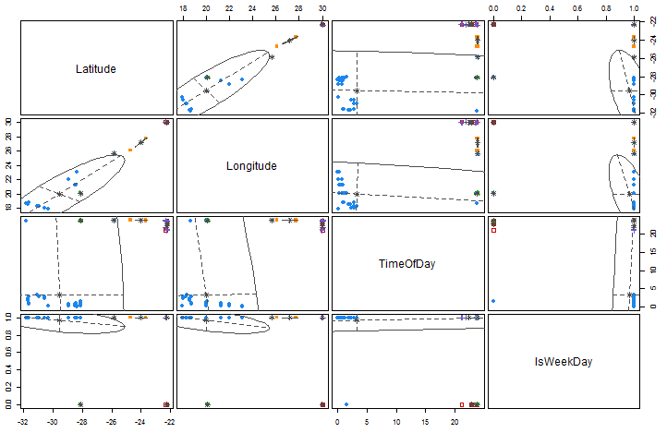
Figure 138: Clustered the GMM anomalies using the Gaussian Mixture Model (GMM) algorithm
The anomalies were further analysed by creating density plots for the TimeOfDay and IsWeekDay features as can be seen in Figure 139, Figure 140, Figure 141 and Figure 142. Comparing these plots shows that the TimeOfDay plot for the Isolation Forest anomalies described in Figure 139 follows the curve of the input data displayed in Figure 130, whereas the TimeOfDay density feature plot for the GMM anomalies in Figure 141 is the inverse of Figure 130.
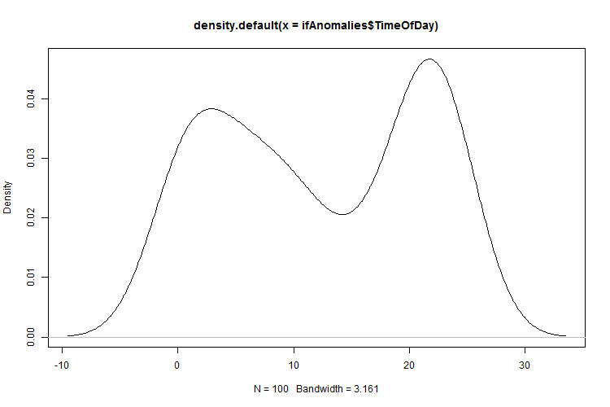
Figure 139: Density Plot for the TimeOfDay feature for the Isolation Forest anomalies
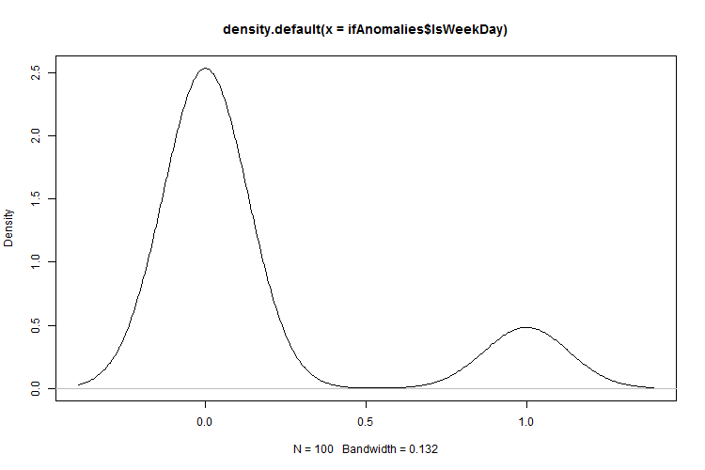
Figure 140: Density Plot for the IsWeekDay feature for the Isolation Forest anomalies
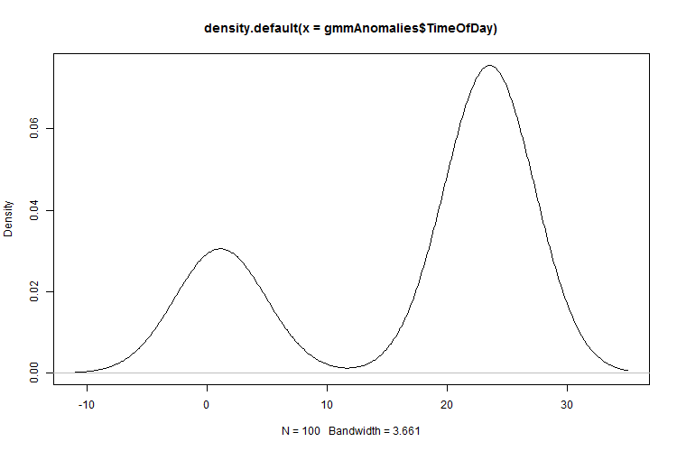
Figure 141: Density Plot for the TimeOfDay feature for the GMM anomalies
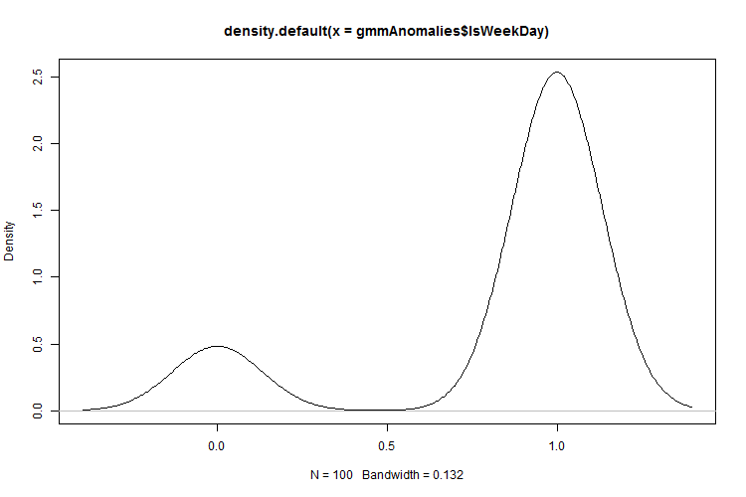
Figure 142: Density Plot for the IsWeekDay feature for the GMM anomalies

Experiment 3 – Conclusion
An insider thread scenario as well as an interesting anomaly was discovered. This shows that the ITDVMT process model is a valid approach in the search for previously unknown insider threats.
The data analysis of the anomalies indicated that the two anomaly detection algorithms ranked anomalies differently.

Experiment 4
For this experiment, trips were utilised as the input dataset to the anomaly detection algorithm. The location where a vehicle’s ignition was switched on was paired with the corresponding ignition-off location. This corresponds with the definition of a trip as described in Chapter 2.
This experiment investigated the value of transforming a location dataset into a trip dataset for the discovery of insider threats utilising anomaly detection.

Environmental Study
No new environmental information became available.

Data Preparation

Data Collection and Integration
Vehicle location data from 01 June 2018 up to and including 30 September 2018 was selected for the specified fleet.

Data Cleaning
- Rule 1: Remove duplicate locations. A location was seen as duplicate of another when latitude and longitude values are the same. The vehicle-tracking devices in this study only sent the same GPS coordinates if they could not obtain a location from their GPS module.
- Rule 2: Remove locations with Latitude and Longitude values of zero.

Data Transformation
A total of 1 059 207 trips were obtained from the fleet by pairing the corresponding ignition-on locations next to each ignition-off location per vehicle. The resulting trips were written to a Microsoft SQL database table called Trip.
Table 20 provides a description of each attribute contained within the Trip table.
Table 20: Trip attributes
Attribute | Description
StartLongitude | The longitude of the area where the trip started
StartLatitude | The latitude of the area where the trip started
EndLongitude | The longitude of the area where the trip ended
EndLatitude | The latitude of the area where the trip ended
StartDateTime | The date and time the trip started
EndDateTime | The date and time the trip ended
StartOdometer | The odometer value at the start of the trip
EndOdometer | The odometer value at the end of the trip

Feature Engineering
The features described Table 21 were extracted from the attributes described in Table 20 and have been added to the Trip table.
Table 21: Trip features
Feature | Description
StartTimeOfDay | The time of day when the trip started was extracted from the trip StartDateTime attribute.
EndTimeOfDay | The time of the day when the trip ended was extracted from the trip End DateTime attribute.
StartIsWorkDay | This indicates if the day the trip started was a workday – 1 for workdays and 0 for weekends and public holidays. The value was extracted from the trip StartDateTime attribute.
EndIsWorkDay | This indicates if the day when the trip ended was a workday – 1 for workdays and 0 for weekends and public holidays. The value was extracted from the trip EndDateTime attribute.
Distance | Distance was calculated by subtracting the StartOdometer attribute from the EndOdometer attribute described in Table 11.
DurationSeconds | This value was calculated by subtracting the DateTime value for the trip start location from the DateTime value for the trip end location for each trip.
StartEndDistance-Metre | This value was obtained by calculating the straightline distance in metres between the StartLongitude and StartLatitude and the EndLongitude and End Latitude values.

Data Cleaning
- Rule 1: Remove trips where trip ended with less than 4 satellites visible to the GPS.
- Rule 2: Remove trips where the distance between the start and end location was less than 1 metre.
- Rule 3: Remove trips where the trip duration was less than 60 seconds.
- Rule 4: Remove trips where the trip duration exceeded 8 hours.
- Rule 5: Remove trips with negative distance values. (Negative odometer values can occur when the odometer on the vehicle-tracking device is updated during a trip or the vehicle-tracking device is restarted.)
After the cleaning process there remained 807 715 trips to work with.

Selected Attributes and Features
The StartLongitude, StartLatitude, EndLongitude, EndLatitude, StartTimeOfDay, EndTimeOfDay, StartIsWeekDay, EndIsWeekDay, Distance, DurationSeconds and StartEndDistanceMetre values were selected from the above locations dataset to form the dataset on which the anomaly detection would be performed.

Data Reduction
A principal component analysis (PCA) (Soh et al., 2018) was performed on the input dataset to determine if the obtained dataset could be reduced. The result of the PCA, as shown in Figure 143 and Figure 144, indicates that the dataset columns could be reduced to a smaller number of columns without a significant loss in accuracy. The results also indicated that there were no redundant attributes or features in the dataset.
Figure 143: Summary and Loadings of the Principal Component Analysis performed on the dataset
Figure 144: Plot of the Principal Component Analysis on the dataset

Analysis of Feature Values
Density plots were created for the features in the dataset.
Figure 145: Density plot for the trip StartTimeOfDay feature
Figure 146: Density plot for the trip EndTimeOfDay feature
Figure 145 and Figure 146 look similar because of the short duration of a high percentage of trips, as can be deducted from Figure 150.
Figure 147: Density plot for the trip StartIsWeekDay feature
Figure 148: Density plot for the trip EndIsWeekDay feature
Figure 149: Density plot for the trip Distance feature
Using the density plot approach to visualise the data, it was noticed that some trips had a negative distance, because the odometer values on the vehicle-tracking devices had been changed. The trips with a negative distance were removed in the data-cleaning process.
Figure 150: Density plot for the trip DurationSeconds feature
Using the density plot approach to visualise the data, it was found that some trips exceeded 8 hours. A total of 40 trips exceeded 8 hours and were removed from the dataset.

Creation of Unsupervised Model and Detection of Anomalies
A greedy search estimated that 7 clusters describe the data for the GMM model. The GMM model was created within 1 hours and 30 minutes and it used 8.0 MB memory.
The Isolation Forest model was created within 42 minutes and it used 16.9 MB memory.
The dataset was passed to the above models and the top 100 anomalies from each model were selected. Altogether 12 of the anomalies were found to be in both anomaly lists.

Visualisation of Anomalies
Figure 151: Trips detected as anomalies by the Isolation Forest algorithm
Figure 152: Trips detected as anomalies by the GMM algorithm

Investigation of Anomalies
The list of anomalies was presented to the fleet manager and each anomaly was investigated manually.
Two of the anomalies investigated were at locations where the drivers of the vehicles had stopped without approval.
Figure 153: Refuelling at unapproved fuel station
Figure 154: Unauthorised stop

Data Analysis of Anomalies
A principal component analysis (PCA) (Soh et al., 2018) was performed on the anomalies obtained through the Isolation Forest algorithm, as shown in Figure 155 and Figure 156. The PCA analysis indicated that all of the dimensions of the anomaly dataset contributed to the variability of the dataset.
Figure 155: PCA for Isolation Forest anomalies
Figure 156: PCA Plot for the Isolation Forest anomalies
A principal component analysis (PCA) (Soh et al., 2018) was performed on the anomalies obtained by means of the GMM algorithm shown in Figure 157 and Figure 158. The PCA analysis indicated that all of the dimensions of the anomaly dataset contributed to the variability of the dataset.
Figure 157:PCA for GMM anomalies
Figure 158: PCA Plot for the GMM anomalies
Using the greedy search, it was determined that 6 clusters described the Isolation Forest algorithm anomalies. The clustered data is shown in Figure 159.
By using the greedy search again, it was determined that 11 clusters described the GMM algorithm anomalies. The clustered data is shown in Figure 160.

Figure 159: Cluster plot for the Isolation Forest anomalies
Figure 160: Cluster plot for GMM anomalies
The anomalies were further analysed by creating density plots for the features found in the anomalies from the Isolation Forest algorithm and GMM algorithm as shown in Figure 161 to Figure 174. The density plot for each feature of the anomalies for the two algorithms is placed next to each other below.
Figure 161: Density plot for trip Isolation Forest anomalies StartTimeOfDay | Figure 162: Density plot for the GMM anomalies trip StartTimeOfDay
Figure 163: Density plot for the Isolation Forest anomalies trip EndTimeOfDay | Figure 164: Density plot for the GMM anomalies trip EndTimeOfDay
Figure 165: Density plot for the Isolation Forest anomalies trip StartIsWeekDay | Figure 166: Density plot for the GMM anomalies trip StartIsWeekDay
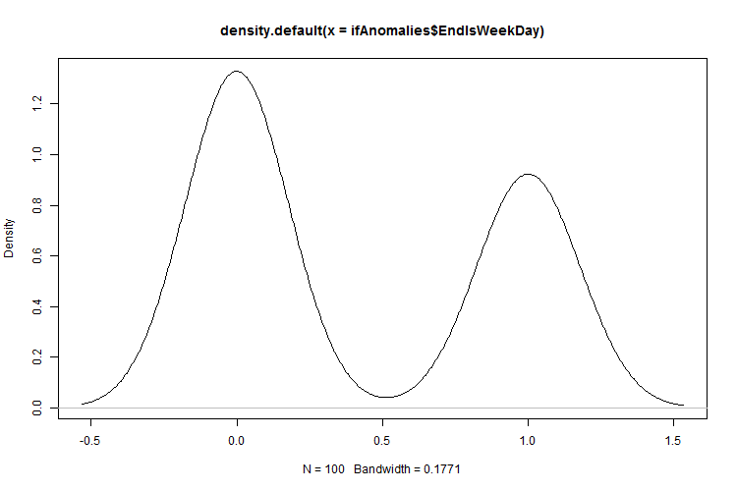  Figure 167: Density plot for the Isolation Forest anomalies trip EndIsWeekDay | 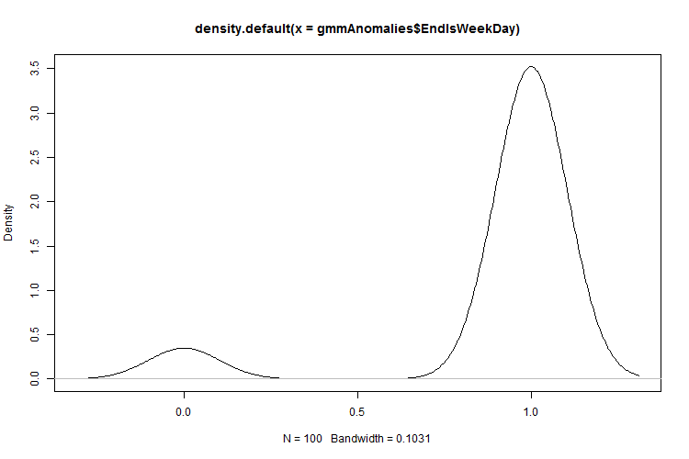  Figure 168: Density plot for the GMM anomalies trip EndIsWeekDay
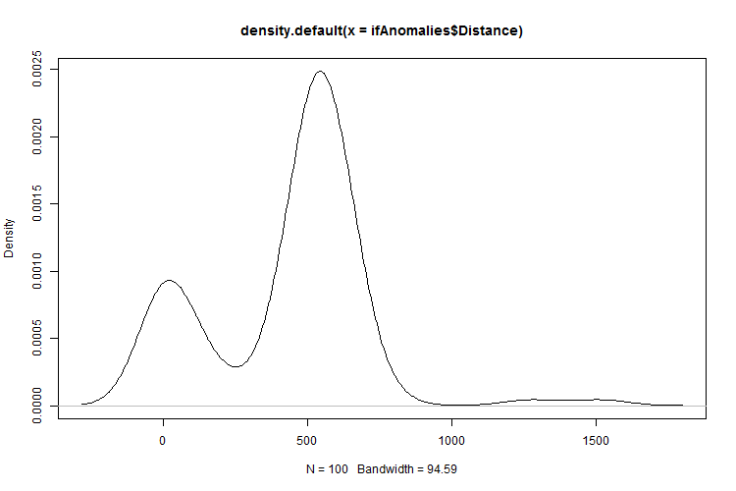  Figure 169: Density plot for the Isolation Forest anomalies trip Distance | 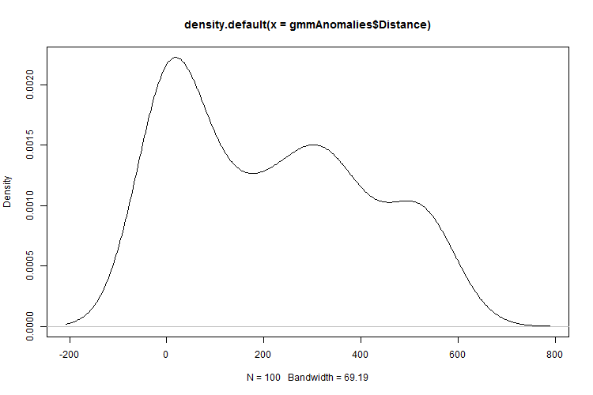  Figure 170: Density plot for the GMM anomalies trip Distance
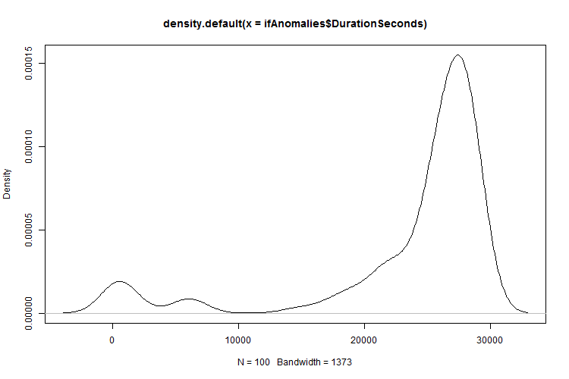  Figure 171: Density plot for the Isolation Forest anomalies DurationSeconds | 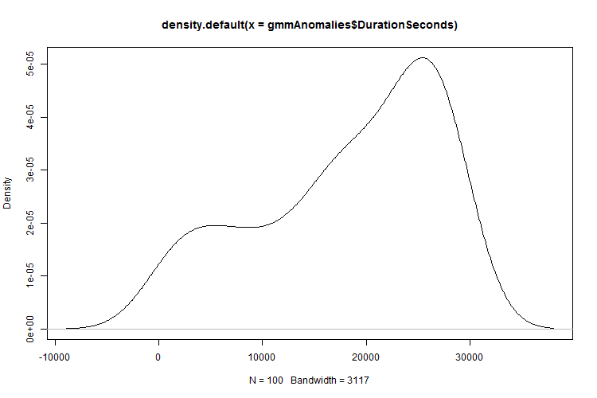  Figure 172: Density plot for the GMM anomalies trip DurationSeconds
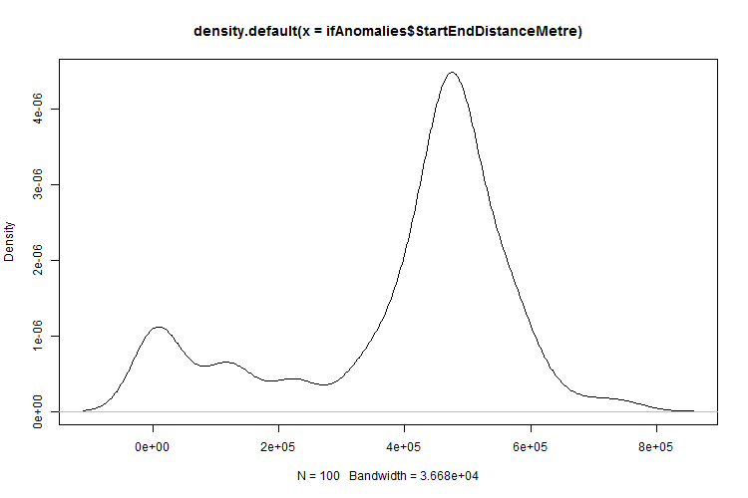  Figure 173: Density plot for the IF anomalies trip StartEndDistanceMetre | 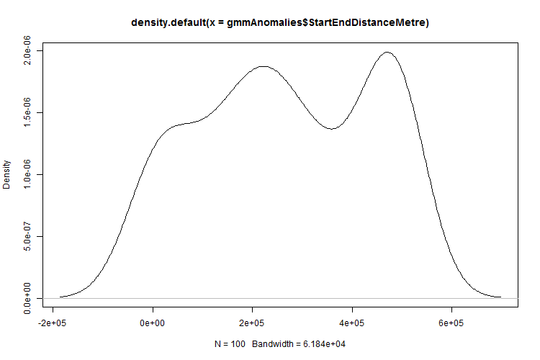  Figure 174: Density plot for the GMM anomalies trip StartEndDistanceMetre

Experiment 4 - Conclusion
An insider thread scenario as well as an interesting anomaly was discovered. This shows that the ITDVMT process model was a valid approach in the search for previously unknown insider threats.
The data analysis of the anomalies indicated that the two anomaly detection algorithms ranked anomalies differently.

Bibliography

Abdelsalam, M., Krishnan, R. & Sandhu, R., 2017. Clustering-Based IaaS Cloud Monitoring. 2017 IEEE 10th International Conference on Cloud Computing (CLOUD), pp. 672-679.
Absolute, 2018. Insider Threat Prevention. [Online]
Available at: https://www.absolute.com/en/solutions/insider-threat
[Accessed 14 04 2018].
Agrafiotis, I., Erola, A., Goldsmith, M. & Creese, S., 2016. A Tripwire Grammar for Insider Threat Detection. Proceedings of the 8th {ACM} {CCS} International Workshop on Managing Insider Security Threats, MIST@CCS 2016, Vienna, Austria, October 28, 2016, pp. 105-108.
Agrafiotis, I. et al., 2016. Validating an Insider Threat Detection System: {A} Real Scenario Perspective. 2016 IEEE Security and Privacy Workshops, SP Workshops 2016, San Jose, CA, USA, May 22-26, 2016, pp. 286-295.
Al tabash, K. & Happa, J., 2018. Insider-threat detection using Gaussian Mixture Models and Sensitivity Profiles. Computers & Security.
Almehmadi, A. & El-Khatib, K., 2017. On the Possibility of Insider Threat Prevention Using Intent-Based Access Control (IBAC). IEEE Systems Journal, 11(2), pp. 373-384.
Altech Netstar (Pty) Ltd, 2015. VIGIL+ DISPATCH. [Online]
Available at: http://www.netstar.altech.co.za/content/vigil-dispatch-1
[Accessed 12 November 2017].
Altech Netstar (Pty) Ltd, 2016. Altech Netstar Fleet Solutions - Our Product Range. [Online]
Available at: http://www.netstar.altech.co.za/sites/netstar/files/Fleet%20product%20brochure_Aug_PROOF.pdf
Altech Netstar (Pty) Ltd, 2017. Safe and Sound Product. [Online]
Available at: http://www.netstar.altech.co.za/product/safe-and-sound
[Accessed 11 11 2017].
Altech Netstar (Pty) Ltd, 2018. [Online]
Available at: http://www.netstar.co.za/
Angelini, M., Catarci, T., Mecella, M. & Santucci, G., 2018. The Visual Side of the Data. In: A Comprehensive Guide Through the Italian Database Research Over the Last 25 Years.. s.l.:Springer, pp. 3-25.
Apache Kafka, 2016. Apache Kafka. [Online]
Available at: http://kafka.apache.org/
[Accessed 05 December 2017].
Azaria, A., Richardson, A., Kraus, S. & Subrahmanian, V. S., 2014. Behavioral Analysis of Insider Threat: A Survey and Bootstrapped Prediction in Imbalanced Data. IEEE Transactions on Computational Social Systems, 1(2), pp. 135-155.
Bao, H., Lu, R., Li, B. & Deng, R., 2016. BLITHE: Behavior Rule-Based Insider Threat Detection for Smart Grid. IEEE Internet of Things Journal, 3(2), pp. 190-205.
BBC, 2005. Timeline: Northern Bank robbery. [Online]
Available at: http://news.bbc.co.uk/2/hi/uk_news/northern_ireland/4117219.stm
[Accessed 2018].
Bechhofer, R. E., 1954. A Single-Sample Multiple Decision Procedure for Ranking Means of Normal Populations with known Variances. Annals of Mathematical Statistics, 25(1), pp. 16-39.
Beebe, N., Liu, L. & Ye, Z., 2017. Insider Threat Detection Using Time-Series-Based Raw Disk Forensic Analysis. Advances in Digital Forensics {XIII} - 13th {IFIP} {WG} 11.9 International Conference, Orlando, FL, USA, January 30 - February 1, 2017, Revised Selected Papers, pp. 149-167.
Bhattacharjee, S. D., Yuan, J., Jiaqi, Z. & Tan, Y. P., 2017. Context-aware graph-based analysis for detecting anomalous activities. 2017 IEEE International Conference on Multimedia and Expo (ICME), pp. 1021-1026.
Bishop, M. et al., 2014. Insider Threat Identification by Process Analysis. s.l.:IEEE.
Blömer, J. & Bujna, K., 2016. Adaptive Seeding for Gaussian Mixture Models. In: Advances in Knowledge Discovery and Data Mining - 20th Pacific-Asia. Auckland: Springer, pp. 296-308.
Bose, B. et al., 2017. Detecting Insider Threats Using RADISH: A System for Real-Time Anomaly Detection in Heterogeneous Data Streams. IEEE Systems Journal, 11(2), pp. 471-482.
Brandman, B., 2001. Inventory Theft: Is Your Company Easy Prey?. [Online]
Available at: http://www.inboundlogistics.com/cms/article/inventory-theft-is-your-company-easy-prey/
[Accessed 27 December 2017].
Buneman, P. & Davidson, S. B., 2010. Data provenance – the foundation of data quality. [Online]
Available at: http://www.sei.cmu.edu/measurement/research/upload/Davidson.pdf
[Accessed 03 March 2017].
Bunn, M. & Sagan, S. D., 2014. A Worst Practices Guide to Insider Threats: Lessons from Past Mistakes. Cambridge: American Academy of Arts and Sciences.
Burges, C. J. C., 1998. A Tutorial on Support Vector Machines for Pattern Recognition. Data Mining and Knowledge Discovery, 2(2), pp. 121-167.
CalAmp, 2018. CalAmp. [Online]
Available at: https://www.calamp.com/
[Accessed 24 September 2018].
Callegati, F., Giallorenzo, S., Melis, A. & Prandini, M., 2016. Data security issues in MaaS-enabling platforms. 2016 IEEE 2nd International Forum on Research and Technologies for Society and Industry Leveraging a better tomorrow (RTSI), pp. 1-5.
Cao, L., 2017. Data science: challenges and directions. Communications of the ACM, 60(8), pp. 59-68.
Carroll, M. D., 2006. Information security: examining and managing the insider threat. Kennesaw, s.n.
Catania, B. & Guerrini, G., 2018. 25+ Years of Query Processing - From a Single, Stored Data Set to Big Data (and Beyond).. In: A Comprehensive Guide Through the Italian Database Research Over the Last 25 Years.. s.l.:s.n., pp. 77-91.
CERT, 2018. CERT Insider Threat Center. [Online]
Available at: https://www.cert.org/insider-threat/cert-insider-threat-center.cfm
[Accessed 31 10 2017].
Chandola, V., Banerjee, A. & Kumar, V., 2009. Anomaly Detection: A Survey. ACM Computing Surveys, July, 41(3), pp. 15:1-15:58.
Chang, J.-R., Chen, Y.-S., Lin, H.-W. & Hu, H.-T., 2017. An advanced computing in fuzzy rule-based preprocessing design of image filters' system for removing impulse noises. The Journal of Supercomputing, 73(7), pp. 3212-3228.
Chen, C. et al., 2011. Real-Time Detection of Anomalous Taxi Trajectories from GPS Traces. Copenhagen, s.n.
Cheng, J., Karambelkar, B. & Xie, Y., 2017. leaflet: Create Interactive Web Maps with the JavaScript 'Leaflet'. [Online]
Available at: https://CRAN.R-project.org/package=leaflet
Chiu, C. Y., Yeh, C. T. & Lee, Y. J., 2013. Frequent Pattern Based User Behavior Anomaly Detection for Cloud System. 2013 Conference on Technologies and Applications of Artificial Intelligence, pp. 61-66.
Chu, W. W. & Opderbeck, H., 1976. Analysis of the PFF Replacement Algorithm via a Semi-Markov Model. Communications of the ACM, 19(5), pp. 298-304.
Contreras, P., Murtagh, F., Hadlington, L. J. & Scott, K., 2015. Clustering Insider Threat Behaviour: An Ultrametric Anomaly Detection System.
Costa, D., 2017. CERT Definition of 'Insider Threat' - Updated. [Online]
Available at: https://insights.sei.cmu.edu/insider-threat/2017/03/cert-definition-of-insider-threat---updated.html
[Accessed 31 March 2017].
Costante, E. et al., 2016. A Hybrid Framework for Data Loss Prevention and Detection. 2016 IEEE Security and Privacy Workshops (SPW), Issue 10.1109/SPW.2016.24, pp. 324-333.
Cussens, J., 1998. Using Prior Probabilities and Density Estimation for Relational Classification. Inductive Logic Programming, 8th International Workshop, ILP-98, Madison, Wisconsin, USA, July 22-24, 1998, Proceedings, pp. 106-115.
Daniel, B. K., 2017. Big Data and data science: A critical review of issues for educational research. British Educational Research Association, Issue November.
Dexler, P., 1999. How to Prevent Drivers From Abusing Vehicles and Privileges. [Online]
Available at: http://www.automotive-fleet.com/channel/operations/article/story/1999/08/how-to-prevent-drivers-from-abusing-vehicles-and-privileges.aspx
[Accessed 28 December 2017].
Ediger, D., McColl, R., Riedy, E. J. & Bader, D. A., 2012. STINGER: High performance data structure for streaming graphs. IEEE Conference on High Performance Extreme Computing, HPEC 2012, Waltham, MA, USA, September 10-12, 2012, pp. 1-5.
Eldardiry, H. et al., 2013. Multi-Domain Information Fusion for Insider Threat Detection. 2013 IEEE Symposium on Security and Privacy Workshops, San Francisco, CA, USA, May 23-24, 2013, pp. 45-51.
Eloff, J. H., 1983. Selection Process for Security Packages. Computers and Security, 2(3), pp. 256-260.
Elsevier, 2018. ScienceDirect. [Online]
Available at: https://www.sciencedirect.com/
[Accessed 09 May 2018].
Endsley, A., 2013. Wicket. [Online]
Available at: http://arthur-e.github.io/Wicket/sandbox-gmaps3.html
[Accessed August 2018].
Fadolalkarim, D., Sallam, A. & Bertino, E., 2016. PANDDE: Provenance-based ANomaly Detection of Data Exfiltration. Proceedings of the Sixth ACM Conference on Data and Application Security and Privacy, pp. 267-276.
Feng, L., Wang, L. & Jin, B., 2010. Research on Maximal Frequent Pattern Outlier Factor for Online High-Dimensional Time-Series Outlier Detection. Journal of Cases on Information Technology, 5(10), pp. 66-71.
Flesca, S., Greco, S., Masciari, E. & Sacca, D., 2018. A Comprehensive Guide Through the Italian Database Research Over the Last 25 Years. Rene: Springer International Publishing.
Ford, N. L., Batchelor, B. G. & Wilkins, B. R., 1970. A learning scheme for the Nearest Neighbour Classifier. Information Science, 2(2), pp. 139-157.
Forrest, C., 2016. How the Mirai botnet almost took down an entire country, and what your business can learn. [Online]
Available at: https://www.techrepublic.com/article/how-the-mirai-botnet-almost-took-down-an-entire-country-and-what-your-business-can-learn/
[Accessed 11 November 2017].
Fraley, C., Raftery, A. E., Murphy, T. B. & Scrucca, L., 2012. mclust Version 4 for R: Normal Mixture Modeling for Model-Based Clustering, Classification, and Density Estimation, Technical Report 597, ashington: Department of Statistics, University of Washington.
Friedland, L., Gentzel, A. & Jensen, D. D., 2014. Classifier-Adjusted Density Estimation for Anomaly Detection and One-Class Classification. Proceedings of the 2014 {SIAM} International Conference on Data Mining, Philadelphia, Pennsylvania, USA, April 24-26, 2014, pp. 578-586.
Gamachchi, A. & Boztas, S., 2017. Insider Threat Detection Through Attributed Graph Clustering. In: 2017 IEEE Trustcom/BigDataSE/ICESS, Sydney, Australia, August 1-4, 2017. Sydney, Australia: IEEE, pp. 112-119.
Gamachchi, A., Sun, L. & Boztas, S., 2017. Graph Based Framework for Malicious Insider Threat Detection. 50th Hawaii International Conference on System Sciences, HICSS 2017, Hilton Waikoloa Village, Hawaii, USA, January 4-7, 2017.
Gama, J. et al., 2014. A Survey on Concept Drift Adaptation. ACM Computing Surveys (CSUR), 46(April 2014), pp. 1-37.
Gasser, M., 1988. Building a Secure Computer System. New York: Van Nostrand Reinhold.
Gates, C. et al., 2014. Detecting Insider Information Theft Using Features from File Access Logs. In: M. Kutylowski & J. Vaidya, eds. Computer Security - ESORICS 2014. s.l.:Springer International Publishing, pp. 383-400.
Gavai, G. et al., 2015. Detecting Insider Threat from Enterprise Social and Online Activity Data. Colorado, s.n.
Gelles, M. G., 2016. Chapter 12 - Workplace Violence and Insider Threat. In: M. G. Gelles, ed. - Prevention, Detection, Mitigation, and Deterrence 2016. Boston: Butterworth-Heinemann, pp. 159-168.
Gelles, M. G., 2016. Chapter 13 – Monitoring and Investigating (Insider Threat). In: M. G. Gelles, ed. Insider Threat - Prevention, Detection, Mitigation, and Deterrence 2016. Boston: Butterworth-Heinemann, p. 169–181.
Gheyas, I. A. & Abdallah, A. E., 2016. Detection and prediction of insider threats to cyber security: a systematic literature review and meta-analysis. Big Data Analytics, 1(1), pp. 1-29.
Goldberg, H. G., Young, W. T., Memory, A. & Senator, T. E., 2016. Explaining and Aggregating Anomalies to Detect Insider Threats. 2016 49th Hawaii International Conference on System Sciences (HICSS), pp. 2739-2748.
Goldberg, H. G. et al., 2017. Insider Threat Detection in PRODIGAL. 50th Hawaii International Conference on System Sciences, HICSS 2017, Hilton Waikoloa Village, Hawaii, USA, January 4-7, 2017.
Goldstein, M., Asanger, S., Reif, M. & Hutchison, A., 2013. Enhancing Security Event Management Systems with Unsupervised Anomaly Detection. ICPRAM 2013 - Proceedings of the 2nd International Conference on Pattern Recognition Applications and Methods, Barcelona, Spain, 15-18 February, 2013., pp. 530-538.
Goldstein, M. & Uchida, S., 2016. A Comparative Evaluation of Unsupervised Anomaly Detection Algorithms for Multivariate Data. PLoS ONE 11(4): e0152173. https://doi.org/10.1371/journal.pone.0152173.
Gollmann, D., 2003. Computer Security. West Sussex, England: John Wiley and Sons.
Google, 2018. Google Scholar. [Online]
Available at: https://scholar.google.co.za
[Accessed 09 May 2018].
Görnitz, N., Kloft, M., Rieck, K. & Brefeld, U., 2014. Toward Supervised Anomaly Detection. Journal of Artificial Intelligence Research, Volume abs/1401.6424.
Greitzer, F. L. & Ferryman, T. A., 2013. Methods and Metrics for Evaluating Analytic Insider Threat Tools. s.l., s.n., pp. 90-97.
Grugq, T., 2017. Real Talk on Reality - Leaking is a High Risk. [Online]
Available at: https://medium.com/@thegrugq/real-talk-on-reality-cf07cbb78530
[Accessed 09 September 2017].
Gunnemann, S., Farber, I., Boden, B. & Seidl, T., 2014. GAMer: a synthesis of subspace clustering and dense subgraph mining. Knowledge and Information Systems, 40(2), pp. 243-278.
Haidar, D. & Gaber, M. M., 2017. Outlier Detection in Random Subspaces over Data Streams: An Approach for Insider Threat Detection. [Online]
Available at: http://www.open-access.bcu.ac.uk/3802/1/dsm_dianahaidar.pdf
[Accessed 05 2017].
Hamamoto, A. H. et al., 2018. Network Anomaly Detection System using Genetic Algorithm and Fuzzy Logic. Expert Systems with Applications, Volume 92, pp. 390-402.
Hassan, A. K. I. & Abraham, A., 2015. Modeling Insurance Fraud Detection Using Imbalanced Data Classification. In: Advances in Nature and Biologically Inspired Computing - Proceedings of the 7th World Congress on Nature and Biologically Inspired Computing (NaBIC 2015) in Pietermaritzburg, South Africa, held December 01-03, 2015. Pietermaritzburg, South Africa: IEEE, pp. 117-127.
Heffernan, M., 2011. Wilful Blindness - Why we ignore the obvious at our peril. London, UK: Simon & Schuster.
Hodge, V. J. & Austin, J., 2004. A Survey of Outlier Detection Methodologies. Artificial Intelligence Review, 22(2), pp. 85-126.
Hoffman, A. J., 1974. A generalization of max flow - min cut. Mathematical Programming, 6(1), pp. 352-359.
Ho, S. M. & Warkentin, M., 2017. Leader's dilemma game: An experimental design for cyber insider threat research. Information Systems Frontiers, 19(2), pp. 377-396.
Howley, K., 2017. The World’s Biggest Terrorist Has a Pikachu Bedspread - Not every leaker is an ideological combatant like Edward Snowden and Chelsea Manning. Reality Winner may be the unlikeliest of all.. [Online]
Available at: http://nymag.com/daily/intelligencer/2017/12/who-is-reality-winner.html
[Accessed 29 December 2017].
Hsieh, C.-H.et al., 2015. AD2: Anomaly detection on active directory log data for insider threat monitoring. In: International Carnahan Conference on Security Technology, ICCST 2015, Taipei, Taiwan, September 21-24, 2015. Taipei: ICCST, pp. 287-292.
Huang, H., Qin, H., Yoo, S. & Yu, D., 2012. Local anomaly descriptor: a robust unsupervised algorithm for anomaly detection based on diffusion space. 21st {ACM} International Conference on Information and Knowledge Management, CIKM'12, Maui, HI, USA, October 29 - November 02, 2012, pp. 405-414.
Iba, H., 2018. Evolutionary Approach to Machine Learning and Deep Neural Networks - Neuro-Evolution and Gene Regulatory Networks. s.l.:Springer.
IEEE, 2018. IEEE Xplore Digital Library. [Online]
Available at: https://ieeexplore.ieee.org/Xplore/home.jsp
[Accessed 09 May 2018].
INFOSEC Research Council (IRC), 2005. Hard Problem List, s.l.: s.n.
Inspector General U.S. Department of Defence, 2016. The National Security Agency Should Take Additional Steps to Effectively Implement Its Privileged Access-Related Secure-the-Net Initiatives, s.l.: U.S. Department of Defence.
Iqbal, S. et al., 2016. On cloud security attacks: A taxonomy and intrusion detection and prevention as a service. Journal of Network and Computer Applications, pp. 98-120.
Jadidi, Z., Muthukkumarasamy, V., Sithirasenan, E. & Singh, K., 2015. Flow-based anomaly detection using semisupervised learning. 9th International Conference on Signal Processing and Communication Systems, {ICSPCS} 2015, Cairns, Australia, December 14-16, 2015, pp. 1-5.
Jahanban, G. A. & Singh, T. S., 2014. Detection of Outlier Schema for Mixed Data using ITB-SP and HilOut Algorithms.
Khan, M. I., Foley, S. N. & O'Sullivan, B., 2017. On Database Intrusion Detection: A Query Analytics-based Model of Normative Behavior to Detect Insider Attacks. In: Proceedings of the 2017 the 7th International Conference on Communication and Network Security. New York, NY, USA: ACM, pp. 12-17.
Kim, J. & Montague, P., 2017. An efficient semi-supervised {SVM} for anomaly detection. 2017 International Joint Conference on Neural Networks, {IJCNN} 2017,, pp. 2843-2850.
Kim, M., Kim, K. & Lee, H., 2018. Development trend of insider anomaly detection system. 2018 20th International Conference on Advanced Communication Technology (ICACT), pp. 373-376.
Klimesova, D. & Saic, S., 1998. Feature selection algorithm and cobweb correlation. Pattern Recognition Letters, 19(8), pp. 681--685.
Ko, L. L., Divakaran, D. M., Liau, Y. S. & Thing, V. L. L., 2017. Insider threat detection and its future directions. International Journal of Security and Networks, 12(3), pp. 168--187.
Kononenko, I., 1991. Semi-Naive Bayesian Classifier. Machine Learning - EWSL-91, European Working Session on Learning, Porto, Portugal, March 6-8, 1991, Proceedings, pp. 206-219.
Kumar, B. S. & Kannan, S., 2015. Removing of Anomalies in High Dimensional Data Multi Clustering Structure. Indian Journal of Science and Technology, 8(32), pp. 1-4.
Lamba, H. et al., 2016. A model-based approach to anomaly detection in software architectures. Proceedings of the Symposium and Bootcamp on the Science of Security, Pittsburgh, PA, USA, April 19-21, 2016, pp. 69-71.
Laxhammar, R., 2008. Anomaly detection for sea surveillance. 11th International Conference on Information Fusion, {FUSION} 2008, Cologne, Germany, June 30 - July 3, 2008, pp. 1-8.
Lazarova-Molnar, S., Logason, H. Þ., Andersen, P. G. & Kjærgaard, M. B., 2016. Mobile Crowdsourcing of Data for Fault Detection and Diagnosis in Smart Buildings. Denmark, s.n.
Legg, P. A., 2015. Visualizing the insider threat: challenges and tools for identifying malicious user activity. 2015 IEEE Symposium on Visualization for Cyber Security, VizSec 2015, Chicago, IL, USA, October 25, 2015, pp. 1-7.
Legg, P. A., 2017. Human-Machine Decision Support Systems for Insider Threat Detection. In: I. Palomares Carrascosa, H. K. Kalutarage & Y. Huang, eds. Data Analytics and Decision Support for Cybersecurity: Trends, Methodologies and Applications. s.l.:Springer International Publishing, pp. 33-53.
Legg, P. A., Buckley, O., Goldsmith, M. & Creese, S., 2015. Caught in the act of an insider attack: detection and assessment of insider threat. IEEE International Symposium on Technologies for Homeland Security, Waltham, USA, 14th-16th April 2015.
Liao, Z., Yu, Y. & Chen, B., 2010. Anomaly detection in GPS data based on visual analytics. Proceedings of the IEEE Conference on Visual Analytics Science and Technology, IEEE VAST 2010, Salt Lake City, Utah, USA, 24-29 October 2010, part of VisWeek 2010, pp. 51-58.
Li, F. et al., 2014. Label matrix normalization for semisupervised learning from imbalanced Data. The New Review of Hypermedia and Multimedia, 20(1), pp. 5-23.
Liu, B., Souza, E. N. d., Hilliard, C. & Matwin, S., 2015. Ship Movement Anomaly Detection using Specialised Distance Measures. Washington DC, s.n.
Liu, F. T., 2009. IsolationForest: Isolation Forest. [Online]
Available at: https://R-Forge.R-project.org/projects/iforest/
[Accessed 2018].
Liu, F. T., Ting, K. M. & Zhou, Z.-H., 2008. Isolation Forest. https://cs.nju.edu.cn/zhouzh/zhouzh.files/publication/icdm08b.pdf.
Lopez, M. A., Lobato, A. G. P., Duarte, O. C. M. B. & Pujolle, G., 2018. An evaluation of a virtual network function for real-time threat detection using stream processing. 2018 Fourth International Conference on Mobile and Secure Services (MobiSecServ), pp. 1-5.
MapCruzin, 2018. MapCruzin. [Online]
Available at: www.mapcruzin.com/free-south-africa-arcgis-maps-shapefiles.htm
[Accessed 12 August 2018].
Marchetti, M., Pierazzi, F., Colajanni, M. & Guido, A., 2016. Analysis of high volumes of network traffic for Advanced Persistent Threat detection. Computer Networks, Volume 109, pp. 127-141.
Margaret, 2016. social engineering. [Online]
Available at: http://searchsecurity.techtarget.com/definition/social-engineering
[Accessed 12 June 2017].
Markov, A. A., 1957. Theory of Algorithms. Journal of Symbolic Logic, 22(1), pp. 77-79.
Matt Bishop, H. M. C. H. P. B. I. S. G. S. A. L. A. C. L. J. O. S. P., 2014. Insider Threat Identification by Process Analysis. s.l.:IEEE.
Medium, 2017. Medium. [Online]
Available at: https://medium.com/
[Accessed 28 November 2017].
Merriam-Webster, 2018. [Online]
Available at: https://www.merriam-webster.com
Meta System, 2004. Meta System - GPS Vehicle Tracking Systems / Telematics / MSYIT. [Online]
Available at: https://www.metasystem.it/index.php/msy_ita_en/content/view/full/4139/
[Accessed 24 September 2018].
Microsoft, 2016. Message Queuing (MSMQ). [Online]
Available at: https://msdn.microsoft.com/en-us/library/ms711472(v=vs.85).aspx
[Accessed 05 December 2017].
Microsoft, 2017. Azure Storage Documentation. [Online]
Available at: https://docs.microsoft.com/en-us/azure/storage/
[Accessed 05 December 2017].
Microsoft, 2017. SQL Server 2017 on Windows and Linux. [Online]
Available at: http://www.microsoft.com/sqlserver
[Accessed 29 July 2018].
Microsoft, 2018. Bing. [Online]
Available at: www.bing.com
Microsoft, 2018. Microsoft Academic. [Online]
Available at: https://academic.microsoft.com/
[Accessed 09 05 2018].
Mike, V., 1967. Contributions to Robust Estimation.
Moriano, P., Pendleton, J., Rich, S. & Camp, L. J., 2017. Insider Threat Event Detection in User-System Interactions. Proceedings of the 2017 International Workshop on Managing Insider Security Threats, Dallas, TX, USA, October 30 - November 03, 2017, pp. 1-12.
Mundie, D. A., Perl, S. J. & Huth, C. L., 2013. Toward an Ontology for Insider Threat Research: Varieties of Insider Threat Definitions. Third Workshop on Socio-Technical Aspects in Security and Trust, STAST 2013, New Orleans, LA, USA, June 29, 2013, pp. 22-36.
Murenin, I. N., Novikova, E. S. & Volkov, A. A., 2017. Uncovering interaction patterns between employees of the organization. 2017 XX IEEE International Conference on Soft Computing and Measurements (SCM), pp. 746-749.
Nasr, P. M. & Yazdian-Varjani, A., 2017. Toward Operator Access Management in SCADA System: Deontological Threats Mitigation. IEEE Transactions on Industrial Informatics, pp. 1-1.
Navarro, P. J., Perez, F., Weiss, J. & Egea-Cortines, M., 2016. Machine Learning and Computer Vision System for Phenotype Data Acquisition and Analysis in Plants. Sensors, 16(5), p. 641.
Ninja, I., 2016. Mirai DDoS BotNet is Back for Renting. [Online]
Available at: http://anonhq.com/mirai-ddos-botnet-is-back-for-renting/
[Accessed 12 November 2017].
Niu, Z., Shi, S., Sun, J. & He, X., 2011. A Survey of Outlier Detection Methodologies and Their Applications. Taiyuan, s.n.
Novikova, E. S., Bekeneva, Y. A., Volkov, A. A. & Shorov, A. V., 2018. Approach for the analysis of the contacts of the critical infrastructure employees. 2018 IEEE Conference of Russian Young Researchers in Electrical and Electronic Engineering (EIConRus), pp. 347-350.
Oliver, J. J. & Hand, D. J., 1994. Averaging Over Decision Stumps. Machine Learning: ECML-94, European Conference on Machine Learning, Catania, Italy, April 6-8, 1994, Proceedings, pp. 231-241.
Olivier, M. S., 2009. Information Technology Research --- A Practical Guide for Computer Science and Informatics. 3rd ed. Pretoria, South Africa: Van Schaik.
Ortega, J. L. & Aguillo, I. F., 2014. Microsoft Academic Search and Google Scholar. Journal of the Association for Information Science and Technology, 65(6), pp. 1149-1156.
Pandey, A. V. et al., 2014. The Persuasive Power of Data Visualization. IEEE transactions on visualization and computer graphics, 20(12), pp. 2211-2220.
Parveen, P. et al., 2013. Evolving Insider Threat Detection Stream Mining Perspective. International Journal on Artificial Intelligence Tools, 22(5).
Pa, Y. M. P. et al., 2015. IoTPOT: Analysing the Rise of IoT Compromises. Washington, DC, USA, USENIX.
Peltz, G. M., 1924. A GRAPHICAL CHART FOR DETERMINING EXCESS AIR IN THE COMBUSTION OF PRODUCER GAS1. Journal of the American Ceramic Society, 7(6), pp. 437-443.
Pineda, F. J., 1987. Generalization of Back propagation to Recurrent and Higher Order Neural Networks. Neural Information Processing Systems, Denver, Colorado, USA, 1987, pp. 602-611.
Pit, D., 2017. Mastermind of massive lottery fraud faces up to 25 years in prison. [Online]
Available at: http://business.financialpost.com/pmn/business-pmn/mastermind-of-lottery-fraud-faces-25-year-prison-sentence
[Accessed 24 August 2017].
Ponomarev, S. & Atkison, T., 2016. Industrial Control System Network Intrusion Detection by Telemetry Analysis. IEEE Transactions on Dependable and Secure Computing, 13(2), pp. 252-260.
Qi, W., Song, Q., Guo, L. & Sun, J., 2017. EDCAR: Enhanced Distributed Coding-Aware Routing for Optical Flying Ad-hoc Networks. Asia Communications and Photonics Conference, p. Su3C.2.
R Foundation for Statistical Computing, 2017. R: A Language and Environment for Statistical Computing. Vienna, Austria: s.n.
Rahm, E. & Do, H. H., 2000. Data Cleaning: Problems and Current Approaches. IEEE data engineering, 23(4), pp. 3-13.
Raman, M. R. G., Kirthivasan, K. & Sriram, V. S. S., 2017. Development of Rough Set – Hypergraph Technique for Key Feature Identification in Intrusion Detection Systems. Computers & Electrical Engineering, Volume 59, pp. 189 - 200.
Rao, V. & Tripathi, S., 2014. Evolving Business Insider Threat and Stream Mining Techniques. International Journal of Ethics in Engineering & Management Education, 1(4), pp. 451-455.
Rashid, H., Arjunan, P., Singh, P. & Singh, A., 2016. Collect, compare, and score: a generic data-driven anomaly detection method for buildings. Proceedings of the Seventh International Conference on Future Energy Systems, Waterloo, ON, Canada, June 21 - 24, 2016 - Poster Sessions, pp. 12:1-12:2.
Rashid, T., Agrafiotis, I. & Nurse, J. R., 2016. A New Take on Detecting Insider Threats: Exploring the Use of Hidden Markov Models. Proceedings of the 8th ACM CCS International Workshop on Managing Insider Security Threats, pp. 47-56.
Redis, 2017. Redis. [Online]
Available at: https://redis.io/
[Accessed 05 December 2017].
Reidy, P., 2013. Combating the Insider Threat at the FBI: Real World Lessons Learned. [Online]
Available at: https://media.blackhat.com/us-13/US-13-Reidy-Combating-the-Insider-Threat-At-The-FBI-Slides.pdf
Riveiro, M. & Falkman, G., 2010. Evaluating the usability of visualizations of normal behavioral models for analytical reasoning. 2010 Seventh International Conference on Computer Graphics, Imaging and Visualization, pp. 179-185.
Rose, I. et al., 2017. Something Is Better Than Everything: {A} Distributed Approach to Audit Log Anomaly Detection. IEEE Cybersecurity Development, SecDev 2017, Cambridge, MA, USA, September 24-26, 2017, pp. 77-82.
Røsok, J. M., 2014. Combining smart energy meters with social media: Increasing energy awareness using data visualization and persuasive technologies. s.l., s.n.
RStudio, 2018. RStudio. [Online]
Available at: https://www.rstudio.com/
[Accessed 12 August 2018].
Sallam, A. & Bertino, E., 2017. Detection of Temporal Insider Threats to Relational Databases. 2017 IEEE 3rd International Conference on Collaboration and Internet Computing (CIC), pp. 406-415.
Sallam, A., Xiao, Q., Bertino, E. & Fadolalkarim, D., 2016. Anomaly Detection Techniques for Database Protection Against Insider Threats (Invited Paper). In: 17th IEEE International Conference on Information Reuse and Integration, IRI 2016, Pittsburgh, PA, USA, July 28-30, 2016. Pittsburgh: IEEE, pp. 20-29.
Sammut, C. & Webb, G. I., 2017. Encyclopedia of Machine Learning and Data Mining. s.l.:Springer.
Sanzgiri, A. & Dasgupta, D., 2016. Classification of Insider Threat Detection Techniques. Oak Ridge, TN, USA, ACM, pp. 25:1--25:4.
Saperstein, B., 1975. Note on a Clustering Problem. Journal of Applied Probability, 12(3), pp. 629-632.
Schiff, L. & Schmid, S., 2016. PRI: Privacy Preserving Inspection of Encrypted Network Traffic. 2016 IEEE Security and Privacy Workshops (SPW), pp. 296-303.
Schlicher, B. G., MacIntyre, L. P. & Abercrombie, R. K., 2016. Towards Reducing the Data Exfiltration Surface for the Insider Threat. 2016 49th Hawaii International Conference on System Sciences (HICSS), pp. 2749-2758.
Schloss Dagstuhl – Leibniz-Zentrum für Informatik, Tier University, 2018. dblp - computer science bibliography. [Online]
Available at: https://dblp.uni-trier.de/
[Accessed 08 05 2018].
Schneier, B., 2018. Schneier on Security.
Securonix, 2018. Insider Threat Management. [Online]
Available at: https://www.securonix.com/solution/insider-threat-detection/
[Accessed 14 04 2018].
Semantic Scholar, 2018. Semantic Scholar. [Online]
Available at: https://www.semanticscholar.org
[Accessed 09 May 2018].
Senator, T. E. et al., 2013. Detecting insider threats in a real corporate database of computer usage activity. Chicago, s.n.
Shu, Q., Tu, Q. & Wang, K., 2011. The Impact of Computer Self-Efficacy and Technology Dependence on Computer-Related Technostress: A Social Cognitive Theory Perspective. International Journal of Human–Computer Interaction, 27(10), pp. 923-939.
Sichani, M. H. & Movaghar, A., 2009. A New Analysis of RC4 - A Data Mining Approach (J48). SECRYPT 2009, Proceedings of the International Conference on Security and Cryptography, Milan, Italy, July 7-10, 2009, SECRYPT is part of ICETE - The International Joint Conference on e-Business and Telecommunications, pp. 213-218.
Siegel, A., 2014. Convergence of physical and cyber security. [Online]
Available at: https://www.helpnetsecurity.com/2014/05/06/convergence-of-physical-and-cyber-security/
[Accessed 13 June 2014].
Siegel, E., 2013. Predictive analytics : the power to predict who will click, buy, lie, or die.
Sinclair, S. & Smith, S. W., 2008. Preventative Directions For Insider Threat Mitigation Via Access Control. In: Insider Attack and Cyber Security - Beyond the Hacker. s.l.:Springer, pp. 165-194.
Singh, A. & Patel, S. S., 2014. Applying Modified K-Nearest Neighbor to Detect Insider Threat in Collaborative Information Systems. International Journal of Innovative Research in Science, Engineering and Technology, 3(6), pp. 14146-14151.
Skiena, S., 2017. The Data Science Design Manual. s.l.:Springer.
Smyth, P., 1993. Probabilistic Anomaly Detection in Dynamic Systems. Advances in Neural Information Processing Systems 6, [7th {NIPS} Conference, Denver, Colorado, USA, 1993], pp. 825-832.
Soh, W., Kim, H. & Yum, B.-J., 2018. Application of kernel principal component analysis to multi-characteristic parameter design problems. Annals Operations Research, 263(1-2), pp. 69-91.
Springer, 2018. Springer LInk. [Online]
Available at: https://link.springer.com/
[Accessed 10 05 2018].
Stepanova, K. & Vavrecka, M., 2018. Estimating number of components in Gaussian mixture model using combination of greedy and merging algorithm. Pattern Anal Applic, 21(1), pp. 181-192.
Subrahmanian, V. S., 2013. ADEN: Anomaly Detection Engine for Networks, s.l.: s.n.
Subrahmanian, V. S., 2015. DARPA ADAMS Project.
Takagi, H. & Lee, M. A., 1993. Neural Networks and Genetic Algorithm Approaches to Auto-Design of Fuzzy Systems. Fuzzy Logic in Artificial Intelligence, 8th Austrian Artificial Intelligence Conference, FLAI '93, Linz, Austria, June 28-30, 1993, Proceedings, pp. 68-79.
TechSmart, 2010. Garmin Live Traffic launched. [Online]
Available at: http://www.techsmart.co.za/features/news/Garmin_Live_Traffic_launched.html
[Accessed 11 November 2017].
Timcenko, V. & Gajin, S., 2017. Ensemble classifiers for supervised anomaly based network intrusion detection. 13th {IEEE} International Conference on Intelligent Computer Communication and Processing, {ICCP} 2017, Cluj-Napoca, Romania, September 7-9, 2017, pp. 13-19.
Ting, K. M., Tan, S. C. & Liu, F. T., 2009. Mass: A New Ranking Measure for Anomaly Detection. [Online]
Available at: http://www.dtic.mil/dtic/tr/fulltext/u2/a512628.pdf
[Accessed 29 07 2017].
Ting, K. M., Zhou, G.-T., Liu, F. T. & Tan, J. S. C., 2010. Mass Estimation and Its Applications. In: Proceedings of the 16th ACM SIGKDD International Conference on Knowledge Discovery and Data Mining. Washington, DC, USA: ACM, pp. 989-998.
Tonyali, S. et al., 2018. Privacy-preserving protocols for secure and reliable data aggregation in IoT-enabled Smart Metering systems. Future Generation Computer Systems, Volume 78, pp. 547-557.
Tuor, A. et al., 2017. Deep Learning for Unsupervised Insider Threat Detection in Structured Cybersecurity Data Streams. CoRR, Volume abs/1710.00811.
U.S. Department of Energy - Office of Inspector General, 2004. Inspection Report: Protective Force Performance Test Improprieties. [Online]
Available at: http://energy.gov/ig/downloads/inspection-report-protective-force-performance-test-improprieties-doeig-0636
[Accessed 29 January 2018].
Udd, R. et al., 2016. Exploiting Bro for Intrusion Detection in a SCADA System. Proceedings of the 2Nd ACM International Workshop on Cyber-Physical System Security, pp. 44-51.
Veeralakshmi, V. & Ramyachitra, D., 2015. Ripple Down Rule learner (RIDOR) Classifier for IRIS Dataset. International Journal of Computer Science Engineering, pp. 79-85.
Wang, H. et al., 2017. Road Traffic Anomaly Detection via Collaborative Path Inference from GPS Snippets. Sensors, 17(3), pp. 550-571.
Wang, X. & Bertrand, G., 1992. Some Sequential Algorithms for a Generalized Distance Transformation Based on Minkowski Operations. IEEE Trans. Pattern Anal. Mach. Intell., 14(11), pp. 1114-1121.
Wang, Z., Wong, S. K. M. & Yao, Y., 1992. An Analysis of Vector Space Models Based on Computational Geometry. Proceedings of the 15th Annual International {ACM} {SIGIR} Conference on Research and Development in Information Retrieval. Copenhagen, Denmark, June 21-24, 1992, pp. 152-160.
Wikipedia, 2017. Computer Security. [Online]
Available at: https://en.wikipedia.org/wiki/Computer_security#cite_note-2
[Accessed 12 June 2017].
Wikipedia, 2017. Usage-based insurance. [Online]
Available at: https://en.wikipedia.org/wiki/Usage-based_insurance
[Accessed 12 November 2017].
William T. Young, A. M. H. G. G. T. E. S., 2014. Detecting Unknown Insider Threat Scenarios. IEEE.
Wood, S. & Marshall-Mies, J. C., 2003. Improving Supervisor and Co-Worker Reporting, Monterey, California: Defense Personnel Security Research.
Xie, C., Gao, J. & Tao, C., 2017. Big Data Validation Case Study. Redwood City, IEEE, pp. 281-286.
Yang, P. et al., 2013. Ensemble-Based Wrapper Methods for Feature Selection and Class Imbalance Learning. In: Advances in Knowledge Discovery and Data Mining: 17th Pacific-Asia Conference, PAKDD 2013, Gold Coast, Australia, April 14-17, 2013, Proceedings, Part I. Pakdd: Springer Berlin Heidelberg, pp. 544-555.
Yao, D. (., Shu, X., Cheng, L. & Stolfo, S. J., 2017. Anomaly Detection as a Service: Challenges, Advances, and Opportunities. Synthesis Lectures on Information Security, Privacy, and Trust, 9(3), pp. 1-173.
Young, W. T. et al., 2013. Use of Domain Knowledge to Detect Insider Threats in Computer Activities. 2013 IEEE Symposium on Security and Privacy Workshops, San Francisco, CA, USA, May 23-24, 2013, pp. 60-67.
Young, W. T., Memory, A., Goldberg, H. G. & Senator, T. E., 2014. Detecting Unknown Insider Threat Scenarios. IEEE.
Yuan, E. & Malek, S., 2016. Mining Software Component Interactions to Detect Security Threats at the Architectural Level. 2016 13th Working IEEE/IFIP Conference on Software Architecture (WICSA), pp. 211-220.
Zanero, S., 2008. ULISSE, a Network Intrusion Detection System. ACM.
Zhang, D. et al., 2011. iBAT: detecting anomalous taxi trajectories from GPS traces. UbiComp 2011: Ubiquitous Computing, 13th International Conference, UbiComp 2011, Beijing, China, September 17-21, 2011, Proceedings, pp. 99-108.
Zhao, X., Wang, G. & Li, Z., 2016. Unsupervised network anomaly detection based on abnormality weights and subspace clustering.. Proceedings of the 2016 sixth international conference on information science and technology (ICIST), p. 482–486.
Zhou, L. et al., 2017. Speed-Based Location Tracking in Usage-Based Automotive Insurance. In: 37th IEEE International Conference on Distributed Computing Systems, ICDCS 2017, Atlanta, GA, USA, June 5-8, 2017. Atlanta: IEEE, pp. 2252-2257.
Zhu, T. et al., 2017. An Insider Threat Detection Method Based on Business Process Mining. International Journal of Business Data Communications and Networking, 13(2), pp. 83-98.

