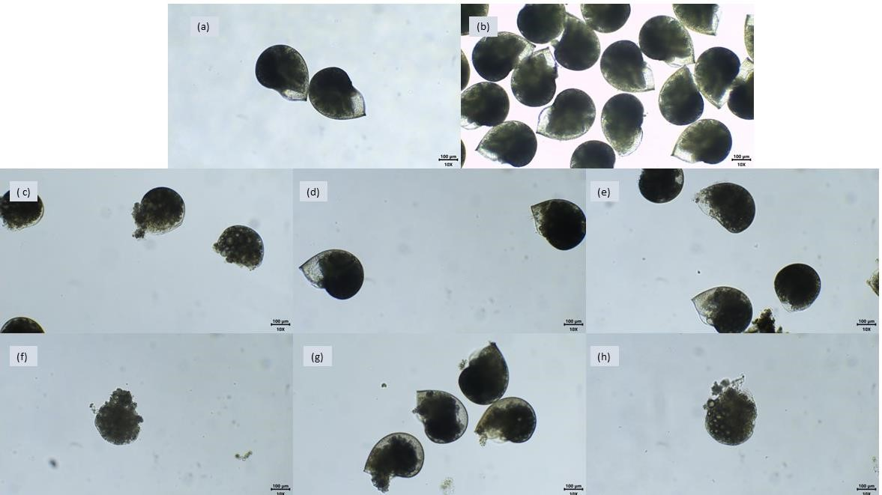
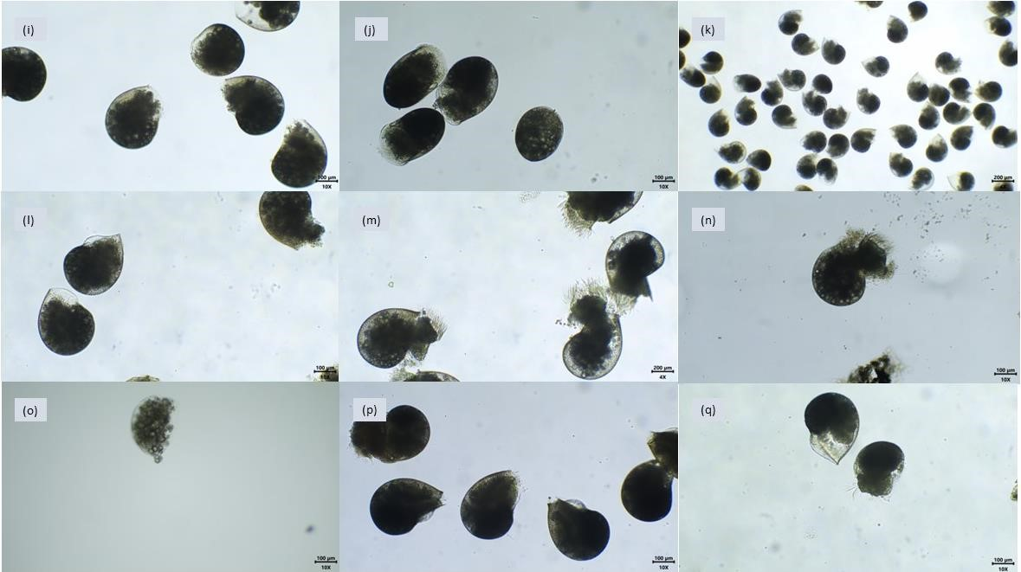
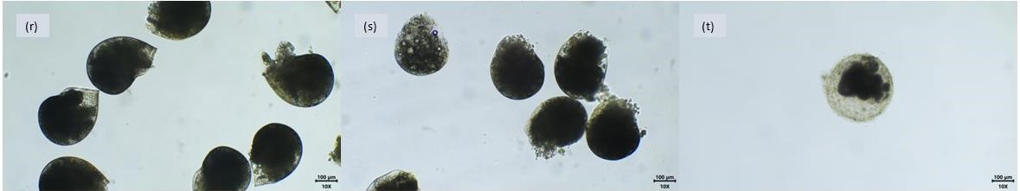
SUPPLEMENTARY DATA

Figure S1: Development of the H. midae embryos and larvae in different concentrations of ECs. a–b represent the control without DMSO and the control with DMSO respectively; c–e represent the embryos and larvae exposed to Acetaminophen at 25, 50, and 100 μg/L respectively; f–h represent the embryos and larvae exposed to Carbamazepine at 25, 50 and 100 μg/L respectively; i–k represent the embryos and larvae exposed to Benzotriazole at 25, 50 and 100 μg/L respectively; l–n represent the embryos and larvae exposed to Atrazine at 25, 50, and 100 μg/L respectively; o-q represent the embryos and larvae exposed to Emtricitabine at 25, 50, and 100 μg/L; r-t represent the embryos and larvae exposed to the mixture at 25, 50, and 100 μg/L. Black lines with numbers represent the plotting scale (100 μm).
Table S1: Maximum reported concentrations of selected emerging contaminants (ECs) the environment from various global locations, including South Africa. Concentrations are expressed in nanograms per litre (ng/L). References are provided for each dataset.
Emerging Contaminant | Location | Concentrations (ng/L) - Max | Reference*
Acetaminophen | Cape Town, SA | 5327.3 | (Newman et al, 2024)
Acetaminophen | Kenya Coastline, Mombasa and Gazi Bay | 84 500 | (Wanjeri et al., 2023)
Atrazine | Camps Bay, SA | 1.9 | (Ojemaye et al., 2022)
Atrazine | Istanbul, Turkey | 41 | (Nödler et al., 2013)
Atrazine | Jiao Zhou Bay, China | 174 | (Ouyang et al., 2019)
Benzotriazole | Baltic Sea (Germany) | 135 | (Nödler et al., 2014)
Benzotriazole | Okinawa Island, Japan | 290 | (Tashiro and Kameda, 2013)
Carbamazepine | Saudi Arabian Coastal waters of the Red Sea | 109.6 | (Ali et al., 2017)
Carbamazepine | Kenya Coastline, Mombasa and Gazi Bay | 2380 | (Wanjeri et al., 2023)
Carbamazepine | Baltic Sea (Germany) | 157 | (Nödler et al., 2014)
Emtricitabine | Germany | 280 | (Funke et al., 2016)
Emtricitabine | Western Cape, South Africa | 352000 | (Mosekiemang et al., 2019)
*
Table S2: Maximum reported global concentrations of selected emerging contaminants (ECs) in marine and estuarine environments, with documented effects on molluscs where available.
Emerging Contaminant | Max Global Concentration (ng/L) | Known Impacts on Molluscs | Reference
Acetaminophen | 84,500 (Kenya Coastline) | Shell abnormalities, reduced growth in bivalves | (Wanjeri et al., 2023)
Atrazine | 174 (Jiao Zhou Bay, China) | Reduced reproduction, growth effects in oysters | (Ouyang et al., 2019)
Benzotriazole | 290 (Okinawa Island, Japan) | Limited direct data; oxidative stress in mussels | (Tashiro & Kameda, 2013)
Carbamazepine | 2,380 (Kenya Coastline) | Altered feeding, oxidative stress in bivalves | (Wanjeri et al., 2023)
Emtricitabine | 280 (Germany) | No direct mollusc data; toxicity in other invertebrates | (Funke et al., 2016)

References:
Ali, A.M., Rønning, H.T., Al Arif, W.M., Kallenborn, R., Kallenborn, R., 2017. Occurrence of pharmaceuticals and personal care products in effluent-dominated Saudi Arabian coastal waters of the Red Sea. Chemosphere 175, 505–513. https://doi.org/10.1016/j.chemosphere.2017.02.095
Funke, J., Prasse, C., Ternes, T.A., 2016. Identification of transformation products of antiviral drugs formed during biological wastewater treatment and their occurrence in the urban water cycle. Water Res 98, 75–83. https://doi.org/10.1016/j.watres.2016.03.045
Mosekiemang, T.T., Stander, M.A., de Villiers, A., 2019. Simultaneous quantification of commonly prescribed antiretroviral drugs and their selected metabolites in aqueous environmental samples by direct injection and solid phase extraction liquid chromatography - tandem mass spectrometry. Chemosphere 220, 983–992. https://doi.org/10.1016/j.chemosphere.2018.12.205
Newman, B.K.; Velayudan, A.; Petrović, M.; Álvarez-Muñoz, D.; Čelić, M.; Oelofse, G.; Colenbrander, D.; le Roux, M.; Ndungu, K.; Madikizela, L.M.; Chimuka, L.; Richards, H. (2024). Occurrence and potential hazard posed by pharmaceutically active compounds in coastal waters in Cape Town, South Africa. Sci. Total Environ. 949, 174800, https://10.1016/j.scitotenv.2024.174800.
Nödler, K., Licha, T., Voutsa, D., 2013. Twenty years later - Atrazine concentrations in selected coastal waters of the Mediterranean and the Baltic Sea. Mar Pollut Bull 70, 112–118. https://doi.org/10.1016/j.marpolbul.2013.02.018
Nödler, K., Voutsa, D., Licha, T., 2014. Polar organic micropollutants in the coastal environment of different marine systems. Mar Pollut Bull 85, 50–59. https://doi.org/10.1016/j.marpolbul.2014.06.024
Ojemaye, C. Y., Pampanin, D. M., Sydnes, M. O., Green, L., & Petrik, L. (2022). The burden of emerging contaminants upon an Atlantic Ocean marine protected reserve adjacent to Camps Bay, Cape Town, South Africa. Heliyon, 8(12), e12625. https://doi.org/10.1016/j.heliyon.2022.e12625
Ouyang, W., Zhang, Y., Gu, X., Tysklind, M., Lin, C., Wang, B., Xin, M., 2019. Occurrence, transportation, and distribution difference of typical herbicides from estuary to bay. Environ Int 130. https://doi.org/10.1016/j.envint.2019.05.052
Tashiro, Y., Kameda, Y., 2013. Concentration of organic sun-blocking agents in seawater of beaches and coral reefs of Okinawa Island, Japan. Mar Pollut Bull 77, 333–340. https://doi.org/10.1016/j.marpolbul.2013.09.013
Wanjeri, V.O.W., Okuku, E., Gachanja, A., Ngila, J.C., Ndungu, P.G., (2023). Occurrence, distribution, and environmental risk of pharmaceutical residues in Mombasa peri-urban creeks, Kenya. Chemosphere, 311, 137144. https://doi.org/10.1016/j.chemosphere.2022.137144

