S1 Fig: Average (cardiologists, oncologists, USA, Germany) percentage of IVD subtype use and average rated importance of IVD subtype use during initial patient workup
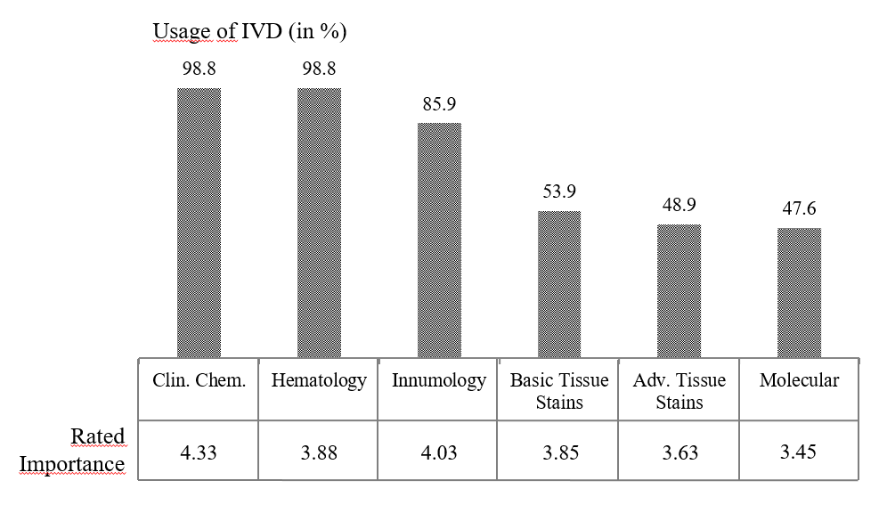
Rated according to Likert scale: 1=very low, 5 very high, Clin.Chem. Clinical chemistry, adv: advanced.

