Supplementary material
Supplementary Table 1. Isolates of D. sapinea used for genome sequencing and analyses.
Isolate | Host | Country of isolation | Illumina accession | Nanopore accession
CMW39103 | Pinus patula | South Africa | SRR32830896 | SRR32830895
CMW190 | Pinus banksiana | South Africa | SRR32830892 | SRR32830891
CMW45410 | Pinus nigra | Sweden | SRR32830890 | SRR32830889
CBS109727 | Pinus radiata | South Africa | SRR32830888 | N/A
CBS119938 | Pinus radiata | Italy | SRR32830887 | N/A
CBS120833 | Prunus persica | South Africa | SRR32830886 | N/A
CBS623.74 | Pinus radiata | Chile | SRR32830885 | N/A
1684n^{e}6-1 | Pinus pinaster | France | SRR32830894 | N/A
Pier4 | Pinus nigra | France | SRR32830893 | N/A

Supplementary Table 2. Species of Botryosphaeriaceae used in protein clustering and phylogenomic analysis.
Genus | Species | Isolate | Genome accession | Original source | References
Botryosphaeria | dothidea | CMW8000 | N/A | (Marsberg, et al. 2017) | (Nagel, et al. 2021)
 | dothidea | sdau11-99 | WWBZ00000000 | (Yu, et al. 2021) | (Yu, et al. 2021)
 | kuwatsukai | LW030101 | MDSR00000000 | (Liu, et al. 2016) | (Nagel, et al. 2021)
Diplodia | corticola | CBS112549 | MNUE01000001 | (Fernandes, et al. 2014) | (Fernandes, et al. 2014)
 | scrobiculata | CMW30223 | LAEG00000000 | (Wingfield, et al. 2015) | (Nagel, et al. 2021)
 | seriata | F98.1 | MSZU00000000 | (Robert-Siegwald, et al. 2017) | (Nagel, et al. 2021)
 | seriata | DS831 | LAQI00000000 | (Morales-Cruz, et al. 2015) | (Nagel, et al. 2021)
Eutiarosporella | darliae | 2G6 | GFXH01000000 | (Thynne, et al. 2019) | (Nagel, et al. 2021)
 | pseudodarliae | V4B6 | GFXI01000000 | (Thynne, et al. 2019) | (Nagel, et al. 2021)
 | tritici-australis | 153 | GFXG01000000 | (Thynne, et al. 2019) | (Nagel, et al. 2021)
Lasiodiplodia | gonubiensis | CBS115812 | RHKH00000000 | (Nagel, et al. 2021) | (Nagel, et al. 2021)
 | pseudotheobromae | CBS116459 | RHKG00000000 | (Nagel, et al. 2021) | (Nagel, et al. 2021)
 | theobromae | CBS164.96 | RHKF00000000 | (Nagel, et al. 2021) | (Nagel, et al. 2021)
 | theobromae | AM2As | QCYV00000000 | (Ali, et al. 2020) | (Ali, et al. 2020)
 | theobromae | CSS-01s | MDYX00000000 | (Yan, et al. 2018) | (Yan, et al. 2018)
 | theobromae | LA-SOL3 | VCHE00000000 | (Félix, et al. 2019) | (Félix, et al. 2019)
Macrophomina | phaseolina | MS6 | AHHD00000000 | (Islam, et al. 2012) | (Nagel, et al. 2021)
Neofusicoccum | cordaticola | CBS123634 | RHKC00000000 | (Nagel, et al. 2021) | (Nagel, et al. 2021)
 | cordaticola | CBS123638 | RHKD00000000 | (Nagel, et al. 2021) | (Nagel, et al. 2021)
 | kwambonambiense | CBS123639 | RHKE00000000 | (Nagel, et al. 2021) | (Nagel, et al. 2021)
 | kwambonambiense | CBS123642 | RKSS00000000 | (Nagel, et al. 2021) | (Nagel, et al. 2021)
 | parvum | CBS123649 | RHJY00000000 | (Nagel, et al. 2021) | (Nagel, et al. 2021)
 | parvum | CMW9080 | RHJX00000000 | (Nagel, et al. 2021) | (Nagel, et al. 2021)
 | parvum | UCRNP2 | AORE00000000 | (Blanco-Ulate, et al. 2013) | (Nagel, et al. 2021)
 | ribis | CBS121.26 | RHKA00000000 | (Nagel, et al. 2021) | (Nagel, et al. 2021)
 | ribis | CBS115475 | RHJZ00000000 | (Nagel, et al. 2021) | (Nagel, et al. 2021)
 | umdonicola | CBS123644 | RHKB00000000 | (Nagel, et al. 2021) | (Nagel, et al. 2021)

Supplementary Table 3. Primer design for detection of ACs in D. sapinea.
Chr | Primer name | Primer seq (5’→3’) | Tm (℃) | Amplicon (bp) | Targeted gene | Targeted gene function
Control | DSBt_F | CTGCCTTCTGGTTTGTTGCC | 60.0 | 804 | g10611.t1 | Beta-tubulin
 | DSBt_R | TGCAGATGTCGTACAGAGCC | 59.8
Chr 15 | Ch15_1F | GGCATCCAGGGACTTCGATT | 59.8 | 210 | g7929.t1 | Hypothetical protein
 | Ch15_1R | AGGGAGAGAGAGCTGTTGGT | 59.9
 | Ch15_2F | CAATACCCCTCCGTTGTCGT | 59.8 | 415 | g7939.t1 | PKS
 | Ch15_2R | CGTGCGAGATGGTAGAGGAC | 60.0
 | Ch15_3F | CGGTTTCGGTCTCCTGGAAA | 60.0 | 640 | g7955.t1 | Toxin synthesis
 | Ch15_3R | GATGATCTCGTCCCGGTAGG | 59.1
Chr 16 | Ch16_1F | CCTCCGTTAGCCTTTGTCGT | 60.0 | 186 | CMW45410_12287-RA | C6 finger domain protein
 | Ch16_1R | CCACACACCCGACACTTGTA | 59.9
 | Ch16_2F | TGCTAGCCCACCTGGATTTG | 60.0 | 419 | CMW45410_g2720.t1 | Hypothetical protein
 | Ch16_2R | GACGGCGTAGAGTTCCTAGC | 60.0
 | Ch16_3F | GGCGGATATGAATGTCGGGT | 60.0 | 626 | CMW45410_12231-RA | NACHT and WD40 domain
 | Ch16_3R | CATCGAGAAGCTTGCGTTCG | 60.0

Supplementary Table 4. Results of PCR assays to identify dispensable chromosomes in D. sapinea isolates from various countries around the world.
Isolate (CMW) | Chr 15 | Chr 16 | Country
39103 | - | - | South Africa
190 | + | - | South Africa
45410 | + | + | Sweden
29644 | + | - | Ethiopia
4237 | + | - | South Africa
29133 | + | - | South Africa
29309 | + | - | South Africa
29311 | + | - | South Africa
31572 | + | - | South Africa
31649 | + | - | South Africa
31655 | + | - | South Africa
32008 | + | - | South Africa
34302 | + | - | South Africa
24705 | + | - | China
24707 | + | - | China
24708 | + | - | China
4889 | - | - | Indonesia
32287 | - | - | Indonesia
32361 | - | - | Indonesia
34220 | - | - | Indonesia
8750 | + | - | Great Britain
33544 | + | - | Great Britain
39331 | + | - | Montenegro*
39333 | + | - | Montenegro
39337 | + | - | Montenegro
39341 | + | - | Montenegro
8749 | + | - | Netherlands
33543 | + | - | Netherlands
39329 | + | - | Serbia
39338 | + | - | Serbia
39342 | + | - | Serbia
32277 | + | - | Switzerland*
8754 | + | - | USA
31975 | + | - | Brazil
14971 | + | - | Chile
14974 | + | - | Chile
5850 | + | - | Colombia
32112 | + | - | Colombia
32425 | + | - | New Zealand
32431 | + | - | New Zealand

Supplementary Table 5. Summary of D. sapinea isolates used in pathogenicity trials.
Isolate (CMW) | Origin | Host | DCs
39103 | South Africa | P. patula | -
4889 | Indonesia | P. patula | -
34220 | Indonesia | P. patula | -
29644 | Ethiopia | P. patula | Chr 15
8754 | USA | Pseudotsuga menziessi | Chr 15
45410 | Sweden | P. nigra | Chr 15, Chr 16

Supplementary Table 6. Statistics of genome assemblies produced by Canu and Flye for each D. sapinea isolate.
Isolate | Assembler | Contigs | Size (Mb) | N50 | L50 | Mis-joins | Splits
CMW39103 | Canu | 14 | 36.88 | 2859033 | 6 | 0 | 0
 | Flye | 13 | 36.7 | 2852626 | 6 | 1 | 0
CMW190 | Canu | 16 | 37.98 | 2831583 | 6 | 0 | 1
 | Flye | 13 | 37.27 | 3188804 | 5 | 2 | 0
CMW45410 | Canu | 18 | 38.07 | 2676158 | 7 | 0 | 2
 | Flye | 15 | 37.93 | 2861173 | 5 | 1 | 0

Supplementary Table 7. Homologous genes within and between the accessory chromosomes
Orthogroup | Gene ID | Functions | Gene coordinates
OG0000046 | CMW45410_12209-RA | Hypothetical protein | C16: 315435–317112
OG0000046 | CMW45410_g2750.t1 | Phosphatidylserine decarboxylase | C16: 454129–455696
OG0000046 | CMW45410_g7366.t1 | Hypothetical protein | C15: 67836–69319
OG0000109 | CMW45410_g2702.t1 | Uracil phosphoribosyltransferase | C16 :94575–95528
OG0000109 | CMW45410_g2703.t1 | Uracil phosphoribosyltransferase | C16: 95772–96557
OG0000109 | CMW45410_g7406.t1 | Uracil phosphoribosyltransferase | C15: 372465–374576
OG0000244 | CMW45410_g2740.t1 | TPR-like protein | C16: 376859–379465
OG0000244 | CMW45410_g2742.t1 | Kinesin light chain | C16: 383637–387395
OG0001324 | CMW45410_g2714.t1 | p-loop containing nucleoside triphosphate hydrolase | C16: 168319–177832
OG0001324 | CMW45410_g2744.t1 | p-loop containing nucleoside triphosphate hydrolase | C16: 394379–401270
OG0007116 | CMW45410_g2730.t2 | Pisatin demethylase | C16: 278952–280650
OG0007116 | CMW45410_g2754.t2 | Pisatin demethylase | C16: 473573–475271
OG0008997 | CMW45410_12211-RA | Intracellular protein transport protein | C16: 322762–324416
OG0008997 | CMW45410_g2721.t1 | Hypothetical protein | C16: 221616–222379
OG0012891 | CMW45410_12275-RA | P-loop containing nucleoside triphosphate hydrolase protein | C16: 563756–565406
OG0012891 | CMW45410_g2766.t1 | MMR-HSR1 multi-domain protein | C16: 566501–567674
OG0013704 | CMW45410_g2719.t1 | FabD/lysophospholipase-like protein | C16: 214039–217469
OG0013704 | CMW45410_g2761.t1 | FabD/lysophospholipase-like protein | C16: 522608–525852
OG0013704 | CMW45410_12323-RA | FabD/lysophospholipase-like protein | C15: 117129–118392
OG0013710 | CMW45410_12130-RA | Hypothetical protein | C16: 11300–12803
OG0013710 | CMW45410_12193-RA | Hypothetical protein | C16: 254769–255704
OG0013710 | CMW45410_12258-RA | Hypothetical protein | C16: 500049–501552
OG0013710 | CMW45410_12329-RA | Hypothetical protein | C15: 131632–132168
OG0014162 | CMW45410_12215-RA | Transcription factor jumonji/aspartyl beta-hydroxylase | C16: 330645–333686
OG0014162 | CMW45410_12241-RA | Transcription factor jumonji/aspartyl beta-hydroxylase | C16: 443975–446881
OG0014162 | CMW45410_12305-RA | Transcription factor jumonji/aspartyl beta-hydroxylase | C15: 59333–63116
OG0014167 | CMW45410_g2691.t1 | DUF221-domain-containing protein | C16: 1185–4726
OG0014167 | CMW45410_g2716.t1 | DUF221-domain-containing protein | C16: 199774–202146
OG0014167 | CMW45410_g2717.t1 | Hypothetical protein | C16: 202303–203157
OG0014167 | CMW45410_g2759.t1 | DUF221-domain-containing protein | C16: 508290–511664
OG0014167 | CMW45410_12319-RA | Phosphate metabolism protein | C15: 95453–97867
OG0014168 | CMW45410_g2718.t1 | G-protein coupled receptor | C16: 206172–207859
OG0014168 | CMW45410_g2726.t1 | G-protein coupled receptor | C16: 250343–251956
OG0014168 | CMW45410_g2760.t1 | G-protein coupled receptor | C16: 514744–516431
OG0014169 | CMW45410_12190-RA | Zinc finger CCHC-type protein | C16: 241789–242812
OG0014169 | CMW45410_g2725.t1 | Zinc finger CCHC-type protein | C16: 240811–241647
OG0014169 | CMW45410_g2746.t1 | Zinc finger CCHC-type protein | C16: 423511–425019
OG0014169 | CMW45410_g2769.t1 | Zinc finger CCHC-type protein | C16: 601214–602734
OG0014834 | CMW45410_12205-RA | Hypothetical protein | C16: 303765–305447
OG0014834 | CMW45410_12206-RA | Putative aspartic-type endopeptidase | C16: 306016–307641
OG0014834 | CMW45410_12330-RA | Serine/threonine-protein kinase PKH1 | C15: 133670–135262
OG0014978 | CMW45410_g2692.t1 | Hypothetical protein | C16: 12943–13647
OG0014978 | CMW45410_g2727.t1 | Hypothetical protein | C16: 256362–257069
OG0014978 | CMW45410_g2758.t1 | Hypothetical protein | C16: 499205–499909
OG0014979 | CMW45410_g2693.t1 | Hypothetical protein | C16: 28062–29127
OG0014979 | CMW45410_g2729.t1 | Hypothetical protein | C16: 272906–273821
OG0014979 | CMW45410_g2757.t1 | Hypothetical protein | C16: 483037–483932
OG0014980 | CMW45410_g2731.t1 | Hypothetical protein | C16: 281650–282736
OG0014980 | CMW45410_g2755.t1 | Hypothetical protein | C16: 476271–477432
OG0014981 | CMW45410_12137-RA | Transmembrane protein | C16: 41900–42374
OG0014981 | CMW45410_12281-RA | Transmembrane protein | C16: 590071–590545
OG0014982 | CMW45410_12132-RA | Hypothetical protein | C16: 18990–19976
OG0014982 | CMW45410_12195-RA | F-box domain-containing protein | C16: 262746–263876
OG0014982 | CMW45410_12256-RA | Hypothetical protein | C16: 492018–493004
OG0016363 | CMW45410_g2695.t1 | Hypothetical protein | C16: 46523–46834
OG0016363 | CMW45410_g2753.t1 | Hypothetical protein | C16: 469715–470569
OG0016363 | CMW45410_g2768.t1 | Hypothetical protein | C16: 594450–595004
OG0016364 | CMW45410_g2722.t1 | N/A | C16: 232339–233148
OG0016364 | CMW45410_g2762.t1 | N/A | C16: 528326–529234
OG0016365 | CMW45410_g2738.t1 | Rhodopsin kinase | C16: 362628–365091
OG0016365 | CMW45410_g2765.t1 | Rhodopsin kinase | C16: 554467–556930
OG0016367 | CMW45410_12133-RA | Hypothetical protein | C16: 21051–21999
OG0016367 | CMW45410_12255-RA | Hypothetical protein | C16: 490090–490944
OG0016368 | CMW45410_12141-RA | Hypothetical protein | C16: 53766–56390
OG0016368 | CMW45410_12207-RA | Hypothetical protein | C16: 311894–313462
OG0016368 | CMW45410_12208-RA | Hypothetical protein | C16: 313755–314756
OG0016369 | CMW45410_12134-RA | Hypothetical protein | C16: 25729–26427
OG0016369 | CMW45410_12197-RA | Hypothetical protein | C16: 270021–271837
OG0016369 | CMW45410_12254-RA | Hypothetical protein | C16: 485567–486361
OG0016371 | CMW45410_12185-RA | Ferric reductase | C16: 228420–230259
OG0016371 | CMW45410_12188-RA | Putative cell surface metalloreductase | C16: 235049–236748
OG0016371 | CMW45410_12268-RA | Ferric reductase | C16: 531178–533015
OG0017888 | CMW45410_12129-RA | Proteophosphoglycan | C16: 9987–10744
OG0017888 | CMW45410_12259-RA | Proteophosphoglycan | C16: 502108–502865
OG0017889 | CMW45410_12128-RA | Hypothetical protein | C16: 5765–7402
OG0017889 | CMW45410_12260-RA | Hypothetical protein | C16: 505448–507084
OG0017891 | CMW45410_12146-RA | Hypothetical protein | C16: 66569–67644
OG0017891 | CMW45410_12278-RA | Hypothetical protein | C16: 578974–580049
OG0017892 | CMW45410_12145-RA | Start control protein | C16: 63841–64439
OG0017892 | CMW45410_12279-RA | Start control protein | C16: 582177–582775
OG0000215 | CMW45410_g2701.t1 | GTP cyclohydrolase I | C16: 92482–93352
OG0000215 | CMW45410_g7405.t1 | GTP cyclohydrolase I | C15: 370359–371229
OG0000243 | CMW45410_g2706.t1 | NFX1-type zinc finger-containing protein 1 | C16: 133492 139435
OG0000243 | CMW45410_g7410.t1 | NFX1-type zinc finger-containing protein 1 | C15: 404797–410735
OG0010181 | CMW45410_12161-RA | Hypothetical protein | C16: 123447–125303
OG0010181 | CMW45410_g7409.t1 | Hypothetical protein | C15: 395743–396060
OG0011053 | CMW45410_g2700.t1 | Phosphoribosyl transferase domain protein | C16: 87980–91444
OG0011053 | CMW45410_g7404.t1 | Phosphoribosyl transferase domain protein | C15: 365853–369317
OG0012849 | CMW45410_g2748.t1 | Hypothetical protein | C16: 433120–434727
OG0012849 | CMW45410_g7364.t1 | Hypothetical protein | C15: 48790–49929
OG0012895 | CMW45410_12238-RA | Hypothetical protein | C16: 435115–436415
OG0012895 | CMW45410_12302-RA | Hypothetical protein | C15: 50305–50964
OG0014161 | CMW45410_g2751.t1 | Proline-rich receptor-like protein kinase perk4-like | C16: 456861–458762
OG0014161 | CMW45410_g7367.t1 | Ring-infected erythrocyte surface antigen-like | C15: 71062–72243
OG0014968 | CMW45410_g2694.t1 | Putative serine threonine protein kinase | C16: 35405–37855
OG0014968 | CMW45410_g7396.t1 | Serine threonine protein kinase | C15: 288856–291087
OG0016340 | CMW45410_12154-RA | Ribonuclease III | C16: 98211–100232
OG0016340 | CMW45410_12381-RA | Ribonuclease III | C15: 376050–377996
OG0016345 | CMW45410_g2749.t1 | Hypothetical protein | C16: 450269–450889
OG0016345 | CMW45410_g7365.t1 | Hypothetical protein | C15: 66495–67115
OG0016347 | CMW45410_12156-RA | Ubiquinol-cytochrome-c reductase cytochrome c1 | C16: 111204–111733
OG0016347 | CMW45410_12383-RA | Ubiquinol-cytochrome-c reductase cytochrome c1 | C15: 385869–386276
OG0016348 | CMW45410_12248-RA | Hypothetical protein | C16: 461733–463723
OG0016348 | CMW45410_12311-RA | Hypothetical protein | C15: 74938–76930
OG0008436 | CMW45410_g7358.t1 | UPF0394 membrane protein | C15: 23570–23914
OG0008436 | CMW45410_g7359.t1 | UPF0394 membrane protein | C15: 23932–24593
OG:0008659 | CMW45410_g7356.t1 | Fungal-specific transcription factor domain-containing protein | C15: 20930–21642
OG:0008659 | CMW45410_g7357.t1 | Fungal specific transcription factor | C15: 21723–23417

Supplementary Table 8. Summary of all isolates used in the current study and whether the DCs are present or absent.
Isolate | Chr 15 | Chr 16 | Evidence | Country | Source
CMW39103 | - | - | Whole genome alignment | South Africa | Current study
CMW190 | + | - | Whole genome alignment | South Africa | Current study
CMW45410 | + | + | Whole genome alignment | Sweden | Current study
CMW29644 | + | - | PCR assay | Ethiopia | Current study
CMW4237 | + | - | PCR assay | South Africa | Current study
CMW29133 | + | - | PCR assay | South Africa | Current study
CMW29309 | + | - | PCR assay | South Africa | Current study
CMW29311 | + | - | PCR assay | South Africa | Current study
CMW31572 | + | - | PCR assay | South Africa | Current study
CMW31649 | + | - | PCR assay | South Africa | Current study
CMW31655 | + | - | PCR assay | South Africa | Current study
CMW32008 | + | - | PCR assay | South Africa | Current study
CMW34302 | + | - | PCR assay | South Africa | Current study
CBS109727 | + | - | Illumina resequencing | South Africa | Current study
CBS120833 | + | - | Illumina resequencing | South Africa | Current study
ZXD319 | - | - | Whole genome alignment | China | (Wang et al. 2025)
KE8364 | + | - | Whole genome alignment | China | (Yu, et al. 2022)
KE8391 | + | - | Whole genome alignment | China | (Yu, et al. 2022)
KE8634 | + | - | Whole genome alignment | China | (Yu, et al. 2022)
CMW24705 | + | - | PCR assay | China | Current study
CMW24707 | + | - | PCR assay | China | Current study
CMW24708 | + | - | PCR assay | China | Current study
CMW4889 | - | - | PCR assay | Indonesia | Current study
CMW32287 | - | - | PCR assay | Indonesia | Current study
CMW32361 | - | - | PCR assay | Indonesia | Current study
CMW34220 | - | - | PCR assay | Indonesia | Current study
162220 | - | - | Whole genome alignment | Singapore | GCA_964300245.1
162225 | - | - | Whole genome alignment | Singapore | GCA_964300275.1
142926 | + | - | Whole genome alignment | Estonia | GCA_964300335.1
1684n^{e}6-1 | + | - | Illumina resequencing | France | Current study
Pier4 | + | - | Illumina resequencing | France | Current study
CMW8750 | + | - | PCR assay | Great Britain | Current study
CMW33544 | + | - | PCR assay | Great Britain | Current study
CBS119938 | + | - | Illumina resequencing | Italy | Current study
CMW39331 | + | - | PCR assay | Montenegro | Current study
CMW39333 | + | - | PCR assay | Montenegro | Current study
CMW39337 | + | - | PCR assay | Montenegro | Current study
CMW39341 | + | - | PCR assay | Montenegro | Current study
CMW8749 | + | - | PCR assay | Netherlands | Current study
CMW33543 | + | - | PCR assay | Netherlands | Current study
150338 | + | - | Whole genome alignment | Russia | GCA_964300325.1
150346 | + | - | Whole genome alignment | Russia | GCA_964300295.1
163419 | + | - | Whole genome alignment | Russia | GCA_964300345.1
163102 | + | - | Whole genome alignment | Russia | GCA_964300265.1
CMW39329 | + | - | PCR assay | Serbia | Current study
CMW39338 | + | - | PCR assay | Serbia | Current study
CMW39342 | + | - | PCR assay | Serbia | Current study
CMW32277 | + | - | PCR assay | Switzerland | Current study
158147 | + | - | Whole genome alignment | Canada | GCA_964300305.1
157895 | + | - | Whole genome alignment | Canada | GCA_964300285.1
CMW8754 | + | - | PCR assay | USA | Current study
CMW31975 | + | - | PCR assay | Brazil | Current study
164087 | + | - | Whole genome alignment | Brazil | GCA_964300255.1
164117 | + | - | Whole genome alignment | Brazil | GCA_964300315.1
CBS623.74 | + | - | Illumina resequencing | Chile | Current study
CMW14971 | + | - | PCR assay | Chile | Current study
CMW14974 | + | - | PCR assay | Chile | Current study
CMW5850 | + | - | PCR assay | Colombia | Current study
CMW32112 | + | - | PCR assay | Colombia | Current study
CMW32425 | + | - | PCR assay | New Zealand | Current study
CMW32431 | + | - | PCR assay | New Zealand | Current study

Supplementary Table 9. Lesion lengths measured from pathogenicity trial.
Isolate | ACs | Lesion lengths (mm) | Average lesion length (mm)
CMW39103 | None | 53  66  68  71  72  74  77 | 68.71
CMW4889 | None | 7  13  57  65  78  88  97 | 57.86
CMW34220 | None | 32  49  63  71  76  88  91 | 67.14
CMW8754 | Chr 15 | 42  43  45  48  62  79  92 | 58.71
CMW29644 | Chr 15 | 7  8  11  12  24  28  43 | 19
CMW45410 | Chr 15, Chr 16 | 14  43  49  52  87  91  98 | 62

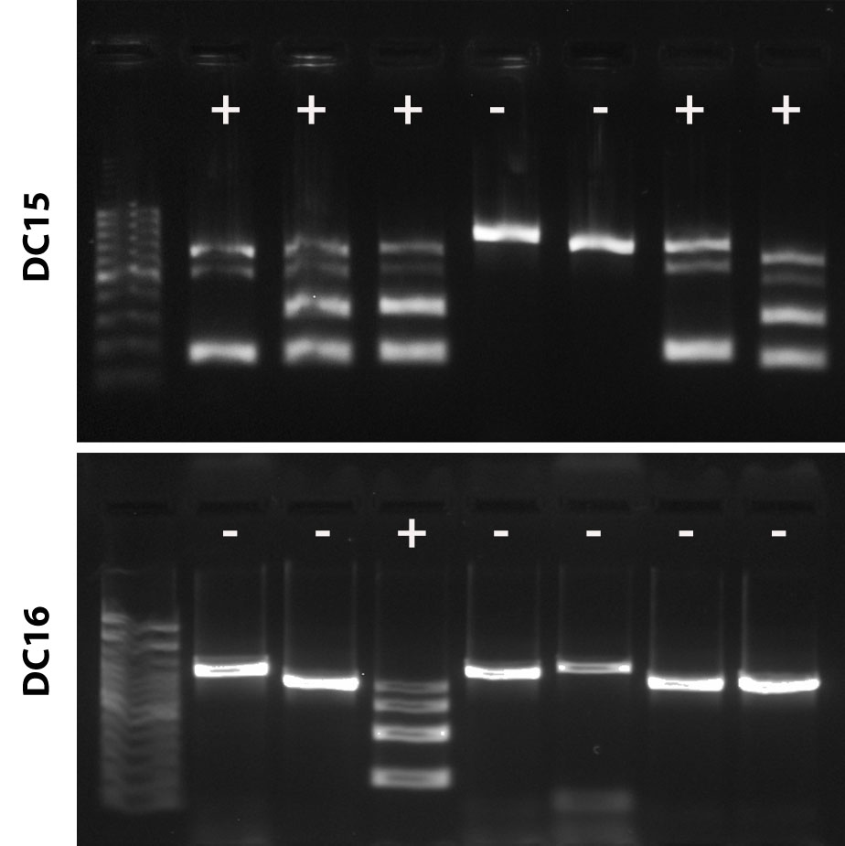
Supplementary Figure 1. Gel electrophoresis image showing multiplex PCR assays for the detection of each AC. A single amplicon shows samples without the AC, and multiple amplicons indicate the presence of the AC.
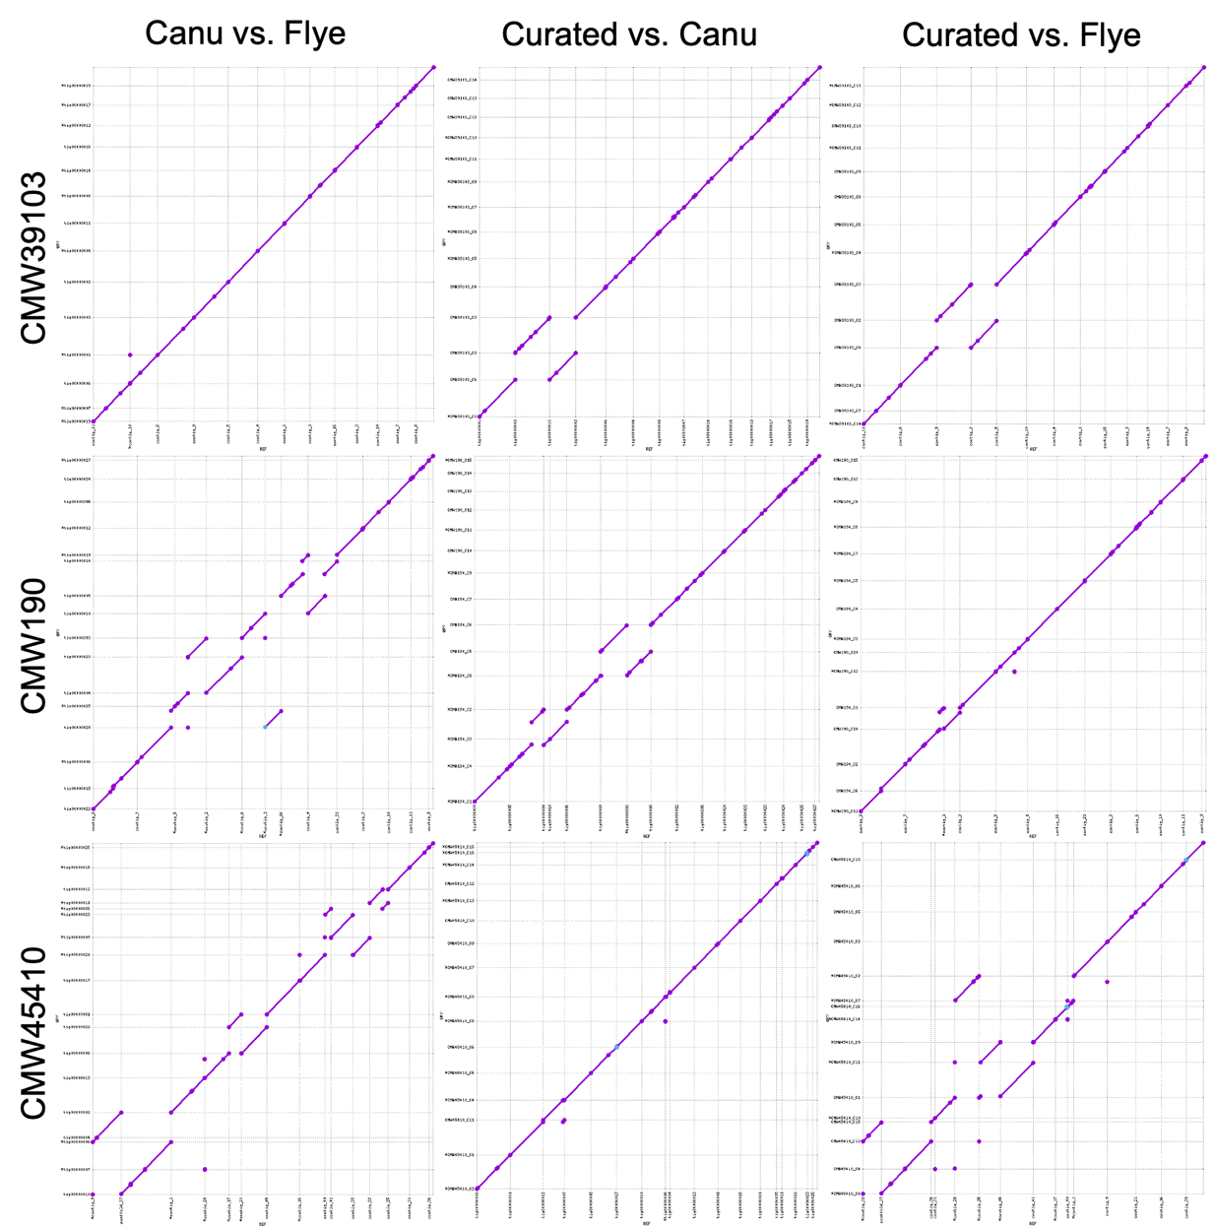
Supplementary Figure 2. Whole genome alignments generated using MUMmer of the initial assemblies and the final curated assemblies.
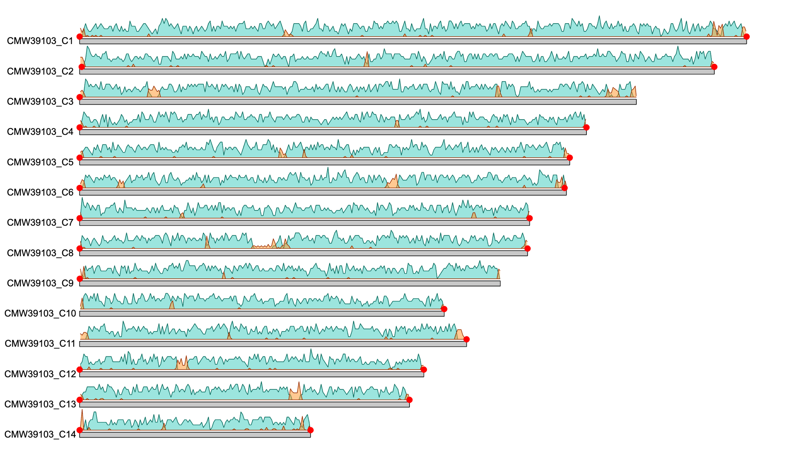
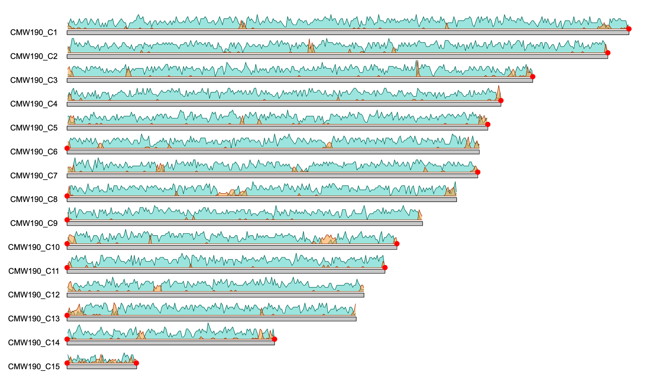
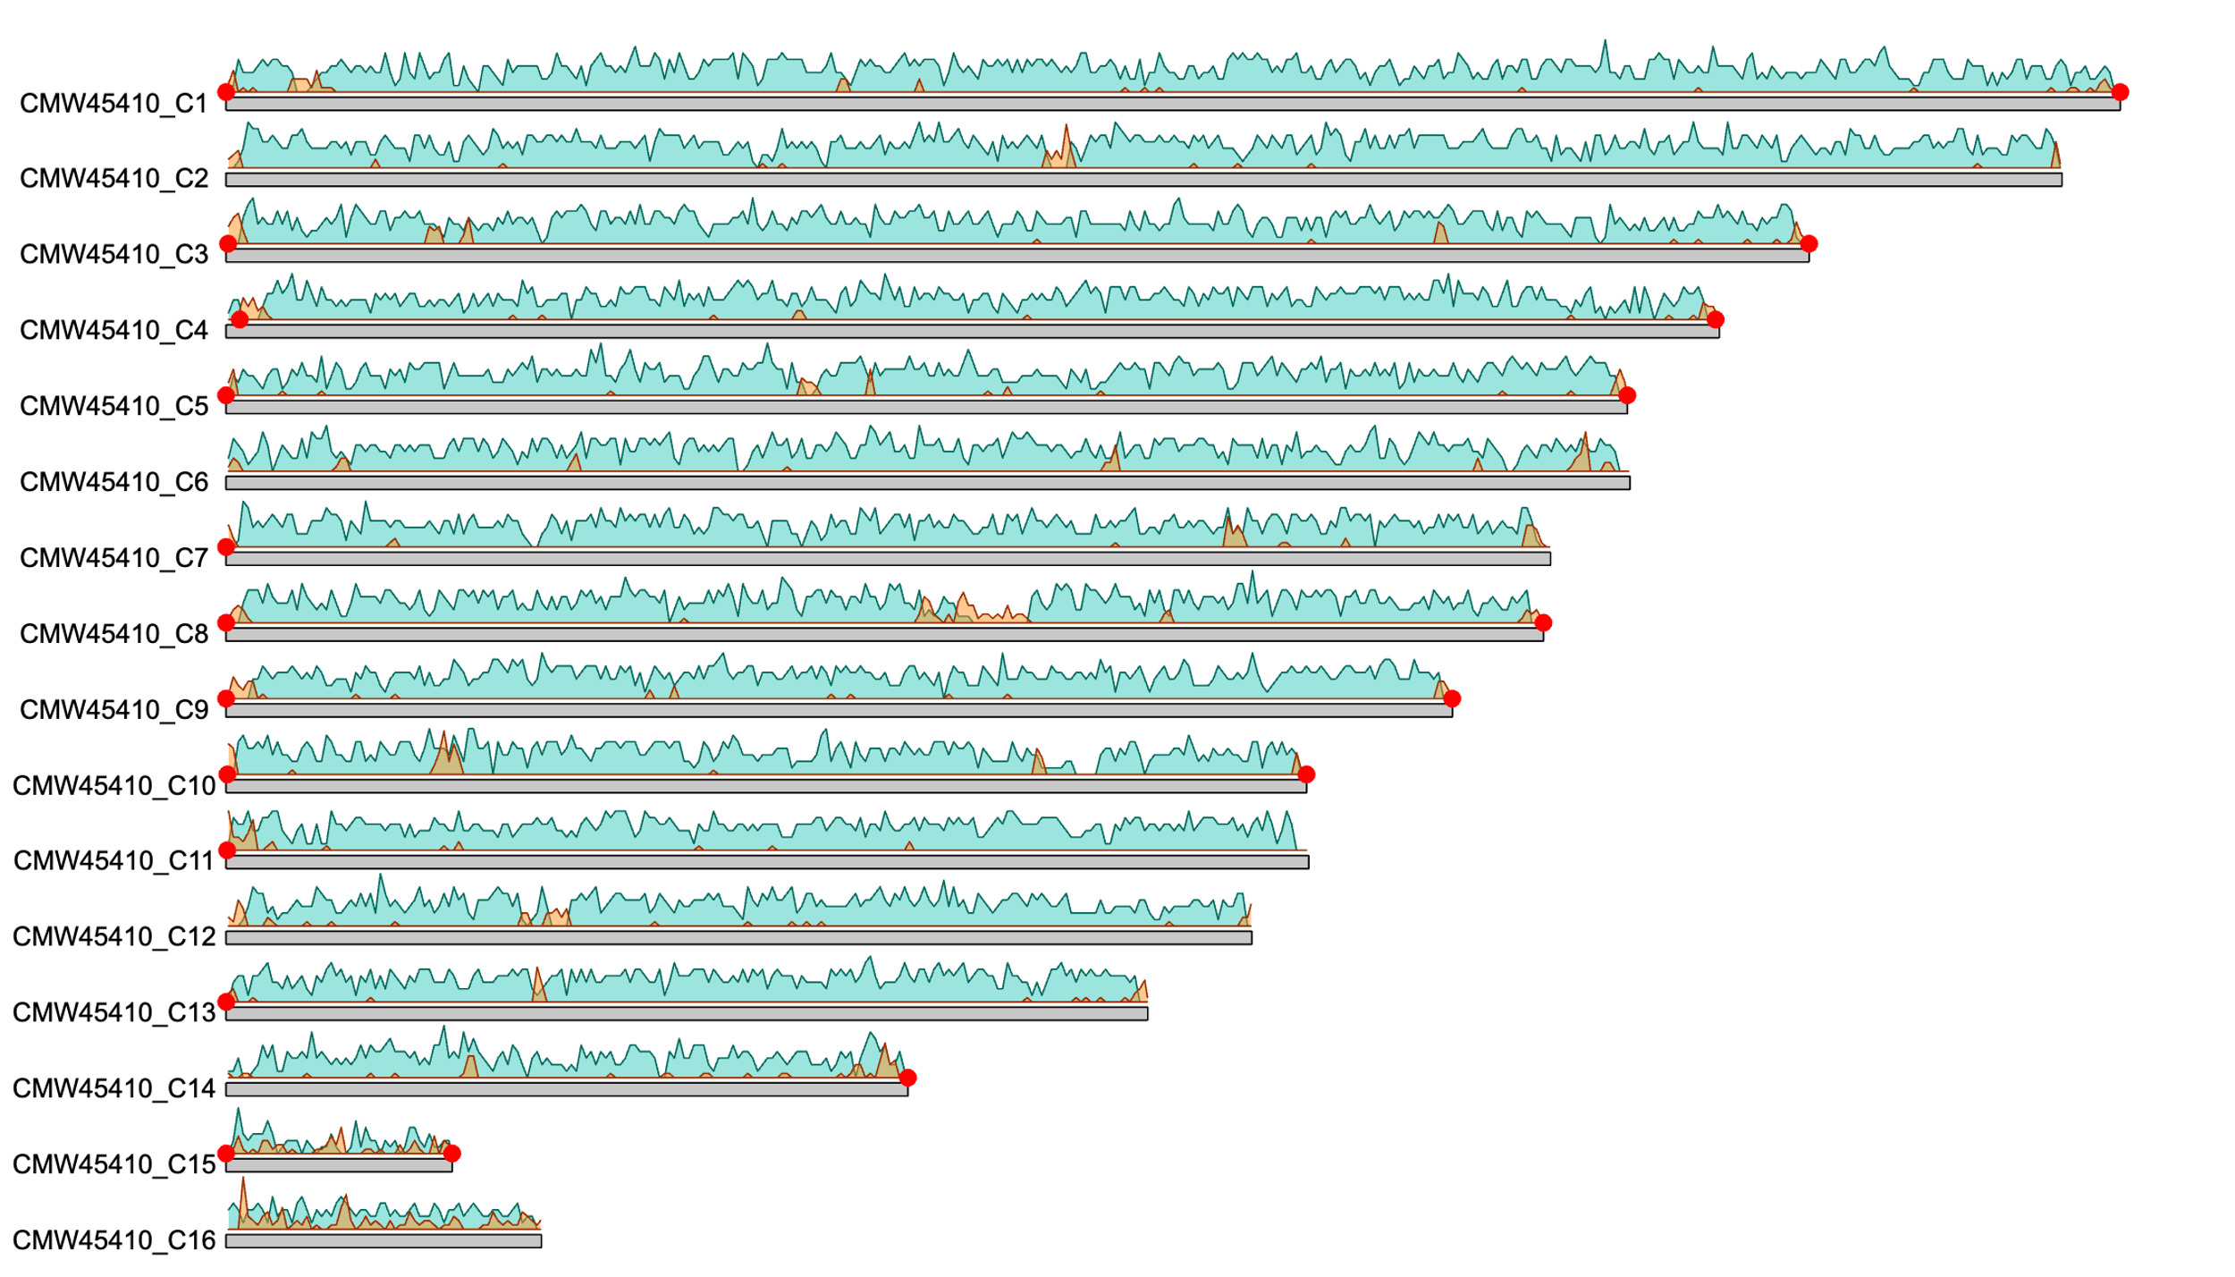
Supplementary Figure 3. Karyoplots of the genome assemblies generated in this study for CMW39103, CMW190 and CMW45410 using karyoploteR v1.28.0 using a window size of 10 Kb (Gel and Serra 2017). Grey bars represent the assembled contigs, blue density plots show gene density, and orange density plots show TE density. Red dots indicate an identified telomeric region.
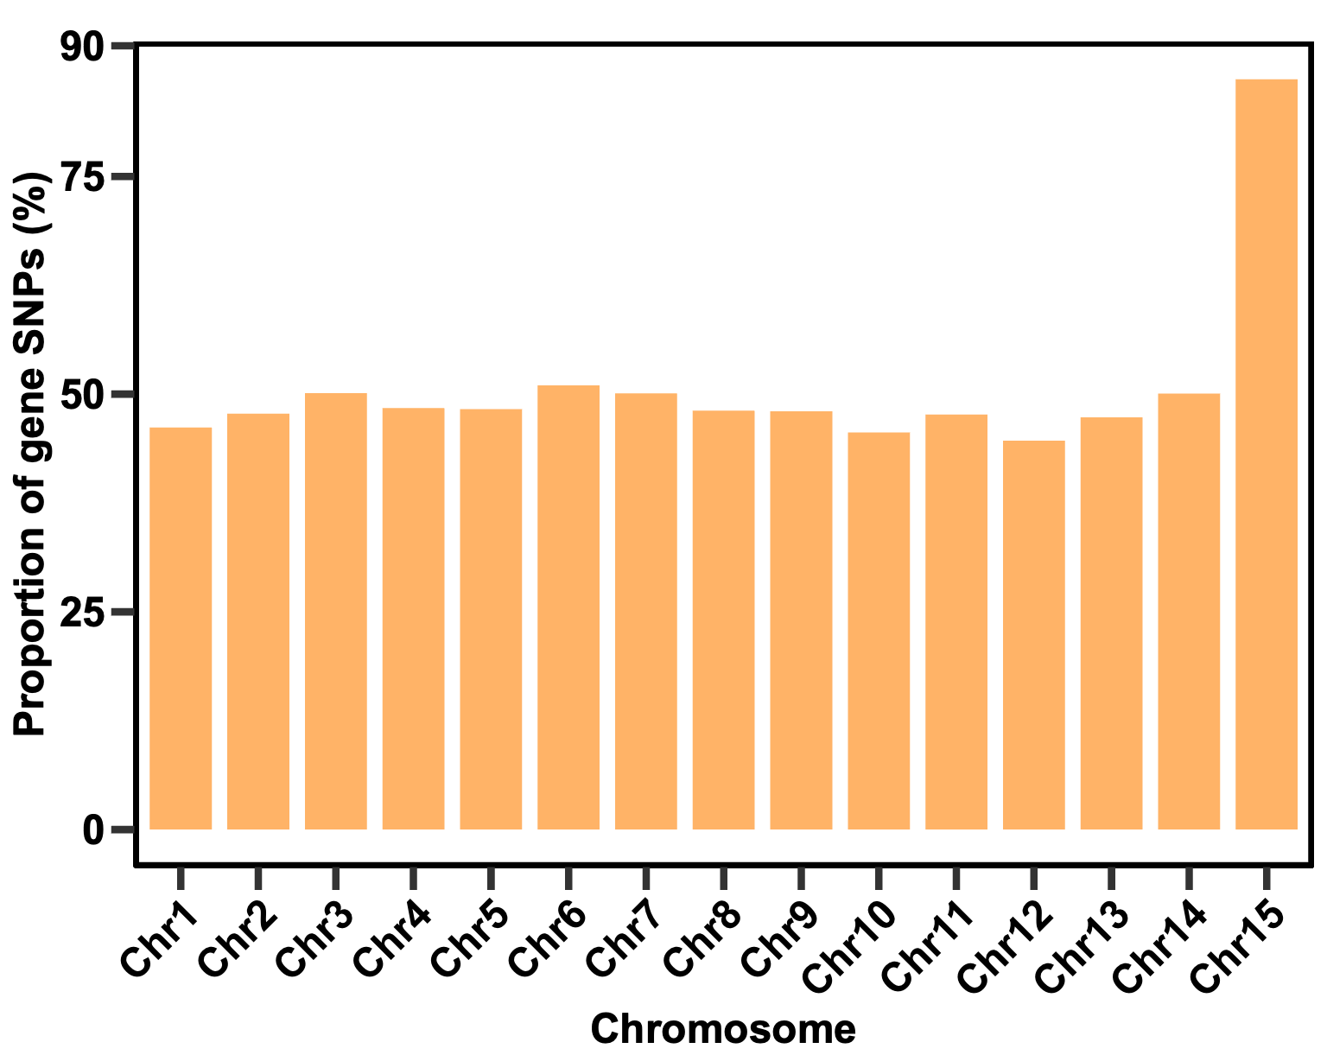
Supplementary Figure 4. Bar graph comparing the proportion of RIP-like SNPs in gene regions between each chromosome of CMW45410.
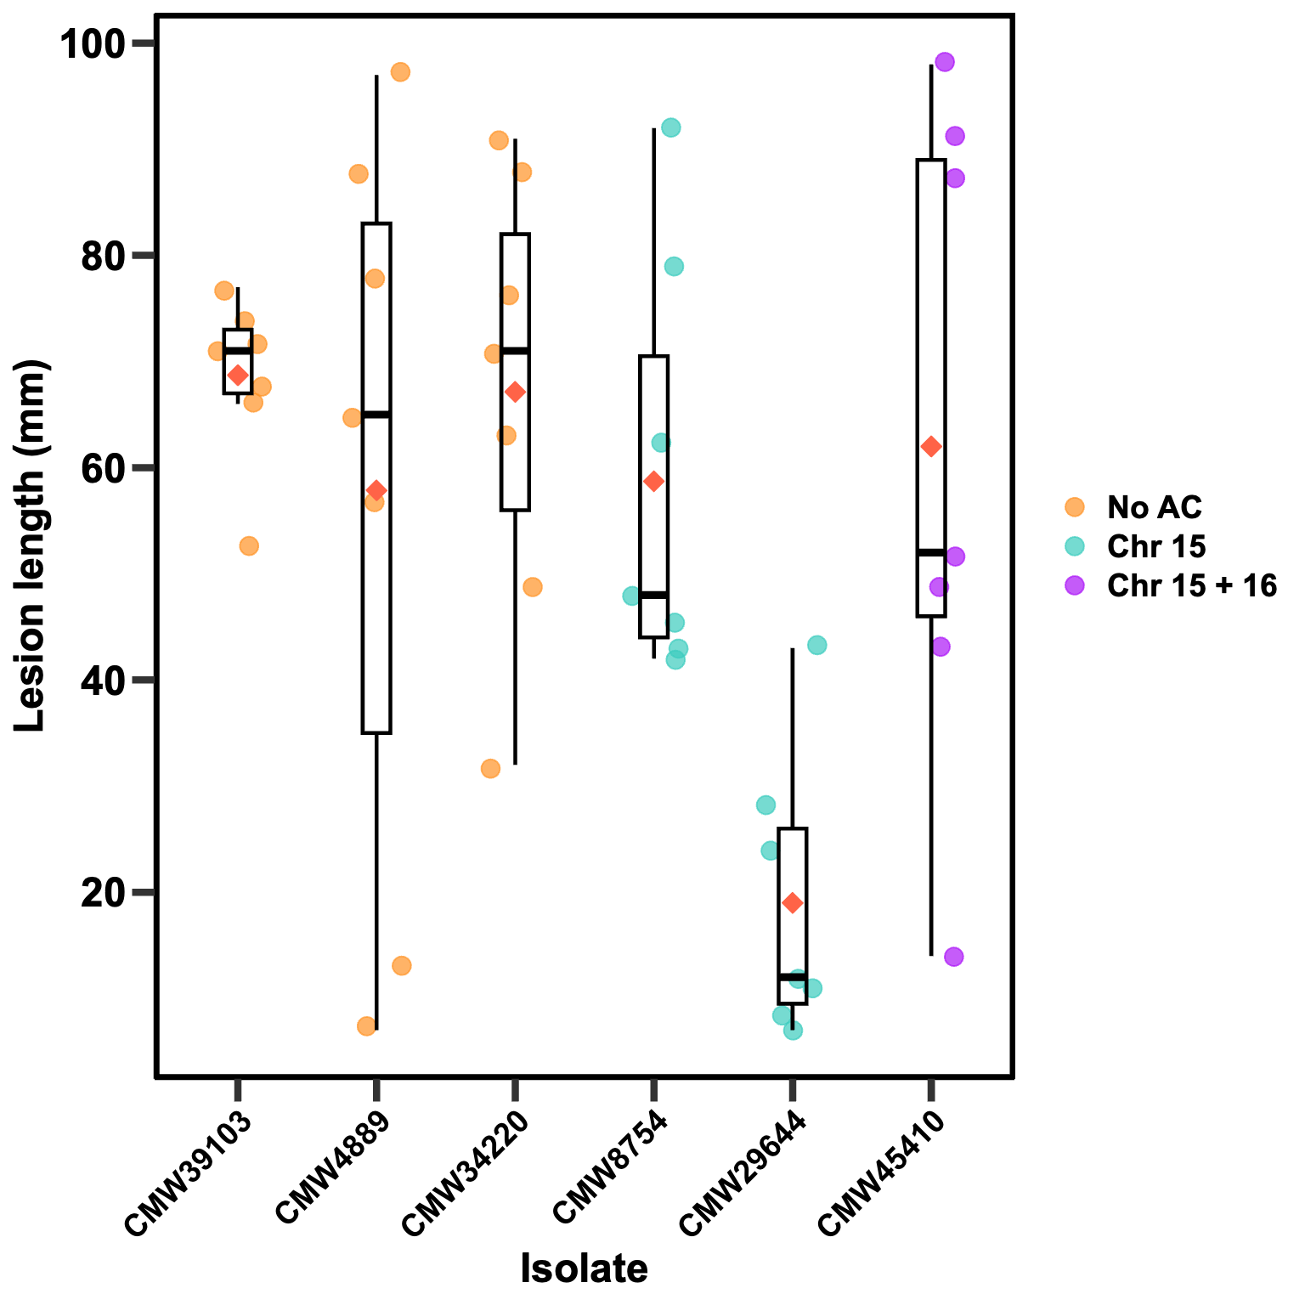
Supplementary Figure 5. Lesion measurements produced by D. sapinea isolates used in the pathogenicity trial.
References
Ali SS et al. 2020. Genome and transcriptome analysis of the latent pathogen Lasiodiplodia theobromae, an emerging threat to the cacao industry. Genome. 63(1):37–52. https://doi.org/10.1139/gen-2019-0112
Blanco-Ulate B, Rolshausen P, Cantu D. 2013. Draft genome sequence of Neofusicoccum parvum isolate UCR-NP2, a fungal vascular pathogen associated with grapevine cankers. Genome Announc. 1(3):e00339–00313. https://doi.org/10.1128/genomeA.00339-13.
Félix C et al. 2019. A multi-omics analysis of the grapevine pathogen Lasiodiplodia theobromae reveals that temperature affects the expression of virulence-and pathogenicity-related genes. Sci Repo. 9(1):1–12. https://doi.org/10.1038/s41598-019-49551-w.
Fernandes I, Alves A, Correia A, Devreese B, Esteves AC. 2014. Secretome analysis identifies potential virulence factors of Diplodia corticola, a fungal pathogen involved in cork oak (Quercus suber) decline. Fungal Biol. 118(5-6):516–523. https://doi.org/10.1016/j.funbio.2014.04.006.
Gel B, Serra E. 2017. KaryoploteR: an R/Bioconductor package to plot customizable genomes displaying arbitrary data. Bioinformatics. 33(19):3088–3090. https://doi.org/10.1093/bioinformatics/btx346.
Islam MS et al. 2012. Tools to kill: Genome of one of the most destructive plant pathogenic fungi Macrophomina phaseolina. BMC Genomics. 13(1):1–16. https://doi.org/10.1186/1471-2164-13-493.
Liu Z et al. 2016. Draft genome sequence of Botryosphaeria dothidea, the pathogen of apple ring rot. Genome Announc. 4(5):e01142–01116. https://doi.org/10.1128/genomeA.01142-16.
Marsberg A et al. 2017. Botryosphaeria dothidea: a latent pathogen of global importance to woody plant health. Mol Plant Pathol. 18(4):477–488. https://doi.org/10.1111/mpp.12495.
Morales-Cruz A et al. 2015. Distinctive expansion of gene families associated with plant cell wall degradation, secondary metabolism, and nutrient uptake in the genomes of grapevine trunk pathogens. BMC Genomics. 16(1):1–22. https://doi.org/10.1186/s12864-015-1624-z.
Nagel JH, Wingfield MJ, Slippers B. 2021. Increased abundance of secreted hydrolytic enzymes and secondary metabolite gene clusters define the genomes of latent plant pathogens in the Botryosphaeriaceae. BMC Genomics. 22(1):1–24. https://doi.org/10.1186/s12864-021-07902-w.
Robert-Siegwald G et al. 2017. Draft genome sequence of Diplodia seriata F98. 1, a fungal species involved in grapevine trunk diseases. Genome Announc. 5(14):e00061–00017. https://doi.org/10.1128/genomeA.00061-17.
Thynne E, Mead OL, Chooi Y-H, McDonald MC, Solomon PS. 2019. Acquisition and loss of secondary metabolites shaped the evolutionary path of three emerging phytopathogens of wheat. Genome Biol Evol. 11(3):890–905. https://doi.org/10.1093/gbe/evz037.
Wang Q, Liu F, Xu H, Zhou X. 2025. Whole-genome sequencing of global forest pathogen Diplodia sapinea causing pine shoot blight. BMC Genom Data. 26(1):1–4. https://doi.org/10.1186/s12863-025-01328-z.
Wingfield BD et al. 2015. Draft genome sequences of Chrysoporthe austroafricana, Diplodia scrobiculata, Fusarium nygamai, Leptographium lundbergii, Limonomyces culmigenus, Stagonosporopsis tanaceti, and Thielaviopsis punctulata. IMA Fungus. 6(1):233–248. https://doi.org/10.5598/imafungus.2015.06.01.15.
Yan JY et al. 2018. Comparative genome and transcriptome analyses reveal adaptations to opportunistic infections in woody plant degrading pathogens of Botryosphaeriaceae. DNA Res. 25(1):87-102. https://doi.org/10.1093/dnares/dsx040.
Yu C et al. 2021. Genome assembly and annotation of Botryosphaeria dothidea sdau11-99, a latent pathogen of apple fruit ring rot in China. Plant Dis. 105(05):1555-1557. https://doi.org/10.1094/PDIS-06-20-1182-A.
Yu C, Diao Y, Lu Q, Zhao J, Cui S, Xiong X, Lu A, Zhang X, Liu H. 2022. Comparative genomics reveals evolutionary traits, mating strategies, and pathogenicity-related genes variation of Botryosphaeriaceae. Front Microbiol. 13. https://doi.org/10.3389/fmicb.2022.800981.

