Supplementary file:

Appendix 1: Online questionnaire

Patient experience and satisfaction with hearing health care received
Section A: Short Assessment of Patient Satisfaction [as per reference 40]

Section B: Process Evaluation

Please answer the questions on the following pages relating to the steps you have completed in seeking help with the Hearing Research Clinic NPC. Click on the arrow to continue.
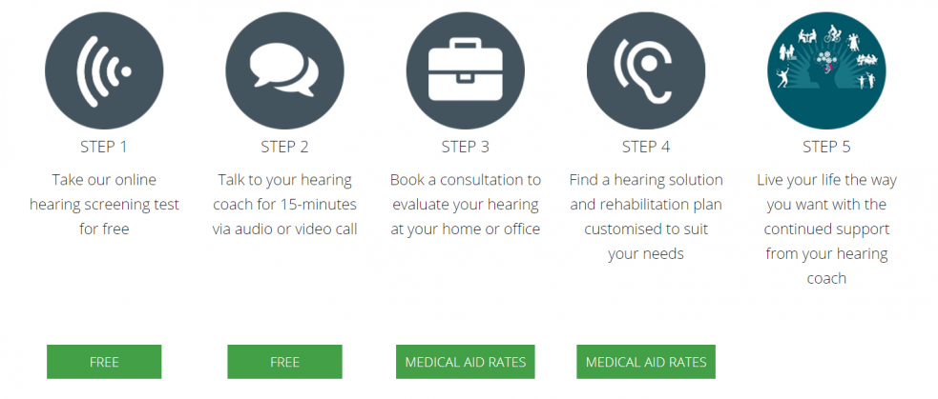
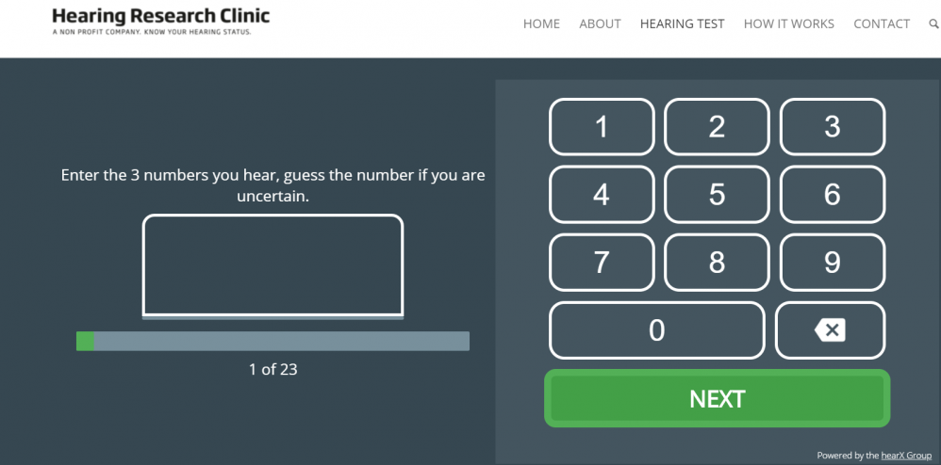
Step 1: Online hearing screening test
Do you remember taking an online hearing screening test, which played numbers in background noise? If ‘no’, select "I did not complete this step (N/A)", if ‘yes’, go ahead as is. Click on the arrow to continue.

Please answer these questions related to the online hearing screening test:
 | Strongly disagree (1) | Disagree (2) | Neutral (3) | Agree (4) | Strongly agree (5) | I did not complete this step (N/A) (6)
B1. Taking the online test was simple (1)
B2. Taking the online test was quick (2)
B3. Taking the online test was informative (3)
B4. I found this online test easy to use (4)
B5. I thought the online test was fast (5)
B6. The test result seemed reliable (6)
B7. Taking this online test has helped me to take the next steps to improve my hearing (7)

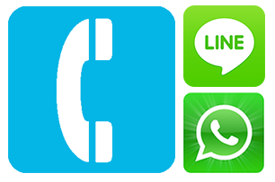
Step 2: Phone call/WhatsApp
Do you remember talking to us on the phone or by WhatsApp to discuss your hearing challenges?’ If ‘no’, select "I did not complete this step (N/A)", if ‘yes’, go ahead as is.

Please answer these questions related to the phone call/WhatsApp messaging to assess your hearing challenges:

 | Strongly disagree (1) | Disagree (2) | Neutral (3) | Agree (4) | Strongly agree (5) | I did not complete this step (N/A) (6)
B8. The phone call/WhatsApp was informative (1)
B9. The phone call/WhatsApp was an easy way for me to communicate with the audiologist/clinic (2)
B10. The phone call/WhatsApp helped me in taking the next step (3)
B11. The phone call/WhatsApp provided me with relevant information regarding my hearing (4)
B12. The phone call/WhatsApp helped me to take the next step and book my hearing evaluation consulation (5)
B13. The phone call/WhatsApp was a quick way for me to communicate with the audiologist/clinic (6)
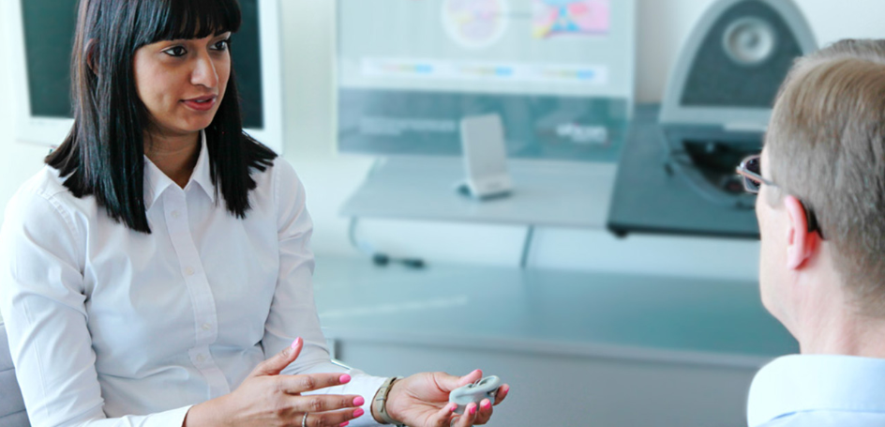
Step 3: Hearing evaluation consultation
Do you remember completing your hearing evaluation with our Audiologist? If ‘no’, select "I did not complete this step (N/A)", if ‘yes’, go ahead as is. Click on the arrow to continue.

Please answer these questions related to the diagnostic hearing test you completed with our audiologist:
 | Strongly disagree (1) | Disagree (2) | Neutral (3) | Agree (4) | Strongly agree (5) | I did not complete this step (N/A) (6)
B14. The diagnostic hearing test was comprehensive (1)
B15. The audiological consultation provided me with the information I needed (2)
B16. The diagnostic hearing test was an easy test to complete with the guidance from the audiologist (3)
B17. It was beneficial to have a hearing aid trial option available after my diagnostic hearing test (in the first consultation) (4)
B18. It was easy to use the hearing aid during the trial period offered to me (5)
B19. I trust the results from my diagnostic hearing test (6)
B20. The time spent on my diagnostic hearing test was adequate (7)

Step 4: Your customised hearing solution and rehabilitation plan
Do you remember being fitted with your trial hearing aids or to purchase your own hearing aids? If ‘no’, select "I did not complete this step (N/A)", if ‘yes’, go ahead as is.


Please answer these questions related to your hearing aid trial:
 | Strongly disagree (1) | Disagree (2) | Neutral (3) | Agree (4) | Strongly agree (5) | I did not complete this step (N/A) (6)
B21. The hearing aid trial helped me experience the difference hearing aids can make in my life (1)

The following questions B22-B25 -only shown to group who discontinued HHC (did not complete all five steps):

B22. Reasons why, I did not proceed with purchasing my hearing aids (select all that apply):
(Randomization of answers was implemented by online software)
- I believe hearing aids are too costly (1)
- I am concerned about the way hearing aids would look on me (2)
- I am concerned about what my family and friends would think of me as a person wearing hearing aids (3)
- I do not believe I could use hearing aids (4)
- I do not believe my hearing impairment is bad enough yet to seek hearing health care (5)
- I did not try any hearing aids (7)
- Other, please explain: (6) ________________________________________________

B23. What would you need to continue with treatment for your hearing loss?
________________________________________________________________
________________________________________________________________

B24. Have you gone elsewhere to get help for your hearing challenges?
Yes (4)
No (5)

Display This Question:
If B24. Have you gone elsewhere to get help for your hearing challenges? = Yes
Or B24. Have you gone elsewhere to get help for your hearing challenges? = No

B25. Please explain why?
________________________________________________________________

The following questions B22B-B27B -only shown to group who continued with HHC (completed all five steps):
 | Strongly disagree (1) | Disagree (2) | Neutral (3) | Agree (4) | Strongly agree (5) | I did not complete this step (N/A) (6)
B22B. The opportunity to try hearing aids helped me make an informed decision to buy hearing aids (2)
B23B. I felt it was easy to use the hearing aids in the trial period which gave me the confidence in my ability to use it on my own (3)
B24B. I trust that the hearing aids will assist me to hear better in my daily life (4)
B25B. The time I had to trial the hearing aids in my daily life (home/work) was adequate (5)
B26B. My quality of life has improved by using my hearing aids (6)
B27B. The online programme was helpful to me (7)

Section C: Personal preferences
C1. Select all the types of communication that you used to stay in touch with your audiologist:
- Phone call (1)
- Email (2)
- WhatsApp (3)
- SMS messages (4)
- Facebook (5)
- Other, please specify (6) ________________________________________________

C2. Select all the types of communication that you prefer to use in order to stay in touch with your audiologist:
- Phone call (1)
- Email (2)
- WhatsApp (3)
- SMS messages (4)
- Facebook (5)
- Other, please specify (6) ________________________________________________

C3. Think about how much you used your present hearing aid(s) over the past two weeks (during your trial period). On an average day, how many hours did you use the hearing aid(s)?
None (1)
Less than 1 hour a day (2)
1 to 4 hours a day (3)
4 to 8 hours a day (4)
more than 8 hours a day (5)

C4. Have you had previous hearing tests/evaluations completed by another clinic/audiologist?
Yes (1)
No (2)

Display This Question:
If C4. Have you had previous hearing tests/evaluations completed by another clinic/audiologist? = Yes
C5. How do you rate your experience with this clinic (Hearing Research Clinic NPC) compared to your past experiences?
Worse (1)
Same (2)
Better (3)

Display This Question:
If C4. Have you had previous hearing tests/evaluations completed by another clinic/audiologist? = Yes
C6. What's different compared to your previous experiences with other audiologists?
________________________________________________________________
________________________________________________________________

C7. What made you continue with your treatment plan with the Hearing Research Clinic NPC? Name your top 3 reasons.
________________________________________________________________
________________________________________________________________
________________________________________________________________

C8. On a scale from 0-10, how likely are you to recommend this clinic (Hearing Research Clinic NPC) to your friends and family?
0 (0)
1 (1)
2 (2)
3 (3)
4 (4)
5 (5)
6 (6)
7 (7)
8 (8)
9 (9)
10 (10)

Please explain your rating above:
________________________________________________________________
________________________________________________________________

C9. How do you think we can improve our services?
________________________________________________________________
________________________________________________________________
________________________________________________________________
________________________________________________________________

END

