Supplementary data

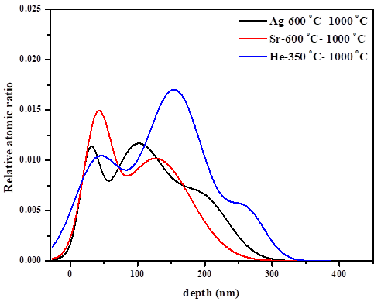
Fig. S1.Shows the depth profiles of Ag, Sr, and He of the annealed samples.

