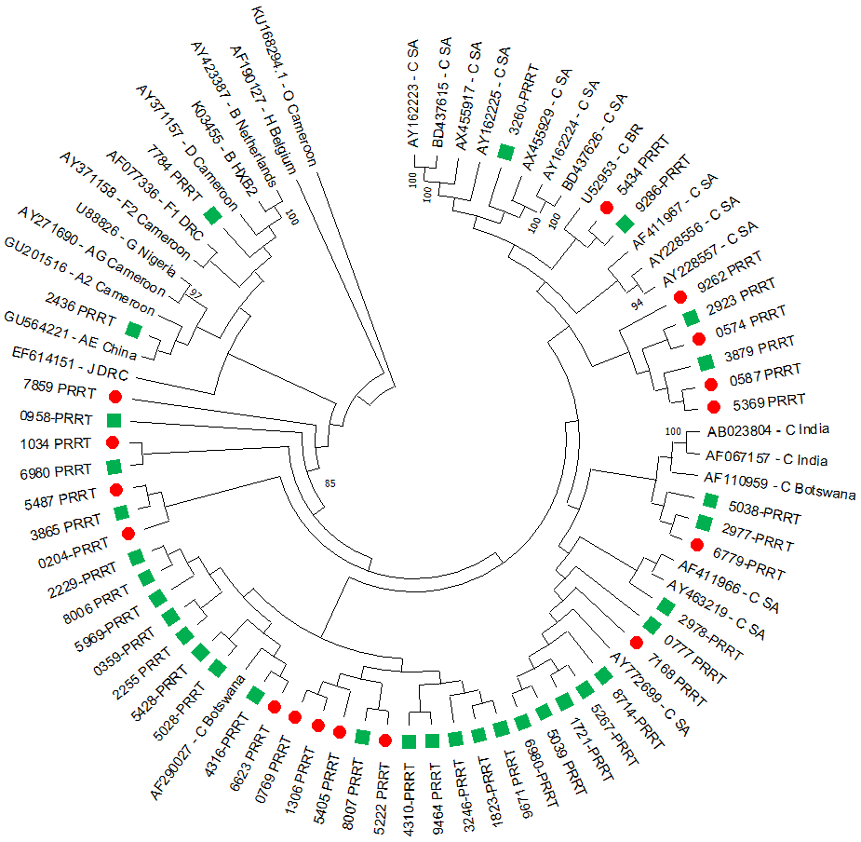
A
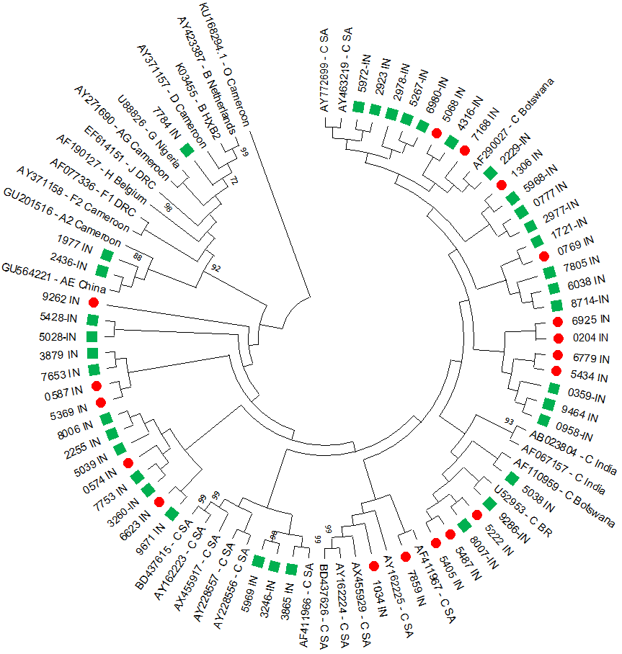
B
Supplementary figure 5: Neighbour-Joining phylogenetic trees using PR-RT and IN sequences. An HIV-1 subtype O strain from Cameroon was used to root the phylogenetic trees. A. Majority of PR-RT sequences clustered with HIV-1 subtype C, and only a small proportion clustered with non-subtype C strains. B. Similarly the majority of IN sequences clustered with HIV-1 subtype C, and only two IN sequences clustered with non-subtype C strains. SA – South Africa; DRC – Democratic Republic of Congo; – Lancet samples; – National Health Laboratory Services (NHLS) samples; IN – Integrase; PR-RT – Protease-Reverse transcriptase; HIV-1 – Human Immunodeficiency virus type 1. Accession numbers: PQ282969 - PQ283067.

