S2 Annex of terms
S2:1 Levels of food insecurity
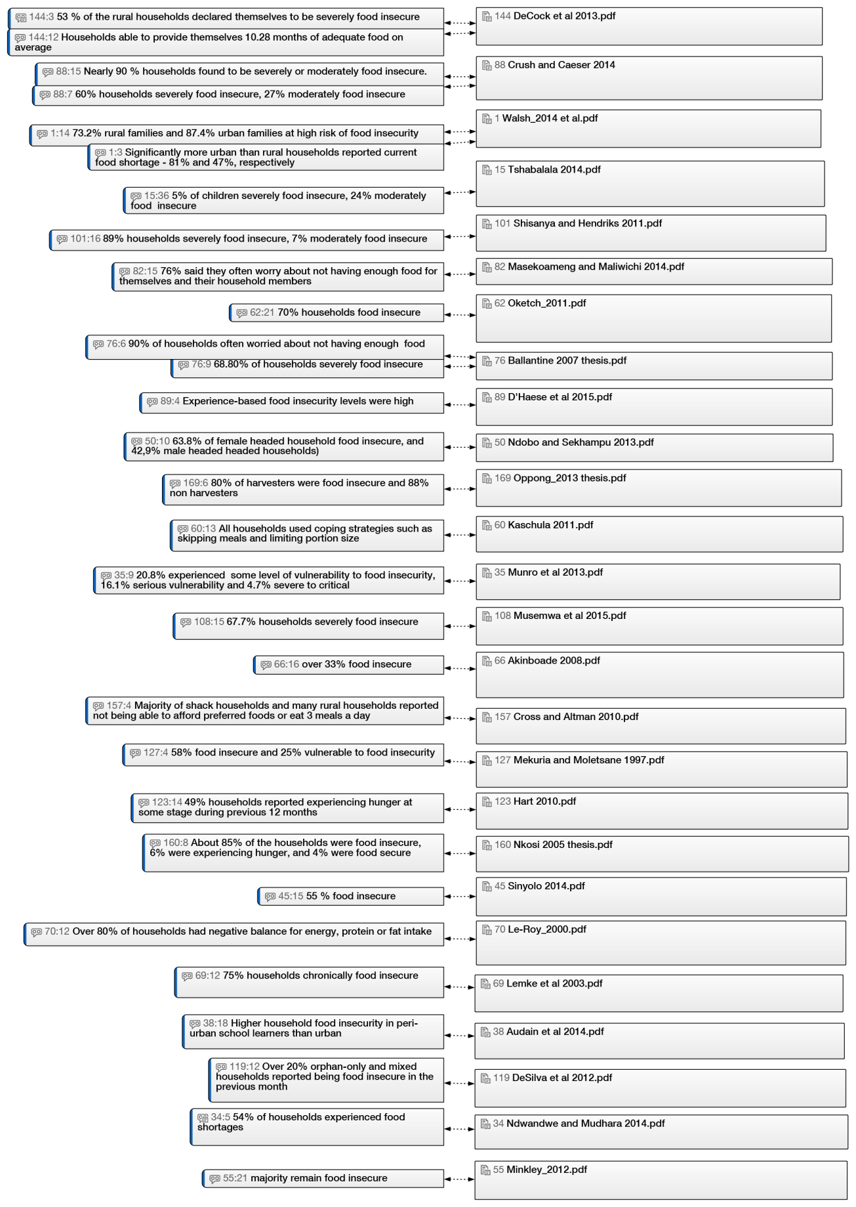
S2:2 Diet quality
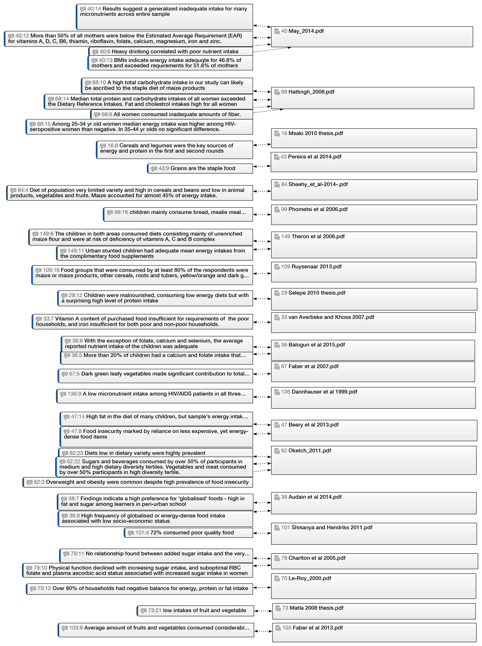

S2:3 Anthropometry
