Appendix A Supplementary Information
To develop the formulations for OLA-Simple dried reagents, we adopted the additive formulation 5% trehalose for lyophilization of Taq DNA polymerase [41], and developed new additive formulations for dry ligase enzyme and gold nanoparticles. We tested the preservative effects of bulky sugars and polyol additives previously-used for dry enzymes and proteins: trehalose, dextran, mannitol, poly(ethylene glycol), and poly(vinyl alcohol). Sensitivity (Supplementary Fig.1c) and specificity (Supplementary Fig.1d) of probe ligation in the presence of these additives were compared to standard probe ligation with CLIA-OLA buffer. None of these additives strongly inhibited ligation, but some mixtures increased non-specific ligation. We chose a mixture of 5% trehalose and 1.5% poly(ethylene glycol) for lyophilizing ligation reagents because it enhanced ligation yield without causing non-specific ligation, and it was compatible with the 5% trehalose carried over from the PCR. Next, we tested the sensitivity and specificity of four commercial hot-start Taq polymerases in the presence of 5% trehalose with WT plasmid control and DNA extracted from six clinical specimens (Supplementary Fig.1,e-f). Roche FastStartTM PCR in the presence of 5% trehalose yielded maximum target amplicon with minimal non-specific amplification signal, and the ligation reaction using the product of this PCR mixture showed comparable results to CLIA-OLA (Supplementary Fig.1,g-i). Hence, Roche FastStartTM PCR with 5% trehalose was selected. We also evaluated the long-term stability of the dry PCR and ligation reagents with the selected additive formulations. After 9-month storage at 4 °C, dry PCR reagents showed similar sensitivity to freshly-prepared PCR reagents in the absence of additives (Supplementary Fig.2, a-b). Similarly, after 4-month storage at 4 °C, dry ligase reagents retained activity and specificity to differentiate wild-type and mutant bases (Supplementary Fig.2, c-h). Multiple additive formulations have been used to preserve dry nanoparticles [42]. For lateral flow detection, anti-biotin gold nanoparticles dry in buffer with 1% poly(ethylene glycol) and 1% sucrose performed similarly to freshly-prepared gold solution after 4-month storage at 4 °C (Supplementary Fig.2, i-j).
Supplementary Fig 1. Simplification of OLA-Simple workflow from CLIA-OLA. (a) Comparison of CLIA-OLA and OLA-Simple workflow. A nested PCR in CLIA-OLA was replaced by a single-round PCR amplification. 1:4 amplicon dilution step and deactivation of ligase enzyme step used in CLIA-OLA were eliminated. Instead of traditional reaction setup, ready-to-use, dry PCR and ligation reagents were used in OLA-Simple. Enzyme immunoassay (EIA)-based detection was replaced by lateral flow detection. CLIA-OLA gives semi-quantitative results; optical densities (ODs) of samples’ ligated products are compared to plasmid standards containing known mutant frequencies. OLA-Simple uses computer classification or human visual classification to analyse qualitative results of coloured bands on lateral flow tests. (b) Comparison of ligation reaction with and without addition of ligation stop solution. 12µL 0.1% tritonX-100 or 12µL of stop solution (0.1% tritonX-100 and 10mM EDTA) were added to the ligation reaction prior to detection with CLIA-OLA’s EIA. MUT ODs (means ± SD, n=5) from the ligation reactions with and without stop solution were compared and had no significant (n.s.) difference (P<0.05, t-test, Holm-Bonferroni correction). (c) Effect of additives on ligation yield. Ligation reactions spiked with 0.05% – 10% of a single additive (trehalose, dextran, poly(vinyl alcohol) (PVA), poly(ethylene glycol) (PEG), sucrose, or mannitol), or a combination of additives (5% trehalose mixed with 1.5% dextran, PEG, PVA, mannitol or sucrose) were mixed with a PCR-amplified 5% Y181C/Y181Y plasmid mixture. The vertical axis shows the MUT OD of the mixture spiked with additive(s) divided by the MUT OD by CLIA-OLA. Reported values are means ± SE of three to four replicates. (d) Effect of additives on the specificity of ligation. Similar experiments done in (c) were performed on PCR-amplified 0% MUT plasmid. Mixtures with significant higher background than the OD detected by CLIA-OLA are in red (P<0.05, t-test comparing the MUT OD of the mixture spiked with additive(s) and the MUT OD by CLIA-OLA). Reported values are means of three replicates. Note that 5%-10% (w/v) PVA were difficult to dissolve at room temperature and too viscous to flow in lateral flow detection. (e) Comparison of PCR-amplified products from 10 copies of WT plasmid from three replicates using commercially-available Taq polymerases in the presence of 0%, 5%, and 10% (w/v) trehalose. Signal from each gel band (means, n=3) was calculated from the 95th percentile band intensity of expected band size minus 95th percentile band intensity of areas underneath the expected band size on 1% (w/v) Agarose stained with EtBr. All polymerases tested (MaximaTM (Life Technology), FastStartTM (Roche), HotStart-ITTM (Affymetrix), and MyTaqHS (Bioline)) had increased amplification yield when adding 5% trehalose to the PCR mixture. FastStart polymerase had the highest and most reliable amplification of 10 HIV copy input. (f) Comparison of PCR-amplified products from six patient DNA specimens. Black and white images of 1% agarose gel stained with EtBr were rotated 90° and the average signal across the distance that the amplification band migrated was plotted. The peak between 500-800 bp corresponded to the expected products. (g) The amplified products from (f) were subjected to CLIA-OLA ligation. MUT and WT OD is reported (means, n=2), respectively. (h) & (i) % mutant estimated from each PCR product compared to previously-reported values by CLIA-OLA for K103N and M184V, respectively. MyTaq was associated with false MUT signal in WT controls. Roche FastStart PCR yielded the most comparable results to original CLIA-OLA.
Supplementary Fig.2. Performance of OLA-Simple components after long-term storage. (a)-(b) Dry PCR mixtures stored at 4°C for 9 months were compared to freshly-prepared PCR without additives (means ± SD, n=3). (a) HIV DNA at 10, 50, or 100 copies was amplified in a 50µL PCR reaction. 1µL amplicon was run on a high-sensitivity TapeStation DNA chip. PCR was specific for HIV templates, showing primer dimers only at low input concentrations or no-template control. (b) PCR sensitivity was reported by integrating area under the curve for the 760 bp HIV band. Sensitivity of the freshly-prepared versus dry PCR reagents was similar (P=0.64, 0.64 and 0.137 for 10, 50, and 100 copies, respectively, two-tailed t-test, Holm-Bonferroni correction). (c-h) Specificity of dried ligation mixture for detection of 100% MUT or 100% WT at K65R, K103N, V106M/I, Y181C, M184V, and G190A, respectively. Ligation products obtained from plasmid amplicons containing either WT or MUT bases at each target codon (means ± SD, n=3) were tested using OLA-Simple lateral flow strips. The signal of WT and MUT bands from scanned images was quantified by subtracting the 95th percentile of Linear Discriminant Analysis (LDA)-converted intensities in the area adjacent to the expected band position (background) from the 95th percentile LDA-converted intensities at the area of expected band position. (i) Dynamic range of OLA-Simple lateral flow detection using a synthetic MUT ligation product (5’-FAM, 3’-biotinylated poly(T)₂₀) at concentrations of 0, 0.01, 0.06, 0.2, 0.6, 1, and 6 nM in ligation buffer using freshly-prepared gold solution. (j) Stability of dried gold mixture. MUT ligation products at 0.3nM, a concentration within the dynamic range shown in (i), were spiked into the ligation reaction mixture and tested using >4-month-old lateral flow strips chased with either freshly-prepared gold solution or 4-month-old gold solution. After 20 min, images were scanned and the signal for WT and MUT bands was analysed (means ±SD, n=3). We observed no significant difference in sensitivity (expected signal at MUT band) and specificity (false signal at WT band) between the 4-month-old and the freshly-prepared dry gold (P=0.724 for WT band signal; P=0.594 for MUT band signal, two-tailed t-test).
To develop the lateral flow detection, we have performed the following design and optimization. For the multiplexed detection of MUT and WT ligation probes, we used EIA to quantitatively assess the performance of eight commercially-available molecular binding pairs. Digoxigenin/anti-D, FAM/anti-F, and Texas Red/anti-T Red pairs bound without cross-reactivity (Supplementary Fig.3,a-d) and maintained high specificity when immobilized onto lateral flow strips (Supplementary Fig. 3e). More sensitive anti-FAM and anti-digoxigenin antibodies were selected to use as capture antibodies for MUT and WT ligation probes, respectively. Next, we investigated denaturation methods to remove unligated probe:template complexes which can cause false signals. The alkaline buffer used in CLIA-OLA was incompatible with immobilized antibody in OLA-Simple detection, as the alkalinity stripped away the immobilized antibody (Supplementary Fig. 3f). Heat has also been used for denaturation in EIA, but heating the strip released the biotin-BSA. In OLA-Simple detection, an excess of single-stranded oligonucleotide complementary to the target DNA was used as a “competing oligo” to displace both ligated and unligated probes from the amplicon template. Competing oligos at 1.5µM eliminated the false signal (Fig. 2b).
To optimize the shared nanoparticle label for WT and MUT ligated probes, we next estimated the proportion of ligated probes in the EIA; finding that <5% of biotinylated common probes were ligated. Therefore, premixing the ligation product with anti-biotin gold nanoparticles would primarily label the unligated common probes (>95%, >10¹⁰ molecules of the total common probe). To overcome this issue, we used a sample/chase buffer detection system. After probe displacement by competing oligo, the ligation product is added to the lateral flow test. Only ligated probes are captured by immobilized antibody whereas unligated common probes flow past to the absorbent pad. A lateral flow chase buffer containing diluted gold nanoparticles (optical density = 0.7 at 520 nm) is subsequently added to chase and label the ligated products. Since gold nanoparticles are present at a low concentration, additional chase buffer was not required to remove the background colour from the gold particles remaining in the fluid on the strip.

Supplementary Fig.3. Characterization of antibody capture for lateral flow tests. Commercially-available small molecules and antibody pairs were tested for their specificity and sensitivity using EIA. Synthetic ligated products: 3’-biotinylated poly(T)20 with 5’-end tagged with digoxigenin (Dig), FAM, rhodamine (Rho), Texas Red (Texas) diluted in ligation buffer at 0.01-1 nM were added to immobilized capture antibody. Optical densities (OD) (means ± SD, n=6) were plotted for TMB substrate reaction with streptavidin conjugated horseradish peroxidase that bound to biotinylated synthetic ligated product captured by immobilized antibody: (a) anti-digoxigenin antibody (b) anti-FAM antibody) (c) anti-rhodamine antibody, and (d) anti-Texas Red antibody. Anti-Rhodamine and anti-Texas Red showed cross-reactivity. Three antibody pairs – anti-FAM, anti-digoxigenin, and anti-Texas Red can be used for multiplexed detection. For OLA-Simple, only two combinations are needed so we selected economical options (anti-digoxigenin type 2 and anti-FAM type 2). (e) Specific antibody pairs tested on the lateral flow detection. Immobilized anti-D, Anti-F, and anti-Texas Red antibodies (Anti-T) were used to detect each or a mixture of synthetic ligated products (0.6µM Syn-D, Syn-F, and Syn-T) pre-mixed with anti-biotin antibody coated gold nanoparticles. Average signal across the strip width was plotted. (f) Effect of different denaturation methods on immobilized antibody. Strips treated with 1x PBS (control), pH 11 buffer (alkaline denaturation), or 95°C for 5 minutes (heat denaturation) were stained with Ponceau dye to detect protein presence as described [43]. Signal from WT, MUT, and CTRL lines (means ± SD, n=5) were compared (t-test, Holm-Bonferroni correction).
Supplementary Fig.4. Impact of carryover inhibitors from different blood specimen types. (a) Mock specimen panels were generated from a healthy donor. The OLA-Simple kit was used to analyse a plasmid mixture of 10% G190A in WT plasmid or pure WT plasmid (2000 copies input) spiked into 10 µL of eluate from each processed specimen compared to plasmid alone (Control). FTA DBS and PBMC DNA were prepared as described in the Materials and Method section. DBS collected on Whatman 903 cards were prepared as previously described using Chelex Solution [35]. To prepare sample for CD4-negative selection, 500µL anti-coagulated whole blood diluted with 1mL Dulbecco's PBS without Ca²⁺ and Mg²⁺ was mixed with 25µL EasySep Direct RapidSpheres and EasySep Isolation Cocktail (STEMCELL Technologies) and separated following the manufacturer’s protocol using an in-house manufactured magnetic rack. Final cell suspension was pelleted, resuspended in 1mL RBC lysis buffer (150mM NH₄Cl, 10mM NaHCO₃, 1mM EDTA), re-pelleted and washed with 1mL Dulbecco's PBS. PBMC separation from whole anti-coagulated blood was performed using Ficoll medium. Washed PMBC pellets were either lysed with an in-house lysis buffer or lysis buffer provided by 5 Prime DNA purification kit. Preparation of CD4 or PBMC lysate: The remaining cell pellet after CD4- cell depletion containing CD4+ cell or PBMC pellet was lysed in 30µl in-house white blood cell (WBC) lysis buffer (10mM Tris pH 8.3, 50mM KCl, 0.45% Tween-20, 0.45% Nonidet-40, 0.5 mg/ml proteinase K) at 56°C for 10 minutes, followed by proteinase K de-activation at 95°C for 5 minutes. 10µL room-temperature lysate was added to 50µL PCR reaction, or frozen at -20°C. As an alternative method for processing freshly drawn whole blood, we developed this in-house approach using customized 3D-printed magnetic bar ($1-2) to deplete CD4-negative cells and lysis buffer that are compatible with downstream PCR. This method also addresses the issue of PCR inhibition caused by using >2µg human background DNA by pre-enriching HIV targets to increase the ratio of HIV copy/total DNA. (b) Signal (means ± SD, n=3) of the MUT and WT bands of samples with WT plasmid versus 10% G190A in 90% WT plasmid were plotted. MUT signal from 0% and 10% G190A samples were compared using two-tailed t-test with Holm-Bonferroni correction.

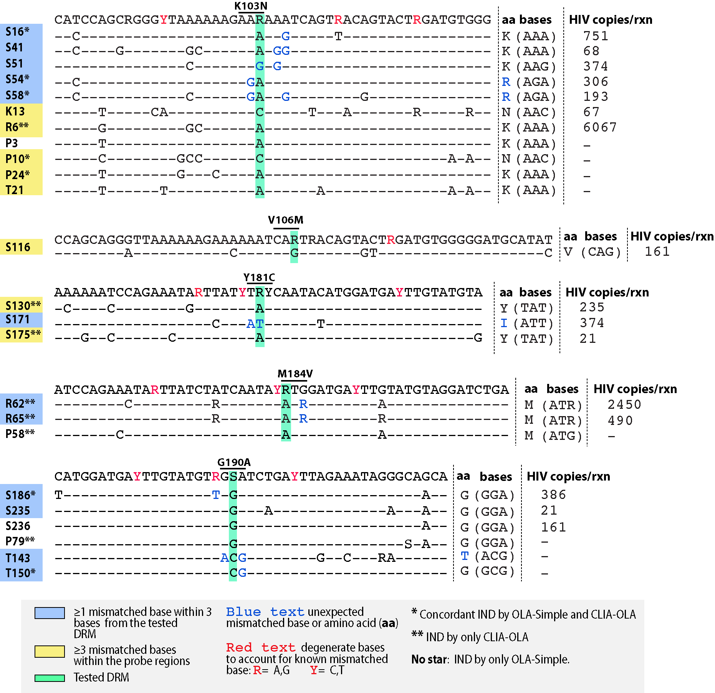
Supplementary Fig. 5. Nucleotide sequences in the regions of the OLA-Simple’s ligation probes for indeterminates identified by OLA-Simple and/or CLIA-OLA. Sequences were obtained by Sanger sequencing. The letter in the specimen code indicated the country of specimen origin (S = South Africa, K = Kenya PBMC DNA, R = Kenya Plasma RNA, P = Peru, T = Thailand)

Supplementary Fig. 6. Receiver Operating Characteristic (ROC) curves of OLA-Simple and Sanger sequencing. Typical ROC curves set qualitative patient state outcomes as state outcomes and test a quantitative variable for its ability to predict the state outcomes. However, both OLA-Simple and Sanger sequencing results are qualitative. In order to plot ROC curves, we have set quantitative data from CLIA-OLA or NGS as a test variable and used nominal results by OLA-Simple and Sanger sequencing as the state outcomes. Area under the ROC curve of OLA-Simple and Sanger sequence was both 0.993. SPSS was used to plot these ROC curves.

Supplementary Fig. 7. Analysis of OLA-Simple by human visual calls from scanned images. (a) Human mode call scores from all cohorts combined. (b)-(f) Human mode call scores based on multiple evaluators (n=11 for B-E; n=13 for F) analyzing the strip images in batch sizes of 236, 92, 92, 96, and 148, respectively. (g) Visual calls from online participants. To evaluate the consistency and accuracy of human interpretation of test strips results 72 participants were recruited to fill out an online survey http://homes.cs.washington.edu/~psr23/ola/. The participants included 48 undergraduate students and 19 graduate students. None of the participants had prior knowledge of the OLA-Simple chemistry and completed the survey on their personal computers. Each participant was presented with 20 strips drawn randomly from a collection of 100 images, and asked to make calls using a legend depicting the possible band patterns. Option D (no bands visible) was not selected by any participants. (h) Heatmap of concordance scores from online participant calls on the 100 images are represented, columns are images, rows show calls, with the key for number of calls below. Red boxes surround the human mode calls for each image. (i) Human mode call scores for all 100 images when evaluators analysed 20 strips at a time. Batch size did not have a significant effect on the number of images with >80% concordant scores ( Chi-square analysis, P=0.741)

Supplementary Fig. 8. Software Image Processing. (a) – (c) Image processing for signal quantification. The image processing algorithm takes as input a full colour image from a flatbed scanner. The array of OLA-Simple strips is detected in the image, rotated to alignment, and cropped. The five paper strips for each codon are then cropped separately. To convert each strip image (a) into a single-channel image, the three- colour channels are linearly combined with weights chosen using linear discriminant analysis (LDA) to differentiate bands from background pixels (b). The locations of the three bands are identified on each strip by a combination of peak detection and windowed search heuristics (c). Paired rectangular sample regions are selected on and adjacent to each of the three bands. The independent two-sample t-statistics are calculated for the means of the paired sample regions. The t-statistics for each band are normalized by dividing by the square root of the number of pixels in the sample region to account for differences in image resolution. (d) Image processing training and testing. The thresholds for the algorithm were assigned and evaluated using a clinical image data set, classified as WT, MUT, or IND by human mode calls from 13 evaluators (Thai cohort) and 11 evaluators (the other cohorts). Total 594 images were divided into training data set (434 images) and testing data set (160 images). Based on the training data set, the threshold for the MUT band was selected as the average of the lowest normalized t-statistic of MUT data and the highest normalized t-statistic of WT data. The threshold for the WT band was selected as the average of the lowest normalized t-statistic of WT data and the highest normalized t-statistic of IND data. The algorithm was used to classify strips based on these thresholds. If the MUT band t-statistic is above the MUT band threshold, then the algorithm reports a MUT sample. Next, if the WT band t-statistic is above the WT band threshold, then the algorithm reports a WT sample. If the WT band t-statistic is below the WT band, the algorithm reports an IND sample. This algorithm was used to evaluate 160 test images (unknowns) and achieved 99% concordance with a single call different from the human mode call but concordant with the sensitive comparator assay result. The MUT signal of this sample fell right between the lowest training MUT and the highest training WT and missed the threshold by just 0.2% of the overall pixel intensity range.
Supplementary Fig. 9. Fast PCR for OLA-Simple. (a) Real-time amplification curves of HIV gene fragments present at 20, 200, 2000, 20000, 200,000 copies and no template control (NTC) using newly-developed two-stage PCR protocol. 50 µL of PCR reaction contained 2.5 units of OnetaqTM Hot Start polymerase (NEB), 1x PCR reaction buffer (50 mM Tris/HCl, 10mM KCl, 5mM (NH₄)₂SO₄; pH 8.3 at 25°C) (Roche), 147mM trehalose (Sigma-Aldrich), 3.5mM MgCl₂, 200 µM dNTPs (ea.), 0.5X Evagreen (Biotium), 400 mM forward primer: 5’-CCGCAGCCATTGACAGAAGARAAAATAAAAGCA-3’, 400 mM reverse primer: 5’-CGCCACTGTCCATTTGTCAGGATGGAGTTCATA-3’. The reaction underwent the first stage of 1 cycle of 94 °C for 30 seconds, 62 °C for 10 seconds, and 68 °C for 20 seconds; and the second stage of 43 cycles of 94 °C for 1 second and 64 °C for 15 seconds and read SYBR channel). Modified tags enabled a higher annealing temperature in the second-stage of the PCR and sped up cycling time. (b) Melt analysis showed distinctive peaks of dimers (2/3 NTC reactions and 1/3 20 copy reactions) at 77 °C from the expected product melting peak at 82 °C. (c) Gel electrophoresis showed the expected amplicon size at 651 bp in the PCR reactions containing ≥200 copies.
Supplementary Table 1. Comparison of genotyping results by OLA-Simple to other comparator assays.
Green, blue, and black cells are codons classified as WT, MUT, and IND, respectively. Red wedges are codons with low WT OD; % MUT by CLIA-OLA may be overestimated as it was estimated from the ratio of MUT OD/(MUT OD + WT OD) and WT signals are typically near signal saturation in CLIA-OLA.

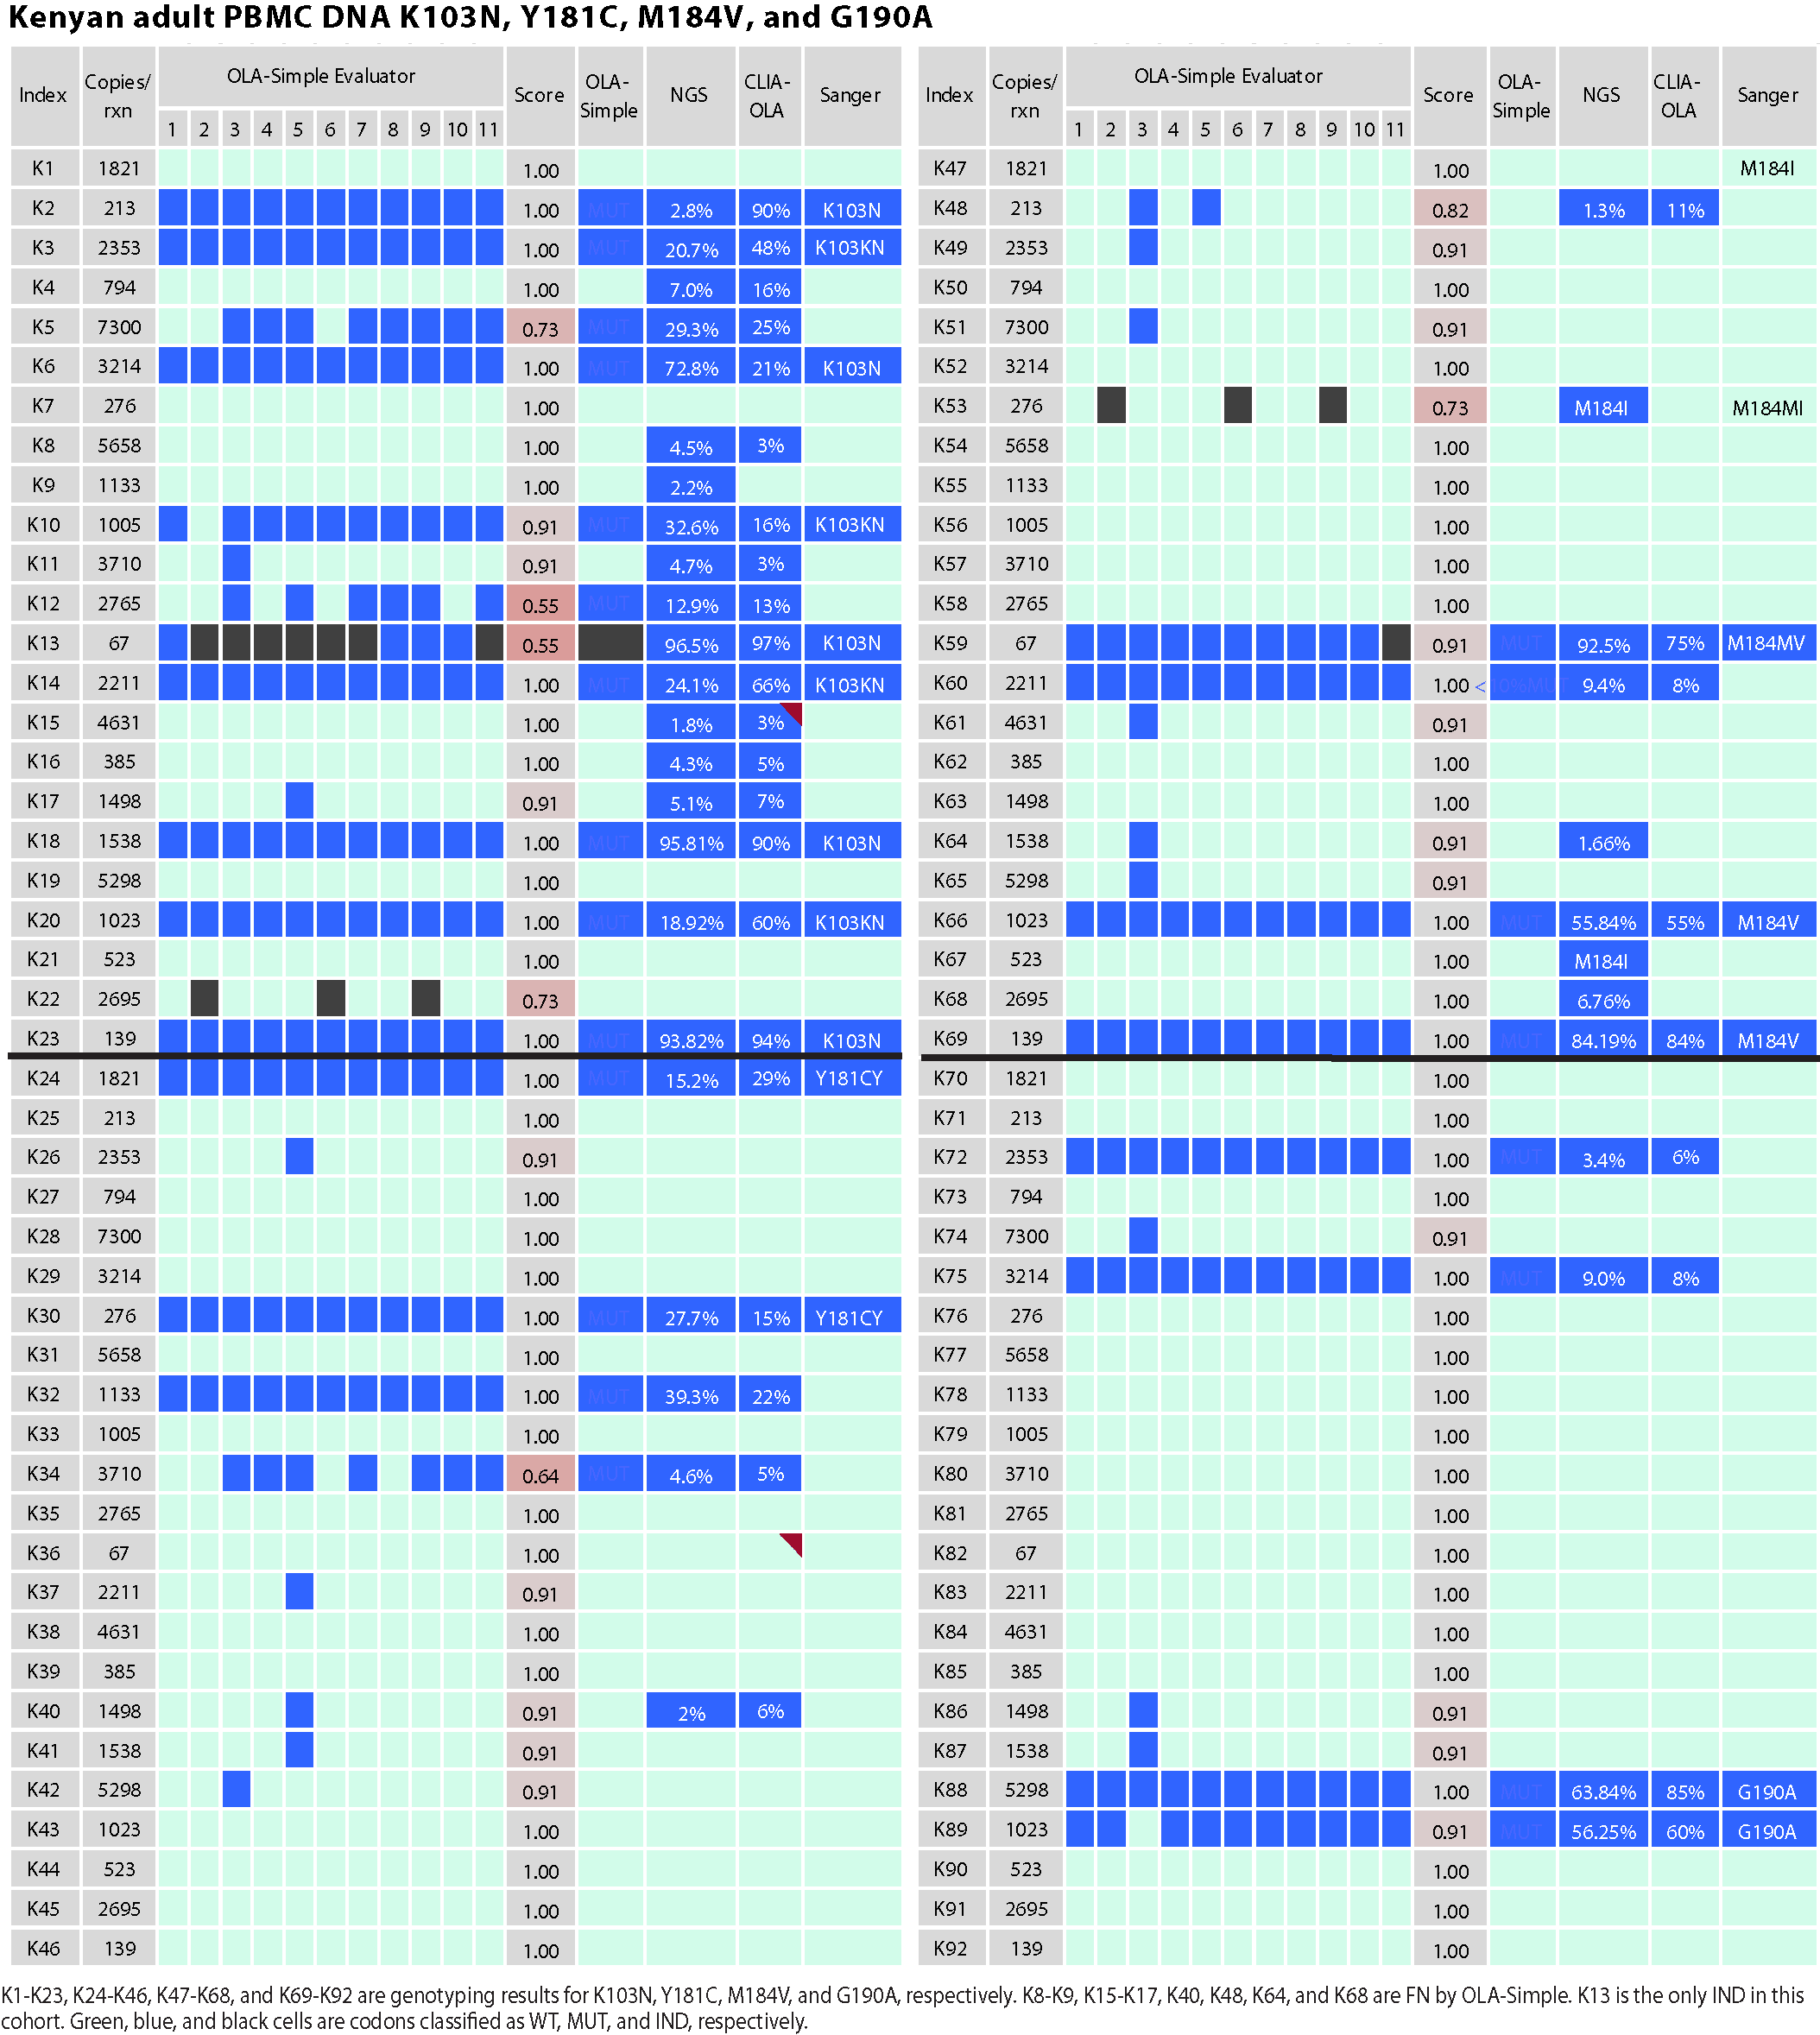
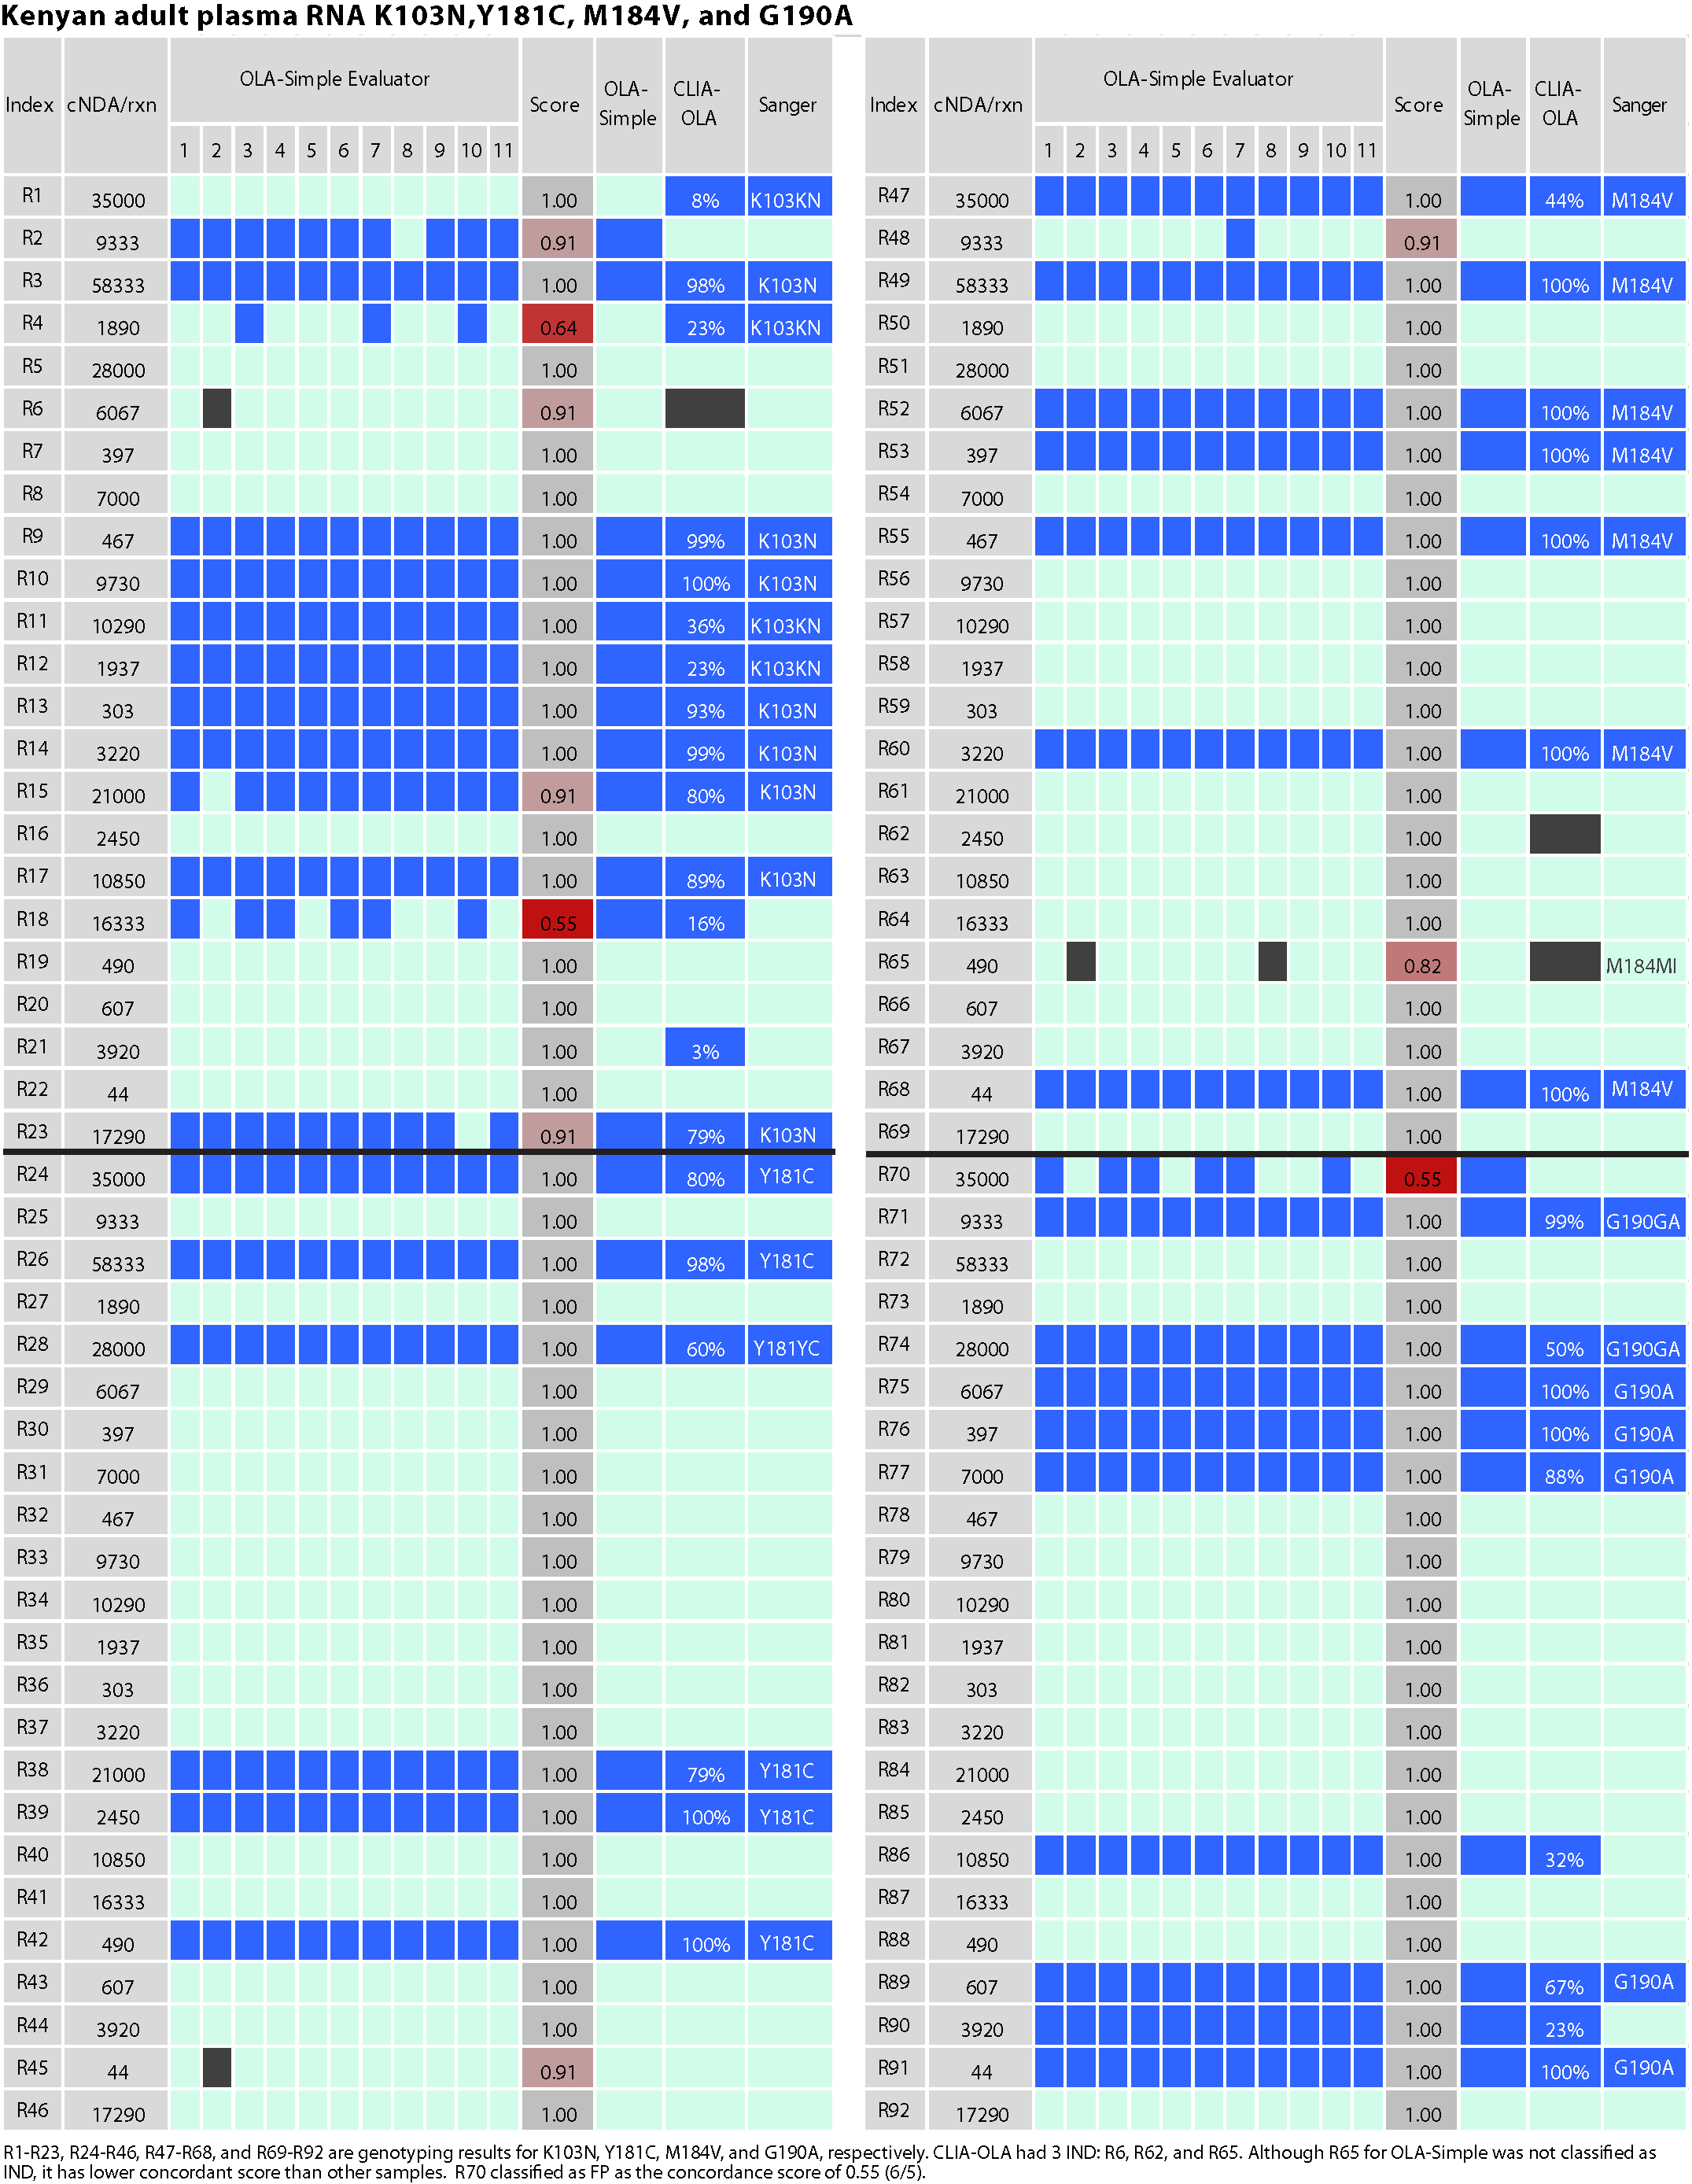

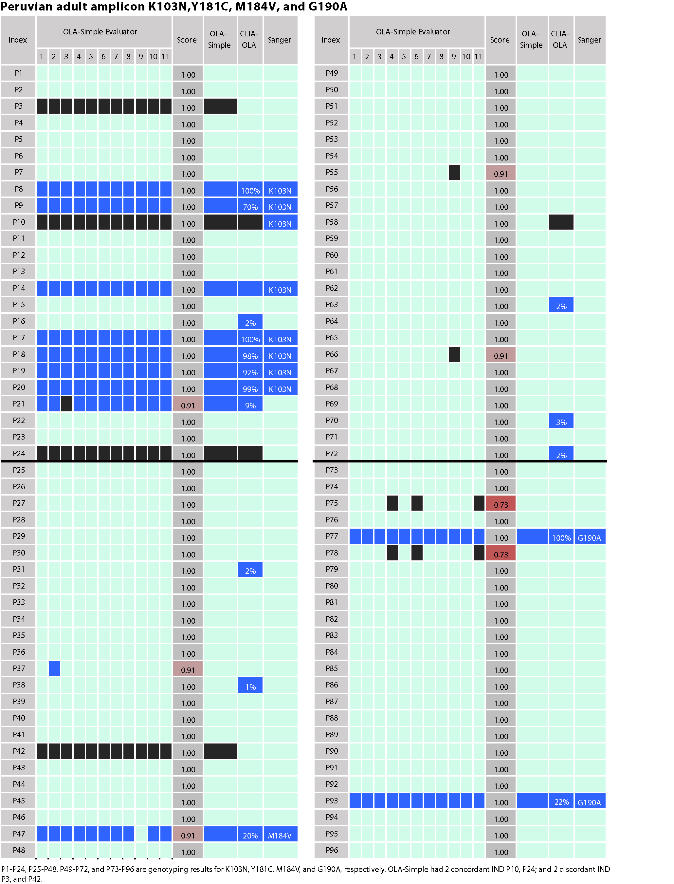
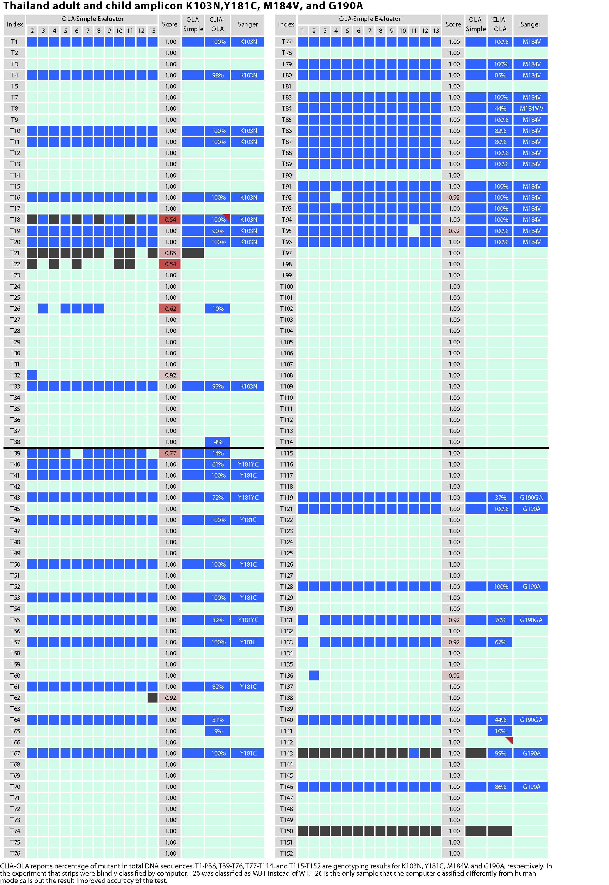

(b) Comparison of OLA-Simple for detection of DRMs in HIV-1 from multiple-cohort specimens to genotyping by Sanger sequencing.

(c) Comparison of OLA-Simple for detection of DRMs in HIV-1 from multiple-cohort specimens to genotyping by sensitive comparator assays (NGS for Kenyan PBMC DNA and CLIA-OLA for all other cohort.
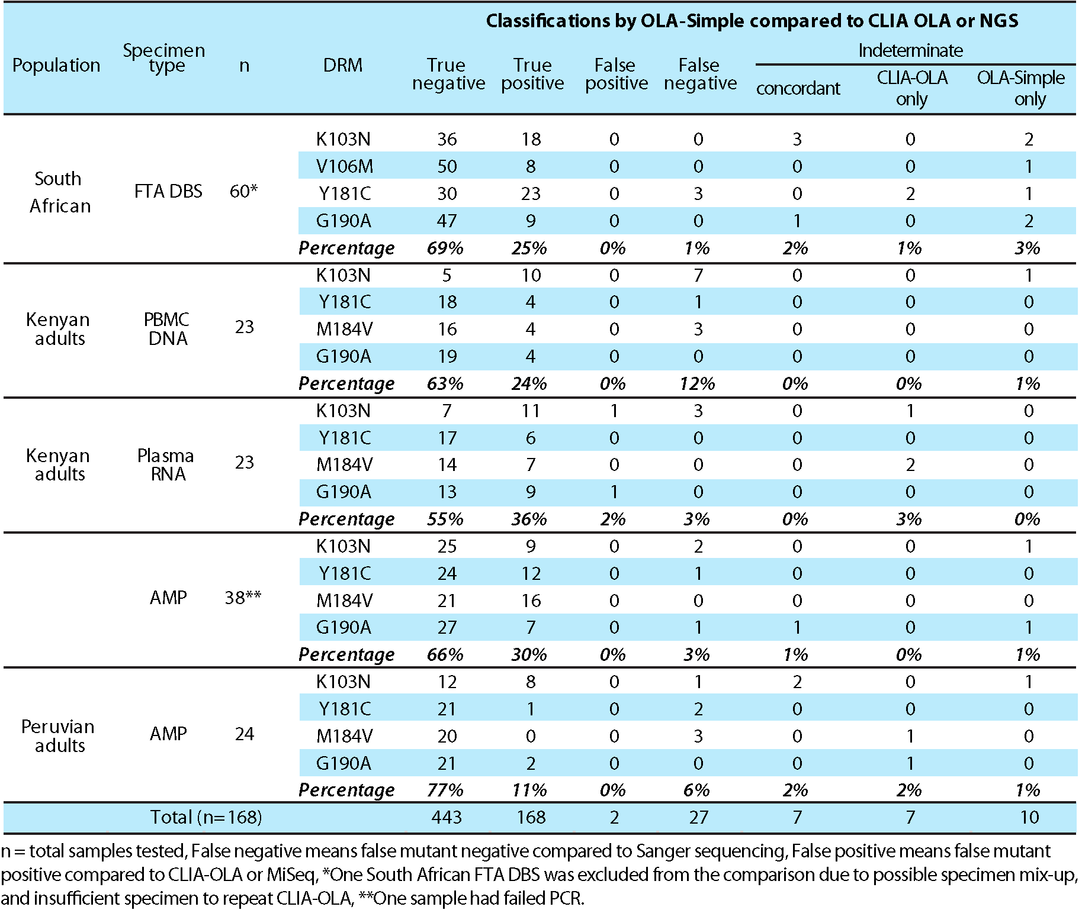

References
[41] Klatser PR, Kuijper S, Ingen CWv, Kolk AHJ. Stabilized, freeze-dried pcr mix for
detection of mycobacteria. J Clin Microbiol 1998;1998:1798–800. 867.
[42] Abdelwahed W, Degobert G, Stainmesse S, Fessi H. Freeze-drying of nanopar-
ticles: formulation, process and storage considerations. Adv Drug Deliv Rev 869
2006;58(15):1688–713.
[43] Panpradist N, Beck IA, Chung MH, Kiarie JN, Frenkel LM, Lutz BR. Simplified paper
format for detecting HIV drug resistance in clinical specimens by oligonucleotide 872
ligation. PLoS ONE 2016;11(1):e0145962.

