Supplementary Information
Nanoarchitectonics with redox active site modulation in bimetallic MIL-125(Ti,Mn) MOF for enhanced supercapacitor performance
Kabir O. Otun*, Ndeye F. Diop, Vusani M. Maphiri, Oladepo Fasakin, Vianney N. Kitenge, Souleymane Thior, Ncholu Manyala*
Department of Physics, Institute of Applied Materials, University of Pretoria, 0001, Pretoria, South Africa

Corresponding authors’ email: otunkabir2705@gmail.com, ncholu.manyala@up.ac.za

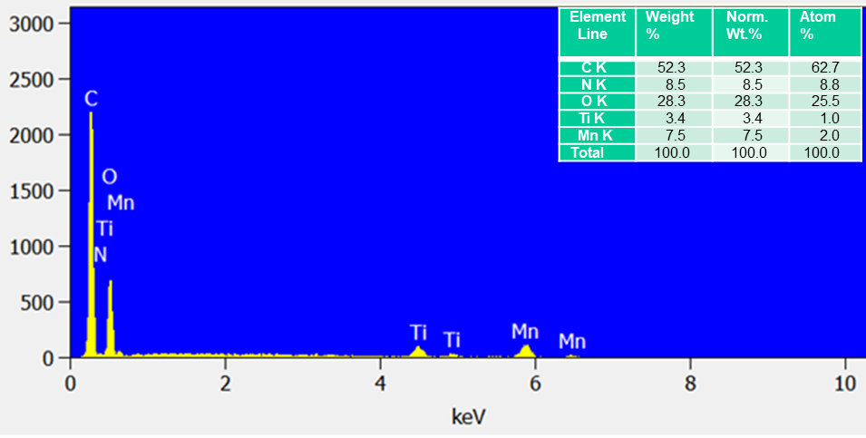
Fig. S1: EDS spectra of MIL-125(T)-Mn-3
Table S1: N₂-adsorption desorption isotherms of pristine and Mn-doped MIL-125(Ti)
Sample | BET Surface area (m²/g) | Micropore surface area (cm²/g) | External Surface area  (cm²/g) | Total Pore volume (cm³) | Average Pore diameter (nm)
MIL-125(Ti) | 54.81 | 15.12 | 39.67 | 0.1040 | 4.50
MIL-125(Ti)-Mn1 | 10.41 | 0.01 | 10.40 | 0.0154 | 3.58
MIL-125(Ti)-Mn2 | 20.23 | 5.97 | 14.26 | 0.0218 | 6.00
MIL-125(Ti)-Mn3 | 13.01 | 2.15 | 10.86 | 0.0133 | 6.39

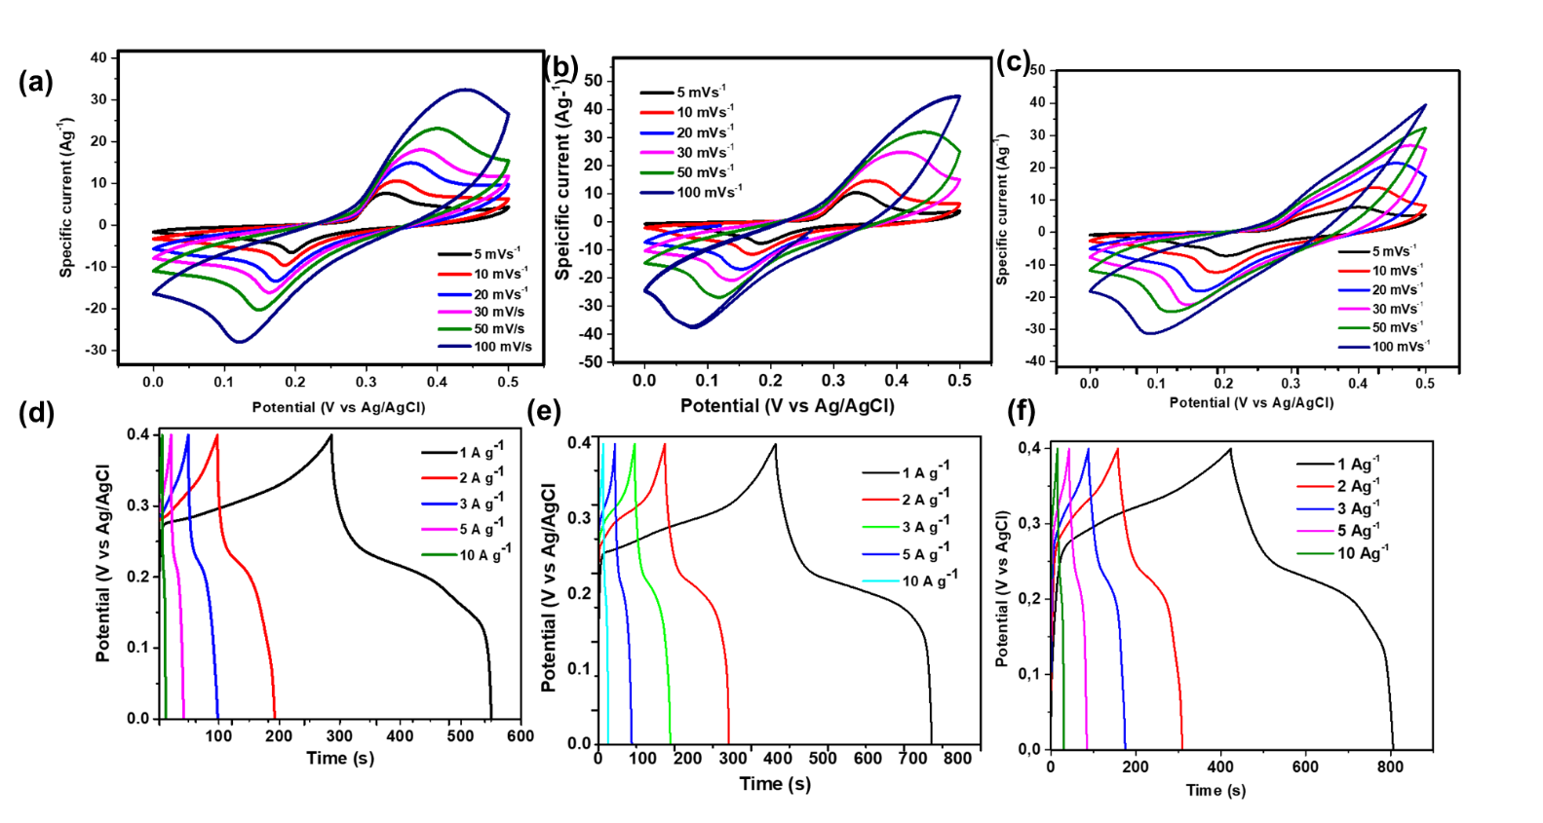
Fig. S2. CV curves of (a) MIL-125(Ti), (b) MIL-125(Ti)-Mn-1, (c) MIL-125(Ti)-Mn-3 at different scan rates; GCD curves of (d) MIL-125(Ti), (e) MIL-125(Ti)-Mn-1, (f) MIL-125(Ti)-Mn-3 at different specific currents.
Fig. S3 CV optimization stages of MIL-125-(Ti)-Mn-2//AC from 0-1.6 V
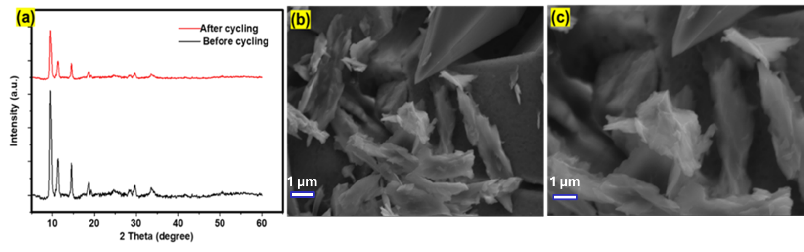
Fig. S4 (a) XRD of MIL-125-(Ti)-Mn-2 before and after cycling stability. SEM images (a) before and (c) after cycling stability tests

