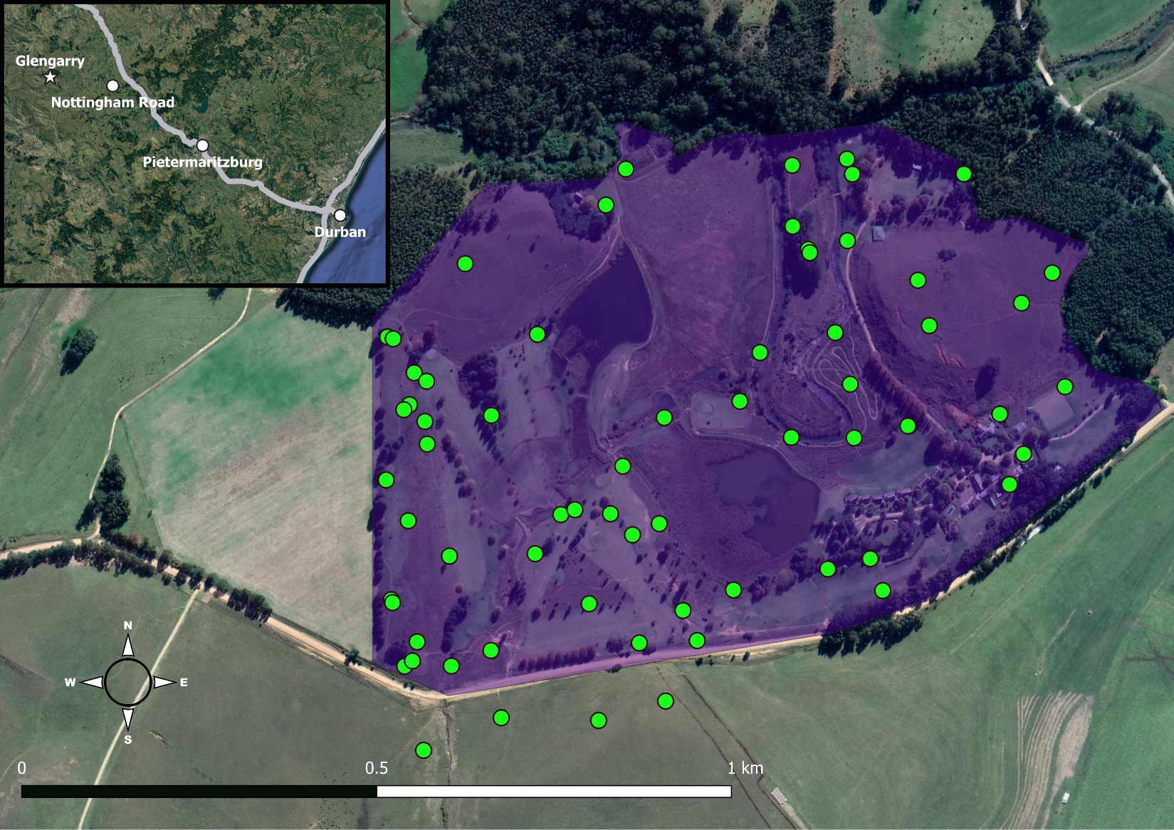

Figure S1: Study site at Glengarry Holiday Farm (purple) in KwaZulu-Natal, South Africa with mole-rat groups indicated in green. Inset shows Glengarry (star) in relation to major cities in KwaZulu-Natal.

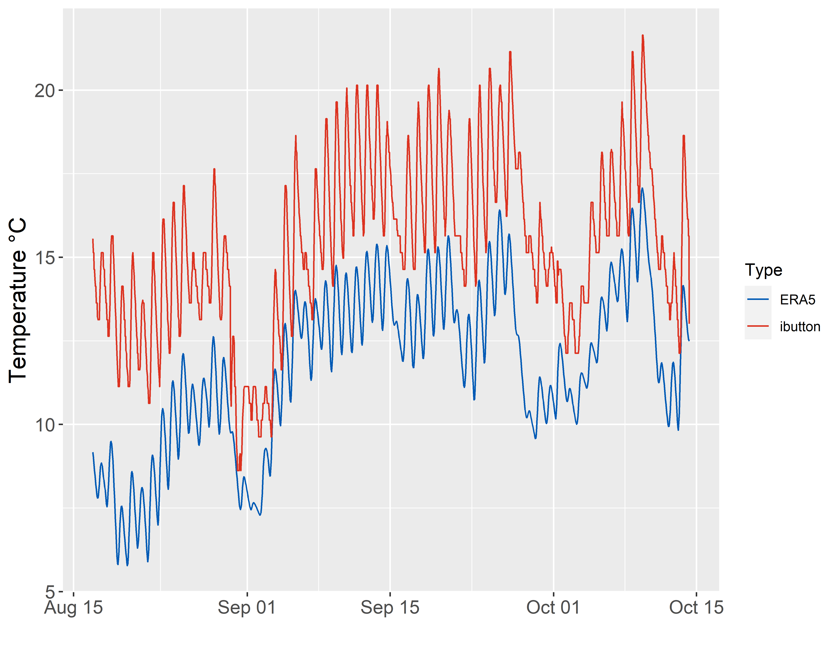
Figure S2: Hourly fluctuation in soil temperatures obtained from temperature loggers (ibutton) and the ERA5-Land dataset (ERA5). Temperature loggers were buried ca. 15 cm below the surface to correspond with the soil temperature at 7-28 cm from ERA5.

RFID Reader Array

The radio-frequency identification (RFID) reader array used in this study was model LID650/608 fromDorsetID, The Netherlands. The detection range of the array was approximately 15 – 20 cm and decreases through soil. Thus, the array was placed directly over a tunnel to allow for the best detection of mole-rats passing within its range. Since many of the mole-rat tunnels were less than 30cm deep, the panel was placed on the soil surface between mounds without burying it into the ground or breaching tunnels (as in Francioli et al. 2020). A shovel was occasionally used to remove grass and level the ground so the reader rested flush to the ground. As a result, the mole-rat activity directly following reader placement was unlikely to be due to tunnel repairs or attempts to block the tunnel.

Due to the stationary nature of the reader array beginning and ending times of an activity bout were unavailable. Animals may continue to be active for an unknown length of time both before and after a single reading was recorded.To assess duration of individual activity the raw data was rounded down to the nearest minute and ordered consecutively by individual. A series of consecutive detection times were assumed to be contained within a single activity bout if the subsequent reading was < 60 minutes after thepreceding time (i.e., T_{n + 1}– T_{n}< 60).The total duration from initial time to the last detection time in a series was then averaged across individuals. For example, if an animal was active at 08:56, 09:12,10:49, 11:15, and 11:35 this would equate to two activity bouts, one from 08:56 – 09:12 (16 minutes) and another 10:49 – 11:35 (46 minutes). While the animal may have been active between 09:12 and 10:49, splitting the bout by 60-minute intervals provided a more conservative estimation.Based on these methods, detected individuals were active for 15 ± 23.1 minutes per day (mean + SD, range 1 – 159 minutes, n = 352), with only 18% (66 of 352) of the activity bouts lasted more than 30 minutes (Figure S5). It is reasonable to assume that each animal would have at least two readings present in the data, one for the initial pass under the reader and another for a return pass. The high number of 5 minute durations of activity may indicate the presence of interconnected tunnels in mole-rat burrows systems which may allow for multiple paths leading between the reader and the nest(Šklíba et al. 2012, Šumbera et al. 2012) which may havecaused an underestimate of activity duration. Therefore, we assuming activity bouts lasted 30 minutes and 60 minutes for analysis using a generalized linear mixed model as described in the text. Thus, the day was divided into 30-minute periods and an animal would get an activity score of 1 if it was active during that time and gain another point 30 or 60 minutes after the initial time. There was no significant difference in the effects of predictor variables between the models assumingan activity period of 30 or 60 minutes (Table S1). However, the model assuming activity periods lasted 60 minutes had a lower AIC value. In both models we included the duration of each reading session, but it was not a significant factor and was removed from the final model (p-value = 0.59).

References
Francioli Y, Thorley J, Finn K, Clutton-Brock T, Zöttl M. 2020. Breeders are less active foragers than non-breeders in wild Damaraland mole-rats. Biology Letters 16:20200475.

Šklíba J, Mazoch V, Patzenhauerová H, Hrouzková E, Lövy M, Kott O, Šumbera. 2012. A maze-lover’s dream: burrow architecture, natural history and habitat characteristics of Ansell’s mole-rat (Fukomys anselli). Mammalian Biology 77:420-427.

Šumbera R, Mazoch V, Patzenhauerová H, Lövy M, Šklíba J, Bryja J, Burda H. 2012. Burrow architecture, family composition and habitat characteristics of the largest social African mole-rat: the giant mole-rat constructs really giant burrow systems. Acta Theriologica 57:121-130.

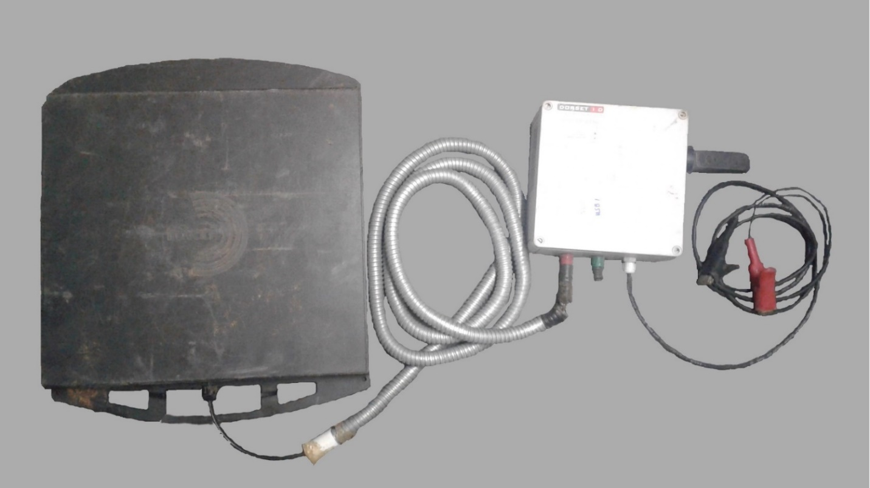

Figure S3: RFID reader array with a custom-made decoder LID650 (white box; DorsetID, Aalten, Netherlands) attached to the panel antenna ANT612 (black square). The antenna scans for passive integrated transponder tags at regular intervals, which are stored on a USB drive. Red and black cables are attached to a power source. A metal guard was added to prevent mole-rats from chewing on the cable. Reprinted from Francioli et al. (2020).

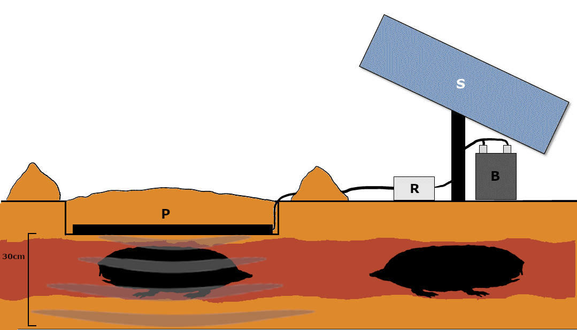

Figure S4: Placement of the reader array in the field. The panel (P) is placed directly over a burrow tunnel and continuously scans for transponder tags within 30cm. Data are stored in internal memory or a USB drive (R). The array is attached to a battery (B) and/or solar panel (S) for power.

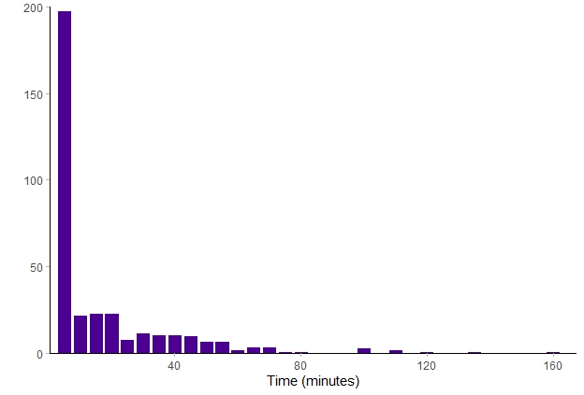

Figure S5: Histogram of activity bout duration in minutes of Natal mole-rats across all recorded data points. A series of consecutive detections were assumed to be contained within a single activity bout of an animal if the subsequent reading was < 60 minutes after the preceding time. Activity points were then summed and grouped into 5-minute intervals.

Table S1: Predictors of daily activity of Natal mole-rat when assuming activity bouts last 30 minutes. Values are from a general linear mixed model with a negative binomial distribution. Animal identity and reader session were added as random variables. All continuous predictors were scaled to the mean and unit variance for model fitting.AIC = 3137.7, Condition R² = 0.03, Marginal R² = 0.08.

Predictor | Estimate | S. E. | P-value
Intercept | -4.64 | 2.01 | 0.02*
Body Mass | 0.04 | 0.23 | 0.87
Sex | -0.17 | 0.37 | 0.63
Reproductive Status | -0.06 | 0.61 | 0.92
Body Mass * Sex | -0.53 | 0.32 | 0.10
Reproductive Status * Sex | 1.06 | 0.79 | 0.18
Group Size | -0.00 | 0.16 | 0.99
sin(time in radians) | 0.87 | 1.54 | 0.57
cos(time in radians) | -0.18 | 0.30 | 0.55
Season | 0.10 | 1.04 | 0.92
Season * sin(time in radians) | -0.71 | 0.81 | 0.38
Daylight | -1.29 | 0.82 | 0.11
Daylight * Season | 0.82 | 0.44 | 0.06
Daylight * sin(time in radians) | -0.95 | 0.84 | 0.25
ΔP | -0.17 | 0.24 | 0.48
ΔP * Season | 0.10 | 0.13 | 0.43
ΔP * sin(time in radians) | 0.20 | 0.34 | 0.55
T_{air} | 3.92 | 1.17 | <0.001*
T_{air} * Season | -1.99 | 0.68 | 0.003*
T_{air}* sin(time in radians) | -3.43 | 1.34 | 0.01*
T_{S1} | -3.90 | 1.71 | 0.02*
T_{S1} * Season | 2.17 | 0.99 | 0.02*
T_{S1} * sin(time in radians) | 5.89 | 1.89 | 0.002*
T_{S2} | -0.79 | 1.26 | 0.53
T_{S2} * Season | 0.28 | 0.72 | 0.70
T_{S2} * sin(time in radians) | -0.99 | 1.13 | 0.38
T_{S3} | 2.31 | 2.24 | 0.30
T_{S3} * Season | -1.26 | 1.26 | 0.32
T_{S3} * sin(time in radians) | -0.86 | 1.82 | 0.63
Season * sin(time in radians) * Daylight | 0.65 | 0.46 | 0.16
Season * sin(time in radians) * ΔP | -0.08 | 0.19 | 0.69
Season * sin(time in radians) * T_{air} | 1.12 | 0.80 | 0.16
Season * sin(time in radians) * T_{S1} | -2.47 | 1.10 | 0.02*
Season * sin(time in radians) * T_{S2} | 0.69 | 0.65 | 0.29
Season * sin(time in radians) * T_{S3} | 0.03 | 1.01 | 0.98

Table S2: Minimum model predicting daily activity patterns of Natal mole-rats. Activity periods were assumed to have a duration of 1 hour. Continuous variables were scaled to unit variance. AIC 2838.6, conditional R² = 0.02, marginal R² = 0.06

Predictor | Estimate | S. E. | P-value
Intercept | -3.05 | 0.69 | < 0.001*
Body Mass | -0.28 | 0.16 | 0.08
Reproductive Status | 0.63 | 0.36 | 0.08
Season | -0.72 | 0.37 | 0.05
sin(time in radians) | -1.12 | 0.55 | 0.04*
cos(time in radians) | -0.08 | 0.29 | 0.77
Season * sin(time in radians) | 0.53 | 0.29 | 0.06
Daylight | -1.25 | 0.65 | 0.06
Daylight * Season | 0.97 | 0.34 | 0.004*
Daylight * sin(time in radians) | -0.74 | 0.65 | 0.26
Daylight * sin(time in radians) * Season | 0.67 | 0.36 | 0.06
T_{air} | 3.32 | 0.94 | 0.004*
T_{air}* Season | -1.52 | 0.54 | 0.005*
T_{air}* sin(time in radians) | -1.92 | 1.01 | 0.06
T_{air}* sin(time in radians) * Season | 0.50 | 0.62 | 0.42
T_{S1} | -3.38 | 1.27 | 0.008*
T_{S1} * Season | 1.59 | 0.72 | 0.03*
T_{S1} * sin(time in radians) | 3.63 | 1.19 | 0.002*
T_{S1} * sin(time in radians) * Season | -1.47 | 0.72 | 0.04*

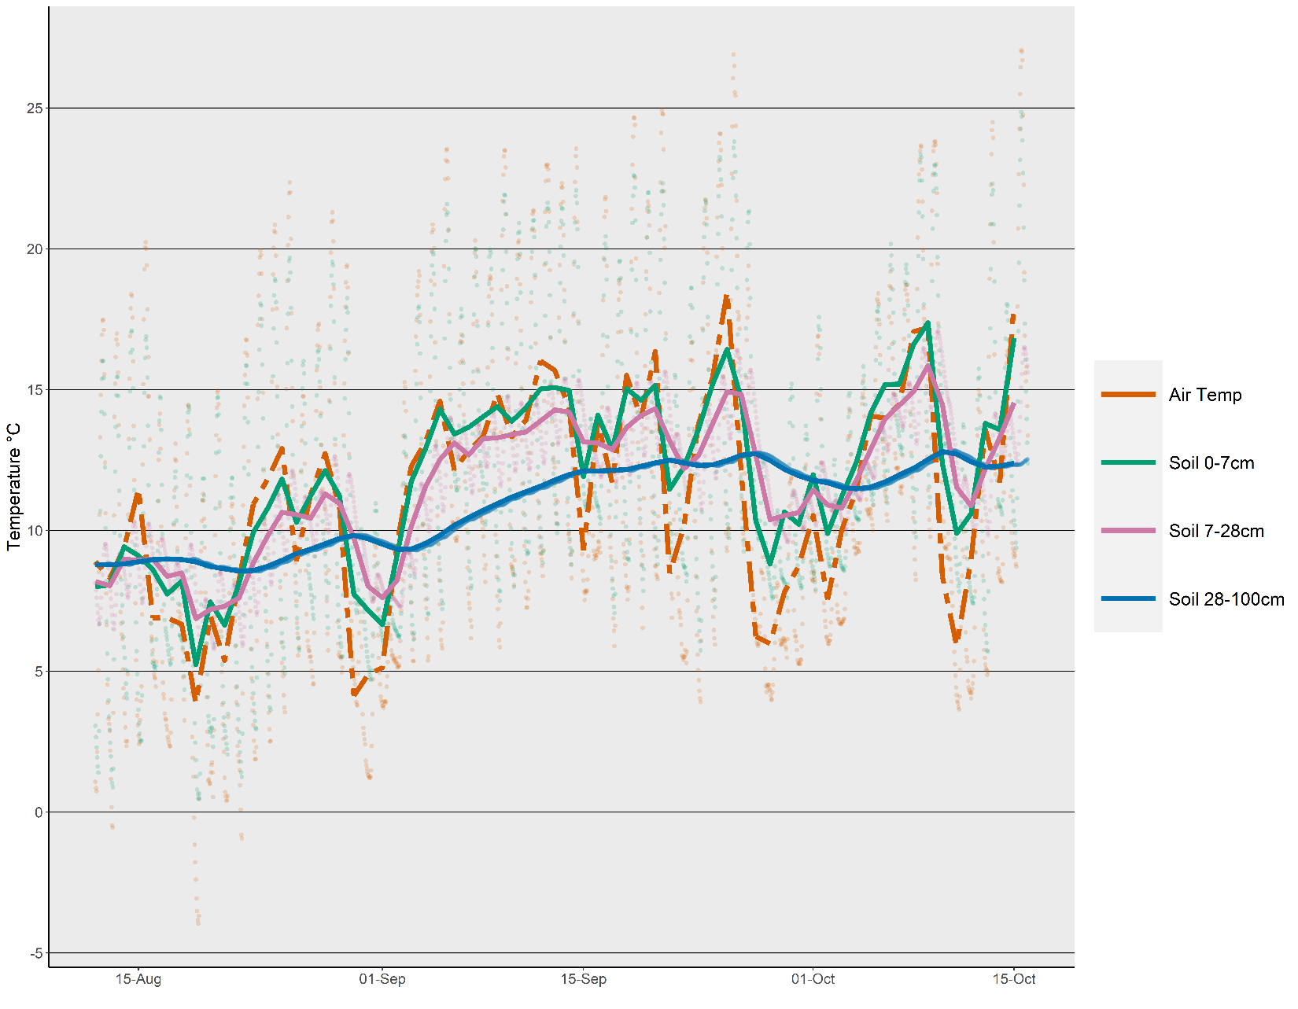
FigureS6: Mean daily air and soil temperatures at Glengarry during winter (August – October) 2020. Raw data temperatures are plotted in the background. The date range coincided with the placement of an RFID reader array to measure mole-rat activity. Air temperature (red, dashed) was measured 2m above the surface of the Earth. Soil temperatures were measured at 0-7cm (green), 7-28cm (violet), and 28-100cm (blue). Data are freely available from the Copernicus Climate Change Service, which holds the intellectual property rights of the raw data.

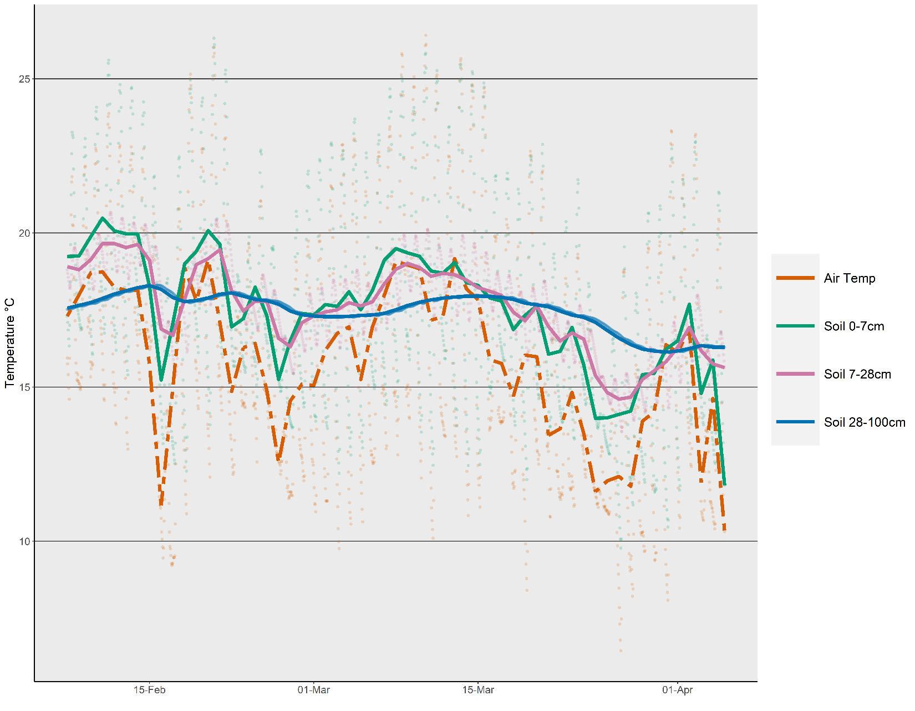
FigureS7: Mean daily air and soil temperatures at Glengarry during summer (February – April) 2021. Raw data temperatures are plotted in the background. The date range coincided with the placement of an RFID reader array to measure mole-rat activity. Air temperature (red, dashed) was measured 2m above the surface of the Earth. Soil temperatures were measured at 0-7cm (green), 7-28cm (violet), and 28-100cm (blue). Data are freely available from the Copernicus Climate Change Service, which holds the intellectual property rights of the raw data.

