Androgen-mediated maternal effects and trade-offs: postnatal hormone development, growth, and survivorship in wild meerkats

Charli S. Davies^{1,2,†,‡}, Caroline L. Shearer^{1,3,†}, Lydia K. Greene ^{1,2,3,§}, Jessica Mitchell^{1,2, ||}, Debbie Walsh^{1,2}, Vivian C. Goerlich^{1,2,#}, Tim H. Clutton-Brock^{2,4,5}, and Christine M. Drea^{1,2,3,6,*}

¹ Department of Evolutionary Anthropology, Duke University, Durham, NC, United States.
² Kalahari Research Trust, Kuruman River Reserve, Northern Cape, South Africa.
³ University Program in Ecology, Duke University, Durham, NC, United States.
⁴ Department of Zoology, University of Cambridge, Cambridge, United Kingdom.
⁵ Mammal Research Institute, University of Pretoria, 0002 Pretoria, South Africa.
⁶ Department of Biology, Duke University, Durham, NC, United States.

† These authors share first authorship

*Correspondence: Christine Drea, cdrea@duke.edu

Present addresses:
‡ Department of Biological and Environmental Science, University of Jyväskylä, Jyväskylä, Finland.
§ Department of Biology, Duke University, Durham, NC, United States
|| Global Academy for Agriculture and Food Science, Veterinary School, University of Edinburgh, UK.
# Animals in Science and Society, Department of Population Health Sciences, Faculty of Veterinary Medicine, Utrecht University, Utrecht, the Netherlands

Abstract

Introduction: Mammalian reproductive and somatic development is regulated by steroid hormones, growth hormone (GH), and insulin-like growth factor-1 (IGF-1). Based largely on information from humans, model organisms, and domesticated animals, testosterone (T) and the GH/IGF-1 system activate sexually differentiated development, promoting male-biased growth, often at a cost to health and survivorship. To test if augmented prenatal androgen exposure in females produces similar developmental patterns and trade-offs, we examine maternal effects in wild meerkats (Suricata suricatta), a non-model species in which adult females naturally, albeit differentially by status, express exceptionally high androgen concentrations, particularly during pregnancy. In this cooperative breeder, the early growth of daughters predicts future breeding status and reproductive success.

Methods: We examine effects of normative and experimentally induced variation in maternal androgens on the ontogenetic patterns in offspring reproductive hormones (androstenedione, A4; T; estradiol, E2), IGF-1, growth from pup emergence at 1 month to puberty at 1 year, and survivorship. Specifically, we compare the male and female offspring of dominant control (DC or high-T), subordinate control (SC or lower-T), and dominant treated (DT or blocked-T) dams, the latter having experienced antiandrogen treatment in late gestation.

Results: Meerkat offspring showed sex differences in absolute T and IGF-1 concentrations, developmental rates of A4 and E2 expression, and survivorship — effects that were sometimes socially or environmentally modulated. Atypical for mammals were the early male bias in T that disappeared by puberty, the absence of sex differences in A4 and E2, and the female bias in IGF-1. Food availability was linked to steroid concentrations in females and to IGF-1, potentially growth, and survival in both sexes. Maternal treatment significantly affected rates of T, E2, and IGF-1 expression, and weight, with marginal effects on survivorship; offspring of DT dams showed peak IGF-1 concentrations and the best survivorship.

Discussion: Maternal effects thus impact offspring development in meerkats, with associated trade-offs: Whereas prenatal androgens modify postnatal reproductive and somatic physiology, benefits associated with enhanced competitiveness in DC lineages may have initial costs of reduced IGF-1, delay in weight gain, and decreased survivorship. These novel data further confirm the different evolutionary and mechanistic pathways to cooperative breeding and call for greater consideration of natural endocrine variation in both sexes.

Keywords: female masculinization, flutamide, IGF-1, life-history trade-offs, ontogeny, prenatal programming, sex steroids, sexual differentiation

Table S1 | Predictors of serum hormone concentrations in meerkat (Suricata suricatta) offspring, based on top models. The offspring were from one of three maternal treatment groups: Dominant Control (DC) had naturally greater androgen exposure in utero; Subordinate Control (SC) had naturally lower androgen exposure; Dominant Treated (DT) had experimentally blocked androgen receptors during late gestation.

Hormone | Model information
Androstenedione, A₄*  n = 249 | Parametric terms | Estimate (SE) | t | P
Androstenedione, A₄*  n = 249 | Sex: Female | 0.17 (0.18) | 0.92 | 0.358
Androstenedione, A₄*  n = 249 | Maternal treatment: SC | - 0.21 (0.22) | -1.24 | 0.325
Androstenedione, A₄*  n = 249 | Maternal treatment: DT | -0.12 (0.27) | -0.44 | 0.661
Androstenedione, A₄*  n = 249 | Smooth terms | EDF | F | P
Androstenedione, A₄*  n = 249 | Age (Male) | 3.421 | 3.34 | 0.017
Androstenedione, A₄*  n = 249 | Age (Female) | 2.615 | 3.36 | 0.019
Androstenedione, A₄*  n = 249 | Total monthly rainfall | 1.704 | 1.31 | 0.354
Androstenedione, A₄*  n = 249 | Body condition residuals | 5.582 | 6.87 | < 0.001
Testosterone, T*  n = 236 | Parametric terms | Estimate (SE) | t | P
Testosterone, T*  n = 236 | Sex: Female | -1.60 (0.24) | -6.78 | < 0.001
Testosterone, T*  n = 236 | Maternal treatment: SC | -0.18 (0.32) | -0.57 | 0.567
Testosterone, T*  n = 236 | Maternal treatment: DT | 0.03 (0.41) | 0.08 | 0.934
Testosterone, T*  n = 236 | Smooth terms | EDF | F | P
Testosterone, T*  n = 236 | Age (Male) | 1.957 | 2.34 | 0.256
Testosterone, T*  n = 236 | Age (Female) | 2.25 | 2.24 | 0.094
Testosterone, T*  n = 236 | Age (DC) | 1.002 | 1.78 | 0.184
Testosterone, T*  n = 236 | Age (SC) | 1.000 | 1.16 | 0.283
Testosterone, T*  n = 236 | Age (DT) | 1.557 | 3.50 | 0.032
Testosterone, T*  n = 236 | Total monthly rainfall (Male) | 1.352 | 1.12 | 0.421
Testosterone, T*  n = 236 | Total monthly rainfall (Female) | 1.745 | 3.84 | 0.031
Testosterone, T*  n = 236 | Body condition residuals | 2.692 | 28.04 | < 0.001
Estradiol, E₂  n = 160 | Parametric terms | Estimate (SE) | t | P
Estradiol, E₂  n = 160 | Sex: Female | 0.20 (0.17) | 1.15 | 0.252
Estradiol, E₂  n = 160 | Maternal treatment: SC | -0.21 (0.29) | -0.71 | 0.477
Estradiol, E₂  n = 160 | Maternal treatment: DT | 0.06 (0.38) | 0.15 | 0.881
Estradiol, E₂  n = 160 | Total monthly rainfall | 0.001 (0.003) | 0.40 | 0.688
Estradiol, E₂  n = 160 | Clan size | -0.04 (0.01) | -3.15 | 0.002
Estradiol, E₂  n = 160 | Total monthly rainfall*Sex | -0.01 (0.005) | -3.03 | 0.003
Estradiol, E₂  n = 160 | Smooth terms | EDF | F | P
Estradiol, E₂  n = 160 | Age (Male) | 1.000 | 0.88 | 0.351
Estradiol, E₂  n = 160 | Age (Female) | 2.501 | 8.99 | 0.015
Estradiol, E₂  n = 160 | Age (DC) | 0.073 | 0.002 | 0.999
Estradiol, E₂  n = 160 | Age (SC) | 1.000 | 3.47 | 0.065
Estradiol, E₂  n = 160 | Age (DT) | 1.000 | 7.10 | 0.009
Estradiol, E₂  n = 160 | Body condition residuals | 1.002 | 3.97 | 0.048
Insulin-like growth factor-1, IGF-1  n = 155 | Parametric terms | Estimate (SE) | t | P
Insulin-like growth factor-1, IGF-1  n = 155 | Sex: Female | 0.26 (0.11) | 2.31 | 0.023
Insulin-like growth factor-1, IGF-1  n = 155 | Maternal treatment: SC | 0.15 (0.17) | 0.87 | 0.387
Insulin-like growth factor-1, IGF-1  n = 155 | Maternal treatment: DT | 0.26 (0.22) | 1.18 | 0.242
Insulin-like growth factor-1, IGF-1  n = 155 | Total monthly rainfall | 0.01 (0.002) | 4.75 | < 0.001
Insulin-like growth factor-1, IGF-1  n = 155 | Body condition residuals | 0.003 (0.001) | 2.94 | 0.004
Insulin-like growth factor-1, IGF-1  n = 155 | Clan size | -0.03 (0.01) | -2.81 | 0.006
Insulin-like growth factor-1, IGF-1  n = 155 | Total monthly rainfall*Sex | -0.01 (0.003) | -2.07 | 0.041
Insulin-like growth factor-1, IGF-1  n = 155 | Smooth terms | EDF | F | P
Insulin-like growth factor-1, IGF-1  n = 155 | Age (DC) | 2.462 | 3.30 | 0.040
Insulin-like growth factor-1, IGF-1  n = 155 | Age (SC) | 3.131 | 3.04 | 0.016
Insulin-like growth factor-1, IGF-1  n = 155 | Age (DT) | 2.437 | 2.47 | 0.069
Note. These results derive from generalized additive models (GAM). Random effects include individual and litter. All comparisons were made against the indicated levels of each factor: Sex = male; Maternal treatment = dominant control. Terms in parentheses are levels of the “by” factor for a given smooth. Estimates are on log scale. The empirical distribution function (EDF) is related to the non-linearity of the smooth term, with values close to 1 approaching linear. t = Wald parametric test statistic. F = test statistic for confidence interval of smooth terms. Bolding indicates significant terms (P < 0.05); italics indicate trends (P < 0.10).
*Clan size was excluded from the model because it did not reach significance or improve the deviance explained by at least 1%.

Table S2 | Predictors of serum hormone concentrations in meerkat (Suricata suricatta) offspring at 12 months. The offspring were from one of three maternal treatment groups: Dominant Control (DC) had naturally greater androgen exposure in utero; Subordinate Control (SC) had naturally lower androgen exposure; Dominant Treated (DT) had experimentally blocked androgen receptors during late gestation.

Hormone | Model information
Androstenedione, A₄  n = 43 | Parametric terms | Estimate (SE) | z | P
Androstenedione, A₄  n = 43 | Sex: Female | 0.83 (0.45) | 1.85 | 0.064
Androstenedione, A₄  n = 43 | Maternal treatment: SC | -0.24 (0.48) | -0.50 | 0.619
Androstenedione, A₄  n = 43 | Maternal treatment: DT | -0.25 (0.57) | -0.45 | 0.656
Androstenedione, A₄  n = 43 | Total monthly rainfall | 0.07 (0.04) | 1.90 | 0.057
Androstenedione, A₄  n = 43 | Body condition residuals | 0.003 (0.003) | 1.20 | 0.229
Testosterone, T  n = 33 | Parametric terms | Estimate (SE) | z | P
Testosterone, T  n = 33 | Sex: Female | -0.67 (1.11) | -0.61 | 0.542
Testosterone, T  n = 33 | Maternal treatment: SC | 0.17 (0.66) | 0.25 | 0.801
Testosterone, T  n = 33 | Maternal treatment: DT | 0.64 (0.76) | 0.84 | 0.403
Testosterone, T  n = 33 | Total monthly rainfall | 0.06 (0.04) | 1.46 | 0.144
Testosterone, T  n = 33 | Total monthly rainfall*Sex | 0.005 (0.005) | 1.06 | 0.288
Testosterone, T  n = 33 | Body condition residuals | 0.15 (0.24) | 0.65 | 0.518
Estradiol, E₂  n = 36 | Parametric terms | Estimate (SE) | z | P
Estradiol, E₂  n = 36 | Sex: Female | 0.69 (0.47) | 1.46 | 0.145
Estradiol, E₂  n = 36 | Maternal treatment: SC | -0.64 (0.36) | -1.80 | 0.072
Estradiol, E₂  n = 36 | Maternal treatment: DT | 0.14 (0.38) | 0.38 | 0.706
Estradiol, E₂  n = 36 | Total monthly rainfall | 0.08 (0.02) | 3.43 | <0.001
Estradiol, E₂  n = 36 | Clan size | -0.10 (0.03) | -3.37 | <0.001
Estradiol, E₂  n = 36 | Total monthly rainfall*Sex | -0.05 (0.08) | -0.63 | 0.526
Estradiol, E₂  n = 36 | Body condition residuals | 0.004 (0.002) | 2.15 | 0.032
Insulin-like growth factor 1, IGF-1  n = 33 | Parametric terms | Estimate (SE) | t | P
Insulin-like growth factor 1, IGF-1  n = 33 | Sex: Female | 0.38 (0.24) | 1.58 | 0.114
Insulin-like growth factor 1, IGF-1  n = 33 | Maternal treatment: SC | 0.10 (0.15) | -0.64 | 0.523
Insulin-like growth factor 1, IGF-1  n = 33 | Maternal treatment: DT | 0.24 (0.16) | 1.54 | 0.124
Insulin-like growth factor 1, IGF-1  n = 33 | Total monthly rainfall | 0.04 (0.01) | 3.83 | <0.001
Insulin-like growth factor 1, IGF-1  n = 33 | Body condition residuals | 0.005 (0.001) | 5.80 | <0.001
Insulin-like growth factor 1, IGF-1  n = 33 | Clan size | -0.03 (0.01) | -2.10 | 0.036
Insulin-like growth factor 1, IGF-1  n = 33 | Total monthly rainfall*Sex | -0.02 (0.05) | -0.35 | 0.723
Note. These results derive from generalized linear mixed models (GLMMs). Random effects include individual. All comparisons were made against the indicated levels of each factor: Sex = male; Maternal treatment = dominant control. Estimates are on log scale. z = test statistic. Bolding indicates significant terms (P < 0.05); italics indicate trends (P < 0.10). Model terms were based on top GAM model for each hormone in Table S1.

Table S3 | Predictors of weight in meerkat (Suricata suricatta) offspring. The offspring were from one of three maternal treatment groups: Dominant Control (DC) had naturally greater androgen exposure in utero; Subordinate Control (SC) had naturally lower androgen exposure; Dominant Treated (DT) had experimentally blocked androgen receptors during late gestation.

Parametric terms | Estimate (SE) | t | P
Sex: Female | 3.62 (4.41) | 0.82 | 0.412
Maternal treatment: SC | 3.99 (21.03) | 0.19 | 0.850
Maternal treatment: DT | -0.59 (28.86) | -0.02 | 0.984
Total monthly rainfall | -0.15 (0.09) | -1.68 | 0.094
Average hindfoot length | 5.81 (0.66) | 8.76 | < 0.001
Smooth terms | EDF | F | P
Age (DC) | 3.466 | 44.33 | < 0.001
Age (SC) | 3.583 | 67.67 | < 0.001
Age (DT) | 2.540 | 35.26 | < 0.001
Clan size | 1.926 | 18.28 | < 0.001
Note. These results derive from a generalized additive model (GAM). Random effects include individual (n = 299) and litter. All comparisons were made against the indicated levels of each factor: Sex = male; Maternal treatment = dominant control. Terms in parentheses are levels of the “by” factor for a given smooth. Estimates are on response scale. The empirical distribution function (EDF) is related to the non-linearity of the smooth term, with values close to 1 approaching linear. t = Wald parametric test statistic. F = test statistic for confidence interval of smooth terms. Bolding indicates significant terms (P < 0.05); italics indicate trends (P < 0.10).

Table S4 | Predictors of weight at 12 months in meerkat (Suricata suricatta) offspring. The offspring were from one of three maternal treatment groups: Dominant Control (DC) had naturally greater androgen exposure in utero; Subordinate Control (SC) had naturally lower androgen exposure; Dominant Treated (DT) had experimentally blocked androgen receptors during late gestation.

Parametric terms | Estimate (SE) | t | P
Sex: Female | -7.46 (23.19) | -0.32 | 0.748
Maternal treatment: SC | -21.17 (26.19) | -0.81 | 0.419
Maternal treatment: DT | -31.55 (33.52) | -0.94 | 0.347
Total monthly rainfall | 1.59 (2.02) | 0.79 | 0.430
Average hindfoot length | 15.92 (5.92) | 2.69 | 0.007
Clan size | -1.06 (2.15) | -0.49 | 0.623
Note. These results derive from generalized linear mixed models (GLMMs). Random effects include individual (n = 39). All comparisons were made against the indicated levels of each factor: Sex = male; Maternal treatment = dominant control. Estimates are on log scale. z = test statistic. Bolding indicates significant terms (P < 0.05); italics indicate trends (P < 0.10). Model terms were based on top GAM model for weight in Table S2.

Table S5 | Survivorship from pup emergence to adulthood (1 year) in meerkat (Suricata suricatta) offspring. The offspring were from one of three maternal treatment groups: Dominant Control (DC) had naturally greater androgen exposure in utero; Subordinate Control (SC) had naturally lower androgen exposure; Dominant Treated (DT) had experimentally blocked androgen receptors during late gestation.

Terms | ß | SE | z | P
(Intercept) | 0.50 | 0.82 | 0.06 | 0.952
Maternal treatment: Dominant control | 0.30 | 0.66 | 0.45 | 0.653
Maternal treatment: Dominant treated | 1.60 | 0.96 | 1.67 | 0.095
Sex: Male | 1.20 | 0.59 | 2.01 | 0.044
Monthly rainfall at emergence | -0.03 | 0.01 | -3.01 | 0.003
Clan size at emergence | 0.02 | 0.04 | 0.56 | 0.575
Note. These results derive from a binomial generalized linear mixed model (GLMM) on n = 92 individuals. β = the conditional model-averaged estimates. All continuous factors were standardised. Estimates are in reference to: Sex = female; Maternal treatment = subordinate control. Bolding indicates significant terms (P < 0.05); italics indicate trends (P < 0.10).

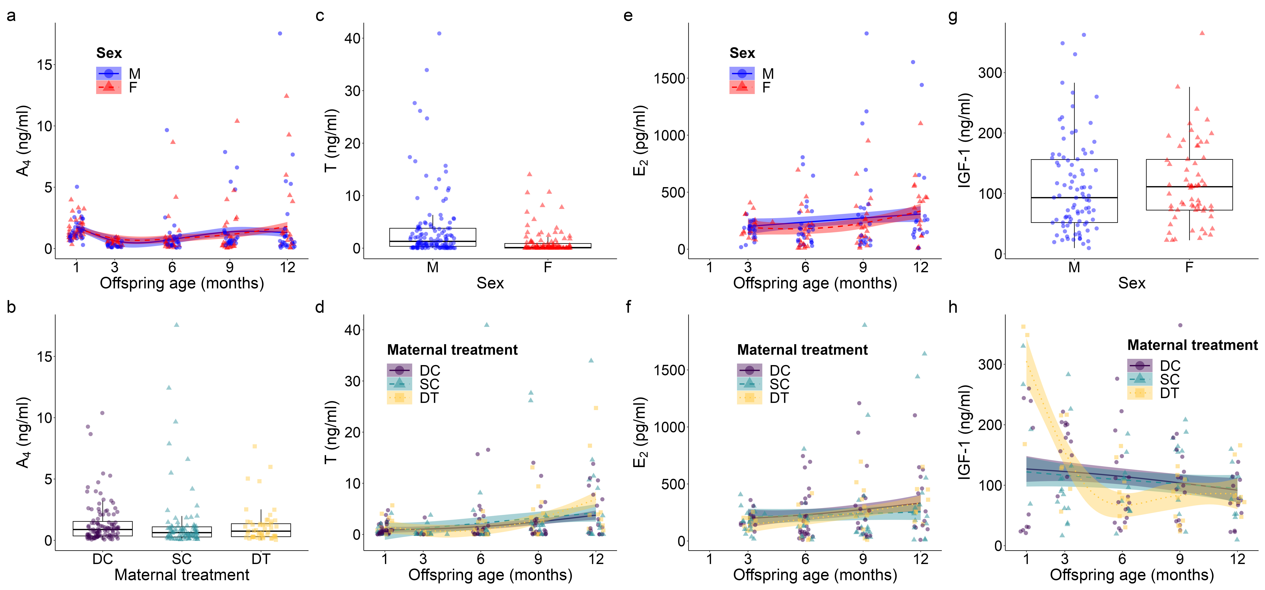

Figure S1. Top model-predicted serum concentrations of (a, b) androstenedione or A₄, (c, d) testosterone or T, (e, f) estradiol or E₂, and (g, h) insulin-like growth factor 1 or IGF-1 for meerkats by sex (male, M; female, F), age, and/or maternal treatment (dominant control, DC; subordinate control, SC; dominant treated, DT). Sections reprise Figure 1 in the main text, but additionally provide all individual values.

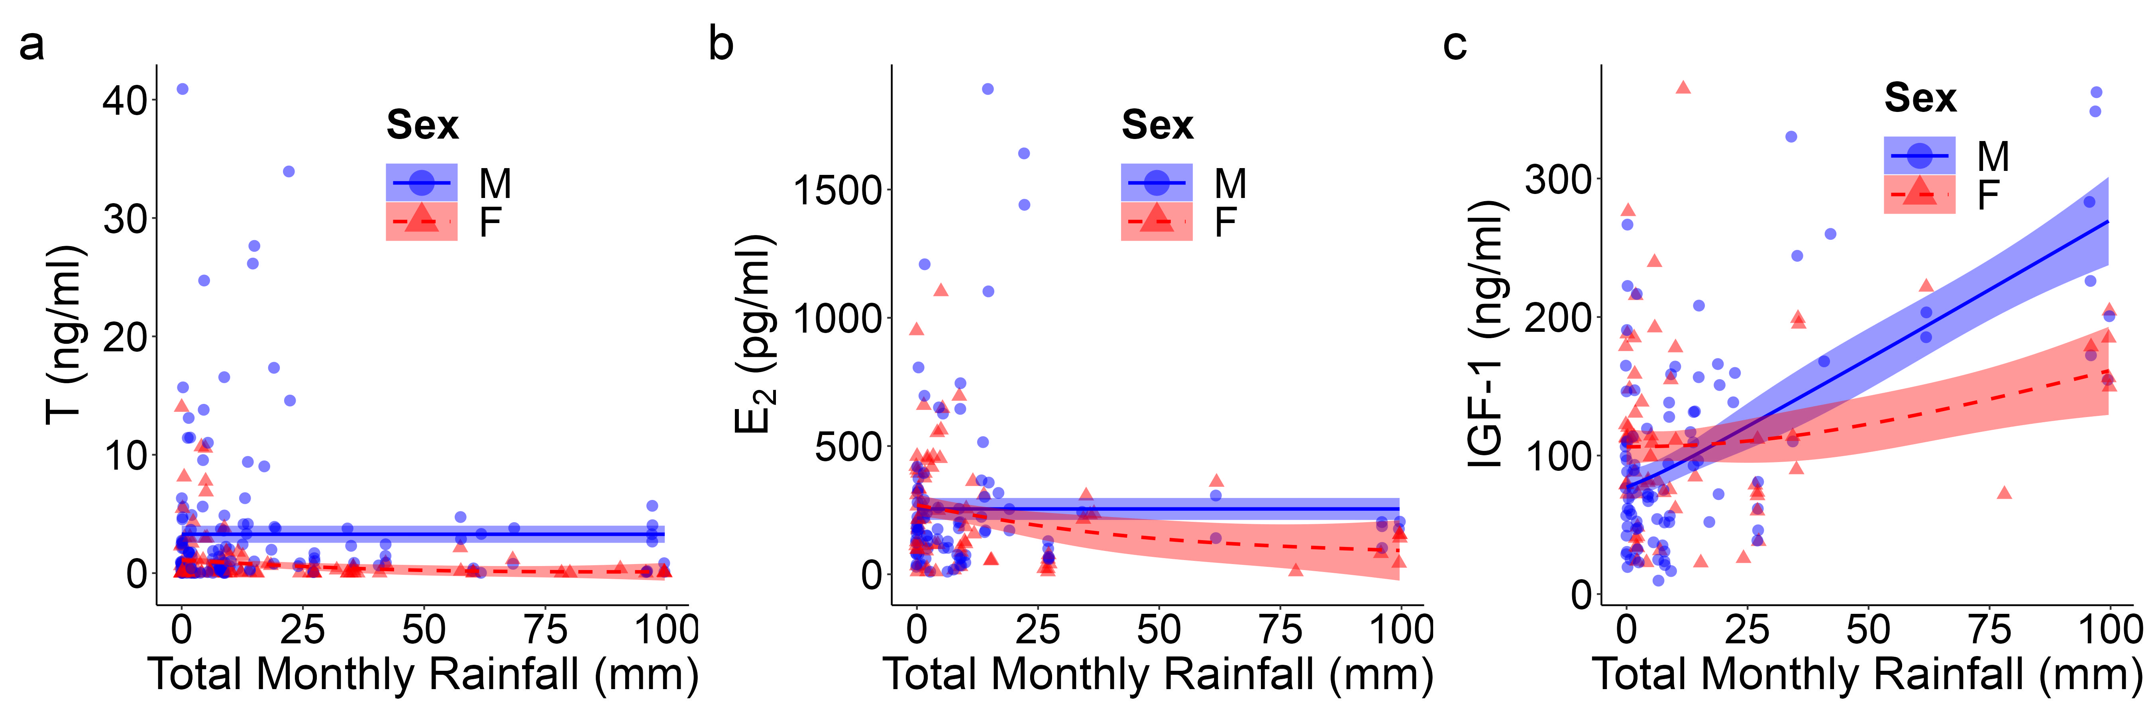

Figure S2. Top model-predicted serum concentrations of (a) testosterone or T, (b) estradiol or E₂, and (c) insulin-like growth factor 1 or IGF-1 for meerkats by sex (male, M; female, F) and total monthly rainfall (mm). Sections reprise Figure 2 in the main text, but additionally provide all individual values.

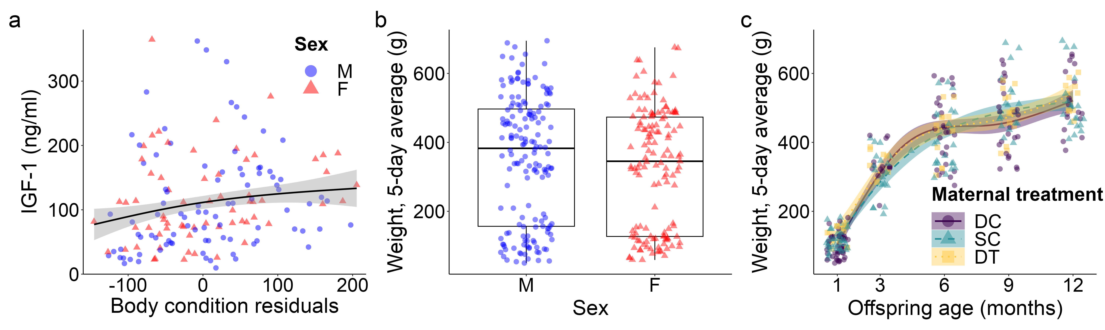

Figure S3. Top model-predicted (a) IGF-1 concentrations and (b, c) weights for meerkat offspring. Sections reprise Figure 3 in the main text, but additionally provide all individual values.

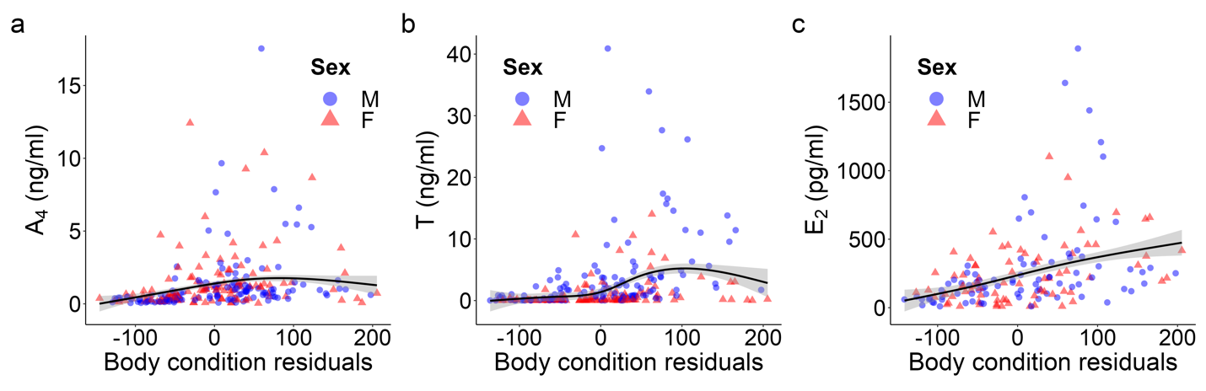
Figure S4. Plots of serum hormone concentrations by body condition residuals from top models generated for young meerkats (Suricata suricatta), showing (a) androstenedione or A₄, (b) testosterone or T, and (c) estradiol or E₂. Raw data are plotted by sex (male, M; female, F) from 1-12 months of age, with a smooth of model estimates and their 95% confidence interval. In (a), a single value of A₄ (~30 ng/ml) at 1 month of age was excluded for a young male from a dominant control dam (with the highest testosterone concentrations), for ease of visualization.

