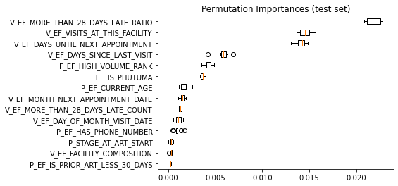
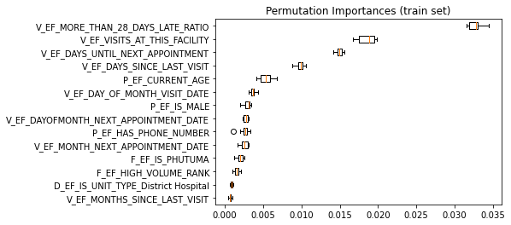
B
A
Supplementary Figure 1: Feature permutation importance stratified by training set (A) and test set (B)

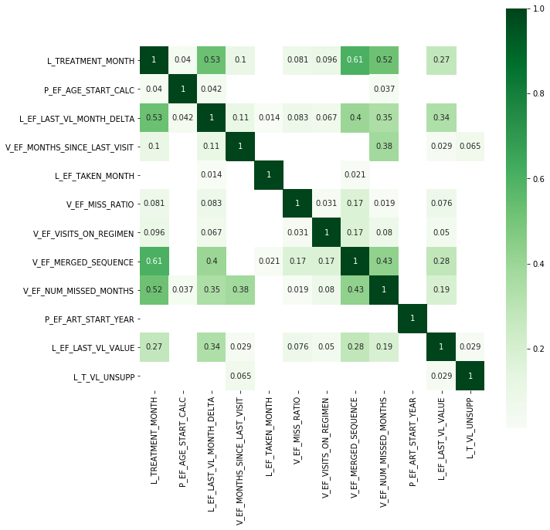

Supplementary Figure 2: Feature correlation matrix (VL model)

Supplementary Table 1: Model performance metrics stratified by number of included features
N Features | N | Train % | Test % | Precision | Recall | F1 score | Acc % | AUC
Top 5 | 711737 | 50% | 10.70% | 0.14 | 0.51 | 0.22 | 62% | 0.603
Top 7 | 436910 | 50% | 9.73% | 0.14 | 0.51 | 0.22 | 64% | 0.612
Top 10 | 711737 | 50% | 10.60% | 0.17 | 0.59 | 0.27 | 66% | 0.674
Top 25 | 436910 | 50% | 9.80% | 0.16 | 0.59 | 0.25 | 66% | 0.674
All 75 inputs | 711737 | 50% | 10.60% | 0.16 | 0.51 | 0.25 | 67% | 0.638

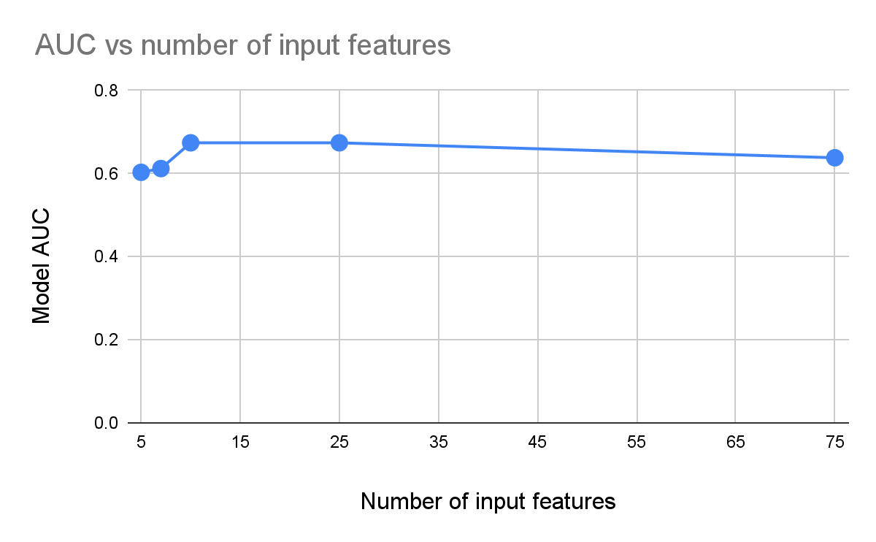

Supplementary Figure 3: Variation in Area Under the Curve (AUC) by number of input features included in the model

