Supplementary Information for ‘Conference contributions by section members of the International Union for the Study of Social Insects (IUSSI) at international IUSSI conferences (1952-2022) are not in accordance with membership numbers’

Anja Buttstedt, Christian W. W. Pirk & Abdullahi A. Yusuf

1. SUPPLEMENTARY MATERIAL AND METHODS
1.2 Peculiarities per year
1957 – Affiliations were taken from the 1957 member list (Richard, 1957). 1961 – B. Hocking is in the programme specified as ‘Arusha’ which is in Tanzania, but in the participants list the University of Alberta, Canada is given as affiliation. Thus, this was counted as Canada. 1973 – No indication whether a contribution was a talk or a poster; thus, we assumed that all contributions were talks as posters were not common at that time. 1977 – 16 more ‘papers’ were known to the editor by title only (no abstract and no affiliations listed, page 162 (Proceedings of the eighth International Congress of the IUSSI, 1977)) which we could not include due to missing information. 1982 – No indication whether a contribution was a talk or a poster. As in 1986 poster contributions were certainly included, we listed all contributions of 1982 as unclear. 1998 – No indication whether a contribution was a talk or a poster and we listed all contributions as unclear. The “inlay” paper with the contribution of C. L. Gross was included. J. Korb is in two different contributions listed with two different affiliations (Australian and German) which we counted once as Oceania and once as Europe. While duplicate contributions were counted once like in the abstract by J. Nakamura, J. Takahashi, T. Yoshida & H. Hoshiba which was printed twice. 2006 – Presenting authors were taken from the printed congress programme. Presenters of posters were not indicated in the printed programme but on the online website. Data from the website (https://iussi.confex.com/iussi/2006/techprogram/MEETING.HTM) were obtained in October 2021. Since September 2023 the website does not exist any more. 2014 – Presenting authors are not clearly specified within the ‘Abstract book’ but one of the authors is highlighted in bold. We therefore assumed that is the presenting author. In the ‘Abstract book’ affiliations are not listed but the ‘Program book’ has a ‘Presenting authors index’ and a ‘Delegate list’. Only the ‘Delegate list’ includes affiliation and country. Thus, country and continent of the ‘Delegate list’ were assigned to presenting authors identified in the ‘Abstract book’. However, some presenting authors were not listed among the delegates and thus the country and continent of 146 contributions out of 622 was identified as unclear. Further, few authors in the ‘Presenting authors index’ were not found in the Abstract book and were not included. ‘Posters’ and ‘Poster talks’ are duplicates of the very same thing. However, we counted them as individual contribution each as the presenting author thus had two “appearances” at the conference. In addition, there were a few mismatches between the ‘Abstract book’ and the ‘Program’: for example, Stefano Turillazzi (P050 & P147), Kevin Loope (P105) and Tamara Hartke (P176) are all included in the ‘Abstract book’ but not in the ‘Program’ and Georg Fischer (P194) is listed in the ‘Program’ but not in the ‘Abstract book’. As they were all included in the ‘Delegate list’, we included all of these contributions. Takao Sasaki appeared twice on the ‘Delegate list’ (for UK and USA) whereas Ken Sasaki is missing and we included the contributions from both authors as country ‘Unclear’. As affiliations were only given for ‘Presenting authors’ and ‘Delegates’ but not for additional authors, affiliation, country and continent number could not be assigned for this year. 2018 – For three presenters their institution was not matched to their countries (Pierre Blacher, University Lausanne, France; Flávio Camarota, George Washington University, Brazil; Ana Jesovnik, Smithsonian Institution, Croatia). We assumed that those were mismatches of the ‘Current institution’ and the nationality of the presenter and the country was taken from publications of those authors (De Gasperin et al., 2020; Koch et al., 2018; Li et al., 2020). The University of Lausanne was counted as Switzerland and the George Washington University as well as the Smithsonian Institution as USA. As the PDF programme only included the presenting authors and affiliations, information on numbers of authors and study system were taken from the abstracts on the website (www.iussi2018.com/symposia-abstract) in October 2021. As of September 2023, the website does not exist any more (The first author was usually listed in duplicate on the website (sometimes as first and last), thus we counted this as one contribution. For nine presentations, the abstracts were not found online although they were in the PDF programme. For these presentations no data on author number and affiliation number were available. 2022 – As the PDF programme only included the presenting authors; information on affiliation, numbers of authors and study system were taken in July 2022 from the available websites https://iussi2022.pathable.co/speakers and https://burkclients.com/IUSSI/symposiums/#/ which do not exist any more (19.09.2023). Evelyn Aviles Rios, Emma Courtney, Tim Gernat, Jerome Gippet, Rodrigo Pracana and Yosef Hamba Tola are listed as speakers on the website but are not in the PDF programme. Thus, they were not included in the analysis. This was the first hybrid conference of the IUSSI and we would have liked to include which presenters were in San Diego ‘in person’ and who presented ‘online’. Even though the PDF programme differentiates between ‘Virtual Poster Sessions’ and ‘Virtual Sessions’ (presumably online presenters) and ‘Poster Sessions’ and ‘Symposia’ (presumably in person presenters) we personally know several presenters who intended attending ‘in person’ and were listed within the normal ‘Symposia’ sessions but eventually presented ‘online’. Thus, we did not think that this information in the programme was reliable enough to include them.

2. SUPPLEMENTARY FIGURES

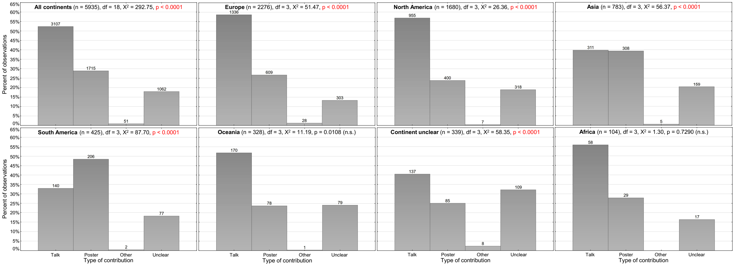
Figure S1: Type of contribution according to continent affiliation of the presenting author. Numbers on top of the bars are counts. Statistics have been performed using first an overall Χ²-test for all continents followed by multiple Χ²-tests for the individual continents (corrected p-value for multiple (7) testing: p < 0.0071). Significant p-values are highlighted in red. n.s., not significant.

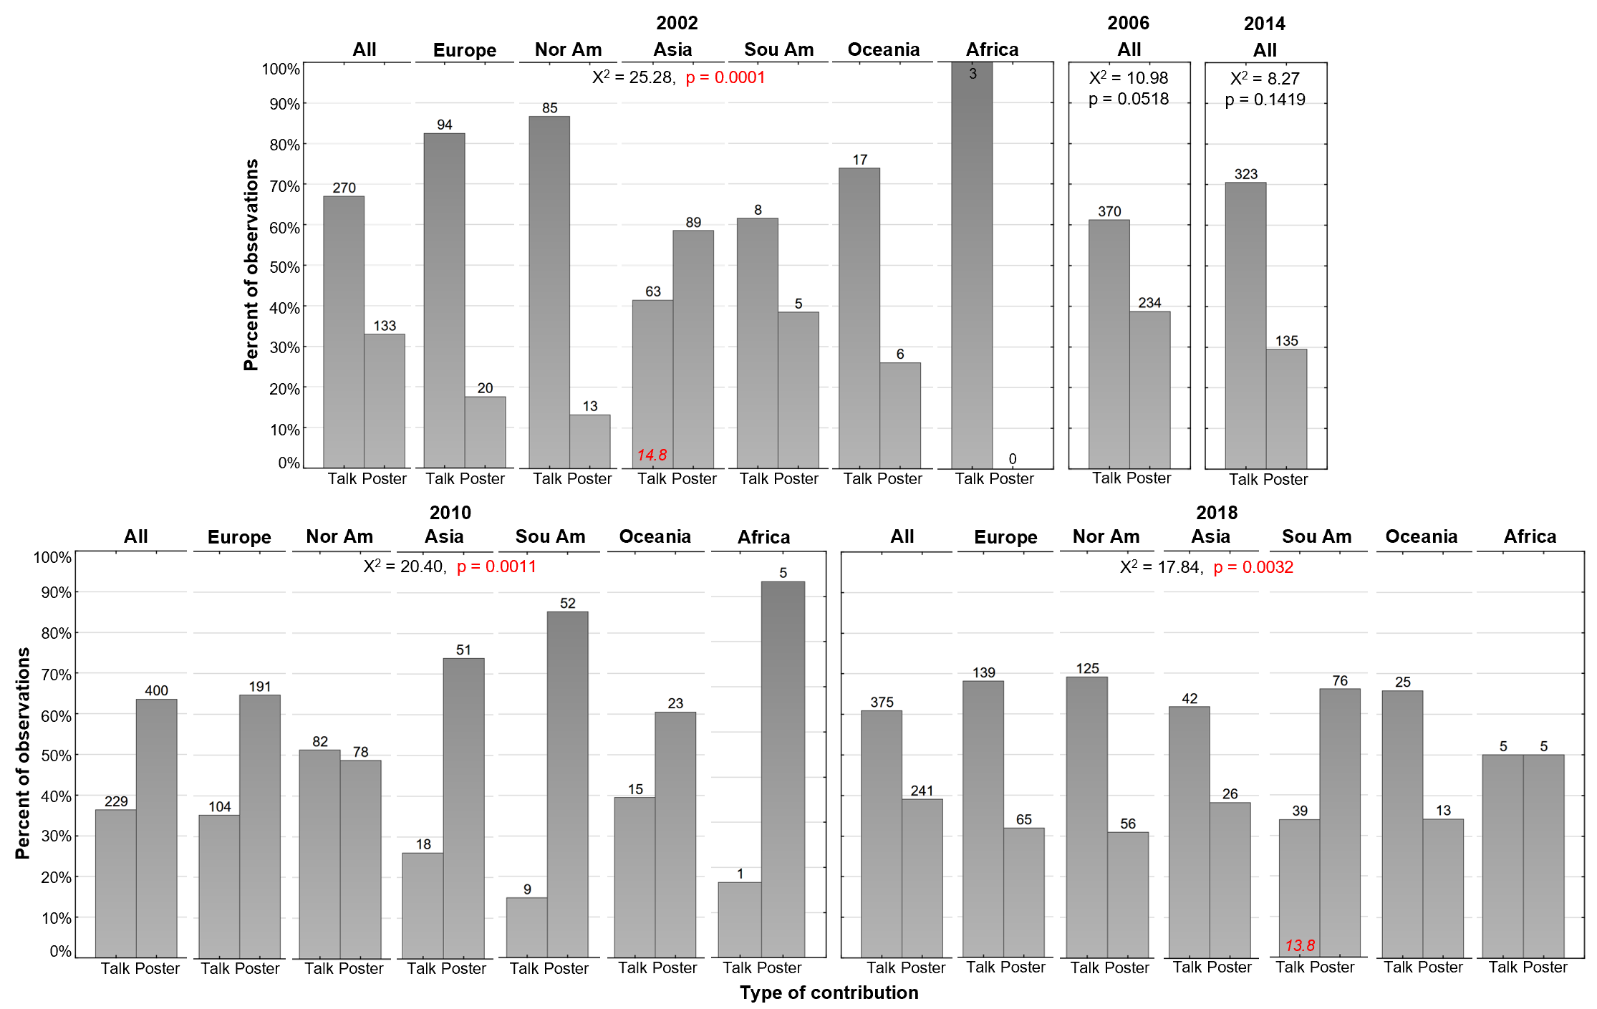
Figure S2: Talk and poster contributions according to continent affiliation of the presenting author for the years 2002, 2006, 2010, 2014 and 2018. Numbers on top of the bars are counts. Statistics have been performed using multiple Χ²-tests for the individual years (corrected p-value for multiple (5) testing: p < 0.01). Significant p-values are highlighted in red. Individual $Χ^{2}$-values are given in italics at the bottom of the bars if they exceeded the critical $Χ^{2}$ = 11.1 (df = 5).

3. SUPPLEMENTARY RESULTS
3.1 Author, country and continent numbers per contribution
Across all years (1952-2022), author numbers per contribution (n = 5917) were between one and 32 (2 ± 3 (median ± IQR)) with most contributions having a single author (n = 1907, 32.1%), followed by contributions with two (n = 1442, 24.3%), three (n = 1051, 17.7%), four (n = 698, 11.8%), more than five (n = 418, 7.0%) and five authors (n = 401, 6.8%) (Table S3). There was a significant correlation (Spearman’s rank correlation, n = 5917, ρ = 0.453, p < 0.0001) between number of authors per contribution and conference year (Figure S3).
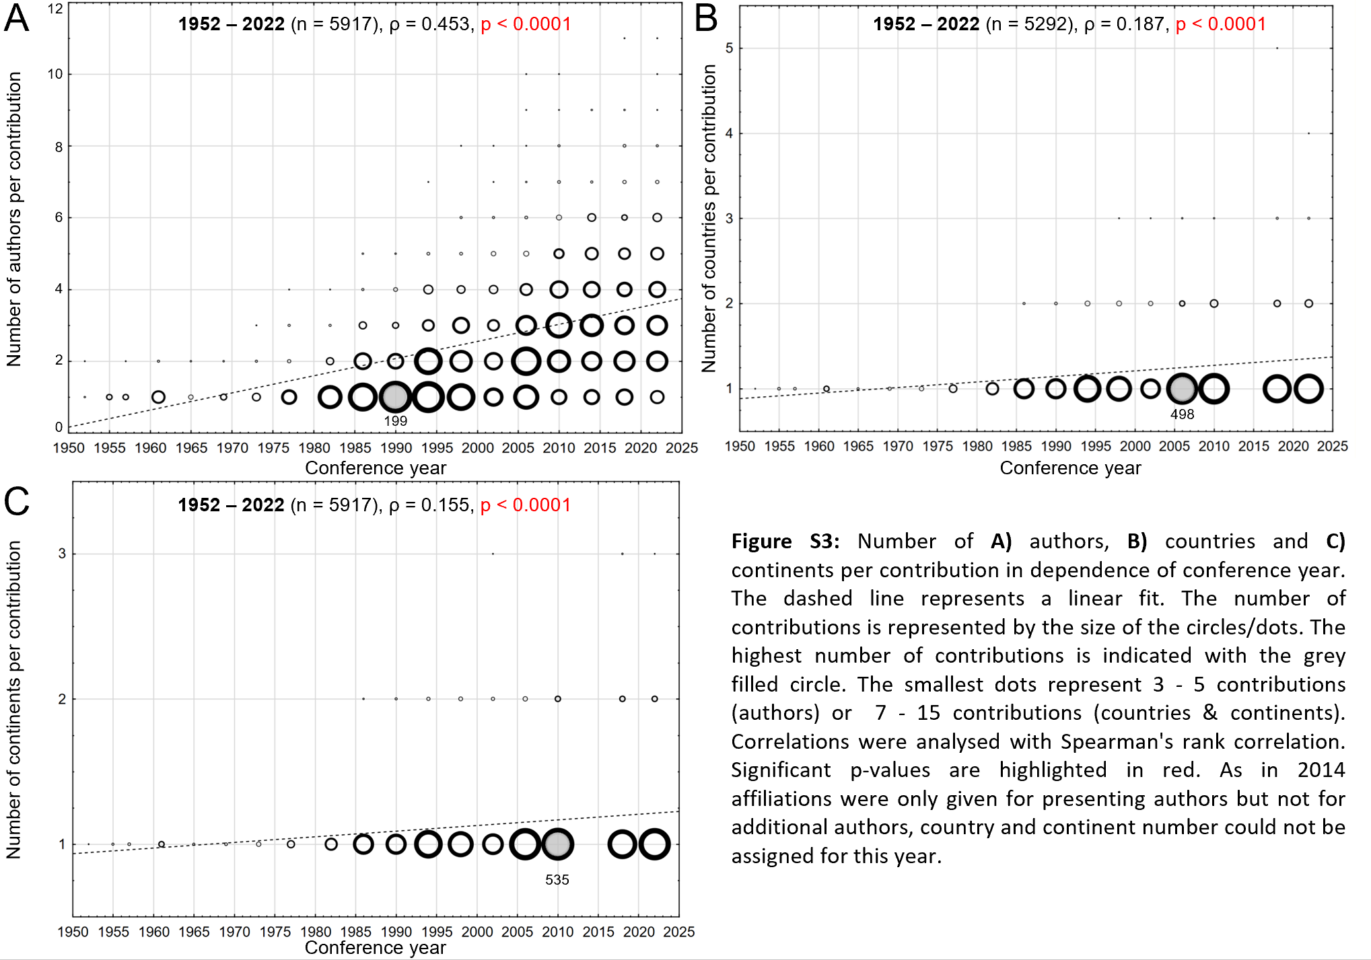

In addition, author number (defined as 1, 2, 3, 4, 5 and >5) was significantly influenced by conference year (considered from 1977 – 2022, as 1977 was the first year with more than 100 contributions) (overall $Χ^{2}$ = 1105.4, df = 55, n = 5587, p < 0.0001) (Table S2) with only 2002 and 2006 not deviating from the ‘1977-2022’ average distribution (for multiple-testing (12) corrected p-value = 0.0042; 2002: $Χ^{2}$ = 3.5, df = 5, p = 0.6222; 2006: $Χ^{2}$ = 14.0, df = 5, p = 0.0155) (Figure S4, Table S3). All other years deviated from the ‘1977-2022’ average author number distribution with years before 2002 in general showing higher numbers of single author contributions and lower numbers of > 2 author contributions (all df = 5 and p < 0.0001, 1977: $Χ^{2}$ = 111.5, 1982: $Χ^{2}$ = 183.5, 1986: $Χ^{2}$ = 112.6, 1990: $Χ^{2}$ = 145.4, 1994: $Χ^{2}$ = 70.4, 1998: $Χ^{2}$ = 29.5) and years after 2006 showing the opposite (all df = 5 and p < 0.0001, 2010: $Χ^{2}$ = 86.7, 2014: $Χ^{2}$ = 107.2, 2018: $Χ^{2}$ = 92.6, 2022: $Χ^{2}$ = 148.4) (Figure S4, Table S3). Taking the data together, it points to the fact that over the years the number of single author contributions decreased whereas the number of multiple author contributions increased. Furthermore, there was a significant positive correlation between numbers of countries per contribution and conference year and number of continents per contribution and conference year (Spearman’s rank correlation, n = 5292, p < 0.0001 for both) (Figure S3, Table S3). However, in both cases the correlation was very weak (number of countries: ρ = 0.187, number of continents: ρ = 0.155).
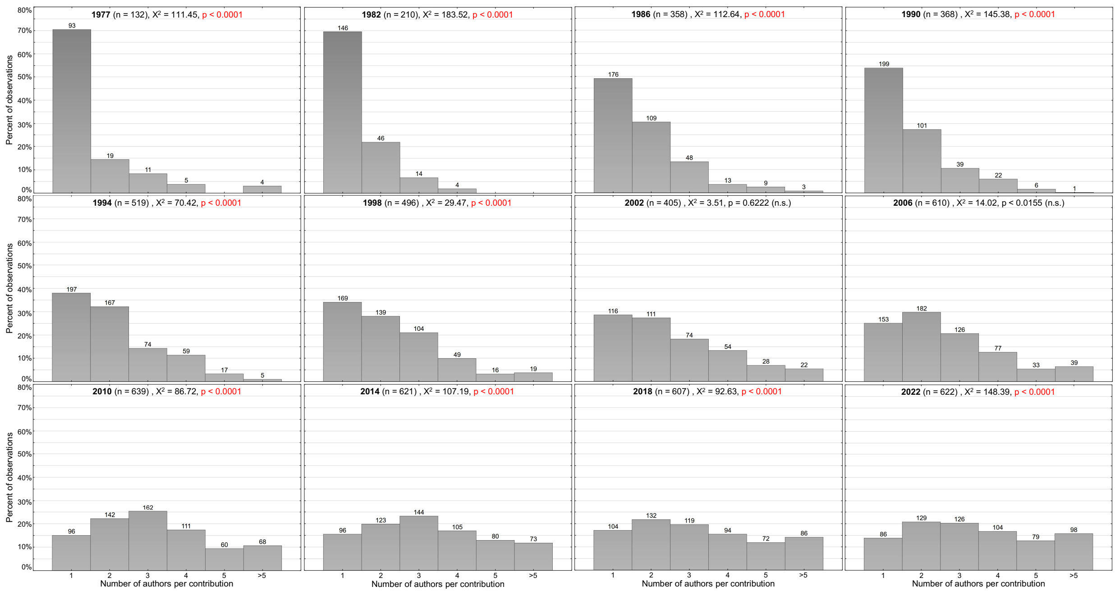
Figure S4: Author number distribution according to conference year. Numbers on top of the bars are counts. Statistics have been performed using first an overall Χ²-test (Χ² = 1105.37, df = 55, p < 0.0001) followed by multiple Χ²-tests for the individual years (corrected p-value for multiple (12) testing: p < 0.0042). Significant p-values are highlighted in red. n.s., not significant.

3.2 Field of study according to type of social insect
The most often investigated social insects were ants (2299 contributions, 38.7%), followed by Apis bees (1111 contributions, 18.7%), termites (784 contributions, 13.2%), other bees (716 contributions, 12.1%), wasps (402 contributions, 6.8%), combinations of the different groups (372 contributions, 6.3%) and other social species (mainly other arthropods but also amoeba, naked mole rats and others) (250 contributions, 4.2%) (Table 1; Figure 6, red arrows)). When considering only the following five groups of social insects (18.579 extant species estimated) – ants (13.500 species (Borowiec et al., 2021)), Apis bees (9 species (Smith, 2021)), other bees (1.000 social species (Engel et al., 2021)), termites (3.000 species (Korb, 2021)) and wasps (1.070 social species (Arévalo et al., 2004; Field, 2021; Yamane & Yamane, 2021)) – for all IUSSI conferences, the presented species distribution deviates tremendously from the expected species distribution in terms of actual species number per social insect group ($Χ^{2}$ = 473,834.1, df = 4, n = 5312, p < 0.0001) (Table S2). This is primarily due to the extremely strong over-representation of Apis bees (observed 20.9%, expected 0.05%, 432-fold over-representation). Furthermore, other bees are over-represented (observed 13.5%, expected 5.4%, 2.5-fold over-represented), while ants are under-represented (observed 43.3%, expected 72.7%, 1.7-fold under-represented). The strong over-representation of Apis bees is furthermore stable throughout conference history as contribution percentage (range: 12.9 (1977) – 33.3% (1955), Table S3) does not correlate with conference year (Spearman’s rank correlation, ρ = - 0.1466, p = 0.549; for multiple-testing (7) corrected p-value = 0.0071). The nevertheless negative nature of the correlation coefficient is primarily due to 33.3% of Apis contributions in 1955. If this single year is removed from the analysis, ρ approaches zero (ρ = - 0.0093). Furthermore, also for wasps (ρ = 0.0597, p = 0.808) and combinations (ρ = 0.5560, p = 0.0134) no significant correlation was found between percentage of contributions and conference year. Contributions of other bees (ρ = 0.6295, p = 0.0039) and ants (ρ = 0.9039, p < 0.0001) increased whereas contributions of termites (ρ = - 0.8965, p < 0.0001) and other social species (ρ = - 0.6526, p = 0.0025) decreased over the conference years (Figure S5). While contributions on other bees, ants and termites rather constantly increased or decreased, the significant correlation for other social species was mainly due to the fact that other contributions made up a rather high percentage before 1973 (> 8%) whereas from 1973 on other contributions stabilised at around 2 - 5% (1973-2022: ρ = - 0.0469, p = 0.8791) (Table 1, Figure S5).
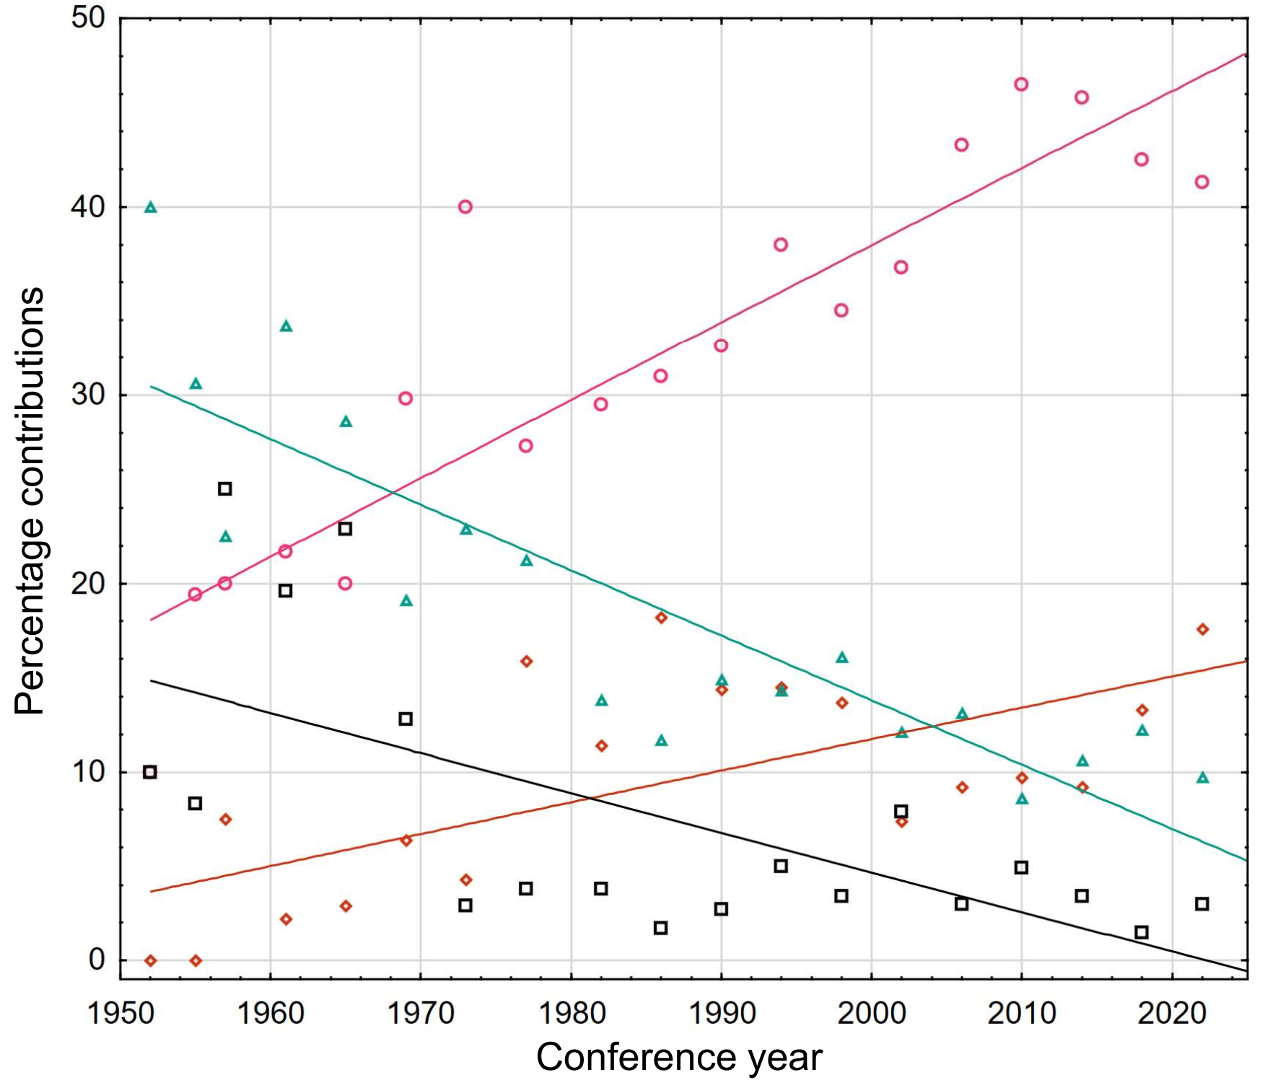 | Figure S5: Significant correlations between social insect group and conference year (Spearman’s rank correlation, for multiple-testing (7) corrected p-value = 0.0071). Correlations were analysed with Spearman's rank correlation and the line represents a linear fit. Ants, magenta circles (ρ = 0.9039, p < 0.0001); other bees, red diamonds (ρ = 0.6295, p = 0.0039); green triangles, termites (ρ = - 0.8965, p < 0.0001); black squares, other social species (ρ = - 0.6526, p = 0.0025).

Furthermore, the field of study was influenced by continent affiliation of the presenting author ($Χ^{2}$ = 443.7, df = 42, n = 5935, p < 0.0001) (Table S2) with deviations from the overall average found for all continents (Figure S6).
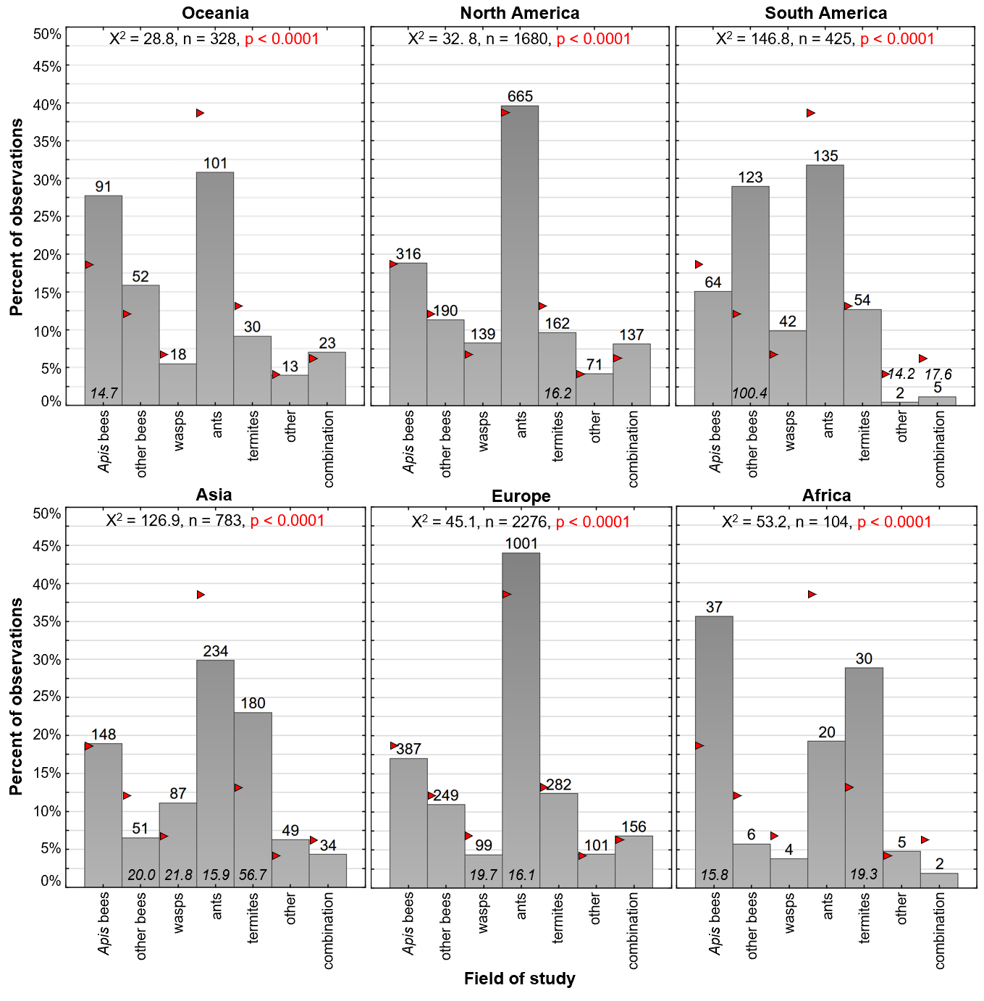
Figure S6: Contributions according to field of study by continental affiliation of the presenting author. Numbers on top of the bars are counts. Red triangles represent expected contributions based on the overall average. Statistics have been performed using multiple $Χ^{2}$-tests for the individual continents (corrected p-value for multiple (7) testing: p < 0.0071; df = 7 for all years). Significant p-values are highlighted in red. Individual $Χ^{2}$-values are given in italics at the bottom of the bars if they exceeded the critical $Χ^{2}$ = 14.1 (df = 7).

Authors with Oceanian affiliation presented more contributions than expected on Apis bees (observed 27.7%, expected 18.8%, 1.5-fold over-represented). North American authors presented fewer contributions on termites (observed 9.6%, 1.4-fold under-represented). South American authors presented particularly many contributions about other bees (observed 28.9%, expected 12.1%, 2.4-fold over-represented) while Asian authors contributed fewer talks/posters about other bees (observed 6.5%, 1.9-fold under-represented) and ants (observed 29.9%, 1.3-fold under-represented) but more about wasps (observed 11.1%, 1.6-fold over-represented) and termites (observed 23.0%, expected 13.2%, 1.7-fold over-represented). Contributions about wasps were under-represented among authors with European affiliation (observed 4.3%, 1.6-fold under-represented) but those presented more contributions on ants (observed 44.0%, expected 38.7%, 1.1-fold over-represented). Contributions by authors with African affiliation contained more research on Apis bees (observed 35.6%, 1.9-fold over-represented) and termites (observed 28.8%, 2.2-fold over-represented) (Figure S6).

4. SUPPLEMENTARY REFERENCES
Arévalo E, Zhu Y, Carpenter JM, Strassmann JE (2004) The phylogeny of the social wasp subfamily Polistinae: evidence from microsatellite flanking sequences, mitochondrial COI sequence, and morphological characters. BMC Evol Biol 4:8. https://doi.org/10.1186/1471-2148-4-8
Borowiec ML, Moreau CS, Rabeling C (2021) Ants: Phylogeny and Classification. In: Starr KC (ed) Encyclopedia of Social Insects. Springer Nature Switzerland AG, Cham, pp 52-69
Engel MS, Rasmussen C, Gonzalez VH (2021) Bees. In: Starr KC (ed) Encyclopedia of Social Insects. Springer Nature Switzerland AG, Cham, pp 93-109
Field J (2021) Hover Wasps (Stenogastrinae). In: Starr KC (ed) Encyclopedia of Social Insects. Springer Nature Switzerland AG, Cham, pp 500-504
Korb J (2021) Termites. In: Starr KC (ed) Encyclopedia of Social Insects. Springer Nature Switzerland AG, Cham, pp 952-960
Smith DR (2021) Biogeography of Honey Bees. In: Starr KC (ed) Encyclopedia of Social Insects. Springer Nature Switzerland AG, Cham, pp 117-131
Yamane S, Yamane S (2021) Vespinae. In: Starr KC (ed) Encyclopedia of Social Insects. Springer Nature Switzerland AG, Cham, pp 1000-1008

Table S3: Contributions at International IUSSI conferences from 1952 to 2022. Language, number of authors, countries and continents per contribution are given as percentage.
 |  | 1952 | 1955 | 1957 | 1961 | 1965 | 1969 | 1973 | 1977 | 1982 | 1986 | 1990 | 1994 | 1998 | 2002 | 2006 | 2010 | 2014 | 2018 | 2022
location |  | FR | DE | FR | IT | FR | CH | GB | NL | US | DE | IN | FR | AU | JP | US | DK | AU | BR | US
Number contributions |  | 10 | 36 | 40 | 92 | 35 | 47 | 70 | 132 | 210 | 358/  355⁸ | 368/  367⁹ | 519 | 496 | 405 | 610 | 639 | 621⁴ | 607⁵ | 622⁶
ants |  | 10.0 | 19.4 | 20.0 | 21.7 | 20.0 | 29.8 | 40.0 | 27.3 | 29.5 | 31.0 | 32.6 | 38.0 | 34.5 | 36.8 | 43.3 | 46.5 | 45.8 | 42.5 | 41.3
termites |  | 40.0 | 30.6 | 22.5 | 33.7 | 28.6 | 19.1 | 22.9 | 21.2 | 13.8 | 11.7 | 14.9 | 14.3 | 16.1 | 12.1 | 13.1 | 8.6 | 10.6 | 12.2 | 9.7
wasps |  | 10.0 | 5.6 | 5.0 | 3.3 | 5.7 | 2.1 | 8.6 | 9.1 | 12.9 | 5.9 | 8.7 | 6.7 | 6.5 | 10.1 | 5.2 | 5.5 | 4.8 | 7.8 | 6.3
Apis bees |  | 20.0 | 33.3 | 17.5 | 15.2 | 17.1 | 23.4 | 14.3 | 12.9 | 23.3 | 25.7 | 20.4 | 16.0 | 20.6 | 16.3 | 20.0 | 17.4 | 19.8 | 18.3 | 15.2
other bees |  | 0.0 | 0.0 | 7.5 | 2.2 | 2.9 | 6.4 | 4.3 | 15.9 | 11.4 | 18.2 | 14.4 | 14.5 | 13.7 | 7.4 | 9.2 | 9.7 | 9.2 | 13.3 | 17.6
others¹ |  | 10.0 | 8.3 | 25.0 | 19.6 | 22.9 | 12.8 | 2.9 | 3.8 | 3.8 | 1.7 | 2.7 | 5.0 | 3.4 | 7.9 | 3.0 | 4.9 | 3.4 | 1.5 | 3.0
combinations² |  | 0.0 | 2.8 | 2.5 | 4.3 | 2.9 | 6.4 | 7.1 | 9.9 | 5.2 | 5.9 | 6.3 | 5.6 | 5.2 | 9.4 | 6.3 | 7.5 | 6.4 | 4.4 | 6.8
language | ENG | 0.0 | 19.4 | 20.0 | 28.3 | 14.3 | 31.9 | 57.1 | 95.5 | 100 | 99.2 | 100 | 98.1 | 100 | 100 | 100 | 100 | 100 | 100 | 99.8
language | FRA | 100 | 30.6 | 62.5 | 16.3 | 80.0 | 29.8 | 31.4 | 3.0 | 0.0 | 0.8 | 0.0 | 1.9 | 0.0 | 0.0 | 0.0 | 0.0 | 0.0 | 0.0 | 0.2
language | GER | 0.0 | 47.2 | 15.0 | 28.3 | 5.7 | 36.2 | 11.4 | 1.5 | 0.0 | 0.0 | 0.0 | 0.0 | 0.0 | 0.0 | 0.0 | 0.0 | 0.0 | 0.0 | 0.0
language | ITA | 0.0¹⁰ | 2.8 | 2.5 | 27.2 | 0.0 | 2.1 | 0.0 | 0.0 | 0.0 | 0.0 | 0.0 | 0.0 | 0.0 | 0.0 | 0.0 | 0.0 | 0.0 | 0.0 | 0.0
authors | 1 | 70.0 | 94.4 | 92.5 | 89.1 | 77.1 | 85.1 | 72.9 | 70.7 | 69.5 | 49.2 | 54.1 | 38.0 | 34.1 | 28.6 | 25.1 | 15.0 | 15.5 | 17.1 | 13.8
authors | 2 | 30.0 | 2.8 | 5.0 | 10.9 | 20.0 | 12.8 | 17.1 | 14.3 | 21.9 | 30.4 | 27.4 | 32.2 | 28.0 | 27.4 | 29.8 | 22.2 | 19.8 | 21.8 | 20.7
authors | 3 | 0.0 | 2.8 | 2.5 | 0 | 2.9³ | 2.1 | 7.1 | 8.3 | 6.7 | 13.4 | 10.6 | 14.3 | 21.0 | 18.3 | 20.7 | 25.4 | 23.2 | 19.6 | 20.3
authors | >3 | 0.0 | 0.0 | 0.0 | 0 | 0.0 | 0.0 | 2.9 | 6.8 | 1.9 | 7.0 | 7.9 | 15.6 | 16.9 | 25.7 | 24.4 | 37.4 | 41.5 | 41.5 | 45.2
countries | 1 | 90.0 | 100 | 100 | 98.9 | 100 | 95.7 | 98.6 | 96.2 | 97.6 | 91.3 | 88.8 | 83.4 | 80.7 | 79.0 | 81.6 | 76.7 |  | 75.0 | 74.8
countries | 2 | 10.0 | 0.0 | 0.0 | 1.1 | 0.0 | 4.3 | 1.4 | 3.0 | 2.4 | 8.2 | 9.8 | 15.4 | 16.5 | 17.0 | 14.6 | 19.7 | N/A⁷ | 17.3 | 19.5
countries | 3 | 0.0 | 0.0 | 0.0 | 0 | 0.0 | 0.0 | 0.0 | 0.8 | 0.0 | 0.6 | 1.1 | 1.2 | 2.6 | 3.2 | 2.8 | 3.1 |  | 5.4 | 4.0
countries | >3 | 0.0 | 0.0 | 0.0 | 0 | 0.0 | 0.0 | 0.0 | 0.0 | 0.0 | 0.0 | 0.3 | 0.0 | 0.2 | 0.7 | 1.0 | 0.5 |  | 2.3 | 1.8
continent | 1 | 100 | 100 | 100 | 98.9 | 100 | 97.9 | 98.6 | 97.7 | 98.1 | 95.5 | 91.3 | 89.0 | 86.1 | 86.4 | 86.9 | 83.7 |  | 80.6 | 83.9
continent | 2 | 0.0 | 0.0 | 0.0 | 1.1 | 0.0 | 2.1 | 1.4 | 2.3 | 1.9 | 4.5 | 8.4 | 10.6 | 13.3 | 11.9 | 12.5 | 15.3 | N/A⁷ | 14.8 | 14.5
continent | 3 | 0.0 | 0.0 | 0.0 | 0 | 0.0 | 0.0 | 0.0 | 0.0 | 0.0 | 0.0 | 0.3 | 0.0 | 0.6 | 1.7 | 0.5 | 0.9 |  | 4.3 | 1.4
continent | >3 | 0.0 | 0.0 | 0.0 | 0 | 0.0 | 0.0 | 0.0 | 0.0 | 0.0 | 0.0 | 0.0 | 0.0 | 0.0 | 0.0 | 0.2 | 0.0 |  | 0.3 | 0.2
¹others means cockroaches, beetles, locusts, aphids, thrips, shield bugs, earwigs, lace bugs, tree hoppers, spiders, spider mites, fireflies, whip scorpions, shrimps, Drosophila, amoeba, naked mole rats, mice; bees also contains combined studies of Apis bees and other bees; ²combination refers to all contributions where work was done on more than one of the defined groups and also those where the abstract and title only refers to social insects as well as method talks. ³ The conference proceedings of 1965 lists three individual contributions from the Université de Léopoldville of the Democratic Republic Congo (from A. Bouillon, F. Hébrant and G. Mathot) but only A. Bouillon is in the list of participants and is listed in the programme (Mercredi 7 Juillet – 9:30 – Bouillon (Léopoldville) Quelques résultats des recherches en cours à Léopoldville.). Because of this and also because of the title of the contribution ‘Some results of ongoing research in Léopoldville’ we assumed that only A. Bouillon was present and gave a talk about all three topics. Thus, we counted only A. Bouillon as presenter and included this contribution as a three author contribution. ⁴Differs from Table 1 as one movie contribution was listed under the name of the production company and thus it is not clear how many people are involved. ⁵Differs from from Table 1 as eight of the talks were only found in the PDF programme and on the pathable platform but not in the online abstracts https://burkclients.com/IUSSI/symposiums/#/ that list the authors. ⁶Differs from table 1 as nine of the talks were listed in the PDF programme but were not found within the online abstracts which contained author numbers and affiliations. ⁷the abstract book from 2014 does not list the affiliations and thus it was not possible to determine the countries and continents of the non-presenters as they could also not be found on the delegate list. ^{8/9}For three/one contributions no affiliations are given. The number of authors is clear but their affiliations are unknown and thus countries and continents only comprise 355/367 contributions.¹⁰Probably this was not a 100% in French but the programme was written completely in French

