Additional file 4 - Forest plots of secondary outcomes
Spontaneous abortion
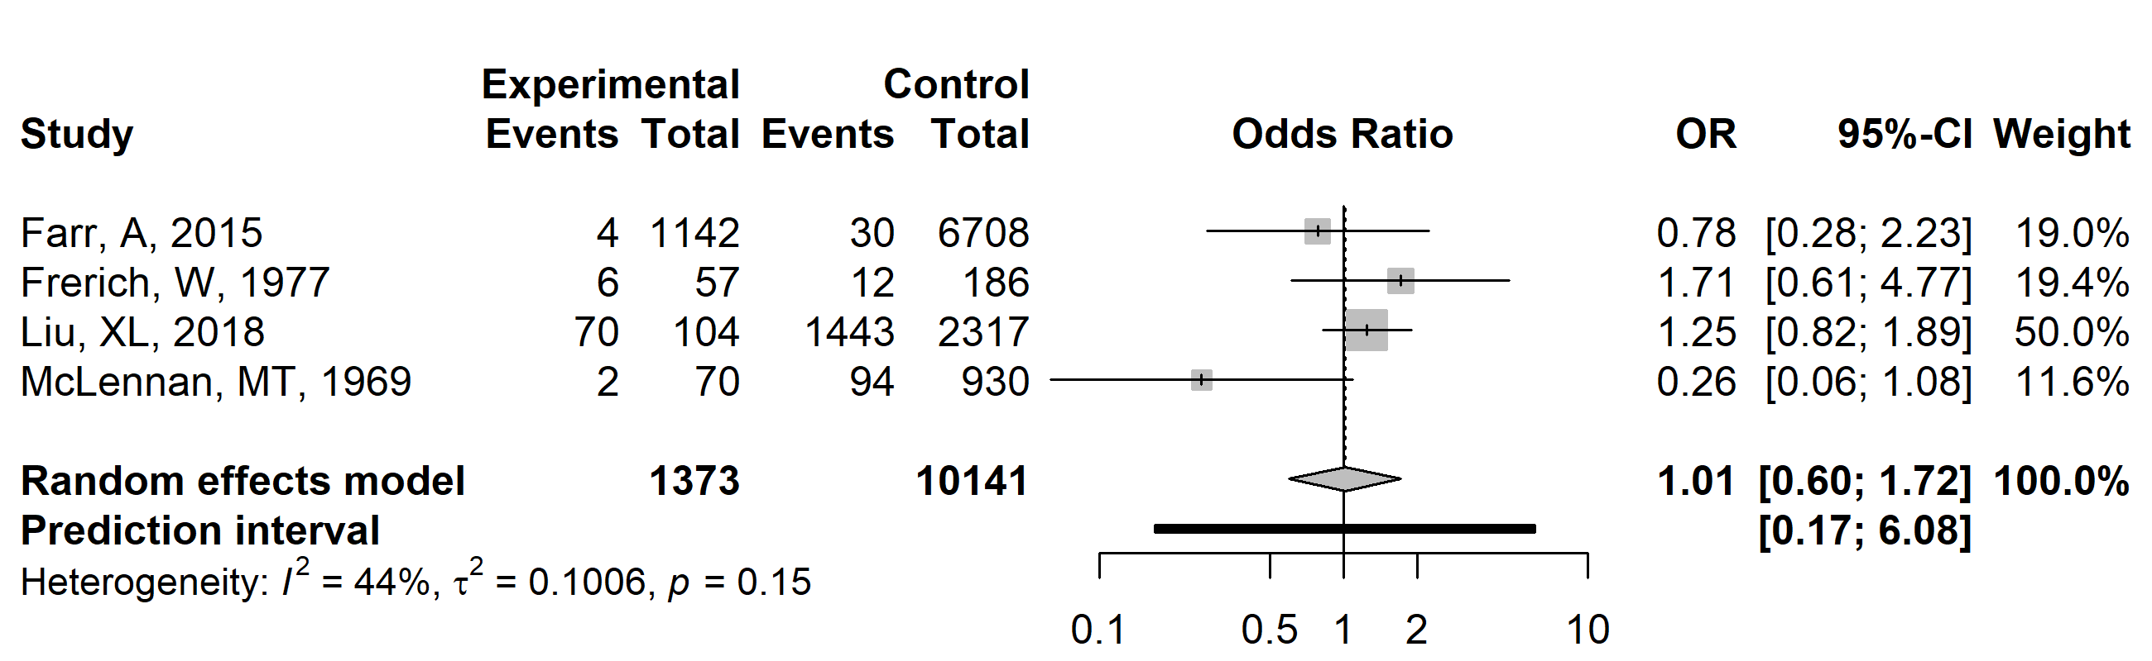
Legend: vertical line, line of no association (odds ratio 1.0); horizontal line, 95% confidence interval; vertical line inside the box, point estimate of odds ratio; grey box, study size; diamond, summary estimate with 95% confidence interval; black bar, 95% prediction interval. To the left of the line of no association, spontaneous abortion was less likely in women with vulvovaginal yeast infection; to the right of the line of no association, spontaneous abortion was more likely.

Stillbirth
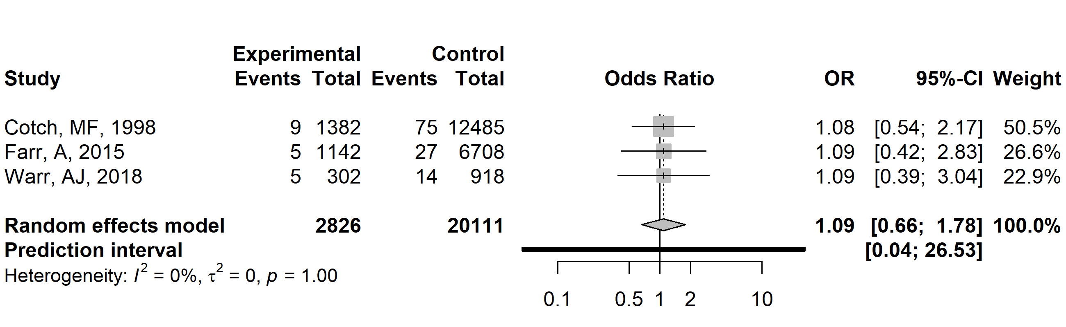
Legend: vertical line, line of no association (odds ratio 1.0); horizontal line, 95% confidence interval; vertical line inside the box, point estimate of odds ratio; grey box, study size; diamond, summary estimate with 95% confidence interval; black bar, 95% prediction interval. To the left of the line of no association, stillbirth was less likely in women with vulvovaginal yeast infection; to the right of the line of no association, stillbirth was more likely.

Preterm premature rupture of membranes
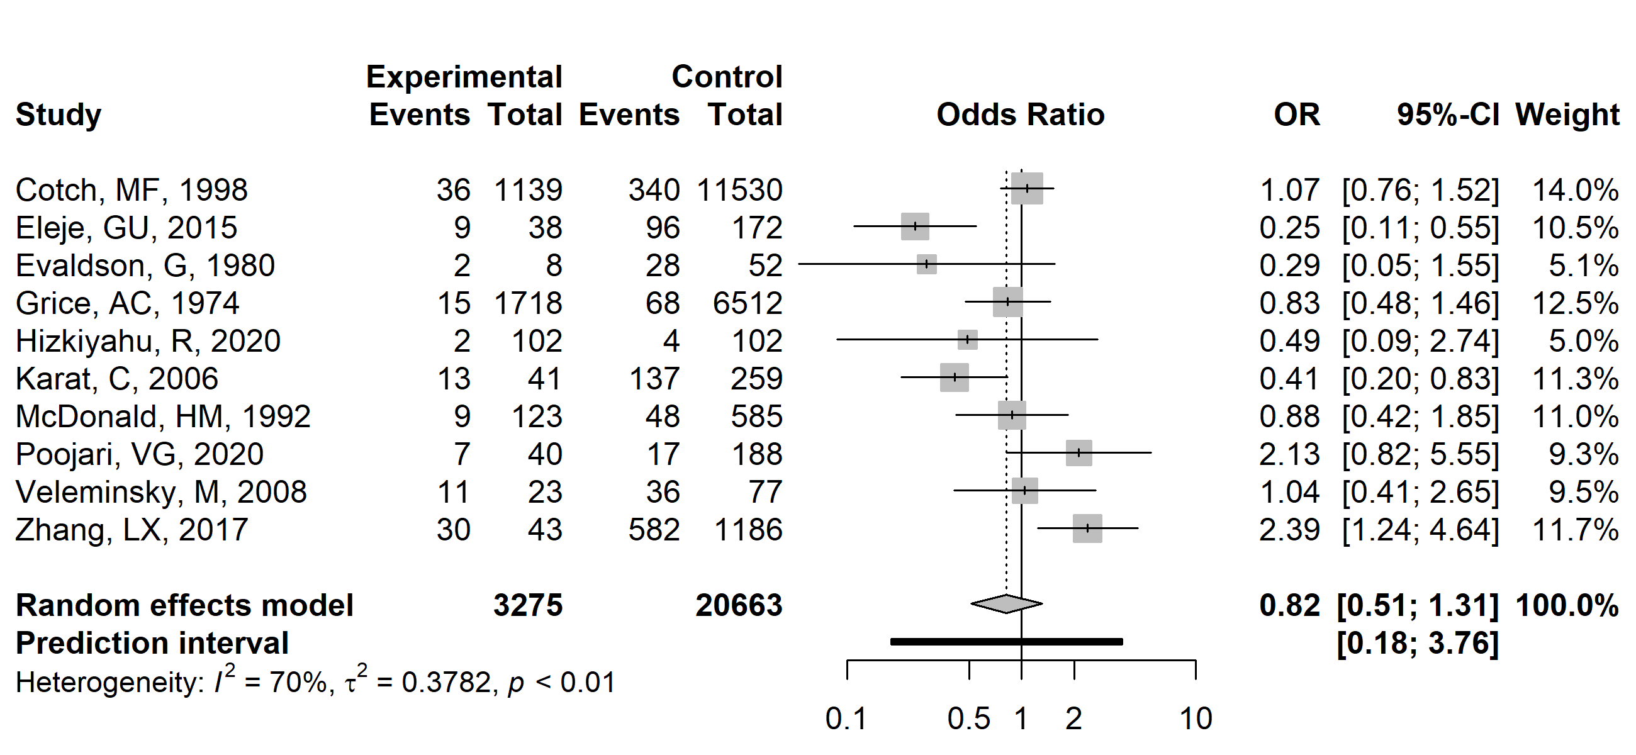
Legend: vertical line, line of no association (odds ratio 1.0); horizontal line, 95% confidence interval; vertical line inside the box, point estimate of odds ratio; grey box, study size; diamond, summary estimate with 95% confidence interval; black bar, 95% prediction interval. To the left of the line of no association, preterm premature rupture of membranes was less likely in women with vulvovaginal yeast infection; to the right of the line of no association, preterm premature rupture of membranes was more likely.

Premature rupture of membranes
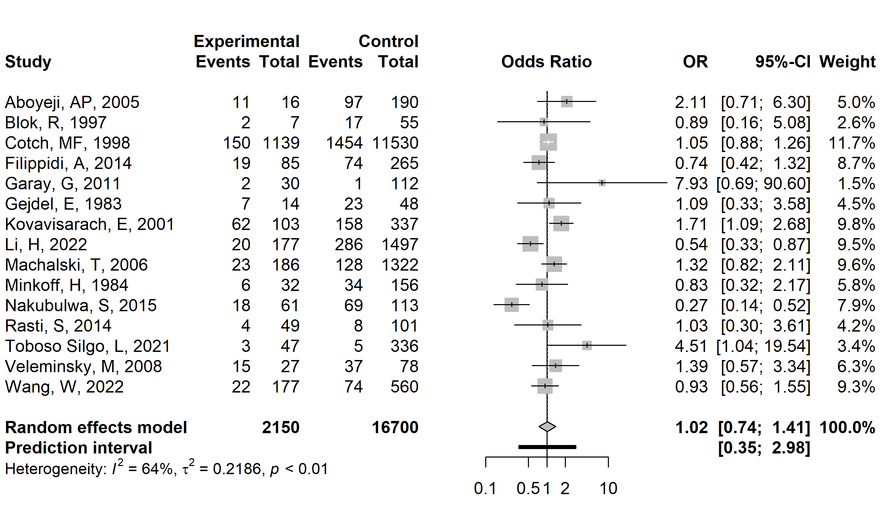
Legend: vertical line, line of no association (odds ratio 1.0); horizontal line, 95% confidence interval; vertical line inside the box, point estimate of odds ratio; grey box, study size; diamond, summary estimate with 95% confidence interval; black bar, 95% prediction interval. To the left of the line of no association, premature rupture of membranes was less likely in women with vulvovaginal yeast infection; to the right of the line of no association, premature rupture of membranes was more likely.

Low birth weight
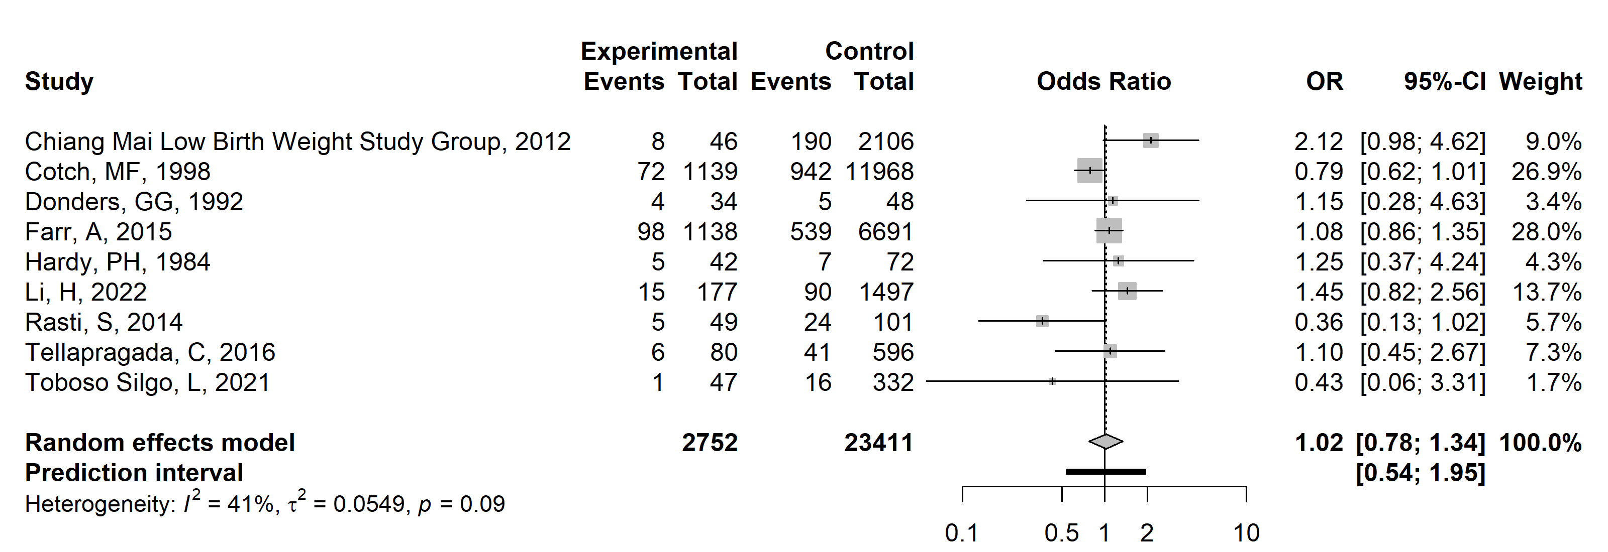
Legend: vertical line, line of no association (odds ratio 1.0); horizontal line, 95% confidence interval; vertical line inside the box, point estimate of odds ratio; grey box, study size; diamond, summary estimate with 95% confidence interval; black bar, 95% prediction interval. To the left of the line of no association, low birth weight was less likely in women with vulvovaginal yeast infection; to the right of the line of no association, low birth weight was more likely.

Inflammation of the placenta or uterus
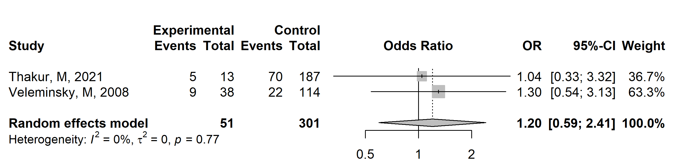
Legend: vertical line, line of no association (odds ratio 1.0); horizontal line, 95% confidence interval; vertical line inside the box, point estimate of odds ratio; grey box, study size; diamond, summary estimate with 95% confidence interval; black bar, 95% prediction interval. To the left of the line of no association, inflammation of the placenta or uterus was less likely in women with vulvovaginal yeast infection; to the right of the line of no association, inflammation of the placenta or uterus was more likely.

