Genomic characterization of Klebsiella pneumoniae causing invasive disease in South African infants: An observational study between 2018 to 2023.

Courtney P. Olwagen¹, Alane Izu¹, Shama Khan¹, Stephanie Jones¹, Carmen Briner¹, Gaurav Kwatra^{1,2,3}, Lara Van der Merwe¹, Nicholas J. Dean¹, Vicky L. Baillie¹ , Sana Mahtab¹, Kimberleigh Storath¹, Imaan Dunn¹, Lubomira Andrew⁴, Urvi Rajyaguru⁴ , Firdose L. Nakwa⁵, Sithembiso C. Velaphi⁵, Jeannette Wadula⁶, Renate Strehlau⁷, Anika M. van Niekerk⁸, Niree Naidoo⁶, Yogandree Ramsamy⁹⁻¹⁰, Mohamed Said¹¹ Robert G.K. Donald⁴, Raphael Simon⁴, Ziyaad Dangor¹, and Shabir A. Madhi^{1,12}

SUPPLEMENTARY TEXT

Study population
K. pneumoniae (KPn) isolates were collected from a sero-epidemiological study that aimed to identify serological markers associated with risk reduction of invasive Group B streptococcus (GBS) disease in infants less than or equal to 90 days of age [1]. Briefly, the study was undertaken from March 4th, 2019 to February 27th, 2021, and included a longitudinal, prospective cohort of 17 752 mother-newborn dyads who were enrolled at the Chris Hani Baragwanath Academic Hospital (CHBAH) and the Rahima Moosa Mother and Child Hospital (RMMCH) in the city of Johannesburg, South Africa. Women were enrolled either antenatally, during the early stages of labour, or immediately postpartum, and the infants born to the women in the cohort were followed up to 90 days of age for all-cause hospitalization and death. In addition to the infants enrolled as part of the cohort, additional infants who were not part of the cohort but identified through daily laboratory-based surveillance at the National Health Laboratory Service (NHLS) as cases of invasive K. pneumoniae disease, where K. pneumoniae was isolated from a normally sterile site (blood, CSF, joint fluid, pleural fluid) were also enrolled at the two facilities where the cohort cases had been enrolled and at four other hospitals in South Africa. The additional hospitals where enrolment of invasive K. pneumoniae cases was undertaken, following identification thereof through laboratory-based surveillance were at the Charlotte Maxeke Johannesburg Academic Hospital (CMJAH) in the City of Johannesburg, the Tshwane Academic Laboratory Network (TALM), Prince Mshiyeni Memorial Hospital (PMMH) in eThekwini and Mowbray Maternity Hospital (MMH) Cape Town. Surveillance for invasive K. pneumoniae isolates and enrolment of cases continued across all six sites until February 27th, 2021.

We also analyzed K. pneumoniae isolates collected from infants up to 90 days of age who were enrolled in a second hospital surveillance study that aimed to strengthen the evidence base of immunological correlates of protection against invasive GBS disease. Briefly, a cohort of 21,202 mother-infant dyads were enrolled between May 22nd 2022 to December 31st, 2023 at the CHBAH or RMMCH and infants were followed up to 90 days of life for all-cause hospitalization and death (cohort cases). Infants who were not part of the cohort (non-cohort cases), but were identified through daily laboratory-based surveillance of the same six sites as the first hospital surveillance study.

Study procedures
Following sequencing, the quality of the raw reads was assessed using FASTQC v0.12.1 and processed using the Jekesa pipeline. Trim Galore removed adapters, ambiguous reads, and low-quality bases (Q >30 and length >50 bp). De novo assemblies were generated with SPAdes and Shovill, and QUAST 5 was used to evaluate their quality and to calculate assembly matrices. Sequences were uploaded onto the Pathogenwatch6 database for species confirmation and ConFindr was used to check for contamination. MLST and cgMLST predictions were performed using Klebsiella PasteurMLST and BIGSdb-Pasteur, respectively. Capsule K and O serotype predictions were made with Kaptive V3. Antimicrobial resistance genes identified with Kleborate compared to the curated version of the Comprehensive Antibiotic Resistance Database program including ResFinder 9. Virulence genes were identified by Kleborate using the BLASTn for Key loci. Phylogenetic analysis was conducted using wgMLST and cgMLST. The sARGs were investigated through ResFinder. iTOL 12 was used to generate and visualize the phylogenetic tree.

Temporal variation of sequence types (ST) over the study period
The distribution of the ST causing invasive disease at CHBAH varied across the six years; Supplementary Figure 1. While ST17 was detected throughout the study period, ST39 and ST307 were mainly detected between October 2019 and May 2020 (75%, 21/28, and 52%, 13/28, respectively). Furthermore, all the ST25 (n=25) isolates were detected only between October 2022 and September 2023. The distribution of ST observed at the other collection sites is shown in Supplementary Figure 1.

Temporal variation of k-loci over the study period
The distribution of K- loci at CHBAH varied over the study period, with 69.7% (23/33) of the KL149 isolates identified between October 2019 and June 2020, 67.5% (25/37) of KL2 isolates detected between October 2022 and December 2023, and 50% (6/12) of KL15 detected between January and September 2023; Supplementary Figure 1. While KL25 isolates were not detected in 2018, they were detected throughout the study period from January 2019. Lastly, 50% (14/28) of the KL102 isolates were detected between October 2019 and June 2020 (53.6%, 15/28), while 32.1% (9/28) were detected between July and December 2022. The distribution of K-loci observed at the other collection sites is shown in Supplementary Figure 1.

Temporal variation of O-antigen over the study period
Although O1αβ,2α isolates were detected throughout the study period at CHBAH, a higher number of isolates were detected between January and December 2020 (26.1%, 30/115) and between January and December 2023 (25.2%, 29/115); Supplementary Figure 1. Moreover, 45.5% (25/55) of the O5 isolates were detected between January 2019 and December 2020 and 38.1% (21/55) between January and September 2023. While the O2β and O4 isolates were detected throughout the study period, 75% (3/4) of the O3γisolates were detected between April and June 2023. Moreover, all of the O13 (n=3) isolates were detected between January and December 2022, while 57.1% (4/7) of the O2α isolates were detected between April and December 2023. The distribution of O antigens observed at the other collection sites is shown in Supplementary Figure 1.

Antimicrobial resistance stratified by Sequence types and K and O antigens
Among the strains with more than 6 isolates, ST152, ST25, ST307, and ST37 isolates were associated with the highest (median: 6 classes each) and ST20 (median: 1 class) the lowest number of antimicrobial resistant (AMR) classes; Supplementary Figure 3a. The KL102 and KL30 isolates were associated with the highest number of AMR classes (median: 6 classes each), whereas KL62, KL39, KL15, and KL149 encoded resistance to fewer classes (median: 3 classes each); Supplementary Figure 3b. TheO2β, O4, and O5 isolates were associated with the highest number of AMR classes (Median: 6 classes each), whereas O1ab encoded resistance to fewer classes (median: 4 classes); Supplementary Figure 3c.

All ST307-KL102-O2β (62.1%, 18/29 and 37.9%, 11/29), ST39-KL149-O1αβ,2α (70.6%, 24/34 and 29.4%, 10/34), ST607-KL25-O1αβ,2α (90.9%, 10/11 and 9.1%, 9/11), and ST17-KL25-O5 (44.6%, 29/65 and 55.4%, 36/65) genotypes harboured genes for ESBL production or carbapenems resistance, respectively, including a single ST17-KL25-O5 isolate that harboured genes encoding for both carbapenems and colistin resistance. Lastly, most of the ST152-KL149-O4 genotypes harboured genes encoding for ESBL production (54.5%, 6/11) or carbapenems (36.4%, 4/11) resistance, while no resistance genes were detected in a single ST152-KL149-O4 isolate.

SUPPLEMENTARY TABLES

Supplementary Table 1: Comparison of study procedures undertaken in the CHAMPS and Mits-lite studies.

Category | CHAMPS | MITs Lite
Eligibility
Stillbirths | √
Neonates and Paediatrics | √ | √ (only DOA’s from 2021)
CHAMPS catchment | √
Greater Soweto |  | √
Verbal autopsy | √ | √ (only from 2021)
Specimen collection
Blood culture | √ | √
CSF culture | √ | √
Lung culture | √ | √
HIV PCR | √ | √
NP swab | √ | √
Rectal swab | √ | √
Malaria testing | √
Brain sample (occipital and transnasal) | √ | √ (only from 2021)
Bilateral lungs | √ | √
Liver | √ | √ (only from 2021)
Placenta for neonates and stillbirths | √
Testing
Histopathology | √ | √
Central pathology | √
TAC | √ (done on TAC array) | √ (done on the open array)
Lungs | √ | √
CSF | √ | Only done on dead on arrival from 2021
Rectal | √
Covid PCR | √ | √

Abbreviations: CSF – cerebral spinal fluid; CHAMPS – Child Health and Mortality Prevention Surveillance; HIV – Human Immunodeficiency Virus; MITs – minimally invasive tissue sampling; NP – nasopharyngeal.

Supplementary Table 2: Genomic characterization of K. pneumoniae causing invasive disease and mortality in South African infants 0-90 days of age, by observational study
 | Observation Study 1: | Observation Study 2: | Observation Study 3: | Observation Study 4:
 | Hospital surveillance | Hospital surveillance | Postmortem sampling - CHAMPS | Postmortem sampling - MITs lite
 | 4 Mar 2019 - 27 Feb 2021 | 30 April 2022 – 13 Nov 2023 | 17 Jan 2017 - 19 Ap 2023 | 21 Feb 2018 - 15 Sept 2022
Sequence types, n(%)
ST101 | 0/24 (0) | 0/74 (0) | 0/96 (0) | 1/5 (20)
ST1207 | 1/24 (4.17) | 1/74 (1.35) | 0/96 (0) | 0/5 (0)
ST1296 | 0/24 (0) | 2/74 (2.7) | 0/96 (0) | 0/5 (0)
ST13 | 0/24 (0) | 1/74 (1.35) | 3/96 (3.12) | 0/5 (0)
ST133 | 0/24 (0) | 1/74 (1.35) | 0/96 (0) | 0/5 (0)
ST1380 | 0/24 (0) | 1/74 (1.35) | 0/96 (0) | 0/5 (0)
ST140 | 0/24 (0) | 0/74 (0) | 0/96 (0) | 0/5 (0)
ST1414 | 0/24 (0) | 0/74 (0) | 1/96 (1.04) | 0/5 (0)
ST1427 | 1/24 (4.17) | 1/74 (1.35) | 0/96 (0) | 0/5 (0)
ST1444 | 0/24 (0) | 0/74 (0) | 0/96 (0) | 0/5 (0)
ST15 | 0/24 (0) | 0/74 (0) | 1/96 (1.04) | 0/5 (0)
ST1552 | 0/24 (0) | 0/74 (0) | 2/96 (2.08) | 0/5 (0)
ST17-1LV | 1/24 (4.17) | 0/74 (0) | 0/96 (0) | 0/5 (0)
ST1873 | 0/24 (0) | 0/74 (0) | 2/96 (2.08) | 0/5 (0)
ST1898 | 0/24 (0) | 0/74 (0) | 0/96 (0) | 0/5 (0)
ST193 | 0/24 (0) | 0/74 (0) | 1/96 (1.04) | 0/5 (0)
ST2039 | 0/24 (0) | 0/74 (0) | 1/96 (1.04) | 0/5 (0)
ST219 | 0/24 (0) | 0/74 (0) | 0/96 (0) | 0/5 (0)
ST2191-1LV | 0/24 (0) | 1/74 (1.35) | 0/96 (0) | 0/5 (0)
ST22 | 0/24 (0) | 0/74 (0) | 0/96 (0) | 0/5 (0)
ST23 | 0/24 (0) | 0/74 (0) | 0/96 (0) | 0/5 (0)
ST2441 | 0/24 (0) | 0/74 (0) | 1/96 (1.04) | 0/5 (0)
ST25-1LV | 0/24 (0) | 1/74 (1.35) | 0/96 (0) | 0/5 (0)
ST252 | 0/24 (0) | 0/74 (0) | 1/96 (1.04) | 0/5 (0)
ST253 | 0/24 (0) | 0/74 (0) | 0/96 (0) | 0/5 (0)
ST26 | 1/24 (4.17) | 0/74 (0) | 0/96 (0) | 0/5 (0)
ST268 | 0/24 (0) | 0/74 (0) | 0/96 (0) | 0/5 (0)
ST294-2LV | 0/24 (0) | 0/74 (0) | 0/96 (0) | 0/5 (0)
ST297-1LV | 0/24 (0) | 0/74 (0) | 0/96 (0) | 0/5 (0)
ST3073 | 0/24 (0) | 0/74 (0) | 0/96 (0) | 0/5 (0)
ST321 | 0/24 (0) | 0/74 (0) | 0/96 (0) | 0/5 (0)
ST3280 | 0/24 (0) | 0/74 (0) | 0/96 (0) | 0/5 (0)
ST336 | 0/24 (0) | 0/74 (0) | 1/96 (1.04) | 0/5 (0)
ST34 | 0/24 (0) | 1/74 (1.35) | 0/96 (0) | 0/5 (0)
ST348 | 0/24 (0) | 1/74 (1.35) | 0/96 (0) | 0/5 (0)
ST3483-1LV | 1/24 (4.17) | 0/74 (0) | 0/96 (0) | 0/5 (0)
ST35 | 0/24 (0) | 1/74 (1.35) | 1/96 (1.04) | 0/5 (0)
ST353 | 0/24 (0) | 0/74 (0) | 4/96 (4.17) | 0/5 (0)
ST380 | 0/24 (0) | 0/74 (0) | 0/96 (0) | 1/5 (20)
ST399 | 0/24 (0) | 0/74 (0) | 0/96 (0) | 0/5 (0)
ST405 | 0/24 (0) | 0/74 (0) | 0/96 (0) | 0/5 (0)
ST416 | 0/24 (0) | 0/74 (0) | 0/96 (0) | 0/5 (0)
ST4291 | 0/24 (0) | 0/74 (0) | 2/96 (2.08) | 0/5 (0)
ST433-1LV | 0/24 (0) | 0/74 (0) | 0/96 (0) | 0/5 (0)
ST474 | 0/24 (0) | 0/74 (0) | 0/96 (0) | 0/5 (0)
ST48 | 0/24 (0) | 0/74 (0) | 0/96 (0) | 0/5 (0)
ST502 | 0/24 (0) | 1/74 (1.35) | 0/96 (0) | 0/5 (0)
ST557 | 0/24 (0) | 0/74 (0) | 0/96 (0) | 0/5 (0)
ST5785 | 0/24 (0) | 0/74 (0) | 1/96 (1.04) | 0/5 (0)
ST587 | 0/24 (0) | 0/74 (0) | 0/96 (0) | 0/5 (0)
ST607-1LV | 0/24 (0) | 0/74 (0) | 0/96 (0) | 0/5 (0)
ST628 | 0/24 (0) | 1/74 (1.35) | 0/96 (0) | 0/5 (0)
ST6580 | 0/24 (0) | 0/74 (0) | 0/96 (0) | 0/5 (0)
ST66 | 1/24 (4.17) | 0/74 (0) | 0/96 (0) | 0/5 (0)
ST664 | 0/24 (0) | 0/74 (0) | 0/96 (0) | 0/5 (0)
ST6792 | 0/24 (0) | 0/74 (0) | 0/96 (0) | 0/5 (0)
ST711 | 0/24 (0) | 1/74 (1.35) | 0/96 (0) | 0/5 (0)
ST872 | 0/24 (0) | 0/74 (0) | 0/96 (0) | 0/5 (0)
K-locus, n (%)
KL1 | 0/24 (0) | 0/74 (0) | 0/96 (0) | 0/5 (0)
KL10 | 1/24 (4.17) | 0/74 (0) | 0/96 (0) | 0/5 (0)
KL104 | 0/24 (0) | 1/74 (1.35) | 0/96 (0) | 0/5 (0)
KL105 | 0/24 (0) | 2/74 (2.7) | 0/96 (0) | 0/5 (0)
KL106 | 0/24 (0) | 0/74 (0) | 0/96 (0) | 1/5 (20)
KL108 | 0/24 (0) | 0/74 (0) | 1/96 (1.04) | 0/5 (0)
KL109 | 0/24 (0) | 0/74 (0) | 0/96 (0) | 0/5 (0)
KL110 | 0/24 (0) | 0/74 (0) | 4/96 (4.17) | 0/5 (0)
KL112 | 0/24 (0) | 0/74 (0) | 1/96 (1.04) | 0/5 (0)
KL113 | 0/24 (0) | 1/74 (1.35) | 0/96 (0) | 0/5 (0)
KL114 | 0/24 (0) | 0/74 (0) | 0/96 (0) | 0/5 (0)
KL116 | 0/24 (0) | 1/74 (1.35) | 0/96 (0) | 0/5 (0)
KL122 | 0/24 (0) | 1/74 (1.35) | 0/96 (0) | 0/5 (0)
KL123 | 0/24 (0) | 1/74 (1.35) | 0/96 (0) | 0/5 (0)
KL132 | 0/24 (0) | 0/74 (0) | 0/96 (0) | 0/5 (0)
KL136 | 1/24 (4.17) | 2/74 (2.7) | 0/96 (0) | 0/5 (0)
KL140 | 0/24 (0) | 0/74 (0) | 0/96 (0) | 0/5 (0)
KL151 | 0/24 (0) | 0/74 (0) | 0/96 (0) | 0/5 (0)
KL16 | 0/24 (0) | 1/74 (1.35) | 1/96 (1.04) | 0/5 (0)
KL166 | 0/24 (0) | 0/74 (0) | 0/96 (0) | 0/5 (0)
KL17 | 0/24 (0) | 0/74 (0) | 0/96 (0) | 0/5 (0)
KL18 | 1/24 (4.17) | 0/74 (0) | 0/96 (0) | 0/5 (0)
KL19 | 0/24 (0) | 0/74 (0) | 0/96 (0) | 0/5 (0)
KL20 | 0/24 (0) | 0/74 (0) | 0/96 (0) | 0/5 (0)
KL22 | 0/24 (0) | 0/74 (0) | 0/96 (0) | 0/5 (0)
KL27 | 0/24 (0) | 0/74 (0) | 0/96 (0) | 0/5 (0)
KL28 | 0/24 (0) | 1/74 (1.35) | 2/96 (2.08) | 0/5 (0)
KL3 | 0/24 (0) | 1/74 (1.35) | 3/96 (3.12) | 0/5 (0)
KL38 | 2/24 (8.33) | 2/74 (2.7) | 0/96 (0) | 0/5 (0)
KL51 | 0/24 (0) | 0/74 (0) | 1/96 (1.04) | 0/5 (0)
KL52 | 0/24 (0) | 1/74 (1.35) | 0/96 (0) | 0/5 (0)
KL54 | 0/24 (0) | 2/74 (2.7) | 0/96 (0) | 0/5 (0)
KL55 | 0/24 (0) | 0/74 (0) | 0/96 (0) | 0/5 (0)
KL60 | 0/24 (0) | 0/74 (0) | 0/96 (0) | 0/5 (0)
KL63 | 0/24 (0) | 0/74 (0) | 0/96 (0) | 0/5 (0)
KL67 | 1/24 (4.17) | 1/74 (1.35) | 0/96 (0) | 0/5 (0)
KL7 | 0/24 (0) | 0/74 (0) | 1/96 (1.04) | 0/5 (0)
KL8 | 0/24 (0) | 0/74 (0) | 1/96 (1.04) | 0/5 (0)
KL9 | 0/24 (0) | 0/74 (0) | 0/96 (0) | 0/5 (0)
Unknown | 2/24 (8.33) | 3/74 (4.05) | 5/96 (5.21) | 0/5 (0)
O-types, n (%)
O13 | 1/24 (4.17) | 2/74 (2.7) | 0/96 (0) | 0/5 (0)
O1αβ,2α | 11/24 (45.83) | 33/74 (44.59) | 45/96 (46.88) | 5/5 (100)
O2α | 1/24 (4.17) | 1/74 (1.35) | 2/96 (2.08) | 0/5 (0)
O2β | 4/24 (16.67) | 11/74 (14.86) | 23/96 (23.96) | 0/5 (0)
O3γ | 0/24 (0) | 4/74 (5.41) | 4/96 (4.17) | 0/5 (0)
O4 | 0/24 (0) | 5/74 (6.76) | 5/96 (5.21) | 0/5 (0)
O5 | 7/24 (29.17) | 18/74 (24.32) | 17/96 (17.71) | 0/5 (0)

Data represent isolates collected from two hospital-based surveillance studies and two temporally aligned post-mortem studies.

Supplementary Table 3: Clinical characteristics of infants with and without available case plates
 | All isolates (n=435) | Case plate not retrieved from NHLS (n=98) | Isolates included in the final analysis (n=337)
Median age in days (IQR) | 8 | 13 (7-26.5) n=98 | 12 (6-28) n=337
Type of infection, n (%)
Presumed hospital-associated | 76 (17.5) n=435 | 14 (14.3) n=98 | 62 (18.4) n=337
Presumed community-acquired | 359 (82.5) n=435 | 84 (85.7) n=98 | 275 (81.6) n=337
Median number of days in hospital (IQR) | 0 (0.0) n=435 | 0 (0.0) n=98 | 0 (0.0) n=337
Age group, n (%) | 22 (6-53) n=373 | 24 (8-52) n=93 | 20 (6-53) n=280
EOD
LOD | 19 (4.4) n=435 | 5 (5.1) n=98 | 14 (4.2) n=337
Year of isolation, n (%) | 416 (95.6) n=435 | 93 (94.9) n=98 | 323 (95.8) n=337
2018 | 0 (0.0) n=435 | 0 (0.0) n=98 | 0 (0.0) n=337
2019
2020 | 44 (10.1) n=435 | 20 (20.4) n=98 | 24 (7.1) n=337
2021 | 104 (23.9) n=435 | 38 (38.8) n=98 | 66 (19.6) n=337
2022 | 92 (21.1) n=435 | 26 (26.5) n=98 | 66 (19.6) n=337
2023 | 29 (6.7) n=435 | 2 (2.0) n=98 | 27 (8.0) n=337
Gender, n (%) | 60 (13.8) n=435 | 6 (6.1) n=98 | 54 (16.0) n=337
Female | 106 (24.4) n=435 | 6 (6.1) n=98 | 100 (29.7) n=337
Male
Unknown | 178 (40.9) n=435 | 42 (42.9) n=98 | 136 (40.4) n=337
Mothers HIV status, n (%) | 245 (56.3) n=435 | 55 (56.1) n=98 | 190 (56.4) n=337
HIV uninfected | 12 (2.8) n=435 | 1 (1.0) n=98 | 11 (3.3) n=337
HIV infected
Unknown | 269 (61.8) n=435 | 50 (51.0) n=98 | 219 (65.0) n=337
Infant HIV status, n (%) | 138 (31.7) n=435 | 43 (43.9) n=98 | 95 (28.2) n=337
HIV uninfected | 28 (6.4) n=435 | 5 (5.1) n=98 | 23 (6.8) n=337
HIV infected
Unknown | 241 (55.4) n=435 | 52 (53.1) n=98 | 189 (56.1) n=337
Gestational age, n (%) | 10 (2.3) n=435 | 3 (3.1) n=98 | 7 (2.1) n=337
<28 weeks | 184 (42.3) n=435 | 43 (43.9) n=98 | 141 (41.8) n=337
28-<34 weeks
34-<37 weeks | 207 (47.6) n=435 | 54 (55.1) n=98 | 153 (45.4) n=337
>=37 weeks | 152 (34.9) n=435 | 33 (33.7) n=98 | 119 (35.3) n=337
Unknown | 76 (17.5) n=435 | 11 (11.2) n=98 | 65 (19.3) n=337
Birth weight, n (%)
<1000 grams | 68 (15.6) n=435 | 10 (10.2) n=98 | 58 (17.2) n=337
1000-<1500 grams | 200 (46.0) n=435 | 57 (58.2) n=98 | 143 (42.4) n=337
1500-<2500 grams | 41 (9.4) n=435 | 4 (4.1) n=98 | 37 (11.0) n=337
2500-<4000 grams | 57 (13.1) n=435 | 14 (14.3) n=98 | 43 (12.8) n=337
>=4000 grams | 69 (15.9) n=435 | 13 (13.3) n=98 | 56 (16.6) n=337
Unknown
Median birth weight in grams (IQR) | 100 (23.0) n=435 | 23 (23.5) n=98 | 77 (22.8) n=337
Antibiotics prelabour, n (%) | 131 (30.1) n=435 | 40 (40.8) n=98 | 91 (27.0) n=337
Intrapartum antibiotics, n (%) | 94 (21.6) n=435 | 14 (14.3) n=98 | 80 (23.7) n=337
Antibiotics during hospital admission, n (%) | 58 (13.3) n=435 | 11 (11.2) n=98 | 47 (13.9) n=337
Infant outcome, n (%) | 1 (0.2) n=435 | 0 (0.0) n=98 | 1 (0.3) n=337
Discharged Home | 51 (11.7) n=435 | 10 (10.2) n=98 | 41 (12.2) n=337
Died | 1312.5 (995-1910) n=384 | 1252.5 (983.75-1547.25) n=88 | 1345 (995-2020) n=296
Unknown | 8 (1.8) n=435 | 1 (1.0) n=98 | 7 (2.1) n=337

Abbreviations: CSF, Cerebral spinal fluid; IQR, interquartile range; pCAI, presumed community acquires; pHAI, presumed hospital-associated

pCAI isolates were defined as invasive KPn detected on admission or within 72 hours of hospitalization or if the death occurred in the community.

pHAI was defined as an invasive KPn detected more than 72 hours after admission to the hospital or if the DeCoDe panel attributed nosocomial infection to the causal pathway of the death.

* Data only collected for postmortem studies.

IQR – interquartile range.

Supplementary Table 4: Clinical characteristics of infants up to 90 days of age with K. pneumoniae isolates that were sequenced
 | All isolates (N=337) | pCAI (N=62) | pHAI (N=275)
Median age in days (IQR) | 12 (6-28) | 6.5 (2-25.75) | 12 (7-28.5)
Type of infection, n (%)
Presumed hospital-associated | 62 (18.4) | 62 (100.0) | 0 (0.0)
Presumed community-acquired | 275 (81.6) | 0 (0.0) | 275 (100.0)
Median number of days in hospital (IQR) | 22 (6-55). N=293 | 5 (0-13.5). N=51 | 30.5 (10-62.75). N=242
Age group, n (%)
EOD | 14 (4.2) | 13 (21.0) | 1 (0.4)
LOD | 323 (95.8) | 49 (79.0) | 274 (99.6)
Year of isolation, n (%)
2018 | 24 (7.1) | 6 (9.7) | 18 (6.5)
2019 | 66 (19.6) | 8 (12.9) | 58 (21.1)
2020 | 66 (19.6) | 12 (19.4) | 54 (19.6)
2021 | 27 (8.0) | 8 (12.9) | 19 (6.9)
2022 | 54 (16.0) | 12 (19.4) | 42 (15.3)
2023 | 100 (29.7) | 16 (25.8) | 84 (30.5)
Gender, n (%)
Female | 144 (42.7) | 24 (38.7) | 120 (43.6)
Male | 191 (56.7) | 38 (61.3) | 153 (55.6)
Unknown | 2 (0.6) | 0 (0.0) | 2 (0.7)
Mothers HIV status, n (%)
HIV uninfected | 226 (67.1) | 39 (62.9) | 187 (68.0)
HIV infected | 97 (28.8) | 15 (24.2) | 82 (29.8)
Unknown | 14 (4.2) | 8 (12.9) | 6 (2.2)
Infant HIV status, n (%)
HIV uninfected | 196 (58.2) | 40 (64.5) | 156 (56.7)
HIV infected | 7 (2.1) | 2 (3.2) | 5 (1.8)
Unknown | 134 (39.8) | 20 (32.3) | 114 (41.5)
Gestational age, n (%)
<28 weeks | 58 (17.2) | 4 (6.5) | 54 (19.6)
28-<34 weeks | 147 (43.6) | 16 (25.8) | 131 (47.6)
34-<37 weeks | 38 (11.3) | 7 (11.3) | 31 (11.3)
>=37 weeks | 47 (13.9) | 15 (24.2) | 32 (11.6)
Unknown | 47 (13.9) | 20 (32.3) | 27 (9.8)
Birth weight, n (%)
<1000 grams | 77 (22.8) | 6 (9.7) | 71 (25.8)
1000-<1500 grams | 94 (27.9) | 9 (14.5) | 85 (30.9)
1500-<2500 grams | 84 (24.9) | 17 (27.4) | 67 (24.4)
2500-<4000 grams | 49 (14.5) | 14 (22.6) | 35 (12.7)
>=4000 grams | 1 (0.3) | 1 (1.6) | 0 (0.0)
Unknown | 32 (9.5) | 15 (24.2) | 17 (6.2)
Median birth weight in grams (IQR) | 1355 (995-2055). N=305 | 2160 (1342.5-2735). N=47 | 1280 (985-1845). N=258
Antibiotics prelabour, n (%) | 7 (2.1) | 1 (1.6) | 6 (2.2)
Intrapartum antibiotics, n (%) | 45 (13.4) | 2 (3.2) | 43 (15.6)
Antibiotics during hospital admission, n (%) | 122 (36.2) | 13 (21.0) | 109 (39.6)
Infant outcome, n (%)
Discharged Home | 135 (40.1) | 22 (35.5) | 113 (41.1)
Died | 180 (53.4) | 36 (58.1) | 144 (52.4)
Unknown | 22 (6.5) | 4 (6.5) | 18 (6.5)
Site of positive culture, n (%)
Blood | 236 (70.0) | 36 (58.1) | 200 (72.7)
CSF | 32 (9.5) | 12 (19.4) | 20 (7.3)
Lung tissue | 39 (11.6) | 10 (16.1) | 29 (10.5)
Unknown | 30 (8.9) | 4 (6.5) | 26 (9.5)

Abbreviations: CSF, Cerebral spinal fluid; IQR, interquartile range; pCAI, presumed community acquires; pHAI, presumed hospital-associated

pCAI isolates were defined as invasive KPn detected on admission or within 72 hours of hospitalization or if the death occurred in the community.

pHAI was defined as an invasive KPn detected more than 72 hours after admission to the hospital or if the DeCoDe panel attributed nosocomial infection to the causal pathway of the death.

* Data only collected for postmortem studies.

IQR – interquartile range.

Supplementary Table 5: Genomic characterization of K. pneumoniae causing invasive disease and mortality in South African infants 0-90 days of age, by collection site
 | Bheki Mlangeni District Hospital (N=1) | Chris Hani Baragwanth Academic Hospital (N=247) | Charlotte Maxeke Johannesburg Academic Hospital (N=2) | Leratong hospital (N=7) | Mowbray Maternity Hospital (N=2) | Prince Mshiyeni Memorial Hospital (N=6) | Rahima Moosa Mother and Child Hospital (N=36) | Steve Biko Academic Hospital (N=11) | Thelle Mogoerane Regional Hospital (N=2) | Tshepo Temba Clinic (N=1) | Zola Clinic (N=1) | Unknown (N=2)
Sequence type, n (%)
ST14 | 0 (0) | 16 (6.48) | 0 (0) | 0 (0) | 0 (0) | 0 (0) | 2 (5.56) | 0 (0) | 0 (0) | 0 (0) | 0 (0) | 0 (0)
ST152 | 0 (0) | 7 (2.83) | 0 (0) | 0 (0) | 0 (0) | 0 (0) | 1 (2.78) | 3 (27.27) | 0 (0) | 0 (0) | 0 (0) | 0 (0)
ST17 | 0 (0) | 62 (25.1) | 1 (50) | 2 (28.57) | 0 (0) | 0 (0) | 5 (13.89) | 0 (0) | 0 (0) | 0 (0) | 1 (100) | 1 (50)
ST20 | 0 (0) | 2 (0.81) | 0 (0) | 2 (28.57) | 0 (0) | 0 (0) | 1 (2.78) | 0 (0) | 0 (0) | 0 (0) | 0 (0) | 0 (0)
ST25 | 0 (0) | 15 (6.07) | 0 (0) | 0 (0) | 0 (0) | 1 (16.67) | 1 (2.78) | 1 (9.09) | 0 (0) | 0 (0) | 0 (0) | 0 (0)
ST29 | 0 (0) | 5 (2.02) | 0 (0) | 2 (28.57) | 0 (0) | 0 (0) | 1 (2.78) | 0 (0) | 0 (0) | 0 (0) | 0 (0) | 0 (0)
ST307 | 0 (0) | 25 (10.12) | 0 (0) | 0 (0) | 0 (0) | 1 (16.67) | 0 (0) | 1 (9.09) | 0 (0) | 0 (0) | 0 (0) | 0 (0)
ST37 | 0 (0) | 7 (2.83) | 0 (0) | 0 (0) | 0 (0) | 0 (0) | 0 (0) | 0 (0) | 0 (0) | 0 (0) | 0 (0) | 0 (0)
ST39 | 0 (0) | 28 (11.34) | 0 (0) | 0 (0) | 1 (50) | 3 (50) | 4 (11.11) | 3 (27.27) | 0 (0) | 0 (0) | 0 (0) | 0 (0)
ST45 | 0 (0) | 4 (1.62) | 0 (0) | 0 (0) | 0 (0) | 0 (0) | 7 (19.44) | 0 (0) | 0 (0) | 0 (0) | 0 (0) | 0 (0)
ST607 | 0 (0) | 10 (4.05) | 0 (0) | 0 (0) | 0 (0) | 0 (0) | 0 (0) | 1 (9.09) | 0 (0) | 0 (0) | 0 (0) | 0 (0)
ST985 | 0 (0) | 8 (3.24) | 0 (0) | 0 (0) | 0 (0) | 0 (0) | 0 (0) | 0 (0) | 0 (0) | 0 (0) | 0 (0) | 0 (0)
ST101 | 0 (0) | 1 (0.4) | 0 (0) | 0 (0) | 0 (0) | 0 (0) | 0 (0) | 0 (0) | 2 (100) | 0 (0) | 0 (0) | 0 (0)
ST1207 | 0 (0) | 2 (0.81) | 0 (0) | 0 (0) | 0 (0) | 0 (0) | 0 (0) | 0 (0) | 0 (0) | 0 (0) | 0 (0) | 0 (0)
ST1296 | 0 (0) | 2 (0.81) | 0 (0) | 0 (0) | 0 (0) | 0 (0) | 0 (0) | 0 (0) | 0 (0) | 0 (0) | 0 (0) | 0 (0)
ST13 | 0 (0) | 4 (1.62) | 0 (0) | 0 (0) | 0 (0) | 0 (0) | 0 (0) | 0 (0) | 0 (0) | 0 (0) | 0 (0) | 0 (0)
ST133 | 0 (0) | 1 (0.4) | 0 (0) | 0 (0) | 0 (0) | 0 (0) | 0 (0) | 0 (0) | 0 (0) | 0 (0) | 0 (0) | 0 (0)
ST1380 | 0 (0) | 0 (0) | 0 (0) | 0 (0) | 0 (0) | 0 (0) | 1 (2.78) | 0 (0) | 0 (0) | 0 (0) | 0 (0) | 0 (0)
ST140 | 0 (0) | 0 (0) | 0 (0) | 0 (0) | 0 (0) | 0 (0) | 0 (0) | 0 (0) | 0 (0) | 1 (100) | 0 (0) | 0 (0)
ST1414 | 0 (0) | 1 (0.4) | 0 (0) | 0 (0) | 0 (0) | 1 (16.67) | 0 (0) | 0 (0) | 0 (0) | 0 (0) | 0 (0) | 0 (0)
ST1427 | 0 (0) | 2 (0.81) | 0 (0) | 0 (0) | 0 (0) | 0 (0) | 0 (0) | 0 (0) | 0 (0) | 0 (0) | 0 (0) | 0 (0)
ST1444 | 0 (0) | 2 (0.81) | 0 (0) | 0 (0) | 0 (0) | 0 (0) | 0 (0) | 0 (0) | 0 (0) | 0 (0) | 0 (0) | 0 (0)
ST15 | 0 (0) | 2 (0.81) | 0 (0) | 0 (0) | 0 (0) | 0 (0) | 0 (0) | 0 (0) | 0 (0) | 0 (0) | 0 (0) | 0 (0)
ST1552 | 0 (0) | 0 (0) | 0 (0) | 0 (0) | 0 (0) | 0 (0) | 2 (5.56) | 0 (0) | 0 (0) | 0 (0) | 0 (0) | 0 (0)
ST17-1LV | 0 (0) | 0 (0) | 0 (0) | 0 (0) | 0 (0) | 0 (0) | 0 (0) | 0 (0) | 0 (0) | 0 (0) | 0 (0) | 0 (0)
ST1873 | 0 (0) | 2 (0.81) | 0 (0) | 0 (0) | 0 (0) | 0 (0) | 0 (0) | 0 (0) | 0 (0) | 0 (0) | 0 (0) | 0 (0)
ST1898 | 0 (0) | 1 (0.4) | 0 (0) | 0 (0) | 0 (0) | 0 (0) | 0 (0) | 0 (0) | 0 (0) | 0 (0) | 0 (0) | 0 (0)
ST193 | 0 (0) | 0 (0) | 0 (0) | 0 (0) | 0 (0) | 0 (0) | 0 (0) | 1 (9.09) | 0 (0) | 0 (0) | 0 (0) | 0 (0)
ST2039 | 0 (0) | 1 (0.4) | 0 (0) | 0 (0) | 0 (0) | 0 (0) | 0 (0) | 0 (0) | 0 (0) | 0 (0) | 0 (0) | 0 (0)
ST219 | 0 (0) | 2 (0.81) | 0 (0) | 0 (0) | 0 (0) | 0 (0) | 0 (0) | 0 (0) | 0 (0) | 0 (0) | 0 (0) | 0 (0)
ST2191-1LV | 0 (0) | 1 (0.4) | 0 (0) | 0 (0) | 0 (0) | 0 (0) | 0 (0) | 0 (0) | 0 (0) | 0 (0) | 0 (0) | 0 (0)
ST22 | 0 (0) | 1 (0.4) | 0 (0) | 0 (0) | 0 (0) | 0 (0) | 0 (0) | 0 (0) | 0 (0) | 0 (0) | 0 (0) | 0 (0)
ST23 | 0 (0) | 0 (0) | 0 (0) | 0 (0) | 0 (0) | 0 (0) | 0 (0) | 0 (0) | 0 (0) | 0 (0) | 0 (0) | 0 (0)
ST2441 | 0 (0) | 1 (0.4) | 0 (0) | 0 (0) | 0 (0) | 0 (0) | 0 (0) | 0 (0) | 0 (0) | 0 (0) | 0 (0) | 0 (0)
ST25-1LV | 0 (0) | 3 (1.21) | 0 (0) | 0 (0) | 0 (0) | 0 (0) | 0 (0) | 0 (0) | 0 (0) | 0 (0) | 0 (0) | 0 (0)
ST252 | 0 (0) | 0 (0) | 0 (0) | 0 (0) | 0 (0) | 0 (0) | 0 (0) | 1 (9.09) | 0 (0) | 0 (0) | 0 (0) | 0 (0)
ST253 | 0 (0) | 2 (0.81) | 0 (0) | 0 (0) | 0 (0) | 0 (0) | 0 (0) | 0 (0) | 0 (0) | 0 (0) | 0 (0) | 0 (0)
ST26 | 0 (0) | 0 (0) | 0 (0) | 0 (0) | 0 (0) | 0 (0) | 0 (0) | 0 (0) | 0 (0) | 0 (0) | 0 (0) | 0 (0)
ST268 | 0 (0) | 1 (0.4) | 0 (0) | 0 (0) | 0 (0) | 0 (0) | 0 (0) | 0 (0) | 0 (0) | 0 (0) | 0 (0) | 0 (0)
ST294-2LV | 0 (0) | 0 (0) | 0 (0) | 0 (0) | 0 (0) | 0 (0) | 1 (2.78) | 0 (0) | 0 (0) | 0 (0) | 0 (0) | 0 (0)
ST297-1LV | 0 (0) | 1 (0.4) | 0 (0) | 0 (0) | 0 (0) | 0 (0) | 0 (0) | 0 (0) | 0 (0) | 0 (0) | 0 (0) | 0 (0)
ST3073 | 0 (0) | 1 (0.4) | 0 (0) | 0 (0) | 0 (0) | 0 (0) | 0 (0) | 0 (0) | 0 (0) | 0 (0) | 0 (0) | 0 (0)
ST321 | 0 (0) | 0 (0) | 1 (50) | 0 (0) | 0 (0) | 0 (0) | 0 (0) | 0 (0) | 0 (0) | 0 (0) | 0 (0) | 0 (0)
ST3280 | 0 (0) | 1 (0.4) | 0 (0) | 0 (0) | 0 (0) | 0 (0) | 0 (0) | 0 (0) | 0 (0) | 0 (0) | 0 (0) | 0 (0)
ST336 | 0 (0) | 0 (0) | 0 (0) | 0 (0) | 0 (0) | 0 (0) | 1 (2.78) | 0 (0) | 0 (0) | 0 (0) | 0 (0) | 0 (0)
ST34 | 0 (0) | 0 (0) | 0 (0) | 0 (0) | 0 (0) | 0 (0) | 1 (2.78) | 0 (0) | 0 (0) | 0 (0) | 0 (0) | 0 (0)
ST348 | 0 (0) | 0 (0) | 0 (0) | 0 (0) | 0 (0) | 0 (0) | 1 (2.78) | 0 (0) | 0 (0) | 0 (0) | 0 (0) | 0 (0)
ST3483-1LV | 0 (0) | 1 (0.4) | 0 (0) | 0 (0) | 0 (0) | 0 (0) | 0 (0) | 0 (0) | 0 (0) | 0 (0) | 0 (0) | 0 (0)
ST35 | 0 (0) | 2 (0.81) | 0 (0) | 0 (0) | 0 (0) | 0 (0) | 1 (2.78) | 0 (0) | 0 (0) | 0 (0) | 0 (0) | 0 (0)
ST353 | 0 (0) | 0 (0) | 0 (0) | 0 (0) | 0 (0) | 0 (0) | 4 (11.11) | 0 (0) | 0 (0) | 0 (0) | 0 (0) | 0 (0)
ST380 | 0 (0) | 1 (0.4) | 0 (0) | 0 (0) | 0 (0) | 0 (0) | 0 (0) | 0 (0) | 0 (0) | 0 (0) | 0 (0) | 0 (0)
ST399 | 0 (0) | 1 (0.4) | 0 (0) | 0 (0) | 0 (0) | 0 (0) | 0 (0) | 0 (0) | 0 (0) | 0 (0) | 0 (0) | 0 (0)
ST405 | 0 (0) | 1 (0.4) | 0 (0) | 0 (0) | 0 (0) | 0 (0) | 0 (0) | 0 (0) | 0 (0) | 0 (0) | 0 (0) | 0 (0)
ST416 | 1 (100) | 0 (0) | 0 (0) | 0 (0) | 0 (0) | 0 (0) | 0 (0) | 0 (0) | 0 (0) | 0 (0) | 0 (0) | 0 (0)
ST4291 | 0 (0) | 2 (0.81) | 0 (0) | 0 (0) | 0 (0) | 0 (0) | 0 (0) | 0 (0) | 0 (0) | 0 (0) | 0 (0) | 0 (0)
ST433-1LV | 0 (0) | 1 (0.4) | 0 (0) | 0 (0) | 0 (0) | 0 (0) | 0 (0) | 0 (0) | 0 (0) | 0 (0) | 0 (0) | 0 (0)
ST474 | 0 (0) | 1 (0.4) | 0 (0) | 0 (0) | 0 (0) | 0 (0) | 0 (0) | 0 (0) | 0 (0) | 0 (0) | 0 (0) | 0 (0)
ST48 | 0 (0) | 1 (0.4) | 0 (0) | 0 (0) | 0 (0) | 0 (0) | 0 (0) | 0 (0) | 0 (0) | 0 (0) | 0 (0) | 0 (0)
ST502 | 0 (0) | 5 (2.02) | 0 (0) | 1 (14.29) | 0 (0) | 0 (0) | 0 (0) | 0 (0) | 0 (0) | 0 (0) | 0 (0) | 0 (0)
ST557 | 0 (0) | 1 (0.4) | 0 (0) | 0 (0) | 0 (0) | 0 (0) | 0 (0) | 0 (0) | 0 (0) | 0 (0) | 0 (0) | 0 (0)
ST5785 | 0 (0) | 1 (0.4) | 0 (0) | 0 (0) | 0 (0) | 0 (0) | 0 (0) | 0 (0) | 0 (0) | 0 (0) | 0 (0) | 0 (0)
ST587 | 0 (0) | 1 (0.4) | 0 (0) | 0 (0) | 0 (0) | 0 (0) | 0 (0) | 0 (0) | 0 (0) | 0 (0) | 0 (0) | 0 (0)
ST607-1LV | 0 (0) | 1 (0.4) | 0 (0) | 0 (0) | 0 (0) | 0 (0) | 0 (0) | 0 (0) | 0 (0) | 0 (0) | 0 (0) | 0 (0)
ST628 | 0 (0) | 0 (0) | 0 (0) | 0 (0) | 0 (0) | 0 (0) | 1 (2.78) | 0 (0) | 0 (0) | 0 (0) | 0 (0) | 1 (50)
ST6580 | 0 (0) | 1 (0.4) | 0 (0) | 0 (0) | 0 (0) | 0 (0) | 0 (0) | 0 (0) | 0 (0) | 0 (0) | 0 (0) | 0 (0)
ST66 | 0 (0) | 0 (0) | 0 (0) | 0 (0) | 0 (0) | 0 (0) | 0 (0) | 0 (0) | 0 (0) | 0 (0) | 0 (0) | 0 (0)
ST664 | 0 (0) | 1 (0.4) | 0 (0) | 0 (0) | 0 (0) | 0 (0) | 0 (0) | 0 (0) | 0 (0) | 0 (0) | 0 (0) | 0 (0)
ST6792 | 0 (0) | 1 (0.4) | 0 (0) | 0 (0) | 0 (0) | 0 (0) | 0 (0) | 0 (0) | 0 (0) | 0 (0) | 0 (0) | 0 (0)
ST711 | 0 (0) | 0 (0) | 0 (0) | 0 (0) | 1 (50) | 0 (0) | 0 (0) | 0 (0) | 0 (0) | 0 (0) | 0 (0) | 0 (0)
ST872 | 0 (0) | 0 (0) | 0 (0) | 0 (0) | 0 (0) | 0 (0) | 1 (2.78) | 0 (0) | 0 (0) | 0 (0) | 0 (0) | 0 (0)
K-loci, n (%)
KL102 | 0 (0) | 28 (11.34) | 0 (0) | 0 (0) | 0 (0) | 1 (16.67) | 0 (0) | 1 (9.09) | 0 (0) | 0 (0) | 0 (0) | 0 (0)
KL149 | 0 (0) | 33 (13.36) | 0 (0) | 0 (0) | 0 (0) | 3 (50) | 3 (8.33) | 3 (27.27) | 0 (0) | 0 (0) | 0 (0) | 0 (0)
KL15 | 0 (0) | 12 (4.86) | 0 (0) | 1 (14.29) | 0 (0) | 0 (0) | 0 (0) | 0 (0) | 0 (0) | 0 (0) | 0 (0) | 0 (0)
KL2 | 0 (0) | 37 (14.98) | 0 (0) | 0 (0) | 1 (50) | 1 (16.67) | 5 (13.89) | 3 (27.27) | 0 (0) | 0 (0) | 0 (0) | 0 (0)
KL24 | 0 (0) | 4 (1.62) | 0 (0) | 0 (0) | 0 (0) | 0 (0) | 7 (19.44) | 0 (0) | 0 (0) | 0 (0) | 0 (0) | 0 (0)
KL25 | 0 (0) | 66 (26.72) | 1 (50) | 2 (28.57) | 0 (0) | 0 (0) | 7 (19.44) | 1 (9.09) | 0 (0) | 0 (0) | 0 (0) | 1 (50)
KL30 | 1 (100) | 3 (1.21) | 0 (0) | 2 (28.57) | 0 (0) | 0 (0) | 1 (2.78) | 1 (9.09) | 0 (0) | 0 (0) | 0 (0) | 0 (0)
KL39 | 0 (0) | 8 (3.24) | 0 (0) | 0 (0) | 0 (0) | 0 (0) | 0 (0) | 0 (0) | 0 (0) | 0 (0) | 0 (0) | 0 (0)
KL62 | 0 (0) | 8 (3.24) | 0 (0) | 0 (0) | 0 (0) | 0 (0) | 1 (2.78) | 1 (9.09) | 0 (0) | 0 (0) | 1 (100) | 0 (0)
KL1 | 0 (0) | 0 (0) | 0 (0) | 0 (0) | 0 (0) | 0 (0) | 0 (0) | 0 (0) | 0 (0) | 0 (0) | 0 (0) | 0 (0)
KL10 | 0 (0) | 3 (1.21) | 0 (0) | 0 (0) | 0 (0) | 0 (0) | 0 (0) | 0 (0) | 0 (0) | 0 (0) | 0 (0) | 0 (0)
KL104 | 0 (0) | 0 (0) | 0 (0) | 0 (0) | 0 (0) | 0 (0) | 1 (2.78) | 0 (0) | 0 (0) | 0 (0) | 0 (0) | 0 (0)
KL105 | 0 (0) | 2 (0.81) | 0 (0) | 0 (0) | 0 (0) | 0 (0) | 0 (0) | 0 (0) | 0 (0) | 0 (0) | 0 (0) | 0 (0)
KL106 | 0 (0) | 1 (0.4) | 0 (0) | 0 (0) | 0 (0) | 0 (0) | 0 (0) | 0 (0) | 0 (0) | 0 (0) | 0 (0) | 0 (0)
KL108 | 0 (0) | 1 (0.4) | 0 (0) | 0 (0) | 0 (0) | 0 (0) | 0 (0) | 0 (0) | 0 (0) | 0 (0) | 0 (0) | 0 (0)
KL109 | 0 (0) | 0 (0) | 0 (0) | 0 (0) | 0 (0) | 0 (0) | 1 (2.78) | 0 (0) | 0 (0) | 0 (0) | 0 (0) | 0 (0)
KL110 | 0 (0) | 0 (0) | 0 (0) | 0 (0) | 0 (0) | 0 (0) | 4 (11.11) | 0 (0) | 0 (0) | 0 (0) | 0 (0) | 0 (0)
KL112 | 0 (0) | 1 (0.4) | 0 (0) | 0 (0) | 0 (0) | 0 (0) | 0 (0) | 0 (0) | 0 (0) | 0 (0) | 0 (0) | 0 (0)
KL113 | 0 (0) | 1 (0.4) | 0 (0) | 0 (0) | 0 (0) | 0 (0) | 0 (0) | 0 (0) | 0 (0) | 0 (0) | 0 (0) | 0 (0)
KL114 | 0 (0) | 2 (0.81) | 0 (0) | 0 (0) | 0 (0) | 0 (0) | 0 (0) | 0 (0) | 0 (0) | 0 (0) | 0 (0) | 0 (0)
KL116 | 0 (0) | 2 (0.81) | 0 (0) | 0 (0) | 0 (0) | 0 (0) | 0 (0) | 0 (0) | 0 (0) | 0 (0) | 0 (0) | 0 (0)
KL122 | 0 (0) | 0 (0) | 0 (0) | 0 (0) | 0 (0) | 0 (0) | 1 (2.78) | 0 (0) | 0 (0) | 0 (0) | 0 (0) | 0 (0)
KL123 | 0 (0) | 0 (0) | 0 (0) | 0 (0) | 0 (0) | 0 (0) | 1 (2.78) | 0 (0) | 0 (0) | 0 (0) | 0 (0) | 1 (50)
KL132 | 0 (0) | 1 (0.4) | 0 (0) | 0 (0) | 0 (0) | 0 (0) | 0 (0) | 0 (0) | 0 (0) | 0 (0) | 0 (0) | 0 (0)
KL136 | 0 (0) | 3 (1.21) | 0 (0) | 0 (0) | 0 (0) | 0 (0) | 1 (2.78) | 0 (0) | 0 (0) | 0 (0) | 0 (0) | 0 (0)
KL140 | 0 (0) | 1 (0.4) | 0 (0) | 0 (0) | 0 (0) | 0 (0) | 0 (0) | 0 (0) | 0 (0) | 0 (0) | 0 (0) | 0 (0)
KL151 | 0 (0) | 1 (0.4) | 0 (0) | 0 (0) | 0 (0) | 0 (0) | 0 (0) | 0 (0) | 0 (0) | 0 (0) | 0 (0) | 0 (0)
KL16 | 0 (0) | 1 (0.4) | 0 (0) | 0 (0) | 0 (0) | 0 (0) | 1 (2.78) | 0 (0) | 0 (0) | 0 (0) | 0 (0) | 0 (0)
KL166 | 0 (0) | 1 (0.4) | 0 (0) | 0 (0) | 0 (0) | 0 (0) | 0 (0) | 0 (0) | 0 (0) | 0 (0) | 0 (0) | 0 (0)
KL17 | 0 (0) | 1 (0.4) | 0 (0) | 0 (0) | 0 (0) | 0 (0) | 0 (0) | 0 (0) | 2 (100) | 0 (0) | 0 (0) | 0 (0)
KL18 | 0 (0) | 1 (0.4) | 0 (0) | 0 (0) | 0 (0) | 0 (0) | 0 (0) | 0 (0) | 0 (0) | 0 (0) | 0 (0) | 0 (0)
KL19 | 0 (0) | 3 (1.21) | 0 (0) | 0 (0) | 0 (0) | 0 (0) | 0 (0) | 0 (0) | 0 (0) | 0 (0) | 0 (0) | 0 (0)
KL20 | 0 (0) | 1 (0.4) | 0 (0) | 0 (0) | 0 (0) | 0 (0) | 0 (0) | 0 (0) | 0 (0) | 0 (0) | 0 (0) | 0 (0)
KL22 | 0 (0) | 1 (0.4) | 0 (0) | 0 (0) | 0 (0) | 0 (0) | 0 (0) | 0 (0) | 0 (0) | 0 (0) | 0 (0) | 0 (0)
KL27 | 0 (0) | 1 (0.4) | 0 (0) | 0 (0) | 0 (0) | 0 (0) | 0 (0) | 0 (0) | 0 (0) | 0 (0) | 0 (0) | 0 (0)
KL28 | 0 (0) | 3 (1.21) | 0 (0) | 2 (28.57) | 0 (0) | 0 (0) | 1 (2.78) | 0 (0) | 0 (0) | 0 (0) | 0 (0) | 0 (0)
KL3 | 0 (0) | 4 (1.62) | 1 (50) | 0 (0) | 0 (0) | 0 (0) | 0 (0) | 0 (0) | 0 (0) | 0 (0) | 0 (0) | 0 (0)
KL38 | 0 (0) | 2 (0.81) | 0 (0) | 0 (0) | 0 (0) | 0 (0) | 0 (0) | 0 (0) | 0 (0) | 0 (0) | 0 (0) | 0 (0)
KL51 | 0 (0) | 0 (0) | 0 (0) | 0 (0) | 0 (0) | 0 (0) | 0 (0) | 1 (9.09) | 0 (0) | 0 (0) | 0 (0) | 0 (0)
KL52 | 0 (0) | 1 (0.4) | 0 (0) | 0 (0) | 0 (0) | 0 (0) | 0 (0) | 0 (0) | 0 (0) | 0 (0) | 0 (0) | 0 (0)
KL54 | 0 (0) | 1 (0.4) | 0 (0) | 0 (0) | 1 (50) | 0 (0) | 0 (0) | 0 (0) | 0 (0) | 0 (0) | 0 (0) | 0 (0)
KL55 | 0 (0) | 2 (0.81) | 0 (0) | 0 (0) | 0 (0) | 0 (0) | 0 (0) | 0 (0) | 0 (0) | 1 (100) | 0 (0) | 0 (0)
KL60 | 0 (0) | 1 (0.4) | 0 (0) | 0 (0) | 0 (0) | 0 (0) | 0 (0) | 0 (0) | 0 (0) | 0 (0) | 0 (0) | 0 (0)
KL63 | 0 (0) | 0 (0) | 0 (0) | 0 (0) | 0 (0) | 0 (0) | 1 (2.78) | 0 (0) | 0 (0) | 0 (0) | 0 (0) | 0 (0)
KL67 | 0 (0) | 2 (0.81) | 0 (0) | 0 (0) | 0 (0) | 0 (0) | 0 (0) | 0 (0) | 0 (0) | 0 (0) | 0 (0) | 0 (0)
KL7 | 0 (0) | 1 (0.4) | 0 (0) | 0 (0) | 0 (0) | 0 (0) | 0 (0) | 0 (0) | 0 (0) | 0 (0) | 0 (0) | 0 (0)
KL8 | 0 (0) | 1 (0.4) | 0 (0) | 0 (0) | 0 (0) | 1 (16.67) | 0 (0) | 0 (0) | 0 (0) | 0 (0) | 0 (0) | 0 (0)
KL9 | 0 (0) | 1 (0.4) | 0 (0) | 0 (0) | 0 (0) | 0 (0) | 0 (0) | 0 (0) | 0 (0) | 0 (0) | 0 (0) | 0 (0)
Unknown | 0 (0) | 7 (2.83) | 1 (50) | 0 (0) | 0 (0) | 0 (0) | 1 (2.78) | 1 (9.09) | 0 (0) | 1 (100) | 0 (0) | 0 (0)
O-types, n (%)
O13 | 0 (0) | 3 (1.21) | 0 (0) | 0 (0) | 0 (0) | 0 (0) | 0 (0) | 0 (0) | 0 (0) | 0 (0) | 0 (0) | 0 (0)
O1αβ,2α | 1 (100) | 115 (46.56) | 0 (0) | 4 (57.14) | 2 (100) | 4 (66.67) | 16 (44.44) | 7 (63.64) | 2 (100) | 1 (100) | 0 (0) | 0 (0)
O2α | 0 (0) | 7 (2.83) | 0 (0) | 0 (0) | 0 (0) | 0 (0) | 7 (19.44) | 0 (0) | 0 (0) | 0 (0) | 0 (0) | 0 (0)
O2β | 0 (0) | 42 (17) | 1 (50) | 0 (0) | 0 (0) | 2 (33.33) | 2 (5.56) | 1 (9.09) | 0 (0) | 0 (0) | 1 (100) | 0 (0)
O3γ | 0 (0) | 4 (1.62) | 0 (0) | 0 (0) | 0 (0) | 0 (0) | 5 (13.89) | 0 (0) | 0 (0) | 0 (0) | 0 (0) | 1 (50)
O4 | 0 (0) | 21 (8.5) | 0 (0) | 1 (14.29) | 0 (0) | 0 (0) | 1 (2.78) | 3 (27.27) | 0 (0) | 0 (0) | 0 (0) | 0 (0)
O5 | 0 (0) | 55 (22.27) | 1 (50) | 2 (28.57) | 0 (0) | 0 (0) | 5 (13.89) | 0 (0) | 0 (0) | 0 (0) | 0 (0) | 1 (50)
Multi-drug resistance (MDR), n (%) | 0 (0) | 214 (86.64) | 1 (50) | 6 (85.71) | 2 (100) | 6 (100) | 29 (80.56) | 11 (100) | 2 (100) | 0 (0) | 1 (100) | 1 (50)
Aminoglycosides | 1 (100) | 211 (85.43) | 1 (50) | 6 (85.71) | 2 (100) | 6 (100) | 30 (83.33) | 10 (90.91) | 2 (100) | 0 (0) | 1 (100) | 1 (50)
Carbapenems | 0 (0) | 83 (33.6) | 1 (50) | 7 (100) | 0 (0) | 3 (50) | 6 (16.67) | 7 (63.64) | 0 (0) | 0 (0) | 0 (0) | 0 (0)
3rd Generation Cephalosporins | 0 (0) | 196 (79.35) | 1 (50) | 6 (85.71) | 2 (100) | 6 (100) | 20 (55.56) | 9 (81.82) | 2 (100) | 0 (0) | 1 (100) | 1 (50)
Colistin | 0 (0) | 4 (1.62) | 0 (0) | 1 (14.29) | 0 (0) | 0 (0) | 2 (5.56) | 0 (0) | 0 (0) | 0 (0) | 0 (0) | 0 (0)
Fluoroquinolones | 0 (0) | 118 (47.77) | 1 (50) | 6 (85.71) | 0 (0) | 5 (83.33) | 18 (50) | 9 (81.82) | 2 (100) | 0 (0) | 0 (0) | 0 (0)
Fosfomycin | 0 (0) | 0 (0) | 0 (0) | 0 (0) | 0 (0) | 0 (0) | 0 (0) | 0 (0) | 0 (0) | 0 (0) | 0 (0) | 0 (0)
Penicillins | 0 (0) | 240 (97.17) | 2 (100) | 7 (100) | 2 (100) | 5 (83.33) | 36 (100) | 11 (100) | 2 (100) | 1 (100) | 1 (100) | 2 (100)
Penicillin (beta-lactamase inhibitors) | 0 (0) | 2 (0.81) | 0 (0) | 0 (0) | 0 (0) | 0 (0) | 0 (0) | 0 (0) | 0 (0) | 0 (0) | 0 (0) | 0 (0)
Amphenicols | 0 (0) | 160 (64.78) | 1 (50) | 1 (14.29) | 2 (100) | 4 (66.67) | 18 (50) | 6 (54.55) | 0 (0) | 0 (0) | 0 (0) | 1 (50)
Sulfonamides | 0 (0) | 183 (74.09) | 1 (50) | 6 (85.71) | 2 (100) | 6 (100) | 28 (77.78) | 9 (81.82) | 2 (100) | 0 (0) | 0 (0) | 1 (50)
Tetracycline | 0 (0) | 47 (19.03) | 0 (0) | 2 (28.57) | 1 (50) | 1 (16.67) | 11 (30.56) | 4 (36.36) | 2 (100) | 0 (0) | 0 (0) | 0 (0)
Tigecycline | 0 (0) | 0 (0) | 0 (0) | 0 (0) | 0 (0) | 0 (0) | 0 (0) | 0 (0) | 0 (0) | 0 (0) | 0 (0) | 0 (0)
Trimethoprim | 0 (0) | 185 (74.9) | 1 (50) | 6 (85.71) | 2 (100) | 6 (100) | 28 (77.78) | 8 (72.73) | 2 (100) | 0 (0) | 0 (0) | 1 (50)
Virulence factors, n (%)
ybt | 0 (0) | 167 (67.61) | 1 (50) | 2 (28.57) | 1 (50) | 4 (66.67) | 24 (66.67) | 6 (54.55) | 0 (0) | 0 (0) | 0 (0) | 1 (50)
clb | 0 (0) | 1 (0.4) | 0 (0) | 0 (0) | 1 (50) | 0 (0) | 0 (0) | 0 (0) | 0 (0) | 0 (0) | 0 (0) | 0 (0)
iuc | 0 (0) | 2 (0.81) | 0 (0) | 0 (0) | 0 (0) | 0 (0) | 0 (0) | 0 (0) | 0 (0) | 0 (0) | 0 (0) | 0 (0)
Virulence factor combinations, n (%)
ybt only | 0 (0) | 165 (66.8) | 1 (50) | 2 (28.57) | 1 (50) | 4 (66.67) | 24 (66.67) | 6 (54.55) | 0 (0) | 0 (0) | 0 (0) | 1 (50)
ybt and clb | 0 (0) | 1 (0.4) | 0 (0) | 0 (0) | 1 (50) | 0 (0) | 0 (0) | 0 (0) | 0 (0) | 0 (0) | 0 (0) | 0 (0)
iuc only | 0 (0) | 0 (0) | 0 (0) | 0 (0) | 0 (0) | 0 (0) | 0 (0) | 0 (0) | 0 (0) | 0 (0) | 0 (0) | 0 (0)
icu and ybt w/o clb | 0 (0) | 1 (0.4) | 0 (0) | 0 (0) | 0 (0) | 0 (0) | 0 (0) | 0 (0) | 0 (0) | 0 (0) | 0 (0) | 0 (0)
ybt, clb and iuc | 0 (0) | 1 (0.4) | 0 (0) | 0 (0) | 0 (0) | 0 (0) | 0 (0) | 0 (0) | 0 (0) | 0 (0) | 0 (0) | 0 (0)
AMR and virulence factor combinations, n (%)
Carbapenems and ybt | 0 (0) | 60 (24.29) | 1 (50) | 2 (28.57) | 0 (0) | 3 (50) | 4 (11.11) | 4 (36.36) | 0 (0) | 0 (0) | 0 (0) | 0 (0)
Carbapenems and clb | 0 (0) | 0 (0) | 0 (0) | 0 (0) | 0 (0) | 0 (0) | 0 (0) | 0 (0) | 0 (0) | 0 (0) | 0 (0) | 0 (0)
ESBL and ybt | 0 (0) | 144 (58.3) | 1 (50) | 2 (28.57) | 1 (50) | 4 (66.67) | 16 (44.44) | 6 (54.55) | 0 (0) | 0 (0) | 0 (0) | 1 (50)
ESBL and clb | 0 (0) | 0 (0) | 0 (0) | 0 (0) | 1 (50) | 0 (0) | 0 (0) | 0 (0) | 0 (0) | 0 (0) | 0 (0) | 0 (0)

Abbreviations: clb = Colibactin, ESBL = Extended Spectrum β-lactamase, iuc = Aerobactin, ST = Sequence type, ybt = Yersiniabactin.

Supplementary Table 6: Antimicrobial resistance genes
ARGs | Overall (n=337) | pCAI (n=62) | pHAI (n=275) | OR (95% CI); p-value | aOR (95% CI); p-value
CMY-4.v1 | 1 (0.3) | 1 (1.61) | 0 (0) | 0.00 (0.00-8.79); 0.184 | -
OXA-1 | 149 (44.21) | 22 (35.48) | 127 (46.18) | 1.56 (0.85-2.91); 0.157 | 1.86 (0.99-3.64); 0.06
DHA-1 | 9 (2.67) | 4 (6.45) | 5 (1.82) | 0.27 (0.06-1.40); 0.063 | -
OXA-10 | 3 (0.89) | 0 (0) | 3 (1.09) | - | -
TEM-1D.v1^ | 207 (61.42) | 30 (48.39) | 177 (64.36) | 1.92 (1.06-3.49); 0.021 | 2.97 (1.57-5.75); NA
SCO-1 | 12 (3.56) | 2 (3.23) | 10 (3.64) | 1.13 (0.23-10.89); >0.999 | -
OXA-1* | 2 (0.59) | 1 (1.61) | 1 (0.36) | 0.22 (0.00-17.76); 0.335 | -
OXA-9.v1 | 2 (0.59) | 0 (0) | 2 (0.73) | - | -
TEM-33 | 1 (0.3) | 1 (1.61) | 0 (0) | 0.00 (0.00-8.79); 0.184 | -
TEM-34 | 1 (0.3) | 0 (0) | 1 (0.36) | - | -
CTX-M-15 | 253 (75.07) | 39 (62.9) | 214 (77.82) | 2.06 (1.09-3.86); 0.022 | 2.99 (1.56-5.73); NA
CTX-M-15* | 1 (0.3) | 1 (1.61) | 0 (0) | 0.00 (0.00-8.79); 0.184 | -
CTX-M-3 | 2 (0.59) | 0 (0) | 2 (0.73) | - | -
SHV-12* | 1 (0.3) | 0 (0) | 1 (0.36) | - | -
NDM-1 | 7 (2.08) | 3 (4.84) | 4 (1.45) | 0.29 (0.05-2.04); 0.119 | 0.69 (0.11-6.85); 0.709
OXA-181 | 89 (26.41) | 13 (20.97) | 76 (27.64) | 1.44 (0.72-3.06); 0.34 | 1.87 (0.86-4.51); 0.133
NDM-5 | 1 (0.3) | 0 (0) | 1 (0.36) | - | -
VIM-1 | 8 (2.37) | 2 (3.23) | 6 (2.18) | 0.67 (0.12-6.95); 0.643 | -
OXA-23 | 1 (0.3) | 0 (0) | 1 (0.36) | - | -
OXA-66 | 1 (0.3) | 0 (0) | 1 (0.36) | - | -
OXA-48 | 1 (0.3) | 0 (0) | 1 (0.36) | - | -
SHV-1 | 10 (2.97) | 4 (6.45) | 6 (2.18) | 0.32 (0.07-1.62); 0.091 | -
SHV-1^ | 50 (14.84) | 14 (22.58) | 36 (13.09) | 0.52 (0.25-1.12); 0.074 | 0.68 (0.32-1.57); 0.342
SHV-101* | 2 (0.59) | 0 (0) | 2 (0.73) | - | -
SHV-107* | 1 (0.3) | 1 (1.61) | 0 (0) | 0.00 (0.00-8.79); 0.184 | -
SHV-11.v1^ | 1 (0.3) | 0 (0) | 1 (0.36) | - | -
SHV-11^ | 165 (48.96) | 25 (40.32) | 140 (50.91) | 1.53 (0.85-2.81); 0.16 | 1.24 (0.66-2.34); 0.505
SHV-13* | 1 (0.3) | 0 (0) | 1 (0.36) | - | -
SHV-172*? | 1 (0.3) | 1 (1.61) | 0 (0) | 0.00 (0.00-8.79); 0.184 | -
SHV-187 | 13 (3.86) | 2 (3.23) | 11 (4) | 1.25 (0.26-11.89); >0.999 | -
SHV-187* | 5 (1.48) | 1 (1.61) | 4 (1.45) | 0.90 (0.09-45.06); >0.999 | -
SHV-187^ | 1 (0.3) | 0 (0) | 1 (0.36) | - | -
SHV-207 | 1 (0.3) | 1 (1.61) | 0 (0) | 0.00 (0.00-8.79); 0.184 | -
SHV-209* | 1 (0.3) | 1 (1.61) | 0 (0) | 0.00 (0.00-8.79); 0.184 | -
SHV-220 | 1 (0.3) | 0 (0) | 1 (0.36) | - | -
SHV-26 | 4 (1.19) | 1 (1.61) | 3 (1.09) | 0.67 (0.05-35.89); 0.558 | -
SHV-27 | 1 (0.3) | 0 (0) | 1 (0.36) | - | -
SHV-28^ | 49 (14.54) | 5 (8.06) | 44 (16) | 2.17 (0.81-7.32); 0.161 | 5.15 (1.42-34.16); 0.035
SHV-32 | 2 (0.59) | 0 (0) | 2 (0.73) | - | -
SHV-33 | 3 (0.89) | 2 (3.23) | 1 (0.36) | 0.11 (0.00-2.16); 0.088 | -
SHV-33* | 1 (0.3) | 0 (0) | 1 (0.36) | - | -
SHV-36 | 3 (0.89) | 0 (0) | 3 (1.09) | - | -
SHV-61 | 1 (0.3) | 0 (0) | 1 (0.36) | - | -
SHV-62 | 6 (1.78) | 2 (3.23) | 4 (1.45) | 0.44 (0.06-5.02); 0.305 | -
SHV-75 | 1 (0.3) | 0 (0) | 1 (0.36) | - | -
SHV-76^ | 1 (0.3) | 0 (0) | 1 (0.36) | - | -

Abbreviations: aOR (adjusted odds ratio), ARGs (Antimicrobial resistant genes), CI (confidence intervals), OR (odds ratio), pCAI (presumed community-acquired), pHAI (presumed hospital-associated).
ARGs: CMY-4.v1 (CMY-4 beta-lactamase gene version 1), DHA-1 (DHA-1 beta-lactamase), CTX-M-15 (CTX-M-15 extended-spectrum beta-lactamase), CTX-M-15* (CTX-M-15 extended-spectrum beta-lactamase variant), CTX-M-3 (CTX-M-3 extended-spectrum beta-lactamase), NDM-1 (New Delhi metallo-beta-lactamase-1), NDM-5 (New Delhi metallo-beta-lactamase-5), OXA-1 (OXA-1 beta-lactamase), OXA-1* (OXA-1 beta-lactamase variant), OXA-9.v1 (OXA-9 beta-lactamase version 1), OXA-10 (OXA-10 beta-lactamase), OXA-23 (OXA-23 beta-lactamase), OXA-48 (OXA-48 beta-lactamase), OXA-66 (OXA-66 beta-lactamase), OXA-181 (OXA-181 beta-lactamase), SHV-1 (SHV-1 beta-lactamase), SHV-1^ (SHV-1 beta-lactamase variant), SHV-11.v1^ (SHV-11 beta-lactamase version 1, variant), SHV-11^ (SHV-11 beta-lactamase variant), SHV-13* (SHV-13 beta-lactamase variant), SHV-172?* (SHV-172 beta-lactamase variant, possibly uncertain), SHV-187 (SHV-187 beta-lactamase), SHV-187* (SHV-187 beta-lactamase variant), SHV-187^ (SHV-187 beta-lactamase variant), SHV-207 (SHV-207 beta-lactamase), SHV-209* (SHV-209 beta-lactamase variant), SHV-220 (SHV-220 beta-lactamase), SHV-26 (SHV-26 beta-lactamase), SHV-27 (SHV-27 beta-lactamase), SHV-28^ (SHV-28 beta-lactamase variant), SHV-32 (SHV-32 beta-lactamase), SHV-33 (SHV-33 beta-lactamase), SHV-33* (SHV-33 beta-lactamase variant), SHV-36 (SHV-36 beta-lactamase), SHV-61 (SHV-61 beta-lactamase), SHV-62 (SHV-62 beta-lactamase), SHV-75 (SHV-75 beta-lactamase), SHV-76^ (SHV-76 beta-lactamase variant), TEM-1D.v1 (TEM-1D beta-lactamase version 1), TEM-33 (TEM-33 beta-lactamase), TEM-34 (TEM-34 beta-lactamase), VIM-1 (Verona integron-encoded metallo-beta-lactamase-1), and SCO-1 (SCO-1 beta-lactamase).
pCAI isolates were defined as invasive KPn detected on admission or within 72 hours of hospitalization or if the death occurred in the community.
pHAI was defined as an invasive KPn detected more than 72 hours after admission to the hospital or if the DeCoDe panel attributed nosocomial infection to the causal pathway of the death.
Adjusted odd ratio and 95% CI calculated using logistic regression analyses. P-values of <0.05 are considered significant.
- too few variables to calculate

SUPPLEMENTARY FIGURES
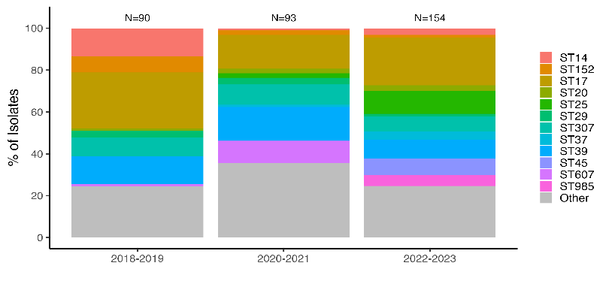
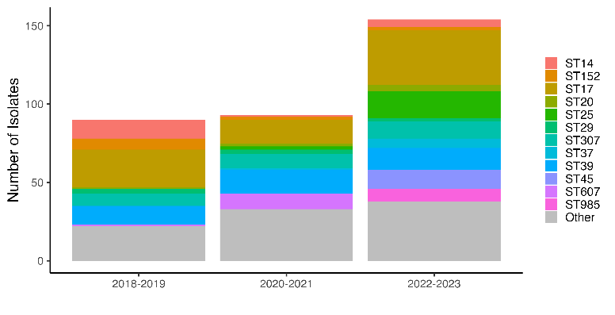
Across all sites: Sequence types

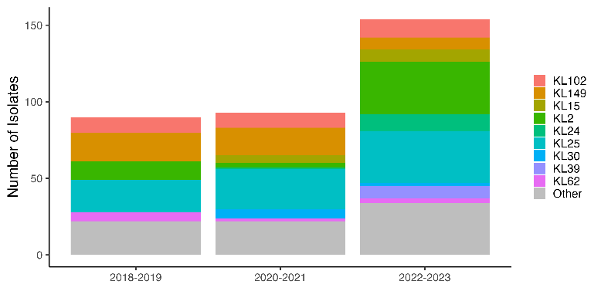
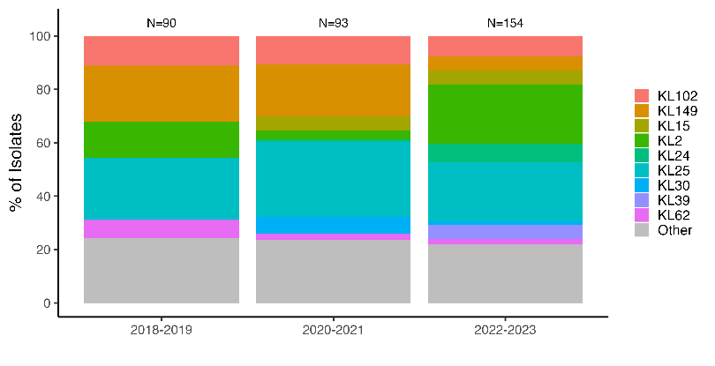
Across all sites: K-loci

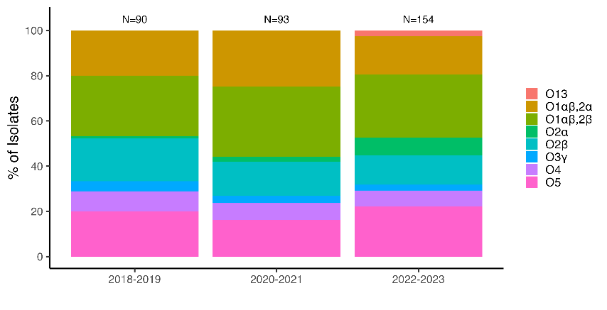
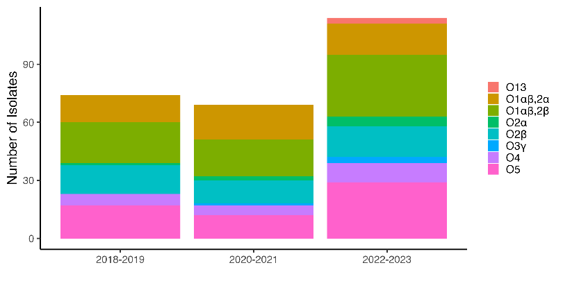
Across all sites: O-antigen types

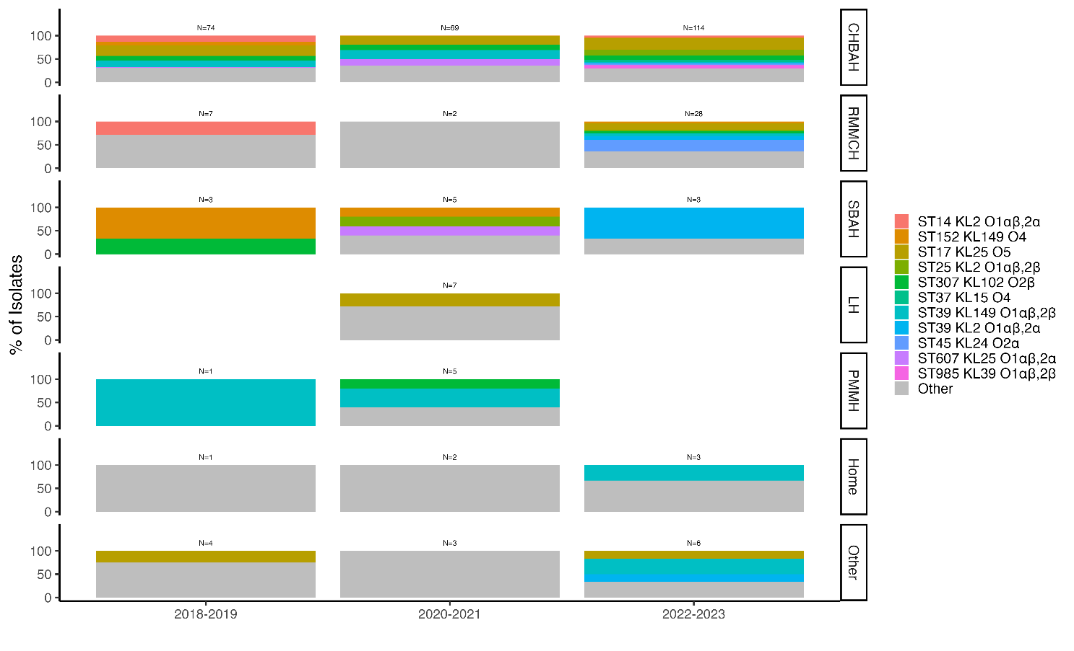
- By site: Clonotypes
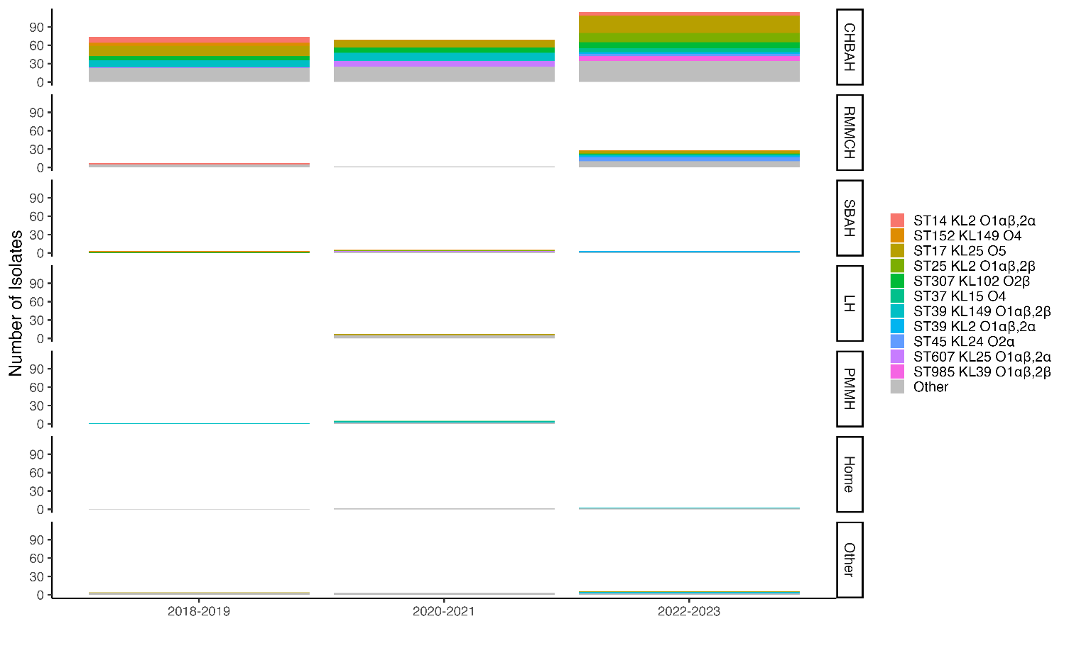

By site: Sequence types

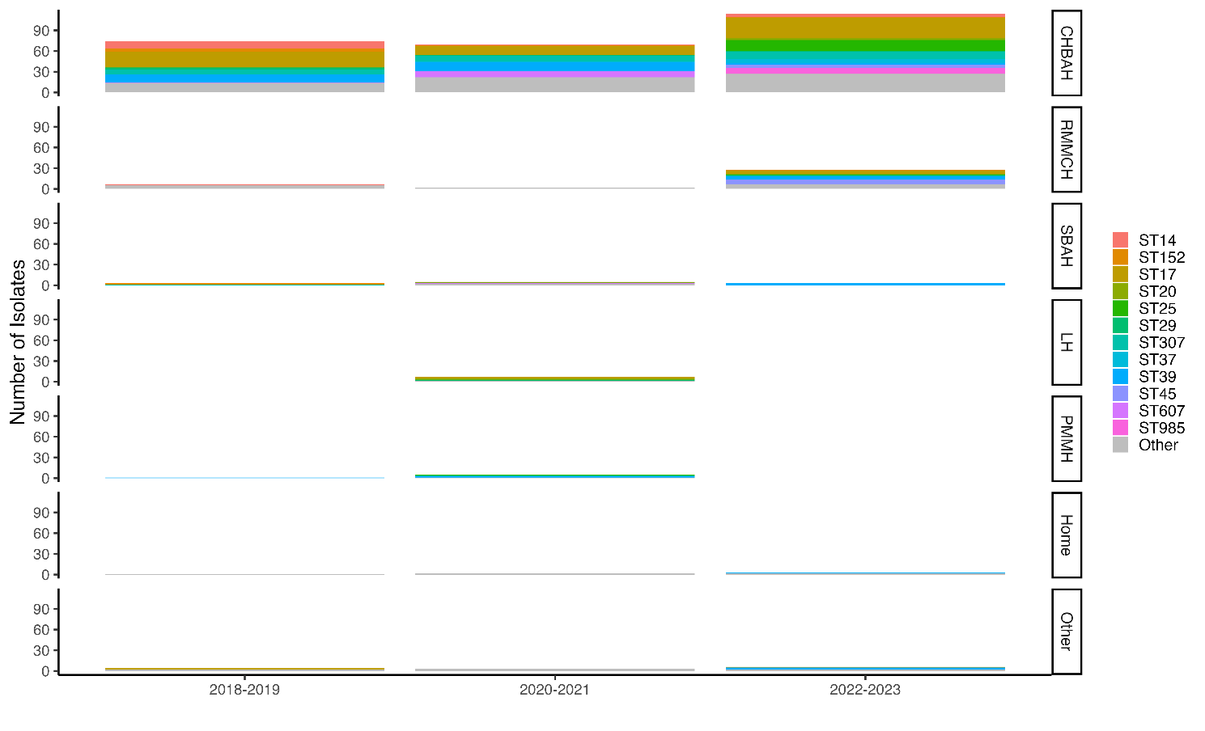
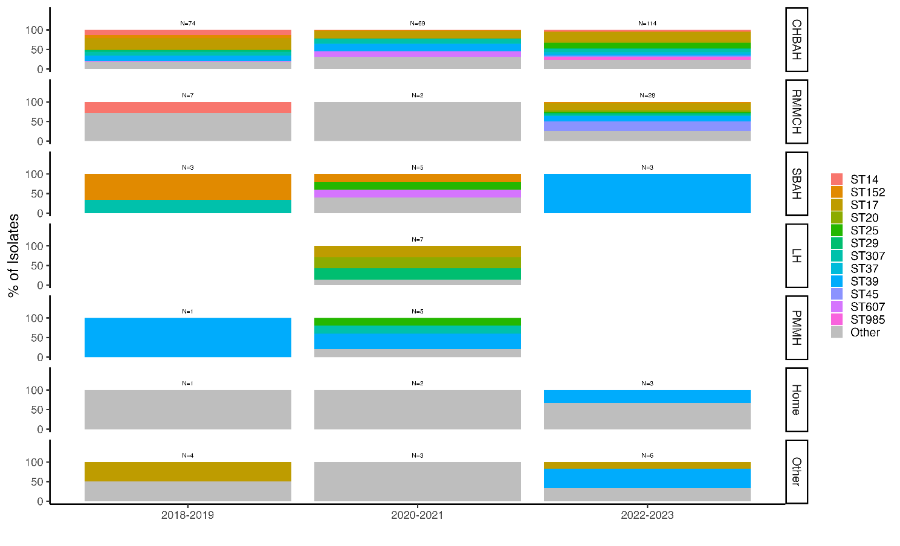

By site: K-loci

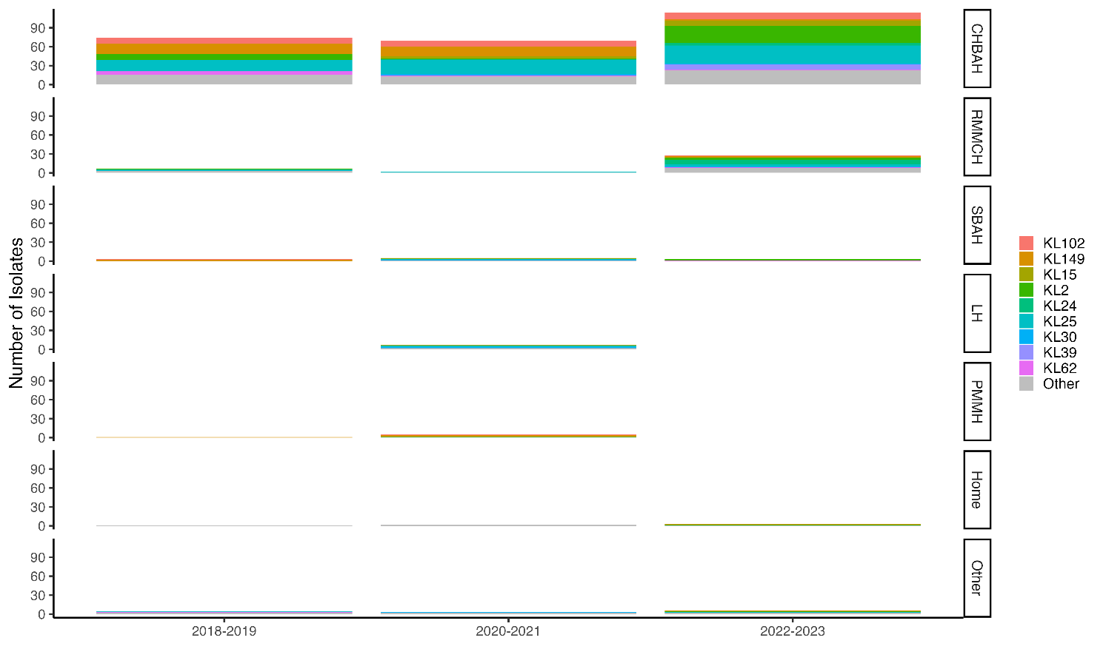

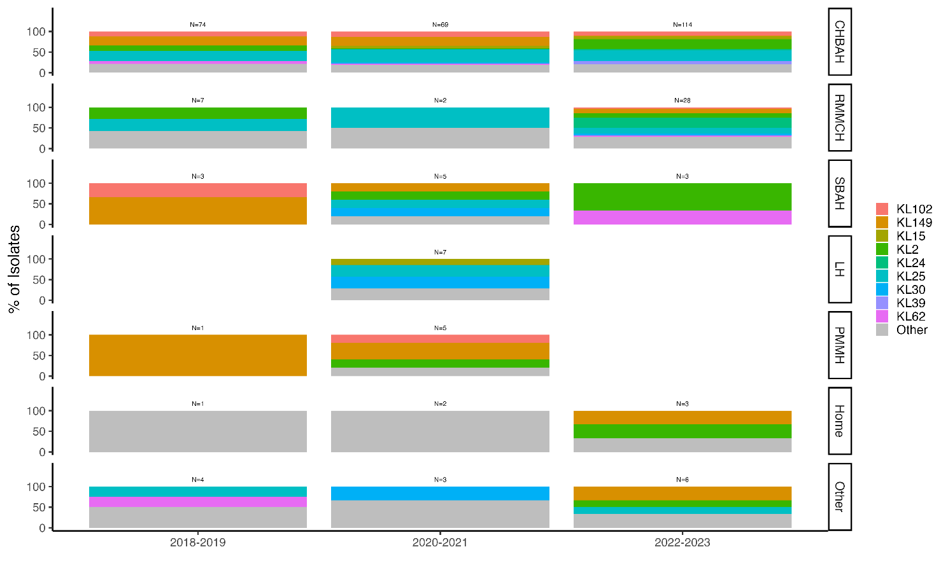

By site: O-antigen types
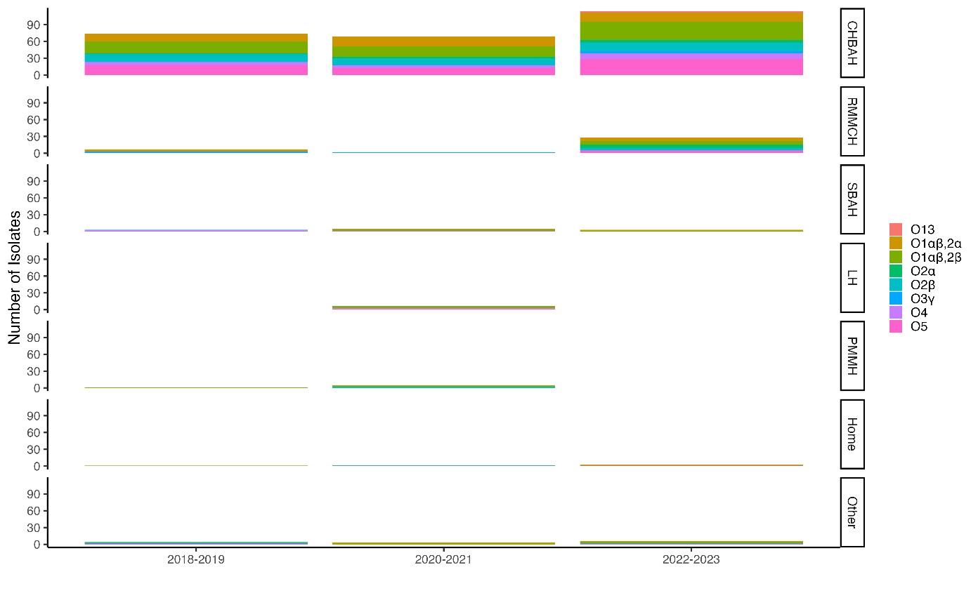
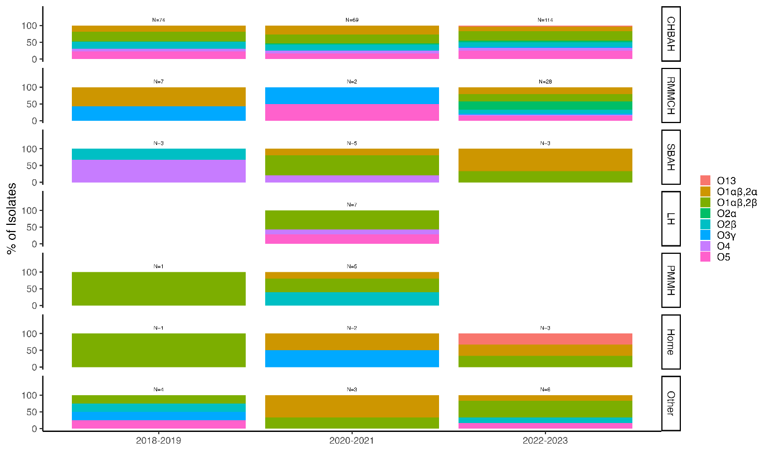

Supplementary Figure 1: Changes in the genotypes, ST, K-loci, and O-antigens of K. pneumoniae causing invasive disease in South African infants (a) across all sites and by sites (b), over the study period.

Alt text: graphs showing the changes in the genotypes, sequence types (ST), K-loci, and O-antigens of Klebsiella pneumoniae causing invasive disease in South African infants. The data is presented for (a) all sites combined, (b) and across sites between 2018 and 2023.

A.
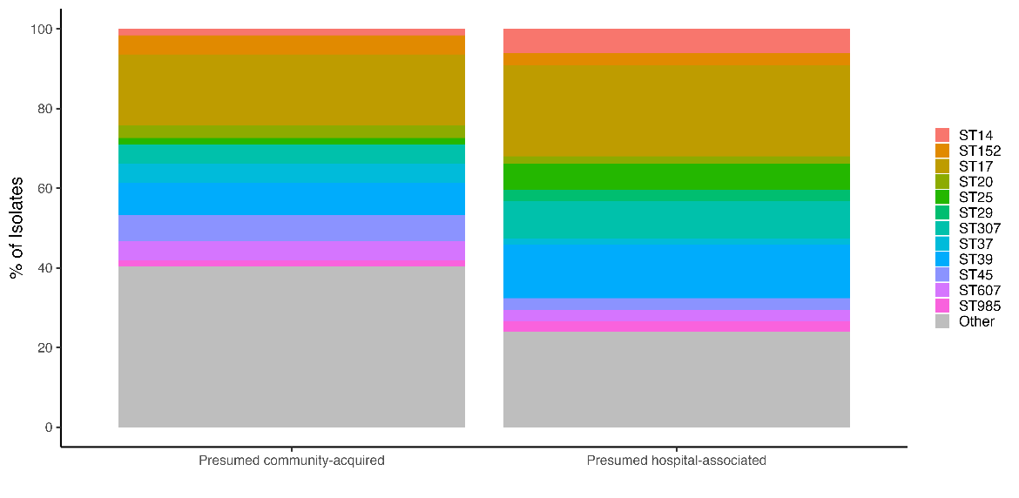
B.
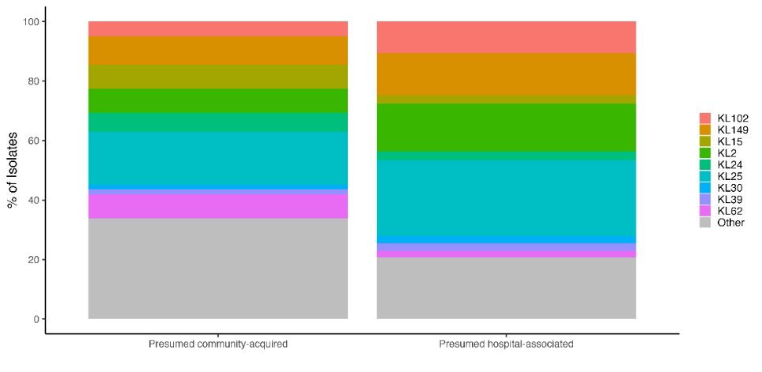
C.
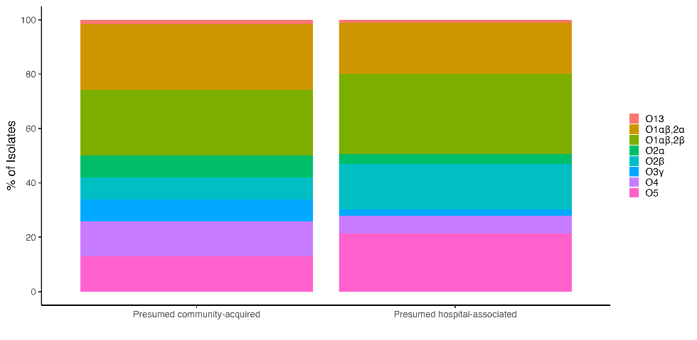

Supplementary Figure 2: Sequence types (a), K-loci (b), and O-antigens (c), by setting
Alt text: Graphs sowing the distribution of (a), sequence types (ST), (b) K-loci, and (c) O-antigens of Klebsiella pneumoniae causing invasive disease in South African infants. The data is stratified by cases presumed to be acquired in the hospital versus those assumed to be acquired in the community.

A.
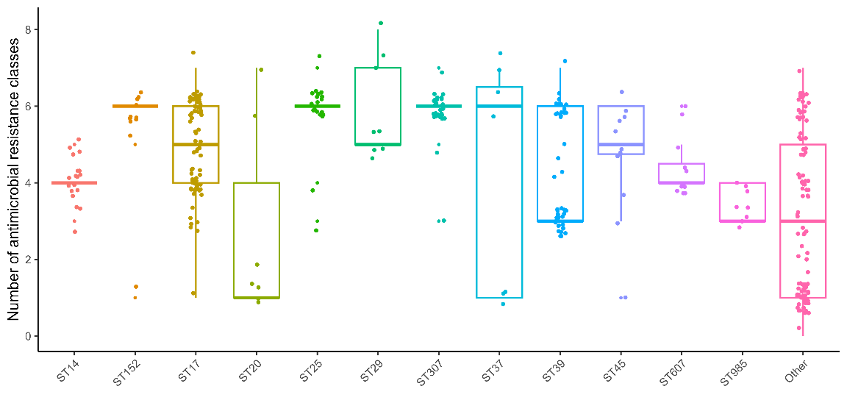
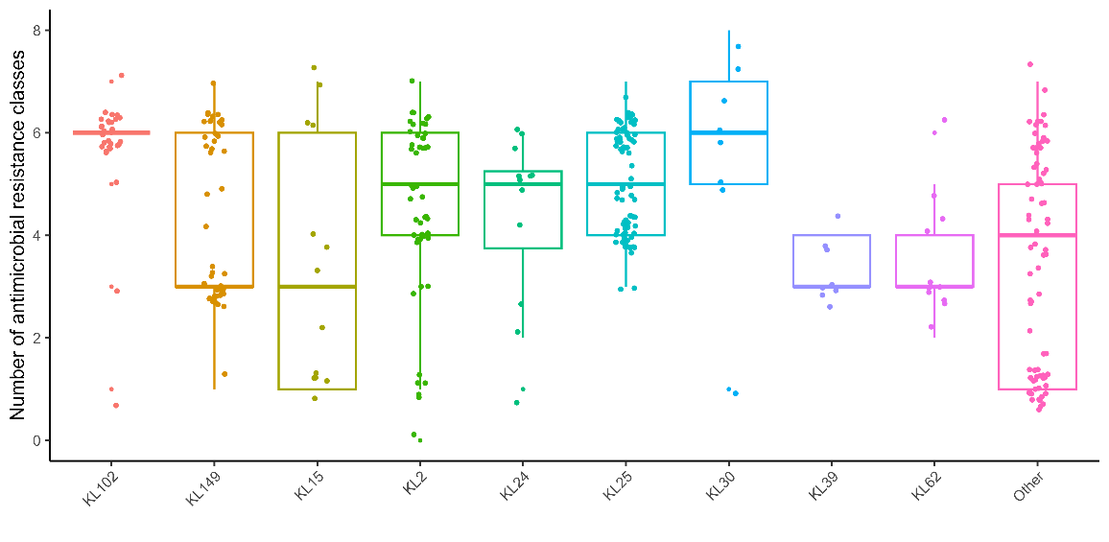
B.

C.
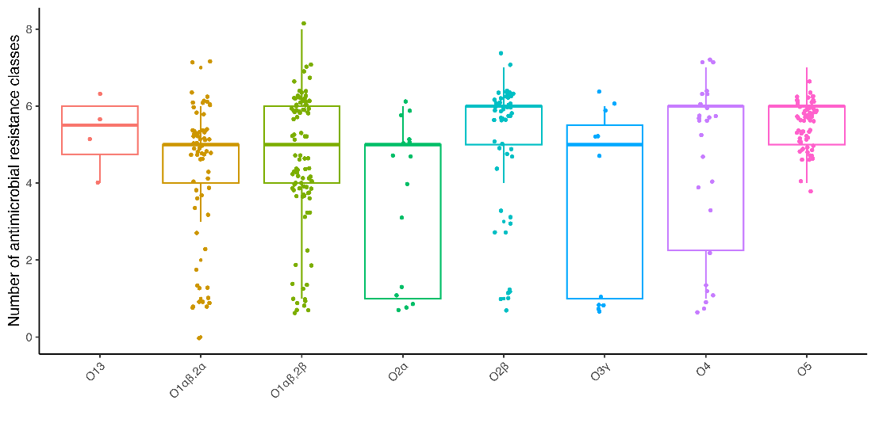
Supplementary Figure 3: Number of antimicrobial resistance classes, stratified by Sequence types (a), K-loci (b), and O-antigens (c).
Alt text: Graphs illustrating the number of different antimicrobial classes to which the Klebsiella pneumoniae strains were resistant. The data is stratified by the most common (a) Sequence types, (b) K-loci, and (c) O-antigens.
- References
1. Madhi, S.A., et al., Potential for maternally administered vaccine for infant Group B Streptococcus. New England Journal of Medicine, 2023. 389(3): p. 215-227.

