Supplementary material

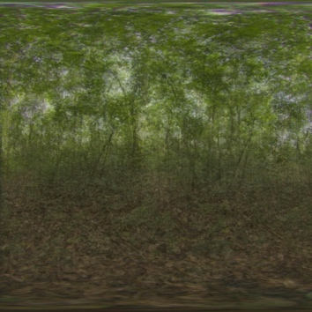 A

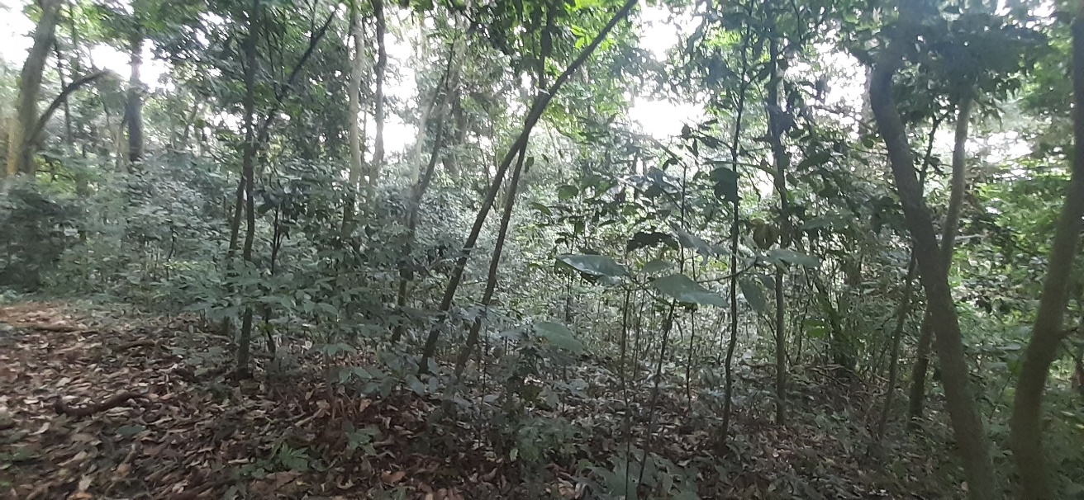 B

Figure S1. Composite image (A) and site picture (B) of the primary forest in Kibale National Park, Uganda.

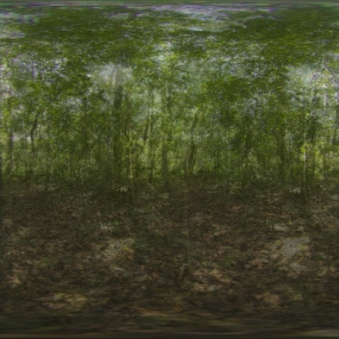A

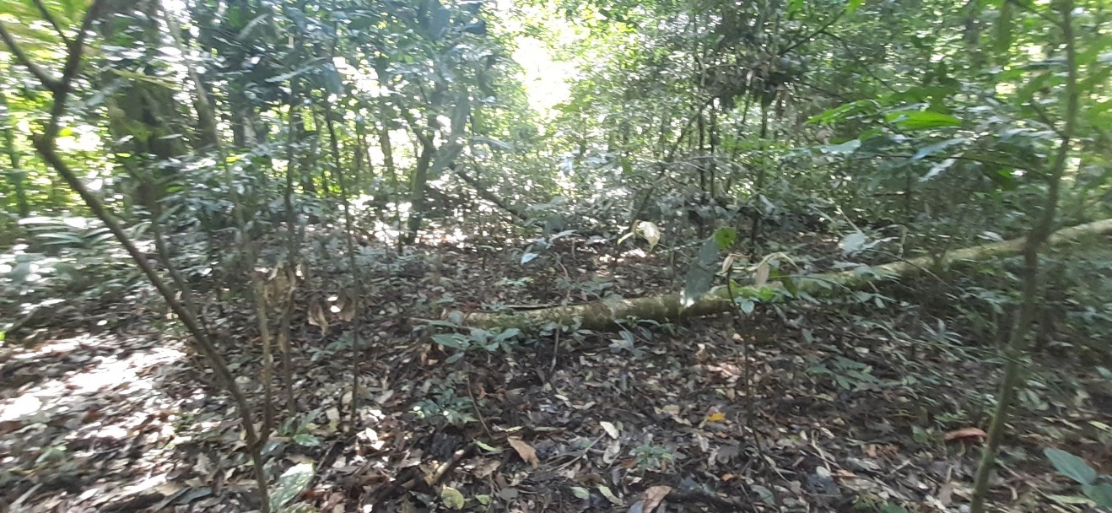 B
Figure S2. Composite image (A) and site picture (B) of the selectively logged forest in Kibale National Park, Uganda.

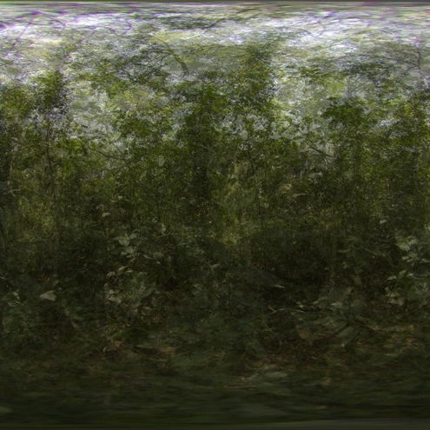A

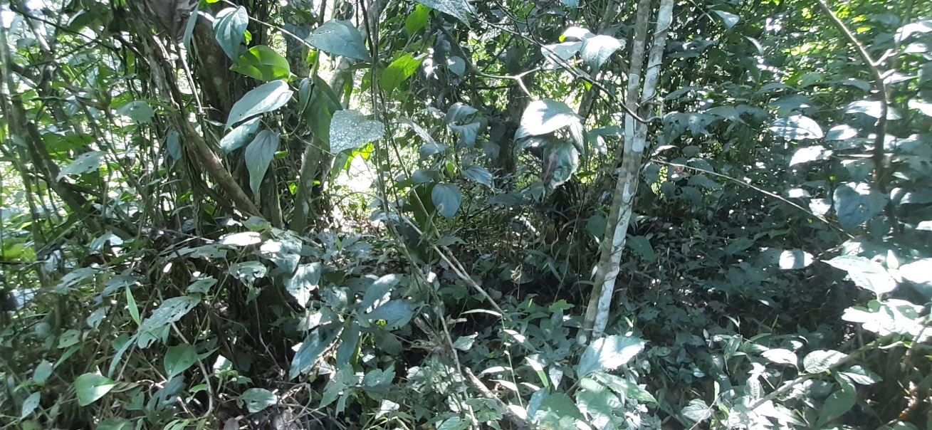 B

Figure S3. Composite image (A) and site picture (B) of the secondary logged forest in Kibale National Park, Uganda.
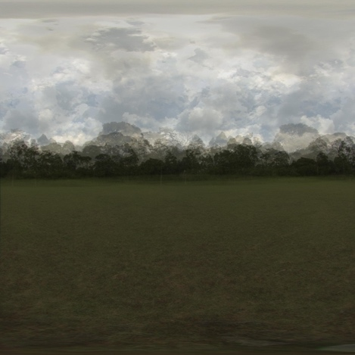A

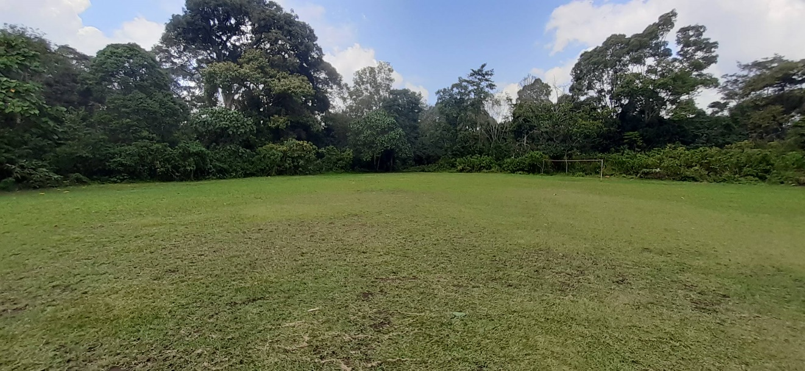B
Figure S4. Composite image (A) and site picture (B) of a clearing outside of Kibale National Park, Uganda.

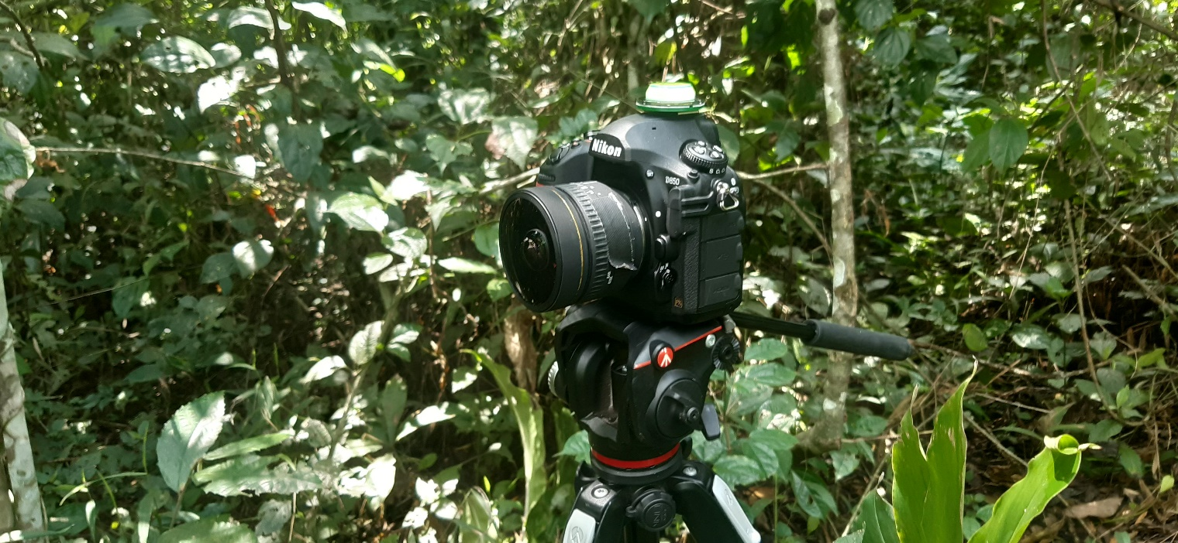
Figure S5. The Environmental Light Field camera deployed in the field. Note the sturdy tripod on a head that can swivel, masking tape to keep the focus ring locked and identical at all sites, the round spirit level, and the spherical 8mm spherical lens.

--- End ---

