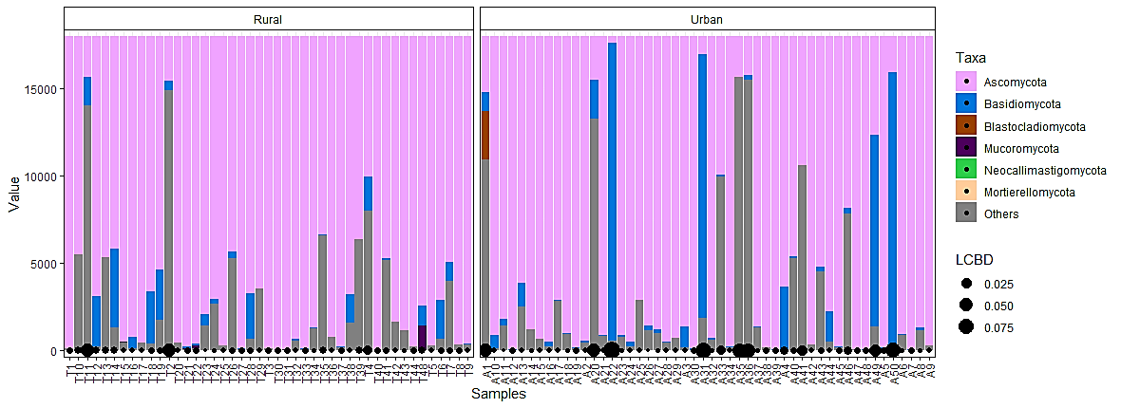

Additional File 5 Figure S3 Taxa abundance data was normalised to obtain the proportion of most abundant taxa per sample. The diameter of the points at the bottom of the plot corresponds to the magnitude of the LCBD value for a particular sample. The bars correspond to taxa that are most abundant with the top taxa sharing a bigger portion of the bar for each sample.

