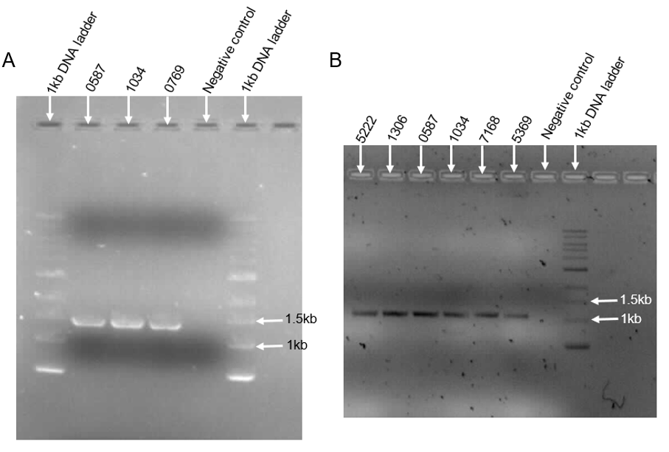
Supplementary figure 1: Agarose gel electrophoretogram showing the separate PR-RT and IN nested PCR results, respectively. Protease-reverse transcriptase (PR-RT) primers were designed and tested together with published integrase (IN) primers in separate nested PCR reactions to assess if they could amplify their target fragments. A. PR-RT was amplified as a 1.4kb fragment. B. IN was amplified as a 1kb fragment. DNA – deoxyribonucleic acid; kb – kilobase.

