Proteomic analysis of chicken bone marrow-derived dendritic cells in response to an inactivated IBV+NDV poultry vaccine
Running title: Proteomic analysis inactivated poultry vaccines
Robin H. G. A. van den Biggelaar¹, Larissa van der Maas², Hugo D. Meiring², Jeroen L.A. Pennings³, Willem van Eden¹, Victor P. M. G. Rutten^{1,4}, Christine A. Jansen^{1,5,*}
¹Division of Infectious Diseases and Immunology, Department of Biomolecular Health Sciences, Faculty of Veterinary Medicine, Utrecht University, the Netherlands
²Intravacc (Institute for Translational Vaccinology), the Netherlands
³Centre for Health Protection, National Institute for Public Health and the Environment (RIVM), the Netherlands
⁴Department of Veterinary Tropical Diseases, Faculty of Veterinary Science, University of Pretoria, South Africa
⁵Cell Biology and Immunology Group, Department of Animal Sciences, Wageningen University and Research, Wageningen, the Netherlands
*email: c.a.jansen@uu.nl

Supplementary Figures
Supplementary Figure 2 Stimulation of chBMDCs with LPS led to the significant downregulation of lysosomal enzymes. The KEGG lysosome map (gga04142)²⁹ shows differentially expressed proteins of LPS-stimulated chBMDCs in the lysosome. Downregulated proteins are shown in blue and upregulated proteins are shown in red.
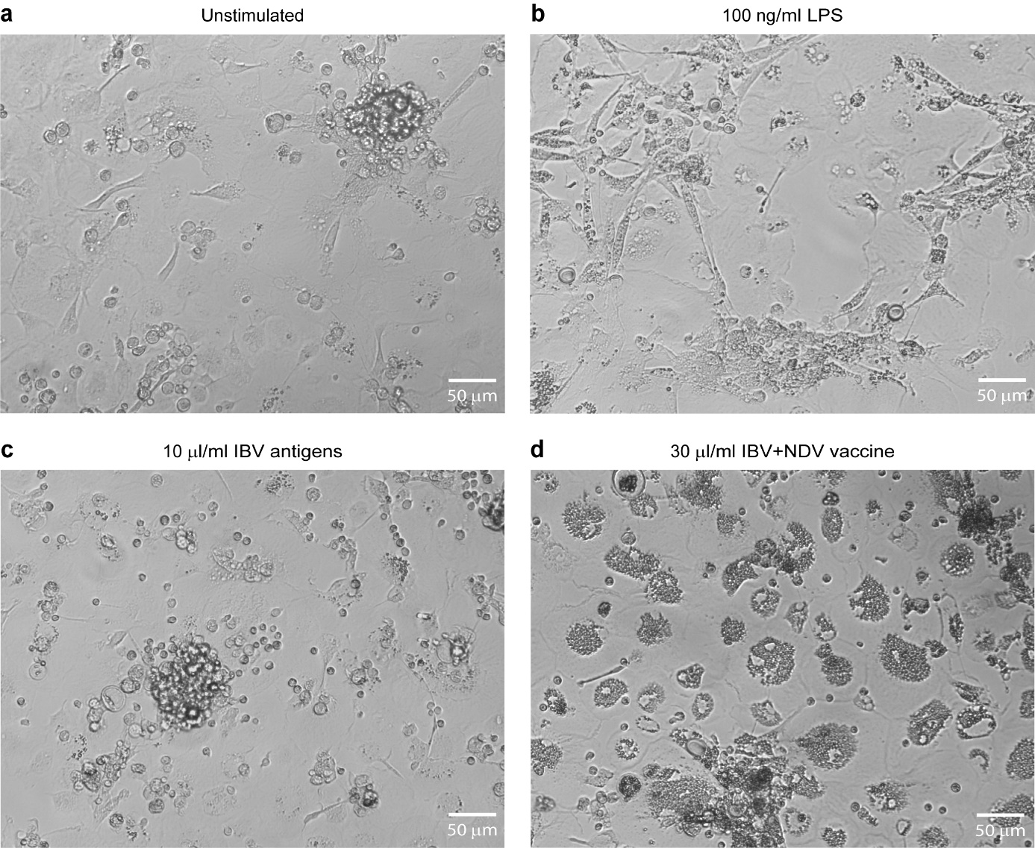
Supplementary Figure 3 The morphology of chBMDCs changes upon stimulation. The chBMDC cultures were left unstimulated (a) or were stimulated with 100 ng/ml LPS (b), 10 μl/ml IBV antigen (c) or 30 μl/ml IBV+NDV vaccine (d). Subsequently, the cell morphology of the cultures was captured with brightfield light microscopy at 100x magnification.

