SUPPLEMENTARY DATA
Table S1: Relative crystallinity index (CrL) of untreated cowpea sidestream, alkali-treated followed by bleaching, extruded (with and without alkali) followed by bleaching and commercial cellulose.
Sample | Crystallinity index CrL (%)
Untreated  Bleached only | 55.65 ± 1.97ª  72.32 ± 2.33^{bc}
Alkali-treated  Bleached alkali-treated | 77.25 ± 0.83^{d}  77.68 ± 0.28^{d}
Extruded  Bleached extruded | 69.34 ± 0.04^{b}  73.37 ± 0.14^{c}
Extruded with alkali  Bleached extruded with alkali | 69.49 ± 0.25^{b}  75.22 ± 0.71^{cd}
C. cellulose | 88.57 ± 0.14e
Means followed by standard deviation. Means with different letters in the same column are significantly different (p<0.05).

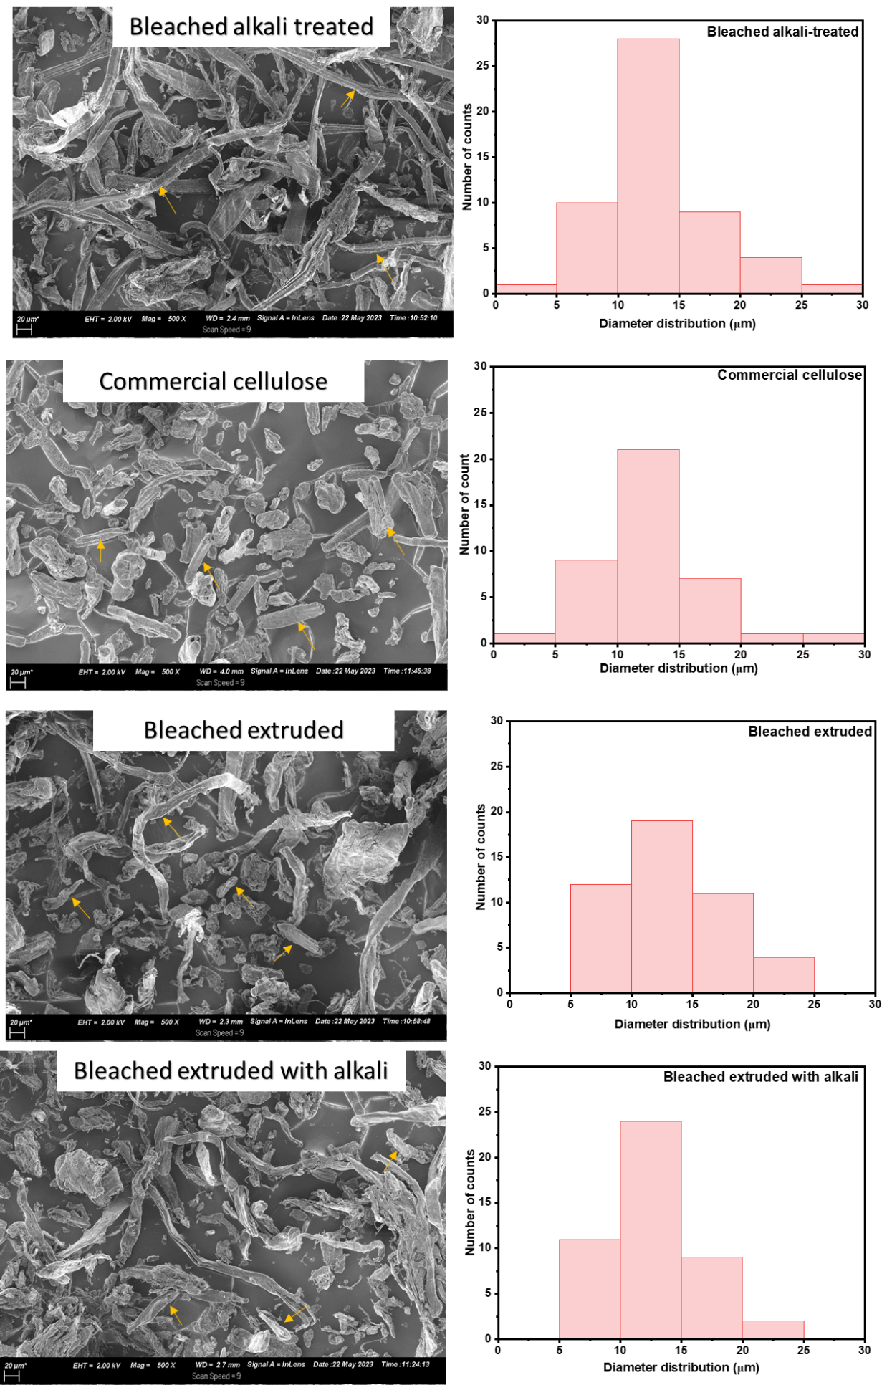
Figure S1: Diameter size distribution of cellulose fibres extracted with conventional alkali pre-treatment followed by bleaching and extrusion pre-treatment (without and with alkali) followed by bleaching.
Table S2: Thermal stabilities of untreated cowpea sidestream, alkali-treated followed by bleaching, extruded (with and without alkali) followed by bleaching and commercial cellulose.
Sample | T_{o}  (°C) | T₂₅  (°C) | T₅₀  (°C) | T_{max}  (°C) | Residues at  500 °C (%)
Untreated  Bleached only | 263.90 ± 0.21^{bc}  263.99 ± 0.91^{bc} | 299.84 ± 0.22^{bc}  307.07 ± 1.17^{d} | 340.48 ± 0.42^{c}  344.16 ± 0.41^{d} | 338.57 ± 1.20de  348.16 ± 0.16^{f} | 24.22 ± 0.37^{f}  19.48 ± 0.60^{c}
Alkali-treated  Bleached alkali-treated | 260.74 ± 1.68^{b}  285.42 ± 2.60e | 296.34 ± 1.53^{ab}  316.52 ± 2.14^{f} | 331.53 ± 0.68^{b}  341.28 ± 0.95^{cd} | 318.15 ± 0.40ª  340.48 ± 0.91de | 24.62 ± 0.34^{f}  16.32 ± 1.02^{b}
Extruded  Bleached extruded | 260.34 ± 2.00^{b}  272.11 ± 0.89^{d} | 296.76 ± 0.66^{ab}  311.39 ± 1.31e | 330.80 ± 1.68^{b}  352.04 ± 2.06e | 328.50 ± 3.57^{bc}  360.24 ± 4.24^{g} | 23.09 ± 0.62^{ef}  20.96 ± 0.22^{cd}
Extruded with alkali  Bleached extruded with alkali | 255.76 ± 0.73ª  266.35 ± 0.42^{c} | 292.38 ± 0.68ª  301.95 ± 0.20^{c} | 327.09 ± 0.17ª  339.35 ± 0.62^{c} | 323.37 ± 1.23^{ab}  333.98 ± 0.16^{cd} | 22.21 ± 0.08de  23.40 ± 0.05^{ef}
C. cellulose | 319.44 ± 0.05^{f} | 332.44 ± 1.45^{g} | 341.84 ± 0.05^{cd} | 345.47 ± 2.13^{ef} | 7.01 ± 0.10ª
Means followed by standard deviation. Means with different letters in the same column are significantly different (p<0.05). T_{o} is the initial degradation temperature, T₂₅ is the temperature at 25 % mass loss, T₅₀ is the temperature at 50 % mass loss, T_{max} is the temperature at maximum degradation.

