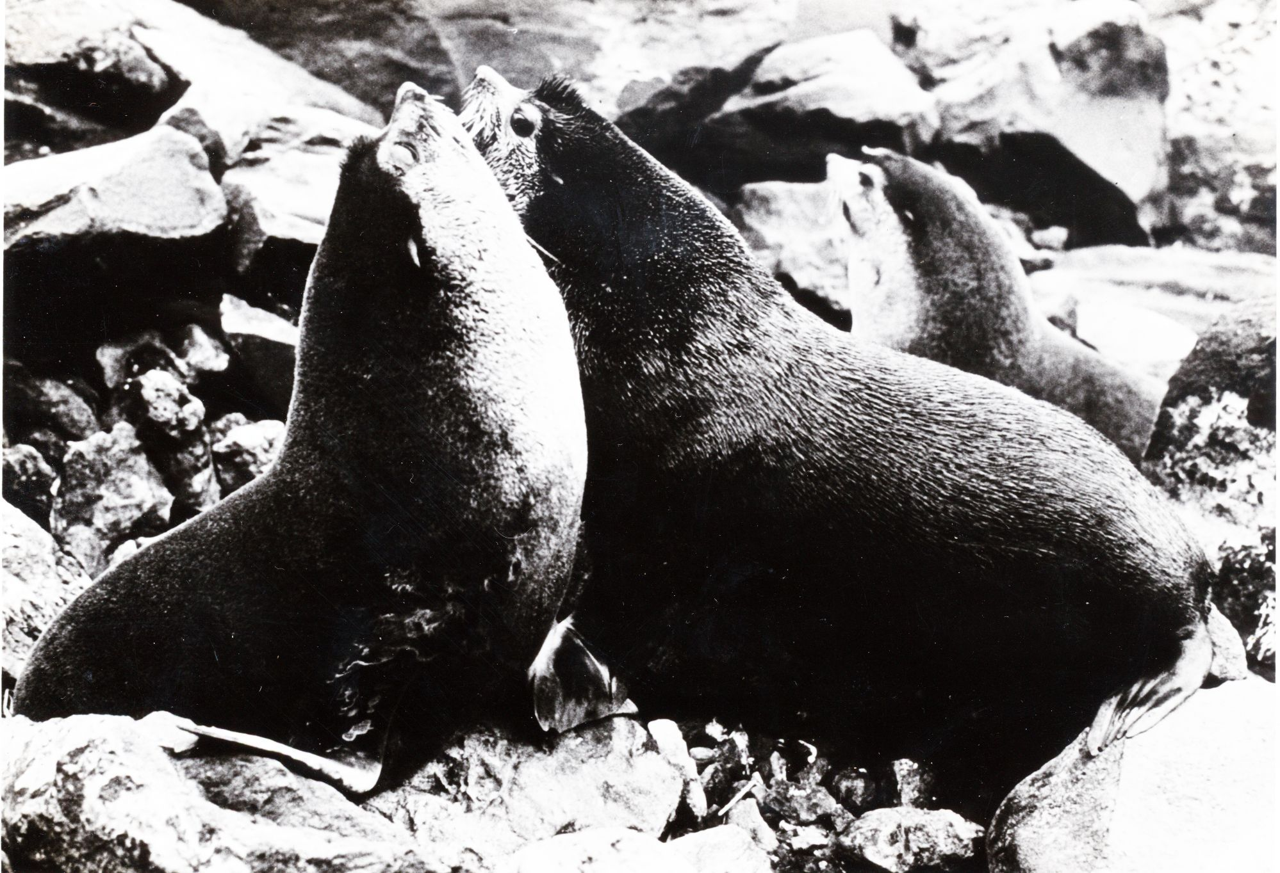

S1 Adult male SAFS at GI positioned chest to chest in physical combat during a territorial dispute which involved biting and inflicting wounds

