SUPPORTING INFORMATION

Data Availability: https://doi.org/10.5061/dryad.08kprr5f4

Table_1_Supp: The total of 64 species that were recorded in ≥10% (≥14) of our plots in the low-lying savanna of Eswatini in 1998, 2008 and 2020. The 'encounter' column enumerates the total number of times a species was detected in the plots during the three periods. Also shown are species diet and habitat traits based on Hockey et al, 2005. Diet traits include invert=insectivore; seeds=granivore; nectar=nectar feeder and fruits=frugivore, whilst the nest column list nesting substrate predominantly utilized by the different species. The nesting trait 'para' indicates brood parasite behavior, where species lay their eggs in other species nests whereas Sav.woodland=savanna woodland, see Method section for further details.

Species | Scientific name | Encounter | Diet | Nest | Habitat
African Paradise Flycatcher | Terpsiphone viridis | 40 | invert | tree | Sav.woodland
Barn Swallow | Hirundo rustica | 15 | invert | cavity | Grassland
Black backed Puffback | Dryoscopus cubla | 68 | invert | tree | Sav.woodland
Black collared Barbet | Lybius torquatus | 15 | fruits | cavity | Sav.woodland
Black crowned Tchagra | Tchagra senegalus | 50 | invert | shrub | Sav.woodland
Black Cuckooshrike | Campephaga flava | 45 | invert | tree | Sav.woodland
Black headed Oriole | Oriolus larvatus | 52 | invert | tree | Sav.woodland
Blue Waxbill | Uraeginthus angolensis | 64 | seeds | shrub | Sav.woodland
Brown crowned Tchagra | Tchagra australis | 56 | invert | shrub | Sav.woodland
Brown hooded Kingfisher | Halcyon albiventris | 14 | invert | cavity | Sav.woodland
Brubru | Nilaus afer | 66 | invert | tree | Sav.woodland
Cape Glossy Starling | Lamprotornis nitens | 48 | invert | cavity | Sav.woodland
Cape turtle Dove | Streptopelia capicola | 86 | seeds | tree | Sav.woodland
Cardinal Woodpecker | Dendropicos fuscescens | 49 | invert | cavity | Sav.woodland
Chinspot Batis | Batis molitor | 99 | invert | shrub | Sav.woodland
Common Scimitarbill | Rhinopomastus cyanomelas | 31 | invert | cavity | Sav.woodland
Crested Francolin | Dendroperdix sephaena | 17 | invert | grass | Sav.woodland
Dark capped Bulbul | Pycnonotus tricolor | 115 | invert | tree | Forest
Diederik Cuckoo | Chrysococcyx caprius | 18 | invert | para | Sav.woodland
Eastern Nicator | Nicator gularis | 51 | invert | shrub | Forest
Emerald spotted Wood Dove | Turtur chalcospilos | 99 | invert | tree | Sav.woodland
Fork tailed Drongo | Dicrurus adsimilis | 93 | invert | tree | Sav.woodland
Golden breasted Bunting | Emberiza flaviventris | 51 | seeds | shrub | Sav.woodland
Golden tailed Woodpecker | Campethera abingoni | 38 | invert | cavity | Sav.woodland
Gorgeous Bushshrike | Telophorus viridis | 14 | invert | shrub | Forest
Green backed Camaroptera | Camaroptera brachyura | 42 | invert | shrub | Forest
Green Wood Hoopoe | Phoeniculus purpureus | 18 | invert | cavity | Sav.woodland
Grey headed Bushshrike | Malaconotus blanchoti | 32 | invert | tree | Sav.woodland
Grey Tit Flycatcher | Myioparus plumbeus | 25 | invert | cavity | Sav.woodland
Helmeted Guineafowl | Numida meleagris | 17 | invert | grass | Sav.woodland
Klaass Cuckoo | Chrysococcyx klaas | 14 | invert | para | Sav.woodland
Kurrichane Thrush | Turdus libonyanus | 55 | invert | tree | Sav.woodland
Laughing Dove | Streptopelia senegalensis | 19 | invert | tree | Sav.woodland
Long billed Crombec | Sylvietta rufescens | 96 | invert | shrub | Sav.woodland
Marico Sunbird | Cinnyris mariquensis | 60 | nectar | tree | Sav.woodland
Orange breasted Bushshrike | Telophorus sulfureopectus | 51 | invert | tree | Sav.woodland
Pale Flycatcher | Bradornis pallidus | 18 | invert | tree | Sav.woodland
Purple banded Sunbird | Cinnyris bifasciatus | 19 | nectar | tree | Sav.woodland
Rattling Cisticola | Cisticola chiniana | 121 | invert | shrub | Sav.woodland
Red backed Shrike | Lanius collurio | 63 | invert | tree | Sav.woodland
Red billed Quelea | Quelea quelea | 17 | seeds | tree | Sav.woodland
Red chested Cuckoo | Cuculus solitarius | 18 | invert | para | Forest
Red eyed Dove | Streptopelia semitorquata | 29 | seeds | tree | Sav.woodland
Red faced Mousebird | Urocolius indicus | 41 | fruits | tree | Sav.woodland
Scarlet chested Sunbird | Chalcomitra senegalensis | 37 | nectar | tree | Sav.woodland
Sombre Greenbul | Andropadus importunus | 50 | fruits | shrub | Forest
Southern Black Flycatcher | Melaenornis pammelaina | 38 | invert | shrub | Sav.woodland
Southern Black Tit | Parus niger | 73 | invert | cavity | Sav.woodland
Southern Boubou | Laniarius ferrugineus | 23 | invert | shrub | Sav.woodland
Southern Grey headed Sparrow | Passer diffusus | 16 | seeds | cavity | Sav.woodland
Southern Yellow billed Hornbill | Tockus leucomelas | 17 | invert | cavity | Sav.woodland
Spotted Flycatcher | Muscicapa striata | 41 | invert | tree | Sav.woodland
Striped Kingfisher | Halcyon chelicuti | 24 | invert | cavity | Sav.woodland
Tawny flanked Prinia | Prinia subflava | 42 | invert | shrub | Sav.woodland
Violet backed Starling | Cinnyricinclus leucogaster | 37 | invert | cavity | Sav.woodland
White bellied Sunbird | Cinnyris talatala | 107 | nectar | shrub | Sav.woodland
White browed Scrub Robin | Cercotrichas leucophrys | 106 | invert | grass | Sav.woodland
White crested Helmet Shrike | Prionops plumatus | 28 | invert | tree | Sav.woodland
White winged Widowbird | Euplectes albonotatus | 23 | seeds | grass | Grassland
Willow Warbler | Phylloscopus trochilus | 17 | invert | tree | Sav.woodland
Woodland Kingfisher | Halcyon senegalensis | 63 | invert | cavity | Sav.woodland
Yellow breasted Apalis | Apalis flavida | 61 | invert | shrub | Sav.woodland
Yellow fronted Canary | Crithagra mozambicus | 60 | seeds | tree | Sav.woodland
Yellow throated Petronia | Petronia superciliaris | 67 | seeds | tree | Sav.woodland

Table_2_Supp: Classification accuracy assessment for grass, shrub, and tree cover for the low-lying savanna of Eswatini in 1998, 2008 and 2020. For each year, class specific accuracy estimates are shown together with overall accuracy and the kappa coefficients.

Year | Cover_class | User.acc (%) | Prod.acc (%)
1998 | grass | 99.9 | 100
 | shrub | 98.6 | 99.8
 | tree | 99.9 | 99.9
Overall accur. | 99.90%
Kappa.coeff. | 0.996
2008 | grass | 99.9 | 99
 | shrub | 85.8 | 89.7
 | tree | 96.6 | 96.6
Overall accur. | 97.30%
Kappa.coeff. | 0.951
2020 | grass | 99.9 | 99.6
 | shrub | 92.1 | 98.7
 | tree | 99.9 | 99.9
Overall accur. | 99.90%
Kappa.coeff. | 0.998

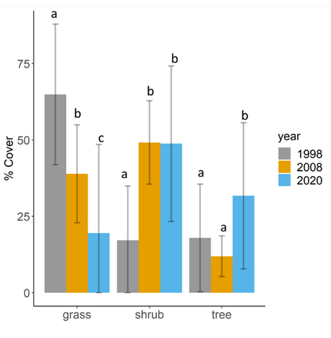
Figure_1_Supp: Overall change in the three vegetation cover types; grass, shrub and tree in the low-lying savanna of Eswatini as quantified in the wet season between 1998, 2008 and 2020 when we exclude five plots that were cleared of all woody vegetation between 2008 and 2020. The bar graphs indicate year sepcific everage cover and also shown are the standard errors (bars) for each cover type during each period. Letters, 'a', 'b' and 'c', represent pairwise comparison of mesaures with diffrent letters suggesting significant diffrences while shared letters indicate no difference. When excluding the five plots that were cleared of woody vegetation, we found that grass cover significantly declined during each period (1998, 2008 and 2020) whereas both variation in shrub and tree cover was similar to when we included all the plots.

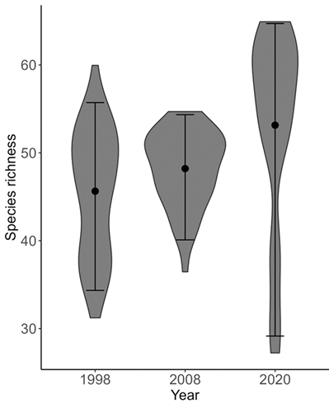
Figure_2_Supp: Estimated species richness (points = mean, error bars = 95% CRI), with violin plots showing posterior distribution for all (121) bird species counted in the low-lying savanna ecosystem of Eswatini during the wet seasons of 1998, 2008 and 2020.

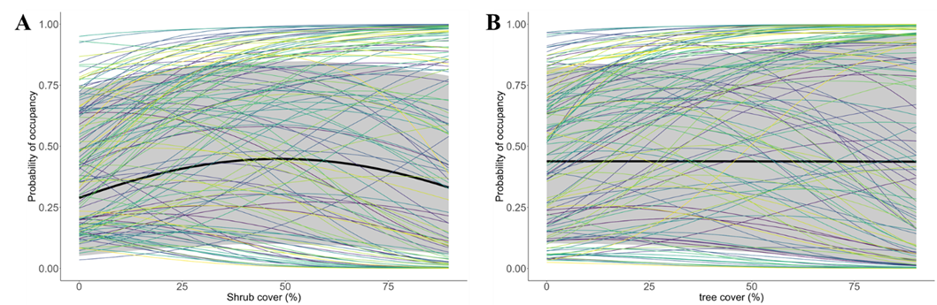
Figure_3_Supp: Community mean (thick black line) and species-specific occupancy (thin lines) responses to shrub (A) and tree (B) cover for all (121) bird species assessed in the low-lying savanna ecosystem of Eswatini during the wet seasons of 1998, 2008 and 2020. The grey ribbon delineates the 95% CRI for community responses.

