SUPPLEMENTAL DIGITAL CONTENT

Prenatal exposure to insecticides and child cardiometabolic risk factors in the VHEMBE birth cohort
Joanne Kim¹, Seungmi Yang¹, Erica EM Moodie¹, Muvhulawa Obida², Riana Bornman², Brenda Eskenazi³, Jonathan Chevrier¹

¹Department of Epidemiology, Biostatistics and Occupational Health, Faculty of Medicine, McGill University, Montreal, Canada
²University of Pretoria Institute for Sustainable Malaria Control, School of Health Systems and Public Health, University of Pretoria, Pretoria, South Africa
³Center for Environmental Research and Children’s Health, School of Public Health, University of California, Berkeley, USA

Section 1. Flow diagram of participants in the VHEMBE study
Section 2. Inverse probability weights for censoring and treatment
Section 3. Multiple imputation by chained equations
Section 4. Effect modification of prenatal insecticide exposure on child size and blood pressure

Section 1. Flow diagram of participants in the VHEMBE study

Figure S1.1. Flow diagram of participants in the VHEMBE study

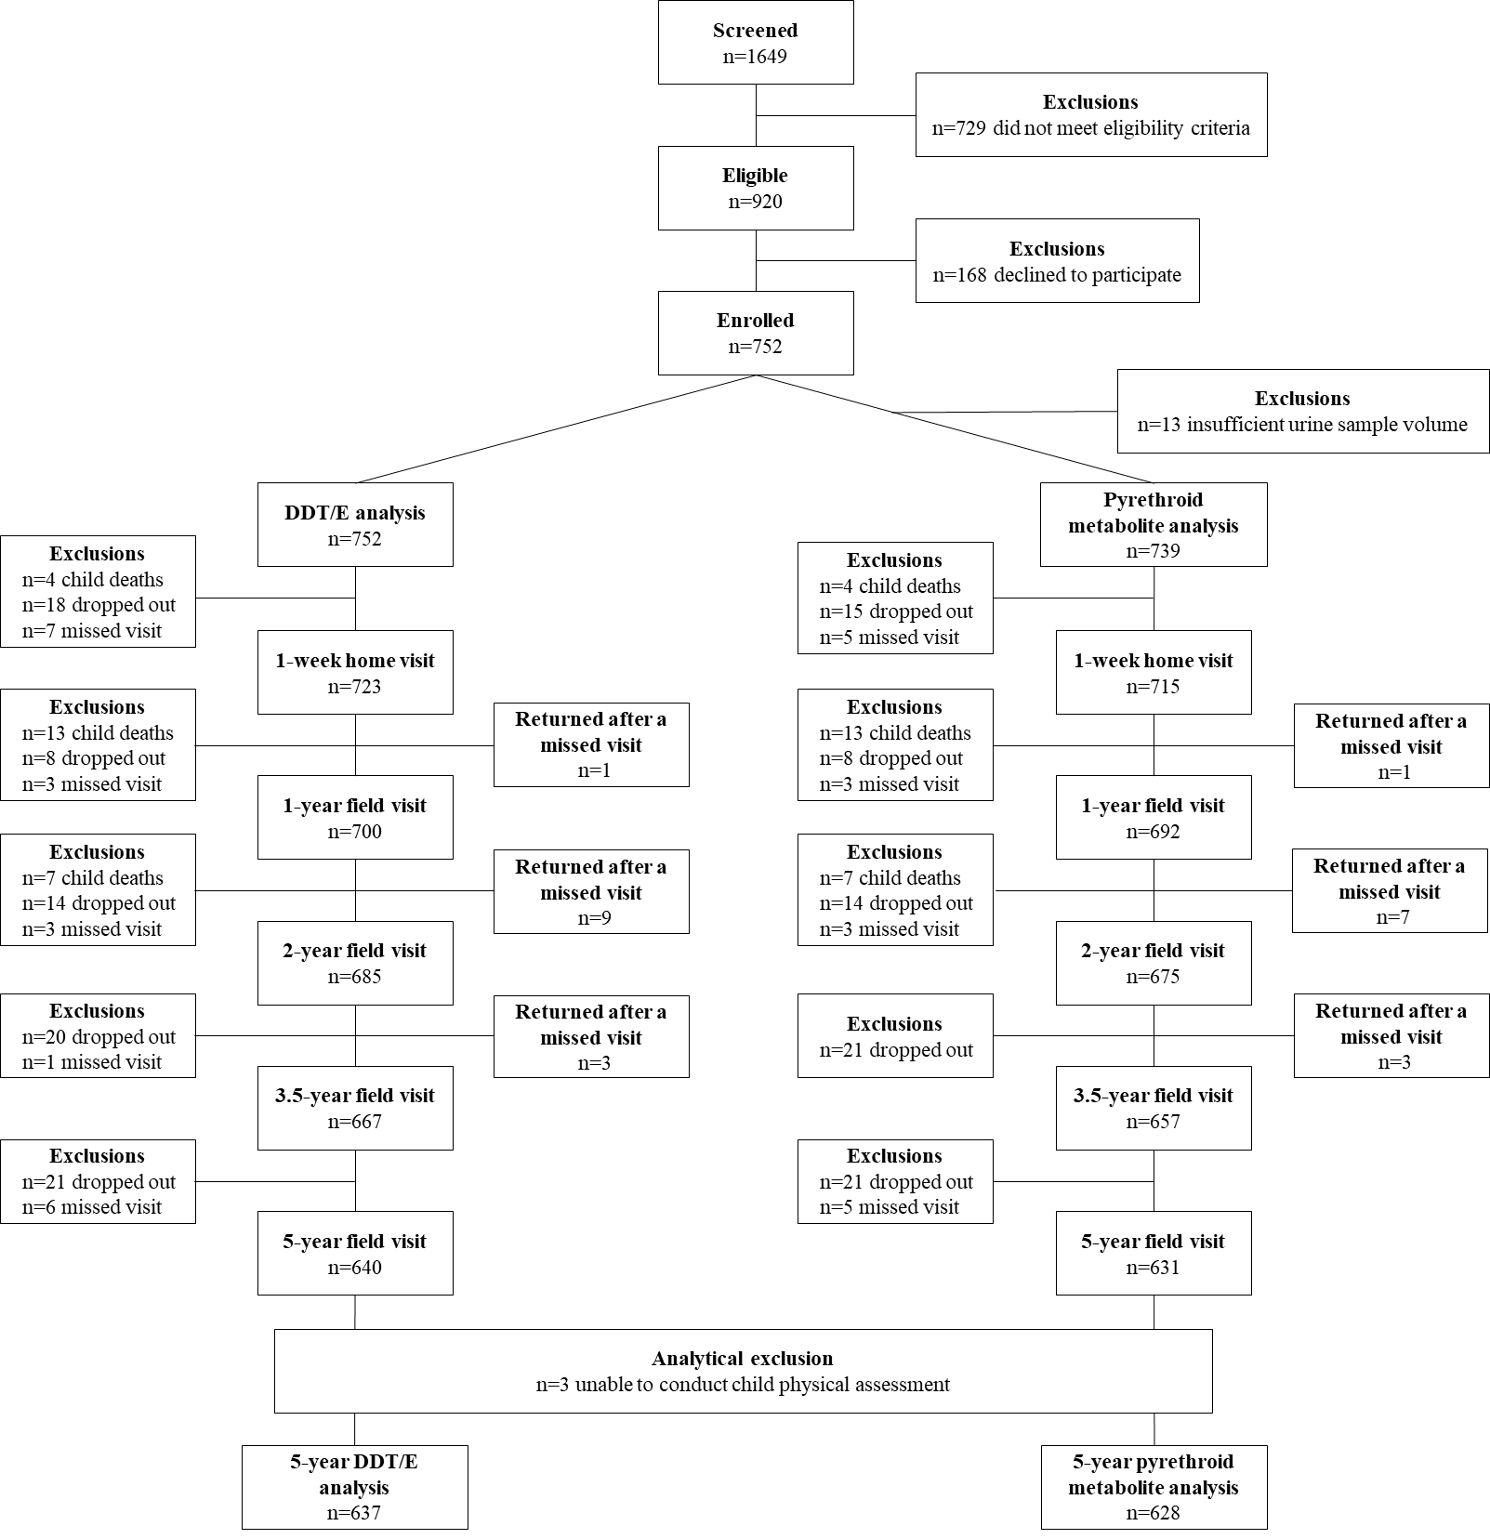

Section 2. Inverse probability weights for censoring and treatment

Methods
Two types of inverse probability weights were constructed: inverse probability of censoring weights (IPCWs), to address selection bias from loss to follow-up from baseline to the 5-year study visit; and inverse probability of treatment weights (IPTWs) for each exposure, to address confounding.

We used a directed acyclic graph (Figure S2.1) to identify the following potential confounders of the exposure-outcome relationship and predictors of censoring and outcomes to be included in both the IPTW and IPCW models: child sex (boy/girl); household food poverty (yes/no), food insecurity (yes/no), and wealth index (continuous); maternal age (years, continuous), height (metres, continuous), post-delivery weight (kg, continuous), education (high school vs. no high school), marital status (married or living-as-married vs. not married), energy intake during pregnancy (insufficient/sufficient), alcohol use during pregnancy (yes/no), HIV status (positive/negative), duration of exclusive breastfeeding (months, continuous), and parity (continuous). In the IPCW models, we also included gestational age (preterm vs. not preterm) and DDT/E and pyrethroid metabolite concentrations.

For the IPCWs, we first used logistic regression to estimate the probability of the censoring status of each subject (i.e. completed the 5-year visit vs. lost to follow-up), conditional on all exposures and covariates identified above.¹ We constructed IPCWs based on the inverse of these probabilities and stabilized the weights with the marginal probability of the censoring status received.¹

Then, excluding censored individuals, we constructed IPTWs based on the generalized propensity score (GPS) method^{2,3} for each exposure, using multivariable linear regression to estimate the exposure density function conditional on the covariates identified above. We then generated stabilized IPTWs with the GPS in the denominator and the marginal exposure density in the numerator.¹ To investigate effect measure modification by child sex, food poverty, and energy intake during pregnancy, we generated IPTWs that were instead stabilized by the exposure density conditional on the effect modifier.

The final inverse-probability weights used in the marginal structural models (i.e. outcome regressions) were the product of the IPCWs and IPTWs.

Balance diagnostics

We assessed covariate balance for the IPCWs and the final inverse probability weights (IPCW × IPTW).^{4,5}

For the IPCWs, we calculated standardized differences and variance ratios for each covariate, comparing participants at the 5-year visit to those lost to follow-up (Figure S2.2). Modelling death and dropout as two separate censoring mechanisms led to poor balance of the IPCW for deaths due to finite sample bias (24 deaths, 3%), therefore, only a single IPCW model was used.

For the final sets of inverse probability weights, we assessed balance using three metrics:

- Pearson correlation coefficients between the exposure and each continuous covariate (Figure S2.3)

- Standardized differences comparing all covariates across each quartile of exposure versus all other quartiles. Their absolute values were then averaged across the four comparisons (Figure S2.4). Quartiles of exposure were used to avoid small cell sizes and finite sample bias when assessing standardized differences.

- Variance ratios comparing the variance of all covariates across each quartile of exposure versus all other quartiles, which were then averaged across the four comparisons (Figure S2.5).

Following published guidelines, variables with mean absolute standardized differences below 0.2 when comparing across exposure quartiles (accounting for additional variability expected from small sample sizes),⁵ below 0.1 when comparing across censoring status, and correlations below 0.1, were considered to be balanced.^{4,5} Variance ratios of 1.0 describes a covariate which has equal variance across exposure categories, and a threshold of <2.0 has been suggested to indicate balance.⁶

Figure S2.1. Directed acyclic graph of the relationship between maternal peripartum DDT/E and pyrethroid metabolite concentrations and child size, adiposity and cardiometabolic health

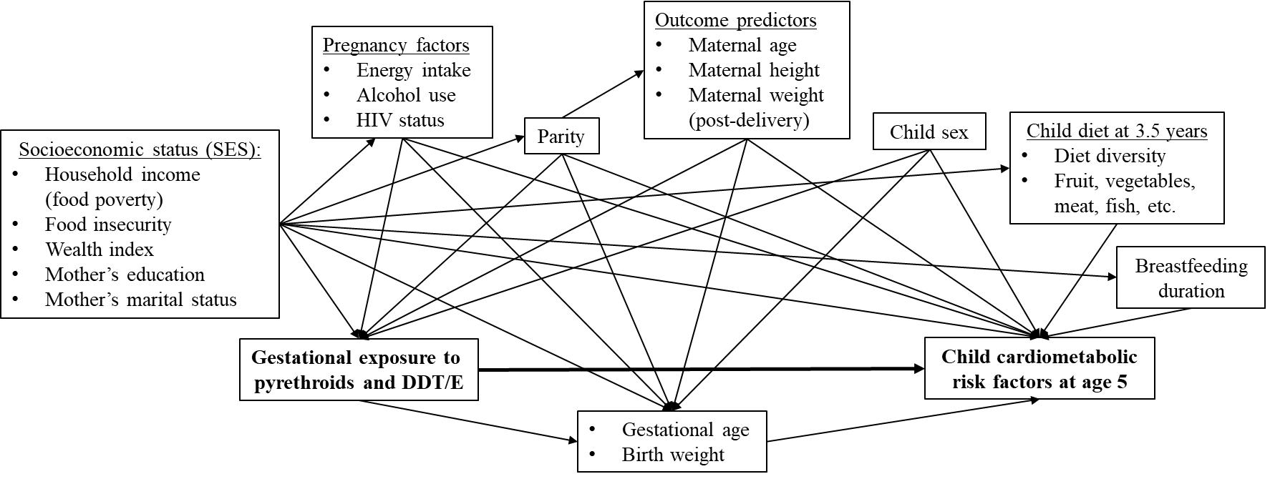

Figure S2.2. Balance diagnostics comparing participants at the 5-year visit to those lost to follow-up, before (×) and after (•) IPCW-weighting

a) Absolute standardized differences
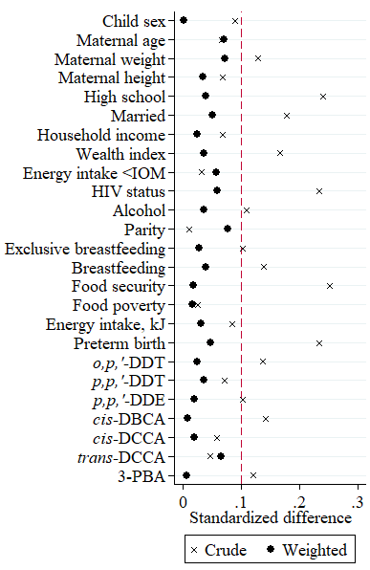
b) Variance ratios
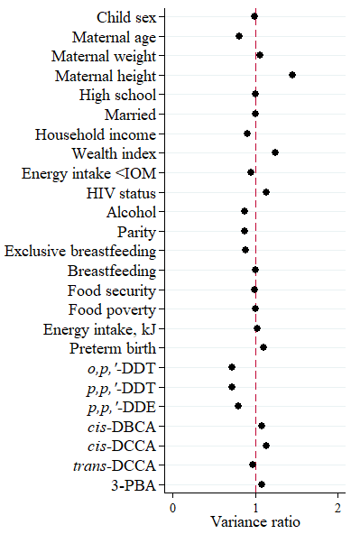

Table S2.1. Distribution of the final inverse probability weights for the overall model and models investigating effect modification

Exposure | Model | n | Mean | SD | Min | Max
p,p’-DDE | Overall | 637 | 1.00 | 0.11 | 0.87 | 1.90
 | Child sex | 637 | 1.00 | 0.26 | 0.27 | 2.74
 | Food poverty | 637 | 1.00 | 0.25 | 0.32 | 2.95
 | Energy intake | 637 | 1.00 | 0.26 | 0.27 | 2.75
o,p’-DDT | Overall | 637 | 1.00 | 0.25 | 0.29 | 2.63
 | Child sex | 637 | 1.00 | 0.23 | 0.21 | 3.83
 | Food poverty | 637 | 1.00 | 0.20 | 0.24 | 2.94
 | Energy intake | 637 | 1.00 | 0.23 | 0.21 | 3.90
p,p’-DDT | Overall | 637 | 1.00 | 0.23 | 0.21 | 3.79
 | Child sex | 637 | 1.00 | 0.22 | 0.36 | 2.34
 | Food poverty | 637 | 1.00 | 0.18 | 0.37 | 1.82
 | Energy intake | 637 | 1.00 | 0.22 | 0.36 | 2.34
cis-DBCA | Overall | 637 | 1.00 | 0.21 | 0.37 | 2.57
 | Child sex | 628 | 1.00 | 0.20 | 0.35 | 2.21
 | Food poverty | 628 | 1.00 | 0.20 | 0.32 | 2.29
 | Energy intake | 628 | 1.00 | 0.20 | 0.36 | 2.17
cis-DCCA | Overall | 628 | 1.00 | 0.20 | 0.44 | 2.09
 | Child sex | 628 | 1.00 | 0.21 | 0.32 | 2.49
 | Food poverty | 628 | 1.00 | 0.21 | 0.33 | 2.62
 | Energy intake | 628 | 1.00 | 0.22 | 0.30 | 2.75
trans-DCCA | Overall | 628 | 1.00 | 0.21 | 0.31 | 2.45
 | Child sex | 628 | 1.00 | 0.21 | 0.38 | 2.15
 | Food poverty | 628 | 1.00 | 0.21 | 0.39 | 2.11
 | Energy intake | 628 | 1.00 | 0.20 | 0.32 | 2.50
3-PBA | Overall | 628 | 1.00 | 0.21 | 0.39 | 2.13
 | Child sex | 627 | 1.00 | 0.24 | 0.45 | 3.13
 | Food poverty | 627 | 1.00 | 0.23 | 0.42 | 2.98
 | Energy intake | 627 | 1.00 | 0.24 | 0.41 | 2.89
Abbreviations: SD, standard deviation; DDE, dichlorodiphenyldichloroethylene; DDT, dichlorodiphenyltrichloroethane; cis-DBCA, cis-3-(2,2-dibromovinyl)-2,2-dimethyl-cyclopropane carboxylic acid; cis-DCCA, cis-3-(2,2,-dicholorvinyl)-2,2-dimethyl-cyclopropane carboxylic acid; trans-DCCA, trans-3-(2,2,-dicholorvinyl)-2,2-dimethyl-cyclopropane carboxylic acid; 3-PBA, 3-phenoxybenzoic acid.

Figure S2.3. Correlations between each exposure and continuous potential confounders, before (×) and after (•) inverse probability weighting
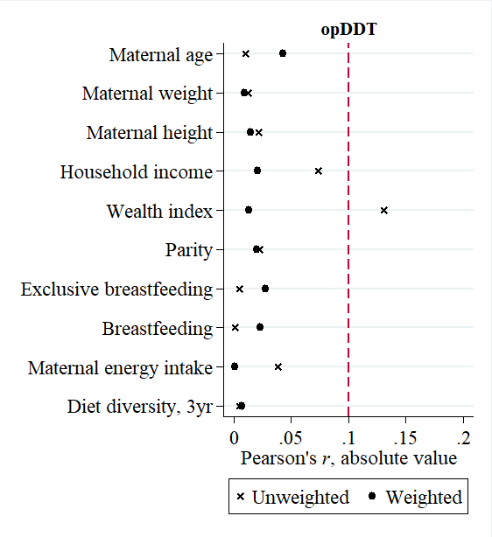
 | o,p’-DDT | 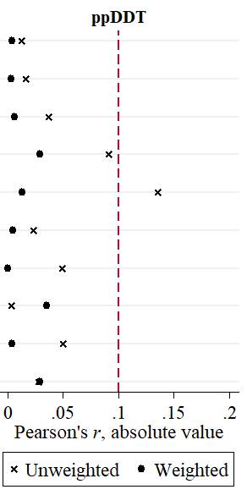  p,p’-DDT | 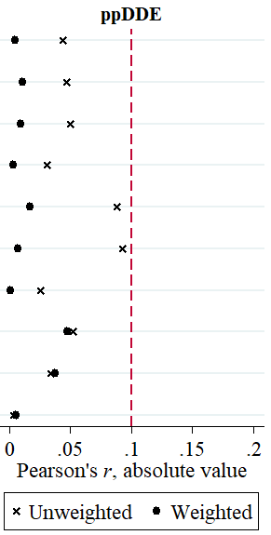  p,p’-DDE

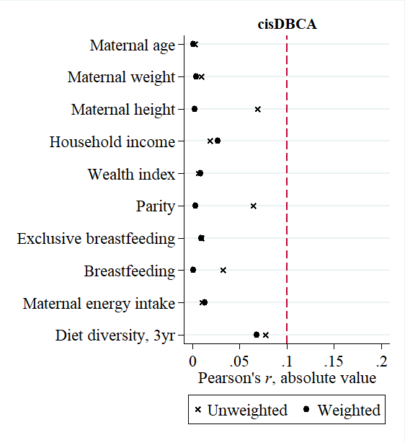
 | cis-DBCA | 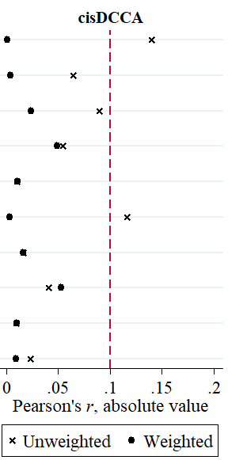  cis-DCCA | 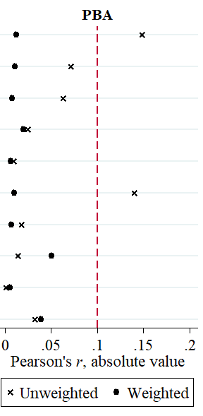  3-PBA

Figure S2.4. Absolute standardized differences of all potential confounders, averaged across exposure quartiles, before (×) and after (•) inverse probability weighting
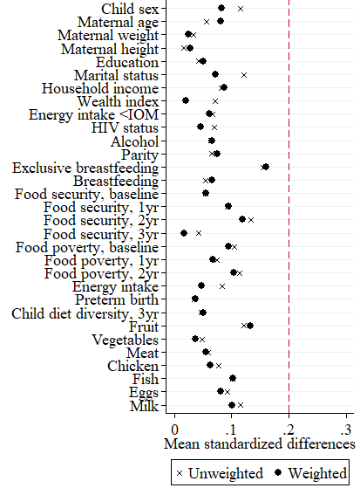
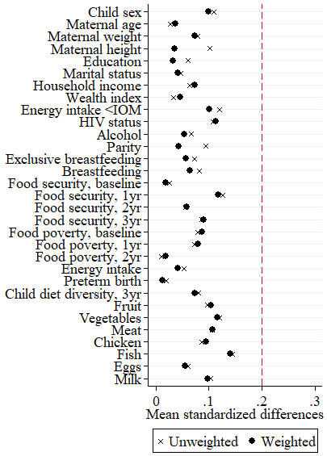
 | o,p’-DDT | p,p’-DDT | p,p’-DDE
 | 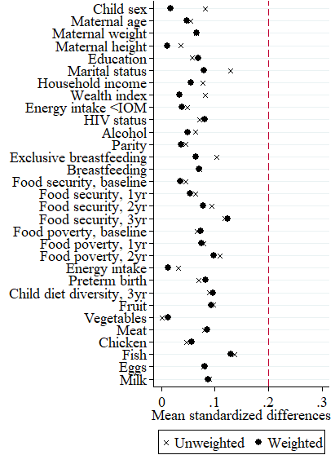 | 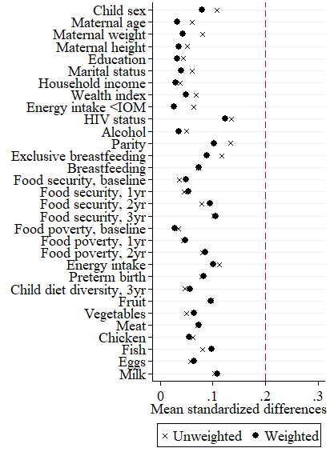
 | 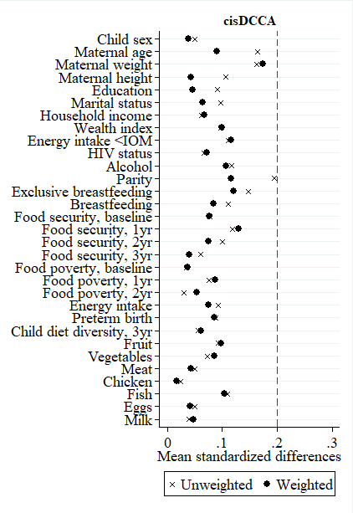  cis-DBCA | 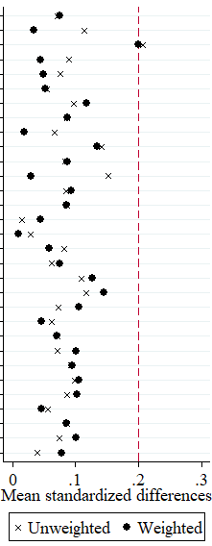  cis-DCCA | 3-PBA

Figure S2.5. Variance ratios for all potential confounders, averaged across exposure quartiles, after inverse probability weighting
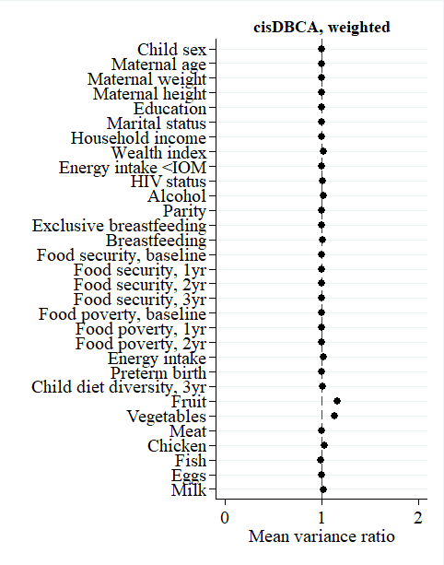
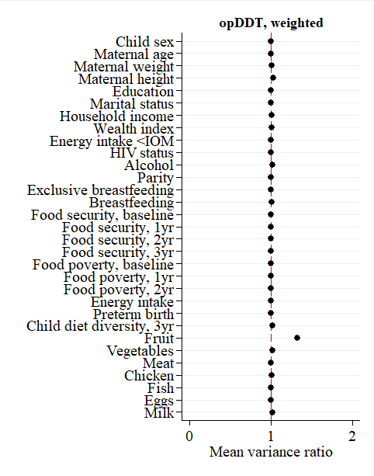
 | o,p’-DDT | 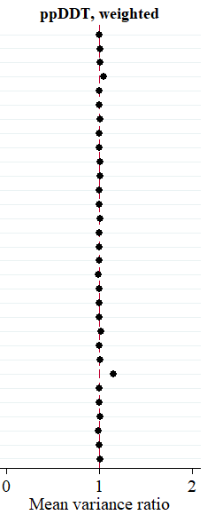  p,p’-DDT | 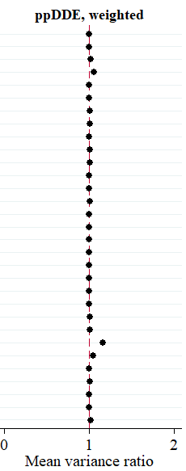  p,p’-DDE
 | cis-DBCA | 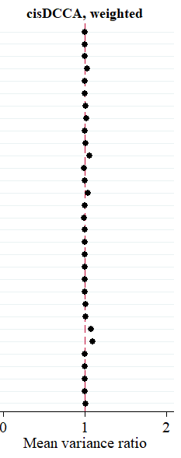  cis-DCCA | 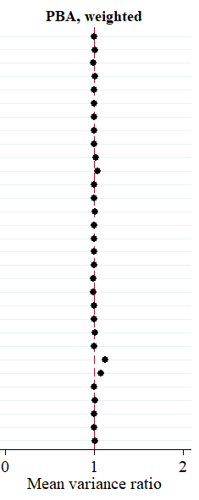  3-PBA

Section 3. Multiple imputation by chained equations

We conducted multiple imputation by chained equations using the mi suite of commands in Stata version 14.2 (StataCorp, College Station, TX). Continuous variables were imputed using predictive mean matching and binary variables were imputed using logistic regression. We used a burn-in period of 10 iterations and generated 10 imputed datasets.⁷

We included in the imputation models all outcomes, exposures and covariates identified in Section 2.5. (Statistical analysis), with the exception of two derived variables (food poverty and insufficient maternal energy intake) and included the component variables in the imputation models instead. Specifically, we derived missing values of food poverty from imputed total household income, and derived missing values of insufficient maternal energy intake from imputed maternal age, height, post-delivery weight, and energy intake during pregnancy.

We also included auxiliary variables in the imputation models to improve prediction of total household income (auxiliary variable: food poverty at the 1-year study visit) and exclusive breastfeeding (auxiliary variable: total breastfeeding duration).⁷

Finally, we also included variables representing the interaction between the exposures and effect modifiers (sex, food poverty, food insecurity, maternal energy intake sufficiency).⁸ However, to address issues of collinearity and to reduce the number of terms added to the imputation models, we only included interaction terms for three of the seven exposures (p,p’-DDT, cis-DBCA and cis-DCCA) and three of the four effect modifiers (sex, food poverty, and maternal energy intake sufficiency). As stated in our Results section, correlations were high between congeners of DDT/E (Pearson’s r= 0.69 to 0.85) and between the pyrethroid metabolites cis-DCCA, trans-DCCA, and 3-PBA (r= 0.83 to 0.88), therefore the analyte that was most strongly correlated with the other two analytes within the group was selected (p,p’-DDT and cis-DCCA, respectively); cis-DBCA was not correlated with the other pyrethroid metabolites. Among the effect modifiers, food poverty and food insecurity were highly associated with each other (p<0.001), therefore only interaction terms with food poverty were created.

Section 4. Effect modification of prenatal insecticide exposure on child size and blood pressure

Table S4.1. Relations between a 10-fold increase in maternal peripartum DDT/E (ng/g lipid) or pyrethroid metabolite (µg/L) concentrations and size and blood pressure, by maternal energy intake sufficiency, among 5-year-old children participating in the VHEMBE study, Limpopo, South Africa
 | Height z-score |  |  | Weight z-score
 | Sufficient  β (95% CI) | Insufficient  β (95% CI) | p_{inter} | Sufficient  β (95% CI) | Insufficient  β (95% CI) | p_{inter}
o,p′-DDT (ng/g lipid) | 0.22 (0.01, 0.43)ª | 0.02 (-0.10, 0.14) | 0.10 | 0.13 (-0.09, 0.35) | 0.07 (-0.04, 0.18) | 0.65
p,p′-DDT (ng/g lipid) | 0.09 (-0.11, 0.29) | -0.04 (-0.15, 0.07) | 0.26 | 0.02 (-0.22, 0.25) | 0.02 (-0.08, 0.11) | 0.99
p,p′-DDE (ng/g lipid) | 0.21 (0.01, 0.41)ª | 0.05 (-0.09, 0.19) | 0.19 | 0.09 (-0.15, 0.33) | 0.10 (-0.01, 0.20) | 0.94
cis-DBCA (µg/L) | 0.11 (-0.13, 0.36) | -0.04 (-0.21, 0.13) | 0.34 | -0.03 (-0.29, 0.23) | -0.16 (-0.32, 0.00) | 0.42
cis-DCCA (µg/L) | 0.09 (-0.14, 0.33) | -0.01 (-0.24, 0.23) | 0.57 | -0.23 (-0.46, 0.01) | -0.04 (-0.24, 0.17) | 0.24
trans-DCCA (µg/L) | 0.21 (-0.01, 0.42) | 0.03 (-0.13, 0.19) | 0.22 | -0.13 (-0.36, 0.10) | -0.03 (-0.18, 0.12) | 0.46
3-PBA (µg/L) | 0.24 (-0.07, 0.55) | -0.07 (-0.30, 0.15) | 0.10 | -0.10 (-0.38, 0.19) | -0.12 (-0.32, 0.09) | 0.91
 | Systolic blood pressure, mmHg |  |  | Diastolic blood pressure, mmHg
 | Sufficient  β (95% CI) | Insufficient  β (95% CI) | p_{inter} | Sufficient  β (95% CI) | Insufficient  β (95% CI) | p_{inter}
o,p′-DDT (ng/g lipid) | 0.04 (-1.61, 1.69) | 0.47 (-1.27, 2.21) | 0.73 | -0.39 (-2.27, 1.50) | 0.83 (-0.74, 2.39) | 0.34
p,p′-DDT (ng/g lipid) | -0.19 (-1.53, 1.16) | 0.14 (-1.06, 1.33) | 0.73 | -0.89 (-2.52, 0.73) | 0.66 (-0.47, 1.79) | 0.13
p,p′-DDE (ng/g lipid) | 0.22 (-1.39, 1.84) | 0.02 (-1.41, 1.44) | 0.85 | -0.48 (-2.34, 1.39) | 0.27 (-1.09, 1.62) | 0.54
cis-DBCA (µg/L) | 1.55 (-0.96, 4.05) | -1.06 (-2.81, 0.70) | 0.09^{b} | 1.41 (-1.80, 4.62) | -0.92 (-2.67, 0.82) | 0.20
cis-DCCA (µg/L) | 0.48 (-2.38, 3.33) | 0.12 (-2.08, 2.32) | 0.85 | -0.82 (-4.10, 2.47) | -0.52 (-3.04, 1.99) | 0.89
trans-DCCA (µg/L) | 0.74 (-1.39, 2.87) | -0.27 (-2.03, 1.49) | 0.49 | -1.11 (-3.47, 1.26) | -1.41 (-3.33, 0.51) | 0.85
3-PBA (µg/L) | 1.89 (-1.69, 5.47) | -0.59 (-2.88, 1.70) | 0.26 | 1.13 (-3.41, 5.67) | -1.81 (-4.19, 0.57) | 0.27
Abbreviations: CI, confidence interval; p_{inter}, p-value for interaction; DDE, dichlorodiphenyldichloroethylene; DDT, dichlorodiphenyltrichloroethane; cis-DBCA, cis-3-(2,2-dibromovinyl)-2,2-dimethyl-cyclopropane carboxylic acid; cis-DCCA, cis-3-(2,2,-dicholorvinyl)-2,2-dimethyl-cyclopropane carboxylic acid; trans-DCCA, trans-3-(2,2,-dicholorvinyl)-2,2-dimethyl-cyclopropane carboxylic acid; 3-PBA, 3-phenoxybenzoic acid.
ª95% CI excludes the null.
^{b}p-value for interaction<0.1.

Table S4.2. Relations between a 10-fold increase in maternal peripartum DDT/E (ng/g lipid) or pyrethroid metabolite (µg/L) concentrations and size and blood pressure, by household food poverty status, among 5-year-old children participating in the VHEMBE study, Limpopo, South Africa
 | Height z-score |  |  | Weight z-score
 | Non-poor  β (95% CI) | Poor  β (95% CI) | p_{inter} | Non-poor  β (95% CI) | Poor  β (95% CI) | p_{inter}
o,p′-DDT (ng/g lipid) | 0.02 (-0.15, 0.19) | 0.10 (-0.02, 0.22) | 0.45 | 0.08 (-0.07, 0.23) | 0.09 (-0.04, 0.22) | 0.93
p,p′-DDT (ng/g lipid) | 0.04 (-0.11, 0.19) | -0.03 (-0.15, 0.09) | 0.48 | 0.06 (-0.06, 0.19) | -0.00 (-0.13, 0.12) | 0.47
p,p′-DDE (ng/g lipid) | 0.14 (-0.05, 0.32) | 0.08 (-0.06, 0.22) | 0.60 | 0.08 (-0.08, 0.23) | 0.11 (-0.04, 0.26) | 0.77
cis-DBCA (µg/L) | 0.01 (-0.25, 0.28) | 0.03 (-0.13, 0.19) | 0.94 | -0.24 (-0.46, -0.01) | -0.03 (-0.20, 0.14) | 0.17
cis-DCCA (µg/L) | -0.08 (-0.38, 0.22) | 0.09 (-0.12, 0.30) | 0.37 | -0.24 (-0.52, 0.03) | -0.02 (-0.22, 0.17) | 0.22
trans-DCCA (µg/L) | 0.02 (-0.24, 0.28) | 0.12 (-0.04, 0.27) | 0.54 | -0.20 (-0.44, 0.05) | 0.00 (-0.16, 0.16) | 0.20
3-PBA (µg/L) | 0.07 (-0.27, 0.41) | 0.02 (-0.20, 0.24) | 0.81 | -0.23 (-0.55, 0.08) | -0.04 (-0.25, 0.18) | 0.33
 | Systolic blood pressure, mmHg |  |  | Diastolic blood pressure, mmHg
 | Non-poor  β (95% CI) | Poor  β (95% CI) | p_{inter} | Non-poor  β (95% CI) | Poor  β (95% CI) | p_{inter}
o,p′-DDT (ng/g lipid) | -0.92 (-2.39, 0.54) | 1.04 (-0.75, 2.83) | 0.08ª | 1.01 (-0.96, 2.99) | 0.12 (-1.46, 1.70) | 0.49
p,p′-DDT (ng/g lipid) | -0.30 (-1.43, 0.82) | 0.32 (-0.98, 1.62) | 0.46 | 0.90 (-0.49, 2.29) | -0.20 (-1.38, 0.98) | 0.24
p,p′-DDE (ng/g lipid) | -0.62 (-2.08, 0.84) | 0.47 (-0.96, 1.89) | 0.28 | 0.90 (-0.86, 2.67) | -0.51 (-1.81, 0.80) | 0.21
cis-DBCA (µg/L) | -0.55 (-2.92, 1.82) | 0.01 (-1.94, 1.97) | 0.72 | 0.33 (-1.90, 2.57) | -0.45 (-2.72, 1.83) | 0.64
cis-DCCA (µg/L) | 0.54 (-2.03, 3.11) | 0.04 (-2.21, 2.29) | 0.78 | -1.08 (-3.57, 1.41) | -0.42 (-3.23, 2.40) | 0.73
trans-DCCA (µg/L) | 0.11 (-2.07, 2.28) | -0.02 (-1.76, 1.72) | 0.93 | -1.30 (-3.53, 0.93) | -1.32 (-3.20, 0.57) | 0.99
3-PBA (µg/L) | 0.08 (-2.96, 3.13) | 0.18 (-2.31, 2.68) | 0.96 | -1.03 (-4.05, 1.99) | -0.95 (-3.76, 1.85) | 0.97
Abbreviations: CI, confidence interval; p_{inter}, p-value for interaction; DDE, dichlorodiphenyldichloroethylene; DDT, dichlorodiphenyltrichloroethane; cis-DBCA, cis-3-(2,2-dibromovinyl)-2,2-dimethyl-cyclopropane carboxylic acid; cis-DCCA, cis-3-(2,2,-dicholorvinyl)-2,2-dimethyl-cyclopropane carboxylic acid; trans-DCCA, trans-3-(2,2,-dicholorvinyl)-2,2-dimethyl-cyclopropane carboxylic acid; 3-PBA, 3-phenoxybenzoic acid.
ªp-value for interaction<0.1.

Table S4.3. Relations between a 10-fold increase in maternal peripartum DDT/E (ng/g lipid) or pyrethroid metabolite (µg/L) concentrations and size and blood pressure, by sex, among 5-year-old children participating in the VHEMBE study, Limpopo, South Africa
 | Height z-score |  |  | Weight z-score
 | Boys  β (95% CI) | Girls  β (95% CI) | p_{inter} | Boys  β (95% CI) | Girls  β (95% CI) | p_{inter}
o,p′-DDT (ng/g lipid) | 0.07 (-0.08, 0.21) | 0.08 (-0.06, 0.22) | 0.93 | 0.03 (-0.09, 0.15) | 0.13 (-0.02, 0.29) | 0.33
p,p′-DDT (ng/g lipid) | 0.07 (-0.05, 0.18) | -0.05 (-0.18, 0.09) | 0.20 | 0.04 (-0.06, 0.13) | 0.02 (-0.12, 0.16) | 0.88
p,p′-DDE (ng/g lipid) | 0.11 (-0.03, 0.25) | 0.10 (-0.07, 0.26) | 0.91 | 0.07 (-0.06, 0.20) | 0.13 (-0.04, 0.31) | 0.60
cis-DBCA (µg/L) | 0.06 (-0.14, 0.27) | -0.00 (-0.19, 0.18) | 0.65 | -0.06 (-0.23, 0.11) | -0.14 (-0.34, 0.07) | 0.57
cis-DCCA (µg/L) | -0.15 (-0.40, 0.10) | 0.18 (-0.05, 0.41) | 0.07^{b} | -0.19 (-0.41, 0.03) | -0.04 (-0.26, 0.19) | 0.34
trans-DCCA (µg/L) | -0.06 (-0.25, 0.14) | 0.23 (0.05, 0.41)ª | 0.04^{b} | -0.14 (-0.32, 0.03) | 0.02 (-0.17, 0.20) | 0.24
3-PBA (µg/L) | 0.01 (-0.25, 0.26) | 0.04 (-0.20, 0.29) | 0.85 | -0.09 (-0.31, 0.13) | -0.13 (-0.37, 0.10) | 0.79
 | Systolic blood pressure, mmHg |  |  | Diastolic blood pressure, mmHg
 | Boys  β (95% CI) | Girls  β (95% CI) | p_{inter} | Boys  β (95% CI) | Girls  β (95% CI) | p_{inter}
o,p′-DDT (ng/g lipid) | -0.39 (-2.03, 1.25) | 1.07 (-0.83, 2.97) | 0.26 | -0.53 (-2.16, 1.10) | 1.50 (-0.41, 3.41) | 0.11
p,p′-DDT (ng/g lipid) | -0.00 (-1.24, 1.23) | 0.18 (-1.13, 1.49) | 0.84 | 0.17 (-0.95, 1.29) | 0.35 (-1.05, 1.75) | 0.84
p,p′-DDE (ng/g lipid) | 0.19 (-1.16, 1.54) | -0.05 (-1.65, 1.54) | 0.82 | 0.05 (-1.28, 1.38) | -0.09 (-1.73, 1.55) | 0.89
cis-DBCA (µg/L) | -1.22 (-3.38, 0.94) | 0.90 (-1.06, 2.85) | 0.15 | -0.09 (-2.25, 2.06) | 0.02 (-2.48, 2.51) | 0.95
cis-DCCA (µg/L) | -0.44 (-2.72, 1.84) | 0.71 (-1.90, 3.32) | 0.52 | -1.88 (-4.25, 0.48) | 0.35 (-2.87, 3.58) | 0.26
trans-DCCA (µg/L) | -0.44 (-2.28, 1.41) | 0.52 (-1.51, 2.56) | 0.50 | -1.65 (-3.77, 0.46) | -1.00 (-3.18, 1.19) | 0.68
3-PBA (µg/L) | -1.36 (-3.78, 1.06) | 1.51 (-1.39, 4.42) | 0.14 | -2.35 (-4.85, 0.16) | 0.19 (-3.12, 3.49) | 0.24
Abbreviations: CI, confidence interval; p_{inter}, p-value for interaction; DDE, dichlorodiphenyldichloroethylene; DDT, dichlorodiphenyltrichloroethane; cis-DBCA, cis-3-(2,2-dibromovinyl)-2,2-dimethyl-cyclopropane carboxylic acid; cis-DCCA, cis-3-(2,2,-dicholorvinyl)-2,2-dimethyl-cyclopropane carboxylic acid; trans-DCCA, trans-3-(2,2,-dicholorvinyl)-2,2-dimethyl-cyclopropane carboxylic acid; 3-PBA, 3-phenoxybenzoic acid.
ª95% CI excludes the null.
^{b}p-value for interaction<0.1.

References

1. Cole SR, Hernan MA. Constructing inverse probability weights for marginal structural models. American journal of epidemiology 2008;168(6):656-64. doi: 10.1093/aje/kwn164 [published Online First: 2008/08/07]
2. Hirano K, Imbens GW. The propensity score with continuous treatments. In: Gelman A, Meng, X.-L., ed. Applied Bayesian Modeling and Causal Inference from Incomplete-Data Perspectives. West Sussex, England: John Wiley & Sons Ltd 2005:73-84.
3. Murray EJ, Logan R. Stata code. In: Hernan MA, Robins JM, eds. Causal Inference: What If. Boca Raton: Chapman & Hall/CRC, 2020.
4. Austin PC, Stuart EA. Moving towards best practice when using inverse probability of treatment weighting (IPTW) using the propensity score to estimate causal treatment effects in observational studies. Statistics in medicine 2015;34(28):3661-79. doi: 10.1002/sim.6607 [published Online First: 2015/08/05]
5. Austin PC. Assessing covariate balance when using the generalized propensity score with quantitative or continuous exposures. Stat Methods Med Res 2019;28(5):1365-77. doi: 10.1177/0962280218756159 [published Online First: 2018/02/09]
6. Zhang Z, Kim HJ, Lonjon G, et al. Balance diagnostics after propensity score matching. Ann Transl Med 2019;7(1):16. doi: 10.21037/atm.2018.12.10 [published Online First: 2019/02/23]
7. White IR, Royston P, Wood AM. Multiple imputation using chained equations: Issues and guidance for practice. Statistics in medicine 2011;30(4):377-99. doi: 10.1002/sim.4067 [published Online First: 2011/01/13]
8. Seaman SR, Bartlett JW, White IR. Multiple imputation of missing covariates with non-linear effects and interactions: an evaluation of statistical methods. BMC Med Res Methodol 2012;12:46. doi: 10.1186/1471-2288-12-46 [published Online First: 2012/04/12]

