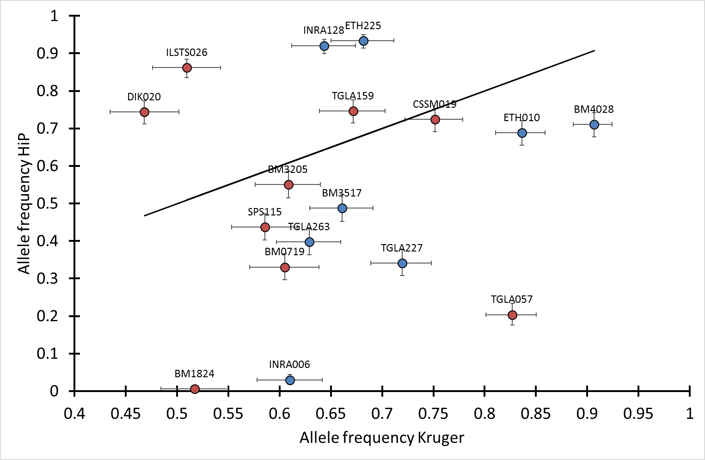
S4 Fig. Frequencies of DE_{majority} and SAE_{pooled} alleles in HiP compared with Kruger.
Red data points: SAE_{pooled} alleles, blue data points: DE_{majority} alleles, error bars: 95% CI (Wilson method), data labels: microsatellite name, line: frequency HiP = frequency Kruger, N_{individuals} HiP = 373-401, N_{individuals} Kruger = 395-458.

