Supplement B:
  - Acta Geophysica
  - Seismic Hazard Assessment in the Podhale Region, Poland - Zone and Zone-Free Approach
  - Beata Plesiewicz¹, Andrzej Kijko², Jan Wiszniowski¹(jwisz@igf.edu.pl), Kamila Karkowska³
  - ¹Institute of Geophysics Polish Academy of Sciences, Warsaw, Poland
  - ²University of Pretoria Natural Hazard Centre, Pretoria, South Africa
  - ³Polish Geological Institute - National Research Institute, Warsaw, Poland

Algorithms for calculation of the seismic hazard in Podhale
We chose to present the seismic hazard in Podhale as the PGA that will not be exceeded with a probability of 90% in 50, 105, and 527 years, equivalent to the return period of 475, 1000, and 5000 years.
The estimating value of the PGA that will not be exceeded with the probability of 90% in $T$ years is to find a PGA value that solves the formula
$$\left(U>u\right)=\sum_{j=1}^{N_{m}}{\sum_{k=1}^{N_{x}}{\sum_{l=1}^{N_{y}}{∙P\left(U>u|m_{j},r\left(x_{k},y_{l}\right)\right){∙P}_{R}\left(x_{k},y_{l}\right){∙P}_{M}\left(m_{j}\right)}}}$$
for
$$\left(U>u\right)= {-ln\left(0.9\right)}/{T,}$$
where $P_{M}\left(m_{j}\right)=F_{M}\left(m_{j}+{∆m}/2\right)-F_{M}\left(m_{j}+{∆m}/2\right)$, $F_{M}$ is the magnitude distribution, and $r\left(x_{k},y_{l}\right)$ is the distance from the point $\left(x_{k},y_{l}\right)$, and $P_{R}\left(x_{k},y_{l}\right)$ is the probability of occurrence of events in the mini area $\left(x_{k}±∆x,y_{l}±∆y\right)$. After this, we will call it the probability at the point $\left(x_{k},y_{l}\right)$.

Counting the GMPE tree
The probability of exceeding ground motion $u$ given the magnitude $m_{j}$ and distance to the point $x_{k},y_{l}$ is calculated according to the formula
$$P\left(U>u|m_{j},r\left(x_{k},y_{l}\right)\right)=\frac{\sum_{i=1}^{8}{{GMPE}^{(i)}\left(m_{j},r\left(x_{k},y_{l}\right)\right)\left(\frac{U-u}{σ_{GMPE}^{(i)}}\right)}w_{GMPE}^{(i)}\left(m_{j}\right)w_{GMPE}^{(i)}\left(r_{k}\right)}{\sum_{i=1}^{8}{w_{GMPE}^{(i)}\left(m_{j}\right)w_{GMPE}^{(i)}\left(r_{k}\right)}},$$
where ${GMPE}^{(i)}$ are the GMPE models, Φ is the normal cumulative distribution function, $σ_{GMPE}^{(i)}$ are the i^{th} GMPE standard deviations, and $w_{GMPE}^{(i)}$ are weights the ith GMPE. The counting the GMPEs tree formula calculates weights for each magnitude and distance and fulfils the conditions:
$∀_{m}∀_{r}\sum_{i=1}^{8}{w_{GMPE}^{\left(i\right)}\left(m,r\right)=1}$.
In the case of the $σ_{GMPE}^{(i)}$ is not given, we assume
$$\left(\frac{U-u}{σ_{GMPE}^{(i)}}\right)=1\left(U-u\right).$$

Counting the probability of occurrence of events at points in the area
The seismic area was divided into micro-areas of equal area and roughly square shape. They were assigned points with coordinates $x,y$.

Zone approach
First, the probabilities of the occurrence of events in zones are calculated. It depends on the number of events that belong to zones. The belonging of an event to a zone is determined based on the probability that the i^{th} event occurred in the given k^{th} zone
$$P\left(e_{i}ϵZ_{k}\right)=\int_{x,y∈Z_{k}}{φ\left(x,y|x_{i},y_{i},σ_{i}\right)dxdy},$$
where $φ$ is the normal probability distribution function truncated to 3$σ_{k}$, $x_{k},y_{k}$ are coordinates of the event epicentre and $σ_{k}$ is the location error. The probability of occurrence of events in the k^{th} zone is then
$$P\left(EϵZ_{k}\right)= \frac{\sum_{c=1}^{C}{\sum_{i=1}^{N_{c}}{P\left(e_{i}ϵZ_{k}\right)w_{c}}}}{\sum_{j=}^{N_{z}}{\sum_{c=1}^{C}{\sum_{i=1}^{N_{c}}{P\left(e_{i}ϵZ_{j}\right)w_{c}}}}},$$
where $C$ is the number of catalogues, $N_{c}$ is the number of events in the c^{th} catalogue, $N_{z}$ is the number of zones, and $w_{c}$ are a catalogue-dependent weight coefficient, which can be chosen arbitrarily, depending on the number of events
$$w_{c}=\frac{N}{N_{c}},$$
or depending on the period of the catalogue
$$w_{c}=T_{c}+1,$$
where $T_{c}$ is the catalogue period in years. We applied the weight depending on the period of the catalogue.
The probability of occurrence of events at points in the area is the sum of the probabilities of occurrence of events for all zones. The probabilities for the single zone are calculated according to the formula
$$P_{R}\left(x,y\right)= \frac{\int_{x_{2},y_{2}∈Z}{\int{φ\left(x_{1},y_{1}|x_{2},y_{2},σ_{z}\right){dx}_{1}dy_{1}{dx}_{2}dy_{2}}}}{\int_{x_{2},y_{2}∈Z}{{dx}_{2}dy_{2}}}.$$
Coefficients of blurring of zone borders $σ_{z}$ are calculated based on localization errors and events located on the borders of zones. The probabilities of earthquake occurrence for zones in Podhale are presented the Fig. S1.
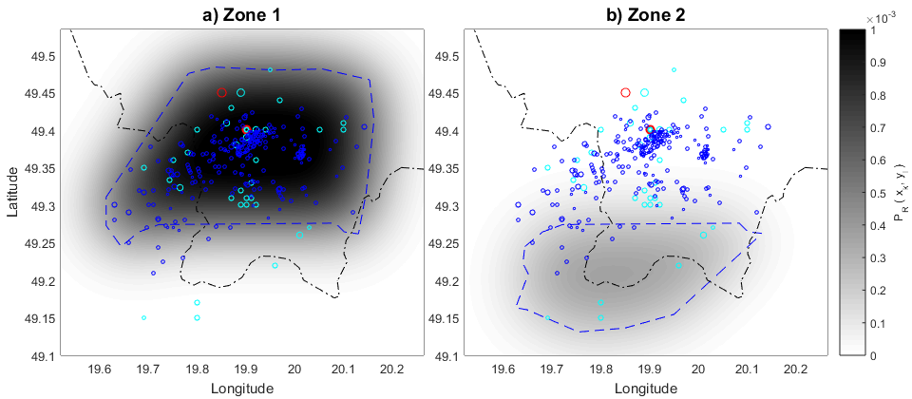
Fig. S1 Probability maps of event occurrence related to zones: a) first, b) second.

Smoothed seismicity approach
We studied two smoothed seismicity models. First, we applied the model with a magnitude-dependent kernel. We compute for all events in all catalogues probability in all points $x,y$ of the defined area.
$$P_{R}\left(x,y\right)=\frac{\sum_{c=1}^{C}{\sum_{i=1}^{N_{c}}{K\left(M_{i},r_{i}\right)w_{c}}}}{\sum_{c=1}^{C}{\sum_{i=1}^{N_{c}}{w_{c}}}} ,$$
where $C$ is the number of catalogues, $N_{c}$ is the number of events in the c^{th} catalogue, and the kernel $K\left(M_{i},r_{i}\right)$ is (Woo, 1996)
$$K\left(M_{i},r_{i}\right)= \frac{1}{π{H\left(M_{i}\right)}^{2}}{\left(1+\frac{r_{i}^{2}}{{H\left(M_{i}\right)}^{2}}\right)}^{-2},$$
$r_{i}$ is the distance between the epicentre and the$x,y$ point and the $H\left(M\right)$ is the magnitude-dependent smoothing coefficient. The catalogue weight $w_{c}$ can be chosen arbitrarily, depending on the number of events
$$w_{c}=\frac{N}{N_{c}},$$
or depending on the period of the catalogue
$$w_{c}=T_{c}+1,$$
where $T_{c}$ is the catalogue period in years. We applied the weight depending on the period of the catalogue. The smoothing parameter depends on magnitude according to (Woo, 1996):
$H\left(M\right)=h_{1}exp\left(h_{2}M\right)$.
The coefficients $h_{1}$ and $h_{2}$ are estimated using the modified methodology proposed by Molina et al. (2001) separately for all complete catalogues. Events are sorted in magnitude bins. The mean values of a few (in our case, not more than 5) shortest distances to other events in the same bin are evaluated for all magnitude bins, and regressions between the shortest distances and the magnitude are performed. The linearized regression estimates them:
$\left[\begin{matrix}log\left(\overline{D_{1}}\right) \\ ⋮ \\ log\left(\overline{D_{B}}\right)\end{matrix}\right]=\left[\begin{matrix}1 & \overline{M_{1}} \\ ⋮ & ⋮ \\ 1 & \overline{M_{B}}\end{matrix}\right]∙\left[\begin{matrix}log\left(h_{1}\right) \\ h_{2}\end{matrix}\right]$,
where $\overline{D_{i}}$ is the mean near distance of epicentres within the $i$-th magnitude bin, $\overline{M_{1}}$ is the mean magnitude within the $i$^{th} bin, and $B$ is the number of magnitude bins. The distances between events are augmented by adding the localization errors. The results for two complete catalogues are presented in Fig. S2. Larger distance values in the case of catalogue one result from larger errors in the location of epicentres.
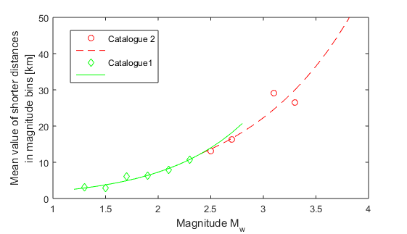
Fig. S2 The magnitude-dependent smoothing parameters for two catalogues having different completeness levels and location errors.
In the second approach, we applied the model with a magnitude-independent Gaussian kernel based on Helmstetter et al. (2007) method:
$$K_{d}\left(r\right)=C\left(d\right)exp\left[\frac{r^{2}}{2d^{2}}\right],$$
where $d$ is the smoothing distance and $C\left(d\right)$ is normalizing factors. However, $d$ is estimated for each catalogue individually, similarly to the first method, but without consideration of magnitude bins.

Reference
Helmstetter A, Kagan YY, Jackson DD (2007) High-resolution Time-independent Grid-based Forecast for M ≥ 5 Earthquakes in California. Seismol. Res. Lett. 78(1): 78–86. https://doi.org/10.1785/gssrl.78.1.78
Molina S, Lindholm C D, Bungum H (2001) Probabilistic seismic hazard analysis: zoning free versus zoning methodology. B. Geofis. Teor. Appl. 42(1–2): 19–39. https://api.semanticscholar.org/CorpusID:132502589
Woo G (1996) Kernel estimation method for seismic hazard area source modeling. Bull. Seism. Soc. Am. 86(2): 353–362. https://doi.org/10.1785/BSSA0860020353

