S1 Text. Chemistry materials and methods.

Chemical abbreviations

Boc: tert-Butoxycarbonyl
DIPEA: N,N-Diisopropylethylamine
DMA: N,N-Dimethylacetamide
DMAP: 4-Dimethylaminopyridine
DMF: N,N-Dimethylformamide
DMSO: Dimethyl sulfoxide
EDCI: 1-Ethyl-3-(3-dimethylaminopropyl) carbodiimide
HPLC: High-performance liquid chromatography
LC-MS: Liquid chromatography-mass spectrometry
NIS: N-Iodosuccinimide
NMR: Nuclear magnetic resonance spectroscopy
p-TsOH: p-Toluenesulfonic acid
TFA: Trifluoroacetic acid
THF: Tetrahydrofuran
TPPTS: Triphenylphosphine-3,3′,3′′-trisulfonic acid trisodium salt
Tyr: Tyrosine

General information
Reagents were purchased from Sigma-Aldrich, Merck, Fisher Scientific, and Combi-Blocks, and were used without further purification. Anhydrous conditions: glassware was dried at >130 °C for >12 h, assembled hot, and purged with nitrogen (N₂) gas where suitable. Reduced pressure/in vacuo implies 900 to 50 mbar under rotary evaporation at 40–50 °C.
Liquid chromatography-mass spectrometry (LC-MS) data were documented on an Agilent 1260 Infinity II LC System with a Diode Array HS (G7117C) UV-Visible detector coupled to a triple quadrupole mass detector. (analytical column: Pursuit XR C18 100 Å, 3 μm, 2 mm × 50 mm; solvent gradient: 5–95% acetonitrile in 0.05% v/v aqueous trifluoroacetic acid; flow rate: 0.4 ml min⁻¹; elution run time: 14 minutes). The charge of the ion specifies that the detection is positive; for instance, [M+H]⁺ denotes positive-ion detection.
Analytical thin-layer chromatography (TLC) was carried out on Merck Silica Gel 60 F₂₅₄-precoated aluminum plates (0.2 mm) and observed using UV irradiation (254 nm and 280 nm). High-temperature reactions were carried out in DrySyn heating blocks.
Proton (¹H) NMR spectra were recorded on a BrukerDRX400 spectrometer operating at 400 MHz for proton nuclei. Deuterated solvents (CDCl₃, CD₃OD and DMSO-d₆) were obtained from Sigma-Aldrich. ¹H chemical shifts are stated in parts per million (ppm). Spectroscopic chemical shifts were calibrated to residual solvent peaks (¹H: CHCl₃ 7.26 ppm, methanol 3.31ppm, dimethyl sulfoxide 2.50 ppm). The multiplicities are labelled as either a singlet (s), doublet (d), triplet (t), doublet of doublets (dd), or multiplet (m).
For preparative HPLC purification, samples were injected onto a Phenomenex Luna C8 column (5 μM particle size, 100 Å, 150 x 21.2 mm) and analysed on Agilent Technologies 1260 Infinity II HPLC system equipped with a photodiode array detector, and a preparative fraction collector (G1364E), (Solvent gradient: 2–35% acetonitrile in 0.05% v/v aqueous trifluoracetic acid; flow rate: 15 ml min⁻¹; elution run time: 40 minutes).

Synthesis and Characterisation of ML471 and Tyr-ML471

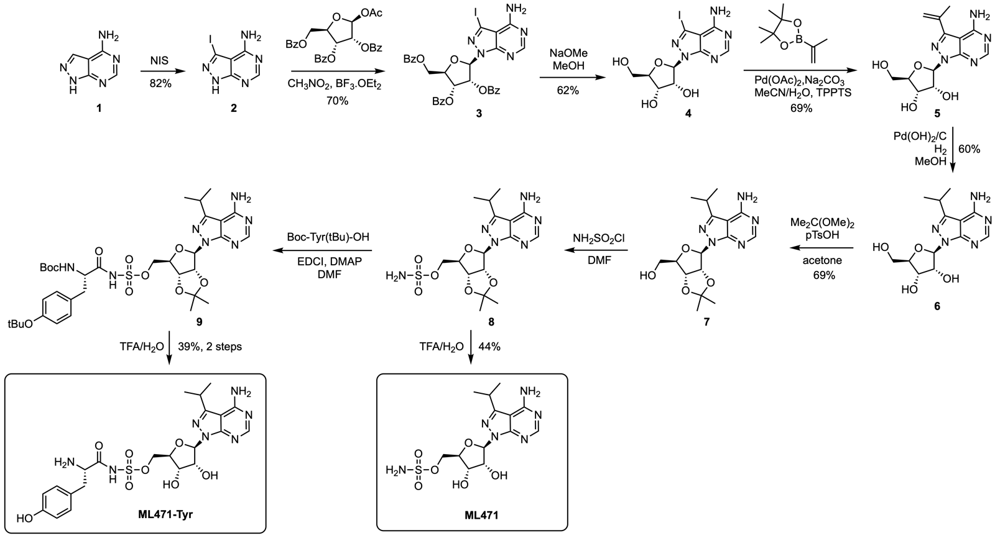

Scheme 1. Synthetic routes to ML471 and Tyr-ML471.

3-iodo-1H-pyrazolo[3,4-d]pyrimidin-4-amine (2).
4-Amino-1H-pyrazolo[3,4-d]pyrimidine (1, 5.0 g, 37 mmol) was dissolved in DMF (40 mL). N-Iodosuccinimide (NIS) (9.16 g, 40.7 mmol) was added, and the mixture was heated at 80 °C overnight. The mixture was cooled to room temperature and poured into ice-cold water (350 mL). The resulting suspension was stirred for 10 min at 0 °C then filtered. The solids were collected and dried in vacuo to afford 2 (8.8 g, 82% yield) as a white solid. ¹H NMR (300 MHz, DMSO-d₆) δ 8.16 (1H, s), 13.80 (1H, br s) ppm. LC-MS: m/z 261.95 (M+H⁺). Characterization data are in accordance with reported values [1].

(2R,3R,4R,5R)-2-(4-amino-3-iodo-1H-pyrazolo[3,4-d]pyrimidin-1-yl)-5-((benzoyloxy)methyl)tetrahydrofuran-3,4-diyl dibenzoate (3).
The pyrazolopyrimidine 2 (1.0 g, 3.83 mmol) and 1-O-acetyl-tri-O-benzoyl-β-D-ribofuranose (2.32 g, 4.6 mmol) were added to dry nitromethane (10 mL). The mixture was heated at reflux, then BF₃·OEt₂ (0.6 mL) was added, upon which the solids started to dissolve. After heating at reflux for 90 min, the solvent was removed in vacuo. The resulting oil was purified by silica column chromatography: excess 1-O-acetyl-tri-O-benzoyl-β-D-ribofuranose was eluted with 100% CH₂Cl₂, then elution with 5% acetone in CH₂Cl₂ afforded the product 3 (1.9 g, 70% yield) as a pale brown oil. ¹H NMR (300 MHz, CDCl₃) δ 4.56–4.90 (3H, m), 6.20 (1H, t, J = 5.6 Hz), 6.36 (1H, dd, J = 5.0, 3.2 Hz), 6.76 (1H, d, J = 2.9 Hz), 7.35–7.62 (9H, m), 7.91–8.14 (6H, m), 8.34 (1H, s) ppm. LC-MS: m/z 706.07 (M+H⁺). Characterization data are in accordance with reported values [1].

(2R,3R,4S,5R)-2-(4-amino-3-iodo-1H-pyrazolo[3,4-d]pyrimidin-1-yl)-5-(hydroxymethyl)tetrahydrofuran-3,4-diol (4).
Protected nucleoside 3 (1.15 g, 1.63 mmol) was dissolved in CH₂Cl₂ (0.85 mL). Methanol (8.5 mL) was added, followed by a solution of NaOMe in MeOH (4.5 M, 0.39 mL). The mixture was stirred at 60 °C for 2 h. The reaction was neutralised to pH 7 by the addition of 4 N HCl, and the solvents were removed in vacuo. The solid residue was purified by silica column chromatography (5–15% MeOH/CH₂Cl₂ gradient) to afford the final product 4 (0.400 g, 62% yield). ¹H NMR (300 MHz, DMSO-d₆) δ 3.43 (1H, dd, J = 11.7, 5.6 Hz), 3.55 (1H, dd, J = 11.7, 4.4 Hz), 3.89 (1H, dd, J = 10.0, 4.4 Hz), 4.16 (1H, t, J = 4.7 Hz), 4.57 (1H, m), 6.03 (1H, d, J = 5.0 Hz), 8.23 (1H, s) ppm. LC-MS: m/z 394.00 (M+H⁺). Characterization data are in accordance with reported values [1].

(2R,3R,4S,5R)-2-(4-amino-3-(prop-1-en-2-yl)-1H-pyrazolo[3,4-d]pyrimidin-1-yl)-5-(hydroxymethyl)tetrahydrofuran-3,4-diol (5).
Compound 4 (500 mg, 1.27 mmol) was added to 2-isopropenylboronic acid pinacol ester (317 mg, 3.81 mmol), Na₂CO₃ (405 mg 3.81 mmol), Pd(OAc)₂ (14.3 mg, 0.065 mmol), and TPPTS (87.4 mg, 0.15 mmol). Acetonitrile (2.5 mL) and H₂O (5 mL) were added to the solids under nitrogen. After 5 min of stirring, the mixture was heated at reflux. Upon completion, the mixture was cooled to room temperature and neutralised to pH ∼7 with 4 M aq. HCl. The mixture was concentrated in vacuo and the residue was purified by silica column chromatography (2–15% MeOH/CH₂Cl₂ gradient) to afford 5 (270 mg, 69% yield) as an off-white solid. ¹H NMR (300 MHz, DMSO-d₆) δ 2.18 (3H, s), 3.45 (1H, m), 3.60 (1H, m), 3.92 (1H, dd, J = 9.7, 4.4 Hz), 4.23 (1H, dd, J = 9.7, 4.7 Hz), 4.59 (1H, dd, J = 9.4, 5.0 Hz), 4.84 (1H, t, J = 5.6 Hz), 5.12 (1H, d, J = 5.3 Hz), 5.29–5.45 (2H, m), 5.53 (1H, s), 6.13 (1H, d, J = 4.1 Hz), 8.23 (1H, s) ppm. LC-MS: m/z 308.14 (M+H⁺). Characterization data are in accordance with reported values [1].

(2R,3R,4S,5R)-2-(4-amino-3-isopropyl-1H-pyrazolo[3,4-d]pyrimidin-1-yl)-5-(hydroxymethyl)tetrahydrofuran-3,4-diol (6).
Compound 5 (500 mg, 1.62 mmol) was dissolved in MeOH (10 mL) and Pd(OH)₂/C (50 mg) was added. The vessel was filled with H₂ at 20 psi, and the mixture was stirred overnight. The mixture was filtered through celite, and the solvents were removed in vacuo. The solid residue was purified by silica column chromatography (4–20% MeOH/CH₂Cl₂ gradient) to afford 6 (300 mg, 60% yield) as a white solid. ¹H NMR (300 MHz, DMSO-d₆) δ 1.26 (6H, d, J = 6.7 Hz), 3.38–3.65 (3H, m), 3.90 (1H, dd, J = 9.4, 4.7 Hz), 4.25 (1H, dd, J = 10.3, 5.0 Hz), 4.56 (1H, dd, J = 10.0, 5.3 Hz), 4.85 (1H, dd, J = 6.7, 5.0 Hz), 5.07 (1H, d, J = 5.6 Hz), 5.32 (1H, d, J = 5.9 Hz), 6.06 (1H, d, J = 4.4 Hz), 8.15 (1H, s) ppm. LC-MS: m/z 310.14 (M+H⁺). Characterization data are in accordance with reported values [1].

((3aR,4R,6R,6aR)-6-(4-amino-3-isopropyl-1H-pyrazolo[3,4-d]pyrimidin-1-yl)-2,2-dimethyltetrahydrofuro[3,4-d][1,3]dioxol-4-yl)methanol (7).
To compound 6 (570 mg, 1.84 mmol) in acetone (25 mL) was added 2,2-dimethoxypropane (1.13 mL, 9.2 mmol) and p-TsOH (350 mg, 1.84 mmol) and the mixture was stirred overnight at room temperature. Chilled aq. sat. NaHCO₃ was added and the mixture was stirred for 5 minutes, then dried in vacuo. The residue was dissolved by stirring in acetone for 1 h, the mixture was filtered and the filtrate evaporated in vacuo. The residue was purified by silica column chromatography (5% EtOH in EtOAc) to afford 7 (450 mg, 69% yield). ¹H NMR (300 MHz, DMSO-d₆) δ 1.26 (6H, d, J = 6.7 Hz), 1.32 (3H, s), 1.51 (3H, s), 3.39 (1H, m), 3.50–3.62 (2H, m), 4.13 (1H, m), 4.94 (1H, d, J = 6 Hz), 5.23 (1H, m), 6.26 (1H, d, J = 1.8 Hz), 8.16 (1H, s) ppm. LC-MS: m/z 350 (M+H⁺). Characterization data are in accordance with reported values [2].

((3aR,4R,6R,6aR)-6-(4-amino-3-isopropyl-1H-pyrazolo[3,4-d]pyrimidin-1-yl)-2,2-dimethyltetrahydrofuro[3,4-d][1,3]dioxol-4-yl)methyl sulfamate (8).
To compound 7 (425 mg, 1.21 mmol) in dry DMF (4.5 mL) was added sulfamoyl chloride (421 mg, 3.64 mmol) and the mixture was stirred at room temperature for 2 h. Several drops of methanol were added and the solvent was evaporated in vacuo. The compound was used in the next step without further purification. LC-MS: m/z 429.1 (M+H⁺).

((2R,3S,4R,5R)-5-(4-amino-3-isopropyl-1H-pyrazolo[3,4-d]pyrimidin-1-yl)-3,4-dihydroxytetrahydrofuran-2-yl)methyl sulfamate (ML471)
Compound 8 (100 mg, 0.23 mmol) was dissolved in TFA/H₂O (4:2). The mixture stirred at room temperature overnight, and completion of the deprotection was confirmed by LC-MS. The solvents were evaporated in vacuo and the residue was purified by HPLC (C8 column, 2–35% acetonitrile/H₂O) to afford the title compound ML471 (40 mg, 44% yield) as a white solid. ¹H NMR (400 MHz, CD₃OD) δ 1.40 (6H, t, J = 7.0 Hz), 3.48 (1H, h, J = 6.8 Hz), 4.20–4.31 (2H, m), 4.35 (1H, dd, J = 10.2, 3.1 Hz), 4.63–4.68 (2H, m), 6.34 (1H, d, J = 1.9 Hz), 8.35 (1H, s). LC-MS: m/z 389.2 (M+H⁺). Characterization data are in accordance with reported values [2].

((3aR,4R,6R,6aR)-6-(4-amino-3-isopropyl-1H-pyrazolo[3,4-d]pyrimidin-1-yl)-2,2-dimethyltetrahydrofuro[3,4-d][1,3]dioxol-4-yl)methyl ((S)-3-(4-(tert-butoxy)phenyl)-2-((tert-butoxycarbonyl)amino)propanoyl)sulfamate (9).
Compound 8 (50 mg, 0.12 mmol) was added to Boc-Tyr(tBu)-OH (60.7 mg, 0.18 mmol), EDCI (92.0 mg, 0.48 mmol), DMAP (16.1 mg, 0.13 mmol) in dry DMF (5 mL) and the mixture was stirred overnight at room temperature. The solvent was evaporated in vacuo. The residue was added to water and the organic layer was extracted using EtOAc, dried using Na₂SO₄, and evaporated in vacuo to give a crude sample of 9 (100 mg), a viscous pale brown oil, which was used in the next step without further purification. LC-MS: m/z 748.1 (M+H⁺).

((2R,3S,4R,5R)-5-(4-amino-3-isopropyl-1H-pyrazolo[3,4-d]pyrimidin-1-yl)-3,4-dihydroxytetrahydrofuran-2-yl)methyl (L-tyrosyl)sulfamate (Tyr-ML471)
The crude compound 9 (100 mg) was dissolved in TFA (0.8 mL) and CH₂Cl₂ (4 mL) and the mixture was stirred at room temperature for 2 h. LC-MS confirmed deprotection of the tBu and Boc groups (m/z 592 (M+H)). Water (0.4 mL) was added, and the mixture was stirred at room temperature overnight. The volatiles were removed in vacuo then the residue was purified by column chromatography (5–15% MeOH/CH₂Cl₂ gradient), followed by HPLC purification (C8 column, 2–35% acetonitrile/H₂O) to afford the title compound Tyr-ML471 (25 mg, 34% yield over 2 steps) as an off-white solid. ¹H NMR (400 MHz, DMSO-d₆) 1.26 (6H, d, J = 6.7 Hz), 2.64–2.88 (2H, m), 3.02 (1H, m), 3.98–4.12 (2H, m), 4.24 (1H, m), 4.37 (1H, t, J = 5.1 Hz), 4.51 (1H, m), 6.13 (1H, d, J = 3.0 Hz), 6.64–6.74 (2H, m), 7.01–7.05 (2H, m), 8.27 (1H, s). LC-MS: m/z 552.2 (M+H⁺).

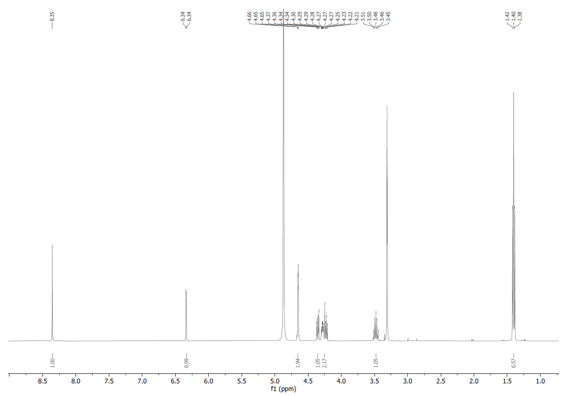

¹H NMR Spectrum of ML471.

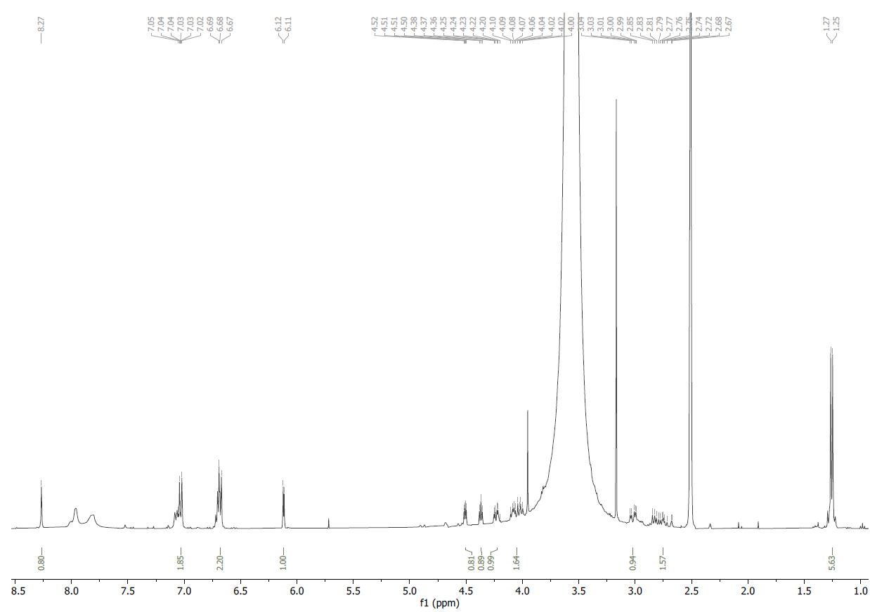

¹H NMR Spectrum of Tyr-ML471.
References

1. Bouton J, Ferreira de Almeida Fiuza L, Cardoso Santos C, Mazzarella MA, Soeiro MdNC, Maes L, et al. Revisiting pyrazolo[3,4-d]pyrimidine nucleosides as anti-Trypanosoma cruzi and antileishmanial agents. Journal of medicinal chemistry. 2021;64(7):4206-38.
2. Adhikari S, Calderwood EF, England DB, Gould AE, Harrison SJ, Huang S-C, et al. Atg7 inhibitors and the uses thereof. World Intellectual Property Organization. 2017;WO/2018/089786 PCT/US2017/061094.

