Supplementary Material
Table S1A Effects of heat treatment methods of moisture conditioned (20% and 53%) Bambara groundnut seeds on the pasting properties of resulting flours ran under buffer conditions. A
Moisture Content (%) | Heat Treatment Method | Treatment time (min) | Pasting Temperature (°C) | Peak  Temperature (°C) | Peak Viscosity (mPa.s) | Hold Viscosity (mPa.s) | Breakdown (mPa.s) (peak - hold) | Setback (mPa.s) (final-peak) | Final Viscosity (mPa.s)
RUT |  | 0 | 80.24ª (0.05) | 90.29ª (0.15) | 1275.66ª (18.53) | 999.33ª (22.18) | 276.33ª (29.23) | 796.66^{b} (22.44) | 2298.22ª (4.13)
20 |  | 0 | 80.26ª (0.05) | 90.30ª (0.10) | 1218.43ª (3.55) | 977.43ª (53.67) | 241.00ª (53.17) | 800.90^{b} (2.22) | 2095.33ª (1.52)
 | Infrared | 5 | 80.25ª (0.05) | 90.30ª (0.03) | 1130.33ª (5.50) | 1030.76ª (11.51) | 99.56^{b} (14.11) | 900.33ª (29.23) | 2019.66ª (3.80)
 |  | 10 | 80.25ª (0.12) | 90.30ª (0.67) | 997.56^{b} (5.34) | 843.83^{b} (2.26) | 153.73^{ab} (6.55) | 865.76^{b} (9.46) | 1873.33^{b} (4.50)
 | Microwave | 5 | 80.26ª (0.01) | 90.30ª (0.04) | 1273.00ª (8.71) | 1015.33ª (4.50) | 257.66ª (6.027) | 725.01^{b} (13.01) | 1998.01ª (4.82)
 |  | 10 | 80.24ª (0.01) | 90.30ª (0.05) | 956.13^{b} (8.03) | 811.03^{b} (7.23) | 244.61ª (13.35) | 610.73^{c} (7.62) | 1866.02^{b} (7.37)
 | Combined | 5 | 80.27ª (0.02) | 90.30ª (0.09) | 1170.33ª (4.01) | 998.33ª (3.11) | 172.00^{ab} (6.28) | 782.33^{b} (55.05) | 1952.66ª (8.05)
 |  | 10 | 80.25ª (0.13) | 90.30ª (0.02) | 1089.66^{b} (64.32) | 883.56^{b} (56.20) | 206.11ª (19.05) | 572.23^{c} (76.42) | 1661.91^{b} (5.01)
53 |  | 0 | 80.26ª (0.06) | 90.30ª (0.01) | 1215.33ª (4.50) | 998.66ª (8.36) | 216.66ª (12.23) | 796.33^{b} (6.42) | 2030.66ª (2.51)
 | Infrared | 5 | 80.26ª (0.04) | 90.30ª (0.03) | 1198.43ª (5.13) | 982.23ª ( (4.80) | 131.11^{ab} (15.37) | 857.33^{b} (17.37) | 1970.66ª ( 6.65)
 |  | 10 | 80.26ª (0.03) | 90.30ª (0.02) | 1107.41^{ab} (4.54) | 739.46^{b} (35.05) | 249.83ª (43.33) | 717.31^{b} (11.32) | 1706.61^{b} (8.44)
 | Microwave | 5 | 80.27ª (0.01) | 90.29ª (0.05) | 1212.21ª (8.23) | 815.40^{b} (56.04) | 245.4ª (19.16) | 617.53^{c} (9.71) | 1678.33^{b} (7.50)
 |  | 10 | 80.25ª (0.01) | 90.30ª (0.04) | 781.51^{c} (5.51) | 731.50^{b} (1.43) | 131.61^{ab} (2.21) | 727.91^{b} (5.40) | 1591.03^{c} (3.10)
 | Combined | 5 | 80.28ª (0.01) | 90.28ª (0.01) | 821.73^{c} (4.13) | 968.66ª (64.23) | 218.33ª (11.01) | 483.16^{c} (54.41) | 1670.16^{c} (0.60)
 |  | 10 | 80.28ª (0.01) | 90.31ª (0.03) | 671.83^{d} (7.01) | 911.10ª (61.71) | 155.46^{ab} (43.01) | 491.93^{c} (10.23) | 1558.51^{c} (2.10)

Values are the means ± (SD). Means with similar letters in a column do not differ significantly (p > 0.05).

Table S1B: Effects of heat treatment methods of moisture conditioned (20% and 53%) Bambara groundnut seeds on the pasting properties of enzyme-treated resulting flours. A
Moisture Content (%) | Heat Treatment Method | Treatment time (min) | Pasting Temperature (°C) | Peak  Temperature (°C) | Peak Viscosity (mPa.s) | Hold Viscosity (mPa.s) | Breakdown (mPa.s) (peak - hold) | Setback (mPa.s) (final-peak) | Final Viscosity (mPa.s)
RUT |  | 0 | 80.29ª (0.01) | 90.30ª (0.01) | 1364.01ª (6.10) | 1154.33ª (6.27) | 209.66ª (0.57) | 929.66ª (15.69) | 2332.66ª (21.50)
20 |  | 0 | 80.26ª (0.010) | 90.30ª (0.05) | 1348.8ª (5.73) | 1037.6ª (4.23) | 277.20ª (24.59) | 755.66^{b} (4.70) | 2104.46^{b} (7.90)
 | Infrared | 5 | 80.28ª (0.05) | 90.27ª (0.02) | 1202.12^{b} (8.03) | 1107.75ª (14.23) | 244.22ª (17.23) | 879.71ª (7.51) | 2081.71^{b} (3.04)
 |  | 10 | 80.24ª (0.01) | 90.30ª (0.01) | 1107.61^{b} (5.11) | 936.74^{b} (5.56) | 170.93^{b} (10.36) | 886.76ª (20.31) | 1994.43^{bc} (15.22)
 | Microwave | 5 | 80.27ª (0.01) | 90.30ª (0.01) | 1206.41^{b} (10.12) | 1105.36ª (6.71) | 201.03ª (15.43) | 743.53^{b} (24.92) | 2079.93^{b} (25.21)
 |  | 10 | 80.26ª (0.05) | 90.31ª (0.01) | 1192.83^{b} (27.71) | 1036.12ª (19.12) | 255.11ª (16.02) | 269.31^{d} (22.46) | 1925.21^{c} (14.73)
 | Combined | 5 | 80.26ª (0.02) | 90.31ª (0.09) | 1135.21^{b} (5.25) | 949.93^{b} (6.12) | 185.26^{b} (5.25) | 544.31^{c} (7.54) | 2047.52^{b} (6.34)
 |  | 10 | 80.28ª (0.01) | 90.30ª (0.03) | 933.66^{c} (5.12) | 793.41^{c} (6.31) | 140.26^{b} (8.57) | 451.16^{c} (5.47) | 1884.83^{c} (9.25)
53 |  | 0 | 80.26ª (0.01) | 90.31ª (0.05) | 1348.81ª (5.93) | 1071.61ª (9.75) | 277.21ª (14.55) | 755.66^{b} (4.70) | 2069.46^{b} (7.90)
 | Infrared | 5 | 80.27ª (0.01) | 90.31ª (0.03) | 1113.33^{b} (10.75) | 806.64^{c} (6.43) | 291.79ª (6.24) | 829.43ª (3.81) | 2027.86^{b} (4.52)
 |  | 10 | 80.26ª (0.01) | 90.30ª (0.01) | 989.30^{c} (8.01) | 768.82^{c} (7.10) | 238.62ª (7.17) | 866.96ª (24.14) | 1974.36^{b} (8.23)
 | Microwave | 5 | 80.25ª (0.03) | 90.31ª (0.23) | 1196.80^{b} (98.43) | 978.93^{b} (5.04) | 233.26ª (8.23) | 458.81^{c} (8.05) | 1701.02^{c} (8.15)
 |  | 10 | 80.25ª (0.03) | 90.30ª (0.01) | 963.10^{c} (3.12) | 669.03^{c} (9.82) | 112.46^{b} (6.40) | 410.93^{c} (1.45) | 1592.43^{d} (4.40)
 | Combined | 5 | 80.26ª (0.02) | 90.36ª (0.06) | 1187.01^{b} (54.50) | 726.72^{c} (4.26) | 95.01^{c} (6.66) | 319.95^{d} (2.24) | 1677.69^{d} (3.40)
 |  | 10 | 80.26ª (0.02) | 90.30ª (0.032) | 966.56^{c} (84.23) | 534.43^{d} (7.51) | 137.41^{b} (14.74) | 457.36^{c} (6.17) | 1580.21^{d} (1.01)
Values are the means ± (SD). Means with similar letters in a column do not differ significantly (p > 0.05).

Table S2. Secondary structure band assignments for Bambara protein secondary structures
Area (%)
Secondary structures | α-helix | β-sheet | β-turns | α-helix:β-sheets
Peak range | 1630-1660 | 1612-1694 | 1662-1684 | ratio
RUT | 67ª (1.04) | 23ª (2.07) | 10ª (1.55) | 2.91ª (0.09)
C20 | 64ª (2.32) | 24ª (1.15) | 12ª (0.85) | 2.66ª (0.07)
20IR5 | 36^{b} (0.71) | 52^{b} (1.01) | 12ª (1.25) | 0.69^{b}(0.05)
20IR10 | 28^{c} (2.02) | 58^{c} (2.44) | 14^{b} (0.84) | 0.48^{d} (0.02)
20MW5 | 32^{b} (0.82) | 55^{c} (0.92) | 13^{b} (0.73) | 0.58^{c} (0.22)
20MW10 | 26^{c} (0.22) | 57^{c} (1.02) | 17^{d} (1.36) | 0.45^{d} (0.06)
20COM5 | 28^{c} (2.00) | 56^{c} (0.34) | 16^{c} (1.54) | 0.50^{c} (0.12)
20COM10 | 19^{d} (0.75) | 63^{d} (0.76) | 18^{d} (0.97) | 0.30e (0.03)
C53 | 62ª (0.90) | 26ª (0.87) | 12ª (1.38) | 2.42ª (0.05)
53IR5 | 30^{b} (1.12) | 55^{c} (3.02) | 15^{c} (0.92) | 0.54^{c} (0.09)
53IR10 | 26^{c} (1.64) | 57^{c} (1.32) | 17^{d} (0.82) | 0.45^{d} (0.02)
53MW5 | 29^{b} (1.41) | 56^{c} (1.52) | 15^{c} (0.82) | 0.51^{c} (0.06)
53MW10 | 25^{c} (1.11) | 57^{c} (2.34) | 18^{d} (0.75) | 0.44^{d} (0.05)
53COM5 | 21^{d} (0.76) | 63^{d} (1.02) | 16^{c} (0.87) | 0.33e (0.07)
53COM10 | 16e (1.34) | 65^{d} (1.18) | 19e (1.87) | 0.25e (0.08)

RUT- raw seeds, C20- 20% moisture, 20IR5- 5 min infrared, 20IR10-10 min infrared, 20MW5- 5 min microwave, 20MW10 - 10 min microwave, 20COM5- 5 min combined, 20COM10- 10 min combined; C53- 53% moisture, 53IR5- 5 min infrared, 53IR10-10 min infrared, 53MW5- 5 min microwave, 53MW10- 10 min microwave, 53COM5- 5 min combined, 53COM10- 10 min combined.

A

RUT
C20
20IR5
20IR10
20MW5

20MW10
20COM5
20COM10

Exothermic flow
Temperature (°C)

Figure S1A Differential scanning calorimeter thermograms of resulting flours from untreated, infrared, microwaved processing alone and in combination of Bambara groundnut seeds with 20% moisture level treated without the addition of an enzyme. RUT- raw seeds, C20- 20% moisture, 20IR5- 5 min infrared, 20IR10-10 min infrared, 20MW5- 5 min microwave, 20MW10 - 10 min microwave, 20COM5- 5 min combined, 20COM10- 10 min combined.

B
Exothermic flow
Temperature (°C)

RUT
C53
53IR5
53IR10
53MW5

53MW10
53COM53
53COM10

Figure S1A-B Differential scanning calorimeter thermograms of resulting flours from untreated, infrared, microwaved processing alone and in combination of cream Bambara groundnut seeds with 530% moisture level ran with the addition of an enzyme. RUT- raw seeds, C20- 53% moisture, 53IR5- 5 min infrared, 53IR10-10 min infrared, 53MW5- 5 min microwave, 53MW10 - 10 min microwave, 53COM5- 5 min combined, 53COM10- 10 min combined

A
Temperature (°C)
Exothermic flow

RUT
C20
20IR5

20IR10
20MW5
20MW10
20COM5
20COM10

Figure S1C Differential scanning calorimeter thermograms of resulting flours from untreated, infrared, microwaved processing alone and in combination of Bambara groundnut seeds with 20% moisture level treated with the addition of an enzyme. RUT- raw seeds, C20- 20% moisture, 20IR5- 5 min infrared, 20IR10-10 min infrared, 20MW5- 5 min microwave, 20MW10 - 10 min microwave, 20COM5- 5 min combined, 20COM10- 10 min combined.

B

RUT
C53
53IR5

53IR10

53MW5

53MW10

53COM5

53COM10

Exothermic flow
Temperature (°C)

Figure S1D Differential scanning calorimeter thermograms of resulting flours from untreated, infrared, microwaved processing alone and in combination of Bambara groundnut seeds with 20% and 53% moisture level ran with the addition of an enzyme. RUT- raw seeds, C53- 53% moisture, 53IR5- 5 min infrared, 53IR10-10 min infrared, 53MW5- 5 min microwave, 53MW10- 10 min microwave, 53COM5- 5 min combined, 53COM10- 10 min combined

A
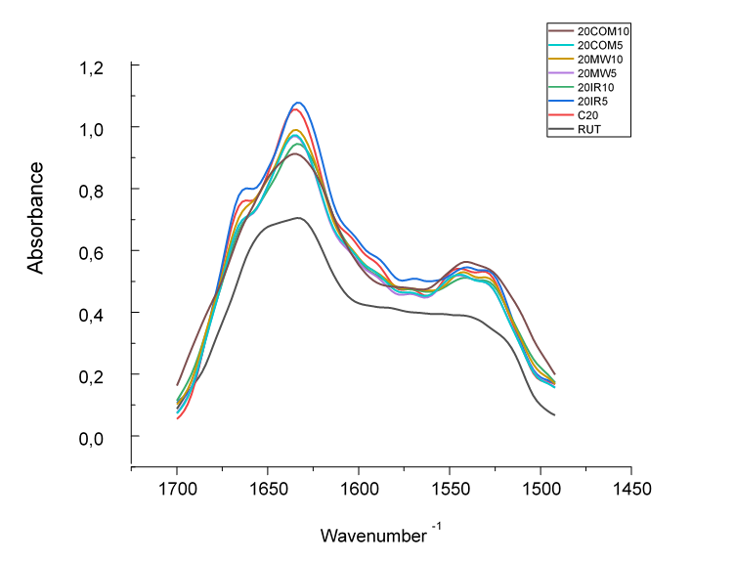
Figure S2A FTIR spectra of Bambara flours protein showing Amide I and Amide II bands. A; RUT- raw seeds, C20- 20% moisture, 20IR5- 5 min infrared, 20IR10-10 min infrared, 20MW5- 5 min microwave, 20MW10 - 10 min microwave, 20COM5- 5 min combined, 20COM10- 10 min combined.

B
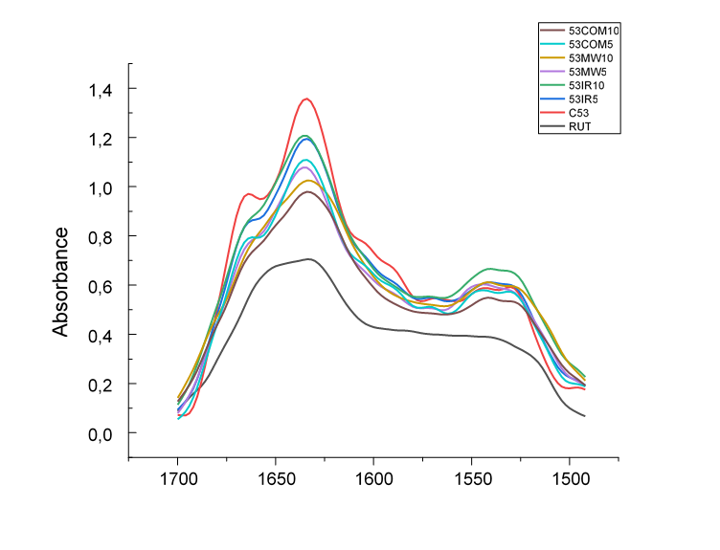
Wavenumber ⁻¹
Figure S2B FTIR spectra of Bambara flours protein showing Amide I and Amide II bands. A; RUT- raw seeds, C53- 53% moisture, 53IR5- 5 min infrared, 53IR10-10 min infrared, 53MW5- 5 min microwave, 53MW10- 10 min microwave, 53COM5- 5 min combined, 53COM10- 10 min combined.

0 min 20%, 5 min 20%, 10 min 53%, 5 min 53%, 10 min
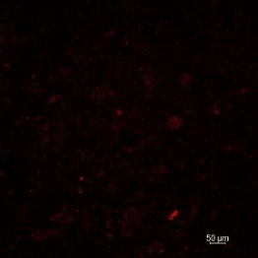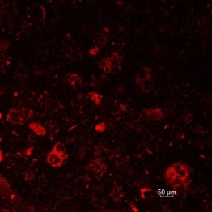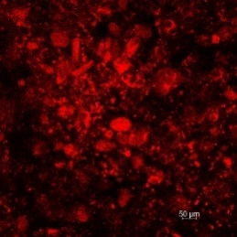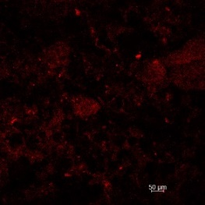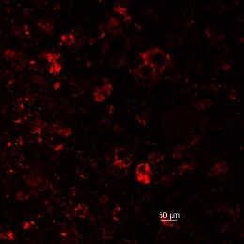
Figure S3A Confocal laser scanning microscopy micrographs of resulting flours from the combine microwave/infrared heat-treated paste of Bambara groundnut seeds moisture conditioned (20 and 53% moisture) before protein hydrolysis. Samples were heat-treated for 0, 5, and 10 minutes using the combined infrared and microwave heat-treatment. Arrows indicate starch-protein aggregates, black spots inside the red stain indicate the starch, and the red indicates the protein matrix. Bar = 50 μm. Pastes stained for protein with 0.02% Acid Fuchsin dye in 1% acetic acid dye.

0 min 20%, 5 min 20%, 10 min 53%, 5 min 53%, 10 min
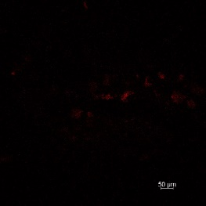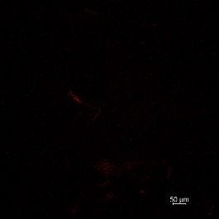
Figure S3B Confocal laser scanning microscopy micrographs of resulting flours from the combine microwave/infrared heat-treated paste of Bambara groundnut seeds moisture conditioned (20 and 53% moisture) after protein hydrolysis. Samples were heat-treated for 0, 5, and 10 minutes using the combined infrared and microwave heat-treatment. Bar = 50 μm. A and B: Pastes stained for protein with 0.02% Acid Fuchsin dye in 1% acetic acid dye.

0 min 20%, 5 min 20%, 10 min 53%, 5 min 53%, 10 min
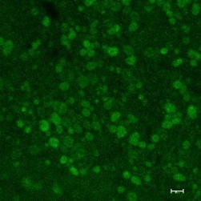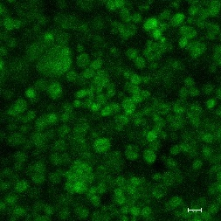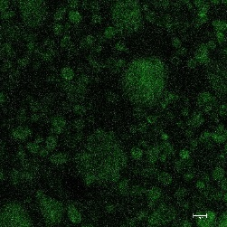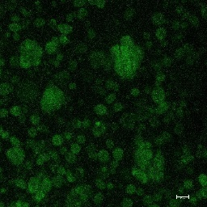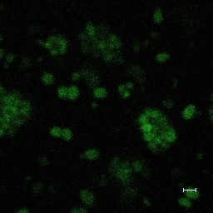
Figure S3C Confocal laser scanning microscopy micrographs of resulting flours from untreated and combine microwave/infrared heat-treated paste of Bambara groundnut seeds moisture conditioned (20 and 53% moisture) before protein Hydrolysis. Samples were heat-treated for 0, 5, and 10 minutes using the combined infrared and microwave heat-treatment. Bar = 50 μm. Pastes were stained for starch with FTIC dye.

0 min 20%, 5 min 20%, 10 min 53%, 5 min 53%, 10 min
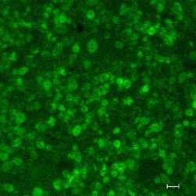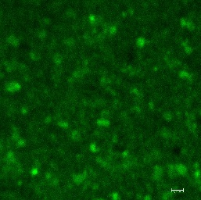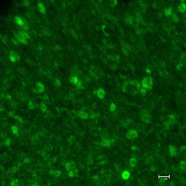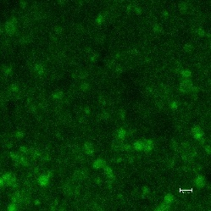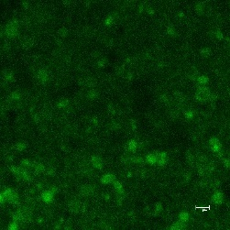
Figure S3D Confocal laser scanning microscopy micrographs of resulting flours from untreated and combine microwave/infrared heat-treated paste of Bambara groundnut seeds moisture conditioned (20 and 53% moisture) after protein hydrolysis. Samples were heat-treated for 0, 5, and 10 minutes using the combined infrared and microwave heat-treatment. Bar = 50 μm. Pastes were stained for starch with FTIC dye.

A: Nonreducing conditions B: Reducing conditions
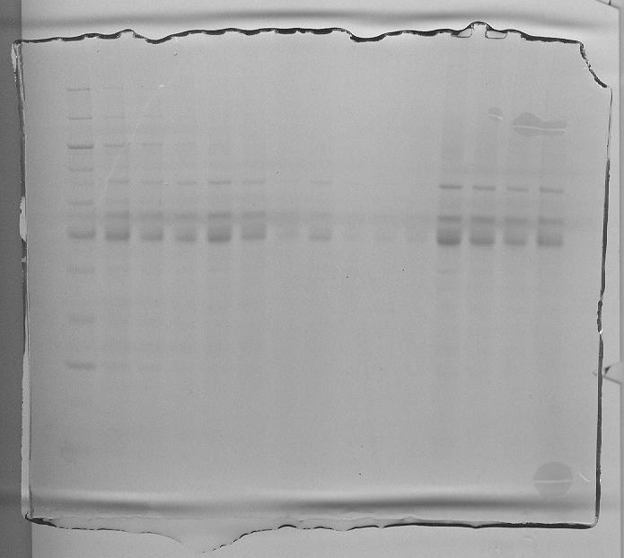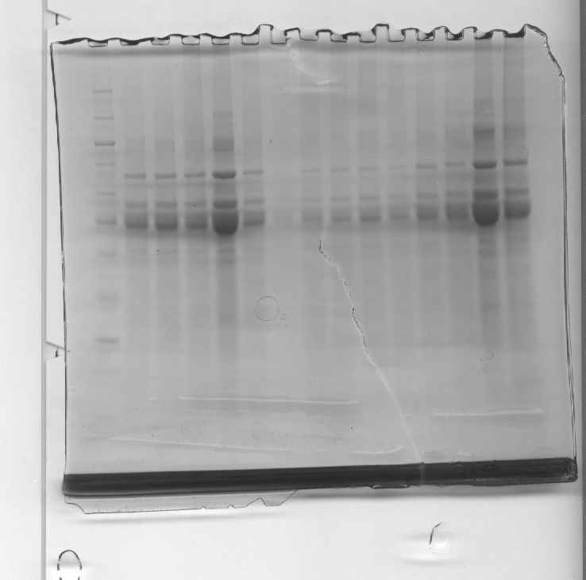

C: Trypsin digested and ran under nonreducing conditions

Figure S4 A and B: SDS-PAGE under reducing and non-reducing condition of Bambara groundnut seeds of 20% or 53% moisture content were heat treated at 130°C; Treatments were performed at 1200W.A and B. Figure S4C depicts SDS-PAGE under non reducing conditions of 20% and 53% Bambara groundnut seed flours after protein hydrolysis with trypsin.

