B
A
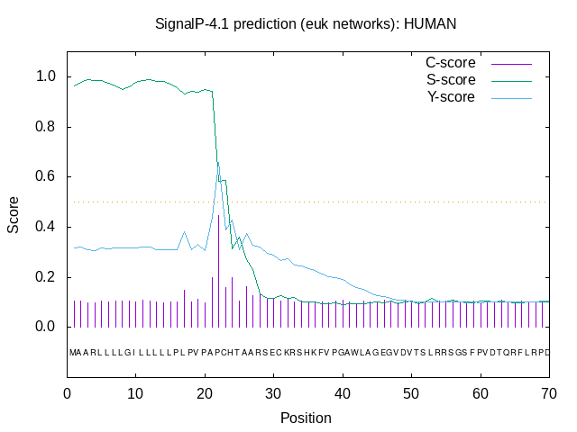

Fig. s1. Signal peptide prediction of chicken (A) and human perforin (B) using SignalP 4.1. Higher value of C-score is indicative of predicted cleavage site in amino acid sequence.
B
A
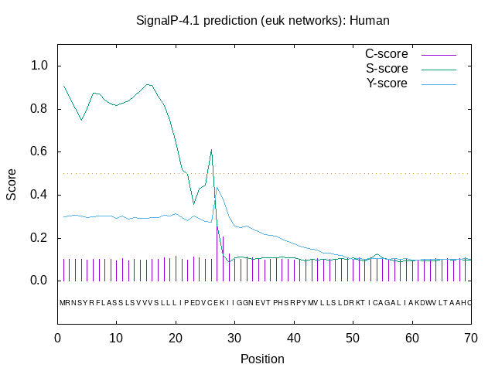
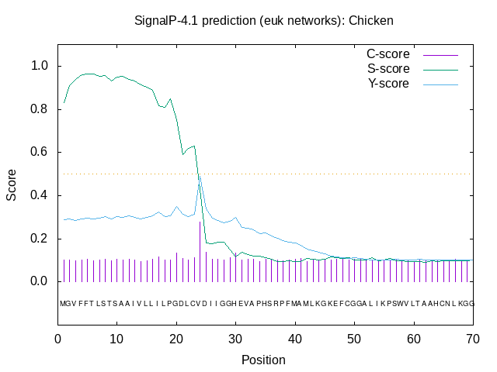
Fig. s2. Signal peptide prediction of chicken (A) and human granzyme A (B) using SignalP 4.1. Higher value of C-score is indicative of predicted cleavage site in amino acid sequence.
Video s1. 3 dimensional z stack of chicken NK cells and T cells (CU91 cells) showing intracellular staining of perforin in granules

Fig. s3. Perforin and granzyme A staining in non-permeabilized chicken NK, CU91, DT40, and HD11 cells (scale bar 10µm, 100x magnification); Images are representative of 3 independent experiments.

I would add this to

Fig. s4. Antibacterial effect of SPE6 on E.coli. Dotted line is medium control.

Table 1. Perforin and granzyme A primers
Gene | GenBank accession | Forward primer | Reverse primer | Fragment length | Annealing temperature
Granzyme A | BU4089623 | AGCACCACACTCAAGACCAT | AGATTTGTCCCCATCCTGCT | 376 | 55
Perforin | XM_425355 | ATGAAGACCACCTCCCACTG | AATGAGTAGCGGTCCTCCTG | 500 | 60

