A haplotype-resolved reference genome for Eucalyptus grandis
Anneri Lötter¹, Tomas Bruna², Tuan A. Duong¹, Kerrie Barry², Anna Lipzen², Chris Daum², Yuko Yoshinaga², Jane Grimwood³, Jerry W. Jenkins³, Jayson Talag⁴, Justin Borevitz⁵, John T. Lovell^{2,3}, Jeremy Schmutz^{2,3}, Jill L. Wegrzyn⁶ and & Alexander A. Myburg^{1,7,*}
¹Department of Biochemistry, Genetics and Microbiology, Forestry and Agricultural Biotechnology Institute (FABI), University of Pretoria, Private bag X20, Pretoria 0028, South Africa
²Department of Energy Joint Genome Institute, Lawrence Berkeley National Laboratories, Mail Stop: 91R183, Berkeley, CA 94720, USA
³Genome Sequencing Center, HudsonAlpha Institute for Biotechnology, 601 Genome Way Northwest, Huntsville, AL 35806, USA
⁴Arizona Genomics Institute, University of Arizona, 1657 E. Helen St., Tucson, AZ 85721, USA
⁵Research School of Biology and Centre for Biodiversity Analysis, ARC Centre of Excellence in Plant Energy Biology, Australian National University, Canberra, ACT 0200, Australia
⁶Department of Ecology and Evolutionary Biology, Institute for Systems Genomics: Computational Biology Core, University of Connecticut, Storrs, CT 06269, USA
⁷Department of Genetics, Stellenbosch University, Private bag X1, Stellenbosch 7600, South Africa
*To whom correspondence should be addressed: zandermyburg@sun.ac.za

Keywords: Eucalyptus grandis, Genome improvement, Phased assembly, Tandem duplications,

Supplementary figures
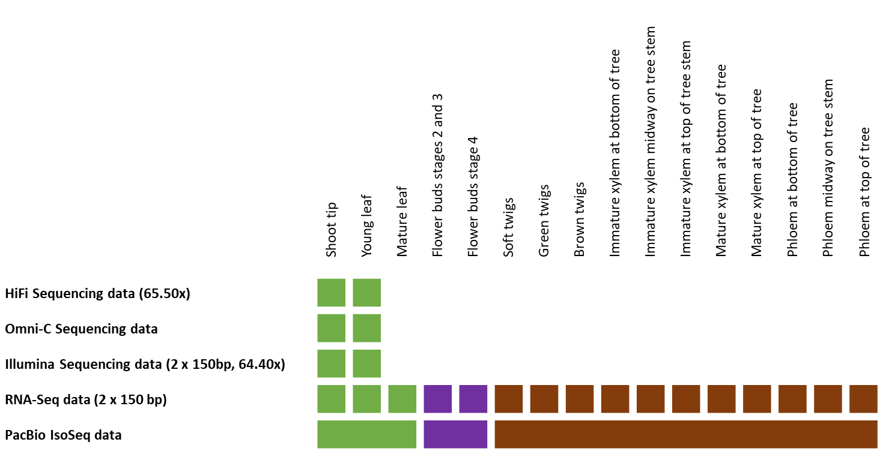
Figure S1. Genome resources overview. The source of the tissue used to generate the relevant sequencing data is indicated at the top. PacBio Iso-Seq sequencing data was generated in tissue pools consisting of the tissues indicated. The type of sequencing and approximate coverage is provided in brackets.
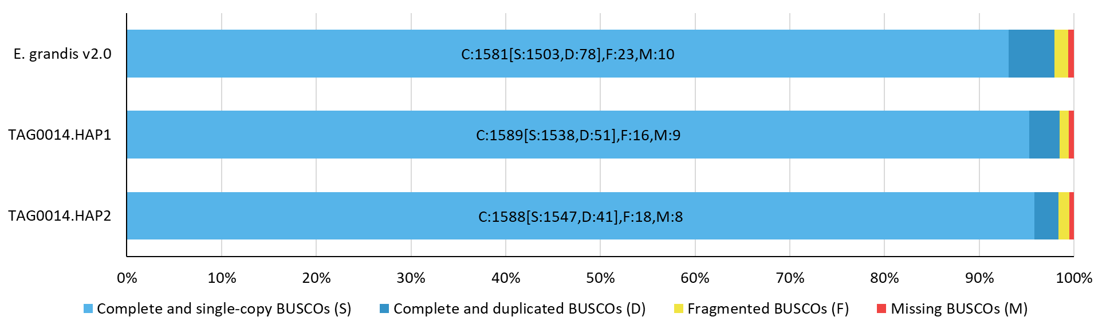
Figure S2. BUSCO completion scores of reference genome assemblies.

Supplementary tables
Table S1. Genome assembly and contiguity statistics.
 | TAG0014 HAP1 |  | TAG0014 HAP2
QUAST assembly statistics
# contigs (>= 0 bp) | 12 |  | 11
# contigs (>= 1000 bp) | 12 |  | 11
# contigs (>= 5000 bp) | 12 |  | 11
# contigs (>= 10000 bp) | 12 |  | 11
# contigs (>= 25000 bp) | 12 |  | 11
# contigs (>= 50000 bp) | 12 |  | 11
Total length (>= 0 bp) | 570,830,339 |  | 552,407,773
Total length (>= 1000 bp) | 570,830,339 |  | 552,407,773
Total length (>= 5000 bp) | 570,830,339 |  | 552,407,773
Total length (>= 10000 bp) | 570,830,339 |  | 552,407,773
Total length (>= 25000 bp) | 570,830,339 |  | 552,407,773
Total length (>= 50000 bp) | 570,830,339 |  | 552,407,773
# contigs | 12 |  | 11
Largest contig | 68,844,007 |  | 66,164,710
Total length | 570,830,339 |  | 552,407,773
GC (%) | 39.50 |  | 39.48
N50 | 57,174,188 |  | 55,768,775
N90 | 37,932,624 |  | 36,908,141
auN | 54,538,915 |  | 52,725,103
L50 | 5 |  | 5
L90 | 10 |  | 10
# N's per 100 kbp | 43.80 |  | 63.36
Scaffolds are divided into the following sets
Set | Number of scaffolds | Size | Number of scaffolds | Size
Main genome | 12 | 570.8 Mbp | 11 | 552.4 Mbp
Redundant (scaffolds composed of ≥95% 24mers >2x in all scaffolds) | 63 | 8.9 Mbp | 100 | 13.9 Mbp
Repetitive (≤250 kbp scaffolds composed of ≥95% 24mers >4x in ≥5 Mbp scaffolds) | 39 | 3.9 Mbp | 21 | 1.5 Mbp
Mitochondria (assembled using OatK) | 1 | 456.9 kbp | 1 | 456.9 kbp
Chloroplast (assembled using OatK) | 1 | 160.2 kbp | 1 | 160.2 kbp
Chromosome statistics
Scaffold | Number of contigs | Scaffold Size | Number of contigs | Scaffold Size
Chr01 | 5 | 44,764,794 | 4 | 41,459,349
Chr02 | 6 | 57,174,188 | 4 | 56,979,195
Chr03 | 3 | 64,190,686 | 4 | 61,673,418
Chr04 | 3 | 37,932,624 | 2 | 36,908,141
Chr05 | 2 | 67,041,112 | 2 | 64,932,641
Chr06 | 4 | 55,026,902 | 9 | 53,665,386
Chr07 | 5 | 58,892,594 | 4 | 55,768,775
Chr08 | 3 | 68,844,007 | 3 | 66,164,710
Chr09 | 2 | 36,944,981 | 6 | 36,522,489
Chr10 | 1 | 38,023,239 | 3 | 37,128,649
Chr11 | 2 | 41,944,707 | 5 | 41,205,020
Remaining | 1 | 50,505 | 0 | 0
Assembly completeness notes
Total primary transcripts (34,121) | Number of sequences | Percentage of sequences | Number of sequences | Percentage of sequences
Sequences placed at 90% identity and 85% coverage | 32,663 | 95.73 | 32,577 | 95.47
Sequences aligned at <50% coverage | 1,068 | 3.13 | 1,171 | 3.43
Sequences not found | 390 | 1.14 | 373 | 1.09
Merqury consensus quality (QV)
Assembly | Unique k-mers | Total k-mers | QV | Error rate
TAG0014 HAP1 | 36,792 | 570,579,599 | 55.13 | 3.07E-06
TAG0014 HAP2 | 30,892 | 552,056,853 | 55.74 | 2.66E-06
Both | 67,684 | 1,122,636,452 | 55.42 | 2.87E-06
Merqury completeness
Assembly | k-mers used | k-mers in assembly | k-mers in reads | Completeness %
TAG0014 HAP1 | all | 397,094,660 | 523,614,206 | 75.84
TAG0014 HAP2 | all | 390,789,882 | 523,614,206 | 74.63
Both | all | 514,083,312 | 523,614,206 | 98.18

Table S2. BUSCO genome assembly and annotation completeness statistics for the E. grandis reference genomes.
Genome | E grandis v2.0 | TAG0014 HAP1 | TAG0014 HAP2
Assembly BUSCO
Percentages | C:97.9% [S:93.1%, D:4.8%], F:1.4%, M:0.7% | C:98.5% [S:95.3%, D:3.2%], F:1.0%, M:0.5% | C:98.3% [S:95.8%, D:2.5%], F:1.1%, M:0.6%
Complete BUSCOs (C) | 1,581 | 1,589 | 1,588
Complete and single-copy BUSCOs (S) | 1,503 | 1,538 | 1,547
Complete and duplicated BUSCOs (D) | 78 | 51 | 41
Fragmented BUSCOs (F) | 23 | 16 | 18
Missing BUSCOs (M) | 10 | 9 | 8
Total BUSCO groups searched | 1,614 | 1,614 | 1,614
Annotation BUSCO
Percentages | C:93.8% [S:88.8%, D:5.0%], F:3.5%, M:2.7% | C:99.4% [S:96.2%, D:3.2%], F:0.4%, M:0.2% | C:99.5% [S:96.7%, D:2.8%], F:0.4%, M:0.1%
Complete BUSCOs (C) | 1,515 | 1,605 | 1,605
Complete and single-copy BUSCOs (S) | 1,434 | 1,553 | 1,560
Complete and duplicated BUSCOs (D) | 81 | 52 | 45
Fragmented BUSCOs (F) | 56 | 6 | 6
Missing BUSCOs (M) | 43 | 3 | 3
Total BUSCO groups searched | 1,614 | 1,614 | 1,614

Table S3. Number of heterozygous and homozygous sites fixed with polishing with Illumina (homozygous) and PacBio CCS (heterozygous) data.
 | TAG0014 HAP1 |  | TAG0014 HAP2
SNP/INDEL Fixing stage | Pre SNP/INDEL fixing | Post SNP/INDEL fixing | Pre SNP/INDEL fixing | Post SNP/INDEL fixing
Heterozygous SNPs | 5,298,407 | 5,298,497 | 5,245,389 | 5,245,433
Homozygous SNPs | 95 | 27 | 148 | 30
Heterozygous INDELs | 534,797 | 535,451 | 533,158 | 533,785
Homozygous INDELs | 3,804 | 51 | 4,109 | 61
Callable Bases | 546,533,710 | 546,535,795 | 531,387,543 | 531,395,648

Table S4. Regions that were misphased and corrected as identified by Omni-C.
Chromosome | Haplotype | Start | End | Haplotype | Start | End
Chr01 | HAP1 | 1,172,920 | 2,957,920 | HAP2 | 1 | 1,930,000
Chr11 | HAP1 | 29,038,515 | 30,269,627 | HAP2 | 27,423,662 | 28,654,774

Table S5. Repeat content of TAG0014 haplotype phased assemblies.
 | TAG0014 HAP1 |  |  |  | TAG0014 HAP2
Repeat element type | Number elements | Length occupied (bp) | Percentage | Number elements |  | Length occupied (bp) | Percentage
DNA
DNA/CMC-EnSpm | 323 | 70,462 | 0.01 | 300 |  | 62,631 | 0.01
DNA/Dada | 150 | 40,262 | 0.01 | 150 |  | 40,737 | 0.01
DNA/hAT-Ac | 1,406 | 781,621 | 0.14 | 1,332 |  | 761,165 | 0.14
DNA/hAT-Charlie | 734 | 280,916 | 0.05 | 752 |  | 270,476 | 0.05
DNA/hAT-Tag1 | 172 | 149,826 | 0.03 | 166 |  | 136,735 | 0.02
DNA/IS3EU | 113 | 25,206 | 0 | 107 |  | 23,363 | 0
DNA/MULE-MuDR | 1,888 | 1,689,454 | 0.3 | 1,737 |  | 1,554,936 | 0.28
DNA/PIF-Harbinger | 1,314 | 923,841 | 0.16 | 1,198 |  | 831,417 | 0.15
DNA/Zisupton | 148 | 69,478 | 0.01 | 108 |  | 39,346 | 0.01
LINE
LINE/L1 | 13,885 | 10,472,401 | 1.83 | 12,822 |  | 9,669,214 | 1.75
LINE/L1-Tx1 | 112 | 49,967 | 0.01 | 111 |  | 54,932 | 0.01
LINE/RTE-BovB | 140 | 38,777 | 0.01 | 130 |  | 36,556 | 0.01
Low complexity | 35,126 | 1,628,973 | 0.29 | 30,767 |  | 1,472,798 | 0.27
LTR
LTR/Caulimovirus | 2,706 | 3,727,706 | 0.65 | 2,737 |  | 3,744,898 | 0.68
LTR/Copia | 34,383 | 51,161,910 | 8.96 | 34,640 |  | 50,735,113 | 9.18
LTR/Gypsy | 19,476 | 20,457,810 | 3.58 | 17,985 |  | 19,075,600 | 3.45
LTR/Pao | 294 | 98,938 | 0.02 | 263 |  | 91,931 | 0.02
PLE
PLE/Chlamys | 297 | 51,079 | 0.01 | 280 |  | 47,867 | 0.01
RC
RC/Helitron | 1,028 | 214,807 | 0.04 | 933 |  | 198,370 | 0.04
Retroposon/L1-dep | 596 | 317,920 | 0.06 | 602 |  | 307,680 | 0.06
rRNA | 406 | 441,698 | 0.08 | 321 |  | 225,857 | 0.04
Simple repeat | 166,769 | 6,917,998 | 1.21 | 164,099 |  | 6,793,321 | 1.23
SINE | 145 | 31,560 | 0.01 | 126 |  | 22,117 | 0
SINE/tRNA | 74 | 10,192 | 0 | 78 |  | 10,471 | 0
SINE/U | 122 | 34,019 | 0.01 | 118 |  | 31,286 | 0.01
snRNA | 66 | 8,046 | 0 | 58 |  | 7,149 | 0
tRNA | 312 | 26,683 | 0 | 313 |  | 28,307 | 0.01
Unknown | 461,811 | 157,020,984 | 27.51 | 439,724 |  | 145,479,922 | 26.34
Total | 743,996 | 256,742,534 | 44.99 | 711,957 |  | 241,754,195 | 43.78

Table S6. Gene annotation statistics for the TAG0014 HAP1 and HAP2 reference genome assemblies.
 | TAG0014 HAP1 | TAG0014 HAP2
Primary transcripts (loci) | 35,929 | 35,583
Alternative transcripts | 28,647 | 28,368
Total transcripts | 64,576 | 63,951
For primary transcripts:
Average number of exons | 5.1 | 5.0
Median exon length | 179 | 179
Median intron length | 208 | 209
Gene model support (value is number of gene models):
Any EST support | 30,914 | 30,666
EST support over 100% of their lengths | 29,269 | 29,071
EST support over 95% of their lengths | 29,526 | 29,315
EST support over 90% of their lengths | 29,666 | 29,450
EST support over 75% of their lengths | 29,954 | 29,710
EST support over 50% of their lengths | 30,255 | 30,000
Peptide homology coverage of 100% | 7,623 | 7,551
Peptide homology coverage of over 95% | 25,444 | 25,314
Peptide homology coverage of over 90% | 28,062 | 27,873
Peptide homology coverage of over 75% | 31,129 | 30,789
Peptide homology coverage of over 50% | 32,879 | 32,606
Pfam annotation | 28,139 | 27,845
Panther annotation | 32,935 | 32,563
KOG annotation | 15,954 | 15,781
KEGG Orthology annotation | 13,671 | 13,636
E.C. number annotation | 11,333 | 11,271

Table S7. gFACS summary statistics of E. grandis v2.0 reference genome and TAG0014 haplotype phased assemblies.
 | E. grandis v2.0 | TAG0014 HAP1 | TAG0014 HAP2
Number of genes | 36,349 | 35,929 | 35,583
Number of monoexonic genes | 7,611 | 6,182 | 6,165
Number of multiexonic genes | 28,738 | 29,747 | 29,418
Number of positive strand genes | 18,244 | 18,064 | 17,694
Monoexonic | 3,935 | 3,121 | 3,093
Multiexonic | 14,309 | 14,943 | 14,601
Number of negative strand genes | 18,105 | 17,865 | 17,889
Monoexonic | 3,676 | 3,061 | 3,072
Multiexonic | 14,429 | 14,804 | 14,817
Average overall gene size | 3,104.21 | 4,020.55 | 3,994.77
Median overall gene size | 2,402 | 3,083 | 3,071
Average overall CDS size | 2,000.79 | 3,842.28 | 3,827.66
Median overall CDS size | 1,394.00 | 1,974.50 | 1,971.00
Average overall exon size | 287.21 | 347.69 | 347.74
Median overall exon size | 156 | 163 | 163
Average size of monoexonic genes | 911.57 | 1,146.96 | 1,139.47
Median size of monoexonic genes | 676 | 933.00 | 931.50
Largest monoexonic gene | 5,377 | 7,502 | 10,192
Smallest monoexonic gene | 201 | 105 | 99
Average size of multiexonic genes | 3,684.90 | 4,617.74 | 4,593.14
Median size of multiexonic genes | 3,010 | 3,627 | 3,621
Largest multiexonic gene | 56,415 | 92,530 | 113,073
Smallest multiexonic gene | 212 | 135 | 199
Average size of multiexonic CDS | 2,289.26 | 4,402.42 | 4,391.01
Median size of multiexonic CDS | 1,617 | 2,312 | 2,315
Largest multiexonic CDS | 43,282 | 402,181 | 400,345
Smallest multiexonic CDS | 201 | 105 | 96
Average size of multiexonic exons | 267.86 | 335.05 | 335.08
Median size of multiexonic exons | 151 | 160 | 160
Average size of multiexonic introns | 344.60 | 338.49 | 337.84
Median size of multiexonic introns | 147 | 125 | 125
Average number of exons per multiexonic gene | 8.55 | 13.14 | 13.11
Median number of exons per multiexonic gene | 5 | 6 | 6
Largest multiexonic exon | 7,890 | 10,064 | 13,880
Smallest multiexonic exon | 1 | 1 | 1
Most exons in one gene | 301 | 1,013 | 1,010
Average number of introns per multiexonic gene | 7.55 | 12.21 | 12.18
Median number of introns per multiexonic gene | 4 | 5 | 5
Largest intron | 9,190 | 87,554 | 39,127
Smallest intron | -1 | -1 | -1
The following columns do not involve codons
Number of complete models | 36,098 | 35,866 | 35,523
Number of 5' only incomplete models | 70 | 28 | 28
Number of 3' only incomplete models | 181 | 20 | 14
Number of 5' and 3' incomplete models | 0 | 15 | 18

Table S8. Summary of structural variants between the reference genomes.
Reference genome | Query genome | Number of events | Length reference (bp) | Percentage reference (%) | Length query (bp) | Percentage query (%)
Syntenic regions
E. grandis v2.0 | TAG0014 HAP1 | 14,029 | 369,254,214 | 53.41 | 370,195,762 | 64.85
TAG0014 HAP1 | TAG0014 HAP2 | 13,349 | 396,000,960 | 69.37 | 396,333,150 | 71.75
TAG0014 HAP2 | E. grandis v2.0 | 14,285 | 371,533,224 | 67.26 | 370,664,106 | 53.61
Inversions
E. grandis v2.0 | TAG0014 HAP1 | 100 | 18,352,964 | 2.65 | 16,783,397 | 2.94
TAG0014 HAP1 | TAG0014 HAP2 | 89 | 9,417,568 | 1.65 | 8,282,210 | 1.5
TAG0014 HAP2 | E. grandis v2.0 | 114 | 7,753,224 | 1.4 | 7,569,510 | 1.09
Translocations
E. grandis v2.0 | TAG0014 HAP1 | 9,982 | 72,043,085 | 10.42 | 72,102,959 | 12.63
TAG0014 HAP1 | TAG0014 HAP2 | 7,827 | 46,538,476 | 8.15 | 46,282,393 | 8.38
TAG0014 HAP2 | E. grandis v2.0 | 10,090 | 76,720,961 | 13.89 | 75,412,281 | 10.91
Duplications - reference
E. grandis v2.0 | TAG0014 HAP1 | 22,713 | 84,524,332 | 12.23
TAG0014 HAP1 | TAG0014 HAP2 | 21,289 | 82,095,122 | 14.38
TAG0014 HAP2 | E. grandis v2.0 | 19,387 | 73,653,973 | 13.33
Duplications - query
E. grandis v2.0 | TAG0014 HAP1 | 17,683 |  |  | 56,211,493 | 9.85
TAG0014 HAP1 | TAG0014 HAP2 | 14,659 |  |  | 48,917,664 | 8.86
TAG0014 HAP2 | E. grandis v2.0 | 19,526 |  |  | 58,631,124 | 8.48
Not aligned - reference
E. grandis v2.0 | TAG0014 HAP1 | 26,566 | 107,699,067 | 15.58
TAG0014 HAP1 | TAG0014 HAP2 | 20,602 | 75,546,270 | 13.23
TAG0014 HAP2 | E. grandis v2.0 | 21,454 | 76,972,257 | 13.93
Not aligned - query
E. grandis v2.0 | TAG0014 HAP1 | 22,602 |  |  | 83,357,649 | 14.6
TAG0014 HAP1 | TAG0014 HAP2 | 18,917 |  |  | 65,828,782 | 11.92
TAG0014 HAP2 | E. grandis v2.0 | 27,446 |  |  | 114,939,770 | 16.63

Table S9. Summary of local variants between the reference genomes.
Reference genome | Query genome | Number of events | Length reference (bp) | Length query (bp)
Single nucleotide polymorphisms (SNPs)
E. grandis v2.0 | TAG0014 HAP1 | 6,453,759 | 6,453,759 | 6,453,759
TAG0014 HAP1 | TAG0014 HAP2 | 6,197,893 | 6,197,893 | 6,197,893
TAG0014 HAP2 | E. grandis v2.0 | 6,675,143 | 6,675,143 | 6,675,143
Insertions
E. grandis v2.0 | TAG0014 HAP1 | 696,627 |  | 16,783,397
TAG0014 HAP1 | TAG0014 HAP2 | 550,834 |  | 8,282,210
TAG0014 HAP2 | E. grandis v2.0 | 626,069 |  | 7,569,510
Deletions
E. grandis v2.0 | TAG0014 HAP1 | 494,858 | 4,448,538
TAG0014 HAP1 | TAG0014 HAP2 | 482,009 | 4,267,853
TAG0014 HAP2 | E. grandis v2.0 | 592,575 | 5,487,780
Copygains (CPG)
E. grandis v2.0 | TAG0014 HAP1 | 1,626 |  | 5,703,905
TAG0014 HAP1 | TAG0014 HAP2 | 1,274 |  | 3,698,389
TAG0014 HAP2 | E. grandis v2.0 | 1,406 |  | 4,562,277
Copylosses (CPL)
E. grandis v2.0 | TAG0014 HAP1 | 1,426 | 4,868,625
TAG0014 HAP1 | TAG0014 HAP2 | 1,219 | 3,916,910
TAG0014 HAP2 | E. grandis v2.0 | 1,639 | 5,566,419
Highly diverged regions (HDR)
E. grandis v2.0 | TAG0014 HAP1 | 9,254 | 29,765,501 | 27,608,817
TAG0014 HAP1 | TAG0014 HAP2 | 4,849 | 16,182,833 | 15,199,906
TAG0014 HAP2 | E. grandis v2.0 | 9,347 | 25,316,307 | 25,061,446
Tandem repeats (TDM)
E. grandis v2.0 | TAG0014 HAP1 | 312 | 549,240 | 659,116
TAG0014 HAP1 | TAG0014 HAP2 | 286 | 970,007 | 1,121,248
TAG0014 HAP2 | E. grandis v2.0 | 328 | 926,751 | 687,677

Table S10. Number of tandem genes and tandem arrays in the reference genomes.
 | E. grandis v2.0 | TAG0014 HAP1 | TAG0014 HAP2
Number of genes | 5,488 | 6,493 | 6,346
Number of arrays | 2,106 | 2,235 | 2,232
Mean number of genes | 2.62 | 2.91 | 2.84
Minimum number of genes within an array | 2 | 2 | 2
Maximum number of genes within an array | 34 | 33 | 36
Proportion of annotated genes (%) | 15.10 | 18.40 | 17.83

